NIH and Other PHS Agency
Research Performance Progress
Report (RPPR) Instruction Guide

Document Version 9.7.1

November 22, 2016

Forms Approved Through 10/31/2018
OMB No. 0925-0002



CONTACT US

Document Comments:
We value your feedback on this document. Please email your comments to eRACommunications@mail.nih.gov.

For policy-related questions:
Please email grantspolicy@od.nih.gov.

Troubleshooting support:

Service Desk Ticketing System!
Log-in with your eRA Commons username and password to access the eRA Service Desk web ticketing system to submit a service desk ticket online, view status of your prior tickets, and update your tickets.
- Access the eRA Service Desk web ticketing system with your eRA Commons user name and password.
- Having trouble logging in?
Click here to submit an online request if you are not able to log in or do not have an eRA Commons account.
- NIH Staff/Agency Partner Staff, click here to access the eRA Service Desk web ticketing system.
For information, see the flyer on the new Service Desk Ticketing System (PDF - 212 KB).

Or to contact the eRA Service Desk directly:

Web: http://grants.nih.gov/support (Preferred method of contact)
Toll-free: 1-866-504-9552
Phone: 301-402-7469
Email: s2ssupport@mail.nih.gov (for System-to-System support)
Hours: Mon-Fri, 7:00 a.m. to 8:00 p.m. Eastern Time, except for Federal Holidays

DISCLAIMER STATEMENT

No data shown in illustrations represents any real account, project, or individual. Any resemblance to actual accounts, projects, or individuals is purely coincidental.

DOCUMENT HISTORY

Date | Commons  System  Version | Document Version | Description of Change | Author
4/25/2012 | 3.3.3.1 | 1.0.0 | Develop initial draft of document | eRA  Documentation Team
1/31/2014 | 3.11.0.5 | 7.0.0 | Updated for AHRQ and multiyear funded awards | eRA  Communications
4/25/2014 | 3.12.0.7 | 7.1.0 | Corrected text and screen prints | eRA  Communications
7/18/2014 | 3.14.0.10 | 8.0.0 | Updated PA PRAM feature; inclusion forms | eRA  Communications
10/17/2014 | 3.16.0.10 | 9.0.0 | Updated for Inclusion  Enrollment; NCT selection on multi-projects; Agency  Requested PRAM changes | eRA  Communications
2/5/2015 | 3.18.0.13 | 9.2.0 | Added Recall for PRAM;  Additional Indirect Cost budget form | eRA  Communications
3/11/2015 | 3.18.2.2 | 9.3.0 | Minor text edits | eRA  Communications
4/17/2015 | 3.19.0.0 | 9.4.0 | AHRQ updates | eRA  Communications
7/17/2015 | 3.21.0.0 | 9.5.0 | Modified instructions for question B.4 | eRA  Communications
11/3/2015 | 3.22 | 9.6.0 | Modified instructions in Chapter  7; replaced policy links throughout | eRA  Communications
1/25/2016 | 3.24 | 9.7.0 | Modified instructions for Section  6.2, questions B.2 and B.6;  Section 7.4, question B.2 | eRA  Communications
11/22/2016 | 3.26.4.1 | 9.7.1 | Updates to Figures 86,87  Update Section 6.3, C.2, C.3, and C.5.a, regarding the new selection menus on the left and updated language regarding selections. | eRA Communications

TABLE OF CONTENTS

1 Purpose 3
1.1 NIH 3
1.2 Agency for Healthcare Research and Quality (AHRQ) 3
2 Background and Paperwork Burden 4
3 RPPR Due Dates 5
3.1 NIH 5
3.2 Agency for Healthcare Research and Quality (AHRQ) 5
4 Data Entry, PDF Attachments, and Style 6
4.1 Data or Text Box, and PDF Size Limits 6
4.2 PDF Attachments 6
4.3 Style 7
5 Navigation 8
5.1 Initiate the RPPR 9
5.2 Edit the RPPR 14
5.3 Check RPPR for Errors and Warnings 37
5.4 5.4 Route the RPPR 40
5.5 5.5 Recall the RPPR 42
5.6 5.6 Submit the RPPR to Agency 43
5.7 View the RPPR 46
5.8 View Routing History 46
5.9 Viewing the Final RPPR in Commons 47
5.10 Public Access Progress Report Additional Materials (PRAM) 50
5.10.1 Initiate Public Access PRAM 50
5.10.2 Recall Public Access PRAM 53
5.10.3 Submit Public Access PRAM 54
5.10.4 View Public Access PRAM for Multi-Year Funded Awards 57
5.11 Agency Requested Progress Report Additional Materials (PRAM) 58
5.11.1 Initiate Agency Requested PRAM 58
5.11.2 Recall Agency Requested PRAM 62
5.11.3 Submit Agency Requested PRAM 63
5.11.4 View Agency Requested PRAM from Status Information 66
6 Instructions for RPPR Sections A–H 69
6.1 Section A – Cover Page 69
6.2 Section B – Accomplishments 70
6.3 Section C – Products 75
6.4 Section D – Participants 80
6.5 Section E – Impact 86
6.6 Section F – Changes 87
6.7 Section G – Special Reporting Requirements 89
6.8 Section H – Budget [Applicable to non-SNAP awards only] 100
6.9 Section I – Interim and Final Research Performance Progress Report……………………….102
7 Supplemental Instructions for Specific Grant RPPR Types 103
7.1 Individual Career Development (K) RPPRs 103
7.2 Fellowship RPPRs 106
7.3 SBIR/STTR RPPRs 107
7.4 Training RPPRs 110
7.5 Education RPPRs 113
7.6 Multi-Project RPPRs and Single-Project RPPRs with Complicated Structure 115
7.6.1 Overall 115
7.6.2 Component Instructions 120
8 Assurances/Certifications 123
9 Government Use of Information Under the Privacy Act 124

LIST OF TABLES

Table 1: Applicable Supplemental Instructions ............................................................................ 94

LIST OF FIGURES

Figure 1: RPPR Navigation Links from Cover Page ...................................................................... 6
Figure 2: Status Screen and List of Applications/Grants Links ...................................................... 7
Figure 3: RPPR Link on Status Result – List of Applications/Grants ............................................ 8
Figure 4: Multi-Year Award RPPR Link ........................................................................................ 8
Figure 5: Manage RPPR List of Grant Applications ...................................................................... 9
Figure 6: Multi-Year RPPR Error Message .................................................................................... 9
Figure 7: RPPR Menu for Initiating the Report ............................................................................ 11
Figure 8: Status Screen and List of Applications/Grants Links .................................................... 13
Figure 9: RPPR Link on Status Result – List of Applications/Grants .......................................... 13
Figure 10: Multi-Year Funded Award RPPR Link ....................................................................... 14
Figure 11: Manage RPPR List of Grant Applications .................................................................. 14
Figure 12: RPPR Menu Buttons ................................................................................................... 15
Figure 13: RPPR Menu Options for Multi-Project RPPRs ........................................................... 16
Figure 14: RPPR Menu for Single-Project with Complicated Structure ...................................... 16
Figure 15: Edit Link for Overall ................................................................................................... 17
Figure 16: Adding and Editing Individual Components ............................................................... 18
Figure 17: RPPR Cover Page and Section Navigation Links ....................................................... 19
Figure 18: Add/New Feature ........................................................................................................ 20
Figure 19: Total Remaining Characters ........................................................................................ 20
Figure 20: Inclusion Link in Question G.4.b ................................................................................ 21
Figure 21: Manage IDRs for Single Project ................................................................................. 22
Figure 22: Manage IDRs for Multi-Year Project .......................................................................... 22
Figure 23: Entering Cumulative Inclusion Data ........................................................................... 24
Figure 24: Edit Planned Inclusion Data–Grantee Updates in Progress ........................................ 26
Figure 25: No Inclusion Data Records–Single Project ................................................................. 27
Figure 26: No Inclusion Data Records – Multi-Year Funded Award ........................................... 28
Figure 27: RPPR H. Budget - Questions H.1 Budget Form & H.2 Subaward Budget Form ....... 31
Figure 28: Organizational DUNS on SF 424 Research & Related Budget .................................. 31
Figure 29: SF 424 R&R Budget Form - Question F.5 .................................................................. 32
Figure 30: Check for Errors Button on RPPR Menu for a Single-Project RPPR ......................... 33
Figure 31: RPPR Error Messages (Examples) .............................................................................. 33
Figure 32: Check for Errors Links for Multi-Project RPPRs ....................................................... 34
Figure 33: Errors and Warnings for One Component of a Multi-Project RPPR .......................... 35
Figure 34: RPPR Menu – Route Button ....................................................................................... 35
Figure 35: Route RPPR to Next Reviewer ................................................................................... 36
Figure 36: PD/PI Assurance Statement......................................................................................... 36
Figure 37: RPPR Successfully Routed ......................................................................................... 37
Figure 38: RPPR Menu – Recall Button ....................................................................................... 37
Figure 39: RPPR Successfully Recalled ....................................................................................... 38
Figure 40: Submit Button on RPPR Menu ................................................................................... 38

Figure 41: Successful Submission Message ............................................................................ 39
Figure 42: Sample of Multi-Project RPPR Error Messages .................................................... 40
Figure 43: RPPR Menu – View Button ................................................................................... 41
Figure 44: RPPR Menu – View Routing History Button ........................................................ 41
Figure 45: RPPR Routing History ........................................................................................... 41
Figure 46: Status Menu Option ............................................................................................... 42
Figure 47: Application ID hyperlink........................................................................................ 42
Figure 48: Status Information Screen – e-Application Link ................................................... 43
Figure 49: Status Information Screen for Multi-Year RPPR .................................................. 43
Figure 50: Public Access PRAM Link..................................................................................... 45
Figure 51: Routing the Public Access PRAM ......................................................................... 45
Figure 52: Route Public Access PRAM to Next Reviewer ..................................................... 46
Figure 53: Public Access PRAM PD/PI Assurance Statement ............................................... 46
Figure 54: Successfully Routed Public Access PRAM ........................................................... 47
Figure 55: Recall Button for Public Access PRAM ................................................................ 48
Figure 56: Public Access PRAM Link for SO ........................................................................ 49
Figure 57: Submitting Public Access PRAM .......................................................................... 49
Figure 58: SO Certification of Public Access PRAM ............................................................. 50
Figure 59: Public Access PRAM Submitted to Agency ......................................................... 50
Figure 60: Status Results Showing Hyperlink for Application ID ......................................... 51
Figure 61: MYF Award PRAM Link in Status Information................................................... 51
Figure 62: Agency Requested PRAM Link ........................................................................... 52
Figure 63: Add Attachment Button for Agency Requested PRAM ....................................... 53
Figure 64: Upload Attachment Pop-up .................................................................................. 53
Figure 65: Routing the Agency Requested PRAM ................................................................ 54
Figure 66: Route Agency Requested PRAM to Next Reviewer ............................................ 54
Figure 67: Agency Requested PRAM PD/PI Assurance Statement ...................................... 54
Figure 68: Successfully Routed Agency Requested PRAM .................................................. 55
Figure 69: Recall Button for Agency Requested PRAM ....................................................... 56
Figure 70: Agency Requested PRAM Link for SO ............................................................... 57
Figure 71: Submitting Agency Requested PRAM ................................................................. 57
Figure 72: SO Certification of PRAM ................................................................................... 58
Figure 73: Agency Requested PRAM Submitted to Agency.................................................. 58
Figure 74: Grant Number Hyperlink on PRAM Screen ......................................................... 59
Figure 75: Application ID Hyperlink on Status Result for PIs ............................................... 59
Figure 76: Application ID Hyperlink on Status Result for SOs ............................................. 60
Figure 77: Status Information with PRAM Link .................................................................... 60
Figure 78: PDF of Multiple Submitted PRAM ....................................................................... 61
Figure 79: RPPR Section A. Cover Page ................................................................................ 63
Figure 80: RPPR Section B. Accomplishments – Question B1 .............................................. 64
Figure 81: RPPR Section B. Accomplishments – Questions B2 & B3 .................................. 65
Figure 82: RPPR Section B. Accomplishments – Question B4 ............................................. 66
Figure 83: RPPR Section B. Accomplishments – Question B5 ............................................. 67
Figure 84: RPPR Section B. Accomplishments – Question B6 ............................................. 67
Figure 85: RPPR Section C. Products – Question C1 ............................................................ 69
Figure 86: RPPR Section C. Products – Questions C2 & C3 .................................................. 70 Figure 87: RPPR Section C. Products – Questions C4 & C5 .................................................. 71
Figure 88: RPPR Section D. Participants – Question D1 ........................................................ 74
Figure 89: RPPR Section D. Participants – Questions D2a & D2b ......................................... 75
Figure 90: RPPR Section D. Participants – Questions D2c – D2e .......................................... 77
Figure 91: RPPR Section E. Impact – Questions E1 through E4 ............................................ 78
Figure 92: RPPR Section F. Changes – Questions F1 & F2 ................................................... 79
Figure 93: RPPR Section F. Changes – Question F3 .............................................................. 80
Figure 94: RPPR Section G. Special Reporting Requirements – Questions G1 through G3 .. 81
Figure 95: Question G.4.b for AHRQ Grantees Only ............................................................. 83
Figure 96: RPPR Section G. Special Reporting Requirements – Question G.4 ...................... 86
Figure 97: RPPR Section G. Special Reporting Requirements – Questions G5 through G7 .. 87
Figure 98: RPPR Section G. Special Reporting Requirements – Question G8 ....................... 88
Figure 99: RPPR Section G. Special Reporting Requirements – Question G9 ....................... 89
Figure 100: RPPR Section G. Special Reporting Requirements – Questions G10 through G12 . 90
Figure 101: Section H.Budget of RPPR for a Non-SNAP Award ........................................... 91
Figure 102: SF 424 Research & Related Budget Form Opened for Editing ........................... 92
Figure 103: SF 424 R&R Budget Form - Question F.5 ........................................................... 92
Figure 104: SF 424 R&R Budget Form - Question F.5 ........................................................... 96
Figure 105: SF 424 R&R Budget Form - Question F.5 ......................................................... 100
Figure 106: SF 424 R&R Budget Form - Question F.5 ......................................................... 104
Figure 107: D.1 Specifying the Components for an Added Individual ................................. 108
Figure 108: Associating a Component with the NCT Number.............................................. 109
Figure 109: SF 424 R&R Budget Form - Question F.5 ........................................................ 110
Figure 110: Sample of Section A. Cover Page for a Component ......................................... 111
Figure 111: SF 424 R&R Budget Form - Question F.5 ........................................................ 113

Purpose

The purpose of this document is to provide those preparing the Research Performance Progress Report (RPPR) with an explanation of the RPPR module in the eRA Commons and the information required in the report. This document also provides the steps for accessing and completing the report in eRA Commons, as well as navigating, validating, routing, and submitting the RPPR to the awarding agency.

NIH
The RPPR is required for all annual non-competing (Type 5) NIH awards. Progress reports submitted in any format other than the RPPR will not be processed by the NIH and will require resubmission through the RPPR. Refer to notices NOT-OD-13-035, NOT-OD-14-026 and NOT-OD-14-092 and NOT-OD-15-014 for more information.
For SBIR/STTR Fast-Track Phase II applications (SBIR/STTR Fast-Track Phase I final progress reports), follow the instructions in the Non-Competing Continuation Progress Report PHS 2590 (http://grants.nih.gov/grants/funding/2590/2590.htm).
NIH continues development of the RPPR for the final progress report and for administrative extensions (Type 4s; e.g., SBIR/STTR Fast-Track Phase II applications). NIH will continue to update the community as progress is made.

Agency for Healthcare Research and Quality (AHRQ)
All Agency for Healthcare Research and Quality (AHRQ) grantees, exclusive of recipients of multi-year funded awards, are required to use the eRA Commons RPPR module, effective January 1, 2015 (NOT-HS-15-001). Multi-year funded awards (awards in which the budget and project periods are the same and are longer than 12 months) are required to submit a paper PHS 2590.

The RPPR includes numerous references to the NIH Grants Policy Statement, 8.1.2 requirement that significant changes in objectives and scope require prior approval of the agency; for AHRQ awardees the analogous requirement is in the HHS Grants Policy Statement under PriorApproval Requirements.

Background and Paperwork Burden

The NIH Research Performance Progress Report (RPPR) implements the uniform reporting format for interim research progress reporting developed under the auspices of the National Science and Technology Council, through the Committee on Science and the Research Business Models Subcommittee, and established by the Office of Management and Budget for use by agencies that support research and research-related activities.
For NIH, all progress reports must be submitted using the RPPR. For the AHRQ, all annual progress reports, exclusive of those for multi-year funded awards, must be submitted using the RPPR effective January 1, 2015. Other PHS agencies that may eventually utilize the NIH RPPR are the Food and Drug Administration, and Centers for Disease Control and Prevention. NonNIH agencies may have requirements that differ from those for NIH grantees; refer to the Notice of Award (NoA) or contact the Grants Management Specialist named in the NoA.
Progress reports are required to continue support of a PHS grant for each budget year within a competitive segment. The RPPR is not used for submitting a Final Progress Report; instructions for submitting a Final Progress Report are at http://grants.nih.gov/grants/funding/finalprogressreport.pdf for NIH and at http://www.ahrq.gov/funding/grant-mgmt/reptemp.html for AHRQ.

PHS estimates that it will take approximately 15 hours to complete this progress report. An agency may not conduct or sponsor, and a person is not required to respond to, a collection of information unless it displays a currently valid OMB control number. If you have comments regarding the burden estimate or other aspect of the collection of information, including suggestions for reducing the burden, send comments to: NIH, Project Clearance Office, 6705 Rockledge Drive MSC 7974, Bethesda, MD 20892-7974, ATTN: PRA (0925-0002). Do not send progress reports to this address.

Background and Paperwork Burden

RPPR Due Dates

Grantees can determine which progress reports are due through the website located at: https://public.era.nih.gov/chl/public/search/index.jsp and should periodically check the site, which is updated on or around the 30th of each month. Progress report due dates are also available in the eRA Commons Status system. In addition, automatic e-mail notifications are sent to the PD/PI prior to due date.

NIH
    - SNAP: If an award is issued under the SNAP (Streamlined Noncompeting Award Process) provisions, the progress report is due the 15th of the month preceding the month in which the budget period ends (e.g., if the budget period ends 11/30, the due date is 10/15). If the 15th falls on a weekend or Federal holiday, the due date is automatically extended to the next business day. Grantees should consult the NoA to determine when SNAP procedures apply.
    - Non-SNAP: If an award is not issued under the SNAP provisions, the progress report is due the first of the month preceding the month in which the budget period ends (e.g., if the budget period ends 11/30, the due date is 10/1).
    - Fellowships: For Fellowships, the progress report is due two months before the beginning date of the next budget period. Occasionally, the Notice of Award (NoA) will indicate a different due date which will supersede these dates.
    - MYF: Progress Reports for MYF awards are due annually on or before the anniversary of the budget/project period start date of the award. The reporting period for a MYF progress report is the calendar year preceding the anniversary date of the award.

Agency for Healthcare Research and Quality (AHRQ)
All AHRQ progress reports due in FY 2015 (10/1/14 – 9/30/15) and beyond are due 3 months before the anniversary of the award. For example, for an FY2014 award issued with a start date of 2/1/14, the annual progress report is due 11/1/14 (i.e., three months before the FY2015 budget period start date (i.e. anniversary date) of 2/1/15). If the due date falls on a weekend or federal holiday, the due date is automatically extended to the next business day.
Please note that AHRQ does not participate in the SNAP (Streamlined Noncompeting Award Process) initiative. AHRQ grantees are to submit detailed budgets for the parent organization and for each consortium involved in the project.

RPPR Due Dates

Data Entry, PDF Attachments, and Style

Data or Text Box, and PDF Size Limits
Most text entry boxes have an 8,000 character limit (~3 pages); this limit is standardized across federal agencies implementing the RPPR and entry of more than 8,000 characters is prevented by the system. In an effort to reduce grantee burden and encourage concise responses NIH has stated the recommended length of the response for some questions and, for agency-specific questions has limited the length of the response with text boxes with a limit of less than 8,000 characters. AHRQ grantees should follow NIH recommended lengths for text entries.

Warning: Text exceeding 8,000 characters is cut to 8,000 when using the cut and paste feature.
PDF file uploads (attachments) do not have page limits, but may not be more than 6 megabytes (6MB). PDF attachments are utilized when there may be a need for a grantee to provide considerable detail (e.g., change in human subject protocols that requires a new or revised Protection of Human Subjects section as described in Part II of the competing application instructions). Even when developing PDF responses, grantees are encouraged to be concise and avoid unnecessary detail.

PDF Attachments
Grantees should generate text attachments using any word processing software and then convert those files to PDF before attaching the files to the appropriate section in the progress report. The PDF format is used to preserve document formatting. All PDF attachments must be submitted as individual files. Although some software packages allow bundling of multiple PDFs into a single file, eRA systems cannot support “Bundling” or “Portfolio” features at this time. Use of these features may result in delays in agency acceptance of the progress report. Paginated PDF files are also discouraged since they can interfere with system pagination of the entire RPPR document upon submission to the agency. File names will be used and displayed in the assembled PDF submitted to the agency.
Save all files with descriptive file names of 50 characters or less and be sure to only use standard characters in file names: A through Z, a through z, 0 through 9, and underscore (_). Do not use any special characters (example: &, -, *, %, /, and #) or spacing in the file name, and for word separation use an underscore (e.g., My_Attached_File.pdf).
Use an Arial, Helvetica, Palatino Linotype, or Georgia typeface, a black font color, and a font size of 11 points or larger. (A Symbol font may be used to insert Greek letters or special characters; the font size requirement still applies.) Type density, including characters and spaces, must be no more than 15 characters per inch. Type may be no more than six lines per inch.
Use standard paper size (8 ½" x 11). Use at least one-half inch margins (top, bottom, left, and right) for all pages. No information should appear in the margins, including the PI’s name and page numbers.

Style
Use English and avoid jargon. Abbreviations and language that may not be known to the broader scientific community should be avoided unless clearly defined. Internet Web site addresses (URLs) should not be used unless provided under C.2.

Navigation

The RPPR is completed using the eRA Commons system. The report in Commons consists of separate screens for each of the sections listed below:
- Cover Page
- Accomplishments
- Products
- Participants
- Impact
- Changes
- Special Reporting Requirements
- Budget
Users may work on various sections in any order, however, it is important to click the Save button in the navigation bar before leaving a screen in order to retain data entered on that screen. Upon submission to the awarding agency, the system will generate a PDF of the progress report, which may be viewed from the RPPR Menu screen using the View button.
Once submitted, the final RPPR, in PDF format, is accessible in Commons via the Status Information screen. Refer to the section titled Viewing the Final RPPR in Commons for detailed steps.
Note that a link to a site outside the RPPR (e.g., U.S. Select Agency Registry in F.3.d,
ClinicalTrials.gov in G.4.c, or the NIH human embryonic stem cell Registry in G.6) opens a site in a new browser window. You must close that window to return to the RPPR. Do not close the browser or use the browser’s back button.

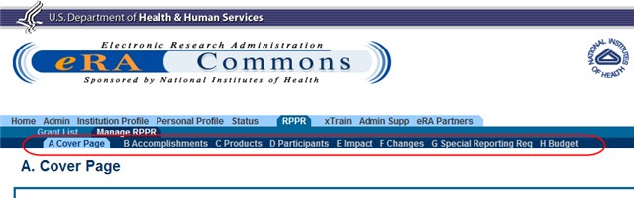

Figure
1
:
RPPR Navigation Links from Cover Page

Initiate the RPPR
Only the PD/PI or the PD/PI delegate may initiate an RPPR. When there are multiple PIs (MPI), only the Contact PI or the PD/PI delegate of the Contact PI may initiate the report. To initiate, the user can choose from one of two ways to access the RPPR functionality:
1. Access RPPR from Status:
- Select the Status tab from the Commons menu options.
- Select the List of Applications/Grants link from the Status screen or from the menu options.

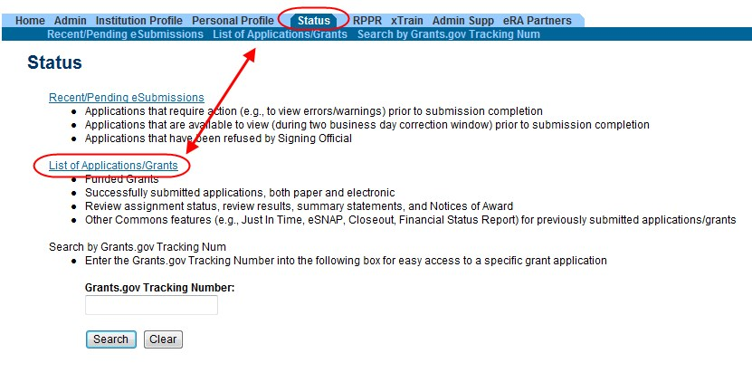

Figure 2: Status Screen and List of Applications/Grants Links

- From the Status Result – List of Applications/Grants screen, locate the grant and select the RPPR link from the Action column for the specific grant. The RPPR link for the current reporting period is available once the Notice of Award for the prior year has been issued. This link remains available until the RPPR for the current reporting year has been submitted.
For multi-year funded awards, the link will display as RPPR Year <X>, the <X> representing the reporting year. The link for a multi-year funded award is available two months prior to the RPPR due date for the current reporting period and remains available until the RPPR is submitted. Note that AHRQ has not yet implemented the RPPR for multi-year funded awards.

NOTE: While RPPR Year <X> links for multiple years may appear at the same time in Status, you are prevented from initiating a reporting year’s progress report until the progress report(s) of the previous year(s) has been submitted.

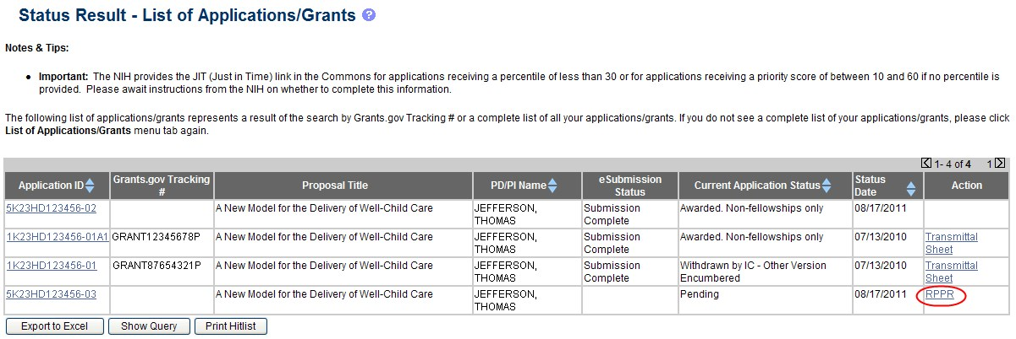

Figure 3: RPPR Link on Status Result – List of Applications/Grants

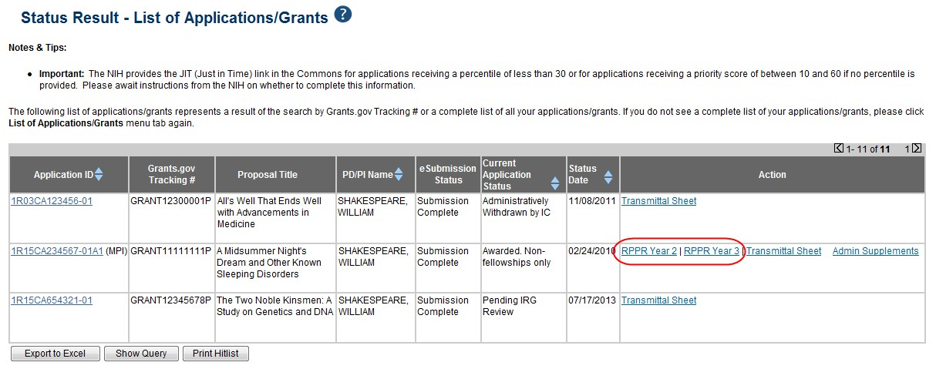

Figure
4
:
Multi
-
Year Award RPPR Link

–OR–
1. Access RPPR from RPPR tab:
- Select the RPPR tab from the Commons menu options.
The Manage RPPR screen displays. Manage RPPR is used to view the progress reports to which the user has access and allows the user to select a progress report in order to perform various actions. PD/PIs or users delegated PD/PI updating authority uses the Manage RPPR screen to view their own progress reports. SOs and AOs use the screen to search for grants from their institutions and/or for grants routed to them for review.
- Select the specific grant by clicking the hyperlink in the Grant Number column on the Manage RPPR screen.

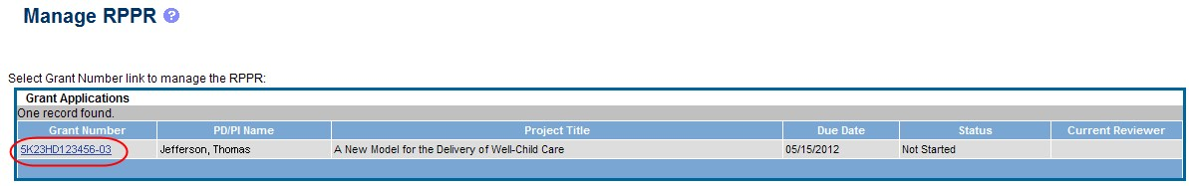

Figure
5
:
Manage
RPPR

List of Grant Applications

If an RPPR exists already, Commons displays the report for editing.
The RPPR Menu screen displays. The options for the uninitiated report are Initiate and Cancel. Once an RPPR is in progress, the buttons for other options are enabled. These options are discussed later, following the steps for initiation.

NOTE: For multi-year funded awards, the following message displays when attempting to initiate an RPPR if the previous year’s report has not been submitted:
The Multi-Year RPPR for the previous year must be submitted prior to initiating this Multi-Year RPPR.
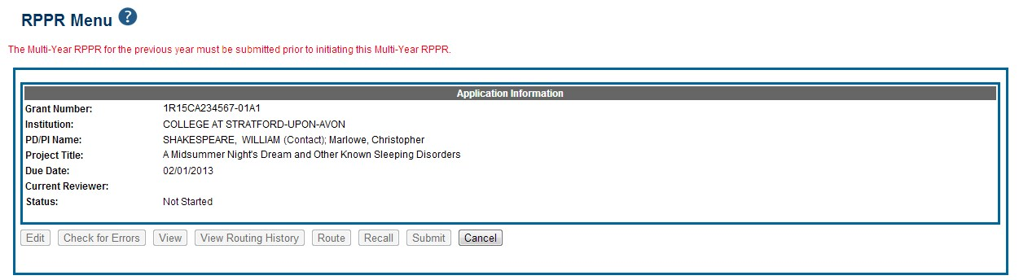
In this case, the option to initiate
is

disabled.

Figure
6
:
Multi
-
Year RPPR Error Message

The RPPR Menu screen includes the following fields:
Grant Number
This is the complete number of the grant
Grantee Institution
This field contains the name of the applicant’s institution
PD/PI Name
The PD/PI of the grant award for which the progress report is being prepared. In the case of MPIs, a list of PD/PI names displays with the Contact PD/PI indicated by the word Contact.
Project Title
The project title of the grant
Due Date
NIH
The due date of the progress report for awards issued under the SNAP (Streamlined
Noncompeting Award Process) provisions is the 15th of the month preceding the month in which the budget period ends (e.g., if the budget period ends 11/30, the due date is 10/15). If the award is not issued under SNAP provisions, the progress report is due the first of the month preceding the month in which the budget period ends (e.g., if the budget period ends 11/30, the due date is 10/1). If the due date falls on a weekend or federal holiday, the due date is automatically extended to the next business day. Progress reports for Fellowships are due two months before the beginning date of the next budget period. Occasionally the Notice of Award (NoA) will indicate a different due date which will supersede these dates. Grantees should consult the NoA to determine when SNAP procedures apply.
AHRQ
All AHRQ progress reports due in FY 2015 (10/1/14 – 9/30/15) and beyond are due 3 months before the anniversary of the award. For example, for an FY2014 award issued with a start date of 2/1/14, the annual progress report is due 11/1/14 (i.e., three months before the FY2015 budget period start date (i.e. anniversary date) of 2/1/15). If the due date falls on a weekend or federal holiday, the due date is automatically extended to the next business day.
Current Reviewer
The name of the current reviewer or organization (e.g., PD/PI name, NIH). This value is blank before the RPPR is initiated.
Status
The current state of the progress report. Possible values are as follows: Not Started, PD/PI Work in Progress, Reviewer Work in Progress, and Submitted to Agency.
Buttons
The displayed and enabled buttons vary depending on the status of the RPPR and/or the limitations of the current user’s role. The possible available actions include the following:
- Initiate: Begins the RPPR process. Available for grants with a status of Not Started. Access is granted to PD/PIs and PD/PI delegates. An RPPR can be initiated even if required information in the Personal Profile and Institution Profile sections is missing. If any of this information is incorrect or missing, a prompt will appear to correct/complete the information after initiating the report. Processing may continue on the RPPR without making the corrections; however, the RPPR will not pass validations for submission to the agency until the errors are corrected.
- Edit: Opens the RPPR for edits. Available for progress reports with a status of Work in Progress (WIP). Access is granted to PD/PIs or PD/PI delegates when the PD/PI is the current reviewer, AOs when the AO is the current reviewer, and SOs when the SO is the current reviewer. The Edit button allows the user to view and edit RPPR information.
- View: Opens the RPPR report in PDF format, as it will be seen by the agency. Available for progress reports with a status of Work in Progress (WIP) or Submitted to Agency.
Access is granted to PD/PIs, PD/PI delegates, and reviewers. Until the RPPR is submitted to agency, the PDF report shows a status of Draft and a blank submission date.
- Check for Errors: Checks the RPPR for any errors or warnings. Available for progress reports with a status of Work in Progress (WIP). Access is granted to any user with access to the grant. The RPPR can be validated at any time while in the status of WIP and can be validated multiple times.
- View Routing History: Opens a page that displays a routing history table. Available for progress reports with a status of Work in Progress (WIP) or Submitted to Agency. Access is granted to PD/PIs, PD/PI delegates, and reviewers.
- Route: Routes the RPPR to the next reviewer for further review or corrections. Available for progress reports with a status of Work in Progress (WIP). Access is granted to the current reviewer. A PD/PI delegate cannot route an RPPR to the next reviewer.
- Recall: Recalls RPPRs that have been forwarded to another reviewer and resets the user as the current reviewer. Available for reports with a status of Work in Progress (WIP). Access is granted to the last reviewer (who recalls the report from the current reviewer). Signing Officials and PD/PIs can recall an RPPR even if they are not the last reviewer whenever it has a status of Reviewer Work in Progress. This is useful in situations when a RPPR has been routed to the wrong person or to someone who is unavailable.
- Submit: Submits the RPPR to the Agency. Available for reports with a status of Work in Progress (WIP). Access is granted to the SO when the SO is the current reviewer and to the PD/PI when the PD/PI has been delegated Progress Report authority.

NOTE: A PD/PI with Progress Report authority cannot submit a non-SNAP or F RPPR.

- Cancel: Closes the RPPR Menu screen and returns the user to the previous screen.
2. Select the Initiate button to begin the RPPR.

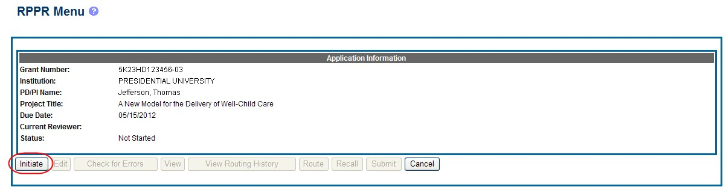

Figure
7
:
RPPR Menu for Initiating the Report

Once initiated, Commons creates the report in a PD/PI Work in Progress status and sets the current reviewer. A message displays as follows:
The RPPR has been successfully initiated.

NOTE: If at any time initiation fails due to business rules validations, error or warning messages display on the screen.

Once initiated, the editing process can begin. The RPPR is accessed for editing via the RPPR Menu screen. The editing feature for single-project RPPRs is different from those of multiproject RPPRs. The steps for accessing each type of RPPR are outlined in the sections that follow. Refer to Accessing a Single-Project RPPR for Editing or Accessing a Multi-Project and Single-Project with Complicated Structure RPPR for Editing as appropriate.

Edit the RPPR
Once an RPPR is initiated, its status becomes PD/PI Work in Progress and it becomes available for editing. The PD/PI or delegate uses the Edit option for viewing and completing the report. Additionally, this option is available to the SO or AO when that user is the current reviewer of the report.

NOTE: For RPPRs with multiple PD/PIs (MPI awards), only the Contact PD/PI has access to the Edit feature unless the Contact PD/PI has granted progress report authority to other PD/PIs. Without this authority, MPIs can only view the RPPR PDF and its routing history.

There are two means of accessing the progress report for editing. These are similar methods used for initiating the report and are as follows:
Access RPPR from Status:
  - Select the Status tab from the Commons menu options.
  - Select the List of Applications/Grants link from the Status screen.

Figure 8: Status Screen and List of Applications/Grants Links

  - From the Status Result – List of Applications/Grants screen, locate the grant and select the RPPR link from the Action column for the specific grant. For multi-year funded awards, the link will display as RPPR Year <X>, the <X> representing the reporting year.

Figure 9: RPPR Link on Status Result – List of Applications/Grants

Figure
10
:
Multi
-
Year

Funded Award RPPR Link

–OR–

Access RPPR from RPPR tab:
  - Select the RPPR tab from the Commons menu options.
  - Select the specific grant by clicking the hyperlink in the Grant Number column on the Manage RPPR screen. SOs/AOs must perform a query first.

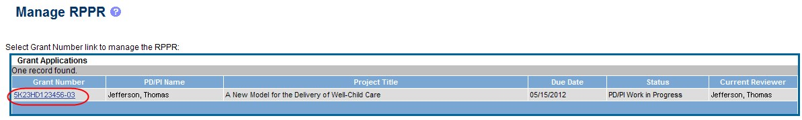

Figure
11
:
Manage
RPPR

List of Grant Applications

The appropriate RPPR Menu screen – either for single-project or multi-project RPPRs – displays with editing options.

5.2.1 Accessing a Single-Project RPPR for Editing
For single-project awards, the RPPR Menu screen displays with buttons for the following available options:
Edit
Check for Errors
View
View Routing History
Route
Cancel

NOTE: Once an RPPR has been routed for review, the Recall and Submit buttons are enabled. These functions are covered in subsequent chapters.

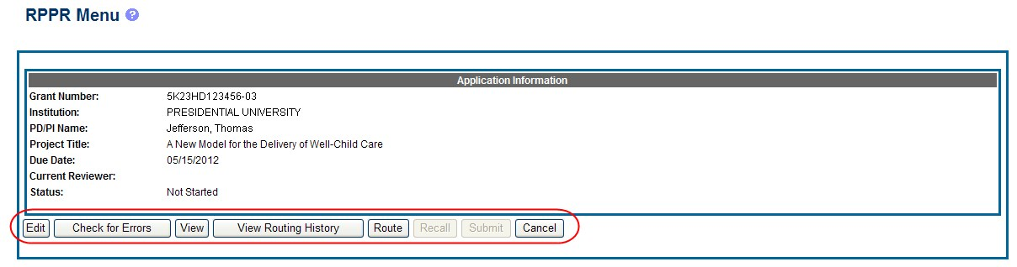

Figure
12
:
RPPR Menu Buttons

Select the Edit button to open the RPPR for editing.
Refer to the section of this document titled Editing the RPPR Forms for more information on editing the forms.

5.2.2 Accessing a Multi-Project and Single-Project with Complicated Structure RPPR for Editing
A multi-project RPPR is a progress report submitted for a funded program (activity code) which has multiple, interrelated components sharing a common focus or objective.
A component (for the purposes of applications and progress reports) is a distinct, reviewable part of the multi-project application or progress report for which there is a business need to gather detailed information identified in the funding opportunity announcement (FOA).
Components typically include general information (component organization, project periods, project title, etc.), performance sites, personnel, and budget. The FOA defines the construction and naming convention for the application; the funded application defines the construction and naming convention for the progress report.
For multi-project awards, the RPPR Menu screen displays with buttons for the following available options found within the Application Information section of the screen:
View
View Routing History
Route
Cancel

NOTE: Once an RPPR has been routed for review, the Recall and Submit buttons are enabled. These functions are covered in subsequent chapters.

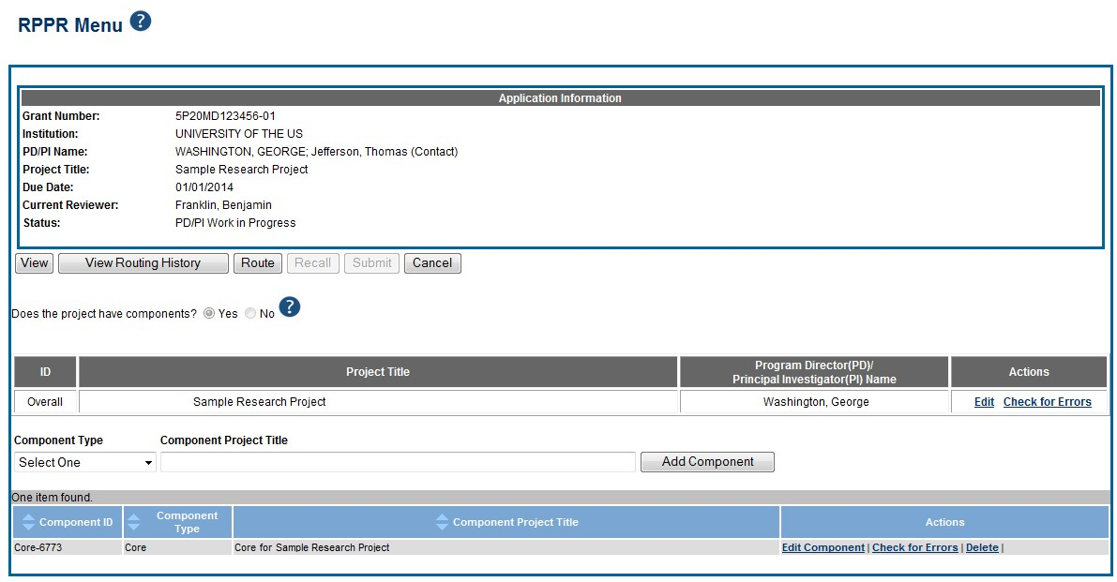

Figure 13: RPPR Menu Options for Multi-Project RPPRs

Overall
Below the Application Information is a table showing the Overall ID, Project Title, Program Director/Principal Investigator (PD/PI) Name, and an Actions column with links.
The RPPR Menu for a multi-project RPPR without components does not include the component table. Additionally, the No radio button on the Does the project have components? Field is selected.
Refer to the figure below for an example of a single-project with complicated structure RPPR.

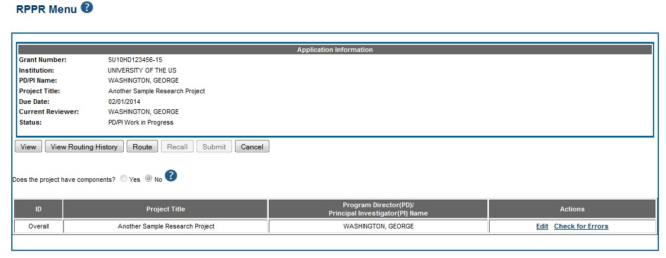

Figure 14: RPPR Menu for Single-Project with Complicated Structure

To edit the RPPR for the Overall, select the Edit link from the Actions column.

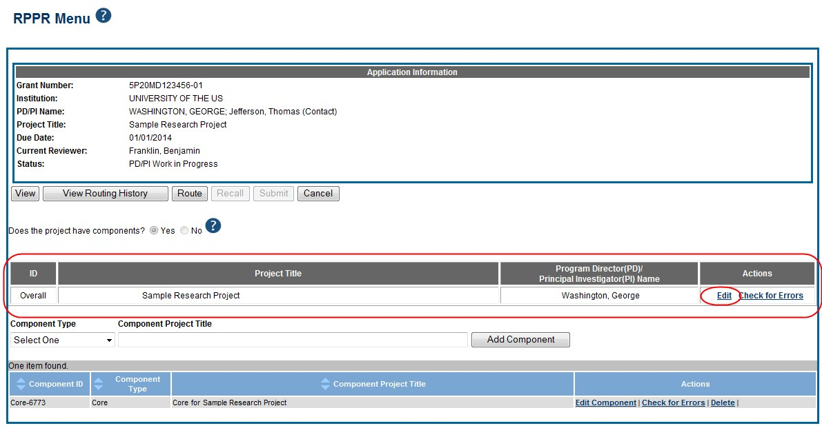

Figure
15
:
Edit Link
for Overall

Individual Components
If the award has individual components (e.g., a multi-project award), each component must be reported in the RPPR. To add components, select the Yes radio button next to the question Does the project have components? Selecting Yes displays the Add Component feature for the individual components.

NOTE: Any individual components previously added will already be displayed in a table beneath this feature. In this scenario, the Does this project have components? option is disabled. This includes components which were part of a previously submitted progress report for the grant.

To add an individual component:
- Select the correct option from the Component Type drop-down list.
- Enter the Component Project Title.
- Select the Add Component button.
Added individual components display in a table beneath the Overall, showing the Component ID, Component Type, Component Project Title, and available links in the Actions column.
- Select the Edit Component link in the Actions column for the component to edit its RPPR.
Refer to the section of this document titled Editing the RPPR Forms for more information on editing the RPPR forms.

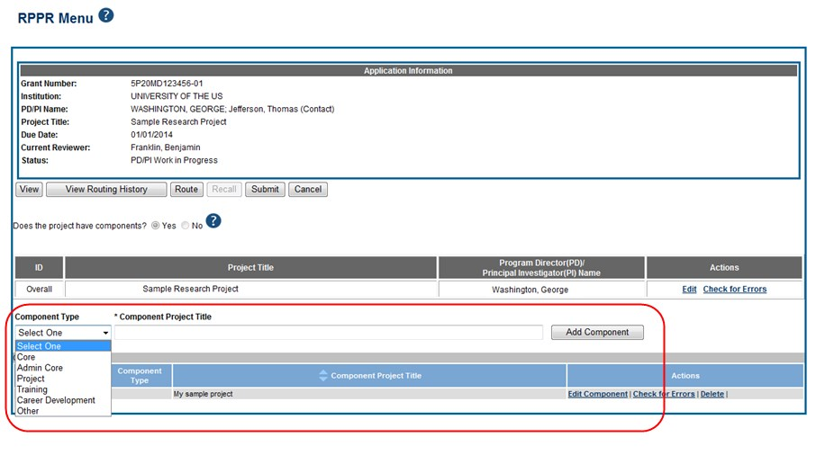

Figure 16: Adding and Editing Individual Components

Individual components can be removed from the RPPR by selecting the corresponding Delete link from the Actions column of the specific component, followed by the OK button on the confirmation pop-up message. The delete option is not available for Overall.

IMPORTANT: If you choose to delete a component, all data related to this component – including all budget data – will be lost. This data cannot be recovered once it has been deleted.

5.2.3 Editing the RPPR Forms
After selecting the appropriate editing option, the RPPR section A. Cover Page displays. The Cover Page includes information about the grant, PD/PI, signing and administrative officials, organization, and project/reporting/budget periods. Some of this information may be autopopulated. For more information on the Cover Page, refer to the section of this document titled Section A – Cover Page located in the Instructions for RPPR Sections A–H.
- Update the information as necessary and select the Save button.
The Cover Page includes tabs at the top and links at the bottom of the page for navigating to the other sections (e.g., Accomplishments, Participants), which may be completed in any order. Before navigating to and from any of these sections, it is always necessary to select the Save button to save all changes on the current page. Navigating away from any page on the RPPR without selecting Save results in the loss of any information entered prior to the last save.

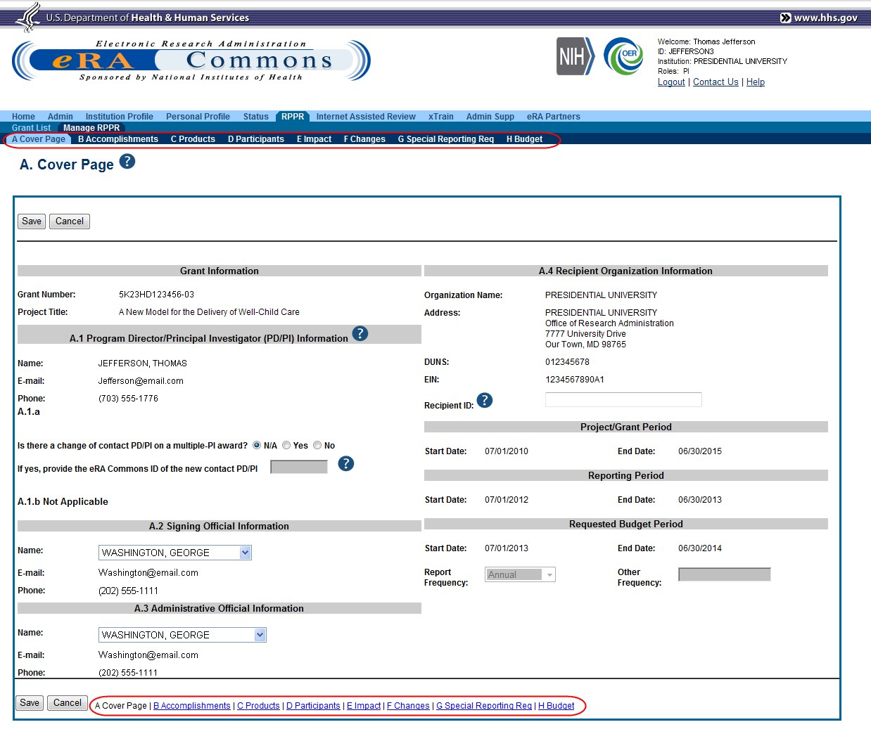

Figure 17: RPPR Cover Page and Section Navigation Links

- Sections can be completed in any order. To navigate and populate the other sections of the RPPR, select the appropriate link from the top or bottom of the page.
The same navigational links appear on each section of the RPPR. For information on the specific fields in each section refer to Chapter 6 Instructions for RPPR Sections A–I
- Complete the appropriate fields of the report.
Details for completing each section are discussed later in this document. Many of the fields on these pages, however, behave in a similar manner and are discussed below.

Add/New
To use the Add/New feature, enter or select data into the appropriate fields. Select the Add/New button to add the data to a table.

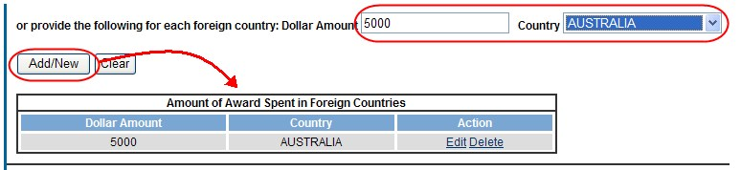

Figure
18
:
Add/New Feature

Items can be edited or deleted from the table using the Action links.

Text Box
All text boxes on the RPPR have character limits. The number of characters available is reflected beneath each text box as characters are entered.

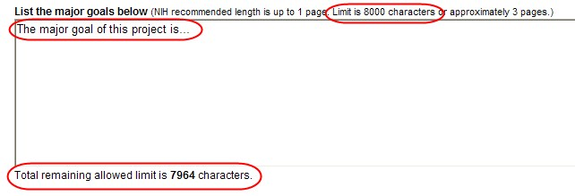

Figure
19
:
Total Remaining Characters

Changing Saved Responses
While in WIP status, answers may be changed. A warning message displays as follows:
The entered/uploaded response will be deleted. Do you wish to continue?
The user editing the information can choose to Continue or Cancel the action. Choosing Continue deletes the previous response, removes any attachments, and disables the relevant fields associated with the question. Choosing Cancel cancels the change.
- Select the Save button before navigating to the next page.
- To return to the RPPR Menu, select the Cancel button.
When an RPPR is ready for review and submission, it is routed to the next reviewer. Refer to the section of this document titled Route the RPPR for steps on routing to the next reviewer.

5.2.4 Editing Inclusion Enrollment Data
The following chapter discusses inclusion data in the Inclusion Management System (IMS) as accessed and processed via your RPPR. For more information on IMS, please refer to the IMS Online Help or the Instructions for Accessing the Inclusion Management System (IMS) via Commons Status.
To update inclusion enrollment data, select the Inclusion link from question G.4.b of section G. Special Reporting Requirements. For additional information on inclusion procedures in the RPPR, please review Chapter 6.7 Section G–Special Reporting Requirements.
IMPORTANT: Before selecting the Inclusion link, select the Save button on the RPPR to save all of your work in Section G. Failure to do so will result in a loss of data on your report.

NOTE: If this link is selected more than 60 days before the progress report due date, the following warning is displayed:
Based on the due date of this RPPR, inclusion data is not yet needed. If you proceed, access to the inclusion data via Commons/Status will be blocked. You cannot undo this action. Are you sure you want to proceed?

Selecting Cancel will abort the action and IMS will not be opened. Continuing will result in inclusion data being blocked for editing when accessed via Commons Status (View action only). In this event, you will see the following message when accessing via Status: RPPR has been initiated. At this time, the data is editable accessing via RPPR only.
The ability to edit IDRs via the Commons Status module will be restored after the successful submission of the RPPR and until the award of the current year.

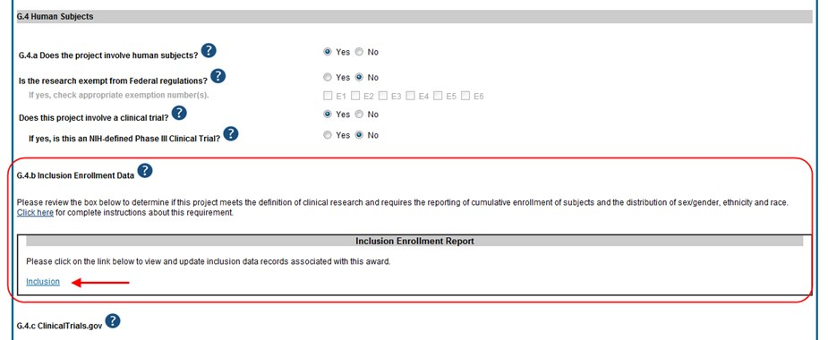

Figure 20: Inclusion Link in Question G.4.b

The Inclusion–Manage Inclusion Data Records (IDRs) screen displays showing the Inclusion Data Records (IDRs) with a status of Required Updates. Once cumulative form updates have been made as required, the status of the IDR(s) becomes Inclusion Updated. However, this only occurs when cumulative data is updated. It is possible to see multiple IDRs in difference statuses.

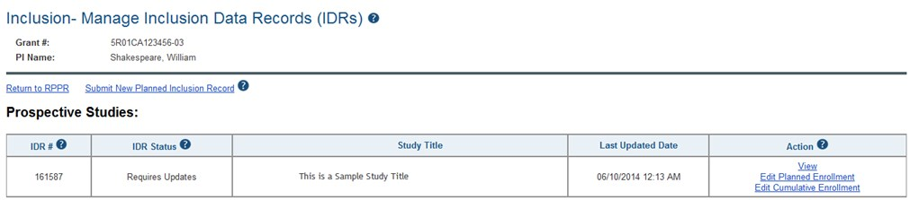

Figure
21
:
Manage IDRs for Single Project

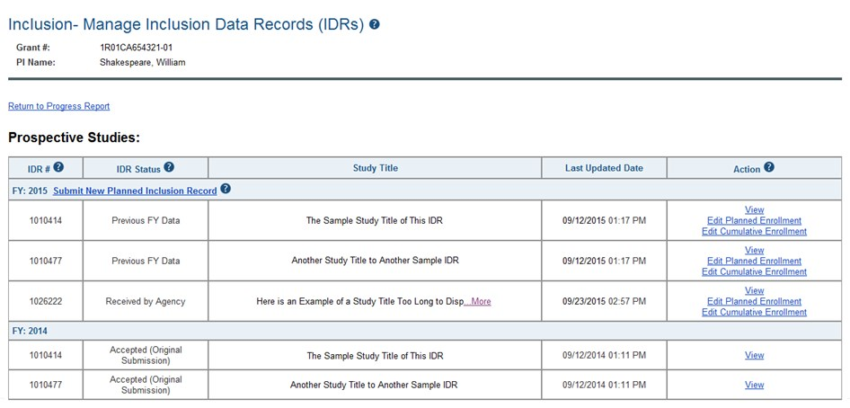

Figure
22
:
Manage IDRs for Multi
-
Year
Project

For multi-year funded awards, only inclusion counts for the current IDR fiscal year can be reported. Once an RPPR is considered late, you will not be able to update and submit inclusion data through the IMS. IMS will indicate this with a message as follows: Because this RPPR is late, the Inclusion Management System is unable to accept the data.
RPPR for current sequential year of multi-year award will be considered late after corresponding anniversary of the budget/project period start date. For example, the RPPR for sequential year 1 is late after 1st anniversary of the budget/project period start date.

Select the Edit Cumulative Enrollment link in the Action column to access the Edit Cumulative Inclusion Data screen and perform the required updates.
The Edit Cumulative Inclusion Data screen contains the following information: Header Fields
- Grant #
- PI Name
The name of the contact PI on the application record.
- Inclusion Data Record (IDR) #
Displays the system-generated identification number of the inclusion data record.
- IDR Status
Shows the status of the record.
- Study Title
The study title of the IDR, pre-populated with the existing title and editable.

Cumulative Inclusion Enrollment Report Fields
- Study Title
Displays the study title for the IDR, pre-populated from the Planned Enrollment Form.
- Comments
An optional text field for entering cumulative enrollment comments. If any comments for cumulative form were entered before, this field is pre-populated when editing an existing IDR.
The cumulative enrollment form includes racial categories along the left side the of the table and ethnic categories, divided by sex/gender, along the top of the table. The individual enrollment count cells are editable and set to zero by default, when populating a new IDR. When editing an existing form, these values are pre-populated with any other value previously entered. The total fields are calculated by IMS and sum up as rows and columns accordingly. The total values are not editable fields.

NOTE: The cumulative inclusion form includes fields for entering Unknown/Not Reported race, ethnicity, and sex/gender data.

Update the values in the individual enrollment count cells as necessary, and select the Save button. To leave the form without saving any changes, select the Cancel button instead. Saving and canceling both return you to the Manage Inclusion Data Records screen.
POLICY: For additional information on racial and ethnic categories or inclusion policy and procedures, refer to PHS Supplemental Instructions for Human Subjects or the OER inclusion web page.

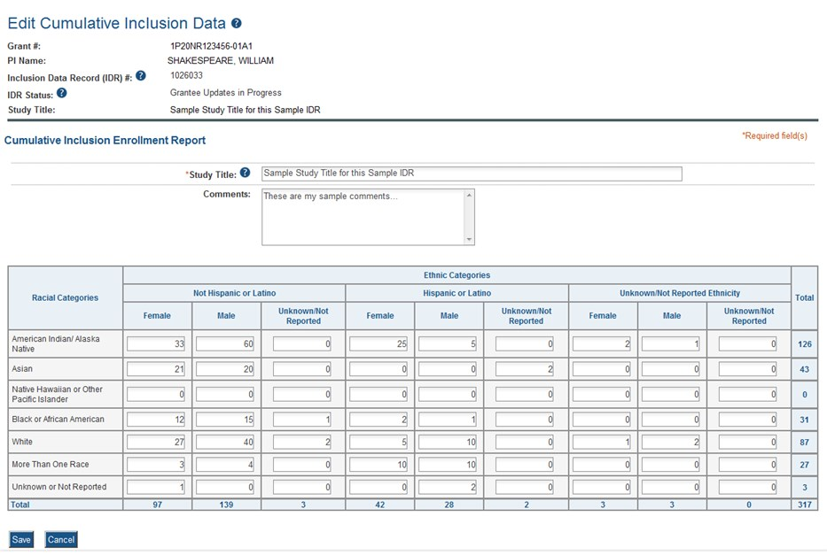

Figure
23
:

Entering
Cumulative
Inclusion Data

IMS will perform validations to make sure the data can be saved. Warnings or errors may appear on the screen preventing you from saving your information.
- If you enter and save 0s on the form when enrollment data previously was migrated from the previous NIH inclusion data system, you will receive a warning message before the data can be saved
Warning: You are about to submit zeroes for your cumulative inclusion enrollment data when data in the previous OMB-approved format exists. Would you like to proceed?
Select Proceed to continue or Cancel to abort the action.
- Planned enrollment count overall total must be greater than 0 before cumulative enrollment data can be entered. If planned enrollment counts equal 0, you will receive the following error:
Planned Enrollment count must exist before entering Cumulative enrollment Data
- If an overall total value is less than the prior year total, you will receive a warning message before data can be saved:
Warning: Some (or all) enrollment counts are less than previous FY. Do you want to continue?
After updating the cumulative enrollment data, the status of the IDR(s) status will change to Inclusion Updated and the links for editing the information remain available. This status only occurs when cumulative data is updated. Updating the planned data does not meet the requirement of the progress report. When only planned data is updated, the IDR status remains at Requires Updates.

5.2.4.1 Changes to Planned Enrollment
If there are changes from the planned enrollment originally approved for funding, contact the program officer to discuss updating/revising the planned enrollment. See Chapter 6.7 Section G– Special Reporting Requirements of this guide for more information.
Select the Edit Planned Enrollment link in the Action column of the Inclusion–Manage Inclusion Data Records (IDRs) screen to access the Edit Planned Inclusion Data screen.
The Edit Planned Inclusion Data screen contains the following information: Header Fields
- Grant #
- PI Name
The name of the contact PI on the application record.
- Inclusion Data Record (IDR) #
Displays the system-generated identification number of the inclusion data record. This field is displayed only when editing existing IDR
- IDR Status
Shows the status of the record.
This field is displayed only when editing existing IDR
- Study Title
The study title of the IDR, pre-populated with the existing title and editable when editing an IDR.
This field is displayed only when editing existing IDR

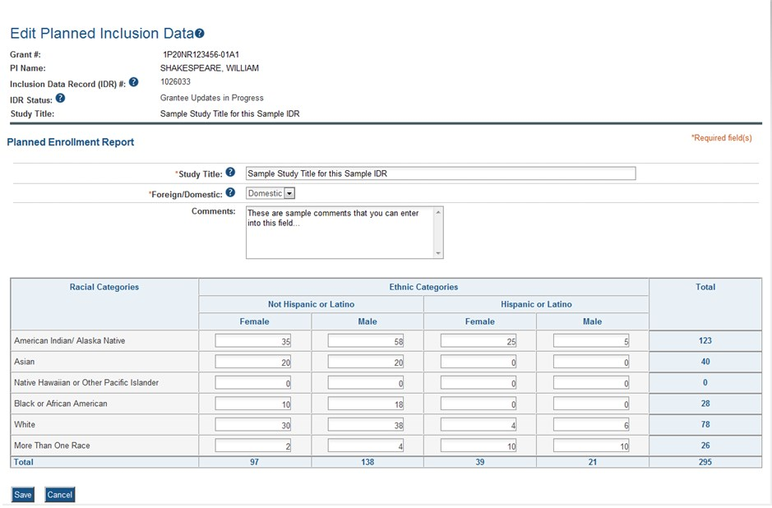

Figure 24: Edit Planned Inclusion Data–Grantee Updates in Progress

Planned Inclusion Enrollment Report Fields
- Study Title
The study title of the IDR, pre-populated with the existing title and editable when editing an IDR.
For a new IDR, this field displays blank. Enter the new IDR's study title into the field. This is required.
- Foreign/Domestic
This field indicates whether the IDR involves participants from a non-US site (i.e., foreign) or a US site (i.e., domestic). This field is pre-populated when editing an existing IDR.
When creating a new IDR, select the value from the drop-down list. This is a required field.
- Comments
An optional text field for entering comments. This field is pre-populated when editing an existing IDR and blank when creating a new IDR. If editing existing Planned Enrollment, you should first discuss with the Program Officer and may want to consider adding a comment here to explain the change.
The planned enrollment form includes racial categories along the left side the of the table and ethnic categories, divided by sex/gender, along the top of the table. The individual enrollment count cells are editable and set to zero by default, when populating a new IDR. When editing an existing form, these values are pre-populated with any other value previously entered. The total fields are calculated by IMS and sum up as rows and columns accordingly. The total values are not editable fields.
POLICY: For additional information on racial and ethnic categories or inclusion policy, refer to PHS Supplemental Instructions for Human Subjects or the OER inclusion web page.
Update the values in the individual enrollment count cells as necessary, and select the Save button. To leave the form without saving any changes, select the Cancel button instead. Saving and cancelling both return you to the Manage Inclusion Data Records screen.
IMS will perform validations to make sure the data can be saved. Warnings or errors may appear on the screen preventing you from saving your information.
• If you enter and save 0s on the form when enrollment data previously was migrated from the previous NIH inclusion data system, you will receive a warning message before the data can be saved:
Warning: You are about to submit zeroes for your planned enrollment when data in the previous OMB-approved format exists. Would you like to proceed?
Select Proceed to continue or Cancel to abort the action.

5.2.4.2 No Inclusion Data Records Provided
When inclusion monitoring is required and no IDRs exist, RPPR system will NOT allow the submission of the progress report without IDR(s). For the current FY it will display an error message and require that you either submit a new enrollment record or provide an explanatory comment for the missing IDRs.

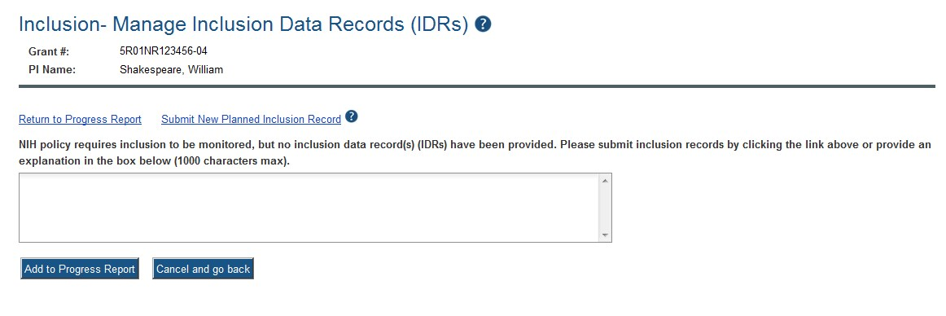

Figure 25: No Inclusion Data Records–Single Project

This is true for the current FY of a multi-year award as well. For the past FYs (when the progress report is late), a standard message is displayed in lieu of the error message as follows:
NIH policy requires inclusion to be monitored, but no inclusion data record(s) (IDRs) have been provided.
This standard message will appear on both the screen and the PDF version of the progress report.

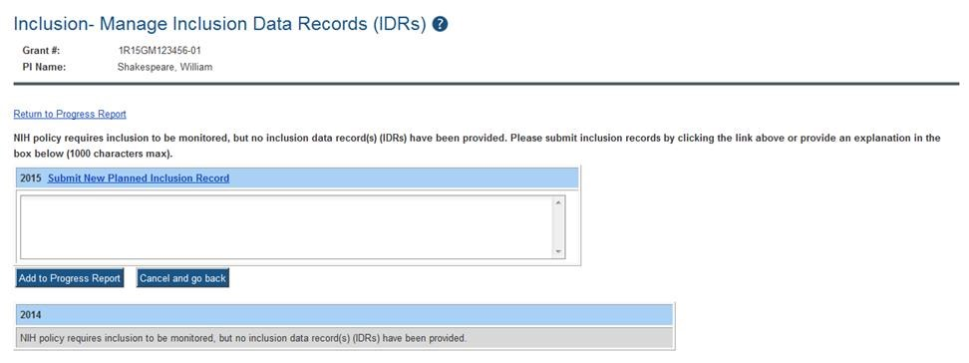

Figure 26: No Inclusion Data Records – Multi-Year Funded Award

To provide an explanation, enter your comments into the provided text box and select the Add to Progress Report button. For multi-year funded awards, the ability to provide an explanation is available only for the current year.

NOTE: Selecting any of the links or buttons other than Add to Progress Report will cancel the action of adding and saving your comments. Any entered comments will be lost unless you select the Add to Progress Report button.

The entered explanation is viewable on the RPPR PDF and on the Inclusion–Manage Inclusion Data Records (IDRs) screen when accessed via Commons Status. For information on access through Commons Status, refer to the IMS Online Help or the Instructions for Accessing the Inclusion Management System (IMS) via Commons Status.

NOTE: Submitting a new IDR after the submission of this explanation, but before submission of the RPPR to Agency, removes the explanation comment from the progress report. See the section below for information on submitting a new planned inclusion record.

5.2.4.3 Submit New Planned Inclusion Record
Select the Submit New Planned Inclusion Record link to access the Edit Planned Inclusion Data screen and submit planned enrollment and create a new IDR. For multi-year funded awards, this link is available only for the current fiscal year.
Upon a successful save of a new IDR, attributes (Study Title, Foreign/domestic indicator/planned comments), Planned Inclusion Data (as entered), and Cumulative Inclusion Data (as zeroes) are also created; the new IDR is assigned a unique IDR #; and the IDR status is set to Grantee Updates in Progress (when accessing through Status in Commons).

5.2.4.4 Inclusion Data Record Statuses
Throughout the process from creation to submission to Agency, an inclusion data record will take on various statuses depending on the action completed against it. These different statuses aid in determining the current point in the work flow, pending needs and requirements, and past actions taken. An IDR’s status also determines what action(s) can be performed against it. IDRs requiring updates can be edited, while IDRs accepted by the Agency can only be viewed.
The following list gives an explanation of each status.
Accepted (PI Revisions): Grantee has modified the IDR after original submission, but before release of the award
Accepted (Original Submission): The IDR has been accepted at award issuance based on what was originally submitted. (Data migrated from the previous data system may also have this status when awarded.)
Grantee Updates in Progress: Grantee user has created the IDR; Grantee user has initiated updates on an IDR (Edit Planned or Edit Cumulative); and/or SO has routed an IDR back to the PI
Inclusion Updated: Grantee has updated cumulative (actual) enrollment counts via the
RPPR module in Commons
Previous FY Data: Data from previous fiscal year has been rolled forward into the next project record
Pending SO: IDR has been routed to the SO
Received by Agency: IDR Form (Planned or Cumulative) has been received as part of the electronic application submission (i.e., Grants.gov/eSub or ASSIST); Grantee user (SO) has routed the IDR via IMS in the Commons Status module to the Agency; Agency user has created a new IDR in IMS
Received by Agency – RPPR: Grantee user submitted IDR to Agency as part of the Research Performance Progress Report (RPPR)
Requires Updates: Grantee user accessed the inclusion data via the RPPR module in Commons;
Grantee user has created a new Planned Inclusion Form via the RPPR module in Commons

5.2.5 Editing the RPPR Budget Forms
Budget Form (H.1)
To add a budget, choose an option from the drop-down list and select the Add Budget button. The added budget type appears in the first table. Use the Edit link in the Action column to open the form for editing. Select the Save button before exiting the form. Most awards now use the SF424 R&R budget form. However, training awards may use the SF424 and/or the PHS 398 training budget. The PHS Additional Indirect Costs budget form is available as an optional form for the Overall component of a multi-project award with multiple institutions/organizations. Please contact the Grants Management Specialist assigned to your grant if you have questions on the appropriate form to use.
Budget types include:
- SF 424 Research & Related Budget form
- PHS 398 Training Budget
- PHS Additional Indirect Costs form
•

NOTE: Budget types can be deleted by selecting the Delete link from the Action column for the specific budget type. After deleting a form, be sure to save the RPPR before navigating away from the H.Budget tab. Save buttons are located at the top and bottom of the screen.

Subaward Budget Form (H.2)
To add a subaward budget, choose an option from the drop-down list and select the Add Subaward button. The added budget type appears in the second table. Use the Edit link in the Action column to open the form for editing. Select the Save button before exiting the form.
Subaward budget types include:
- SF 424 Research & Related Subaward Budget form
- PHS 398 Subaward Training Budget
The grantee may select up to 30 subaward budgets.

NOTE: Subaward budget types can be deleted by selecting the Delete link from the Action column for the specific subaward.

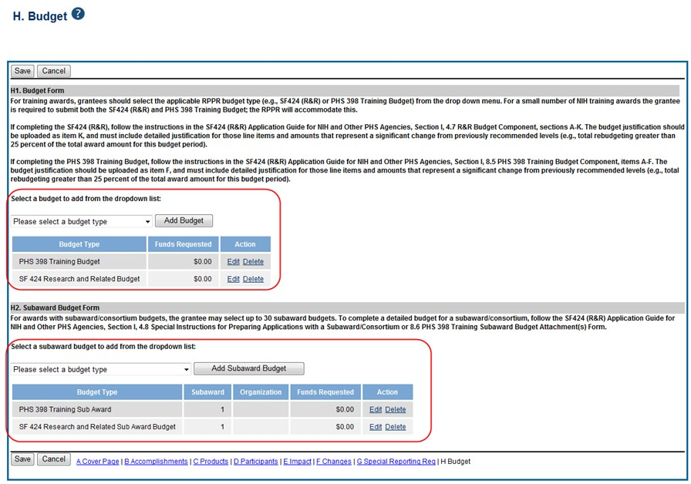

Figure 27: RPPR H. Budget - Questions H.1 Budget Form & H.2 Subaward Budget Form

NOTE: Remember to save the information before exiting the form by selecting one of the Save buttons located at the top and bottom of the form.

For single-project RPPRs, the DUNS number will automatically populate the DUNS number of the grantee organization on the budget form.

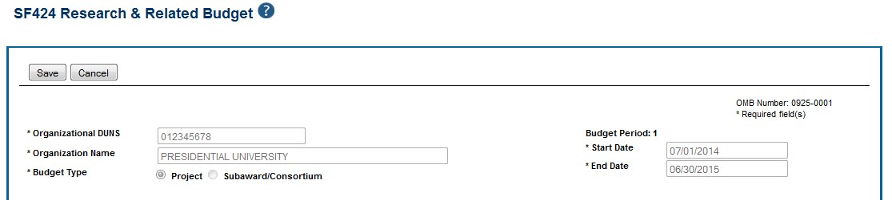

Figure 28: Organizational DUNS on SF 424 Research & Related Budget

For multi-component RPPRs the grantee must enter the DUNS and Organization Name fields, as the DUNS number will not automatically populate the DUNS number.

To add the DUNS number:
Enter the DUNS number into the Organizational DUNS field or select the magnifying glass icon to search for and select the DUNS number. You can search using a secondary DUNS number, however, the form will reflect the primary DUNS after you select the organization.
The Organizational DUNS field updates with the information and the Enter Name of Organization field updates to reflect the new DUNS.

To add the organization name:
Enter the organization name into the Organization Name field or select the magnifying glass icon to search for and select the new organization name.
The Organization Name field updates with the information and the Organizational DUNS field updates to reflect the new organization.

NOTE: If subaward budgets are completed, the system will not calculate the budget line item F.5 for the main budget (see figure below). Total consortium costs for the main budget MUST be computed and entered manually into budget line item F.5.

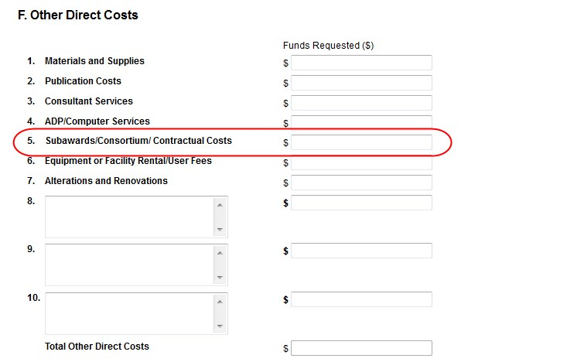

Figure
29
:
SF 424 R&R Budget Form
-

Question F.5

Check RPPR for Errors and Warnings
At any time before an RPPR is submitted to agency, an error check can be performed to verify that the report passes the business rules and system validations in place. Any user who has access to the RPPR may perform the error check.

5.3.1 Checking for Errors on Single-Project RPPRs
To perform an error check on the RPPR for single-project RPPRs, select the Check for Errors button from the RPPR Menu screen.

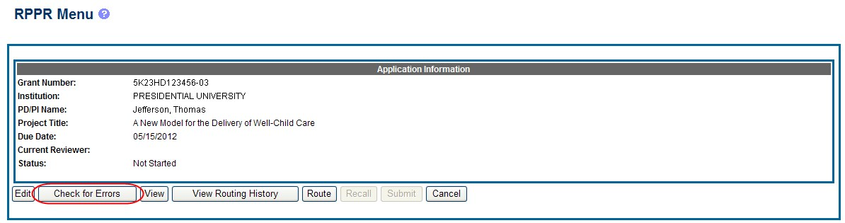

Figure 30: Check for Errors Button on RPPR Menu for a Single-Project RPPR

If errors or a warning exist, the appropriate error or warning message displays for each failed occurrence. All errors must be corrected prior to submission; the system will prevent submission of an RPPR containing errors. However, the system will not prevent submission of an RPPR when a warning message is displayed.



Figure
31
:
RPPR Error Messages (Examples
)

If all validations pass, a message displays indicating: No errors found on validation.

5.3.2 Checking for Errors on a Multi-Project RPPR
To perform an error check on the Overall or individual component of a multi-project RPPR, select the Check for Errors link from the Actions column of the RPPR Menu screen for the Overall or individual component being validated.

NOTE: Refer to section 5.3.2 Accessing a Multi-Project and Single-Project with Complicated Structure RPPR for Editing for information on adding individual components to the RPPR.

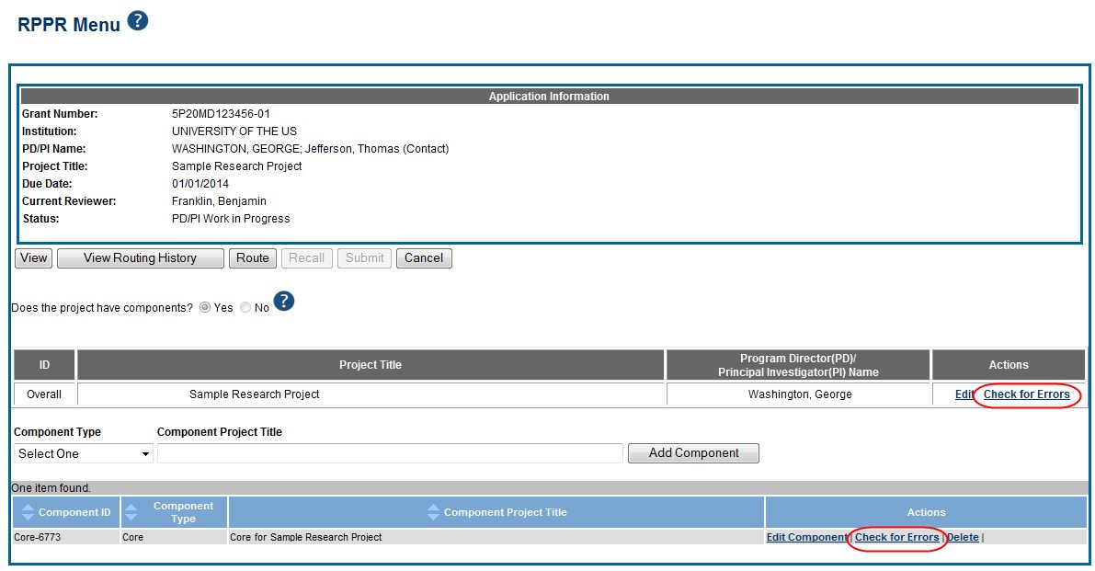

Figure 32: Check for Errors Links for Multi-Project RPPRs

If errors or a warning exist for the chosen component, the appropriate error or warning message displays for each failed occurrence. Select the Check for Errors button of the other components to perform a check against them.
All errors must be corrected prior to submission; the system will prevent submission of an RPPR containing errors. However, the system will not prevent submission of an RPPR when a warning message is displayed.
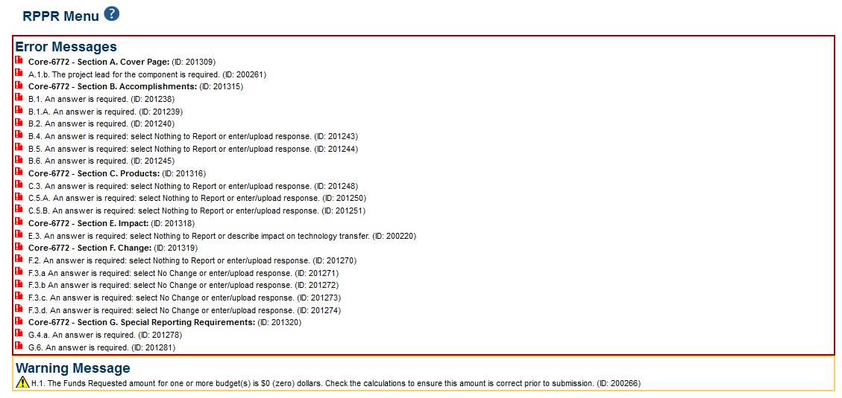

Figure 33: Errors and Warnings for One Component of a Multi-Project RPPR

If all validations pass, a message displays indicating: No errors found on validation.

5.4 Route the RPPR
Progress reports in Work in Progress (WIP) status can be routed to others for review or corrections by the current reviewer of the report. The routing feature is found on the RPPR Menu screen.

NOTE: A PD/PI delegate cannot route an RPPR to the next reviewer.

To route an RPPR to the next reviewer:
- Select the Route button from the RPPR Menu screen.

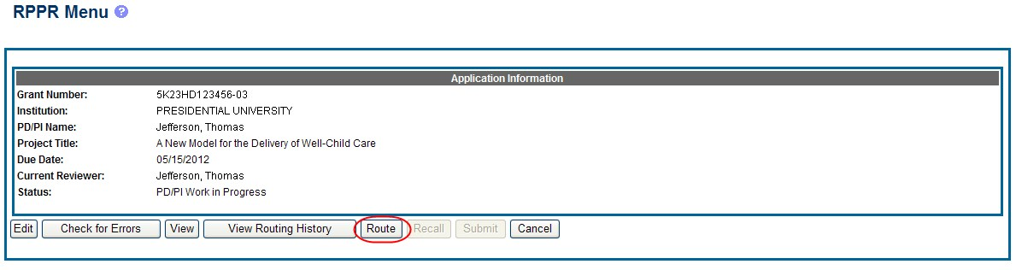

Figure
34
:
RPPR Menu
–

Route Button

NOTE: The figure above shows the RPPR Menu for a single-project RPPR, however, multiproject RPPRs have a similar Route button on their own RPPR Menu screen.

The Route RPPR to Next Reviewer screen displays. From this screen, the next reviewer can be chosen from a list of reviewers, and comments can be added.
- Select a reviewer from the Next Reviewer drop-down list.
- Optional: Enter comments in the Comments text box to provide information to the next reviewer.
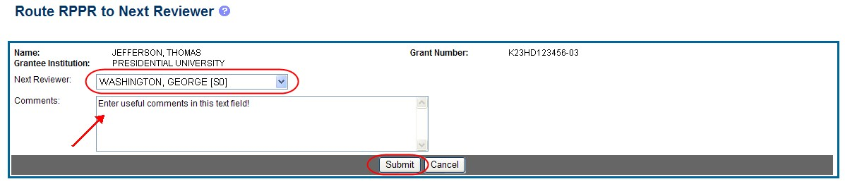
4.

Select the
Submit

button.

Figure
35
:
Route RPPR to Next Reviewer

- When routed by the PD/PI only: The PD/PI Assurance statement displays. Select the I Agree button to continue.

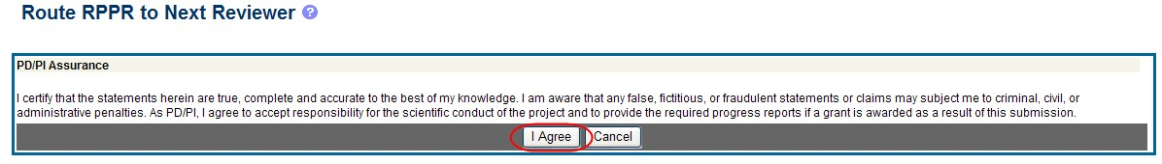

Figure
36
:
PD/PI Assurance Statement

The RPPR Menu displays once again. If the routing is successful, the message on the screen reads as follows:
The RPPR was successfully routed to [Selected Reviewer User ID], [Selected Reviewer Name].
The person who routed the RPPR can no longer edit the report (Edit button becomes disabled). The editing feature is now available only to the new reviewer. The RPPR status is updated to Reviewer Work in Progress.

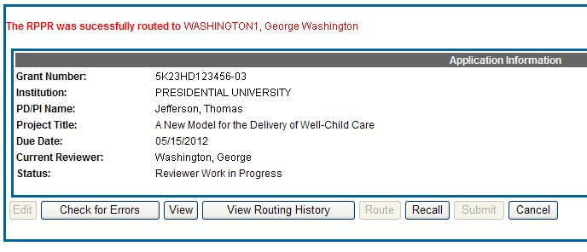

Figure
37
:
RPPR Successfu
lly Routed

5.5 Recall the RPPR
RPPRs that have been routed to a reviewer can be recalled by the person who performed the routing action. This is useful in situations when the report was routed to the wrong person or the reviewer is unavailable. The last reviewer of the report is able to recall it; however, Signing Officials at the Institution and the Contact PD/PI who are not the last reviewer can also recall the report when it is in a status of Reviewer Work in Progress.

NOTE: A PD/PI delegate does not have the ability to recall the RPPR.

To recall an RPPR, select the Recall button from the RPPR Menu screen.

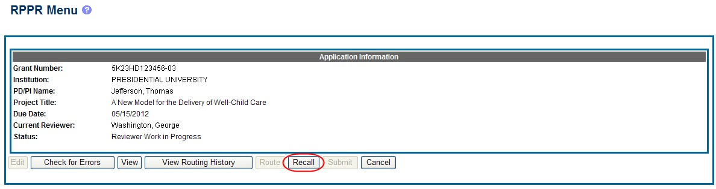

Figure
38
:
RPPR Menu
–

Recall Button

A message displays on the screen indicating: The RPPR has been successfully recalled. You have been set as the Current RPPR Reviewer.
The status of the RPPR is updated to PD/PI Work in Progress or Reviewer Work in Progress, the reviewer from whom the RPPR is recalled receives an email informing him of the action, and the RPPR routing audit history is updated to reflect the action.
Additionally, the Edit and Route buttons are enabled, providing the new reviewer with the ability to continue editing the RPPR or to route it to another reviewer.

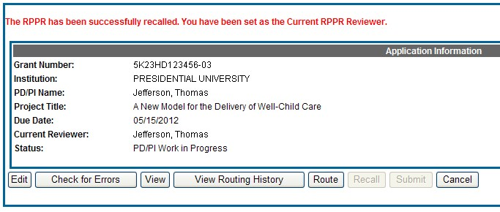

Figure
39
:
RPPR Successfully Recalled

5.6 Submit the RPPR to Agency
Grantees are strongly encouraged to view the RPPR prior to submission to ensure that the correct information and attachments are provided (see 5.7 View the RPPR).
Completed and validated RPPRs in a status of Work in Progress can be submitted to the Agency for acceptance. This act is performed by the Signing Official (SO) when the SO is the current reviewer of the report. For SNAP awards only, PD/PIs may also submit the report if they have been delegated submit authority by the SO.

NOTE: A PD/PI with Progress Report authority cannot submit a non-SNAP or F RPPR.

To submit the RPPR to agency:
  - Select the Submit button from the RPPR Menu screen.

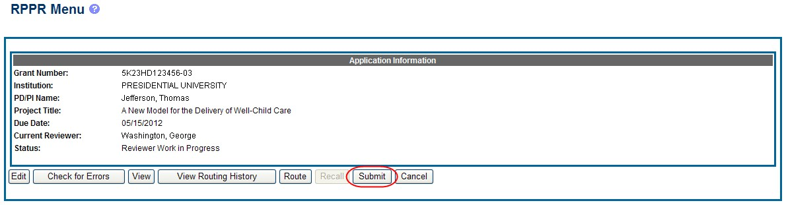

Figure 40: Submit Button on RPPR Menu

The Submit RPPR screen displays a certification statement as follows:
In submitting this RPPR, the SO (or PD/PI with delegated authority), certifies to the best of his/her knowledge that the grantee organization is in compliance with the terms and conditions specified in the Notice of Award and Grants Policy Statement, and verifies the accuracy and validity of all administrative, fiscal, and scientific information in the progress report. The SO (or PD/PI with delegated authority) further certifies that the grantee organization will be accountable for the appropriate use of any funds awarded and for the performance of the grantsupported project or activities resulting from the progress report. Deliberate withholding, falsification, or misrepresentation of information could result in administrative actions such as withdrawal of a progress report, suspension and/or termination of an award, debarment of individuals, as well as possible criminal penalties. The grantee institution may be liable for the reimbursement of funds associated with any inappropriate or fraudulent conduct of the project activity.

  - Select the I Agree button to sign off on the certification.
The RPPR is validated for systemic and business rules. If there are any validation failures, they are indicated by error messages on the RPPR Menu screen. Errors must be corrected in order to submit the RPPR.
If warnings exist, they are displayed on the RPPR Menu screen. Although the RPPR can be submitted with warnings present, the warning messages should be reviewed to determine if an issue should be addressed.
  - If Warnings Exist: To address issues associated with warnings, select the Cancel button, correct the issue, and resubmit the RPPR again. To continue with submission despite the warnings, select the OK button.
If all validations pass, the RPPR Menu screen displays the following message: The RPPR has been successfully submitted to PHS.

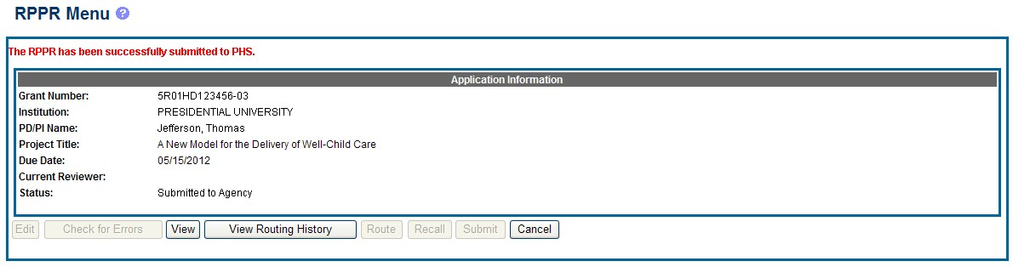

Figure
41
:
Successful Submission Message

The current reviewer is updated to the awarding agency, the RPPR status is updated to Submitted to Agency, and the RPPR Submission date is recorded. The routing history is updated to reflect the submission to Agency.
Any citations associated with the RPPR in C.1. Publications are officially associated with the award in MyNCBI.
If inclusion enrollment data are reported in the RPPR, this information will be provided in a structured data form and updated into the eRA inclusion data system for NIH staff review and acceptance. The data then becomes the data of record for the particular grant year.
When an RPPR is submitted to Agency, email notification is sent to the PD/PI (Contact PI) on the grant and the SO and AO assigned to the RPPR.

5.6.1 Submission Errors and Warnings for Multi-Project RPPRs
Upon submission, multi-project RPPRs are validated for systemic and business rules just as are single-project RPPRs. However, for multi-projects, the errors and warnings are displayed differently. When errors and/or warnings are found on multi-project RPPRs, the RPPR Menu screen displays the Overall messages followed by the messages of the other components.
All errors must be corrected in order to submit the RPPR.
If warnings exist, they are displayed on the RPPR Menu screen under the errors. Although the RPPR can be submitted with warnings present, the warning messages should be reviewed to determine if an issue should be addressed.

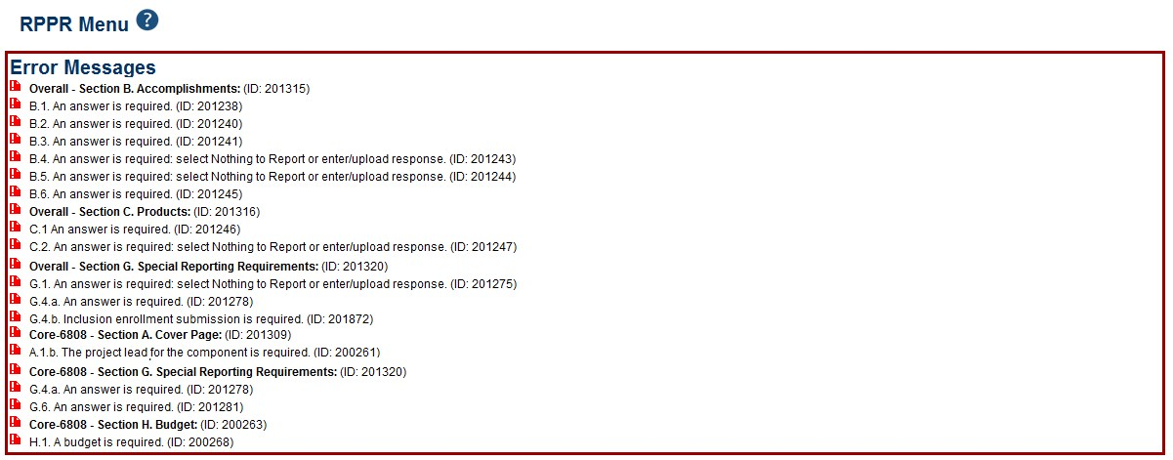

Figure 42: Sample of Multi-Project RPPR Error Messages

5.7 View the RPPR
As indicated in 5.6, grantees are strongly encouraged to view the RPPR prior to submission to ensure that the correct information and attachments are provided (see 5.6 Submit the RPPR to Agency).
PD/PIs, PD/PI delegates, and reviewers can view a PDF version of an RPPR in Work in Progress (WIP) or Submitted to Agency status to see how it will be seen by the Agency. Until the RPPR is submitted to agency, the PDF report shows a status of Draft and a blank submission date.
To view the RPPR form, select the View button from the RPPR Menu screen.

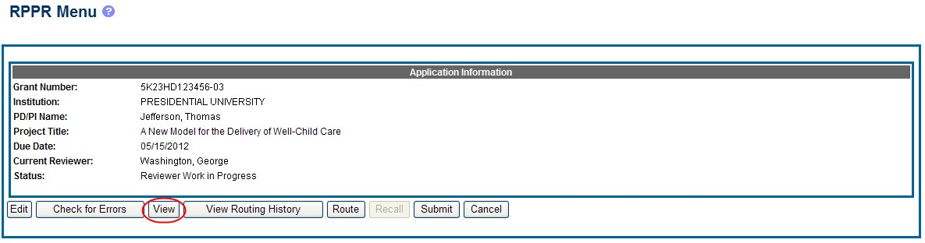

Figure
43
:
RPPR Menu
–

View Button

5.8 View Routing History
From initiation to submission to Agency, the routing of an RPPR is captured for auditing purposes. PD/PIs, PD/PI delegates, and reviewers can view the routing history for Work in Progress or Submitted to Agency RPPRs at any time, even when they are not the current reviewer.
To view the routing history:
- Select the View Routing History button from the RPPR Menu screen.

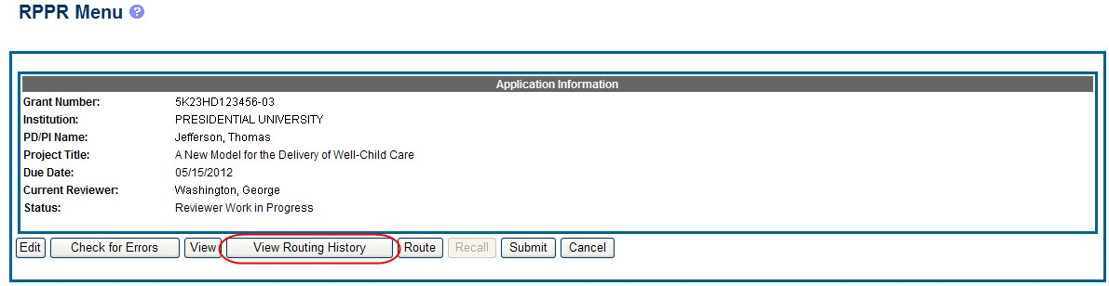

Figure 44: RPPR Menu – View Routing History Button
The Routing History screen displays showing the Reviewer Name, Action, Notification Sent (date and time), Date of Action, Next Reviewer Name, and Comments (when available).

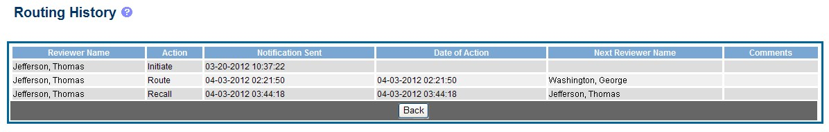

Figure
45
:
RPPR Routing History

- To close the screen, select the Back button.

5.9 Viewing the Final RPPR in Commons
The final RPPR, in PDF format, is accessible in Commons within the Status Information screen. To view the final RPPR, perform the following steps:
- From Commons, select the Status menu option.
- Select the link for List of Applications/Grants.

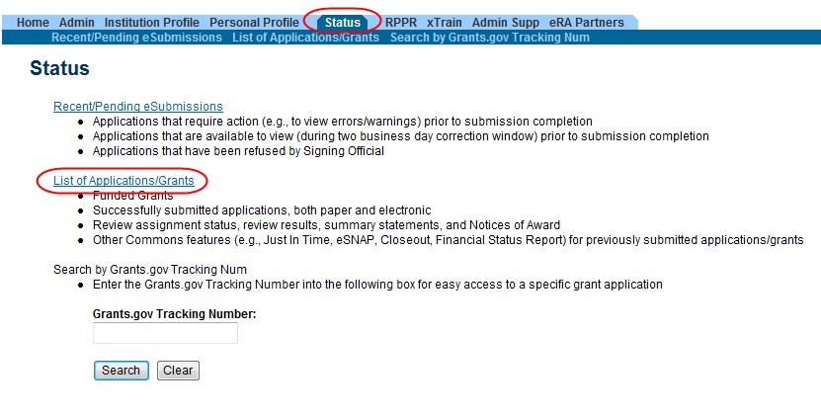

Figure
46
:
Status Menu Option

- From the Status Result – List of Applications/Grants screen, select the hyperlink for the specific Application ID.

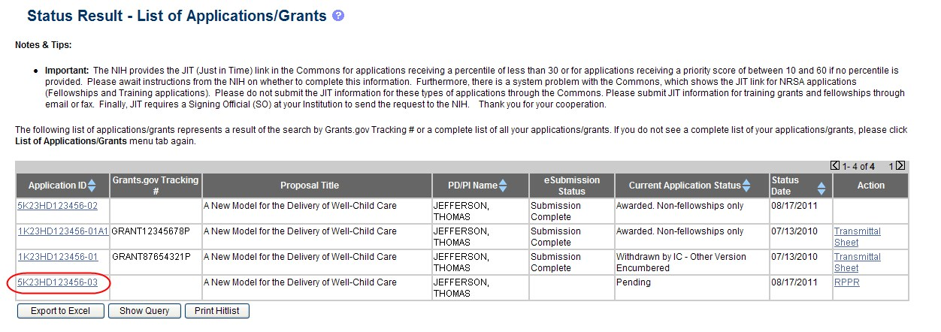

Figure 47: Application ID hyperlink

The Status Information screen displays with the Other Relevant Documents section in the top right corner.
- The progress reports for incrementally-funded and multi-year funded awards are displayed differently in Other Relevant Documents.
  - For an incrementally-funded RPPR: Select the e-Application link from the Other Relevant Documents section of the Status Information screen.

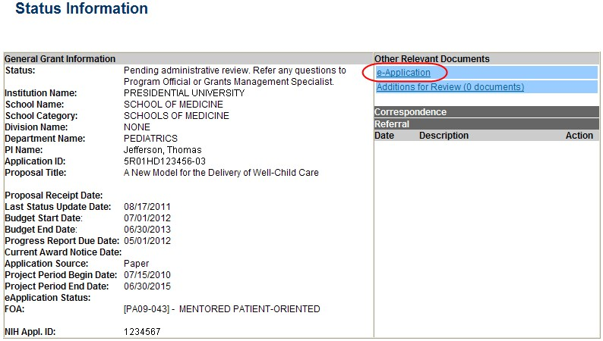

Figure 48: Status Information Screen – e-Application Link

  - For multi-year funded awards: Select the appropriate year’s link in the Research
Performance Progress Report section. Links will appear as follows: RPPR Year <X> <MM/DD/YYYY>

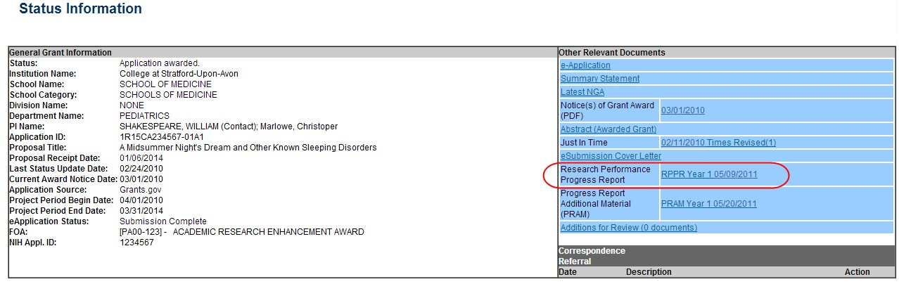

Figure 49: Status Information Screen for Multi-Year RPPR

The PDF version of the RPPR opens in a separate window.

NOTE: The submitted RPPR can also be accessed from the RPPR Menu screen. The View button opens the PDF version of the RPPR.

5.10 Public Access Progress Report Additional Materials (PRAM)
The Public Access Progress Report Additional Materials (PRAM) feature provides a means for the grantee to enter, review, and submit information in response to the automated notification sent when an NIH grantee organization submits an RPPR with non-compliant publications. The system sends the automated email to the PD/PI requesting verification that all publications are in compliance with the NIH Public Access Policy. The SO and AO assigned to the RPPR on the cover page (see 6.1 Section A – Cover Page) will receive a copy (cc:) of the email. While an email response to the GMS and PO is acceptable at this time, the grantee is encouraged to respond using the Public Access PRAM feature in eRA Commons. AHRQ does not currently use the PRAM feature for public access compliance notifications.
Using the PRAM feature, grantees can upload and submit a My NCBI PDF report demonstrating that previously non-compliant papers reported on the RPPR are now compliant. Compliant papers have a status of Complete, N/A (not applicable), PMC Journal in Process, or In process at NIHMS. Please see http://publicaccess.nih.gov/include-pmcid-citations.htm for additional information. If unable to provide the verification of compliance, grantees can upload and submit justification for why specific publications cannot be brought into compliance.
As with the RPPR, a PD/PI (or Contact PI in the case of multiple PIs) can enter the Public Access PRAM, but can only submit it if the PD/PI is delegated with Submit Progress Report authority. Otherwise, only the SO can submit the PRAM to Agency.
The following sections cover the steps for initiating and submitting Public Access PRAM.

5.10.1 Initiate Public Access PRAM
The PD/PI (Contact PI) or PD/PI Delegate can initiate Public Access PRAM by following the steps below:
- Access the eRA Commons Status Result – List of Applications/Grants screen.
- Select the Public Access PRAM link from the Action column of the appropriate grant.

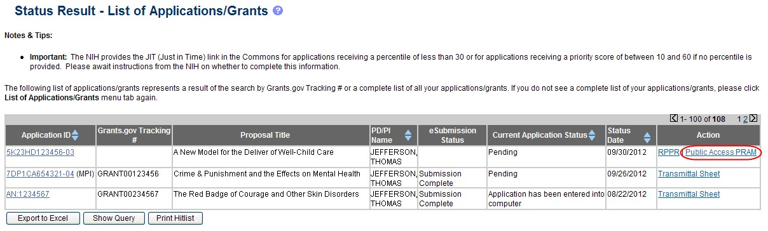

Figure
50
:

Public Access
PRAM Link

The Progress Report Additional Materials (PRAM) screen displays. Grant Information including Grant Number, PD/PI Name, Project Title, Institution, Status, and Current Reviewer displays at the top of the screen. The Public Access Compliance section at the bottom contains guidance for responding to the automated email requesting evidence of compliance with a field and buttons for uploading and maintaining attachments.
- Use the Add Attachment button to browse and select the My NCBI PDF or another PDF document providing justification. Note that selecting the Cancel button closes the screen instead.
- Select the Route button at the bottom of the screen.

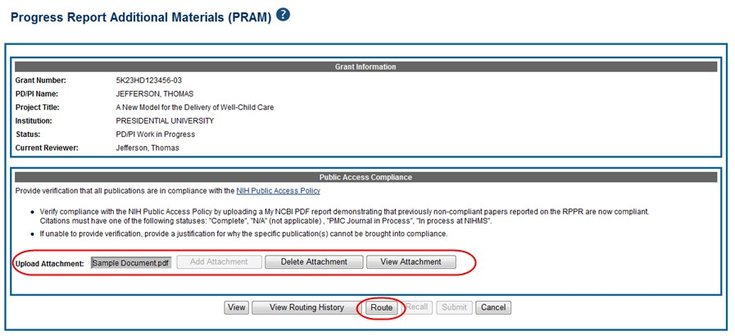

Figure
51
:
Routing the
Public Access
PRAM

NOTE: The options for Delete Attachment and View Attachment display once an attachment has been uploaded.

- Optional: Select the View Attachment button to view the document. Select the Delete Attachment button to remove the document.
When the Route button is selected, the Route PRAM to Next Reviewer screen displays. A list of all available reviewers exists in the drop-down for Next Reviewer.
- Select an SO from the Next Reviewer drop-down list.
- Enter text into the Comments field as necessary. This is not a mandatory field.
- Select the Submit button to continue.

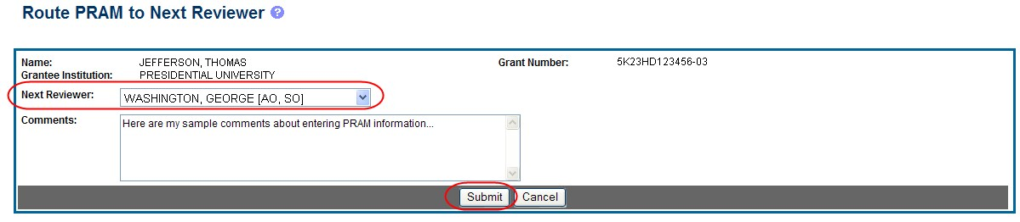

Figure 52: Route Public Access PRAM to Next Reviewer

The Route PRAM to Next Reviewer screen displays the PD/PI Assurance statement.
- Read the assurance statement and select the Submit button to agree to the content and continue routing the PRAM to the next reviewer.

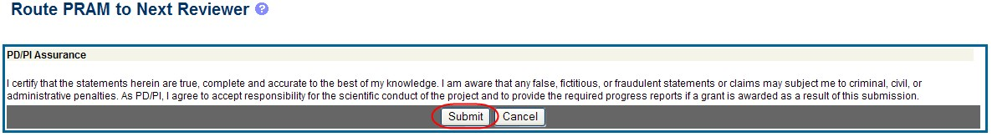

Figure 53: Public Access PRAM PD/PI Assurance Statement

The Progress Report Additional Materials (PRAM) screen displays with a message indicating that the PRAM was successfully routed to the selected reviewer. Additionally, the status is updated and shown as Reviewer Work in Progress. At this point, the PD/PI can only view the PRAM and may not edit it. To be able to allow the PD/PI to edit the PRAM, the SO needs to route the PRAM back to the PD/PI using steps similar to those above.
At the time of routing, an email is sent to the PD/PI and the selected SO (or other Next Reviewer) to notify them of the event.

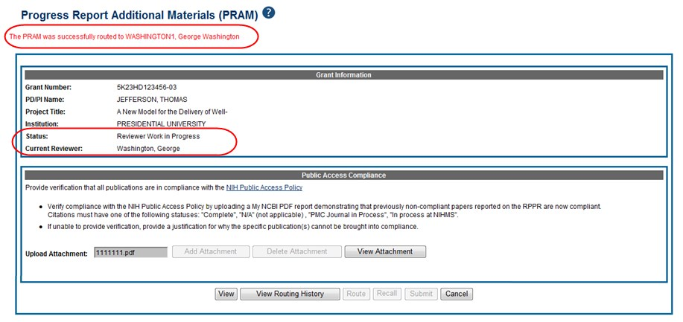

Figure
54
:
Successfully

Routed
Public Access
PRAM

5.10.2 Recall Public Access PRAM
Public Access PRAM that has been routed to a reviewer can be recalled by the person who performed the routing action until the PRAM has been submitted to the Agency. This is useful in situations when the report was routed to the wrong person or the reviewer is unavailable. The last reviewer of the report is able to recall it; however, Signing Officials at the Institution and the Contact PD/PI who are not the last reviewer can also recall the report when it is in a status of Reviewer Work in Progress.

NOTE: A PD/PI delegate does not have the ability to recall the PRAM.

To recall Public Access PRAM, select the Recall button from the Progress Report Additional Materials (PRAM) screen.

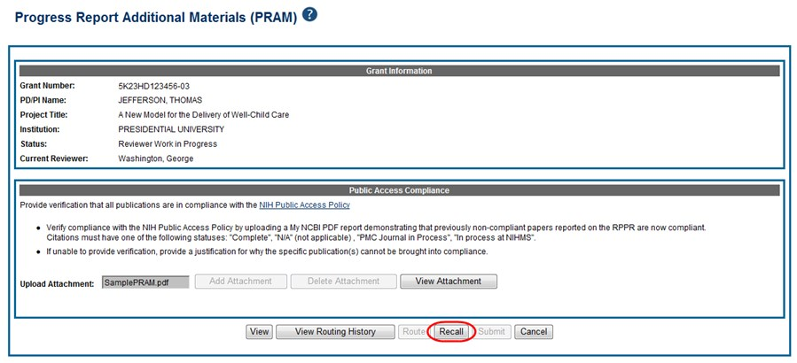

Figure
55
:
Recall Button

for Public Access PRAM

A message displays on the screen indicating: The PRAM has been successfully recalled. You have been set as the Current PRAM Reviewer.
The status of the PRAM is updated to PD/PI Work in Progress if recalled by the PI or Reviewer Work in Progress if recalled by the SO; the reviewer from whom the PRAM is recalled receives an email informing him of the action; and the PRAM routing audit history is updated to reflect the action.
Additionally, the ability to delete the attachment is restored and the Route button is enabled, providing the current reviewer the ability to update the PRAM and route it again.

5.10.3 Submit Public Access PRAM
When the Public Access PRAM is in Reviewer Work in Progress status, the Signing Official (SO) can submit it to the Agency. PD/PIs may also submit the information if they have been delegated Submit Progress Report authority by the SO.
To submit the Public Access PRAM:
- Access the Status screen on eRA Commons.
- Enter the appropriate query parameters to locate the grant and select the Search button.
The Status Result – General Search screen displays with the matching information.
- From the Action column, select the link for PRAM.

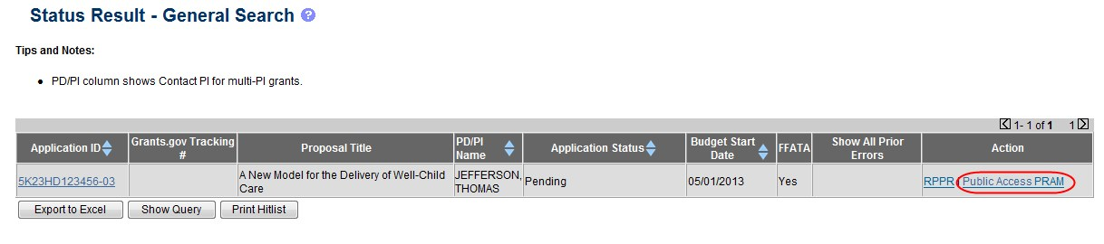

Figure
56
:

Public Access
PRAM Link for SO

The Progress Report Additional Materials (PRAM) screen displays. The screen displays Grant Information on top and the PD/PI comments in the text box at the bottom of the screen. In addition to submitting the PRAM, from this screen, the SO also may View the PRAM as a PDF, Route it to another reviewer (or back to the PD/PI), and view the Route History. Select any of the appropriate buttons to perform these actions. Follow the steps below to continue submitting the PRAM.
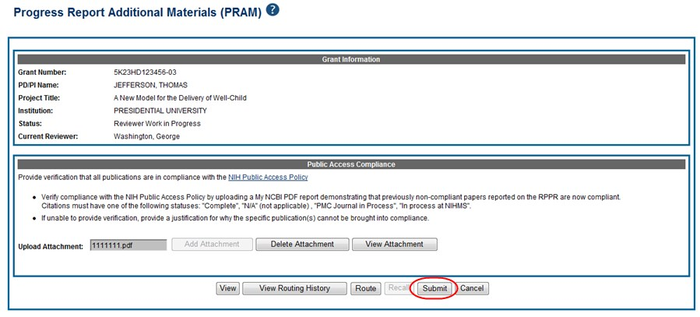
4.

Select the
Submit

button.

Figure
57
:
Submitting
Public Access
PRAM

The Submit PRAM to Agency screen displays. By continuing from this screen, the SO certifies that the submitting organization is in compliance with the terms and conditions specified in the Notice of Award and Grants Policy Statement. The SO also verifies that the information provided in the PRAM is valid and accurate.
5. Read certification agreement. Select the I Agree button to continue submitting the information. (Selecting the Cancel button closes the screen and returns the Progress Report Additional Materials screen without submitting the material.)

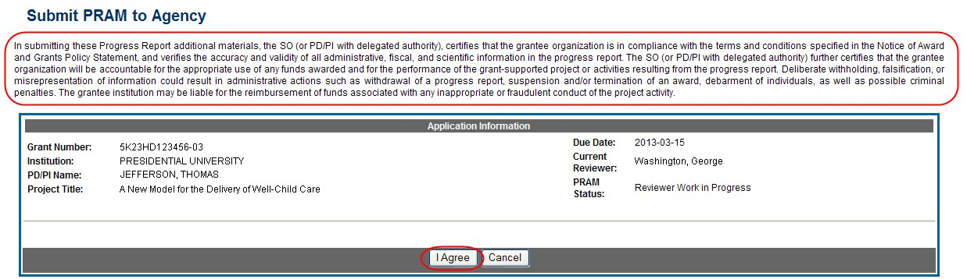

Figure
58
:
SO Certification of
Public Access
PRAM

The Progress Report Additional Materials (PRAM) screen displays with a message indicating that the PRAM was successfully submitted. The current reviewer is updated to the awarding agency, the PRAM status is updated to Submitted to Agency, and the PRAM submission date is recorded. The routing history is updated to reflect the submission to Agency.

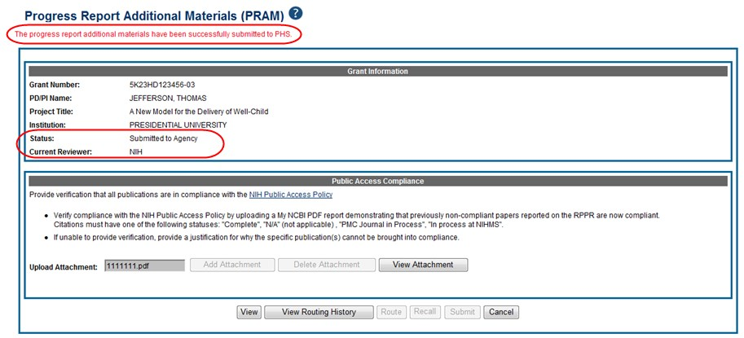

Figure
59
:

Public Access
PRAM Submitted to Agency

When PRAM is submitted to Agency, an email notification is sent to the PD/PI (Contact PI) on the grant, the submitting SO, the SO assigned to the RPPR, and AO assigned to the RPPR and the Public Access PRAM link will no longer be available.

NOTE: To view the submitted PRAM, select the View button on the Progress Report Additional
Materials (PRAM) screen. This option opens the PRAM PDF in a separate window. The Public Access PRAM will appear as the final page of the PDF document. See below for display of IC Requested PRAM.

5.10.4 View Public Access PRAM for Multi-Year Funded Awards
After submitting Public Access PRAM for multi-year funded awards, users with access to the grant information may view the PRAM via the Status Information screen. Status Information is accessed by selecting the Application ID hyperlink from the Status Result – General Search (SOs) and Status Result – List of Applications/Grants (PIs) screens.

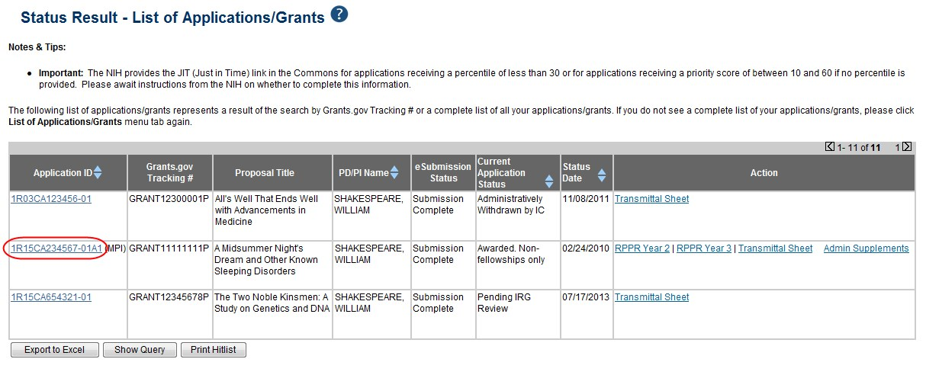

Figure 60: Status Results Showing Hyperlink for Application ID

From the Status Information screen, select the hyperlink in the area marked Progress Report Additional Material (PRAM) in the Other Relevant Documents section. The PRAM links for multi-year funded awards display as PRAM Year <X> <date submitted>.

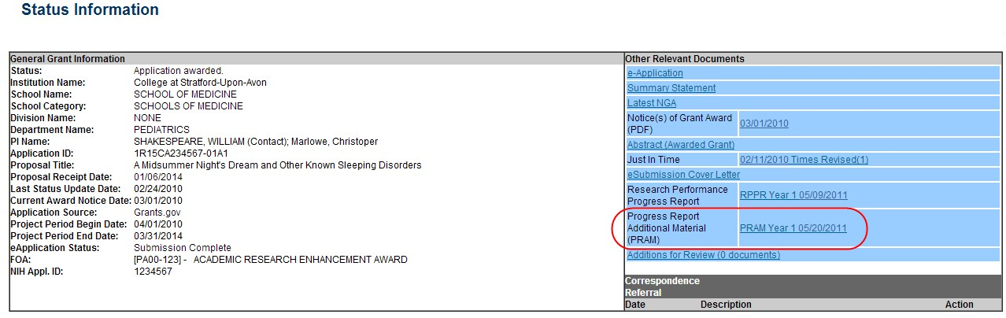

Figure 61: MYF Award PRAM Link in Status Information

5.11 Agency Requested Progress Report Additional Materials (PRAM)
The Agency Requested Progress Report Additional Materials (PRAM) feature provides a means for the grantee to enter, review, route, and submit information in response to specific request(s) by the Grants Management Specialist at the IC (or AHRQ, if applicable) for additional information following the submission of an RPPR.
As with the RPPR, a PD/PI (or Contact PI in the case of multiple PIs) can enter the PRAM, but can only submit it if the PD/PI is delegated with Submit Progress Report authority. Otherwise, only the SO can submit the PRAM to Agency.
The following sections cover the steps for initiating and submitting Agency Requested PRAM.

NOTE: Agency requested PRAM is not available for multi-year funded awards at this time.

5.11.1 Initiate Agency Requested PRAM
The PD/PI (Contact PI) or PD/PI Delegate can initiate Agency Requested PRAM by following the steps below:
- Access the eRA Commons Status Result – List of Applications/Grants screen.
- Select the Agency Requested PRAM link from the Action column of the appropriate grant.

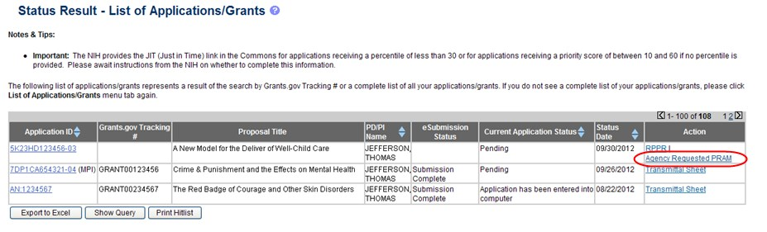

Figure
62
:

Agency
Requested
PRAM Link

The Progress Report Additional Materials (PRAM) screen displays. Grant Information, including Grant Number, PD/PI Name, Project Title, Institution, Status, and Current Reviewer, displays at the top of the screen. The Additional Materials Requested by Agency section at the bottom provides a means for adding the requested materials. Up to 100 attachments can be submitted, but all attachments must be in the form of PDF files.
- Select the Add Attachment button in the Additional Materials Requested by Agency section of the screen.

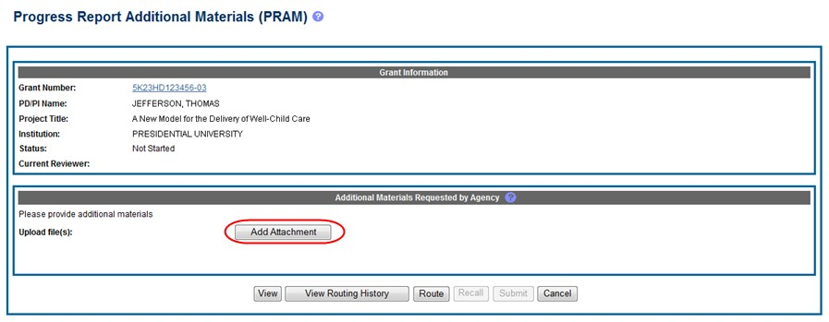

Figure 63: Add Attachment Button for Agency Requested PRAM

- Use the Upload Attachment pop-up Browse and Upload buttons to search for and attach the appropriate file. Repeat for all necessary attachments.

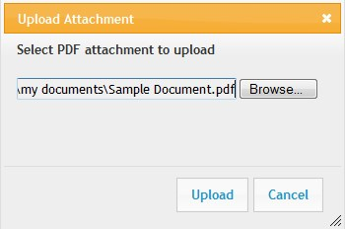

Figure
64
:
Upload Attachment Pop
-
up

The Additional Materials Requested by Agency section updates to show a table of all attachments. The table displays the Document Name and Action links of View and Delete for each attachment.
- Optional: Select the document’s View link in the Action column to view the attachment.
- Optional: Select the document’s Delete link in the Action column to remove the attachment.

NOTE: The options for View and Route History may be selected at this time. Selecting the option for Cancel closes the screen without saving or routing the PRAM information.

- Select the Route button to send the PRAM for review.
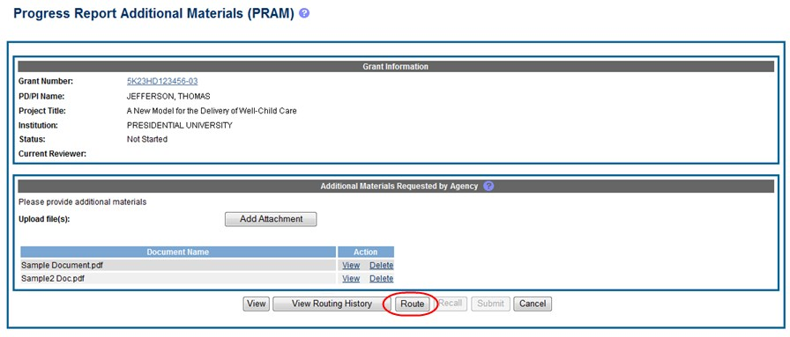

Figure
65
:
Routing the
Agency
Requested
PRAM

When the Route button is selected, the Route PRAM to Next Reviewer screen displays. A list of all available reviewers exists in the drop-down for Next Reviewer.
- Select a name from the Next Reviewer drop-down list.
- Enter text into the Comments field as necessary. This is not a mandatory field.
- Select the Submit button to continue.

Figure 66: Route Agency Requested PRAM to Next Reviewer

The Route PRAM to Next Reviewer screen displays the PD/PI Assurance statement.
- Read the assurance statement and select the Submit button to agree to the content and continue routing the PRAM to the next reviewer.

Figure 67: Agency Requested PRAM PD/PI Assurance Statement

The Progress Report Additional Materials (PRAM) screen displays with a message indicating that the PRAM was successfully routed to the selected reviewer. Additionally, the status is updated and shown as Reviewer Work in Progress. At this point, the PD/PI can only view the PRAM, the attachments, and the Route History; the PD/PI may not edit the PRAM. To be able to allow the PD/PI to edit the PRAM, the SO needs to route the PRAM back to the PD/PI using routing steps similar to those above.
At the time of routing, an email is sent to the PD/PI and the selected SO (or other Next Reviewer) to notify them of the event.

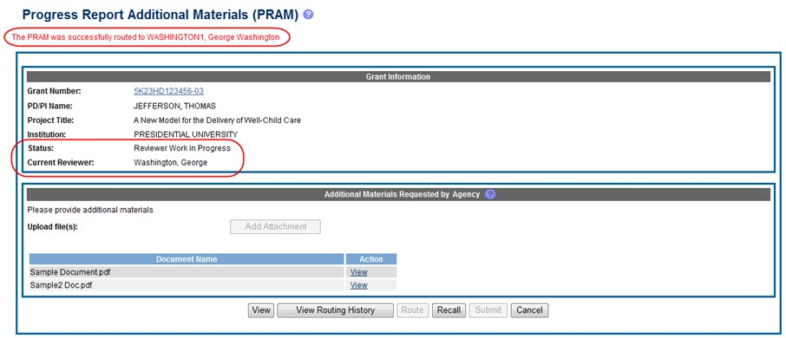

Figure 68: Successfully Routed Agency Requested PRAM

5.11.2 Recall Agency Requested PRAM
Agency Requested PRAM that has been routed to a reviewer can be recalled by the person who performed the routing action up until the submission of the current PRAM attachment(s) to the Agency. This is useful in situations when the report was routed to the wrong person or the reviewer is unavailable. The last reviewer of the report is able to recall it; however, Signing Officials at the Institution and the Contact PD/PI who are not the last reviewer can also recall the report when it is in a status of Reviewer Work in Progress.

NOTE: A PD/PI delegate does not have the ability to recall the PRAM.

To recall Agency Requested PRAM, select the Recall button from the Progress Report Additional Materials (PRAM) screen.

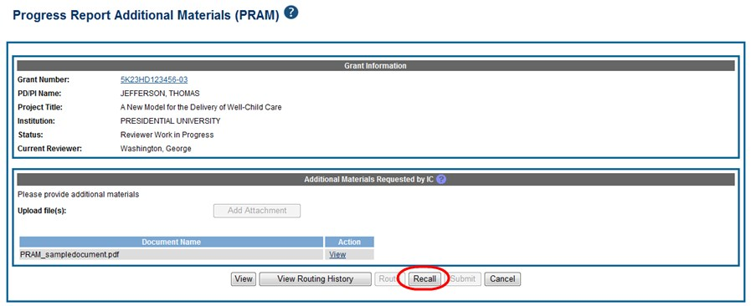

Figure 69: Recall Button for Agency Requested PRAM

A message displays on the screen indicating: The PRAM has been successfully recalled. You have been set as the Current PRAM Reviewer.

NOTE: Only items which have not already been submitted can be recalled. If prior Agency Requested PRAM submissions to the Agency exist, these attachments are not included in the recall.

The status of the PRAM is updated to PD/PI Work in Progress if recalled by the PI or Reviewer Work in Progress if recalled by the SO; the reviewer from whom the PRAM is recalled receives an email informing him of the action; and the PRAM routing audit history is updated to reflect the action.
Additionally, the ability to delete the attachment is restored and the Add Attachment and Route buttons are enabled, providing the current reviewer the ability to update the PRAM and route it again.

5.11.3 Submit Agency Requested PRAM
When the Agency Requested Progress Report Additional Materials (PRAM) is in Reviewer Work in Progress status, the Signing Official (SO) can submit it to the Agency. PD/PIs may also submit the information if they have been delegated Submit Progress Report authority by the SO.
To submit the PRAM:
- Access the Status screen on eRA Commons.
- Enter the appropriate query parameters to locate the grant and select the Search button.
The Status Result – General Search screen displays with the matching information.
- From the Action column, select the link for Agency Requested PRAM.

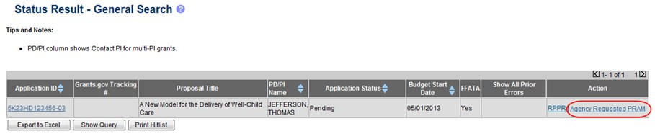

Figure
70
:

Agency
Requested
PRAM Link for SO

The Progress Report Additional Materials (PRAM) screen displays. The screen displays Grant Information on top and the files attached by the PD/PI in the Additional Materials Requested by Agency portion at the bottom. The attached files may be viewed or removed and additional PDF files may be added if necessary.
- Optional: Select the document’s View link in the Action column to view the attachment.
- Optional: Select the document’s Delete link in the Action column to remove the attachment.
- Optional: Select the Add Attachment button to attach additional files. Up to 100 PDF files may be attached.
Before submitting, the SO also may View the PRAM as a PDF, Route it to another reviewer (or back to the PD/PI), and view the Route History. Select any of the appropriate buttons to perform these actions. Follow the steps below to continue submitting the PRAM.
- Select the Submit button.

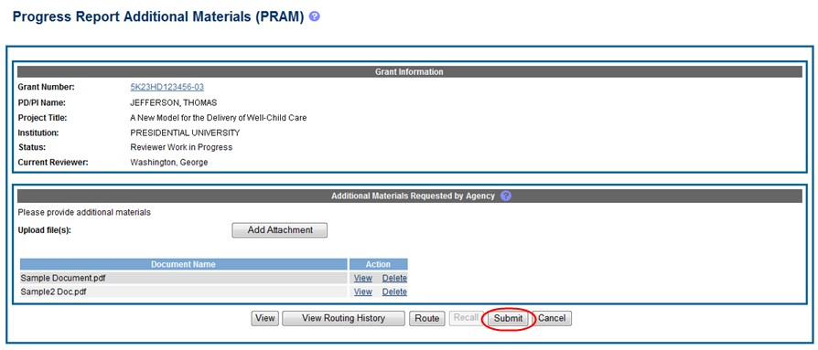

Figure
71
:
Submitting
Agency
Requested
PRAM

The Submit PRAM to Agency screen displays. By continuing from this screen, the SO certifies that the submitting organization is in compliance with the terms and conditions specified in the Notice of Award and Grants Policy Statement. The SO also verifies that the information provided in the PRAM is valid and accurate.
- Read certification agreement. Select the I Agree button to continue submitting the information. (Selecting the Cancel button closes the screen and returns the Progress Report Additional Materials screen without submitting the material.)

Figure
72
:
SO Certification of PRAM

The Progress Report Additional Materials (PRAM) screen displays with a message indicating that the PRAM was successfully submitted. The current reviewer is updated to NIH, the PRAM status is updated to Submitted to Agency, and the PRAM submission date is recorded. The routing history is updated to reflect the submission to Agency.

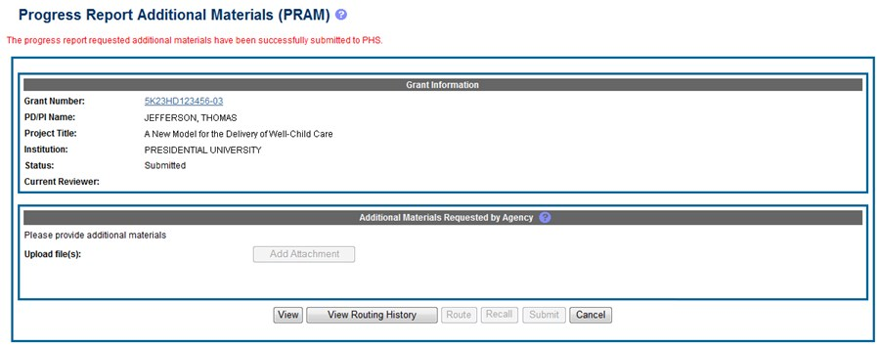

Figure 73: Agency Requested PRAM Submitted to Agency

When PRAM is submitted to Agency, an email notification is sent to the PD/PI (Contact PI) on the grant, the submitting SO, the SO assigned to the RPPR, and AO assigned to the RPPR.
Once the IC Requested PRAM is submitted, the View button remains on the PRAM screen to provide a preview of the latest PRAM submission; however, the ability to view or delete the individual attachments is removed. The ability to upload and submit additional attachments remains until the grant is awarded. Follow the steps provided in the Initiate Agency Requested PRAM section to add additional attachments (starting with Step 3).

NOTE: If multiple PRAM submissions were completed, selecting the View button only provides a preview of the latest PRAM submission. To view all submissions as one document, access the Status Information screen for the grant and select the PRAM link. For more information, refer to the View Agency Requested PRAM from Status Information section of this document.

5.11.4 View Agency Requested PRAM from Status Information
After submitting Agency Requested PRAM, Commons users with access to the grant information may view the PRAM via the Status Information screen. The Status Information is accessed by selecting the Grant Number hyperlink from the Progress Report Additional Materials (PRAM) screen or by selecting the Application ID hyperlink from Status Result – General Search (SOs) and Status Result – List of Applications/Grants (PIs) screens.

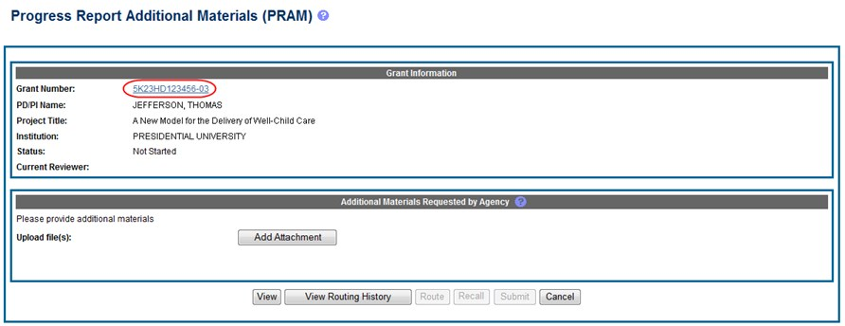

Figure 74: Grant Number Hyperlink on PRAM Screen

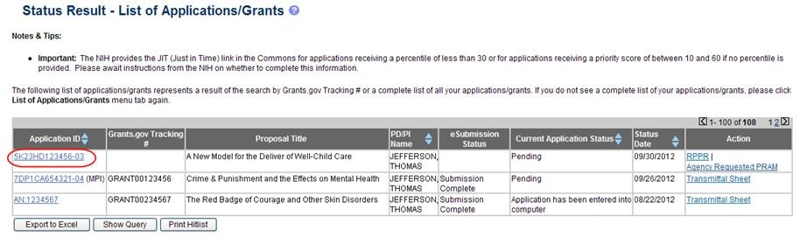

Figure 75: Application ID Hyperlink on Status Result for PIs

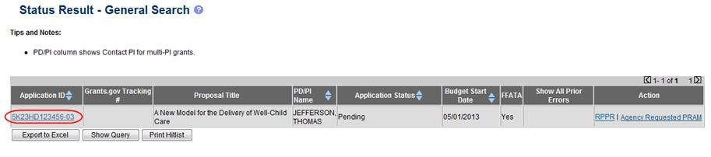

Figure 76: Application ID Hyperlink on Status Result for SOs

From the Status Information screen, select the hyperlink in the area marked Progress Report Additional Material (PRAM) in the Other Relevant Documents section.

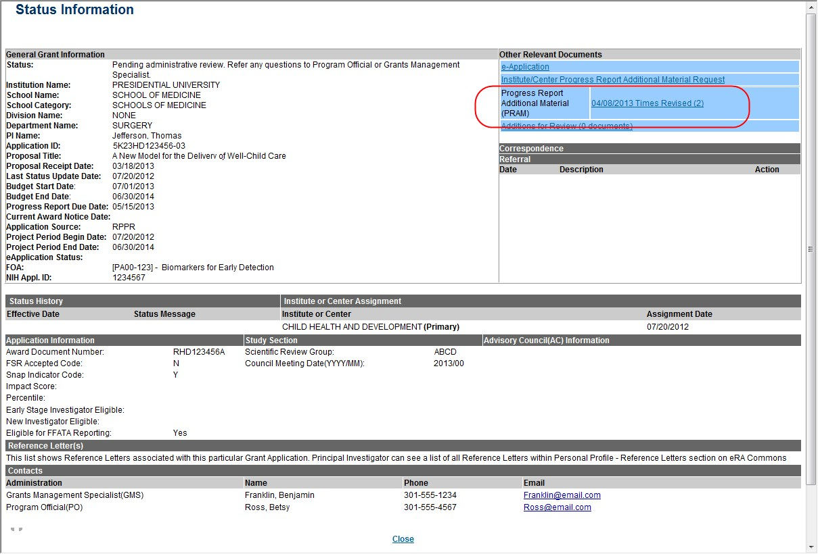

Figure
77
:
Status Information with PRAM Link

The Progress Report Additional Materials file opens as a PDF document. The file is formatted to provide an information header section for each PRAM submission followed by the attached documents provided during that submission. If multiple submissions of Agency Requested PRAM were completed, the additional materials are separated in the document with the most recent submission displayed first followed by earlier submissions in reverse chronological order. Information in the document can be navigated using the provided bookmarks on the left.

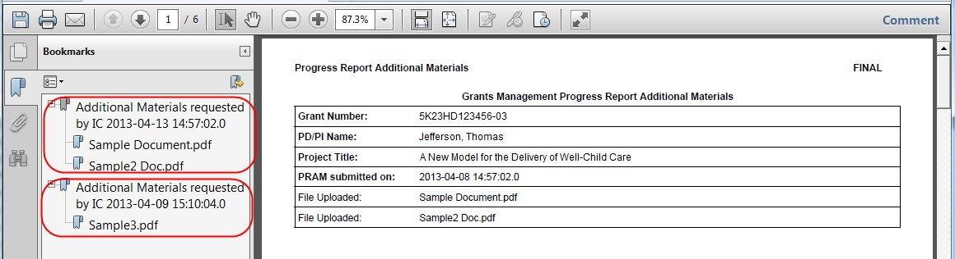

Figure 78: PDF of Multiple Submitted PRAM

Instructions for RPPR Sections A–I

The instructions in chapter 6 apply to the following awards: D71, DP1, DP5, G08, G11, G13,
P40, R00, R01, R03, R18, R21, R33, R34, R36, R37, R56, RC1, RC2, RL1, S21, S22, SC1, SC2, SC3, U1B, UC2, UH1, UH2, and UH3; and also to the following NIH multi-year funded awards, including: C06, DP2, DP3, DP4, R15, R55, RC3, RC4, RF1, UA5, UC4, UC6, UF1. Note that AHRQ has not yet implemented the RPPR for any AHRQ multi-year funded awards.
Many of these instructions apply to other awards, but there may be exceptions (items that are not applicable, replace, or are in addition) for awards not listed above. Refer to the table in chapter 7 Supplemental Instruction for Specific Grant Award Types, and follow the appropriate instruction for the applicable activity code of other awards. Activity codes listed in 7.6 Multi-Project
Awards and Single-Project Awards with Complicated Structure that are issued under the Streamlined Non-competing Award Process (SNAP) will complete the RPPR as described in this section. The electronic RPPR display is dynamic and shows the appropriate questions and instructions based on the activity code and SNAP status of the award.

Agency-specific reporting requirements and instructions are denoted by the DHHS logo displayed to the left of the requirement or instruction, as illustrated here.
Not Applicable next to a particular item indicates that item does not apply to the particular kind of award, and the item should be ignored.
References to competing application instructions means either the SF424 (R&R) Application Guides (http://grants.nih.gov/grants/funding/424/index.htm) or the PHS 398 Grant Application (http://grants.nih.gov/grants/funding/phs398/phs398.html).
The RPPR may not be used for prior approval requests, with the exception of requesting prior approval for a reduction in the level of effort of the PD/PI or other senior/key personnel named in the Notice of Award under D.2 of the RPPR. All other prior approval requests must be submitted directly to the Grants Management Officer of the awarding component in accord with the Grants Policy Statement, 8.1.2.

Section A – Cover Page
The RPPR section A. Cover Page includes information about the award, PD/PI, organization, and project/reporting/budget periods. Much of this information is pre-populated from data in eRA systems, but certain fields are editable.
The addresses, emails and phone numbers are pre-populated from the Commons Profile. To update contact information as displayed, go to the Commons Profile and save the changes there.
To select a Signing Official and Administrative Official, choose a name from the associated drop-down box. The SO and AO may be the same individual. The SO need not be the SO that submits the RPPR.
If there is a change to the Contact PD/PI (Multiple-PD/PI awards only), select the Yes radio button and enter the Commons ID of the new Contact PD/PI in the associated field. The change in Contact PD/PI does not take effect until the agency accepts the report and issues an NoA. The Contact PD/PI must have a PD/PI role in the eRA Commons and must be associated with the grantee institution. The RPPR is not an appropriate vehicle for a prior approval request to change, add, or delete PD/PIs.

The Recipient ID field allows the grantee to record an internal tracking number or identifier for its own use. It is not a mandatory field and the awarding agency will disregard the information.

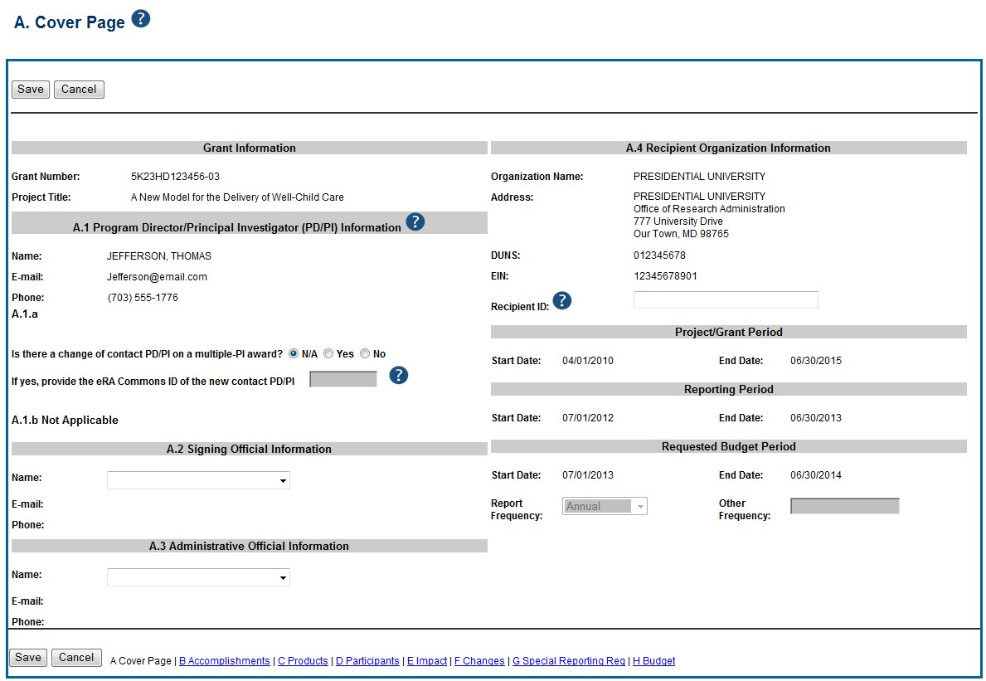

Figure
79
:
RPPR Section A. Cover Page

Section B – Accomplishments
The RPPR section B. Accomplishments allows the agency to assess whether satisfactory progress has been made during the reporting period.
PD/PIs are reminded that the grantee is required to obtain prior written approval from the awarding agency grants official whenever there are significant changes in the project or its direction. See agency-specific instructions for submission of these requests.
B.1 What are the major goals of the project?
List the major goals of the project as stated in the approved application or as approved by the agency. If the application lists milestones/target dates for important activities or phases of the project, identify these dates and show actual completion dates or the percentage of completion.
Generally, the goals will not change from one reporting period to the next. However, if the awarding agency approved changes to the goals during the reporting period, list the revised goals and objectives. Also explain any significant changes in approach or methods from the agency approved application or plan.
Goals are equivalent to specific aims. Significant changes in objectives and scope require prior approval of the agency (e.g., NIH Grants Policy Statement, 8.1.2).
The specific aims must be provided in the initial RPPR (i.e., first non-competing type 5 submission). In subsequent RPPRs this section will pre-populate with the aims/goals previously entered, and may be amended by answering Yes to question B.1.a.
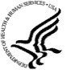

B.1.a Have the major goals changed since the initial competing award or previous
report?

Select Yes if the major goals/specific aims have changed since the initial competing award or previous report, and provide a revised description of major goals/specific aims. Remember that written prior approval from the awarding agency grants official is required for significant changes in the project or its direction. The RPPR is not an appropriate vehicle to request such a change.
The first year that an RPPR is submitted any revised goals should be entered into the text box for B.1. In subsequent years, if the user selects Yes the text box under B.1.a for entering revised major goals will be provided.

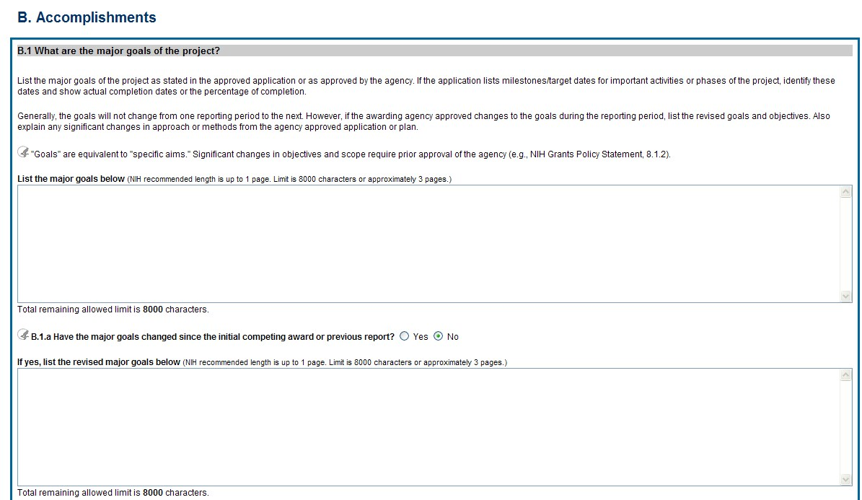

Figure 80: RPPR Section B. Accomplishments – Question B1

B.2 What was accomplished under these goals?
For this reporting period describe: 1) major activities; 2) specific objectives; 3) significant results, including major findings, developments, or conclusions (both positive and negative); and 4) key outcomes or other achievements. Include a discussion of stated goals not met. As the project progresses, the emphasis in reporting in this section should shift from reporting activities to reporting accomplishments.

Goals are equivalent to specific aims. In the response, emphasize the significance of the findings to the scientific field. Include the approaches taken to ensure robust and
unbiased results. For most NIH awards the response should not exceed 2 pages. B.3 Competitive Revisions/Administrative Supplements.
For this reporting period, is there one or more Revision/Supplement associated with this award for which reporting is required?
If yes, identify the Revision(s)/Supplements(s) by grant number (e.g., 3R01CA098765-01S1) or title and describe the specific aims and accomplishments for each Revision/Supplement funded during this reporting period. Include any supplements to promote diversity or re-entry, or other similar supplements to support addition of an individual or a discrete project.
The NoA will indicate any reporting requirements. Be advised that the NoA incorporates requirements of the FOA that may also include reporting requirements.
Select the Add/New button to add the data to the table.

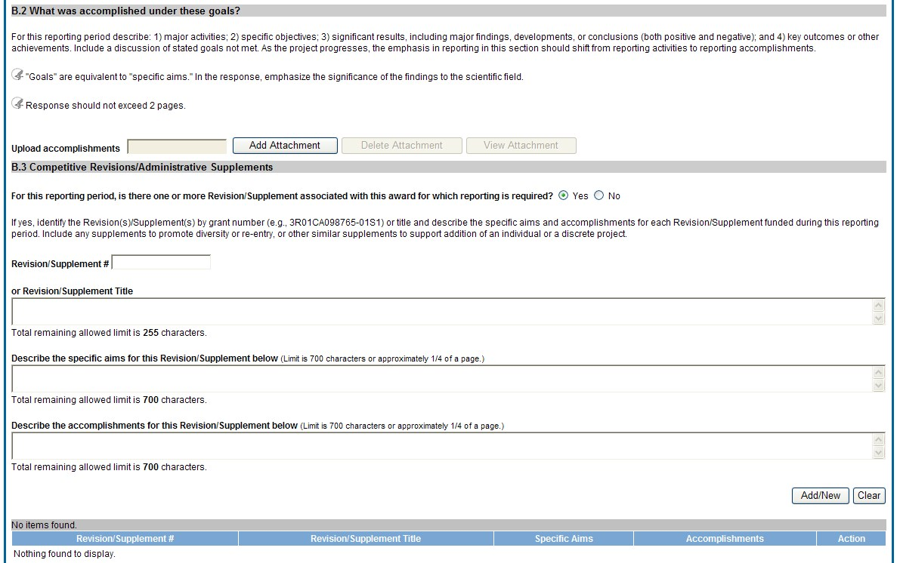

Figure 81: RPPR Section B. Accomplishments – Questions B2 & B3

B.4 What opportunities for training and professional development has the project provided?
If the research is not intended to provide training and professional development opportunities or there is nothing significant to report during the reporting period, select Nothing to Report.
Describe opportunities for training and professional development provided to anyone who worked on the project or anyone who was involved in the activities supported by the project. Training activities are those in which individuals with advanced professional skills and experience assist others in attaining greater proficiency. Training activities may include, for example, courses or one-on-one work with a mentor. Professional development activities result in increased knowledge or skill in one’s area of expertise and may include workshops, conferences, seminars, study groups, and individual study. Include participation in conferences, workshops, and seminars not listed under major activities.
For all projects reporting graduate students and/or postdoctoral participants in Section
D., describe whether your institution has established Individual Development Plans
(IDPs) for those participants. Do not include the actual IDP, instead include information to describe how IDPs are used, if they are used, to help manage the training for those individuals. This information is not required for AHRQ grantees.
For T, F, K, R25, R13, D43 and other awards or award components designed to provide training and professional development opportunities, a response is required. Follow the
B.4 instructions found in the Supplemental Instructions for Training, Education, and Career RPPRs. Do not reiterate what is reported under Accomplishments. Limit the response to this reporting period.

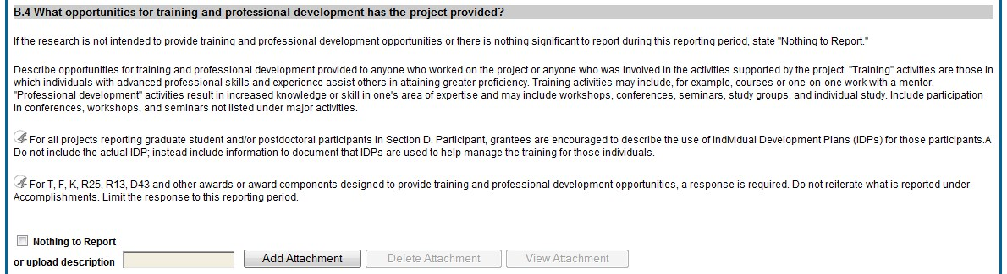

Figure 82: RPPR Section B. Accomplishments – Question B4

B.5 How have results been disseminated to communities of interest?
Describe how the results have been disseminated to communities of interest. Include any outreach activities that have been undertaken to reach members of communities who are not usually aware of these research activities, for the purpose of enhancing public understanding and increasing interest in learning and careers in science, technology, and the humanities.
Reporting the routine dissemination of information (e.g., websites, press releases) is not required. For awards not designed to disseminate information to the public or conduct
similar outreach activities, a response is not required and the grantee should select Nothing to Report. A detailed response is only required for awards or award components that are designed to disseminate information to the public or conduct similar outreach activities. Note that scientific publications and the sharing of research resources will be reported under Products.

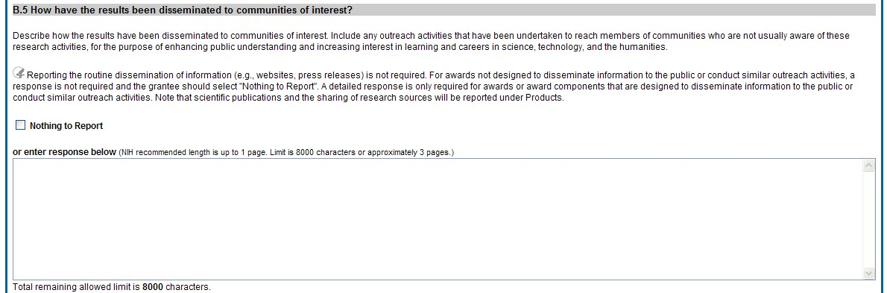

Figure 83: RPPR Section B. Accomplishments – Question B5

B.6 What do you plan to do for the next reporting period to accomplish the goals?
Describe briefly what you plan to do during the next reporting period to accomplish the goals and objectives.
Discuss efforts to ensure that the approach is scientifically rigorous and results are robust and unbiased.
Remember that significant changes in objectives and scope require prior approval of the agency (e.g., NIH Grants Policy Statement, 8.1.2.).
Include any important modifications to the original plans. Provide a scientific justification for any changes involving research with human subjects or vertebrate animals. A detailed description of such changes must be provided under Section F. Changes.

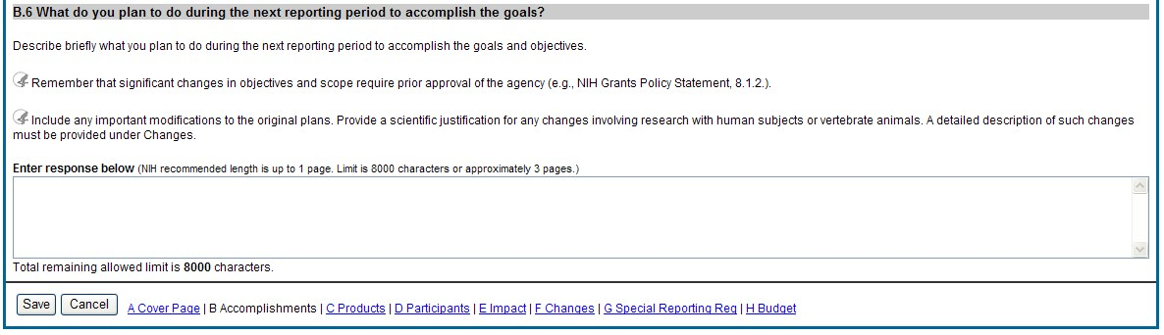

Figure 84: RPPR Section B. Accomplishments – Question B6

Section C – Products
The RPPR section C. Products allows agencies to assess and report both publications and other products to Congress, communities of interest, and the public. C.1 Publications.
Are there publications or manuscripts accepted for publication in a journal or other publication (e.g., book, one-time publication, monograph) during the reporting period resulting directly from the award?
PD/PIs are required to report all publications that arise from their NIH award in this section. Publications listed in other parts of the RPPR will not be tracked as award products. If there are publications to report select Yes and ensure that the Associate with this RPPR box is checked as appropriate. If there are no publications to report select No. The tables draw information from the PD/PI’s My NCBI account. PD/PIs can log in to their My NCBI account via the My NCBI link at the top of C.1. PD/PIs that do not have a My NCBI account can create one by simply logging in to My NCBI with their eRA Commons credentials, which will automatically create a My NCBI account. Any changes they make to their My Bibliography collection will be reflected in the RPPR once the screen is refreshed (i.e., by clicking the Save button). For more information on My NCBI, see:
Get Started with My NCBI: Access My NCBI, Register, and Sign In
Edit Your My Bibliography Settings (Add a Delegate)
The first table, All Publications Associated with this Project in My NCBI, lists all publications that are in the PD/PI’s My Bibliography collection, are associated with this award, and have not been reported in previous electronic progress reports for this award.
The first column Associate with this RPPR is automatically checked. Leaving the box checked upon submission associates the publication with this progress report, results in the publication being displayed in RePORT, and makes the award-publication association in My NCBI permanent and the association will be reported in PubMed. Unchecking the box disassociates the publication with this progress report and, upon submission of the RPPR to NIH, removes the award-publication association in My NCBI.
The second column, NIH Public Access Compliance, indicates the current compliance status with the NIH Public Access Policy. This information is from My NCBI. Publications that fall under the Public Access Policy and are non-compliant still must be reported. Generally, it takes weeks to bring publications into compliance; PD/PIs are advised to do so as soon as possible to ensure their award is renewed in a timely manner. For more information, see Manage
Compliance with the NIH Public Access Policy in My NCBI and the NIH Public Access website. The compliance status for AHRQ grantees will be indicated as NA (not applicable) until such time as AHRQ implements a public access policy.
Note that the publication data in these tables is dynamic until the progress report is submitted to the agency. Any change to the data occurring in PubMed, PubMed Central, the PD/PI’s My Bibliography account, or in the compliance status of a publication will refresh upon saving the C.1 Products section, or opening the RPPR in another session. When the progress report is submitted to the agency, the publication data is frozen in the progress report.
The second table, Publications not associated with this project in MyNCBI, lists all other publications that are in the PD/PI’s My Bibliography collection but do not have an association with this award. Checking Associate with this RPPR box will associate a publication with the award both in the progress report and in My NCBI. Refreshing this screen (i.e., clicking the Save button) will also move the newly associated publications from this table to the first table. Similarly, publications disassociated in the first table will appear in this table when the screen is refreshed.
The final table, Publications previously reported for this project, lists publications reported in a previous electronic progress report for this award. Grantees are responsible for ensuring that these publications comply with the Public Access policy even if they were provisionally compliant (listed as in Progress) when previously reported.
The report may be submitted with noncompliant publications; however the system will generate an automated email to the PD/PI (with cc to the AO and SO) requesting that the grantee provide evidence of compliance or an explanation (e.g., the sole author has passed away before s/he was able to process the manuscript for posting to PubMed Central) by a specified due date two weeks prior to the next budget start date. The grantee must respond either via an email to the GMS and PO, or may respond via the Progress Report Additional Materials (PRAM) link found on the eRA Commons Status page. The PRAM link provides a text box in which the grantee may respond through the eRA Commons. The grantee will be able to view the PRAM in the grant folder. See Section 5.10 Public Access Progress Report Additional Materials (PRAM) for more information.
Publications listed in other parts of a progress report are not captured electronically. They will not be included in this table, and may not be listed as resulting from this award in RePORT.

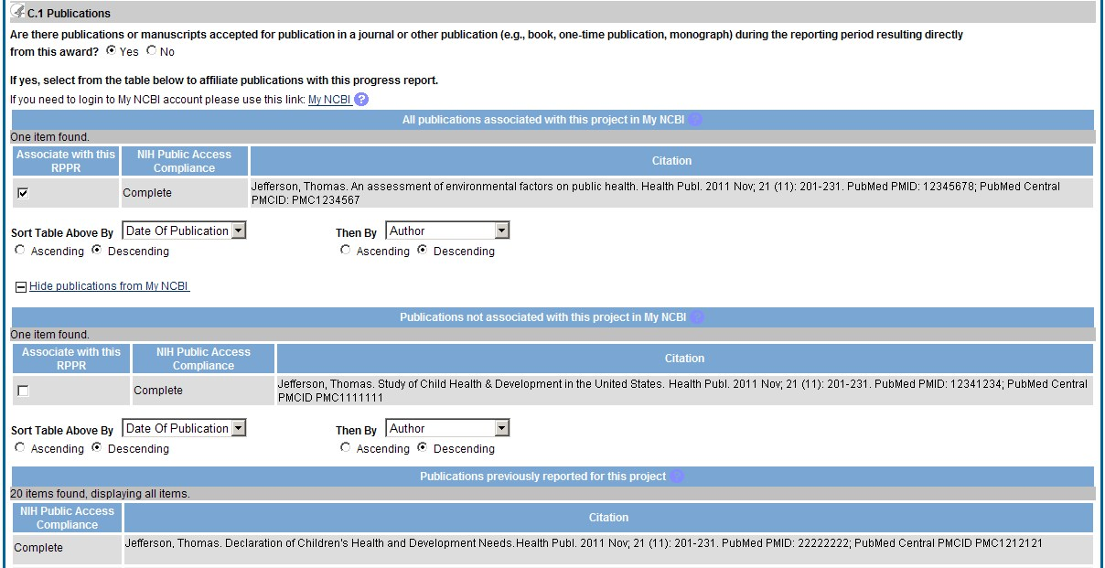

Figure
85
:
RPPR Section C. Produc
ts
–

Question C1

C.2 Website(s) or other internet site(s).
List the URL for any Internet site(s) that disseminates the results of the research activities. A short description of each site should be provided. It is not necessary to include the publications already specified above.
A description is only required for awards designed to create or maintain one or more websites. Limit the response to this reporting period. If the website disseminates a product that falls into one or more of the other product categories, please select the appropriate category(ies) from the pull-down menu (select multiple categories, if appropriate, by holding down the Ctrl button while selecting the categories). For awards not designed to create or maintain one or more websites, select Nothing to Report.

C.3 Technologies or techniques.
Identify technologies or techniques that have resulted from the research activities. Describe the technologies or techniques and how they are being shared.
PD/PIs are required to report all technologies or techniques that arise from their NIH award in this section. If there are technologies or techniques to report, select Yes and enter a short description. If the technology or technique falls into one or more of the product categories, please select the appropriate category (ies) from the pull-down menu (select multiple categories, if appropriate, by holding down the Ctrl button while selecting the categories). If there are no technologies or techniques to report select Nothing to Report. Limit the response to this reporting period.

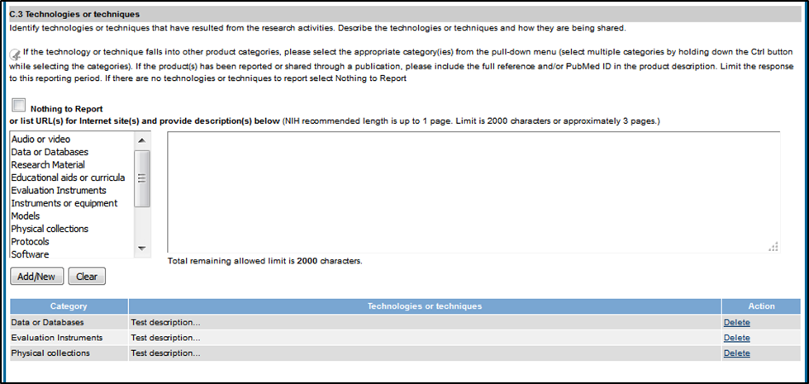
Figure 86: RPPR Section C. Products – Questions C2 & C3

C.4 Inventions, patent applications and/or licenses.
Have inventions, patent applications and/or licenses resulted from the award during this reporting period?
If yes, has this information been previously provided to the PHS or to the official responsible for patent matters at the grantee organization?
Reporting of inventions through iEdison is required.
C.5 Other products and resources.
C.5.a Other products
Identify any other significant products that were developed under this project.

PD/PIs are required to report all products that arise from their NIH award in section C. If there are other products to report not covered in Sections C1 – C4, enter a description for the product and choose the appropriate product category(ies) from the pull down menu (select multiple categories, if appropriate, by holding down the Ctrl button while selecting the categories). If there is more than one product to report, select “add product” to create a workspace for an additional product. Limit the response to this reporting period.
Examples of other products are: audio or video products; data or databases; physical collections; software; models; educational aids or curricula; instruments or equipment; research material (e.g., Germplasm, cell lines, DNA probes, animal models); interventions (e.g., clinical, educational); and new business creation. To review additional guidance for each category, please refer to: http://grants.nih.gov/grants/rppr/Guide-to-Categorizing-Products-in-RPPR-Sec-C_draft.pdf

C.5.b Resource Sharing
PD/PIs and grantee organizations are expected to make the results and accomplishments of their activities available to the research community and to the public at large. For additional information on NIH Sharing Policies and Related Guidance on NIH-Funded Research Resources see http://grants.nih.gov/grants/sharing.htm.
If the initial research plan addressed, or the terms of award require, a formal plan for sharing final research data, model organisms, Genome Wide Association Studies data, or other such project-specific data, describe the progress in implementing that plan. For sharing model organisms, include information on the number of requests received and number of requests fulfilled during this reporting period. If the sharing plan is fully implemented, provide a final statement on data sharing.

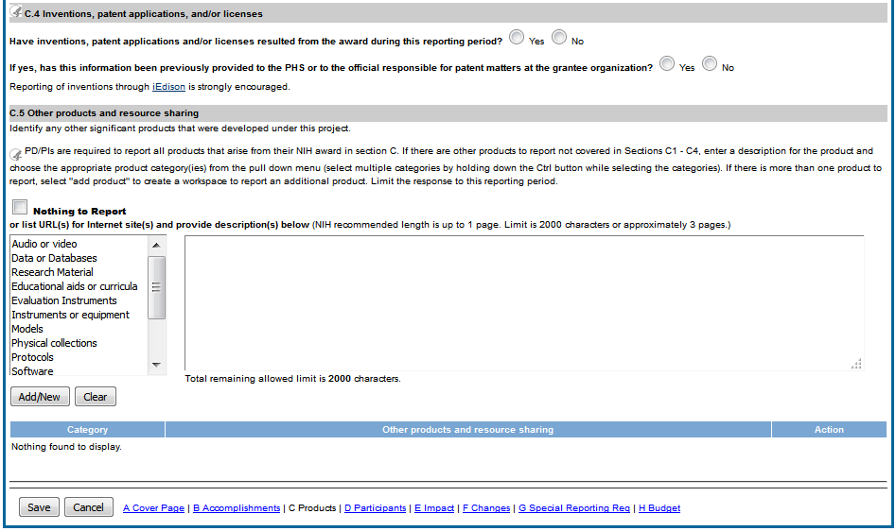
Figure 87: RPPR Section C. Products – Questions C4 & C5

Section D – Participants
The RPPR Section D. allows the agency to know who has worked on the project to gauge and report performance in promoting partnerships and collaborations. D.1 What individuals have worked on the project?
Provide or update the information for: (1) program director(s)/principal investigator(s) (PDs/PIs); and (2) each person who has worked at least one person month per year on the project during the reporting period, regardless of the source of compensation (a person month equals approximately 160 hours or 8.3% of annualized effort).
Provide the name and identify the role the person played in the project. Indicate the nearest whole person month (Calendar, Academic, Summer) that the individual worked on the project.
Show the most senior role in which the person has worked on the project for any significant length of time. For example, if an undergraduate student graduates, enters graduate school, and continues to work on the project, show that person as a graduate student.
NIH Instructions:
- An individual's Commons user ID may be used to partially populate his or her information
- A Commons ID is required for all individuals with a postdoctoral, graduate or undergraduate role (NOT-OD-13-097). The Commons ID is also required for individuals supported by a Reentry or Diversity Supplement. For all other project personnel, the Commons ID is strongly encouraged but currently optional. AHRQ only requires a Commons ID for individuals in a postdoctoral role.
- Individuals with a postdoctoral-like role should be identified as Postdoctoral (scholar, fellow, or other postdoctoral position)
- Do not include Other Significant Contributors who are not committing any specified measurable effort to this project
- Do not report personnel for whom a PHS 2271 Appointment form has been submitted through xTrain
- Required fields are marked with an * eRA Commons User ID: Entering the User ID allows selection of “Populate from Profile” which will partially populate the individual’s information. Those with an Administrator role in the eRA Commons may search for user IDs by following the instructions at:
Search for Commons User Accounts
Senior/key personnel are defined as the PD/PI and other individuals who contribute to the scientific development or execution of a project in a substantive, measurable way, whether or not they receive salaries or compensation under the grant. Typically these individuals have doctoral or other professional degrees, although individuals at the masters or baccalaureate level may be considered senior/key personnel if their involvement meets this definition. Consultants and those with a postdoctoral role also may be considered senior/key personnel if they meet this definition.
Last 4 digits of SS# and Month/Year of birth: The provision of the partial Social Security number and month/year of birth are voluntary, and the information is used only for program management purposes.
Project Role: PD/PI names and information from their Commons Profile(s) will be prepopulated. To update the PD/PI information as displayed, go to the Commons Profile and save the changes there. For all other personnel, select from a dropdown menu of the following options:
- Co-Investigator
- Faculty
- Postdoctoral (scholar, fellow or other postdoctoral position)
- Technician
- Staff Scientist (doctoral level)
- Statistician
- Graduate Student (research assistant)
- Non-Student Research Assistant
- Undergraduate Student
- High School Student
- Consultant
- Other (specify)
Supplement Support: If personnel are supported by a Reentry or Diversity Supplement indicate type of supplement in this field.
Person Months: The metric for expressing the effort (amount of time) devoted to a specific project. The effort is based on the type of appointment of the individual with the organization;
e.g., calendar year, academic year, and/or summer term; and the organization's definition of such. For instance, some institutions define the academic year as a 9-month appointment while others define it as a 10-month appointment.
Include (1) the PD/PI regardless of effort devoted to the project and (2) each person who has worked at least one person month per year on the project during the reporting period, regardless of the source of compensation.
Round to the nearest whole person month that the individual worked on the project. For example, if the individual worked 2.25 person months, indicate 2 person months. If the individual worked 4.7 person months, indicate 5 person months. If the PD/PI worked 0.5 to 1 person month, round up to 1 person month. If the PD/PI worked 0.1 to 0.4 person month, round down to 0 (zero).
To calculate person months, multiply the percentage of effort associated with the project by the number of months of the appointment. For example:
- 25% of a 9 month academic year appointment equals 2.25 (academic year) person months (.25 x 9 = 2.25). Round down to 2.
- 90% of a 12 month calendar appointment equals 10.8 (calendar year) person months (.90 x 12 = 10.8). Round up to 11.
- 35% of a 3 month summer term appointment equals 1.05 (summer) person months (.35 x 3= 1.05). Round down to 1.
- If the regular pay schedule of an institution is a 9 month academic year and the PD/PI will devote 9 academic months at 30% time/effort and 3 months summer term at 30% time/effort , then 3 academic months (.30% x 9 = 2.7, round up to 3), and 1 summer month (.30 x 3 = .9, round up to 1) should be reported
Person months reported on the RPPR are intentionally rounded to the nearest whole number to provide for generalized reporting consistent across federal agencies that support research activities. Although it is possible to report 0 (zero) person month for the PD/PI on the RPPR if the PD/PI worked .1 to .4 person month, a PD/PI must have measurable effort. Change in Level of Effort for the PD/PI(s) and other senior key/personnel designated in the NoA is reported under D.2.a below.
Is the individual’s primary affiliation with a foreign organization?
Check No if the individual’s primary affiliation is with a foreign organization but the individual is working on this award solely while in the U.S.
If Yes, provide the name of the organization and country.
Select the Add/New button to add the data to the table.

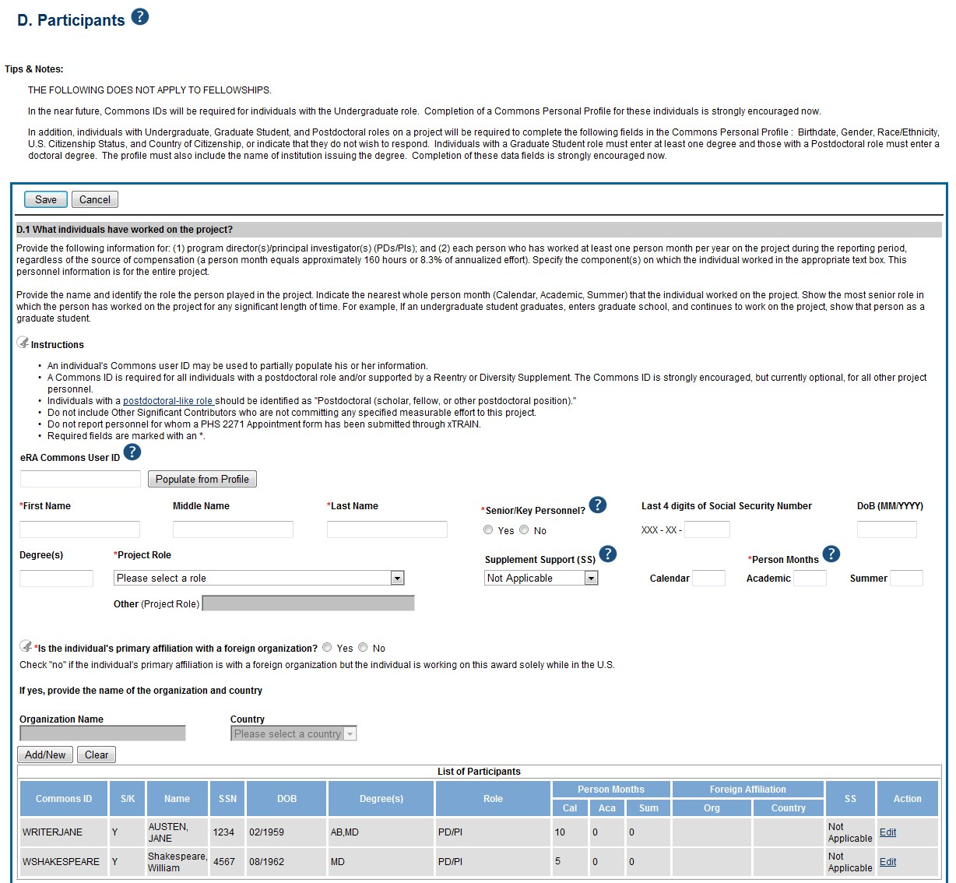

Figure 88: RPPR Section D. Participants – Question D1

D.2 Personnel Updates.
D.2.a Level of effort.
Will there be, in the next budget period, either (1) a reduction of 25% or more in the level of effort from what was approved by the agency for the PD/PI(s) or other senior/key personnel designated in the Notice of Award, or (2) a reduction in level of effort below the minimum amount of effort required by the Notice of Award?
Reductions are cumulative, i.e., the 25% threshold may be reached by two or more successive reductions that total 25% or more. Once agency approval has been given for a significant change in the level of effort, then all subsequent reductions are measured against the approved adjusted level. Selecting Yes constitutes a prior approval request to the agency and the issuance of a subsequent year of funding constitutes agency approval of the request. D.2.b New senior/key personnel.
Are there, or will there be, new senior/key personnel?
Senior/key personnel are those identified by the grantee institution as individuals who contribute in a substantive measurable way to the scientific development or execution of the project, whether or not salaries are requested. Typically these individuals have doctoral or other professional degrees, although individuals at the masters or baccalaureate level may be considered senior/key personnel if the involvement meets this definition. Consultants may be considered senior/key personnel if they meet this definition.
If yes, upload biosketches and other support for all new senior/key personnel.
Follow the biosketch instructions in the competing application guide and provide active other support for all new senior/key personnel. Combine all biosketches and other support into a single PDF.

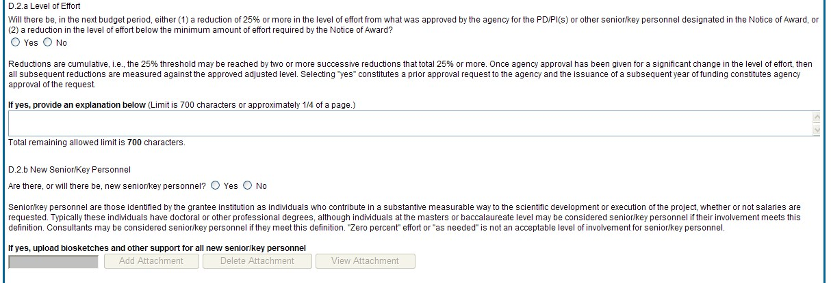

Figure 89: RPPR Section D. Participants – Questions D2a & D2b

D.2.c Changes in other support.
Has there been a change in the active other support of senior/key personnel since the last reporting period?
If yes, upload active other support for senior/key personnel whose support has changed and indicate what the change has been. List the award for which the progress report is being submitted and include the effort that will be devoted in the next reporting period.
Select Yes only if active support has changed for the PD/PI(s) or senior/key personnel.
If a previously active grant has terminated and/or if a previously pending grant is now active, submit complete Other Support information using the suggested format and instructions found at http://grants.nih.gov/grants/funding/2590/Non-competing_othersupport.docx. Annotate this information so it is clear what has changed from the previous submission.
Submission of other support information is not necessary if support is pending or for changes in the level of effort for active support reported previously.
Other support information should be submitted only for the PD/PI and for those individuals considered by the grantee to be key to the project for whom there has been a change in other support. Senior/key personnel are defined as individuals who contribute in a substantive measurable way to the scientific development or execution of the project, whether or not a salary is requested. Do not include other support information for Other Significant Contributors; e.g., those that may contribute to the scientific development or execution of the project, but are not committing any specified measurable effort to the project. D.2.d New other significant contributors.
Are there, or will there be, new other significant contributors?
Other significant contributors are individuals who have committed to contribute to the scientific development or execution of the project, but are not committing any specified measurable effort (i.e., person months) to the project.
If yes, upload biosketches for all new other significant contributors.

D.2.e Will there a change in the MPI Leadership Plan for the next budget period?
Change in status of PD/PI requires prior approval of the agency (e.g., NIH Grants Policy Statement, 8.1.2.6). In accord with the NIH GPS, 9.5, revision of the Leadership Plan during the project period may be accomplished through a joint decision of the PD/PIs and reported in the RPPR. Prior approval of a change in the MPI Leadership Plan is not required.
If yes, upload a revised MPI Leadership Plan that includes a description of the change(s).
All multiple PD/PI awards have a Leadership Plan that describes the roles and areas of responsibility of the named PD/PIs, the process for making decisions concerning scientific directions, allocation of resources, disputes that may arise, and other information related to the management of the proposed team science project. If there has been any change in the governance and/or organizational structure of the Leadership Plan, provide a description, including communication plans and procedures for resolving conflicts, and any changes to the administrative, technical, and scientific responsibilities of the PD/PIs. If the progress report includes a change in the Contact PD/PI (Cover Page, A.1) address this change and the impact, if any, the change has on the administrative, technical, and scientific responsibilities of the PD/PIs. A request to change from a multiple PD/PI model to a single PD/PI model, or a change in the number or makeup of the PD/PIs on a multiple PD/PI award, requires the prior approval of the GMO. The progress report is not the appropriate vehicle to request such a change.

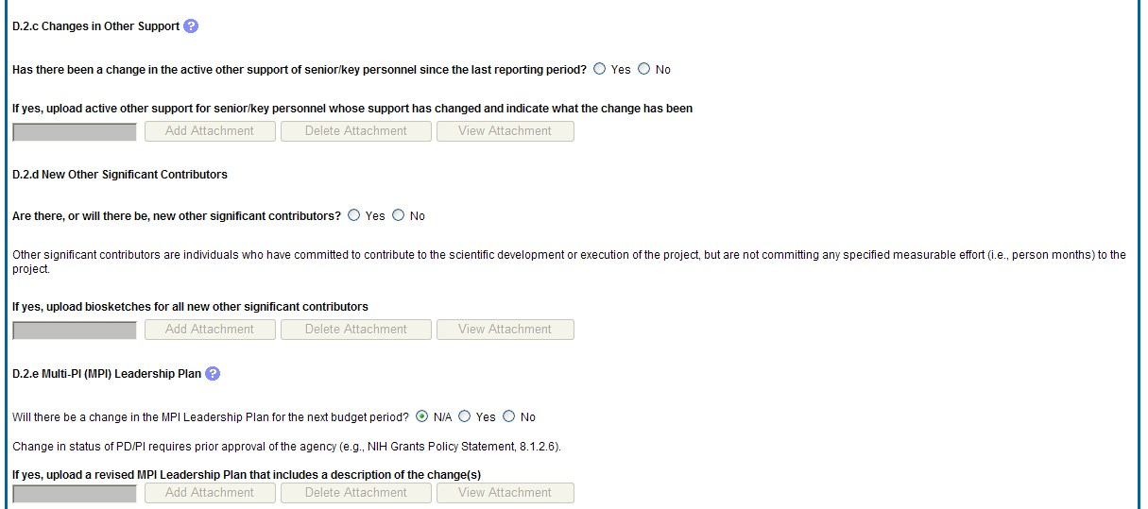

Figure 90: RPPR Section D. Participants – Questions D2c – D2e

Section E – Impact
The RPPR Section E Impact will be used to describe ways in which the work, findings, and specific products of the project have had an impact during this reporting period. E.1 Not Applicable for most awards. See chapter 7 Supplemental Instructions.
E.2 What is the impact on physical, institutional, or information resources that form infrastructure?
Describe ways, if any, in which the project made an impact, or is likely to make an impact, on physical, institutional, and information resources that form infrastructure, including:
- physical resources (such as facilities, laboratories, or instruments);
- institutional resources (such as establishment or sustenance of societies or organizations); or
- information resources, electronic means for accessing such resources or for scientific communication, or the like.
If the award or award component(s) is not intended to support physical, institutional, or information resources that form infrastructure, select Nothing to Report. E.3 Not Applicable for most awards. See chapter 7 Supplemental Instructions.
E. 4 What dollar amount of the award’s budget is being spent in foreign country(ies)?
For domestic awardees provide the dollar amount obligated to first-tier subawards to foreign entities for this reporting period. For foreign awardees provide the dollar amount of the award, excluding all first-tier subawards to U.S. entities, for this reporting period. Dollars provided should reflect total costs.
If more than one foreign country identify the distribution between the foreign countries.
Report only cumulative first-tier subawards dollars by country. Do not report foreign travel, purchases, etc., unless part of a first-tier subaward to a foreign country.
Select the Add/New button to add the data to the table.

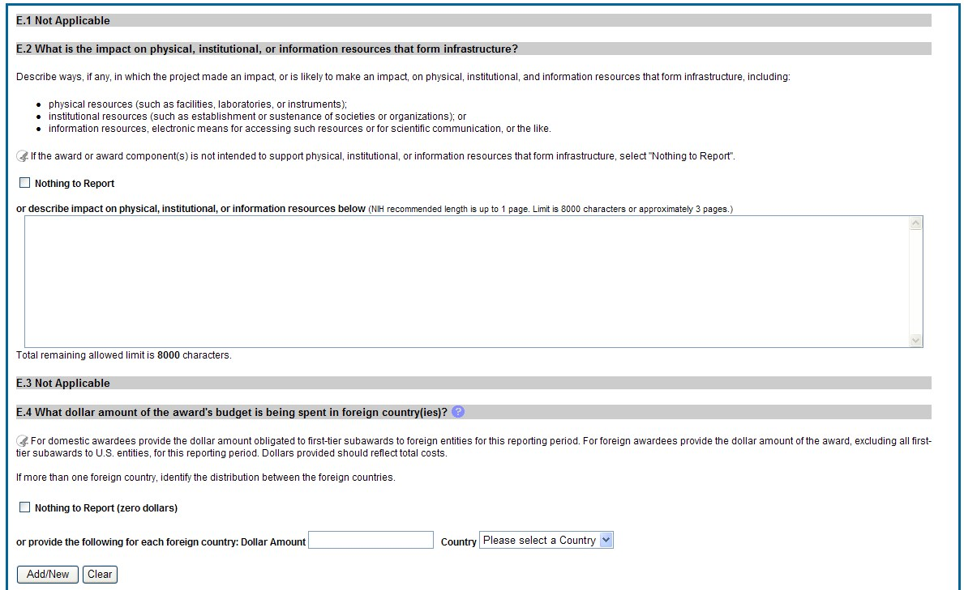

Figure 91: RPPR Section E. Impact – Questions E1 through E4

Section F – Changes
The RPPR Section F addresses Changes. Grantees are reminded that significant changes in objectives and scope require prior approval of the agency.
F.1 Not Applicable to most awards. See chapter 7 Supplemental Instructions.
F.2 Actual or anticipated challenges or delays and actions or plans to resolve them.
Describe challenges or delays encountered during the reporting period and actions or plans to resolve them.
Describe only significant challenges that may impede the research (e.g., accrual of patients, hiring of personnel, need for resources or research tools) and emphasize their
resolution.

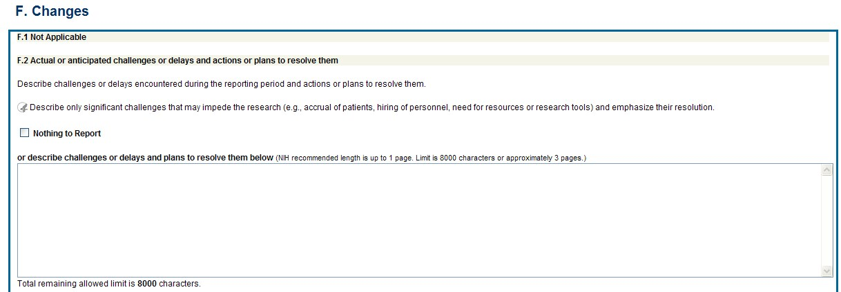

Figure 92: RPPR Section F. Changes – Questions F1 & F2

F.3 Significant changes to human subjects, vertebrate animals, biohazards, and/or select agents.
Describe significant deviations, unexpected outcomes, or changes in approved protocols for human subjects, vertebrate animals, biohazards and/or select agents during this reporting period.
Remember that significant changes in objectives and scope require prior approval of the agency (e.g., NIH Grants Policy Statement, 8.1.2.). If there are changes in any of the following areas, check the appropriate box and provide a description of the changes.
F.3.a Human Subjects
If human subject studies are or will be different from the previous submission, please indicate there are changes here and provide these changes in section G.4.b including a new or revised Protection of Human Subjects Section as described in the competing application instructions. In addition, in G.4.b please provide any updates to enrollment, human subjects protections training, as well as clinical trials milestone information (if conducting one or more clinical trials).
F.3.b Vertebrate Animals
If there are or will be significant changes to the uses of vertebrate animals from the previous submission, provide a description of the changes. Examples of changes considered to be significant include, but are not limited to, changing animal species, changing from noninvasive to invasive procedures, new project/performance site(s) where animals will be used, etc. If studies involving live vertebrate animals are planned and were not part of the originally proposed research design, provide a new or revised Vertebrate Animal Section as described in the competing application instructions.
F.3.c Biohazards
If the use of biohazards is or will be different from that in the previous submission, provide a description and explanation of the difference(s).
F.3 d Select Agents
If the possession, use, or transfer of Select Agents is or will be different from that proposed in the previous submission, including any change in the select agent research location and/or the required level of biocontainment, provide a description and explanation of the differences. If the use of Select Agents was proposed in the previous submission but has not been approved by regulatory authorities, provide an explanation. If studies involving Select Agents are planned and were not part of the originally proposed research design, provide a description of the proposed use, possession, transfer, and research location as described in the competing application instructions.
U.S. Select Agent Registry information:
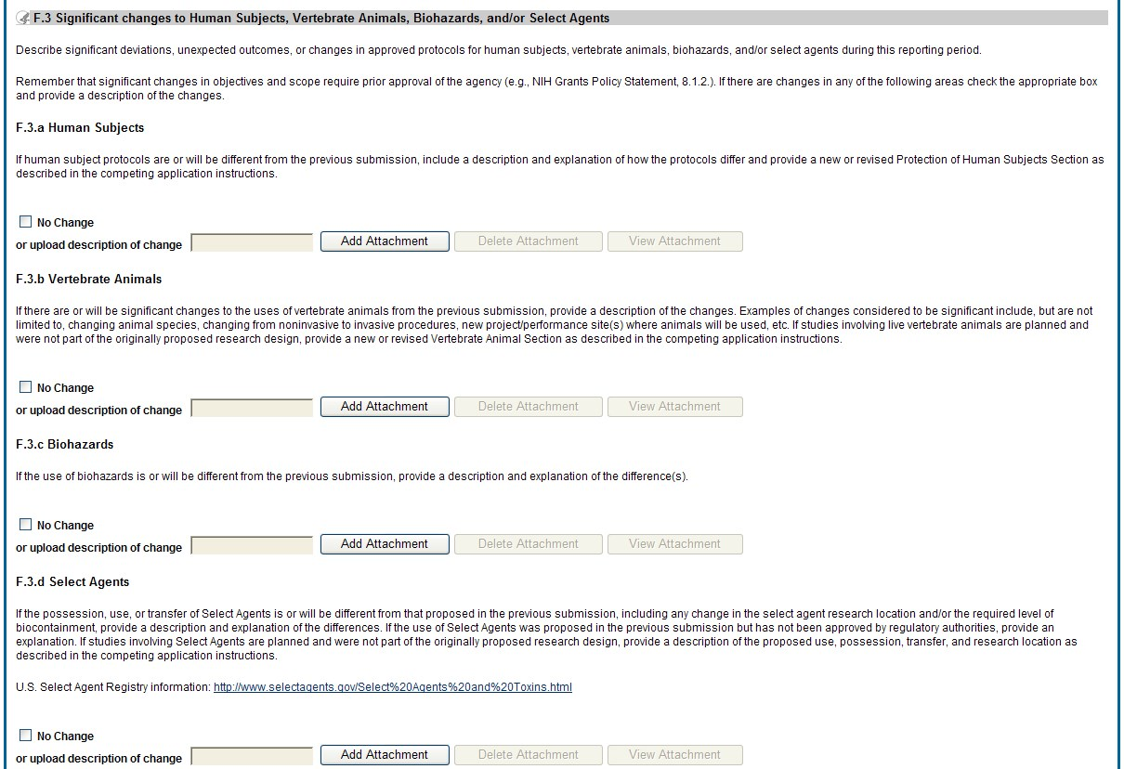
http://www.selectagents.go
v

Figure
93
:
RPPR Section F. Changes
–

Question F3

Section G – Special Reporting Requirements
The RPPR Section G Special Reporting Requirements address agency-specific award terms and conditions, as well as any award specific reporting requirements.

G.1 Special Notice of Award and Funding Opportunity Announcement Reporting Requirements
Address any special reporting requirements specified in the award terms and conditions in the Notice of Award (NoA) or Funding Opportunity Announcement (FOA).
G.2 Not Applicable to most awards. See chapter 7 Supplemental Instructions.
G.3 Not Applicable to most awards. See chapter 7 Supplemental Instructions.

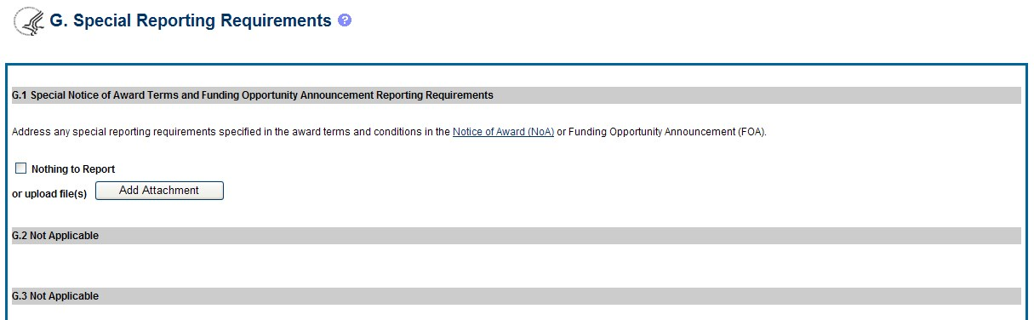

Figure 94: RPPR Section G. Special Reporting Requirements – Questions G1 through G3

G.4. Human Subjects
G.4.a Does the project involve human subjects?
If activities involving human subjects are planned at any time during the next budget period at the grantee organization or at any other project/performance site or collaborating institution, select Yes. Select Yes even if the project is exempt from the Regulations for the Protection of Human Subjects. Select No if activities involving human subjects are not planned at any time during the next budget period.
Policy on research involving human subjects, including definitions, can be found in the NIH Grants Policy Statement or in the competing application instructions.
Is the research exempt from federal regulations? Not applicable unless the answer to G.4.a. is Yes. If all of the proposed human subjects research meet the criteria for one or more of the exemptions from the requirements in the DHHS regulations (45 CFR 46.101(b)), Yes should be selected, and the appropriate exemption number(s) checked. The six categories of research exempt from the DHHS human subject regulations appear in Part III of the competing application instructions, under Definitions, Human Subjects.
If in doubt, consult with the Office for Human Research Protections (OHRP), Department of Health and Human Services, or the NIH Office of Extramural Research, Office of Extramural Programs at OEPMailbox@mail.nih.gov.
Note that if the proposed research involves only the use of human data or biological specimens, first determine whether the research involves human subjects. The exemptions do not apply if the research does not involve human subjects. For help determining whether research that involves the use of human data or biological specimens is human subjects research, refer to the NIH Research Involving Human Subjects website.
Does this project involve a clinical trial? Not applicable unless the answer to G.4.a. is Yes. The NIH defines a clinical trial as a prospective biomedical or behavioral research study of human subjects that is designed to answer specific questions about biomedical or behavioral interventions (drugs, treatments, devices, or new ways of using known drugs, treatments, or devices). Clinical trials are used to determine whether new biomedical or behavioral interventions are safe, efficacious, and effective. Behavioral human subjects research involving an intervention to modify behavior (diet, physical activity, cognitive therapy, etc.) fits this definition of a clinical trial.
Human subjects research to develop or evaluate clinical laboratory tests (e.g. imaging or molecular diagnostic tests) might be considered to be a clinical trial if the test will be used for medical decision making for the subject or the test itself imposes more than minimal risk for subjects.
Biomedical clinical trials of experimental drug, treatment, device or behavioral intervention may proceed through four phases:
Phase I clinical trials test a new biomedical intervention in a small group of people (e.g., 20-80) for the first time to evaluate safety (e.g., to determine a safe dosage range and to identify side effects).
Phase II clinical trials study the biomedical or behavioral intervention in a larger group of people (several hundred) to determine efficacy and to further evaluate its safety.
Phase III studies investigate the efficacy of the biomedical or behavioral intervention in large groups of human subjects (from several hundred to several thousand) by comparing the intervention to other standard or experimental interventions as well as to monitor adverse effects, and to collect information that will allow the intervention to be used safely.
Phase IV studies are conducted after the intervention has been marketed. These studies are designed to monitor effectiveness of the approved intervention in the general population and to collect information about any adverse effects associated with widespread use.
If yes, is this an NIH defined Phase III Clinical Trial?
An NIH-defined Phase III clinical trial is a broadly based prospective Phase III clinical investigation, usually involving several hundred or more human subjects, for the purpose of evaluating an experimental intervention in comparison with a standard or controlled intervention or comparing two or more existing treatments. Often the aim of such investigation is to provide evidence leading to a scientific basis for consideration of a change in health policy or standard of care. The definition includes pharmacologic, non-pharmacologic, and behavioral interventions given for disease prevention, prophylaxis, diagnosis, or therapy. Community trials and other population-based intervention trials are also included. G.4.b Human Subjects, Clinical Trials and Inclusion Enrollment.
Please review the box below to determine if this project meets the definition of clinical research and requires reporting of human subjects and/or clinical trials information, including cumulative enrollment of subjects and the distribution of sex/gender, ethnicity, and race.
Please click on the link below to view and update Human Subjects, Clinical Trials, and Inclusion data records associated with this award:
Human Subjects and Clinical Trials Information

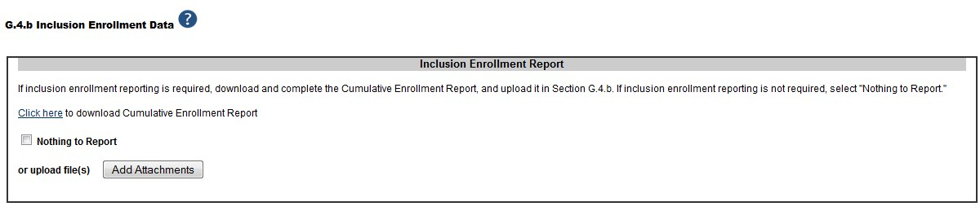

Figure
95
:
Question G.4.b for AHRQ Grantees Only

Guidance for Collecting and Reporting Inclusion Data: Below are instructions for how to collect and report data on the basis of sex/gender, race, and ethnicity with additional guidance for handling subpopulations, non-U.S. populations, changes to planned enrollment data, and NIHdefined Phase III clinical trials.
For questions about the NIH policies for inclusion, please refer to:
http://grants.nih.gov/grants/funding/women_min/women_min.htm or contact the program officer.
Standards for Collecting Data from Study Participants: The Office of Management and Budget (OMB) Directive No. 15 defines minimum standards for maintaining, collecting and presenting data on ethnicity and race for all Federal (including NIH) reporting purposes. The categories in this classification are social-political constructs and should not be interpreted as being anthropological in nature. The standards were revised in 1997 and now include two ethnic categories: Hispanic or Latino, and Not Hispanic or Latino. There are five racial categories: American Indian or Alaska Native, Asian, Black or African American, Native Hawaiian or Other Pacific Islander, and White. Reports of data on ethnicity and race should use these categories. The definitions below apply for the ethnic and racial categories.
Ethnic Categories:
Hispanic or Latino: A person of Cuban, Mexican, Puerto Rican, South or Central American, or other Spanish culture or origin, regardless of race. The term, “Spanish origin,” can be used in addition to “Hispanic or Latino”. Not Hispanic or Latino

Racial Categories:
American Indian or Alaska Native: A person having origins in any of the original peoples of North, Central, or South America and maintains tribal affiliation or community.
Asian: A person having origins in any if the original peoples of the Far East, Southeast Asia, or the Indian subcontinent including, for example, Cambodia, China, India, Japan, Korea, Malaysia, Pakistan, the Philippine Islands, Thailand, and Vietnam.
Black or African American: A person having origins in any of the black racial groups of Africa. Terms such as “Haitian” or “Negro” can be used in addition to “Black or African American.”
Native Hawaiian or Other Pacific Islander: A person having origins in any of the original peoples of Hawaii, Guam, Samoa, or other Pacific Islands.
White: A person having origins in any of the original peoples of Europe, North Africa, or the Middle East.
Reporting Data on Race and Ethnicity: NIH is required to use the above standards and definitions for race and ethnicity to allow comparisons to other federal databases, especially the census and national health databases. Federal agencies shall not present data on detailed categories if doing so would compromise data quality or confidentiality standards.
When collecting data on ethnicity and race, as well as sex/gender, use the categories listed to obtain the data from individuals on the basis of self-identification. Participants should be asked to identify their ethnicity and their race. The OMB recommends collecting this information using two separate questions, with ethnicity information collected first followed by race, with the option to select more than one racial designation
(http://www.whitehouse.gov/omb/fedreg_1997standards). The NIH inclusion enrollment format is not designed for use as a data collection instrument. Collect the data using instruments prepared for the study, and use that information to complete the NIH inclusion enrollment form(s). Study participants who self-identify with more than one of the racial categories should be reported in the aggregate in the "More Than One Race" category.
Collecting and Reporting Data on Subpopulations: Each ethnic/racial group contains subpopulations that are delimited by geographic origins, national origins, and/or cultural differences. It is recognized that there are different ways of defining and reporting racial and ethnic subpopulation data. The subpopulation to which an individual is assigned depends on selfreporting of specific origins and/or cultural heritage. Attention to subpopulations also applies to individuals who self-identify with more than one ethnicity or race. These ethnic/racial combinations may have biomedical, behavioral, and/or social-cultural implications related to the scientific question under study. The collection of greater detail is encouraged, e.g., on ethnic/racial subpopulations; however, any collection that uses more detail needs to be organized in such a way that the additional categories can be aggregated into the OMB categories for reporting data on ethnicity, race, and more than one race. Investigators who have data on subpopulations are encouraged to provide that information in the Comments field of the inclusion enrollment forms and/or in the text of their progress report.

Collecting and Reporting Data on Non-U.S. Populations: If conducting NIH-defined clinical research outside of the United States, design culturally appropriate data collection instruments that allow participants to self-identify their ethnic and/or racial affiliation in a way that is meaningful in the cultural and scientific contexts of the study. However, investigators will need to use the OMB-defined categories for reporting sex/gender, race and ethnicity to NIH (see definitions for each ethnic and racial category above), which will allow for completion of the inclusion enrollment form(s). Since OMB categories reference world-based geographic origin, this should facilitate completion of the form(s). Enrollment of participants at non-U.S. sites should be reported to NIH on a separate inclusion enrollment form from that for reporting participants at U.S. sites, even if they are part of the same study. For additional guidance and FAQs related to this topic, please refer to:
http://grants.nih.gov/grants/funding/women_min/women_min.htm or contact the program officer.
Changes to Planned Enrollment: If there are changes from the planned enrollment originally approved for funding, contact the program officer to discuss updating/revising the planned enrollment, address the change in Section F.3.a of the RPPR, and revise the existing Planned Enrollment for that study by clicking the Inclusion link to update the record in the Inclusion Management System.
Reporting Data on NIH-defined Phase III Clinical Trials: If conducting an NIH-defined Phase
III Clinical Trial, report on the cumulative enrollment (as described above) and indicate in Section F.3.a if any data analysis has begun for the trial. If analysis has begun or data have been published, report any progress made in evaluating potential differences on the basis on sex/gender, racial, and/or ethnicity. G.4.c ClinicalTrials.gov.
Does this project include one or more NIH-Funded clinical trials that must be registered in ClinicalTrials.gov, including any applicable clinical trials subject to FDAAA?
If yes, provide the ClinicalTrials.gov identifier, NCT number (e.g., NCT00654321) for those trials.
See NOT-OD-16-149 , and FAQ What clinical trials need to be registered in clinicaltrials.gov? The NIH Policy on the Dissemination of NIH-Funded Clinical Trial information applies to all clinical trials funded in whole or in part by the NIH. Certain applicable clinical trials are also subject to the Clinical Trial Registration and Results Information Submission regulation at 42 CFR Part 11.
If the grant number was entered into ClinicalTrials.gov, when registering, the ClinicalTrials.gov identifier (NCT number) may be readily identified by using the ClinicalTrials.gov Advanced Search and entering the grant number in the Study IDs field.
Select the Add/New button to add the data to the table.

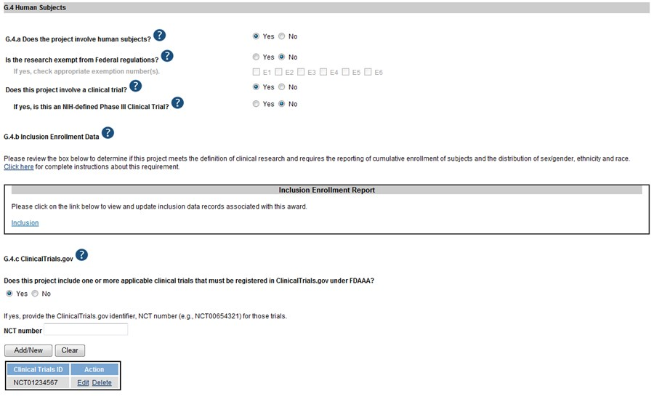

Figure 96: RPPR Section G. Special Reporting Requirements – Question G.4

G.5 Human Subjects Education Requirement.
Are there personnel on this project who are or will be newly involved in the design or conduct of human subjects research?
If yes, provide the following:
  - names of individuals,
  - title of the human subjects education program completed by each individual, and • a one-sentence description of the program. G.6 Human Embryonic Stem Cell(s).
Does this project involve human embryonic stem cells?
Only hESC lines listed as approved in the NIH Registry may be used in NIH funded research.
If yes, identify the hESC Registration number(s) from the NIH Registry.
Select the Add/New button to add the data to the table.
If there is a change in the use of hESCs provide an explanation.
G.7 Vertebrate Animals
Does this project involve vertebrate animals?

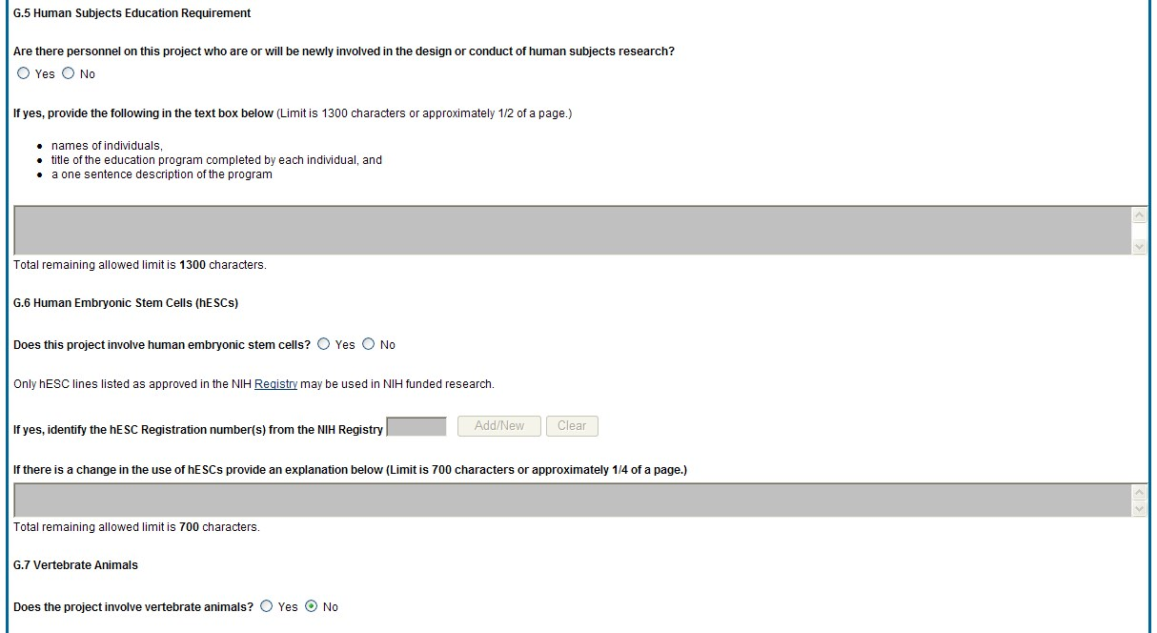

Figure 97: RPPR Section G. Special Reporting Requirements – Questions G5 through G7

G.8 Project/Performance Sites.
If there are changes to the project/performance site(s) displayed, edit as appropriate.
One of the sites indicated must be the identified as the Primary Performance Site. If including a new Project/Performance Site where either human subjects or vertebrate animals will be involved, address the change under F.3.a or F.3.b. If a Project/Performance Site is engaged in research involving human subjects, the grantee organization is responsible for ensuring that the Project/Performance Site operates under an appropriate Federal Wide Assurance for the protection of human subjects and complies with 45 CFR Part 46 and other NIH human subject related policies described in Part II of the competing application instructions and the NIH Grants Policy Statement.
For research involving live vertebrate animals, the grantee organization must ensure that all Project/Performance Sites hold OLAW-approved Assurances. If the grantee organization does not have an animal program or facilities and the animal work will be conducted at an institution with an Assurance, the grantee must obtain an Assurance from OLAW prior to the involvement of vertebrate animals.
Select the Add/New button to add the data to the table.

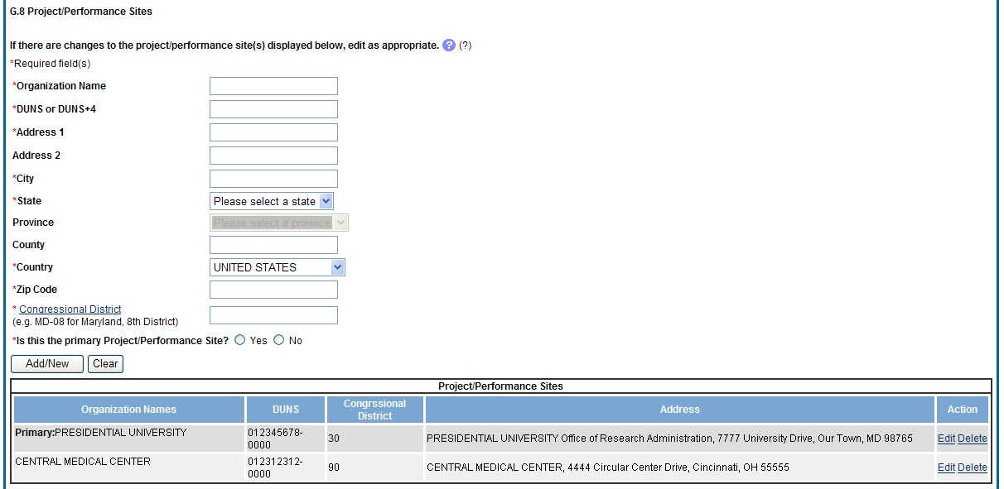

Figure 98: RPPR Section G. Special Reporting Requirements – Question G8

G.9 Foreign component.
Provide the organization name, country, and description of each foreign component.
Foreign component is defined as significant scientific activity that was performed outside of the United States, either by the grantee or by a researcher employed by a foreign organization, whether or not grant funds were expended. The following grant-related activities are significant and must be reported:
- involvement of human subjects or research with live vertebrate animals;
- extensive foreign travel by grantee project staff to collect data, or conduct surveys or sampling activities; or
- any grantee activity that may have an impact on U.S. foreign policy.
Examples of other grant-related activities that may be significant are:
- collaborations with investigators at a foreign site anticipated to result in co-authorship;
- use of facilities or instrumentation at a foreign site; or
- receipt of financial support or resources from a foreign entity.
Foreign travel for consultation does not meet the definition of foreign component.
Select the Add/New button to add the data to the table.

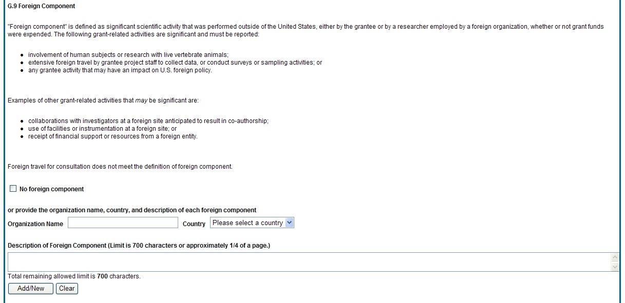

Figure 99: RPPR Section G. Special Reporting Requirements – Question G9

G.10 Estimated unobligated balance.
    - Is it anticipated that an estimated unobligated balance (including prior year carryover) will be greater than 25% of the current year’s total approved budget? If yes, provide the estimated unobligated balance.
The total approved budget equals the current fiscal year award authorization plus any approved carryover of funds from a prior year(s). The numerator equals the total amount available for carryover and the denominator equals the current year’s total approved budget.
AHRQ ONLY: The RPPR is automatically set to “yes” for an AHRQ award because AHRQ grantees must provide the estimated cumulative total cost dollar amount of any unobligated balance that is anticipated, regardless of whether the percentage of unobligated funds is over or under 25%. If the estimated cumulative total cost dollar amount of the unobligated balance is
$0, enter “0” in G.10.a.

    - Provide an explanation for unobligated balance.

AHRQ ONLY: If the estimated unobligated balance exceeds 25% of the current year’s total approved budget, provide an explanation of why this significant balance remains. If the estimated cumulative total cost dollar amount of the unobligated balance is less than 25%, enter
“N/A” in G.10.b.

    - If authorized to carryover the balance, provide a general description of how it is anticipated that the funds will be spent. To determine carryover authorization, see the Notice of Award.
Grantees not authorized to carryover unobligated balances automatically must submit a prior approval request to the awarding IC. See instructions in NIH Grants Policy Statement Section
8.1.2.4 Carryover of Unobligated Balances, or HHS GPS, Part II, Prior Approval Requirements, as applicable.
G.11 Program Income.
Is program income anticipated during the next budget period?
If yes, provide the amount and source(s).
Program Income is defined as gross income earned by the grantee organization, a consortium participant, or a contractor under the grant that is directly generated by the grant-supported project or activity or earned as a result of the award. Program income includes, but is not limited to, income from fees for services performed; charges for the use or rental of real property, equipment or supplies acquired under the grant; the sale of commodities or items fabricated under an award; charges for research resources; registration fees for grant-supported conferences, and license fees and royalties on patents and copyrights. Program income from license fees and royalties from copyrighted material, patents, and inventions is exempt from reporting requirements unless otherwise specified in the terms and conditions of award.
Select the Add/New button to add the data to the table.
G.12 F&A Costs [applicable to SNAP awards only]
Is there a change in performance sites that will affect F&A costs?
If yes, provide an explanation.

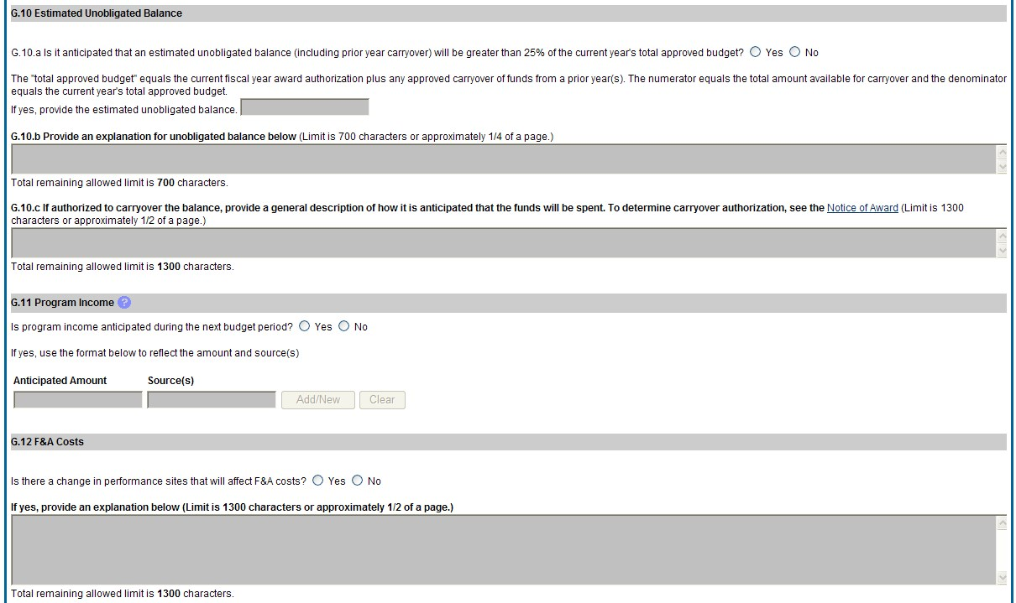

Figure 100: RPPR Section G. Special Reporting Requirements – Questions G10 through G12

Section H – Budget [Applicable to non-SNAP awards only]
H.1 Budget Form
Select the SF424 Research and Related Budget from the drop down menu and follow the instructions in the SF424 (R&R) Application Guide for NIH and Other PHS Agencies, Section I, 4.7 Budget Form, to complete the R&R budget, sections A-K, and the R&R Cumulative Budget, for the remainder of the project period. The budget justification should be uploaded as item K and must include detailed justification for those line items and amounts that represent a significant change from previously recommended levels (e.g., total rebudgeting greater than 25 percent of the total award amount for this budget period).
AHRQ Grantees only: Total costs (direct and indirect) should not exceed the committed level listed on the current NoA for the upcoming budget period. A detailed budget is required because AHRQ does not utilize the NIH SNAP process. If consortia are involved, include a detailed budget for each in H.2.

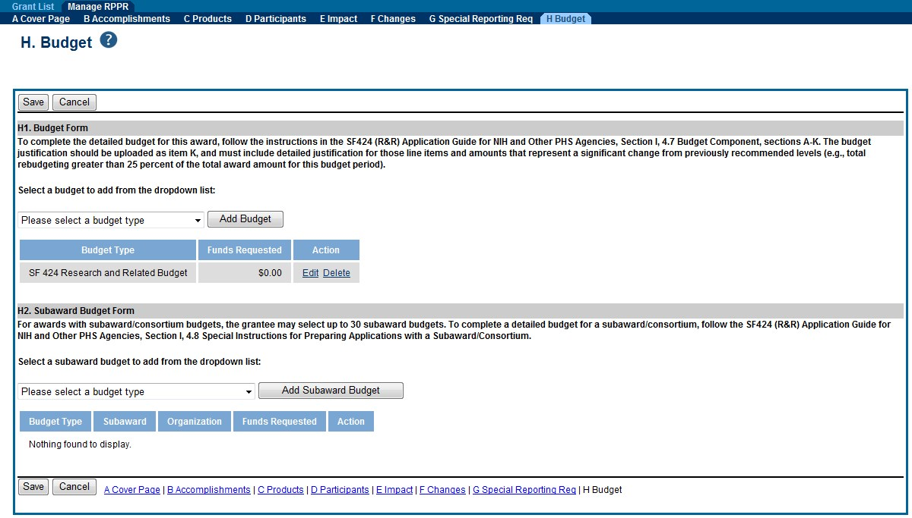

Figure 101: Section H.Budget of RPPR for a Non-SNAP Award

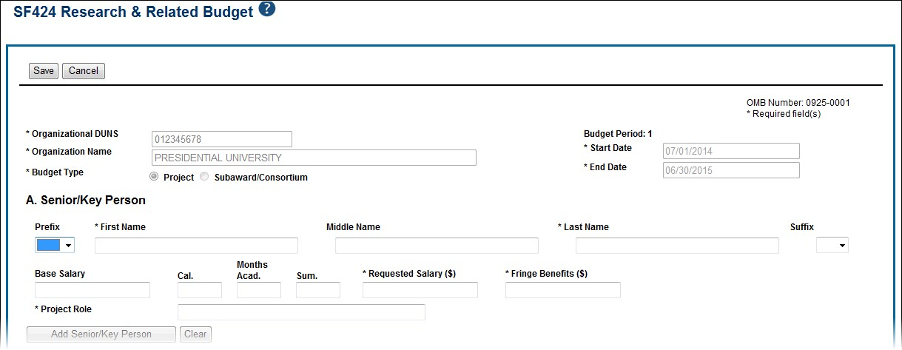

Figure 102: SF 424 Research & Related Budget Form Opened for Editing

NOTE: If subaward budgets are completed, the system will not calculate the budget line item F.5 for the main budget (see figure below). Total consortium costs for the main budget MUST be computed and entered manually into budget line item F.5.

Figure 103: SF 424 R&R Budget Form - Question F.5

H.2 Subaward Budget Form
For awards with subaward/consortium budgets, select the SF424 Research and Related Budget Subaward Budget from the drop down menu and follow the SF424 (R&R) Application Guide for NIH and Other PHS Agencies, Section I, 4.8 Special Instructions for Preparing Applications with a Subaward/Consortium.

Section I - Outcomes
I. Outcomes
I.1 What were the outcomes of the award?
(This section is only applicable to the Interim and Final RPPR. See NOT-OD-17-022 and NOT-OD-17-037).
This component is used to provide information regarding the cumulative outcomes or findings of the project. For the interim or final RPPR for the project, provide a concise summary of the outcomes or findings of the award (no more than 8,000 characters) that:
- Is written for the general public in clear, concise, and comprehensible language;
- Is suitable for dissemination to the general public, as the information may be available electronically;
- Does not include proprietary, confidential information or trade secrets; and includes up to six images (images are optional)

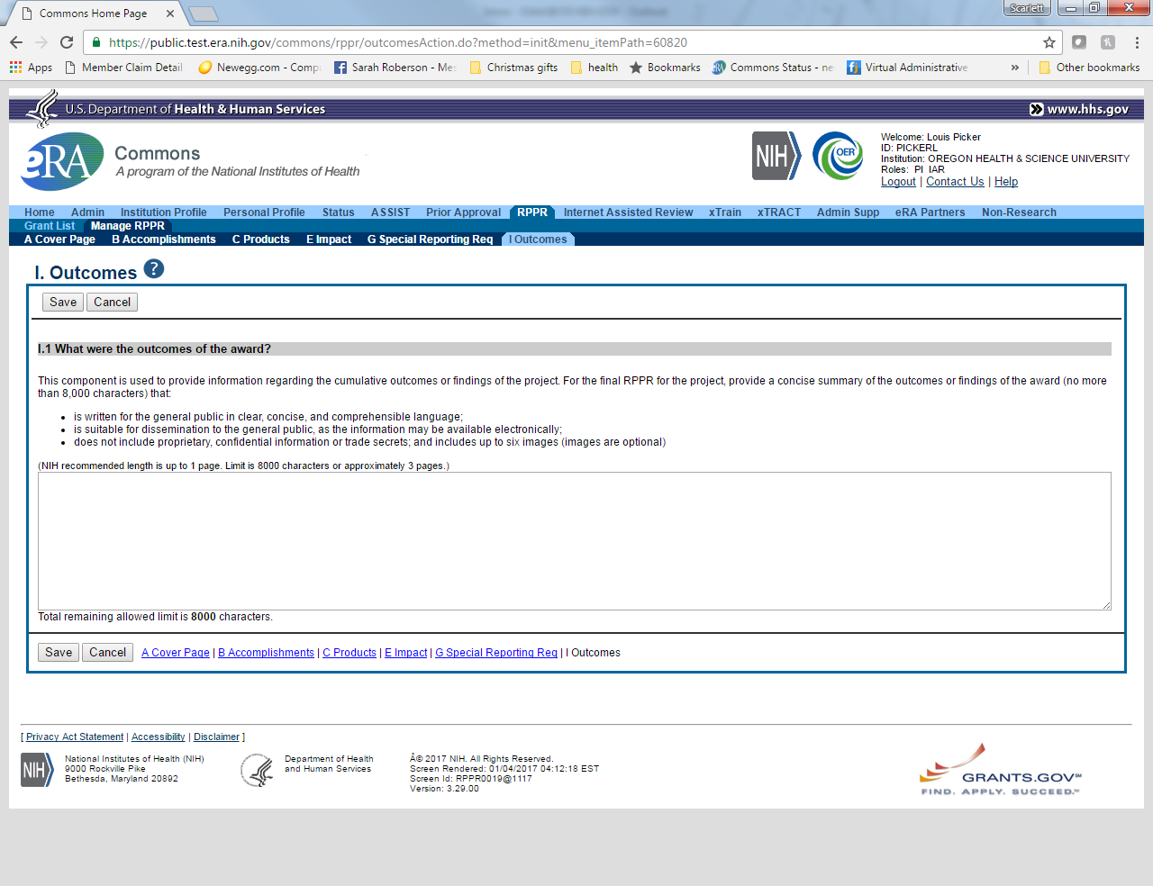

Supplemental Instructions for Specific Grant RPPR Types
The RPPR Instructions in chapter 6, Sections A–H, apply to the following awards: D71, DP1,
DP5, G08, G11, G13, P40, R00, R01, R03, R18, R21, R33, R34, R36, R37, R56, RC1, RC2, RL1, S21, S22, SC1, SC2, SC3, U1B, UC2, UH1, UH2, UH3, and awards listed in Section 7.6 if they issued under SNAP. For all other awards, see Table 1 below and applicable supplemental instructions for specific grant award types that either replace or are in addition to the Instructions for RPPR Sections A–H.

Table 1: Applicable Supplemental Instructions
Applicable Supplemental Instructions | Award Activity Codes
7.1 Individual Career Development (K)  Awards | K01, K02, K05, K06, K07, K08, K18, K22, K23, K24, K25, K26, K99, KL1
7.2 Fellowship Awards | F05, F30, F31, F32, F33
7.3 SBIR/STTR Awards | R41, R42, R43, R44, U43, U44, UT1, UT2
7.4 Training Awards | K12, KL2, R90, RL9, T15, T32, T34, T35, T37, T90, TL1
7.5 Educational Awards | D43, DP7, K30, R13, R25, RL5, T14, T36, U13, U2R
7.6 Multi-Project Awards and SingleProject Awards with Complicated Structure | G12, R34, M01, P01, P20, P2C, P30,  P41, P42, P50, P51, P60, PL1, PM1,  PN1, PN2, R24, R28, RM1, S06, S11,  U01, U10, U19, U24, U2C, U34, U41,  U42, U45, U54, U56, UC7, UL1, UM1,  UM2

Individual Career Development (K) RPPRs
For Career Development Awards (i.e., K01, K02, K05, K06, K07, K08, K18, K22, K23, K24, K25, K26, K99, and KL1) follow the Instructions for RPPR Sections A–H in chapter 6, with the exceptions noted below:
B.4 What opportunities for training and professional development has the project provided?
Describe activities such as teaching, clinical care, professional consultation, service on advisory groups, and administrative activities. Indicate percent of time spent in each of these activities and the relationship to the awardee's research career development.

For mentored career development awards to postdoctoral researchers (e.g., K01, K22, K99), indicate whether the institution uses Individual Development Plans (IDPs), and if so, describe how they were used in this reporting period to help manage the career development of the awardee (do not include the actual IDP). This information is not required for AHRQ grantees.
For awards that include a requirement to mentor others (e.g., K05 and K24), indicate the percent of time devoted to mentoring activities, individuals mentored during the reporting period, the frequency and kinds of mentoring, financial and other support provided to mentees, and the productivity of the mentoring relationship.
B. 6. What do you plan to do for the next reporting period to accomplish the goals?
Provide a timeline for the activities planned for the next year, including plans to apply for subsequent grant support. Recipients of transition awards (e.g., K22, K99) should report on progress in identifying an independent research position. Additionally, awardees charged with mentoring others (e.g., K05, K24) should provide information describing planned mentoring activities and proposed mentees (e.g., backgrounds, interests, professional levels, etc.) sufficient to evaluate the quality of the mentoring. C.2. Not Applicable.
C.3. Not Applicable.
D.2.e Not Applicable.
E.1 Not Applicable.
E.2 Not Applicable.
E.3 Not Applicable.
F.1 Not Applicable.
G.2 Responsible Conduct of Research
Describe the responsible conduct of research instruction received (or instruction given as a course director, discussion leader, etc., in the case of mid-career or senior career awardees) by formal and/or informal means, during this reporting period. If instruction or participation as a course director/discussion leader occurred in a prior budget period, note the dates of occurrence. Any activities undertaken to individualize instruction appropriate to career stage should be discussed. Address the five components: Format, Subject Matter, Faculty Participation, Duration, and Frequency. Additional detailed guidance on this requirement is found in the competing application instructions.
G.3 Mentor’s Report
For mentored K awards, provide a letter signed by the mentor, in PDF format, assessing the awardee's progress and performance during this reporting period, both in research and in terms of development into an independent investigator in the area of the award. Include information on the continued commitment of the required minimum professional effort by the awardee (for most mentored K awardees this will be 75% effort (9 calendar months)) to the career development award and the availability of support for the candidate’s research project during the next budget segment. For applicable career transition awards (e.g., K22, K99), the mentor should describe the awardee’s efforts to transition into a permanent research position and the mentor’s contributions to that process. If required to submit letters from more than one mentor, letters should be assembled in one PDF file. For non-mentored K awards, select “Not Applicable.” G.11 Not Applicable.
G.12 Not Applicable.
- Budget. [Applicable to non-SNAP awards only.]
  - Budget Form
Follow the instructions for SF 424 (R&R) for K awards in SF424 Part I, Section 7.4.6. Base the awardee's salary and fringe benefits request on a full-time, 12-month appointment following the guidelines in the appropriate career award instructions. Support for other personnel and amounts in other budget categories may be requested in accordance with applicable CDA guidelines.

NOTE: If subaward budgets are completed, the system will not calculate the budget line item F.5 for the main budget (see figure below). Total consortium costs for the main budget MUST be computed and entered manually into budget line item F.5.

Figure 104: SF 424 R&R Budget Form - Question F.5

  - Subaward Budget Form
For awards with subaward/consortium budgets, the grantee may select up to 30 subaward budgets. To complete a detailed budget for a subaward/consortium, follow the SF424 (R&R) Application Guide for NIH and Other PHS Agencies, Section I, 4.8 Special Instructions for Preparing Applications with a Subaward/Consortium.

Fellowship RPPRs
For Fellowship Awards (i.e., F05, F30, F31, F32, and F33), follow the Instructions for RPPR Sections A–H in chapter 6, with the exceptions noted below:
B.4 What opportunities for training and professional development has the project provided? Indicate whether the institution uses Individual Development Plans (IDPs), and if so, describe how they were used in this reporting period to help manage the fellow’s training (do not include the actual IDP). This information is not required for AHRQ recipients.
B.6 What do you plan to do during the next reporting period to accomplish the goals?
Include any course work and any important modifications to the original plans. Provide a scientific justification for any changes involving research with human subjects or vertebrate animals. A detailed description of such changes must be provided under Changes. C.2 Not Applicable.
C.3 Not Applicable.
C.4 Not Applicable.
D.1 Not Applicable.
D.2.a Not Applicable
D.2.b Not Applicable.
D.2.e Not Applicable.
E.1 Not Applicable.
E.2 Not Applicable.
E.3 Not Applicable.
F.1 Not Applicable.
G.2 Responsible Conduct of Research
Describe the responsible conduct of research instruction received (or instruction given as a course director, discussion leader, etc., in the case of senior fellows or senior career awardees) by formal and/or informal means, during this reporting period. If instruction or participation as a course director/discussion leader occurred in a prior budget period, note the dates of occurrence. Any activities undertaken to individualize instruction appropriate to career stage should be discussed. Address the five components: Format, Subject Matter, Faculty Participation, Duration, and Frequency. Additional detailed guidance on this requirement is found in the competing application instructions.
G.3 Sponsor Comments
Provide a letter signed by the sponsor, in PDF format, assessing the progress of the research training (including academic work) and the fellow’s accomplishments during this reporting period. For fellowships supporting dual-degree training (e.g. F30) the sponsor should report on the fellow’s progress with respect to the proposed dual-degree timeline and whether the fellow is expected to complete the requirements for the research doctoral degree in the upcoming budget period.
- 10 Not Applicable.
  - Not Applicable.
  - Not Applicable.
- Not Applicable.

SBIR/STTR RPPRs
For SBIR/STTR Awards (i.e., R41, R42, R43, R44, U43, U44, UT1, and UT2), follow the Instructions for RPPR Sections A–H in chapter 6, with the exceptions noted below: B.2 What was accomplished under these goals?
Goals is equivalent to specific aims and/or milestones.
B.3 Competitive Revisions/Administrative Supplements
For this reporting period, is there one or more Revision/Supplement associated with this award for which reporting is required?
If yes, identify the Revision(s) by grant number (e.g., 3R01CA098765-01S1) or title and describe the specific aims and/or milestones for each Revision. Include any supplements to promote or enhance diversity and re-entry, or other similar supplements to support addition of an individual or a discrete project.
B.6 What do you plan to do during the next reporting period to accomplish the goals?
For FastTrack and Phase II progress reports include a one-page abstract describing the research plan for Phase II and, as necessary, an updated commercialization plan.
C.5.a Other products
For SBIR/STTR awards commercial technologies will be addressed under Impact. E.1 Not Applicable.
E.3 What is the impact on technology transfer?
Describe ways in which the project made an impact, or is likely to make an impact, on commercial technology or public use, including:
- transfer of results to entities in government or industry;
- instances where the research has led to the initiation of a start-up company; or • adoption of new practices.
E.3.a Commercialization Activities.
Report on the status of commercialization activities resulting from the award:
⇨ Nothing to report or select one or more of the following:
⇨ Sales = $_______
⇨ Licensing revenue = $_______
⇨ 3rd Party investment since award start (Non-federal) = $_______
⇨ Sale of company
⇨ Sale of technology rights
⇨ Company merger related to product
⇨ Joint venture agreement
⇨ Marketing/Distribution agreement(s)
⇨ Manufacturing agreement(s)
⇨ R&D agreements
⇨ Customer alliance(s)
⇨ Other ________________________ [60 character limit] E.3.b FDA Interactions.
Report on interactions with the Food and Drug Administration during the reporting period related to the technology that is the subject of the award:
⇨ Not applicable to this technology or select one or more of the following:
⇨ Discussion with FDA not initiated
⇨ Discussion with the FDA initiated o Approval in Progress
- Applied for approval
- Review ongoing
- In human clinical trials
- Other________________________ o Approval Granted: Type ________________________ o Not approved F.1 Not Applicable.
  - Not Applicable.
  - Not Applicable.
G.12 F & A Costs. [Applicable to SNAP awards only.]

- Budget [Applicable to non-SNAP awards only.]
  - Budget Form
To complete the detailed budget for this award, follow the instructions in the SF424 (R&R)
SBIR/STTR Application Guide for NIH and Other PHS Agencies, Section I, 4.6 Budget Component, sections A-K. The budget justification should be uploaded as item K, and must include detailed justification for those line items and amounts that represent a significant change from previously recommended levels (e.g., total rebudgeting greater than 25 percent of the total award amount for this budget period).

NOTE: If subaward budgets are completed, the system will not calculate the budget line item F.5 for the main budget (see figure below). Total consortium costs for the main budget MUST be computed and entered manually into budget line item F.5.

Figure 105: SF 424 R&R Budget Form - Question F.5
  - Subaward Budget Form
For awards with subaward/consortium budgets, the grantee may select up to 30 subaward budgets. To complete a detailed budget for a subaward/consortium, follow the SF424 (R&R) SBIR/STTR Application Guide for NIH and Other PHS Agencies, Section I, 4.7 Budget Component.

Training RPPRs
For Training Awards (i.e., K12, KL2, R90, RL9, T15, T32, T34, T35, T37, T90, and TL1) and multi-year funded training awards (i.e., KM1) follow the Instructions for RPPR Sections A–H in chapter 6, with the exceptions noted below.
AHRQ Grantees only: T32 grantees should consult their AHRQ Program Official for additional requirements.
B.1. What are the major goals of the project?
Provide a description of the training objectives and goals. List the major goals of the project as stated in the approved application or as approved by the agency. If the application lists milestones/target dates for important activities or phases of the project, identify these dates and show actual completion dates or the percentage of completion. B.2 What was accomplished under these goals?
Since the last report or application, describe implementation of training and other specific programmatic objectives, and the recruitment and retention of trainees, including those from diverse groups.
B.4 What opportunities for training and professional development has the project provided?
For all awards, provide a PDF that includes the following items: (1) a completed Trainee
Diversity Report, covering the individuals supported by the award during the reporting period (generally not applicable for FIC awards); and (2) a paragraph for each trainee/scholar supported by the award describing activities and progress during the reporting period. Include the following information for each trainee/scholar, as applicable:
- Degrees working toward or held
- Mentor(s)
- Description of the trainee/scholar’s research project and progress
- Coursework
- Conference presentations
- A description of the trainee/scholar’s role in any planned or published papers resulting from research conducted while supported by this award (e.g., designed or conducted experiment, analyzed data, drafted paper)
Note that full citations of all publications arising from work conducted while the trainee/scholar was supported by the award should not be reported here, as they will be collected in Section C.1.
- Fellowships or other support
- Workshops attended
- Career development activities
This description should be sufficient to allow evaluation of the appointees’ progress towards the goals of the training grant.
Indicate whether the institution uses Individual Development Plans (IDPs), and if so, describe how they were used in this reporting period to help manage the training and career development of the trainees/scholars (do not include actual IDPs). This information is not required for AHRQ grantees.
For T awards, for RPPRs submitted on December 1, 2015 or later, provide updated information in Table 8A, 8B and/or 8C, reflecting new appointments and other changes over the reporting period. For RPPRs submitted prior to December 1, 2015 use Table 12 and/or 12 B.
For D43, TU2, T15, T32, T37, T90, U2R, U90, and TL1 awards, include program statistics for doctoral training in Table 8A.
The Trainee Diversity Report format page is available at:
http://grants.nih.gov/grants/funding/2590/2590.htm
B.6 What do you plan to do during the next reporting period to accomplish the goals?
Include plans for any modification based on the findings of your internal evaluations.
C.1 Publications
Recipients must report trainee publications in section C.1 of the RPPR if: (1) the publication was accepted for publication or published during the reporting period; and (2) the publication resulted from work conducted while a trainee was supported by the award (i.e., receiving a stipend or salary from the award). Publications resulting from work the trainee conducted while not actively supported by the training grant should not be reported in section C.1.
Publications must be entered into My Bibliography or its related collection, Other Citations, to display in section C.1 of the RPPR electronic interface. PIs may find it easier to track papers that they do not author in Other Citations. See Section 6.3 and the NIH Public Access Policy for additional guidance. C.2 Not Applicable.
C.3 Not Applicable.
C.4 Not Applicable.
C.5.b Not Applicable.
D.1 What individuals have worked on the project?
Provide or update the following information only for K12 and KL2 progress reports: (1) program director(s)/principal investigators(s) (PDs/PIs); and (2) each person who has worked at least one person month per year on the project during the reporting period, regardless of the source of compensation (a person month equals approximately 160 hours or 8.3% of annualized effort). Do not report personnel for whom a PHS 2271 Appointment form has been submitted through xTRAIN. If not reporting on a K12 or KL2 award, disregard this section. D.2.b New senior/key personnel.
Are there new training faculty?
If yes, provide biosketches and other support for all new training faculty. E.1 Not Applicable.
E.2 Not Applicable.
E.3 Not Applicable.
- 1 Changes in approach and reasons for change
Describe changes in the program for the next budget period, including changes in training faculty. Include, as appropriate, the role of external advisory committees, significant new training content, procedures or experiences, and indicate how these aid in strengthening and realizing the objectives and goals of the program. F.2 Not Applicable.
F.3 Significant changes to Human Subjects, Vertebrate Animals, Biohazards, and/or Select Agents
Complete this section only if the use or care of human subjects, vertebrate animals, biohazards and/or select agents is not reported under another NIH award.
  - Responsible Conduct of Research
Describe the nature of the responsible conduct of research instruction and the extent of trainee (or scholar, in the case of the Institutional Career Development Programs) and faculty participation. Include a description of any enhancements and/or modifications to the five instructional components (Format, Subject Matter, Faculty Participation, Duration, and Frequency) from the plan described in the competing application. Faculty members who were contributors to formal instruction in responsible conduct of research during the last budget period must be named. Additional detailed guidance on this requirement is found in the competing application instructions.
  - Not Applicable
G.6 Human Embryonic Stem Cells (hESCs)
Complete this section only if the use of hESCs is not reported under another NIH award. G.11 Not Applicable.
G.12 Not Applicable.
- Budget
For training awards, grantees should select the applicable RPPR budget type (e.g., SF424 (R&R) or PHS 398 Training Budget) from the drop down menu. For a small number of NIH training programs the grantee is required to submit both the SF424 (R&R) and PHS 398 Training Budget; the RPPR will accommodate this.
H.1 Budget Form
If completing the SF424 (R&R), follow the instructions in the SF424 (R&R) Application Guide for NIH and Other PHS Agencies, Section I, 4.7 R&R Budget Component, sections A-K. The budget justification should be uploaded as item K, and must include detailed justification for those line items and amounts that represent a significant change from previously recommended levels (e.g., total rebudgeting greater than 25 percent of the total award amount for this budget period).
If completing the PHS 398 Training Budget, follow the instructions in the SF424 (R&R)
Application Guide for NIH and Other PHS Agencies, Section I, 8.5 PHS 398 Training Budget Component, items A-F. The budget justification should be uploaded as item F, and must include detailed justification for those line items and amounts that represent a significant change from previously recommended levels (e.g., total rebudgeting greater than 25 percent of the total award amount for this budget period).

NOTE: If subaward budgets are completed, the system will not calculate the budget line item F.5 for the main budget (see figure below). Total consortium costs for the main budget MUST be computed and entered manually into budget line item F.5.

Figure 106: SF 424 R&R Budget Form - Question F.5
H.2 Subaward Budget Form
For awards with subaward/consortium budgets, the grantee may select up to 30 subaward budgets. To complete a detailed budget for a subaward/consortium, follow the SF424 (R&R) Application Guide for NIH and Other PHS Agencies, Section I, 4.8 Special Instructions for Preparing Applications with a Subaward/Consortium or 8.6 PHS 398 Training Subaward Budget Attachment(s) Form.

Education RPPRs
For Education Awards (i.e., D43, DP7, K30, R13, R25, RL5, T14, T36, U13, and U2R), follow the Instructions for RPPR Sections A–H in chapter 6, with the exceptions noted below:
B.4 What opportunities for training and professional development has the project provided?
Describe opportunities for training and professional development provided to anyone who worked on the project or anyone who was involved in the activities supported by the project. Training activities are those in which individuals with advanced professional skills and experience assist others in attaining greater proficiency. Training activities may include, for example, courses or one-on-one work with a mentor. Professional development activities result in increased knowledge or skill in one’s area of expertise and may include workshops, conferences, seminars, study groups, and individual study. Include participation in conferences, workshops, and seminars not listed under major activities
Programs that involve participants should also provide the following information, as applicable:
- A completed Training Diversity Report covering the individuals supported by the award during the reporting period (generally not applicable for FIC awards).
- If relevant to the goals of the program, indicate whether the institution uses Individual Development Plans (IDPs) for graduate students and postdoctoral researchers, and if so, describe how they were used in this reporting period to help manage the training and career development of participants (do not include actual IDPs). This information is not required for AHRQ grantees.
- Grantees with NIH grant awards with the following activity codes are required to provide program statistics for doctoral training in Table 8A: D43 and U2R for RPPRs submitted on or after December 1, 2015. For reports submitted prior to December 1, 2015 use table 12A. C.3. Not Applicable.
C.4 Not Applicable.
C.5.b Not Applicable.
E.1 What is the impact on the development of human resources?
Describe how the project made an impact or is likely to make an impact on human resource development in science, engineering, and technology. For example, how has the project: 1) provided opportunities for research and teaching in the relevant fields; 2) improved the performance, skills, or attitudes of members of underrepresented groups that will improve their access to or retention in research, teaching, or other related professions; 3) developed and disseminated new educational materials or provided scholarships; or 4) provided exposure to science and technology for practitioners, teachers, young people, or other members of the public? E.2 Not Applicable.
E.3 Not Applicable
F.1 Changes in approach and reasons for change
Describe changes for the next budget period. Include, as appropriate, the role of external advisory committees, significant new content, procedures or experiences, and indicate how these aid in strengthening and realizing the objectives and goals of the award.

G.2 Responsible Conduct of Research
If required in the FOA for this award, describe the nature of the responsible conduct of research instruction and the extent of participant and faculty involvement. Include a description of any enhancements and/or modifications to the five instructional components (Format, Subject Matter, Faculty Participation, Duration, and Frequency) from the plan described in the competing application. Faculty members who were contributors to formal instruction in responsible conduct of research during the last budget period must be named. Additional detailed guidance on this requirement is found in the competing application instructions. G.3 Not Applicable.
G.12 F&A Costs [Applicable to SNAP awards only.]

Multi-Project RPPRs and Single-Project RPPRs with Complicated Structure
For the purposes of the RPPR, the following activity codes are always categorized as multiproject awards or single-project awards with complicated structures: G12, M01, P01, P20, P2C. P30, P41, P42, P50, P51, P60, PL1, PM1, PN1, PN2, R24, R28, RM1, S06, S11, U01, U10, U19, U24, U2C, U34, U41, U42, U45, U54, U56, UC7, UL1, UM1, and UM2. These activity codes awards may or may not include multiple components (projects, cores), but they all could potentially include multiple components. For multi-project awards, the grantee will follow the instructions for the overall portion of the RPPR below and for each component of the RPPR the grantee will follow the instructions under component instructions in section 7.6.2.
The Instructions for RPPR Sections A–H in chapter 6, are applicable to these activity codes (even if the award does not include multiple components) with the following exceptions.

Overall
B.1 What are the major goals of the project?
Emphasize the synergy, collaboration and integration of major activities of the project. Report the major goals specific to an individual component under that component. B.2 What was accomplished under these goals?
For this reporting period describe for the overall award: 1) major activities; 2) significant results, including major findings, developments, or conclusions (both positive and negative), and 3) key outcomes or other achievements. Include a discussion of stated goals not met. Report the accomplishments of individual projects and cores under that component.
B.3 Is there one or more Revision associated with this award or a project under this award for which reporting is required?
If the Revision is associated with a specific project or core, identify the component. B.5 How have the results been disseminated to communities of interest?
If there are individual projects/cores designed to disseminate information or conduct outreach activities, report those activities under that component.
B.6 What do you plan to do during the next reporting period to accomplish the goals?
Report goals and objectives of individual projects or cores under that component.
C.5 a Other products
Identify any other significant products that were developed under the overall project. Report other products and resources resulting from an individual project or core under that component.
C.5.b Resource sharing
Report resource sharing for an individual project or core under that component.
D.1 Participants
In addition to the instructions in Section 6.4, specify the component(s) on which the individual worked in the appropriate text box. This personnel information is for the entire project. Use the Ctrl key to select multiple components.

NOTE: If an individual is associated with multiple components, some components may be hidden to reduce the size table. Where applicable, use the show more link to display all of an individual’s components in the row. Use the show less link to collapse the information.

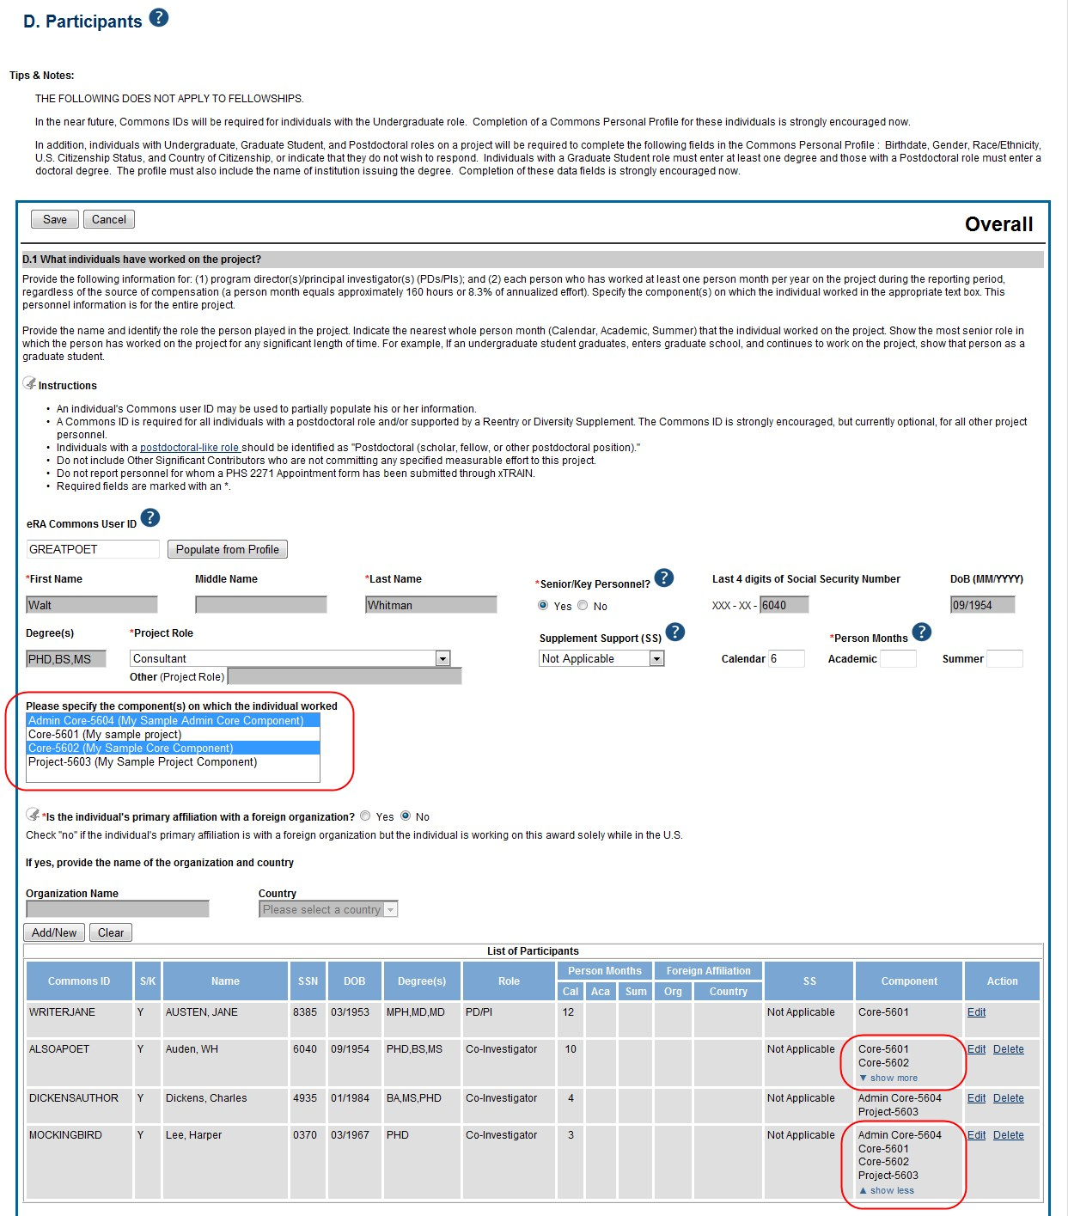

Figure 107: D.1 Specifying the Components for an Added Individual

D.2 Personnel Updates
Personnel questions (D.2.a.-e.) are applicable to entire project. For D.2.b, new senior/key personnel, identify the component(s) on which the individuals worked or will work. For D.2.e, new other significant contributors, identify the component(s) on which the individual worked or will work.
E.1 Not Applicable.
E.3 Not Applicable.
F.1 Not Applicable.
F.3 Significant changes to Human Subjects, Vertebrate Animals, Biohazards, and/or Select Agents.
If there are changes in any of the following areas check the appropriate box and provide a description of the changes. If applicable, report the change under the relevant component. G.2 Not Applicable.
G.3 Not Applicable.
G.4.c ClinicalTrials.gov
Associate the number with the relevant project or core, if applicable, and select the Add/New button. Use the Ctrl key to select multiple components at one time.

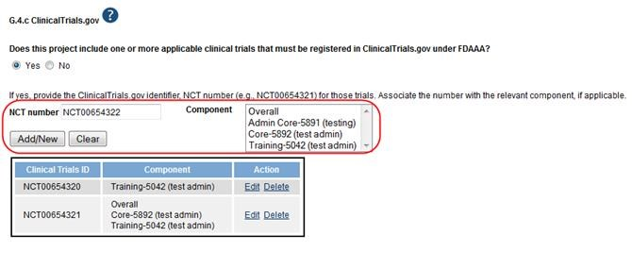

Figure 108: Associating a Component with the NCT Number
G.12 F&A Costs [Applicable to SNAP awards only.]
- Budget
For multi-project RPPRs complete the budget for each component and for each subaward; see Section 7.6.1. A summary budget will be system-generated based on the budgets completed for the components and will be included in the final .pdf submitted to the Agency. The composite budget summaries will reflect the direct costs for the grantee. Although the direct and indirect costs for subawards are direct costs to the grantee institutions, these costs will be listed as a separate line item, called “consortium” and will include all consortium costs. The total consortium costs for the summary budget are automatically calculated by the system and reflect the sum of the consortium costs (budget line item F.5 of the project budget) for the project budgets with the grantee institution DUNS and the total direct and indirect costs (budget line item I.) for project budgets with a DUNS different from that of the grantee institution.
  - Budget Form [Single-Project RPPRs with Complicated Structure only]
For Single-Project RPPRs with Complicated Structure , follow the instructions in the SF424 (R&R) Application Guide for NIH and Other PHS Agencies, Section I, 4.7 Budget Component, sections A-K. The budget justification should be uploaded as item K, and must include detailed justification for those line items and amounts that represent a significant change from previously recommended levels (e.g., total rebudgeting greater than 25 percent of the total award amount for this budget period).

NOTE: If subaward budgets are completed, the system will not calculate the budget line item F.5 for the main budget (see figure below). Total consortium costs for the main budget MUST be computed and entered manually into budget line item F.5.

Figure 109: SF 424 R&R Budget Form - Question F.5

  - Subaward Budget Form[Single-Project RPPRs with Complicated Structure only]
For awards with subaward/consortium budgets, the grantee may select up to 30 subaward budgets. To complete a detailed budget for a subaward/consortium, follow the SF424 (R&R) Application Guide for NIH and Other PHS Agencies, Section I, 4.8 Special Instructions for Preparing Applications with a Subaward/Consortium.

Component Instructions
For each component, click the Add Component button, and complete the instructions. The Instructions for RPPR Sections A–H in chapter 6 are applicable to each individual component with the following exceptions:
- Provide the title or identifying number of the component.
A.1 Provide the name, email, phone number and address of the PI of the component.

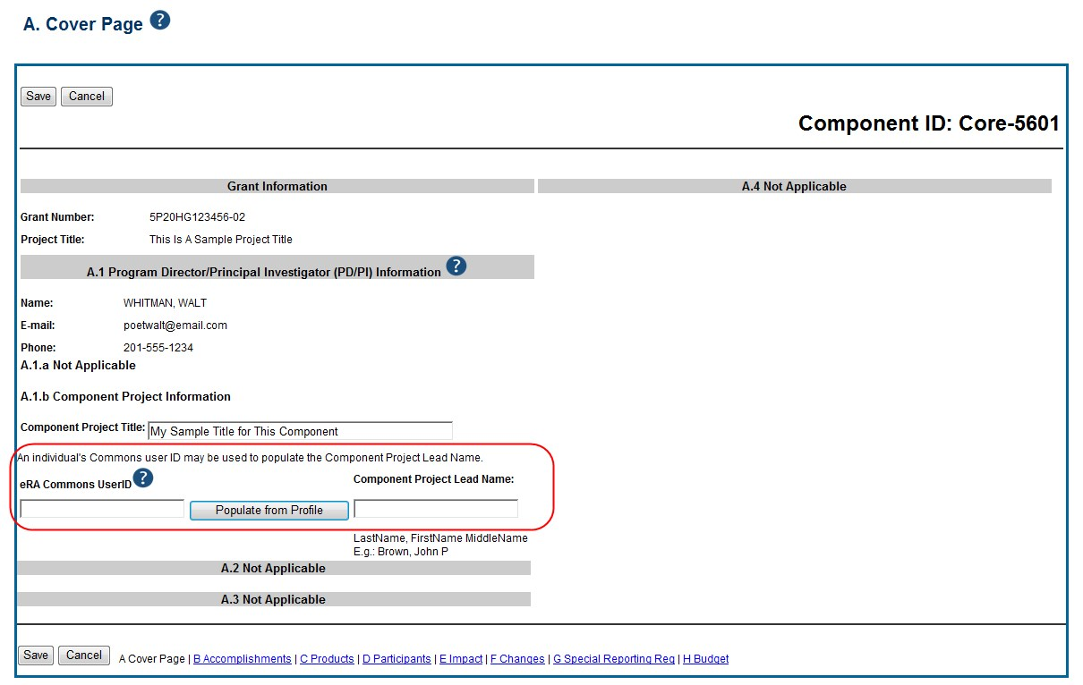

Figure 110: Sample of Section A. Cover Page for a Component B. 3 Not Applicable.
B.5 How have the results been disseminated to communities of interest?
Reporting the routine dissemination of information (e.g., websites, press releases) is not required. If the Component is not designed to disseminate information to the public or conduct similar outreach activities, select Nothing to Report. If the Component is designed to disseminate information or conduct outreach activities, report those activities here. Note that scientific publications and the sharing of research resources will be reported under Products. C.1 Not Applicable.
C.2 Not Applicable.
C.4 Not Applicable.
D. Not Applicable.
E.1 Not Applicable.
E.2 Not Applicable.
E.3 What is the impact on technology transfer?
Describe ways in which the component made an impact, or is likely to make an impact, on commercial technology or public use, including:
    - transfer of results to entities in government or industry;
    - instances where the research has led to the initiation of a start-up company; or • adoption of new practices. E.4 Not Applicable.
F.1 Not Applicable.
G.1 Not Applicable.
G.2 Not Applicable.
G.3 Not Applicable.
G.4.c Not Applicable.
G.5 Not Applicable.
G.7 Not Applicable.
G.8 Not Applicable.
G.9 Not Applicable.
G.10 Not Applicable.
G.11 Not Applicable.
G.12 Not Applicable.
- Budget
H.1 Budget Form [Multi-Project RPPRs only]
When a grantee institution is the lead on the Component, follow the instructions in the SF424 (R&R) Application Guide for NIH and Other PHS Agencies, Section I, 4.7 Budget Component, sections A-K. The budget justification should be uploaded as item K, and must include detailed justification for those line items and amounts that represent a significant change from previously recommended levels (e.g., total rebudgeting greater than 25 percent of the total award amount for this budget period).
When a collaborating institution is the lead on the Component, the information from the collaborating institution should be used to complete the project budget, following the instructions in the SF424 (R&R) Application Guide for NIH and Other PHS Agencies, Section I, 4.7 Budget Component, sections A-K.
For multi-projects RPPRs the grantee must complete the DUNS and Organization Name fields, as the DUNS number will not automatically populate to the DUNS number.

NOTE: If subaward budgets are completed, the system will not calculate the budget line item F.5 for the main budget (see figure below). Total consortium costs for the main budget MUST be computed and entered manually into budget line item F.5.

Figure 111: SF 424 R&R Budget Form - Question F.5
H.2 Subaward Budget Form [Multi-Project RPPRs only]
If the component has subaward/consortium budgets, follow the SF424 (R&R) Application Guide for NIH and Other PHS Agencies, Section I, 4.8 Special Instructions for Preparing Applications with a Subaward/Consortium.

Assurances/Certifications

The list of Assurances, and Certifications, and other Policies that apply to progress reports submitted to NIH and other PHS agencies are explained in Part III: Policies, Assurances, Definitions, and Other Information. Applicants and grantees must comply with a number of additional public policy requirements. Refer to the NIH Grants Policy Statement (http://grants.nih.gov/grants/policy/policy.htm), or the HHS Grants Policy Statement
(http://www.hhs.gov/asfr/ogapa/grantinformation/hhsgps107.pdf), as applicable, for additional information.
The policies, assurances and certifications listed in Part III may or may not be applicable to the project, program, or type of applicant organization. If unable to certify compliance, provide an
explanation and upload it in G.1 Special Notice of Award and Funding Opportunity Announcement Reporting Requirements.
Submission of the RPPR to the agency includes the following certification:
In submitting this RPPR, the SO (or PD/PI with delegated authority), certifies that the grantee organization is in compliance with the terms and conditions specified in the Notice of Award and Grants Policy Statement, and verifies the accuracy and validity of all administrative, fiscal, and scientific information in the progress report. The SO (or PD/PI with delegated authority) further certifies that the grantee organization will be accountable for the appropriate use of any funds awarded and for the performance of the grant-supported project or activities resulting from the progress report. Deliberate withholding, falsification, or misrepresentation of information could result in administrative actions such as withdrawal of a progress report, suspension and/or termination of an award, debarment of individuals, as well as possible criminal penalties. The grantee institution may be liable for the reimbursement of funds associated with any inappropriate or fraudulent conduct of the project activity.

Assurances/Certifications

Government Use of Information Under the Privacy Act

Privacy Act Statement. The NIH maintains application and grant records as part of a system of records as defined by the Privacy Act: NIH 09-25-0036, Extramural Awards and Chartered Advisory Committees (IMPAC 2), Contract Information (DCIS), and Cooperative Agreement Information, HHS/NIH: http://oma.od.nih.gov/ms/privacy/pa-files/0036.htm.

Gov’t Use of Info Under the Privacy Act

