Attachment E – Directions to Econometrica Facility

**Directions to the Econometrica, Inc., Facility**

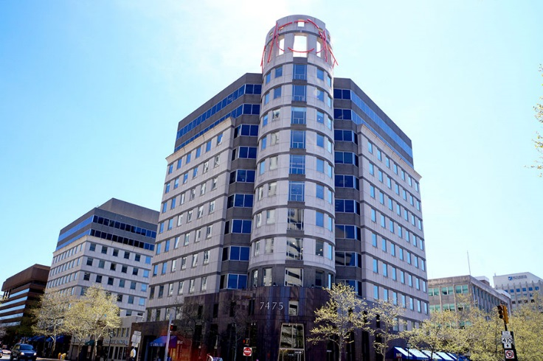**Econometrica’s Location:**

7475 Wisconsin Avenue

Suite 1000

Bethesda, MD 20814

**Phone Number**: (301) 657-9883

**By Metro**

Econometrica is located on the Red Line directly above the **Bethesda Metro Station.** After you exit the farecard turnstiles, take the long escalator to the first below-ground level. At the top of the escalator, you will see a pedestrian tunnel on your right. Walk through the tunnel (to the east, under Wisconsin Avenue) and through the glass doors into the basement level of our building. Take the escalator to the ground floor and proceed through the glass doors on your right to the security desk. You will be greeted by an Econometrica Team member at the security desk to get signed in and escorted to the focus group.

**By Car**

Our office is located on the corner of Wisconsin Avenue and East West Highway in Bethesda. Visitor parking is available in the Bethesda Crescent Parking Garage (underground garage beneath our building) or the Waverly Parking Garage (next door). Both garages are located off Montgomery Avenue. Please see the map below for the access points for each garage.

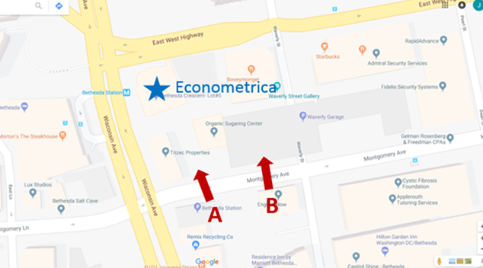

**A.** Bethesda Crescent Parking Garage

**B.** Waverly Parking Garage