# Health Insurance Marketplace Perceptions and Intent Focus Group Guide

Items listed in this section would be used during qualitative data collection, during focus groups. These data collection efforts may take place in person, via the telephone, or on the internet.

## Health Insurance Status and Situation (Uninsured Only)

1. What is the main reason you don’t have health insurance? *[ING4]*
2. How do you feel about being uninsured? *[ISG1]*
3. How likely are you to get health insurance within the next few months? *[BG8]*
4. How important is having health insurance to you personally? *[PE8]*
5. When you think about finding and choosing a health insurance plan, what are the most important things you would look for? *[ISG4]*
6. What have you heard about the penalty for being uninsured? *[AWG2]*

## Awareness and Impact of Current Events

1. How many of you have heard about health care issues in the news? *[AWG1]*
   1. Can you briefly tell me what news you’ve seen, read, or heard? *[AWG2A]*
   2. How would you describe what you saw, read, or heard? Was it positive, negative, or neutral? *[AWG4]*
2. How many of you have heard about the health insurance marketplace or Healthcare.gov, specifically, in the news? *[AWG1]*
   1. Can you briefly tell me what news you’ve seen, read, or heard? *[AWG2A]*
   2. How would you describe what you saw, read, or heard? Was it positive, negative, or neutral? *[AWG4]*
3. How would you describe the future of health care in this country? *[ATG5]*
   1. Do you think things are becoming more positive, negative, or do you think things will stay about the same? *[ATG5]*
4. How does what you have seen or heard in the news impact your likelihood to get health insurance? *[ATG5]*

## Marketplace Advertisements and Information

1. How many of you have recently seen any advertisements for Healthcare.gov? *[AWG2]*
   1. Tell me about the ads you’ve seen. *[AWG2A]*
2. What have you recently heard about the Health Insurance Marketplace or the Healthcare Law? *[AWG2]*
3. How does what you have seen or heard impact your likelihood to get health insurance? *[ATG5]*
4. What is your impression of the Health Insurance Marketplace? *[PE2]*

## General Understanding of Healthcare.gov

1. What, if anything, have you recently heard about Healthcare.gov? *[AW1]*
2. How many of you have visited Healthcare.gov? *[BG1]*
3. What was your experience like on the site? *[PE2]*
4. What are some positive things you’ve heard or seen for yourself about Healthcare.gov? *[PE2]*
   * 1. What makes you feel that way about it? *[PE2A]*
5. What are some negative things you’ve heard or seen for yourself about Healthcare.gov? *[PE2]*
   * 1. What makes you feel that way about it? *[PE2A]*
6. Was there any information you remember wanting to find that you were not able to find? *[PE7]*
7. For those who have heard of the site, but have not visited, why didn’t you go there? *[B2]*
8. What do you expect to find on the website? *[SOI5]*
9. What would get you to go visit the website? *[PE6B]*

## Expectations of a Health Care Plan’s Quality

1. When you think about “quality” as it relates to health care plans, what are the first things that come to mind? *[K2]*
2. In your own words, please describe “quality” as it relates to health care plans. *[K1]*
3. Please describe how you typically assess the quality of a health care plan? *[B1]*
4. Have you ever looked for information about the quality of a health care plan? *[SOI1]*
5. How have you gone about trying to get information about the quality of a health care plan? *[SOI1A]*
6. Where have you found the most useful information? *[SOIB]*
7. Where would you go to find information about the quality of a health care plan? *[G4]*
8. How personally relevant is the quality of a health care plan to you? *[PE8]*
   1. What makes it relevant? *[PE8A]*
9. What do you think is important when rating the quality of a health care plan? *[PE2]*
10. For those of you who have been to Healthcare.gov, do you remember whether there is any information about quality ratings for the plans on the website? *[SOIC2]*

## Quality Ratings System Feature (for Marketplace consumer groups only)

### Quality Rating System Mock-Up

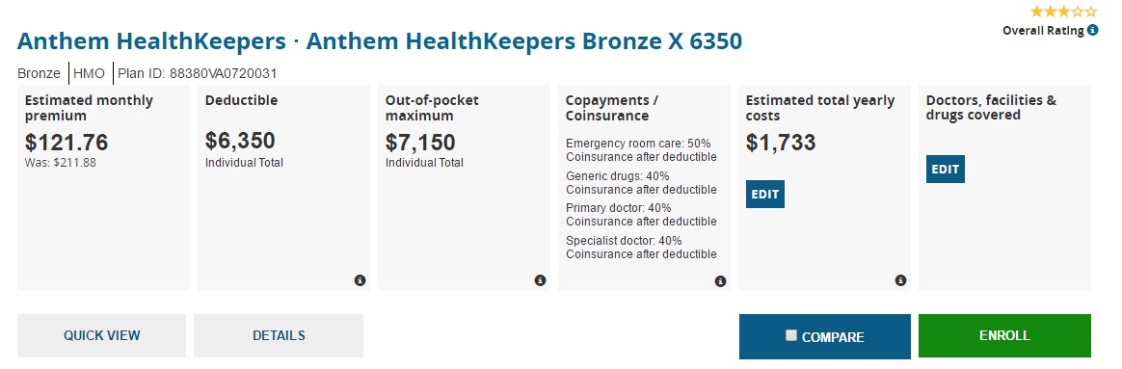

1. [For Wisconsin and Virginia residents only] For those of you who have been to Healthcare.gov, how many of you recall seeing something like this [show mock-up and point out the star rating in the top right corner] when you looked at health plans? *[SOI2]*
2. Even if you don’t remember seeing this, what do you think these stars are telling you? *[SOI2A]*
3. What could make this feature more useful? *[SOI2B]*
4. How confident are you that the information here is correct? *[SOI2D]*
5. [For participants who are not residents of Wisconsin or Virginia only] Here is a new feature being rolled out in the Marketplace in some states [show mock-up and point out the star rating in the top right corner]. What do you think about this new feature? *[PE12]*
6. What do you think these stars are telling you? *[SOI2A]*
7. What could have make this feature more useful? *[SOI2B]*
8. How confident are you that the information here is correct? *[SOI2D]*
9. Would your health insurance selection have been any different if the star ratings feature had been available in your state this year? *[US2]*
10. How likely would you be to use the star ratings feature to find out about the quality of health care plans available in the Marketplace? *[SOI2A]*
11. Would the star ratings feature make you more likely to use the Marketplace website to review and compare health care plans? *[PE6]*
12. What could be done to the star ratings feature that would make it more likely for you to use the Marketplace website to review and compare health care plans? *[PE6B]*
13. How well do you think the star ratings feature would meet your needs for selecting a health care plan? *[PE4]*

## Expectations of a Health Care Plan’s Network

1. When you think about “network” as it relates to health care plans, what are the first things that come to mind? *[K2]*
2. Please describe how you typically assess whether a health care plan’s network is right for you. *[B1]*
3. Have you ever looked for information about a health care plan’s network? *[SOI1]*
4. How have you gone about trying to get information about a health care plan’s network? *[SOI1A]*
5. Where have you found the most useful information? *[SOIB]*
6. Where would you go to find information about a health care plan’s network? *[G4]*
7. How personally relevant is a health care plan’s network to you? *[PE8]*
   1. What makes it relevant? *[PE8A]*
8. What do you think is important when determining whether a health care plan’s network is right for you? *[PE2]*
9. For those of you who have been to Healthcare.gov, do you remember whether there is any information about networks of the health care plans available on the website? *[SOIC2]*

## Network Adequacy Feature (for Marketplace consumer groups only)

### Network Adequacy Feature Mock-Up



1. [For Maine, Ohio, Tennessee, and Texas residents only] For those of you who have been to Healthcare.gov, how many of you recall seeing something like this [show mock-up] when you looked at health plans? *[SOI2]*
2. Even if you don’t remember seeing this, what do you think this information is telling you about a health plan’s network? *[SOI2A]*
3. What could have make this feature more useful? *[SOI2B]*
4. How confident are you that the information here is correct? *[SOI2D]*
5. [For participants who are not residents of Maine, Ohio, Tennessee, and Texas only] Here is a new feature being rolled out in the Marketplace in some states [show mock-up]. What do you think about this new feature? *[PE12]*
6. What do you think this information is telling you about a health plan’s network? *[SOI2A]*
7. What could have make this feature more useful? *[SOI2B]*
8. How confident are you that the information here is correct? *[SOI2D]*
9. Would your health insurance selection have been any different if the network feature had been available in your state this year? *[US2]*
10. How likely would you be to use this feature to find out about the networks of health care plans available in the Marketplace? *[SOI2A]*
11. Would the network feature make you more likely to use the Marketplace website to review and compare health care plans? *[PE6]*
12. What could be done to the network feature that would make it more likely for you to use the Marketplace website to review and compare health care plans? *[PE6B]*
13. How well do you think the network feature would meet your needs for selecting a health care plan? *[PE4]*

## Wrap-Up and Closing

1. Those are all the questions I have for you. Do any of you have any final thoughts you would like to add? *[G5]*

**PRA Disclosure Statement**

According to the Paperwork Reduction Act of 1995, no persons are required to respond to a collection of information unless it displays a valid OMB control number.  The valid OMB control number for this information collection is **0938-XXXX (Expires XX/XX/XXXX)**.  The time required to complete this information collection is estimated to average **[Insert Time (hours or minutes)]** per response, including the time to review instructions, search existing data resources, gather the data needed, and complete and review the information collection.  If you have comments concerning the accuracy of the time estimate(s) or suggestions for improving this form, please write to: CMS, 7500 Security Boulevard, Attn: PRA Reports ClearanceOfficer, Mail Stop C4-26-05, Baltimore, Maryland 21244-1850. **\*\*\*\*CMS Disclosure\*\*\*\***  **Please do not send applications, claims, payments, medical records or any documents containing sensitive information to the PRA Reports Clearance Office. Please note that any correspondence not pertaining to the information collection burden approved under the associated OMB control number listed on this form will not be reviewed, forwarded, or retained.**