**Site Level Survey:**

OMB No. 0990-0379-

Exp. Date 09/30/2020

**Opening Screen:**

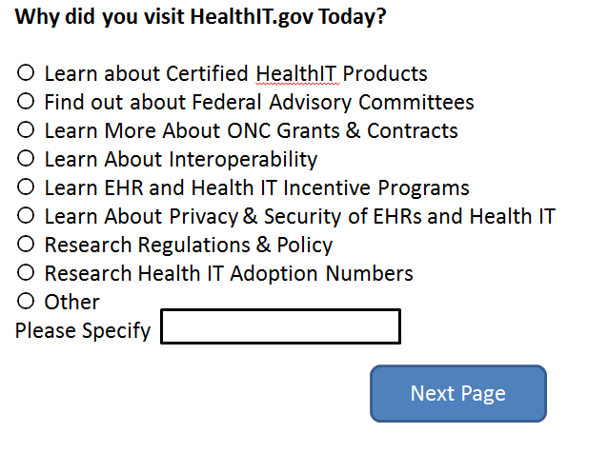

According to the Paperwork Reduction Act of 1995, no persons are required to respond to a collection of information unless it displays a valid OMB control number. The valid OMB control number for this information collection is 0990-0379. The time required to complete this information collection is estimated to average 2 minute per response, including the time to review instructions, search existing data resources, gather the data needed, to review and complete the information collection. If you have comments concerning the accuracy of the time estimate(s) or suggestions for improving this form, please write to: U.S. Department of Health & Human Services, OS/OCIO/PRA, 200 Independence Ave., S.W., Suite 336-E, Washington D.C. 20201, Attention: PRA Reports Clearance Officer

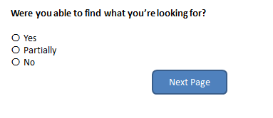

## If Yes:

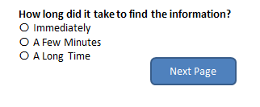

## 

## If No:

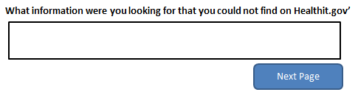

## Last Two Questions Regardless of Answer:

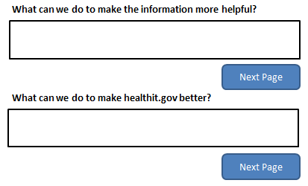

## Page Level Surveys:



