# Welcome

Welcome to this TreeJack study, and thank you for agreeing to participate!

The activity shouldn't take longer than 10 to 15 minutes to complete.

Your response will help us to organize the content on our website. Find out how on the next page...

# Instructions

**Here's how it works:**

* You will be asked to find a certain item and presented with a list of links.
* Click through the list until you arrive at one that you think helps you complete the task.
* If you take a wrong turn, you can go back by clicking one of the links above.

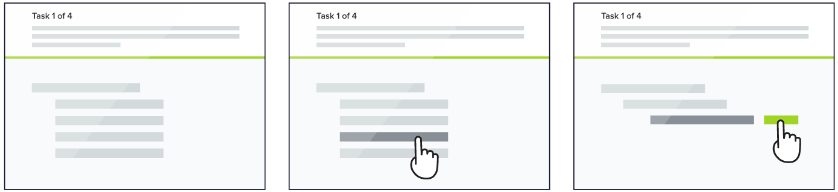

One thing you will notice as you go through the tasks is that the order of the links will change. This is just something we are doing during testing and will not be a part of the new site structure.

Randomizing the lists will help us more easily evaluate the paths people take to find information and spot possible issues with how items are placed or labelled.

As you go through the tasks, please remember there are no right or wrong answers. Our goal is to help site visitors find the information they need quickly & easily, and your efforts today are critical to our reaching that goal.

**Thank you in advance. Now let's get started!**

According to the Paperwork Reduction Act of 1995, no persons are required to respond to a collection of information unless it displays a valid OMB control number. The valid OMB control number for this information collection is 0990-0379. The time required to complete this information collection is estimated to average 15 minutes per response, including the time to review instructions, search existing data resources, gather the data needed, and complete and review the information collection. If you have comments concerning the accuracy of the time estimate(s) or suggestions for improving this form, please write to: U.S. Department of Health & Human Services, OS/OCIO/PRA, 200 Independence Ave., S.W., Suite 336-E, Washington D.C. 20201, Attention: PRA Reports Clearance Officer.

# **Tasks**

## Task #1

**Locate where you can report an allergic reaction to a food product.**

* Report a Problem > How Do I Report a Problem?

## Task #2

**Locate information about how to dispose of unused medicines**

* What FDA Covers > Drugs & Cosmetics

## Task #3

**Locate info about job opportunities at FDA**

* About FDA > Careers @ FDA

## Task #4

**Locate information about government regulation of vapes and e-cigs.**

* What FDA Covers > Tobacco
* Laws, Regulations and Guidance > Laws & Regulations

## Task #5

**Locate FDA webinars for healthcare professionals.**

* Training & Education > Webinars

### Task #6

**Locate information about safe food handling in restaurants**

* What FDA Covers > Food & Dietary Supplements
* Laws, Regulations and Guidance > Guidance for Industry

### Task #7

**Locate FDA guidance on required labelling for cosmetics packaging.**

* What FDA Covers > Drugs & Cosmetics
* Laws, Regulations and Guidance > Guidance for Industry

### Task #8

**Locate studies or publications from FDA about evaluating vaccine safety.**

* What FDA Covers> Biologics & Vaccines
* Science & Research

### Task #9

**Locate information about the food labels for consumers (Nutrition Facts).**

* What FDA Covers > Food & Dietary Supplements

### Task #10

**Locate a recently issued FDA warning letter to a manufacturer.**

* Enforcement and Inspections > Enforcement

### Task #11

**Locate recent pet food recalls.**

* What FDA Covers > Animal & Veterinary
* News and Events > Recalls

### Task #12

**Locate FDA's approved drug products listing (the Orange Book).**

* What FDA Covers > Drugs & Cosmetics

## Post Study Questions

Thank you for completing the sorting exercise. The task will help FDA to learn more about how to best organize information for website users.

We appreciate your time and ask that you answer a few questions.

1. Which of the following descriptions would you use to describe yourself when visiting the FDA.gov website? Please check all that apply:

* Consumer
* Patient
* Caregiver
* Family or friend of a patient
* Researcher or educator
* Journalist or member of the press
* Federal government employee
* Industry or business professional
* Other ___________

2. Have you visited the FDA.gov website this year?

* Yes
* No
* Cannot recall

3. Is FDA.gov a website you do or might visit for professional reasons for personal reasons, for both professional and personal reasons?

* Personal
* Professional
* Both
* Neither

4. Thinking of the current FDA.gov website, how easy or difficult is it to understand the labels used to organize the information on FDA.gov?

* Very easy
* Easy
* Neither easy nor difficult
* Difficult
* Very difficult

5. Please tell us more about your rating.

6. When you think about looking for information on the current FDA.gov website, how confident are you that you can find the information you might need?

* Likert item
* Very confident
* Confident
* Neutral
* Not very confident
* Not confident at all

7. Please tell us more about your confidence rating.

8. Thinking of the way information was categorized on FDA.gov website during this exercise, how confident are you that you could find the information you might need in your new structure?

* Very confident
* Confident
* Neutral
* Not very confident
* Not confident at all

9. Final comments: