ODPHP: Website Survey Screenshots
OMB Control Number: 0990-0379

Screenshots Overview
Below are examples from the previous submission of page-level and site-level ODPHP survey tools. The screenshots illustrate how ODPHP website surveys were situated on the site and how the surveys are structured at the site level and page level.

Site-Level Survey Example Screenshots

From HealthyPeople.gov, a pop-up invitation to begin survey:

From healthfinder.gov, the invitation for feedback in the footer:

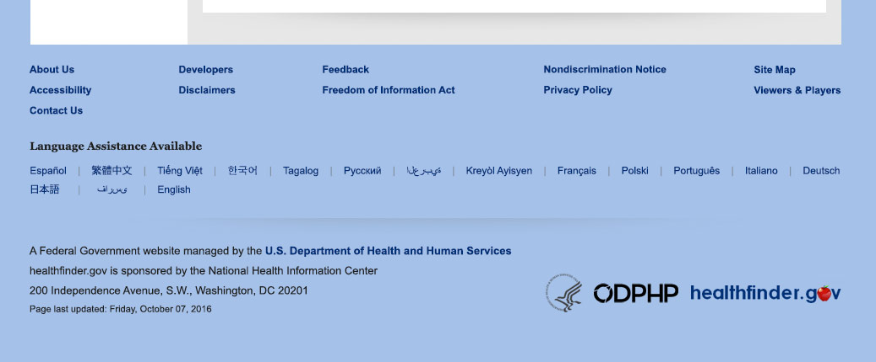

From HealthyPeople.gov, sample questions:

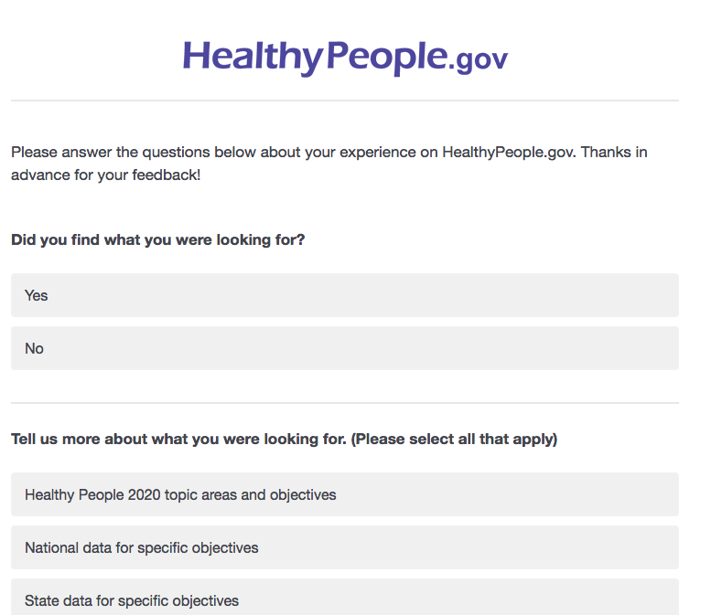

From HealthyPeople.gov, sample end of survey:

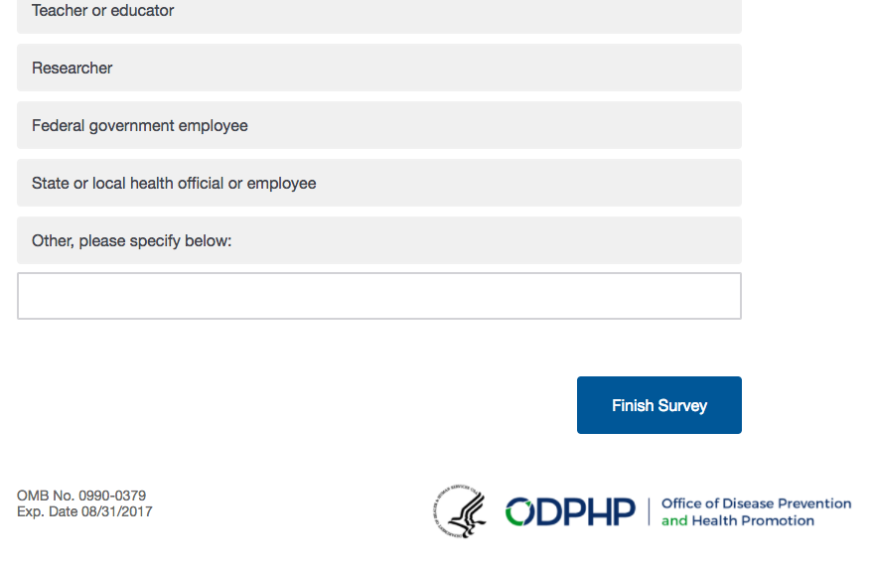
Page-Level Survey Example Screenshot

From HealthyPeople.gov, sample first question:

