**For OMB: Tree Testing Grants.gov**

Form Approved

OMB Control Number: #0990-0379

Exp. Date 09/30/2020

# Welcome

Welcome to this TreeJack study, and thank you for agreeing to participate!

The activity shouldn't take longer than 10 to 15 minutes to complete.

Your response will help us to organize the content on our website. Find out how on the next page...

# Instructions

**Here's how it works:**

* You will be asked to find a certain item and presented with a list of links.
* Click through the list until you arrive at one that you think helps you complete the task.
* If you take a wrong turn, you can go back by clicking one of the links above.

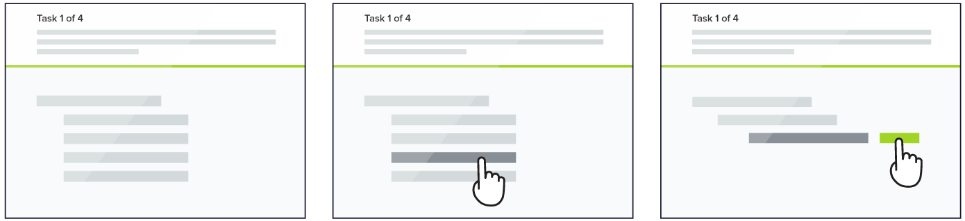

One thing you will notice as you go through the tasks is that the order of the links will change. This is just something we are doing during testing and will not be a part of the new site structure.

Randomizing the lists will help us more easily evaluate the paths people take to find information and spot possible issues with how items are placed or labelled.

As you go through the tasks, please remember there are no right or wrong answers. Our goal is to help site visitors find the information they need quickly & easily, and your efforts today are critical to our reaching that goal.

**Thank you in advance. Now let's get started!**

According to the Paperwork Reduction Act of 1995, no persons are required to respond to a collection of information unless it displays a valid OMB control number. The valid OMB control number for this information collection is 0990-0379. The time required to complete this information collection is estimated to average 15 minutes per response, including the time to review instructions, search existing data resources, gather the data needed, and complete and review the information collection. If you have comments concerning the accuracy of the time estimate(s) or suggestions for improving this form, please write to: U.S. Department of Health & Human Services, OS/OCIO/PRA, 200 Independence Ave., S.W., Suite 336-E, Washington D.C. 20201, Attention: PRA Reports Clearance Officer.

**Tasks**

## Task #1

**Locate information on how to spot Grants fraud.**

* Home > Learn About Grants > Fraud

## Task #2

**Please locate information to check your eligibility.**

* Home > How to Apply > Am I Eligible?

## Task #3

**Locate Grant application forms.**

* Home > How to Apply > Forms

## Task #4

**Find information on Grant policies.**

* Home > Learn About Grants > Policies

## Task #5

**Find information on the steps in the Grant process or lifecycle.**

* Home > Learn About Grants > Lifecycle

### Task #6

**Locate contact information for a Grants.gov Program Advisor.**

* Home > Learn about Grants > Grant-making Agencies

### Task #7

**Locate training on how to use the Grants.gov website.**

* Home > About Grants.gov > Calendar > Training

### Task #8

**Register to create an account on Grants.gov.**

* Home > Register

### Task #9

**Where would you report Grant fraud?**

* Home > Help Center > Fraud

### Task #10

**Locate information on S2S applicant systems.**

* Home > About Grants.gov > S2S > Applicant Systems

### Task #11

**Locate S2S information.**

* Home > About Grants.gov > S2S

### Task #12

**Locate information on upcoming Webinars.**

* Home > About Grants.gov > Calendar > Webinars

### Task #13

**Where would you expect to find contact information for the Grants.gov help desk?**

* Home > Help Center > Online User Guide

### Task #14

**Find your submitted grant applications.**

* Home > How to Apply > Portal > My Workspaces.

### Task #15

**If you had an issue with the Grants.gov website, where would you look for assistance?**

* Home > Help Center > Technical Assistance

## Post Study Questions

Thank you for completing the sorting exercise. The task will help FDA to learn more about how to best organize information for website users.

We appreciate your time and ask that you answer a few questions.

1. Which of the following terms would you use to describe yourself, please check all that apply.
   1. Grantor/federal grant provider
   2. Grant applicant
   3. Member of the public / consumer
   4. Federal Gov’t employee (not a member of grants.gov community)
   5. Member of a tribal community
   6. Other

2. Have you visited the Grants.gov website this year?

* Yes
* No
* Cannot recall

3. Thinking of the current Grants.gov website, how easy or difficult is it to understand the labels used to organize the information on FDA.gov?

* Very easy
* Easy
* Neither easy nor difficult
* Difficult
* Very difficult

4. Please tell us more about your rating.

5. When you think about looking for information on the current Grants.gov website, how confident are you that you can find the information you might need?

* Likert item
* Very confident
* Confident
* Neutral
* Not very confident
* Not confident at all

6. Please tell us more about your confidence rating.

7. Thinking of the way information was categorized on Grants.gov website during this exercise, how confident are you that you could find the information you might need in your new structure?

* Very confident
* Confident
* Neutral
* Not very confident
* Not confident at all

8. Final comments: