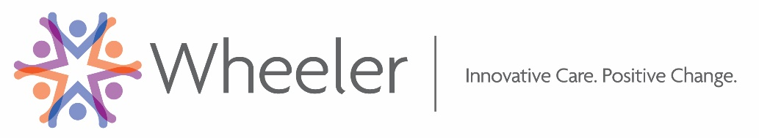

**Connecticut Opioid Misuse Prevention (COMP) Initiative**

**Adolescent SBI Online Training Access Instructions**

Thank you for registering for the Adolescent SBIRT for Adolescent Girls training made possible through grant funding from the Office on Women’s Health, Office of the Assistant Secretary for Health, US DHHS. In preparation for your live training, you are asked to complete the online Adolescent SBI training from Kognito.This interactive online training uses role play simulations with virtual youth to prepare you to have real life conversations with adolescents on substance use or misuse. Continuing education credits are available and access instructions follow*.

1. Go to URL:  [**www.kognitocampus.com**](http://www.kognitocampus.com)
2. Create a Kognito account by selecting “**Don’t have an account?  Click Here**”
3. Enter enrollment key (please don’t share with others)   **sbirtforct**

For any additional questions, please don’t hesitate to contact Aisha Hamid at [ahamid@wheelerclinic.org](mailto:ahamid@wheelerclinic.org) or (860)793-4625.

* Note that a browser other than Internet Explorer (such as Safari, Chrome, Firefox, Edge, etc.) is needed and

Pop-ups must be enabled. See <https://support.kognito.com/customer/portal/articles/941060> for additional details.