Form Approved
0990-0379
Exp. Date: XX/XX/XX2X

Office of Adolescent Health (OAH)

Individual Technical Assistance (TA) Survey

According to the Paperwork Reduction Act of 1995, no persons are required to respond to a collection of information unless it displays a valid OMB control number. The valid OMB control number for this information collection is 0990-0379. The time required to complete this information collection is estimated to average 3 minutes per response, including the time to review instructions, search existing data resources, gather the data needed, and complete and review the information collection. If you have comments concerning the accuracy of the time estimate(s) or suggestions for improving this form, please write to: U.S. Department of Health & Human Services, OS/OCIO/PRA, 200 Independence Ave., S.W., Suite 336-E, Washington D.C. 20201, Attention: PRA Reports Clearance Officer.
Office of Adolescent Health (OAH)
Grantee Satisfaction Surveys

Individual TA Survey

E-mail Transmittal Script and Instructions

Dear OAH Grantee:

We would greatly appreciate your feedback on your recent technical assistance. Please use the link below to complete a brief survey about your experience. Thank you in advance for your participation.

To provide your feedback, please visit: https://www.surveymonkey.com/r/[survey code]

If you have any questions, please email OAHPAFTA@mayatech.com.

Individual T/TA Participant Feedback
OAH Grantee Satisfaction Feedback Survey
- 1. Grant Type
 PAF
 TPP Tier 1A
 TPP Tier 1B
TPP Tier 2A
TPP Tier 2B
 FY 2018 TPP Tier 2
- 2. TA Topic

*3. Date of TA Activity
Date
MM/DD/YYYY

4. Please rate your agreement with the following statements related to the TA request process:
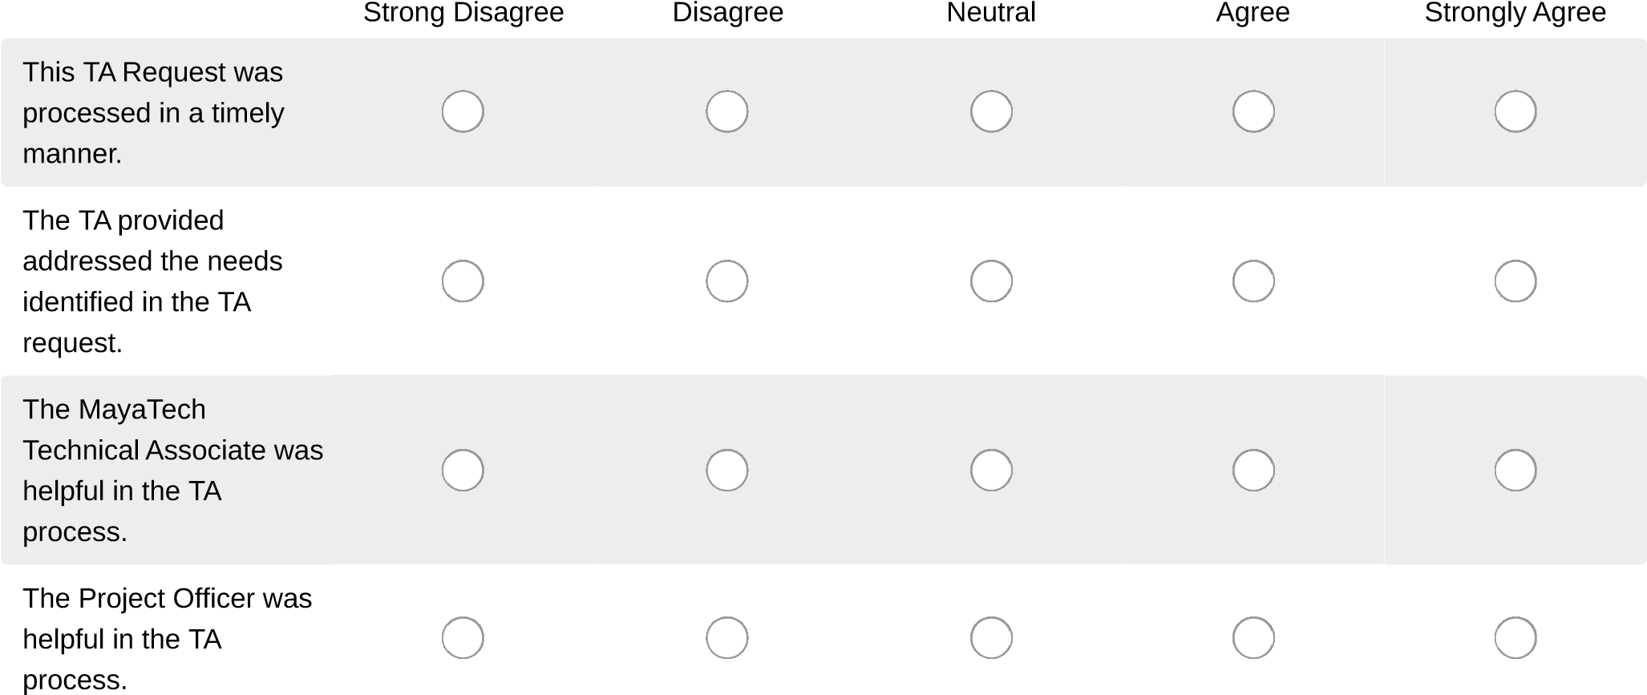

- Please rate your agreement with the following statements related to the TA activity:

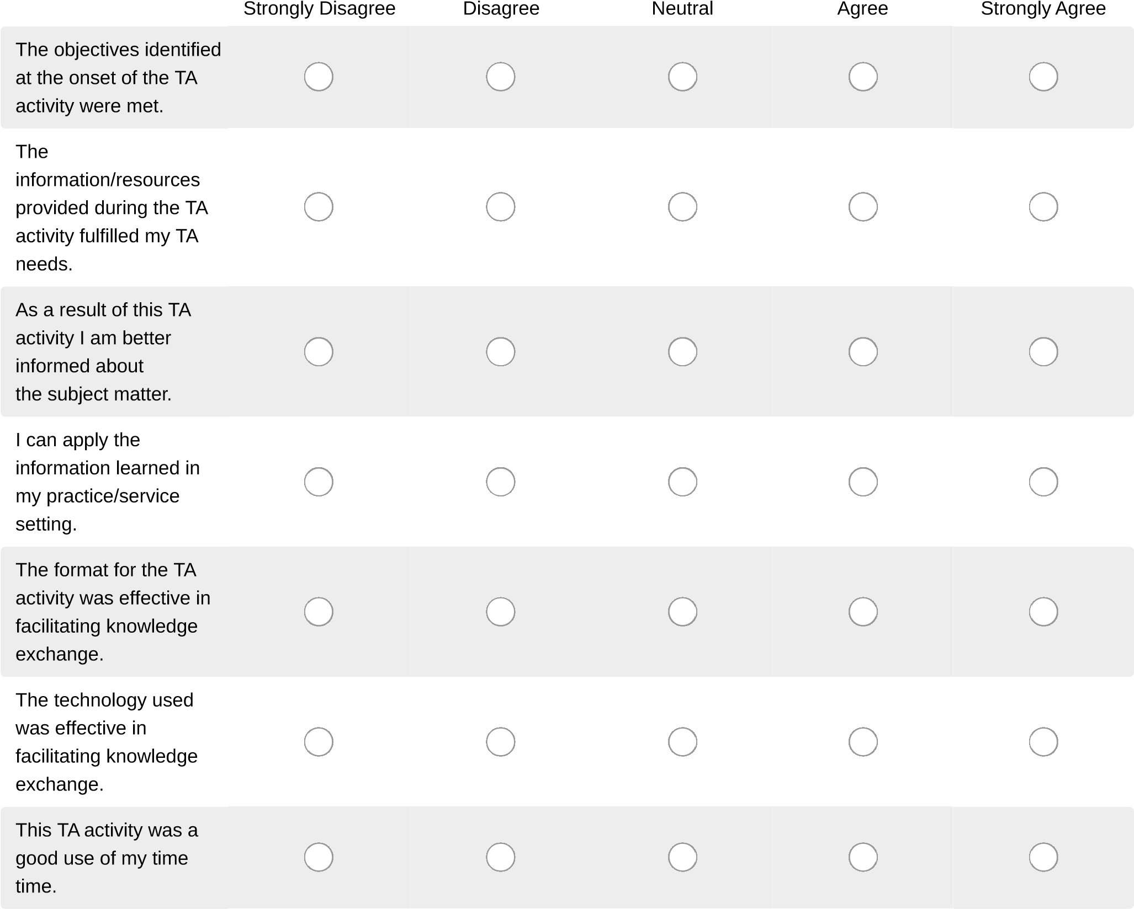

- Please rate your agreement with the following statements related to the TA provider(s). Note that TA provider can refer to a subject matter expert, a grantee presenter, or an OAH staff member:
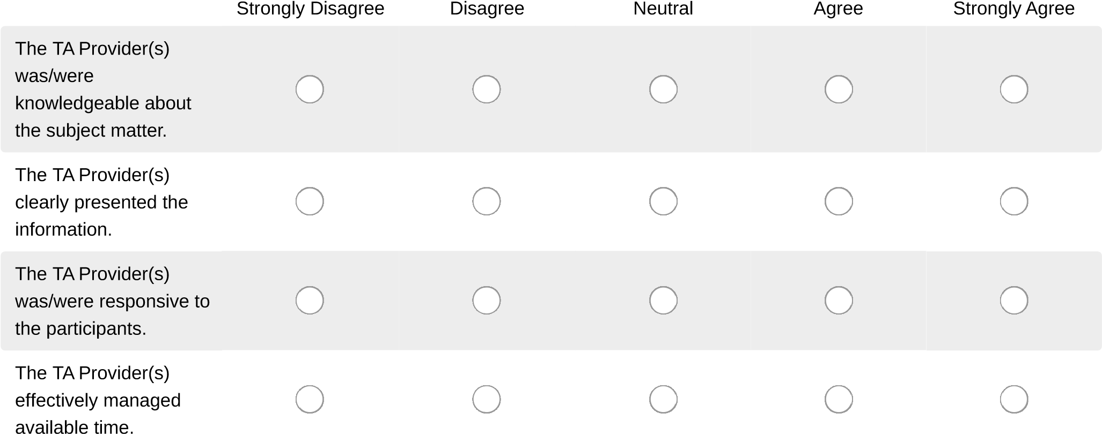

- What else would you have liked to learn from this TA activity?

- In what ways could this TA activity be improved - either in delivery or content?

- What other TA topics would be of interest to you?

- Do you have any additional comments?

Thank you for your participation.

