**Attachment B: In person interviews**

*Phone Screener*

Hi, may I speak to (respondent name).

My name is ___. I work for the Office of Survey Methods Research at the Department of Labor, Bureau of Labor Statistics.

We are contacting you because you previously participated in the Occupational Employment Statistics (OES) report – thank you! The Labor Department is requesting information from businesses like yours to improve our data. Your participation is voluntary and will just take 30 minutes. The information you provide will be kept confidential and will be used for research purposes only.

*Verify the business*

First, we’d like to verify some information about your business.

The OES report collects occupation and wage information from businesses. Are you the person in your company who is responsible for responding to data requests like this at your location, <insert address>?

* Yes
* No (ask to speak to the person who handles data requests)

If you have a few minutes now, we’d like to schedule an appointment to come to your place of business to talk to you.

(If yes) Great, let’s go ahead and schedule a date and time.

(If no) Thank you for your time.

**In person protocol**

Thank you for agreeing to talk to us today about your experience with the OES report. Your feedback will provide vital information in improving our data on occupations and wages for businesses like yours.

*<Provide respondent consent form and have them read and sign it.>*

*Point Estimate Feedback*

Let’s take a look at this form together, and an example of one filled out.

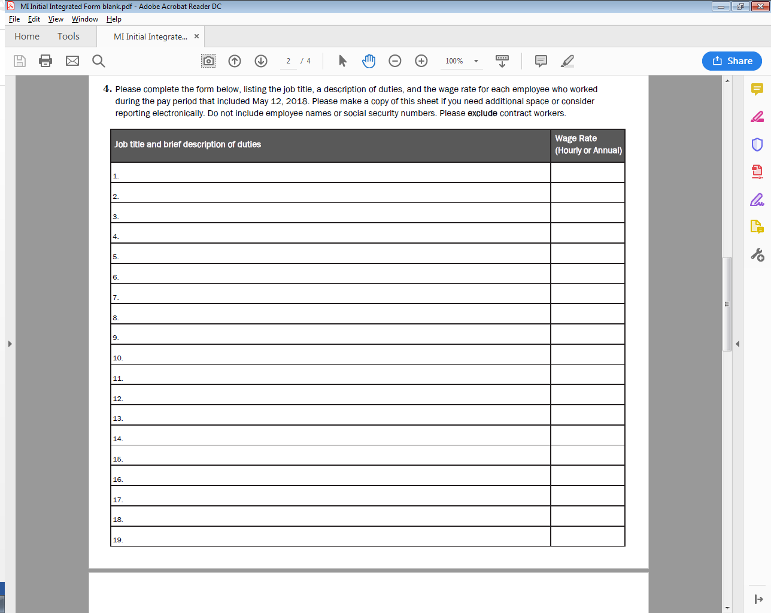



1. What would your initial reaction be if you were asked to fill this out for your location? _____
   * What do you think the form is asking you to write in?
2. Can you walk me through the process you’d use to fill this form out?

[Probes to select from; not all probes will be asked. At researcher’s discretion.]

* What records or reports would you have to access to get this information?
* Do those give you this information directly, or would you have to do something custom or manual?
* Would this require additional consultation with other employees?
* Looking up records in another place?
* Generating a spreadsheet from payroll software?
* Recall from memory?
* Calculations?
* Guessing or estimating?
* What challenges might be involved?

1. How long do you think it’d take you to fill it out?
2. As you can see on the example, we’re asking for exact wage rates for each occupation. Are exact wage levels available in your current records?
3. Would you be able to export a report or spreadsheet that could be sent to BLS instead of you filling out the form? How easy or difficult would it be for you to get such a report?
4. Do employees with the same job title and duties typically make the same wages, or does it vary?
   * How much does it vary?
   * Would you be able to list each occupation that makes a different wage separately? How would you go about that?
5. Do you think it would be easy or difficult to provide exact wages for each of your employees?
6. Would be willing to report exact wage data for your employees, or not? For what reasons?
   * Would you have any concerns about providing this information to the Bureau of Labor Statistics?
7. How confident would you be in the accuracy of the exact wage amounts you report?

[Other emergent probes as needed]

*Comparison to Wage Ranges*

Here you see another form, similar to the previous one. But this one includes income ranges. So instead of providing exact wage amounts for each occupation, for this form, you would indicate the number of employees that fall into each wage range. You can see the example for Registered Nurses on the email.



* What are your reactions to providing wage data in ranges instead of the exact amounts?
* How does this approach compare to the previous one, where you would indicate exact wage amounts?
* Do you prefer one approach over the other? For what reasons?

*Conclusion*

* The Bureau of Labor Statistics currently collects wage information in these ranges, but is looking to get specific wages instead as they provide much more information about the US Economy. We’re doing these interviews to understand if respondents like yourself would be able, and willing, to provide the more specific information. In general, do you think your company would be able and willing to provide specific wages?
* Do you have any comments on suggestions on how we could make it easier for companies to give us this important information?

Thank you for talking to us! We appreciate your time.