**Tutorial (Instructions) for TTB F 5120.17, Report of Wine Premises Operations**

As Posted to the TTB website at <https://www.ttb.gov/forms/5000.shtml>.

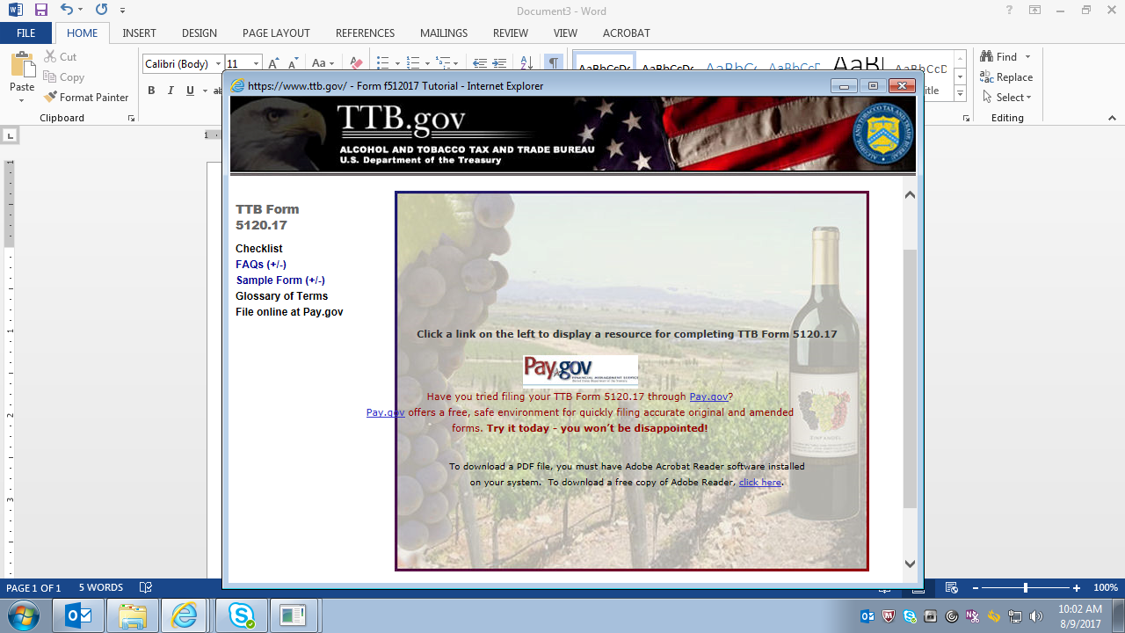

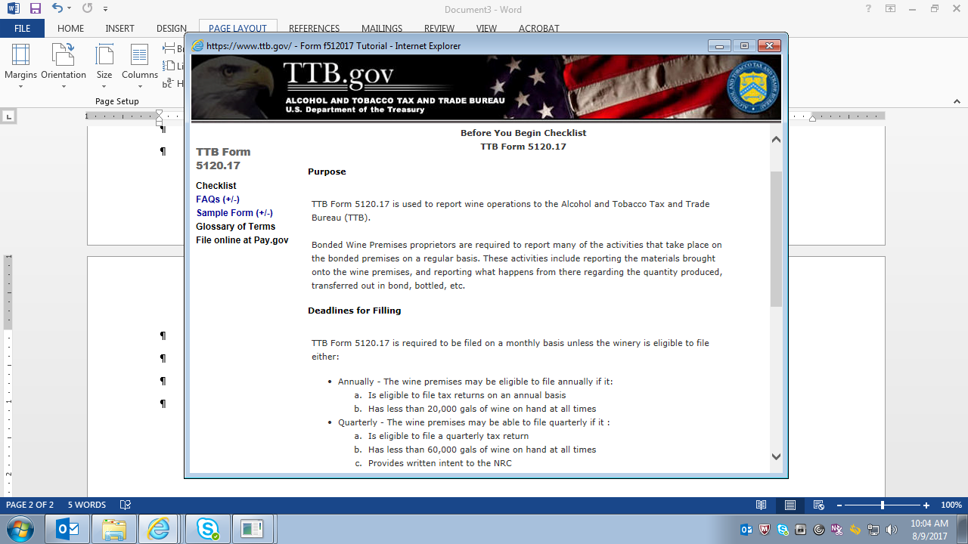

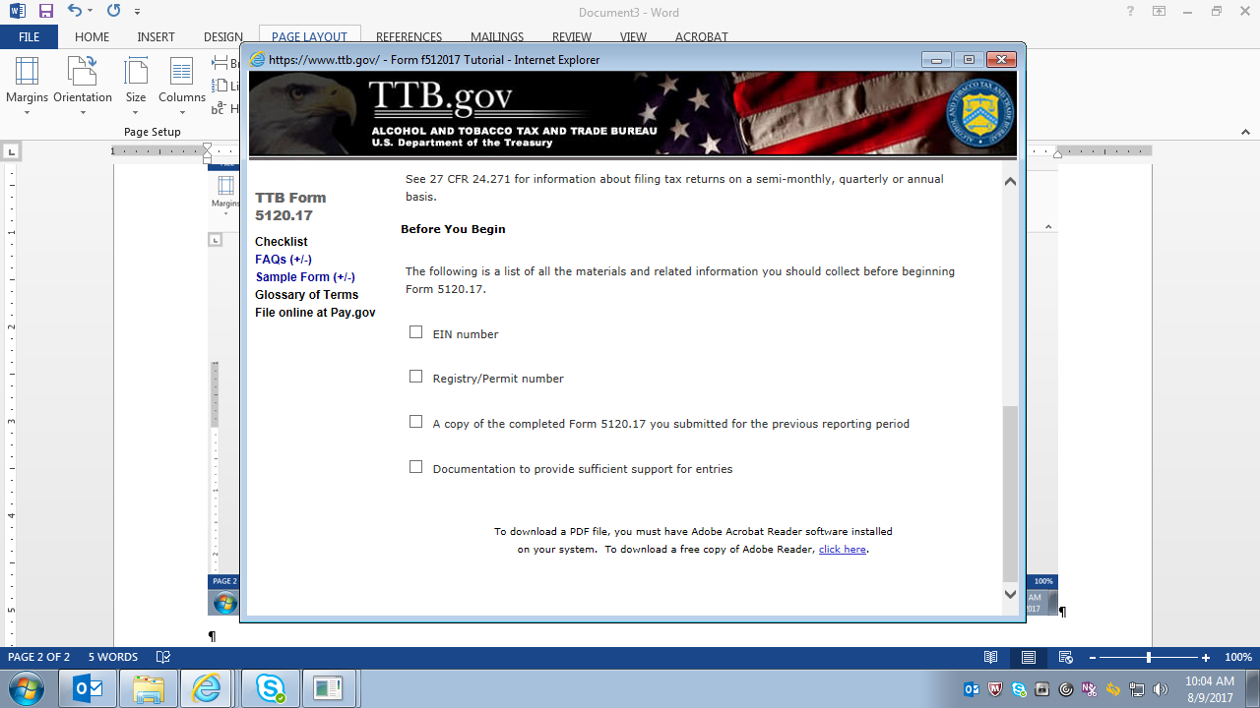

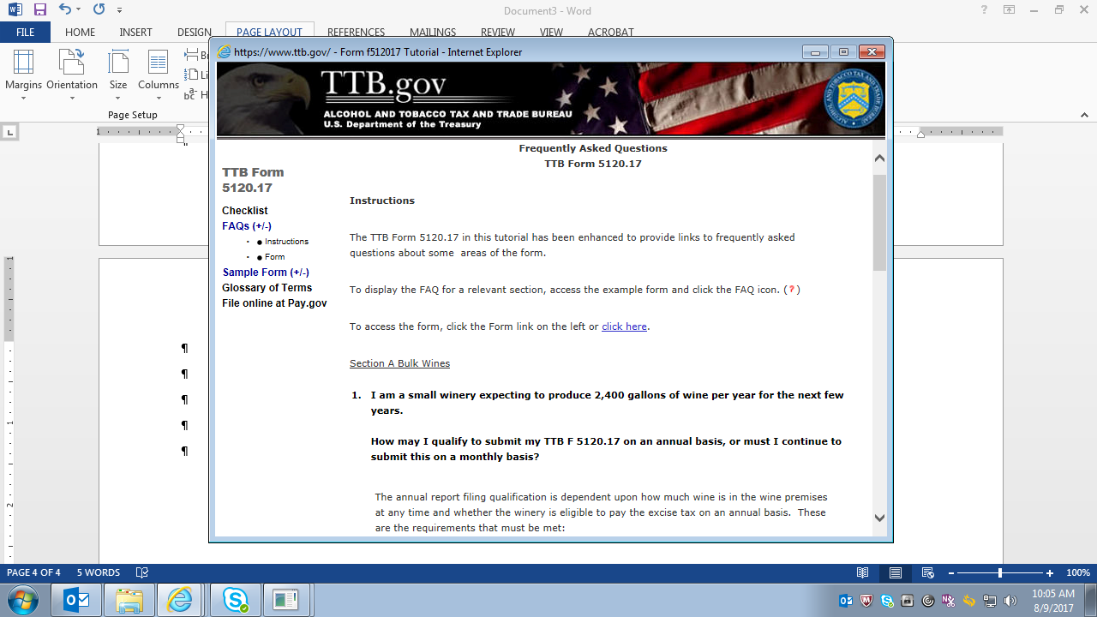

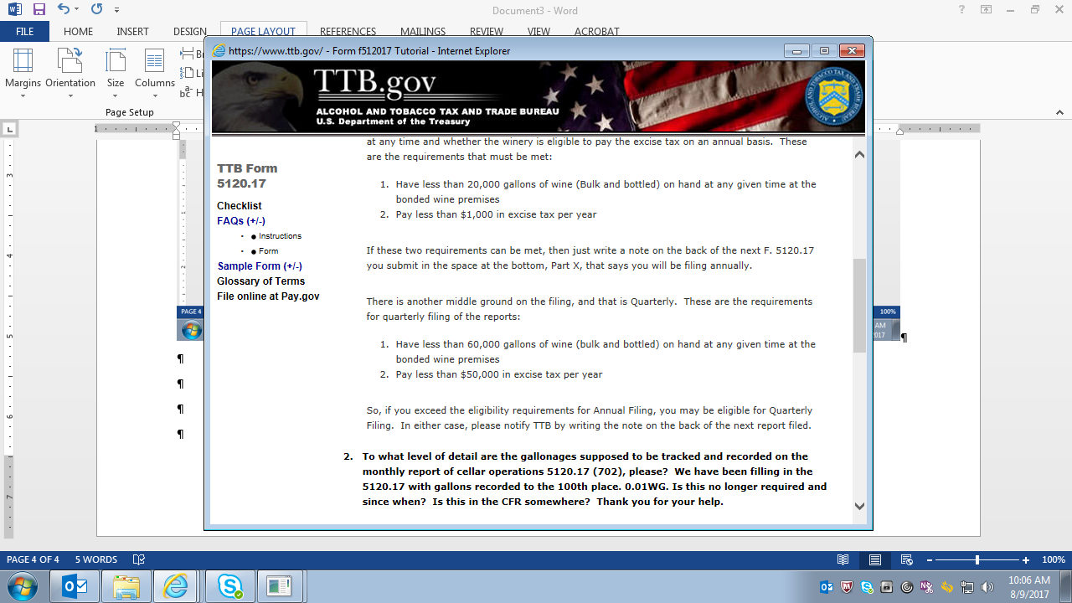

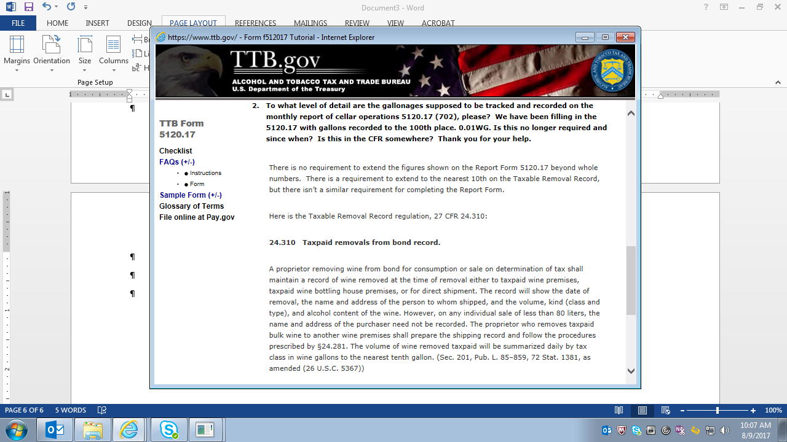

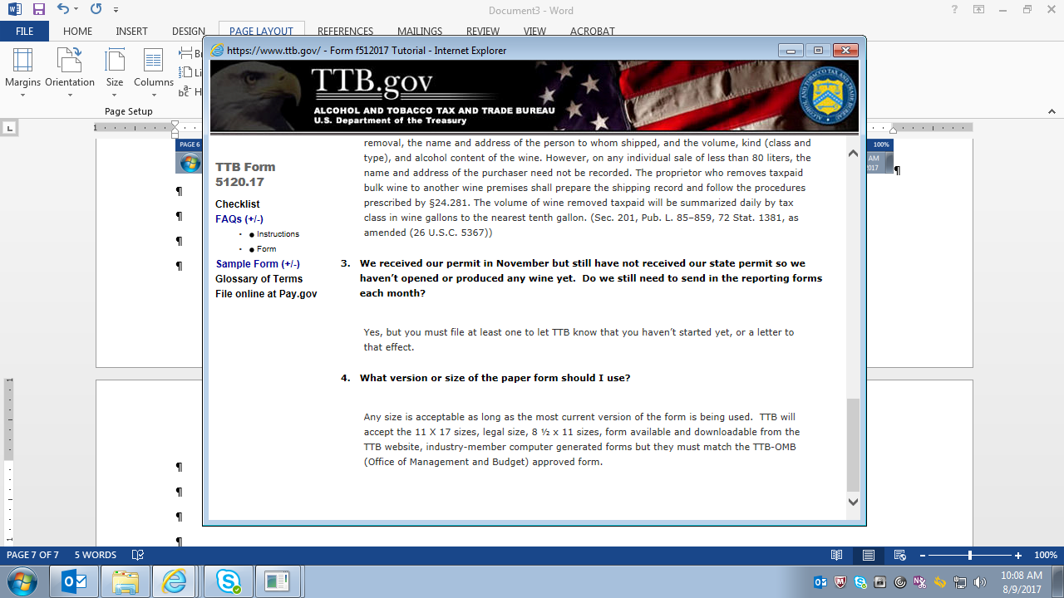

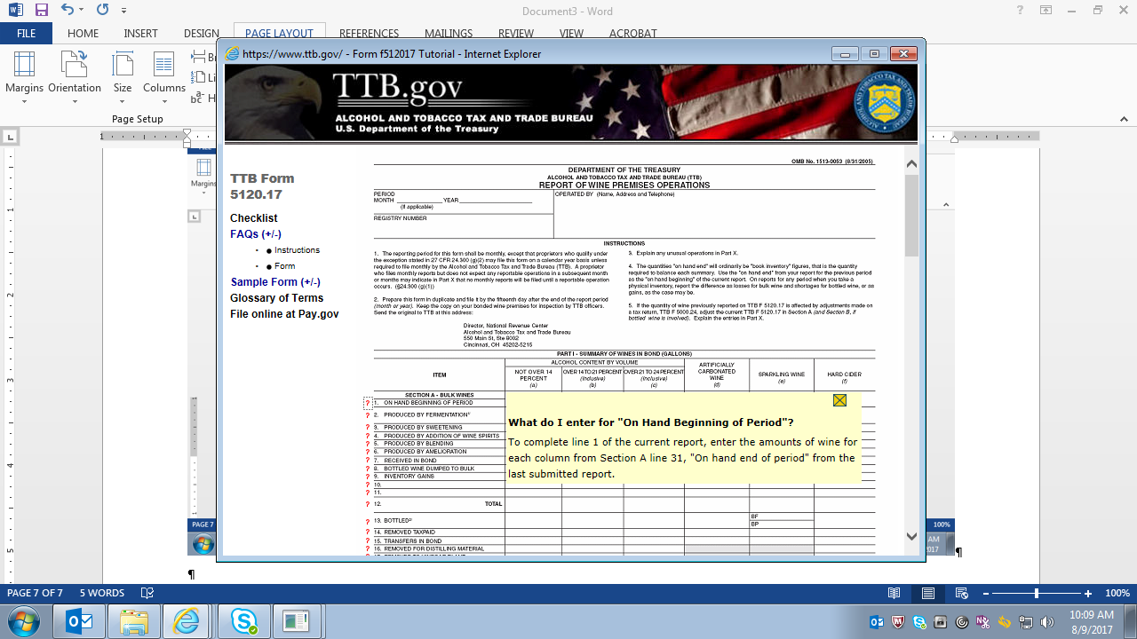

NOTE: For each line of the form, clicking on the Red Question Mark (“?”) beside the line will bring up instructions or hints in a light-yellow colored box. An example, for Line 1, is shown above.

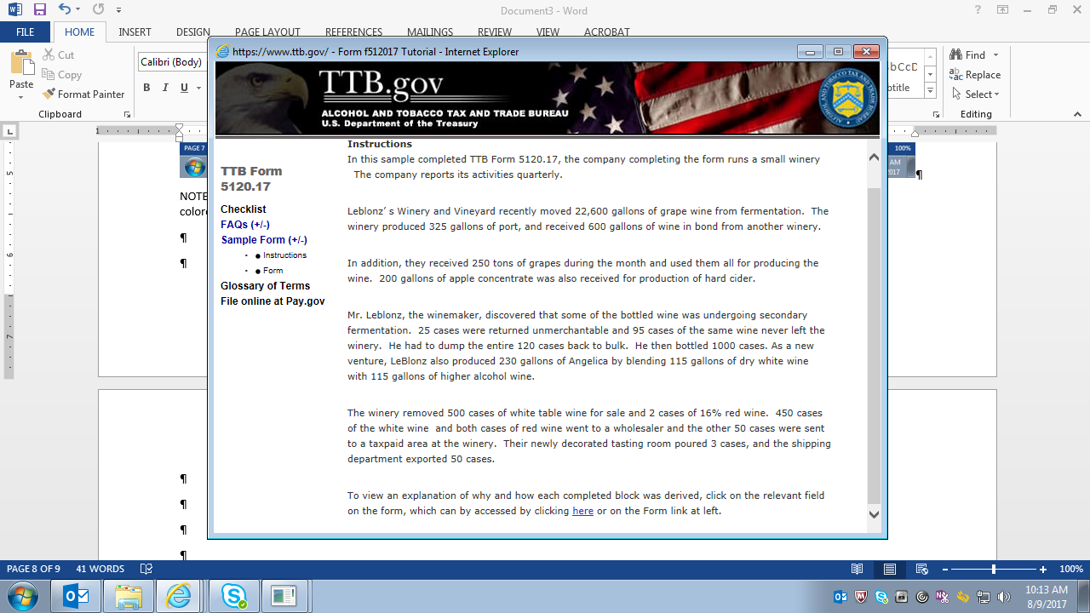

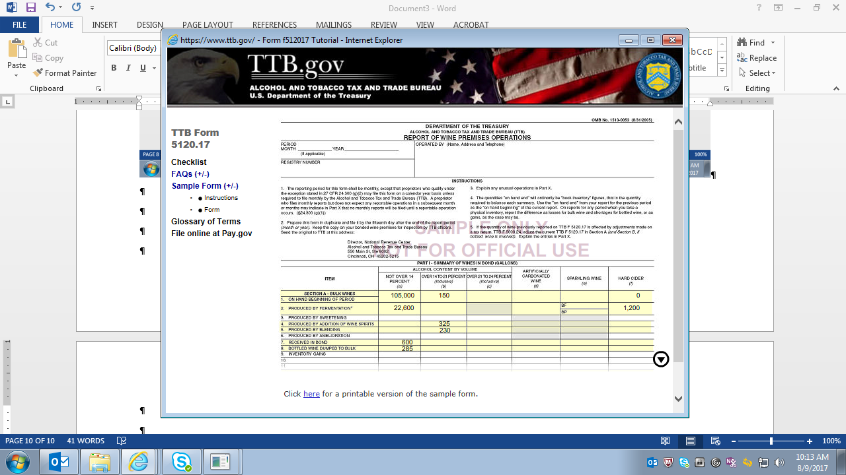

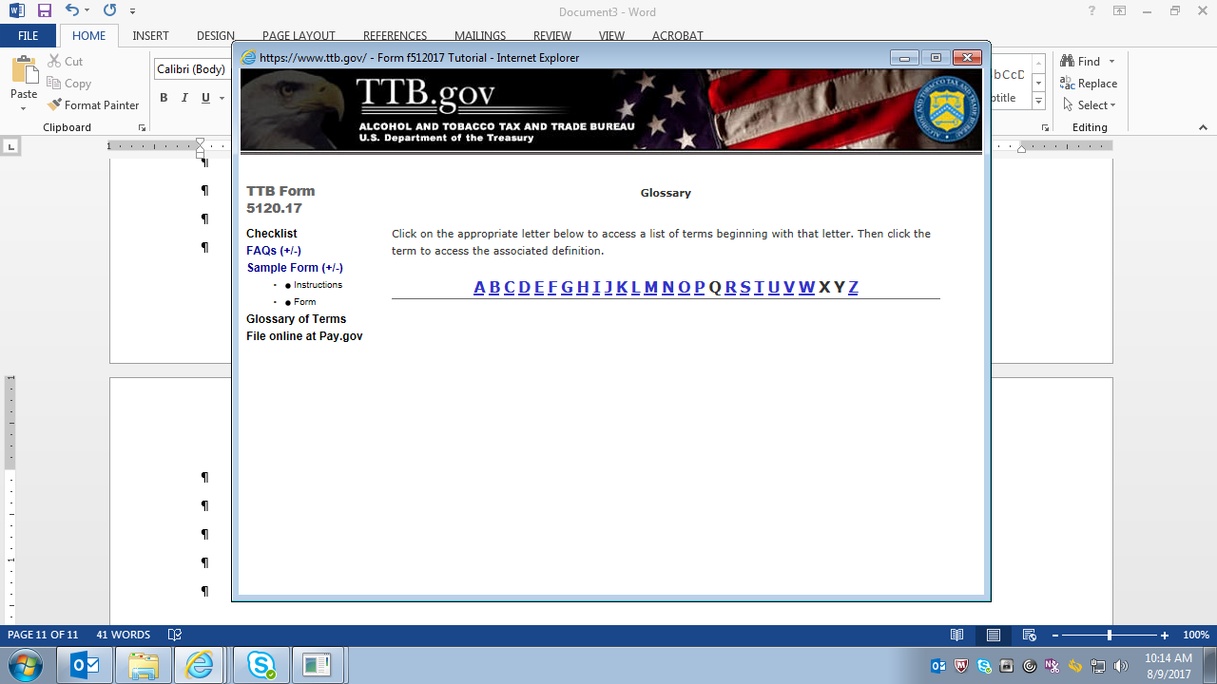

Clicking on the Pay.gov link in this Tutorial takes the user to the Pay.gov introductory page on the TTB website at <https://www.ttb.gov/epayment/epayment.shtml>, which is shown below:

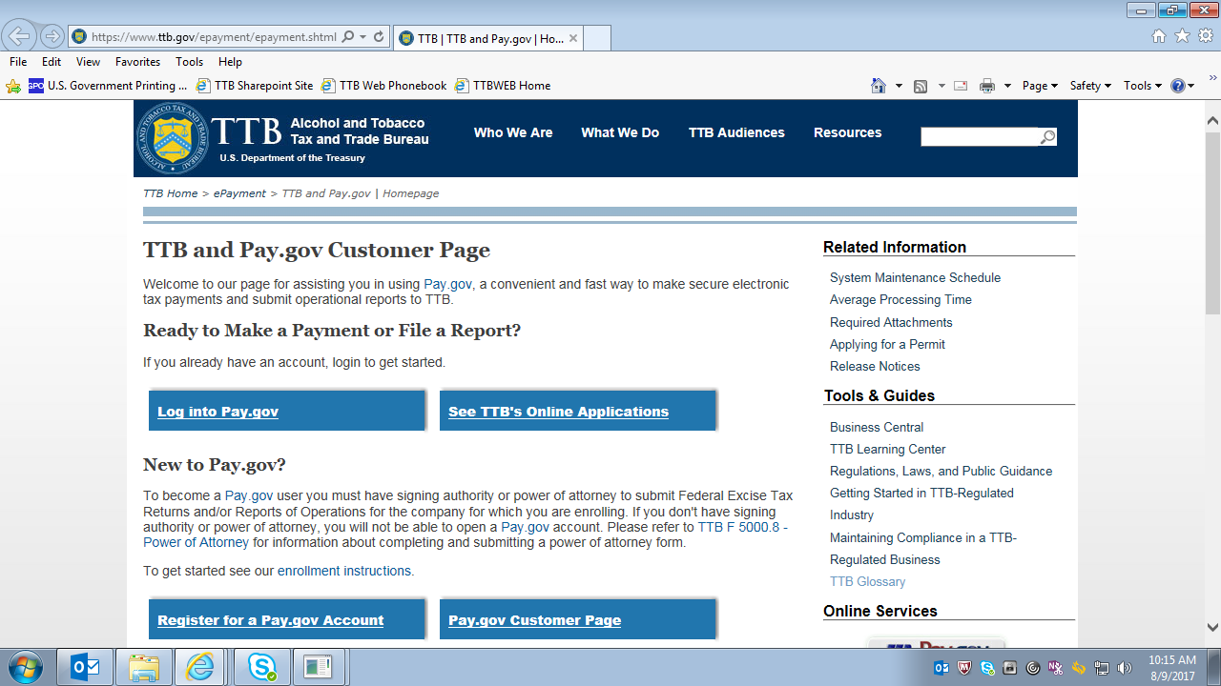

=== End ===