Permits Online — Screen Shot for Transfer in Bond Portion of the Original Distilled Spirits Plant (DSP) Application:
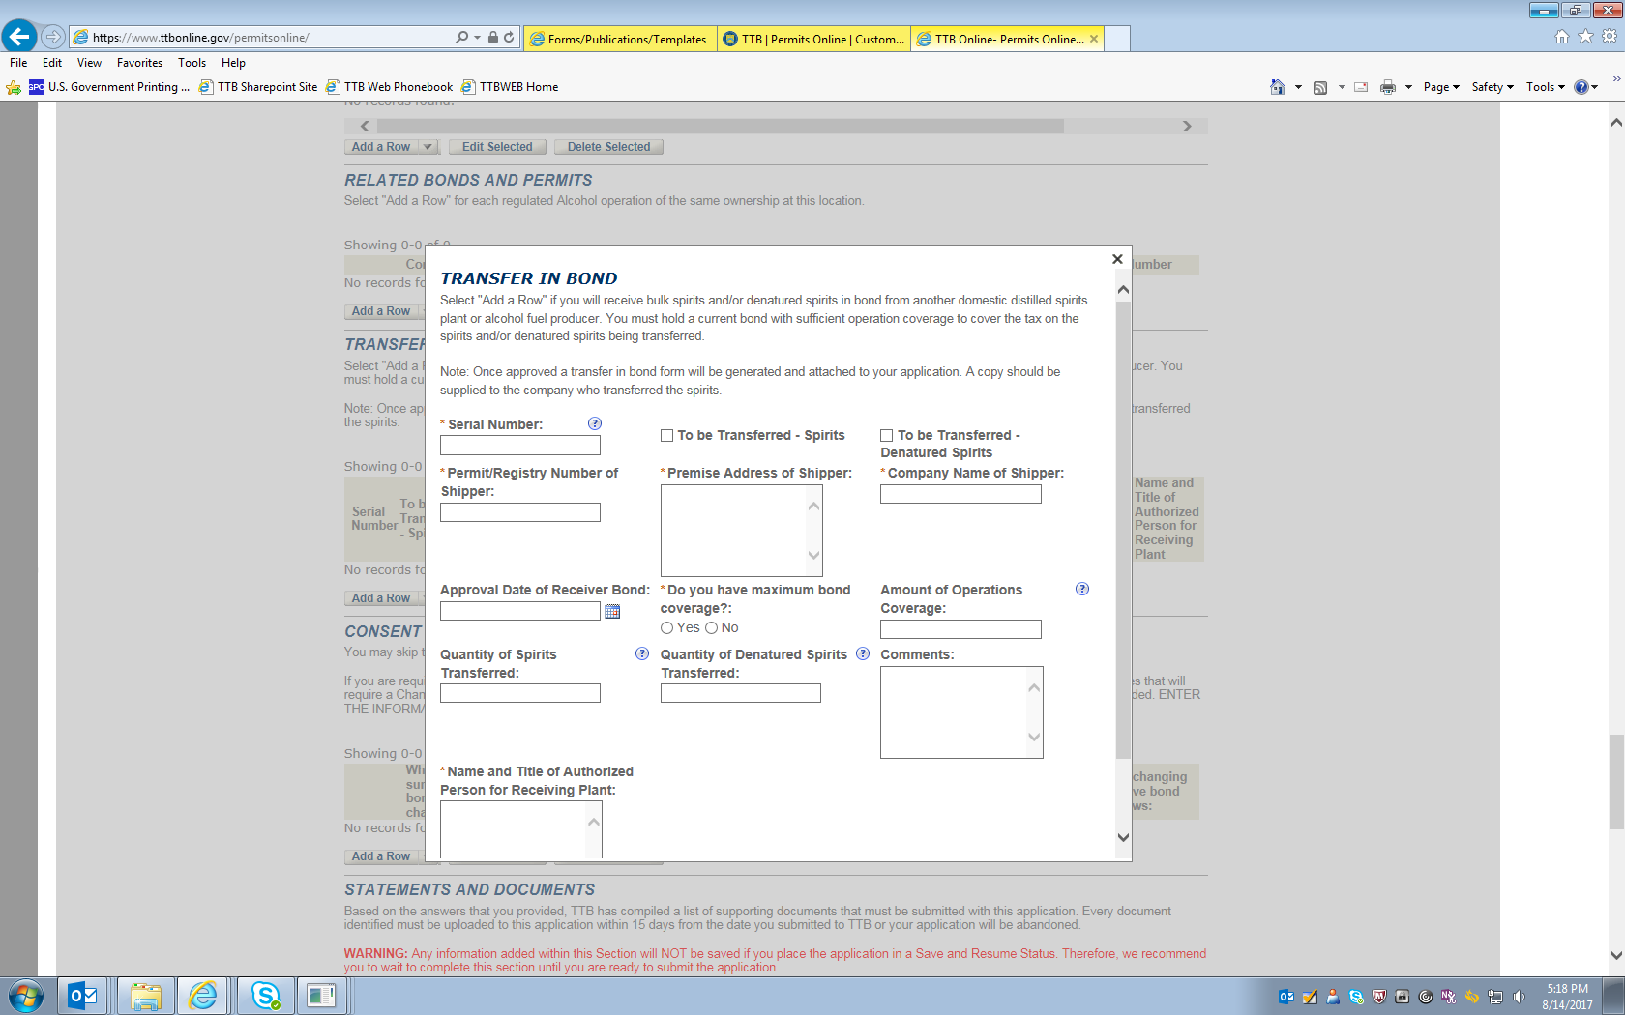
NOTE: The data entered on this screen, along with data identifying the receiving plant retrieved by the PONL system from stored data collected under other OMB control numbers, is equivalent to TTB F 5100.16, Application to Receive Spirits and/or Denatured Spirits by Transfer in Bond.
Summary screen:
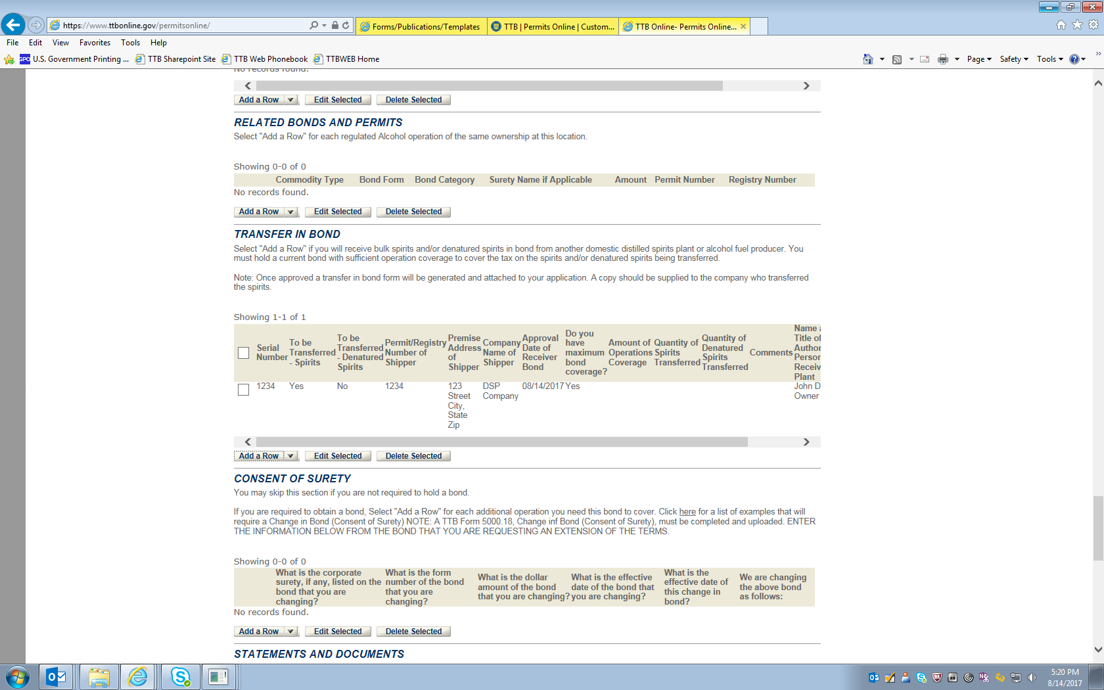

Declaration screen:
