Steps to submit Original Brewery Application:
1.
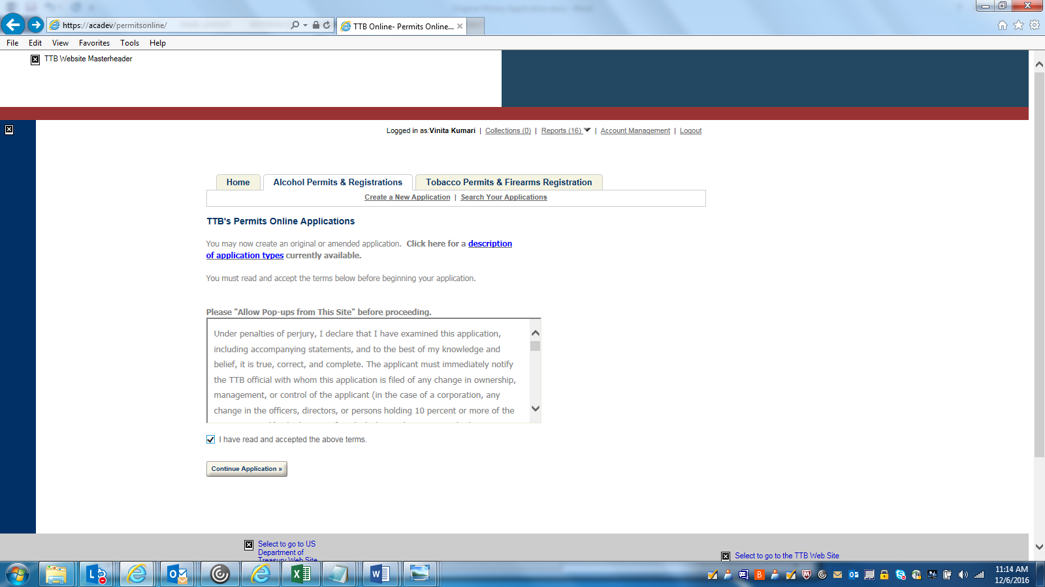
2.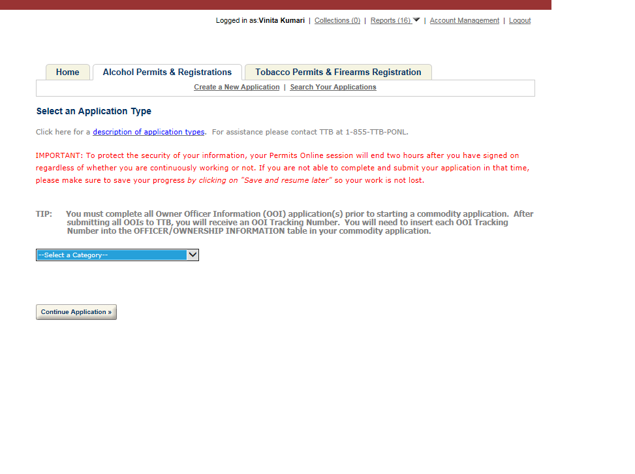
3. 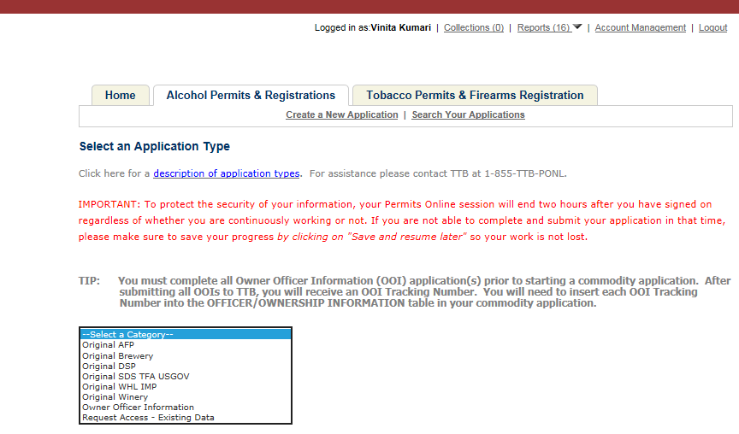
4.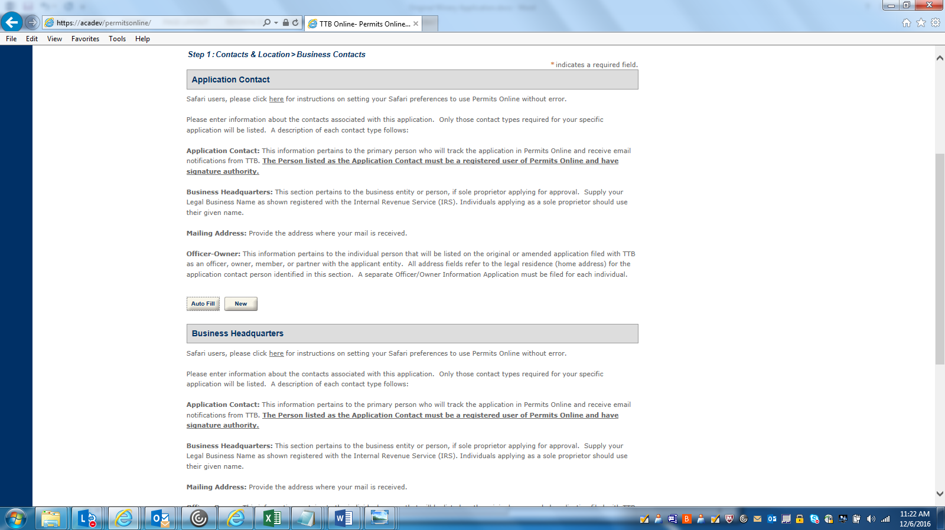
APPLICATION CONTACT DETAILS: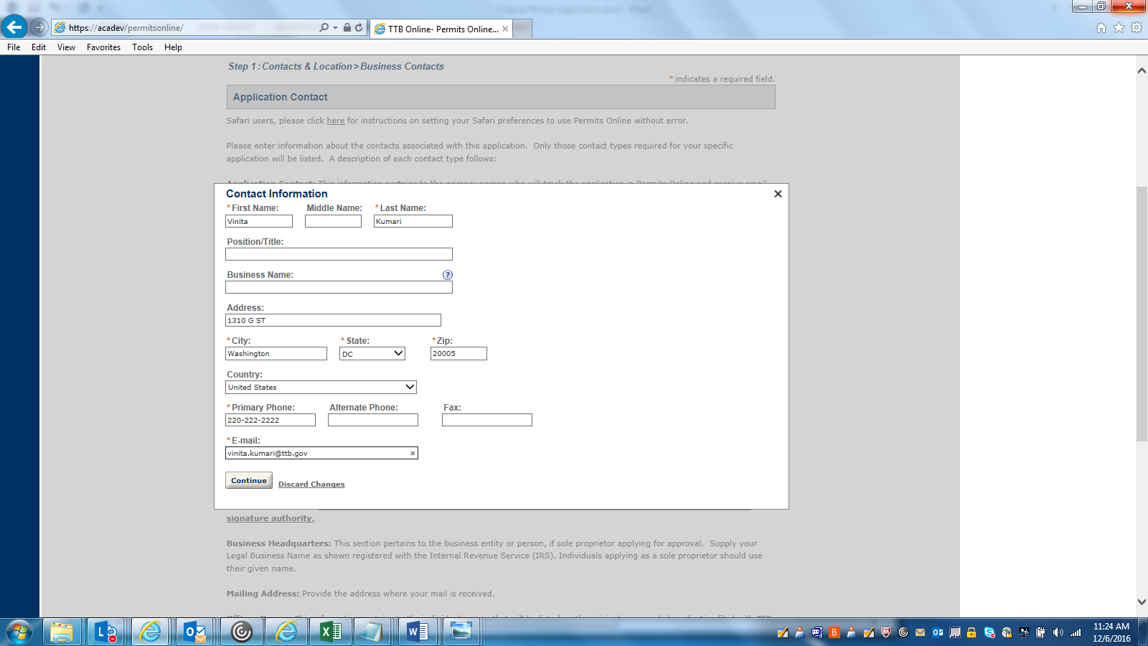

BUSINESS HEADQUARTER DETAILS: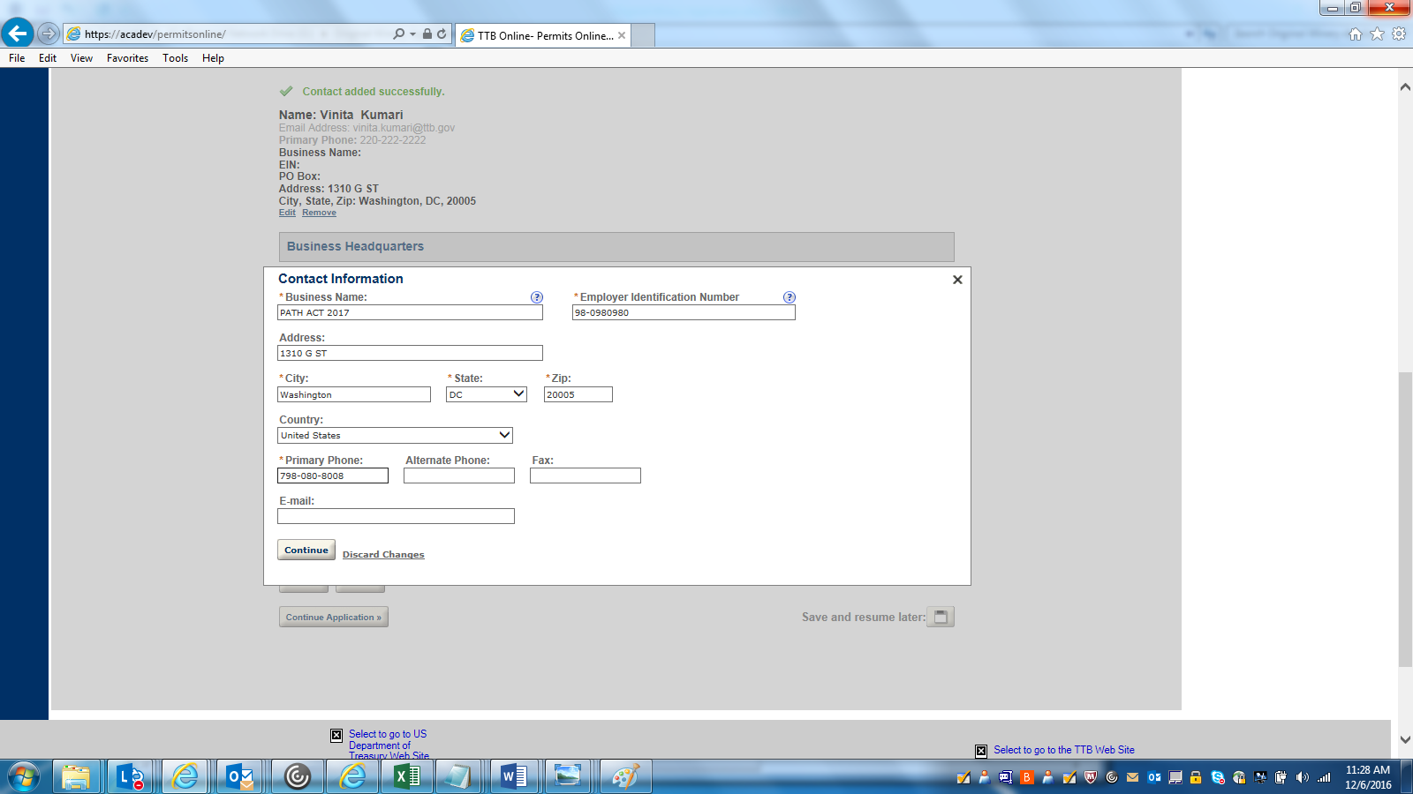

PREMISE ADDRESS DETAILS: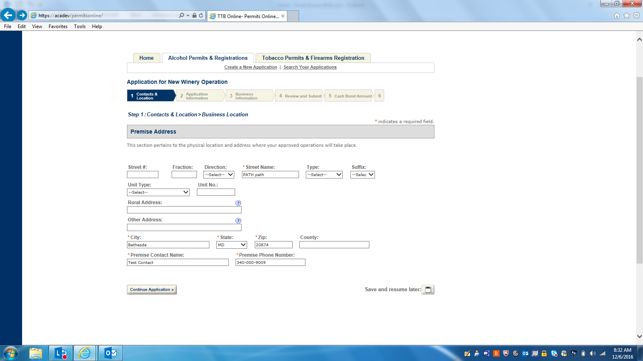

MAILING ADDRSS DETAILS: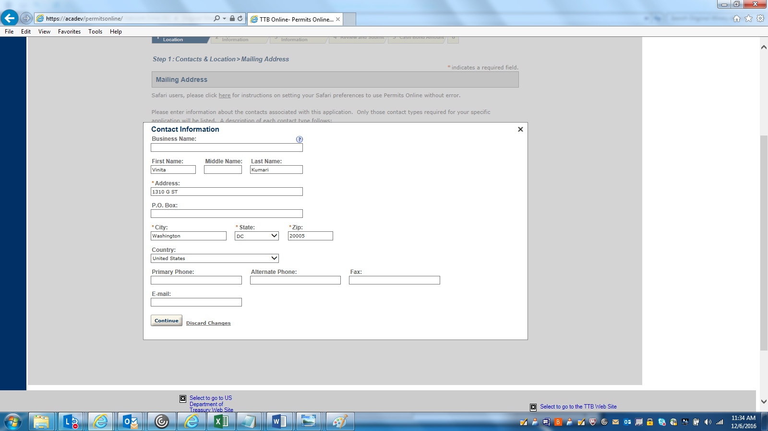

APPLICATION INFORMATION:
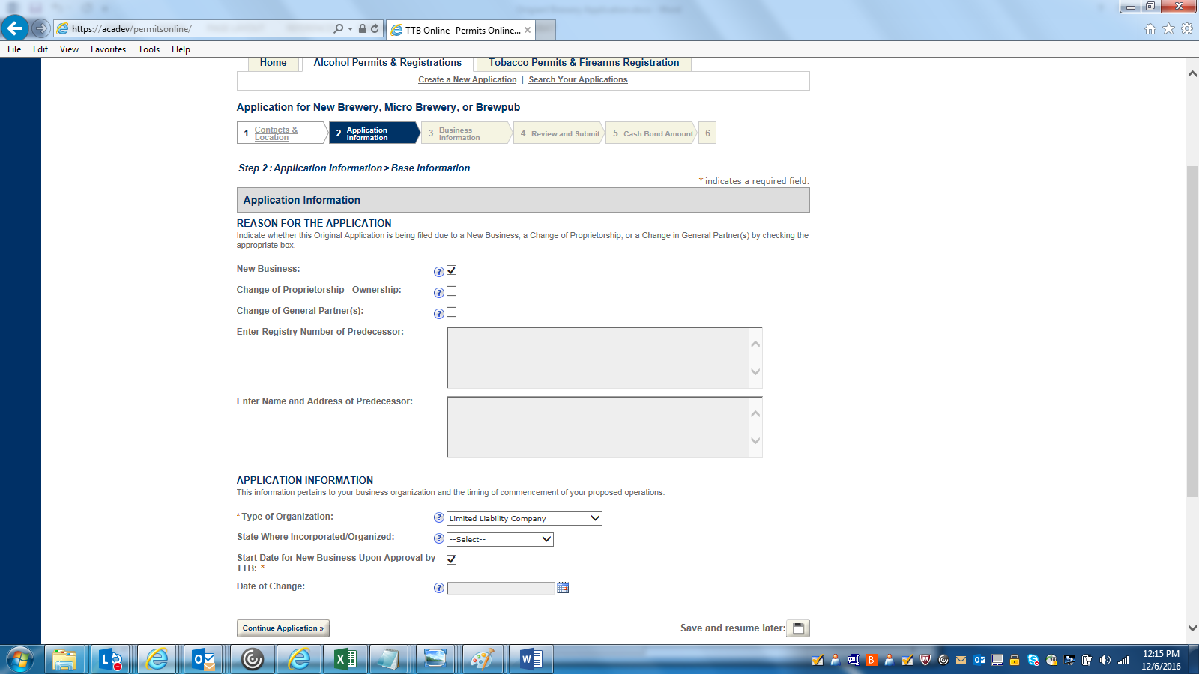

OWNER BACKGROUND INFORMATION: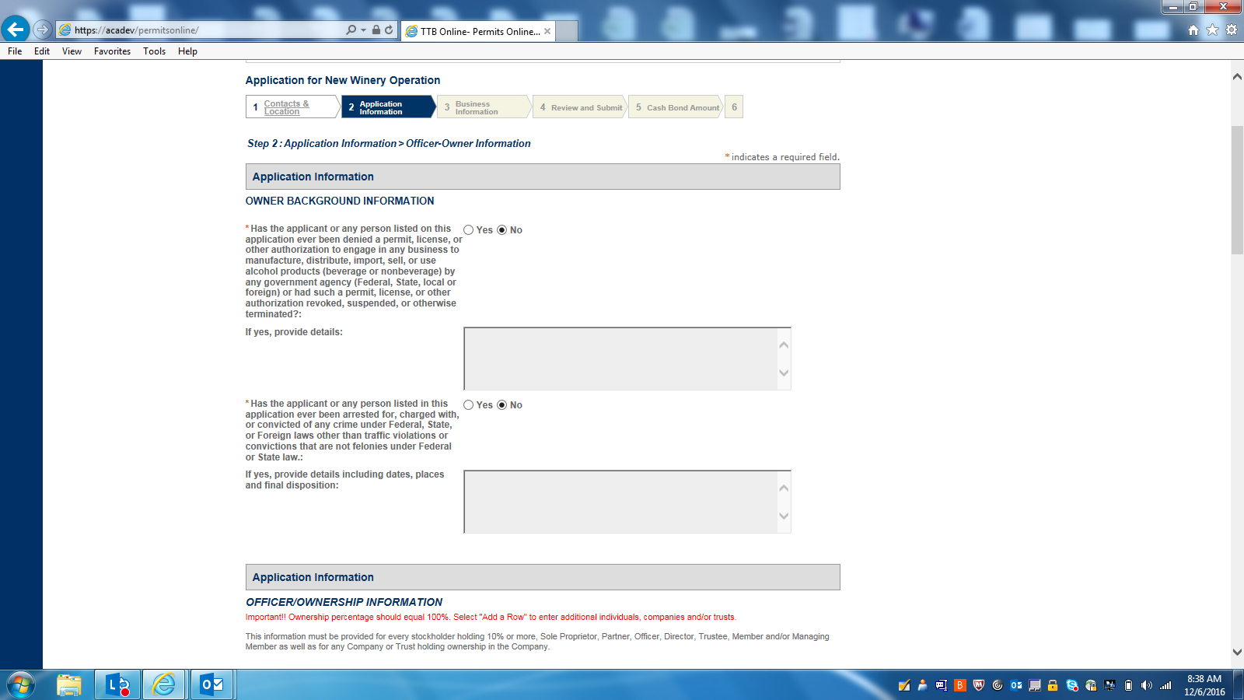

OFFICER-OWNER INFORMATION-1: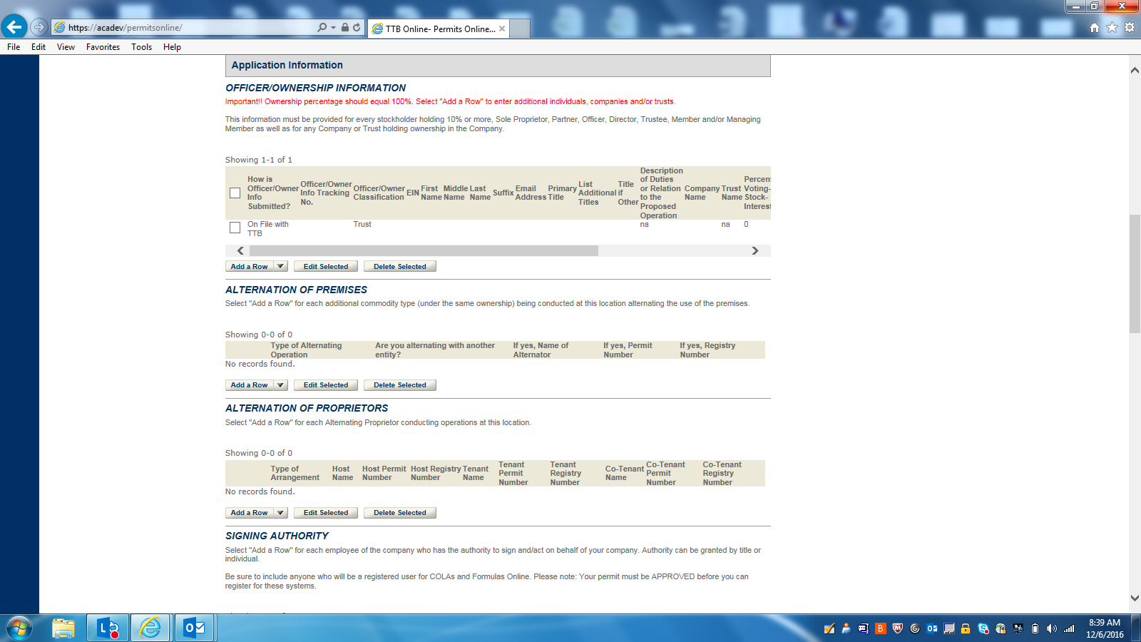OFFICER-OWNER INFORMATION (DETAIL):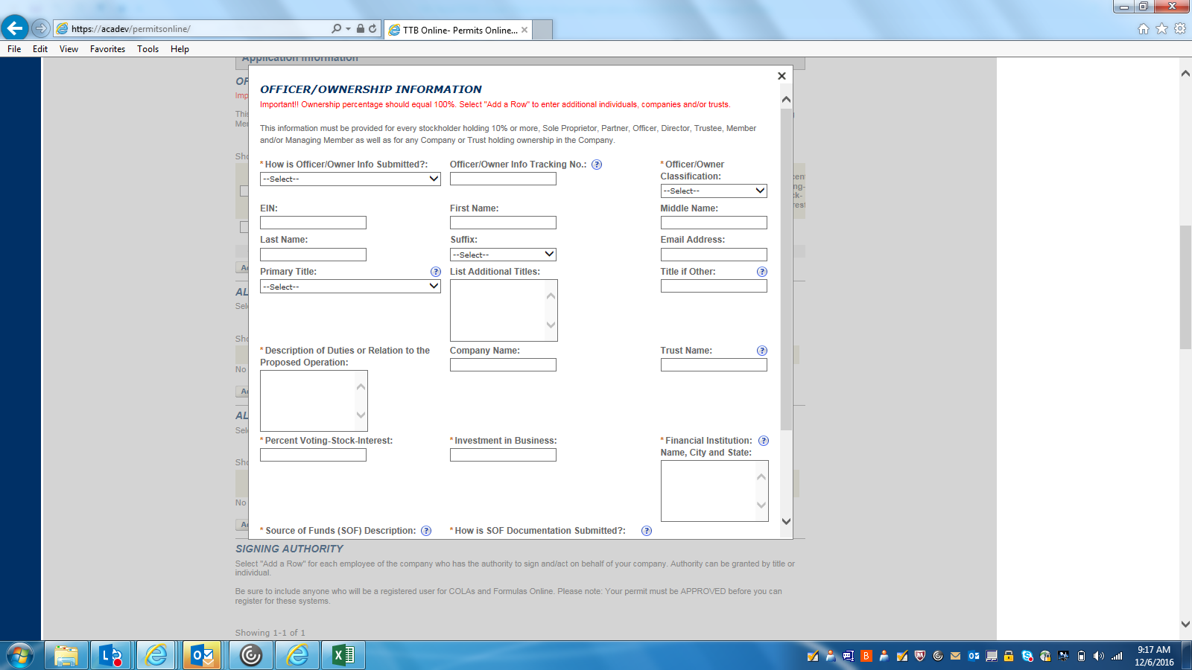

ALTERNATION OF PREMISES(DETAILS):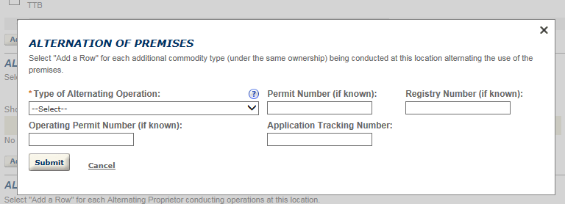ALTERNATION OF PROPRIETORS (DETAILS):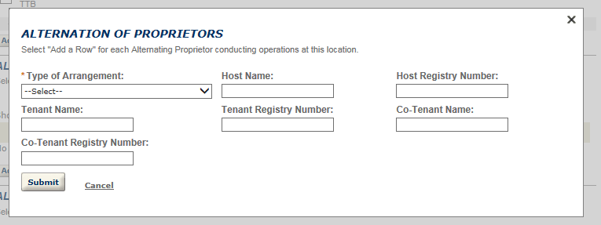

SIGNING AUTHORITY(DETAILS):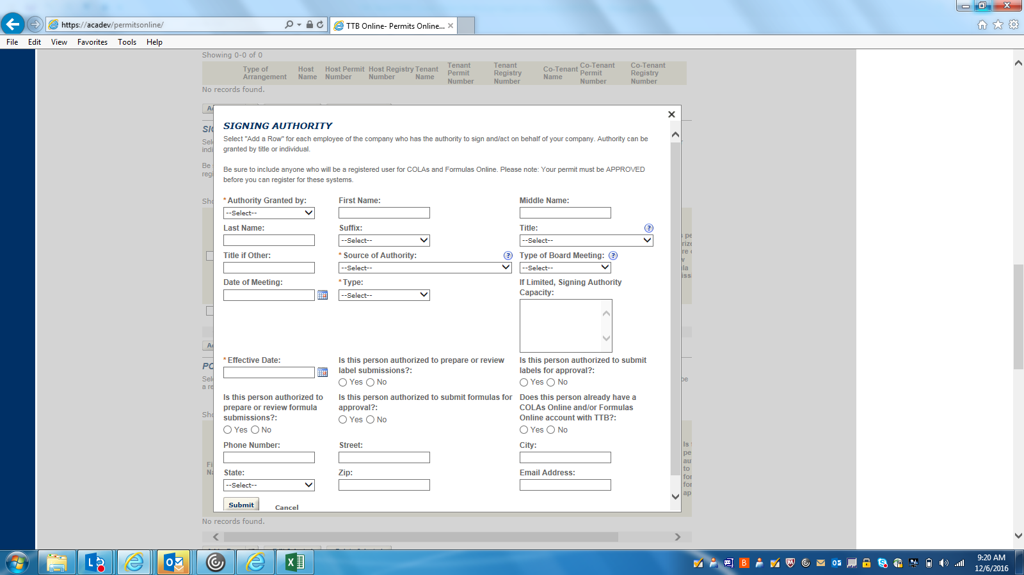OFFICER-OWNER INFORMATION-2: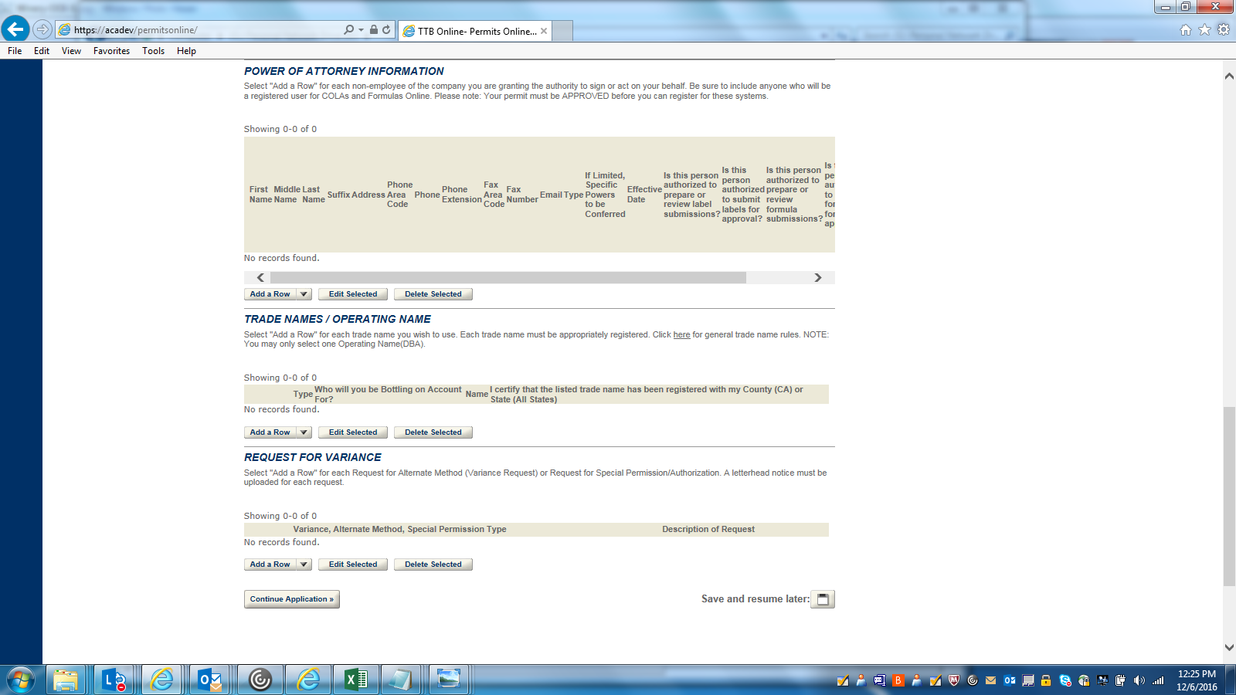

POWER OF ATTORNEY (DETAILS):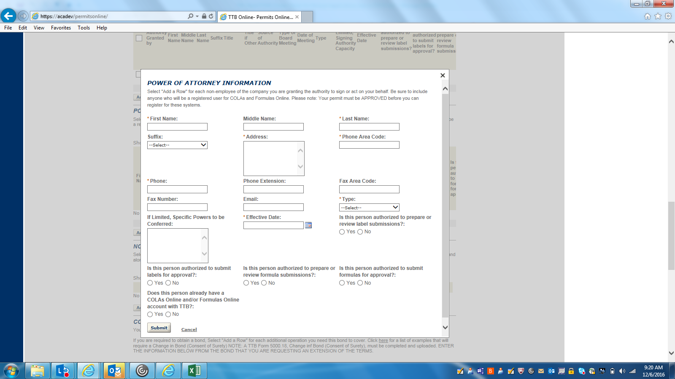
TRADE NAMES/ OPERATING NAME (DETAILS):
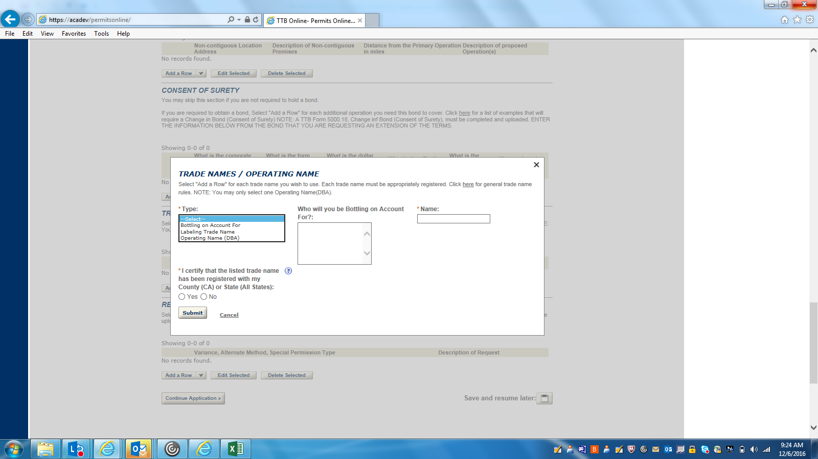
REQUEST FOR VARIANCE (DETAIL):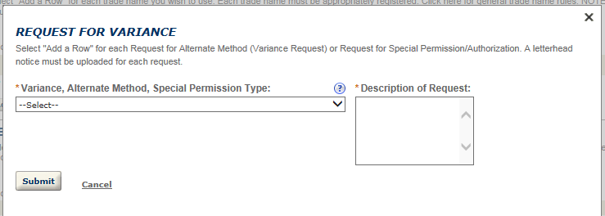
BREWERY OPERATION INFORMATION -1: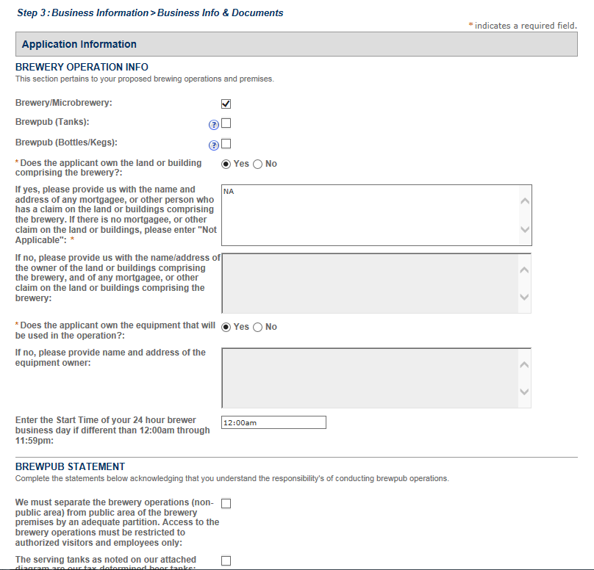
BREWERY OPERATION INFORMATION 2: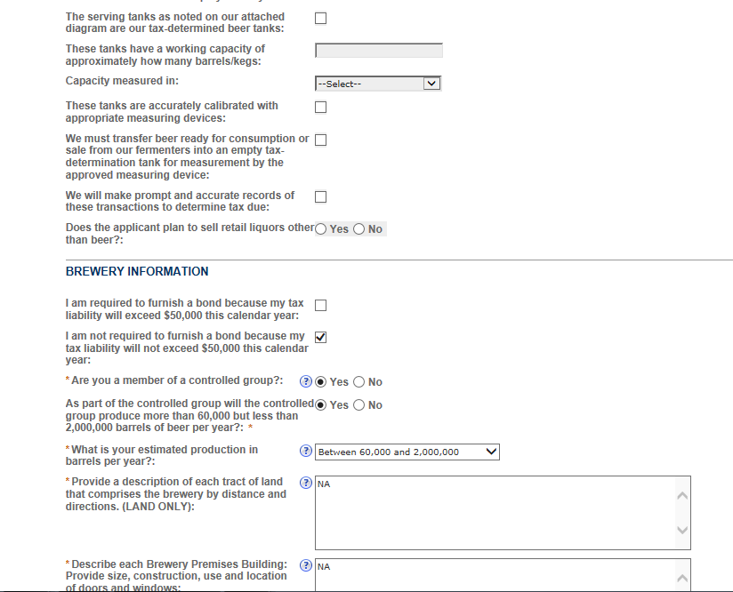
BREWERY OPERATION INFORMATION 3: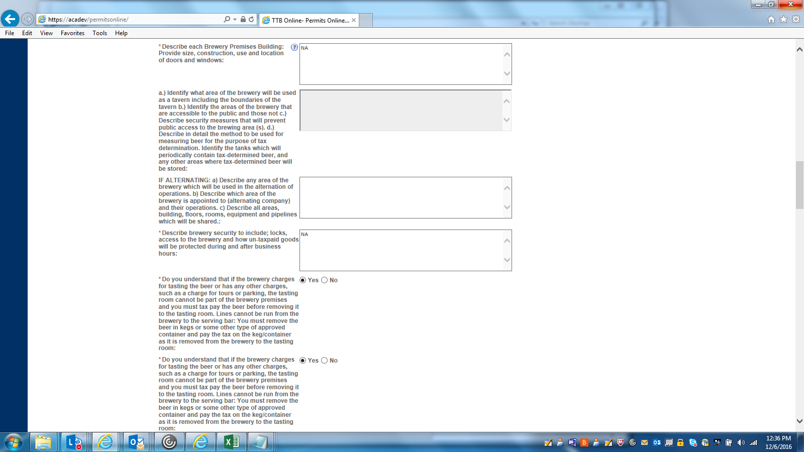
BREWERY OPERATION INFORMATION 4: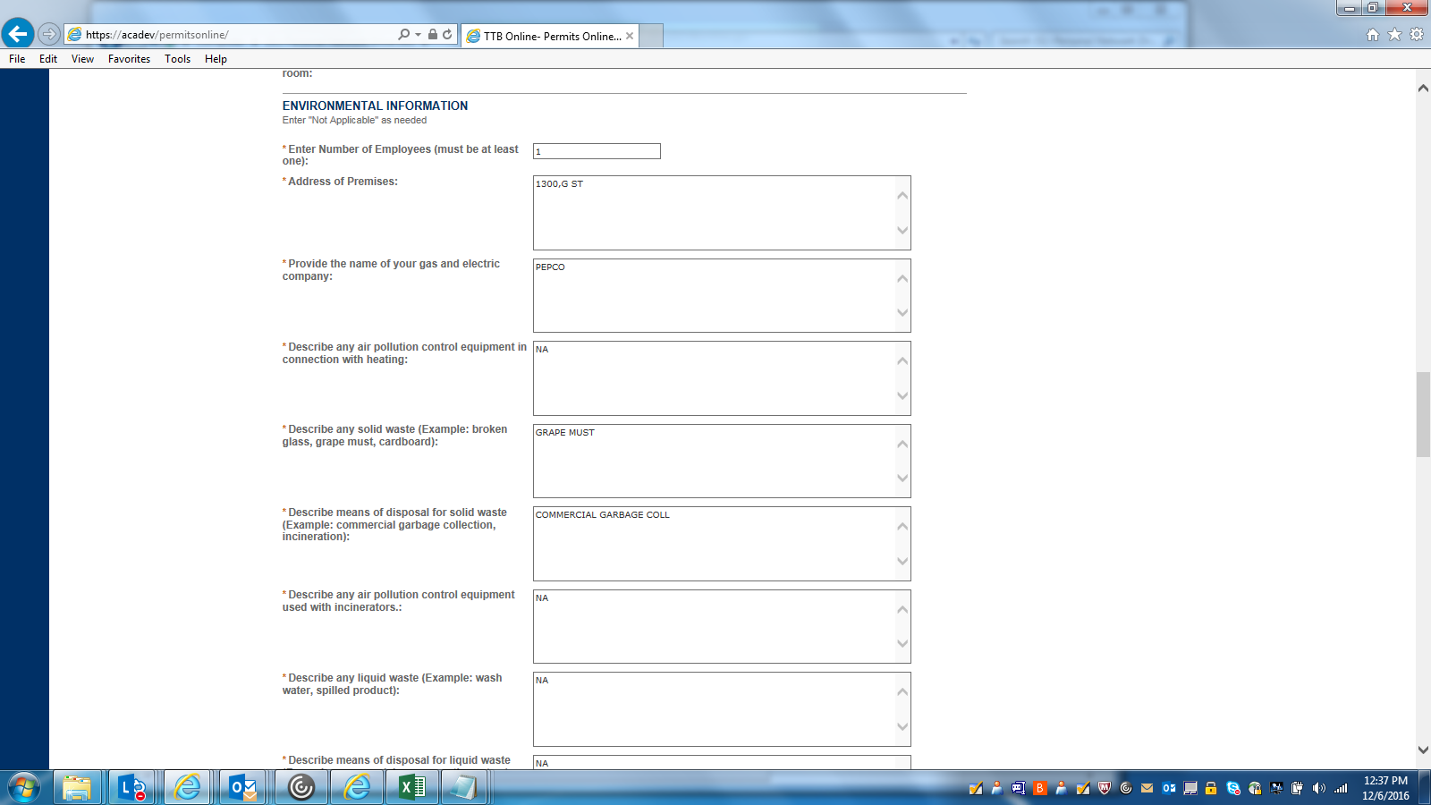
BREWERY OPERATION INFORMATION 5: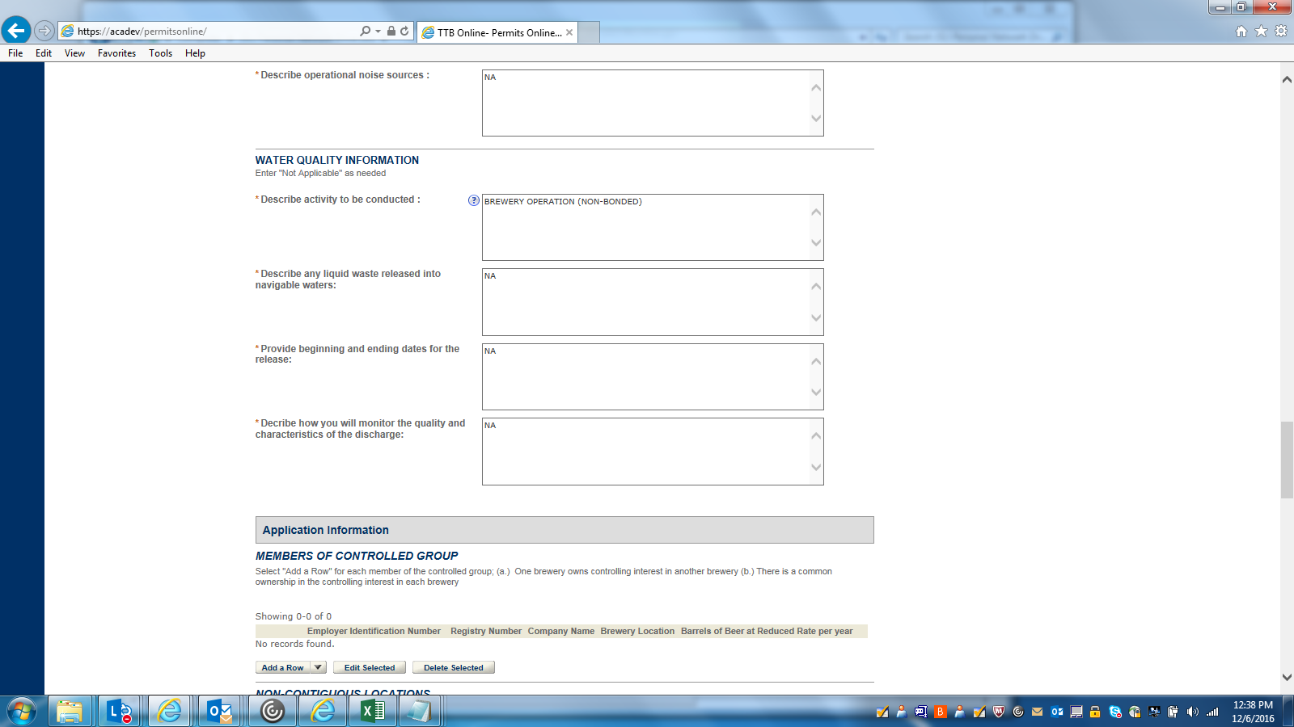
MEMBER OF CONTROLLED GROUP (DETAILS):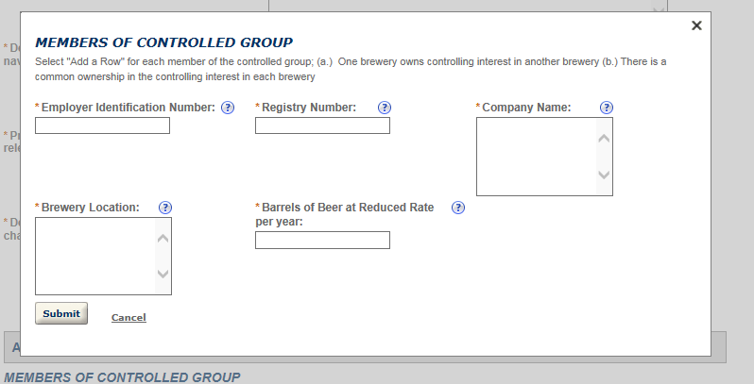
BREWERY OPERATION INFORMATION 6: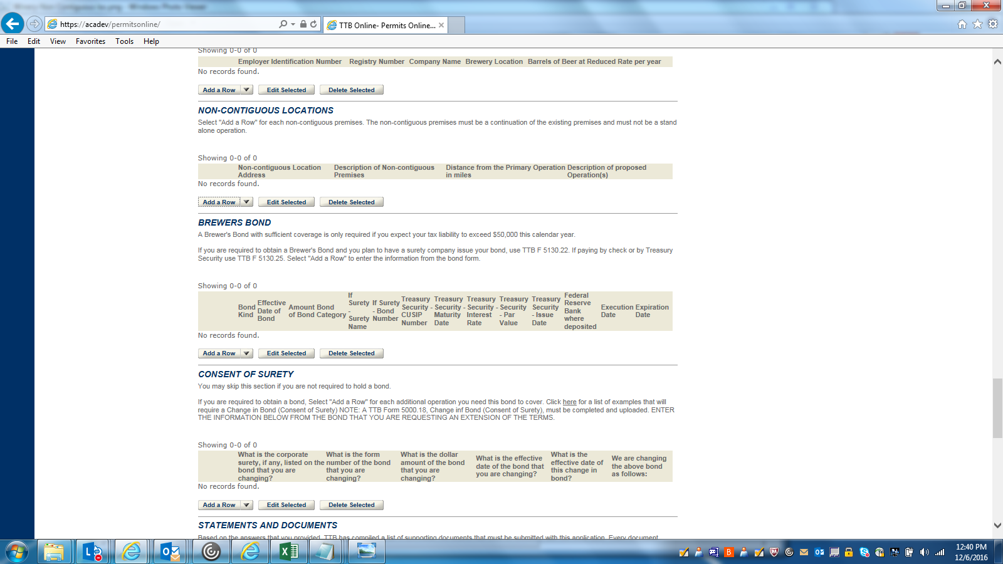
NON-CONTIGUOUS LOCATION (DETAILS):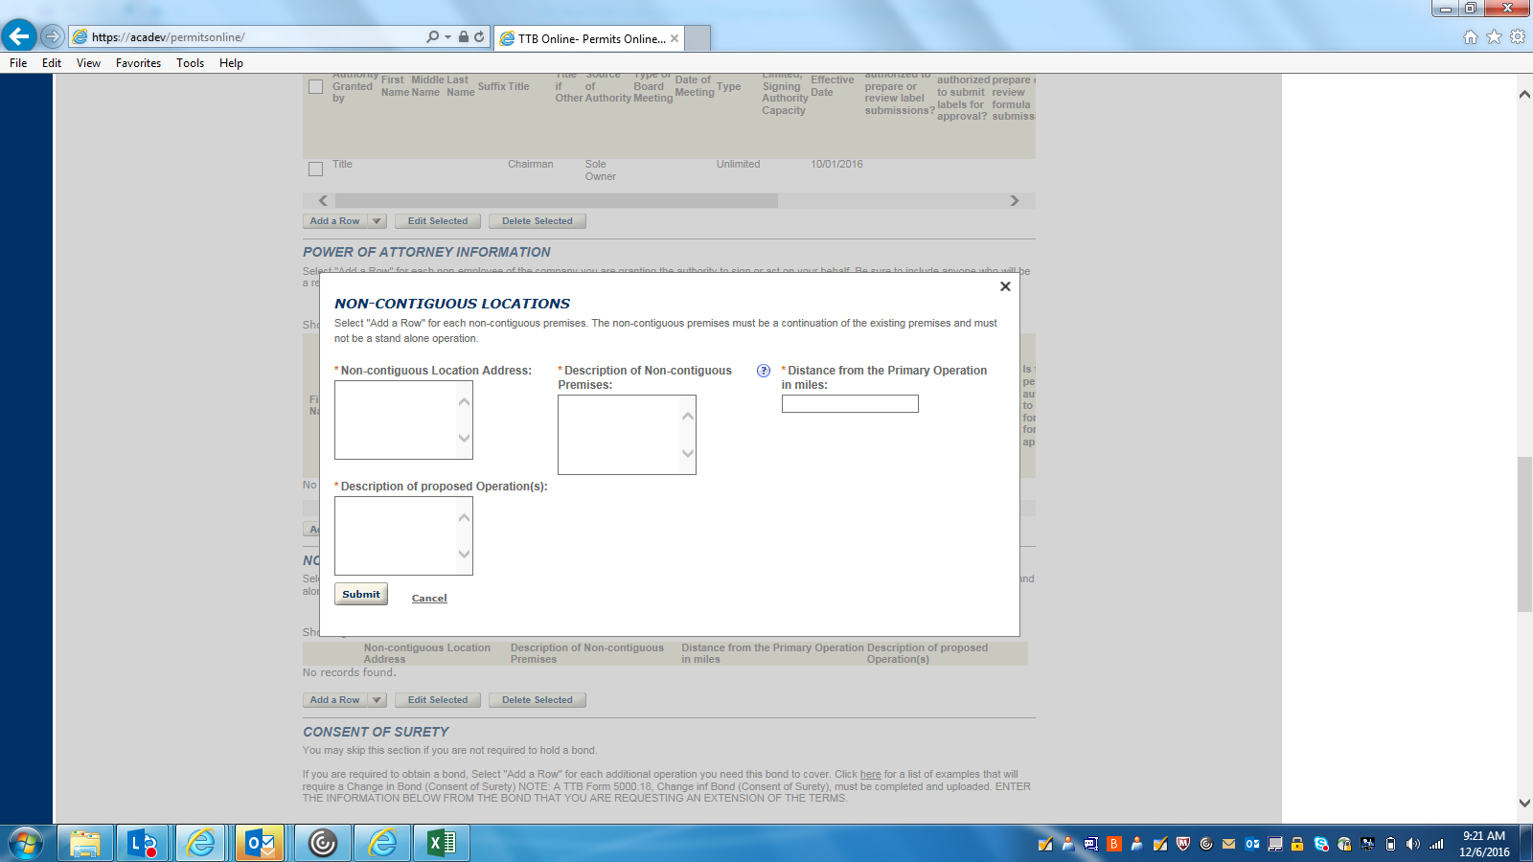BREWERS BOND (DETAILS):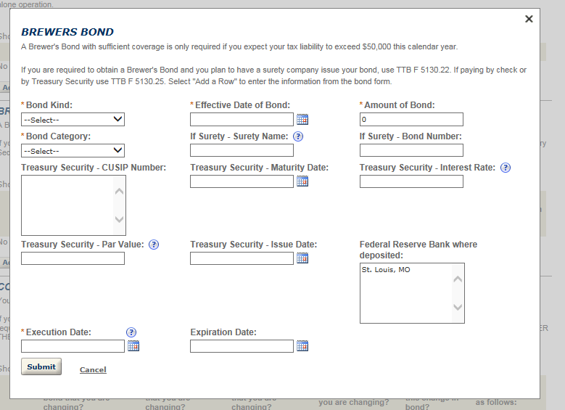
CONSENT OF SURETY (DETAILS):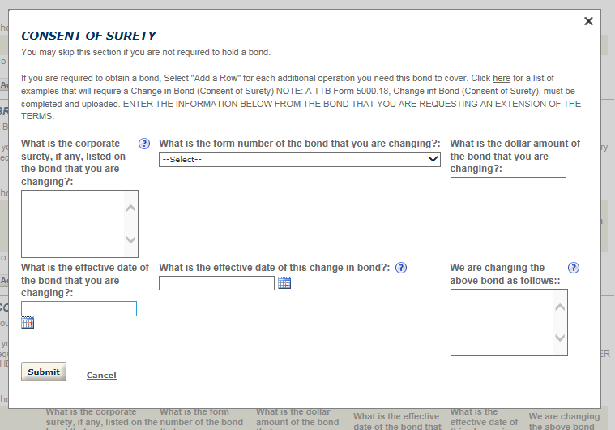
BREWERY OPERATION INFORMATION 7: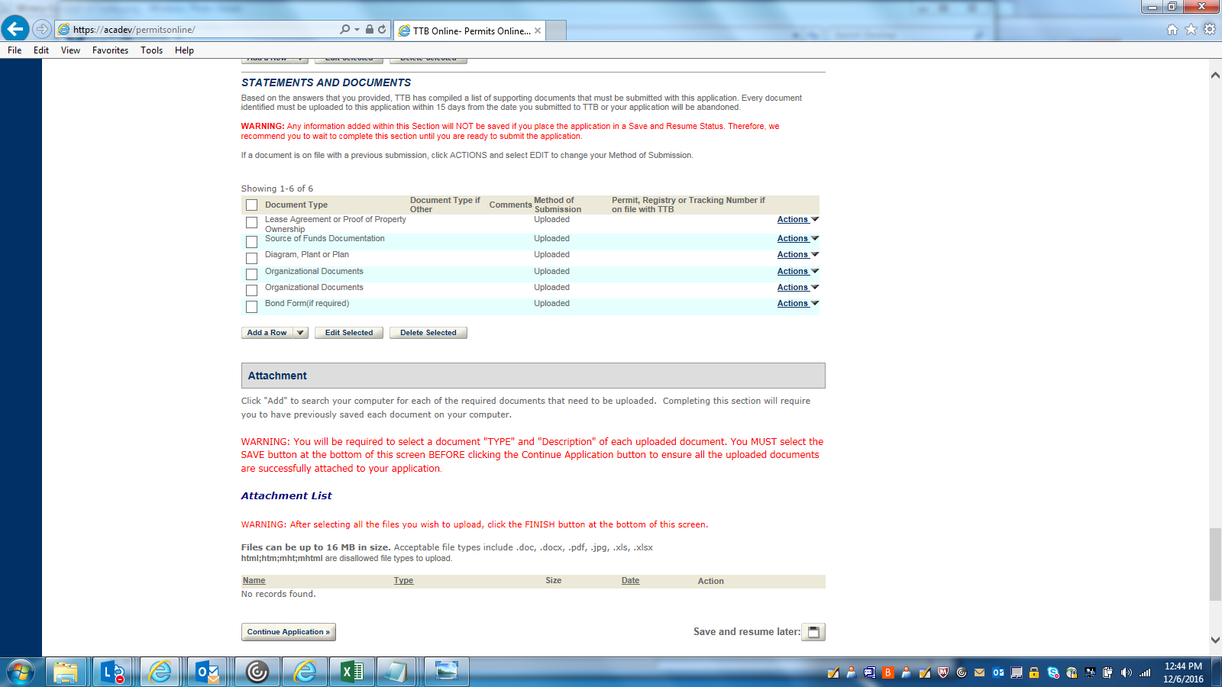
DECLARATION: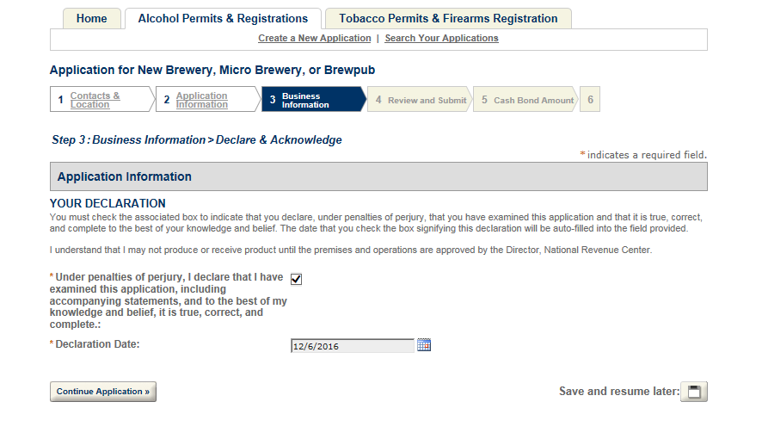
REVIEW AND SUBMIT 1:
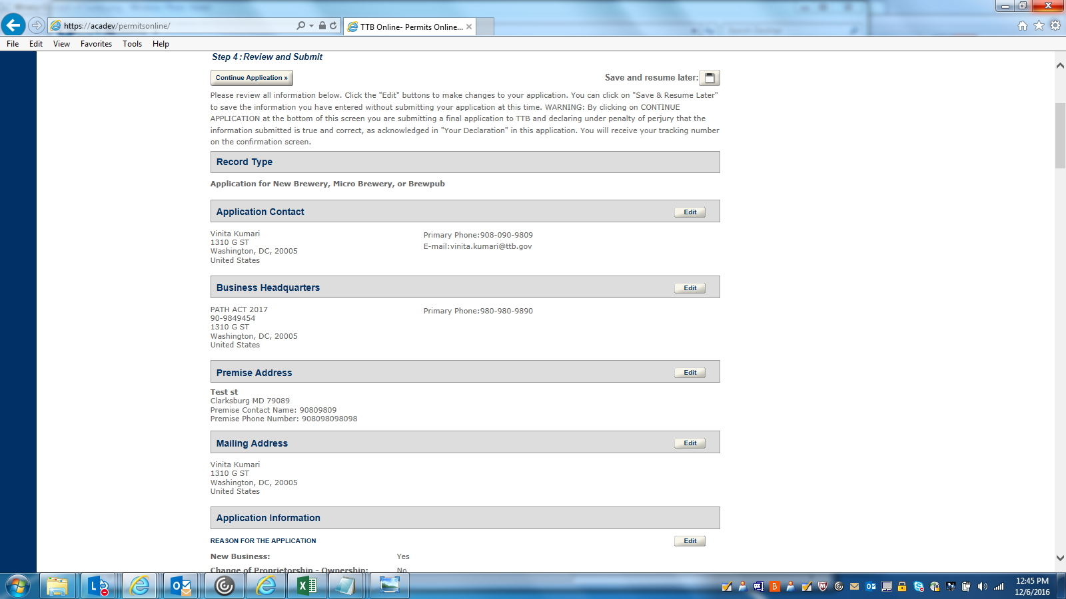
REVIEW AND SUBMIT 2: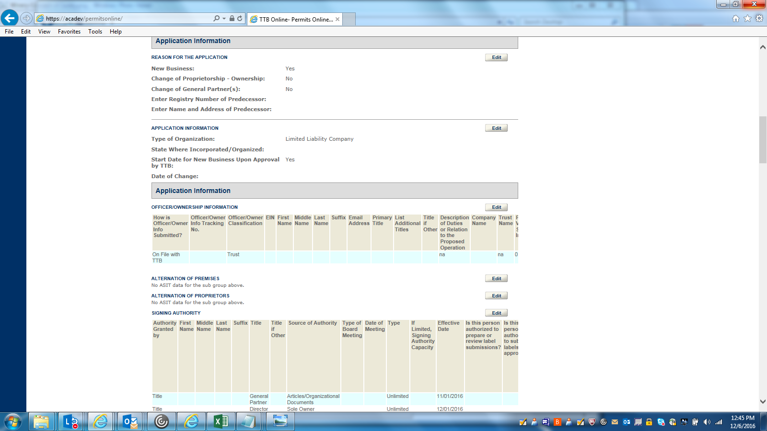
REVIEW AND SUBMIT 3: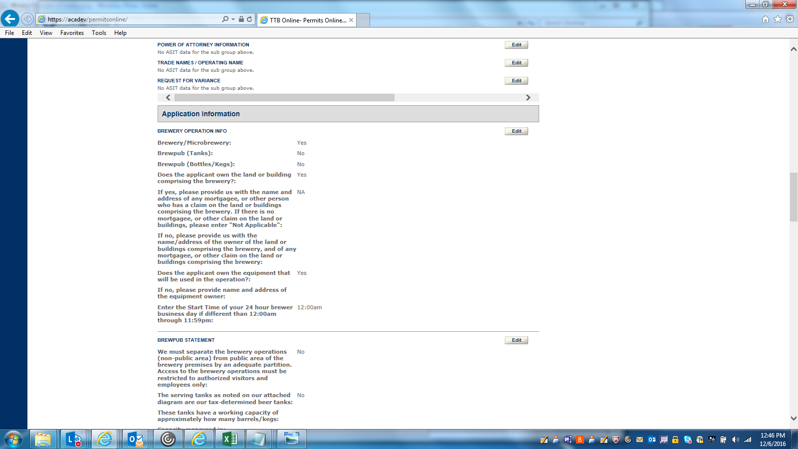
REVIEW AND SUBMIT 4: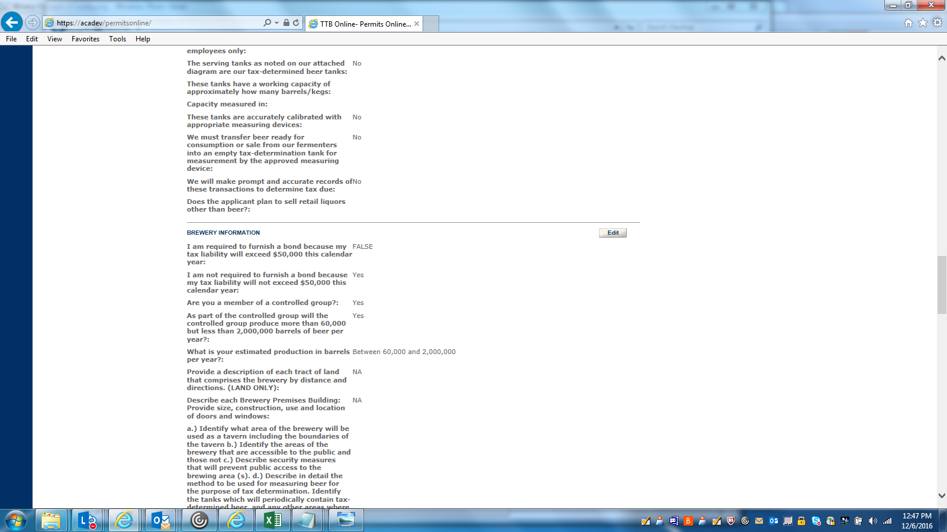
REVIEW AND SUBMIT 5: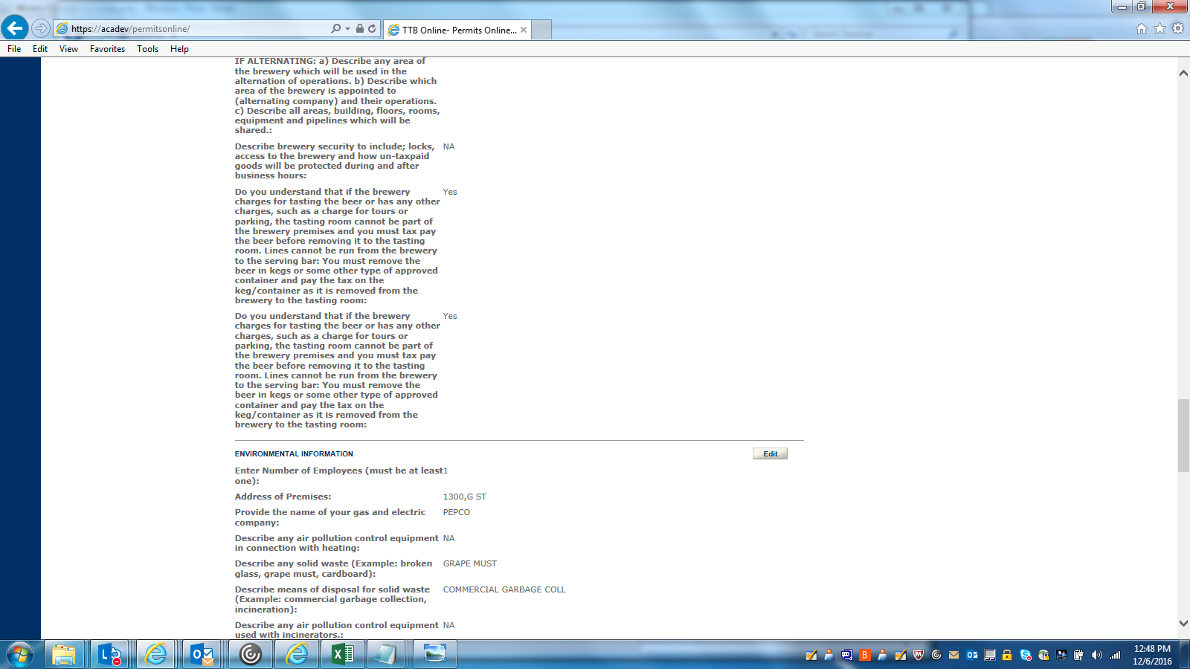
REVIEW AND SUBMIT 6: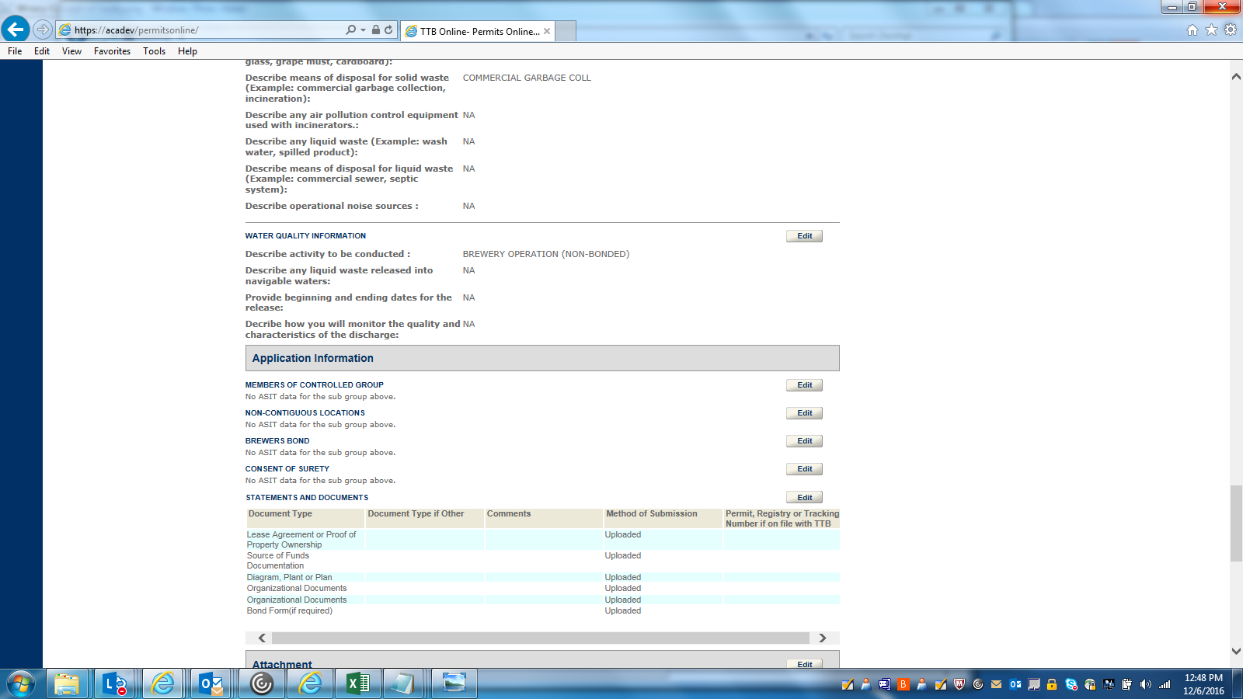
REVIEW AND SUBMIT 7: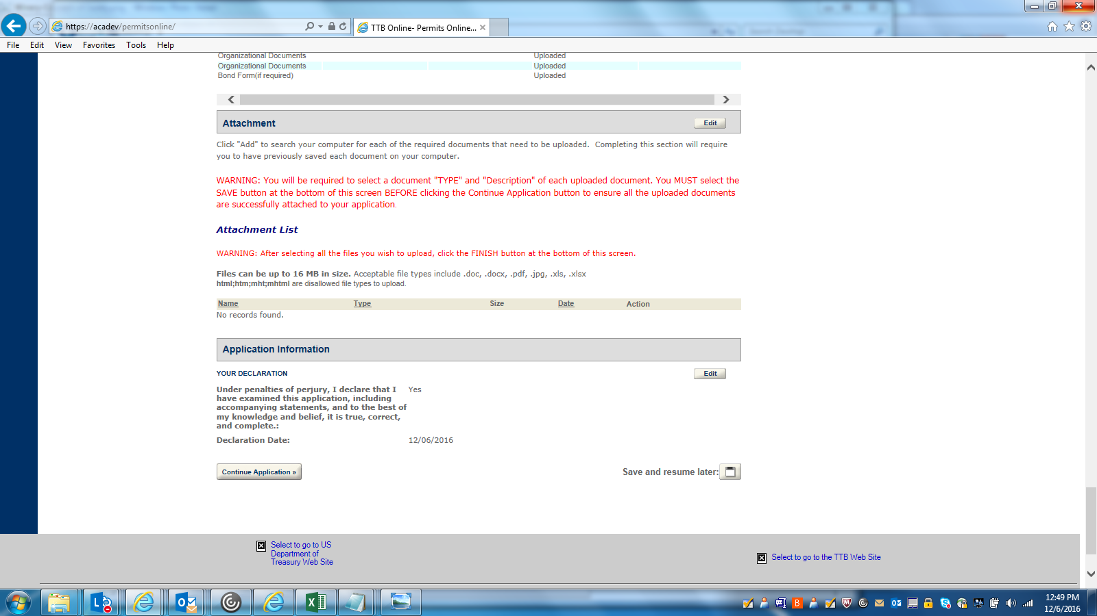
RECORD SUBMITTAL 1: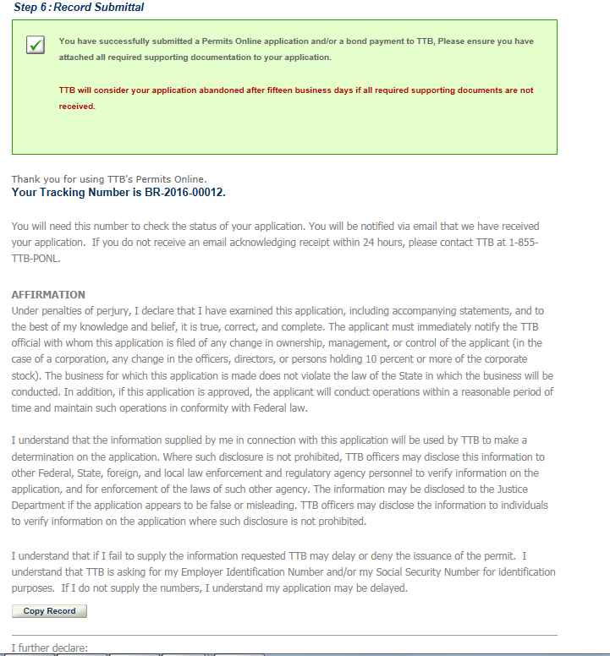
RECORD SUBMITTAL 2: