Permits Online – Original Winery Application

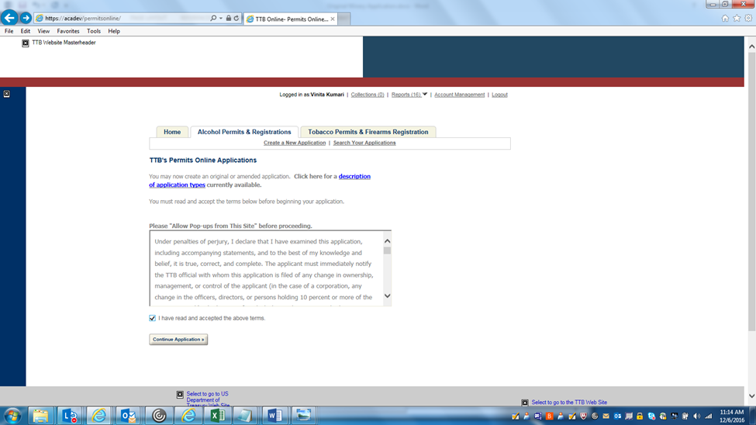
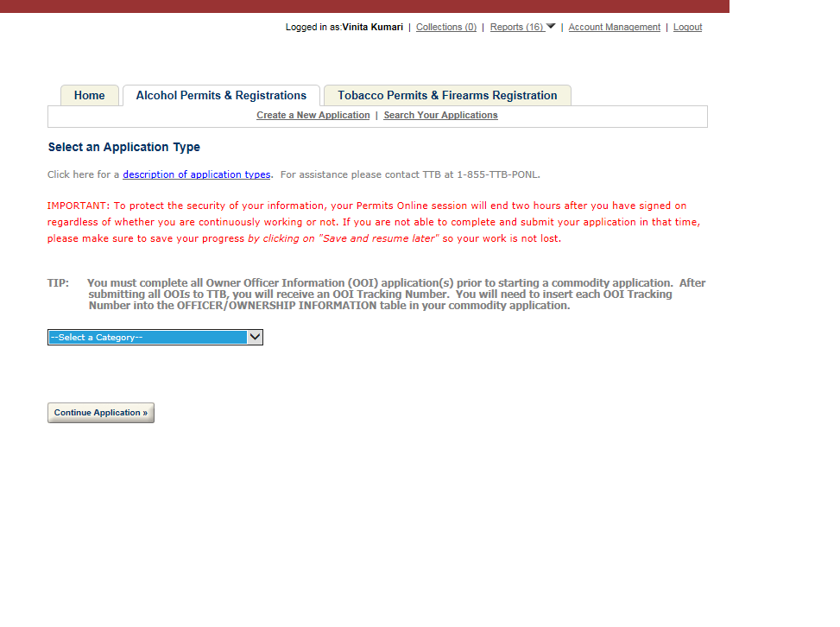

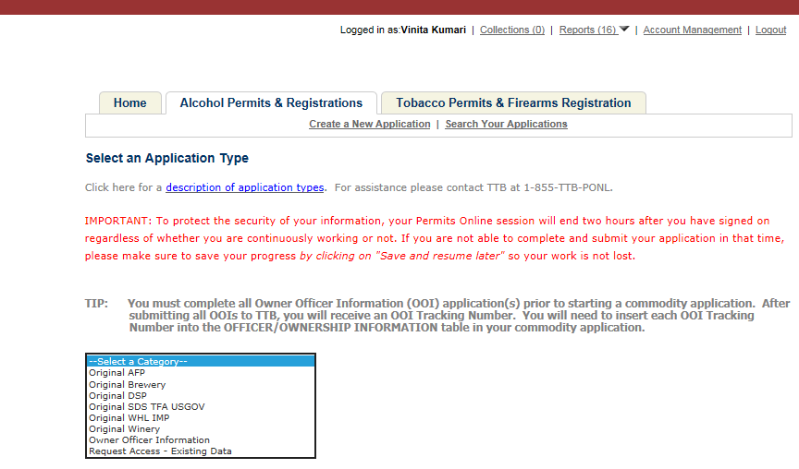
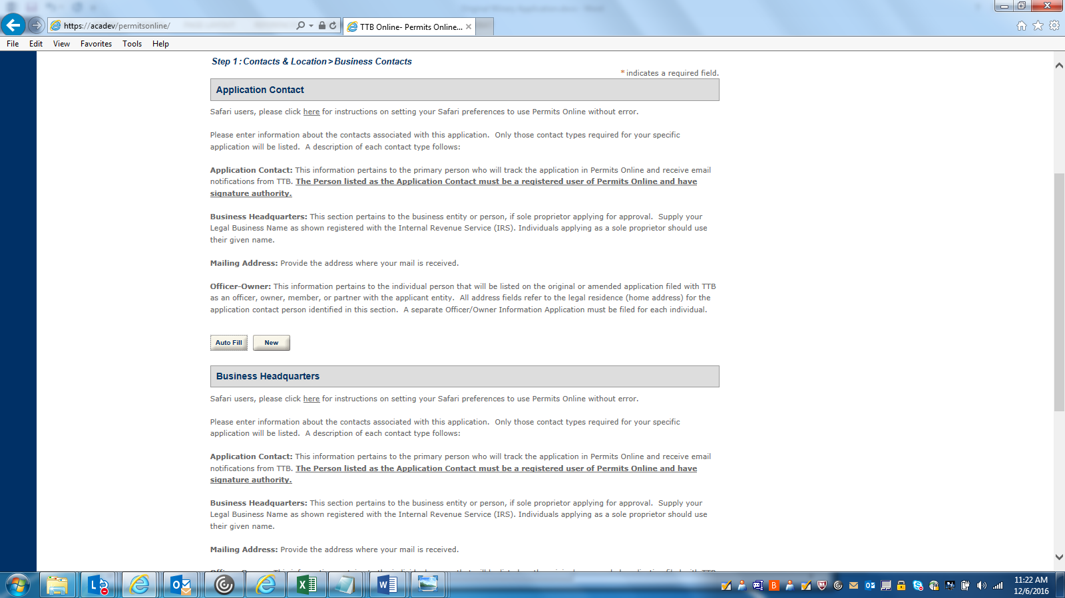
APPLICATION CONTACT DETAILS: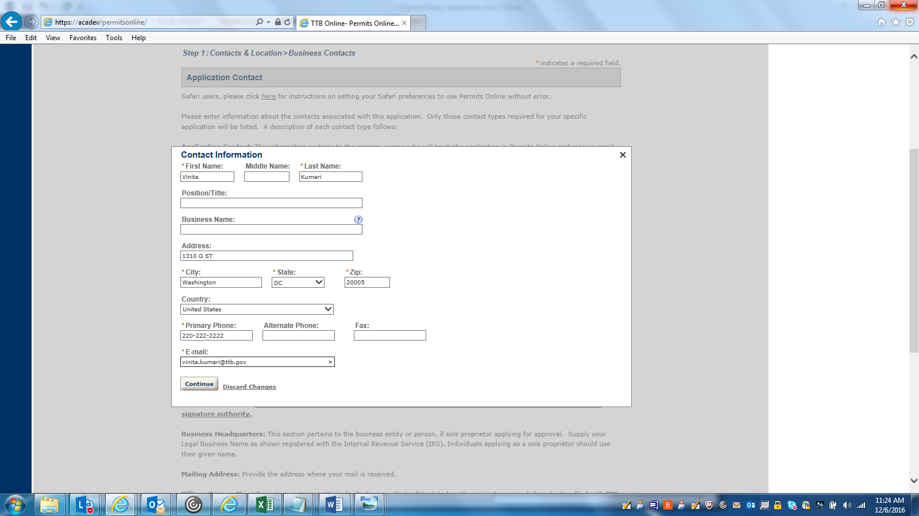

BUSINESS HEADQUARTERS DETATILS: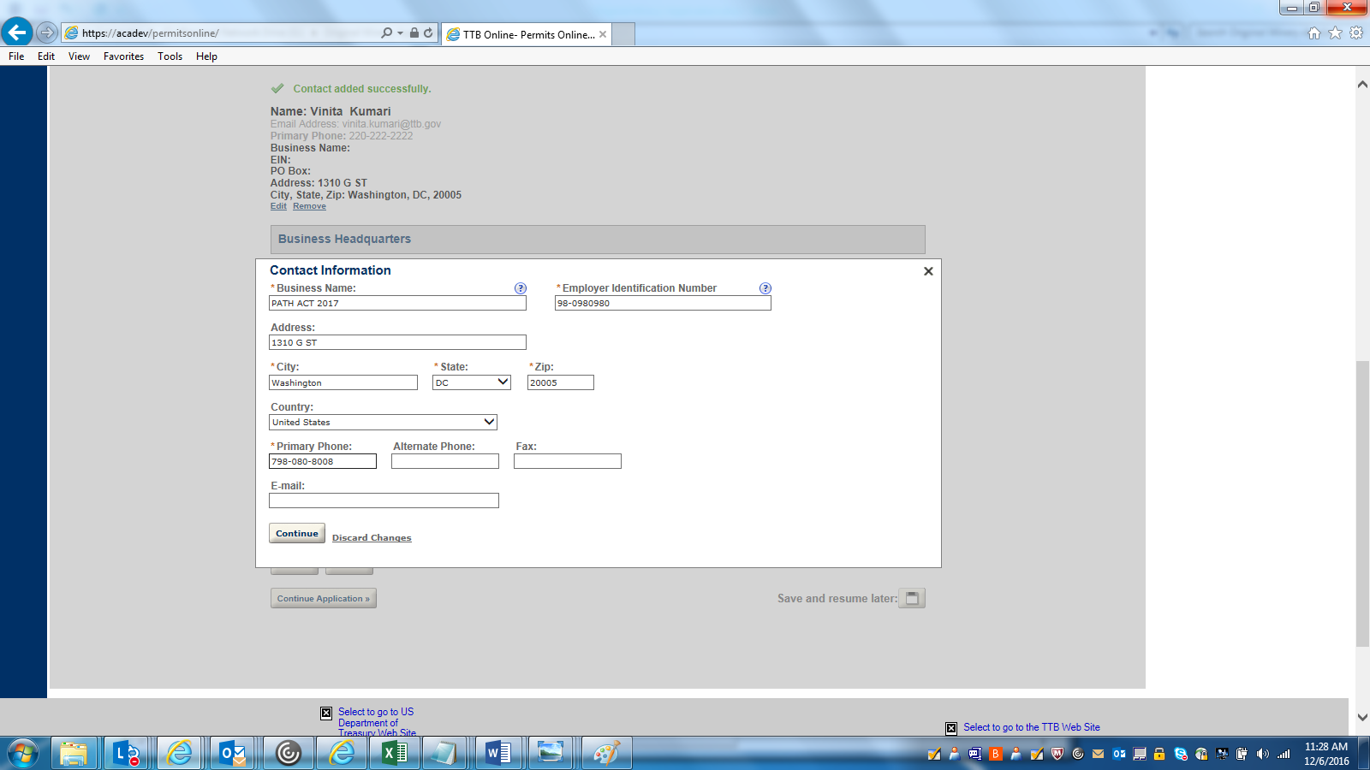

PREMISE ADDRESS DETAILS:
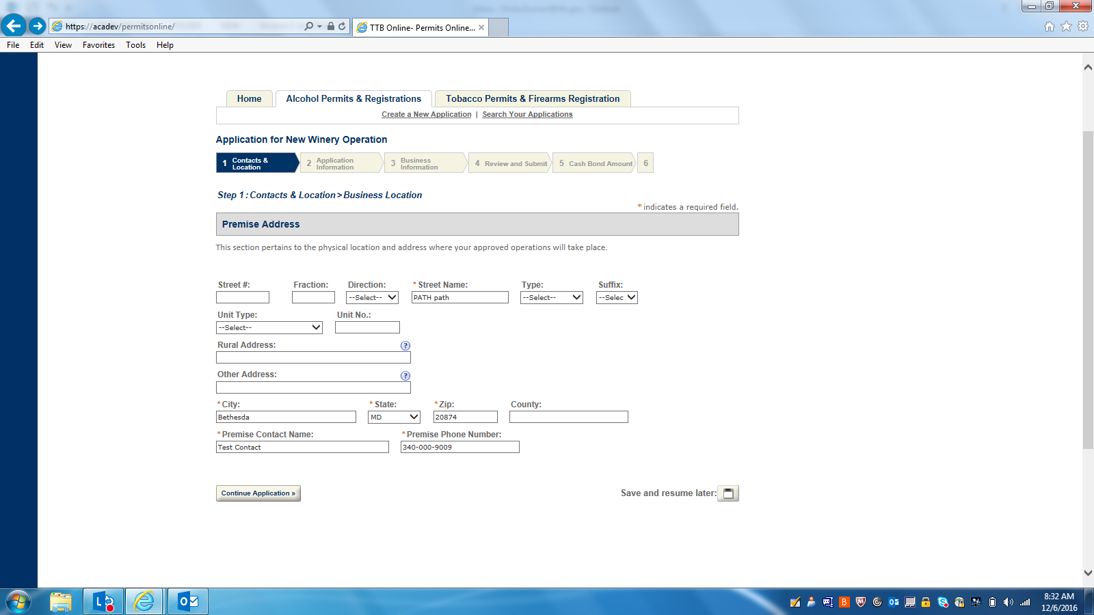

MAILING ADDRSS DETAILS:
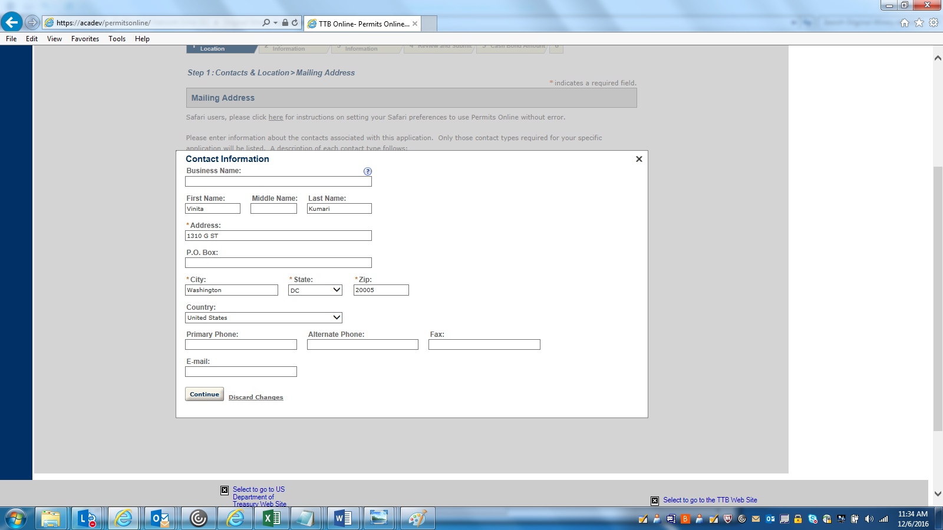

APPLICATION INFORMATION--1: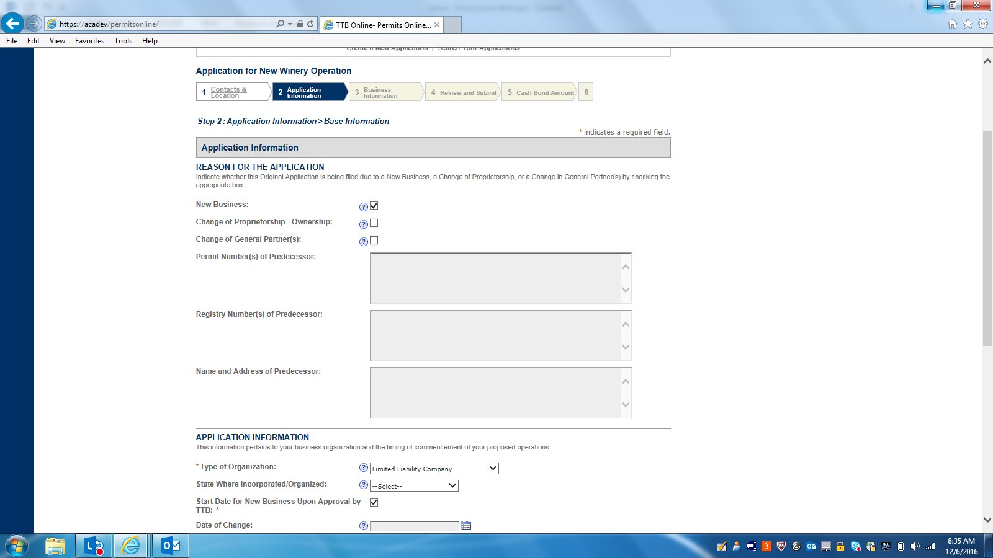

APPLICATION INFORMATION--2: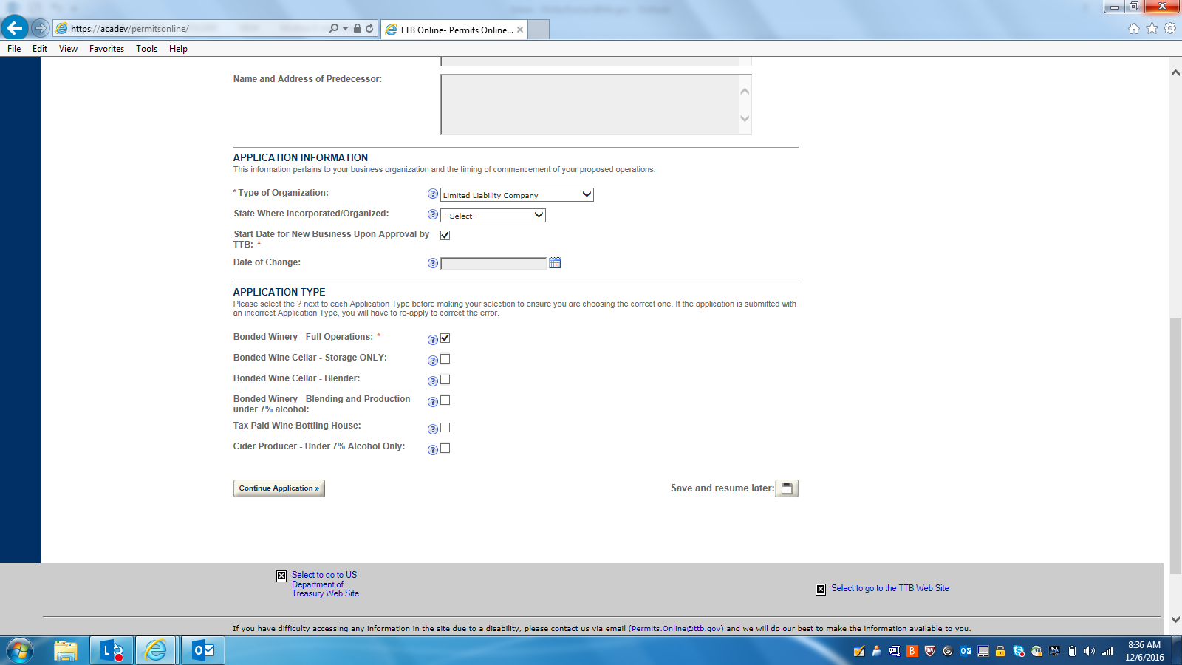

OWNER BACKGROUND INFORMATION: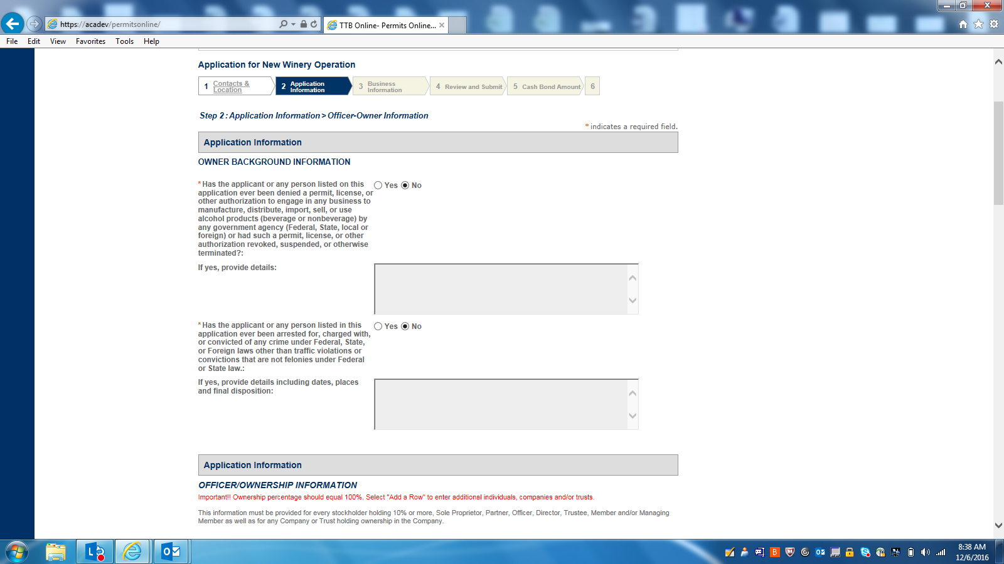

OFFICER-OWNER INFORMATION--1: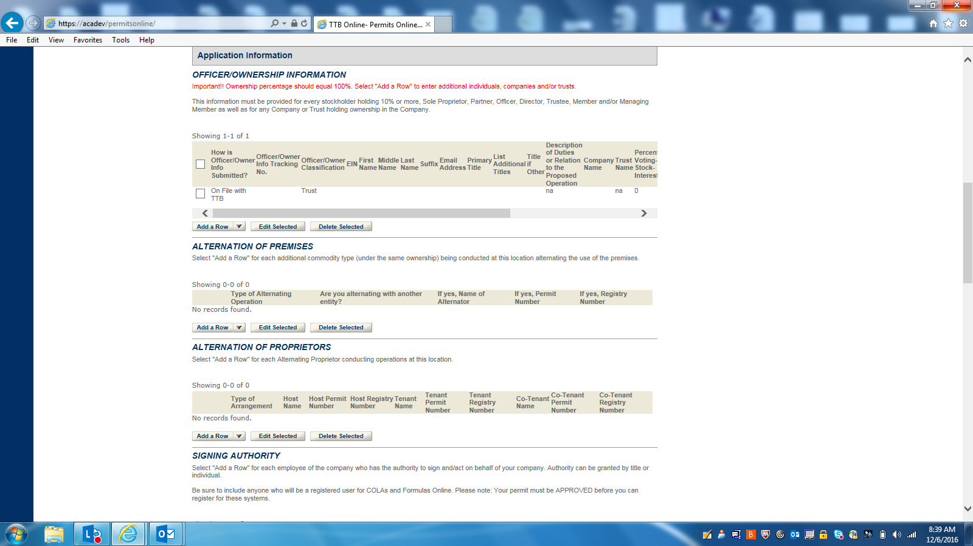

OFFICER-OWNER INFORMATION (DETAILS):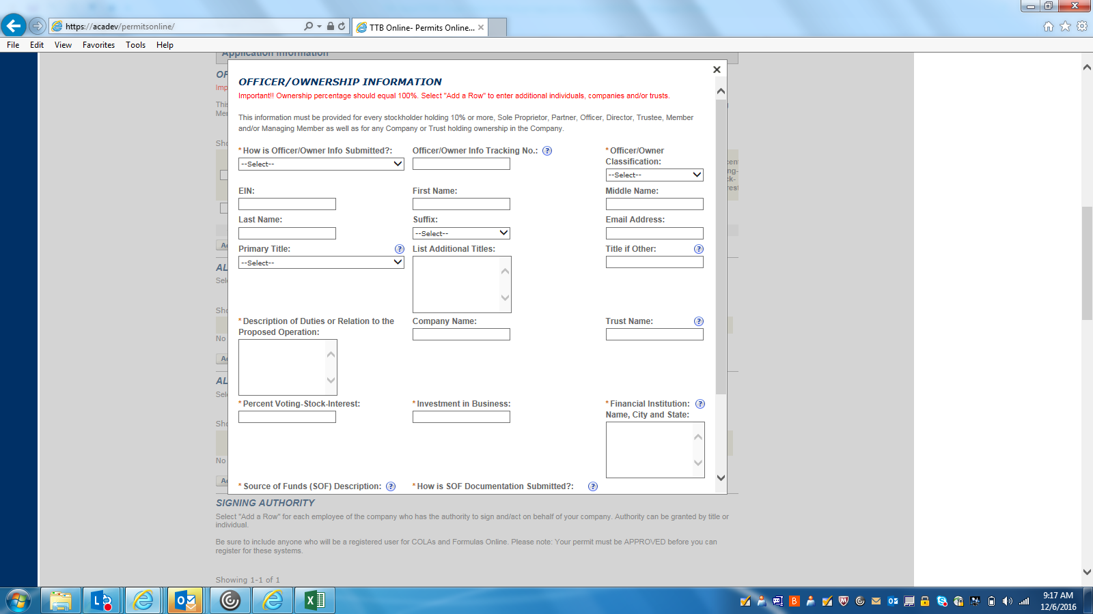

ALTERNATION OF PREMISES (DETAILS):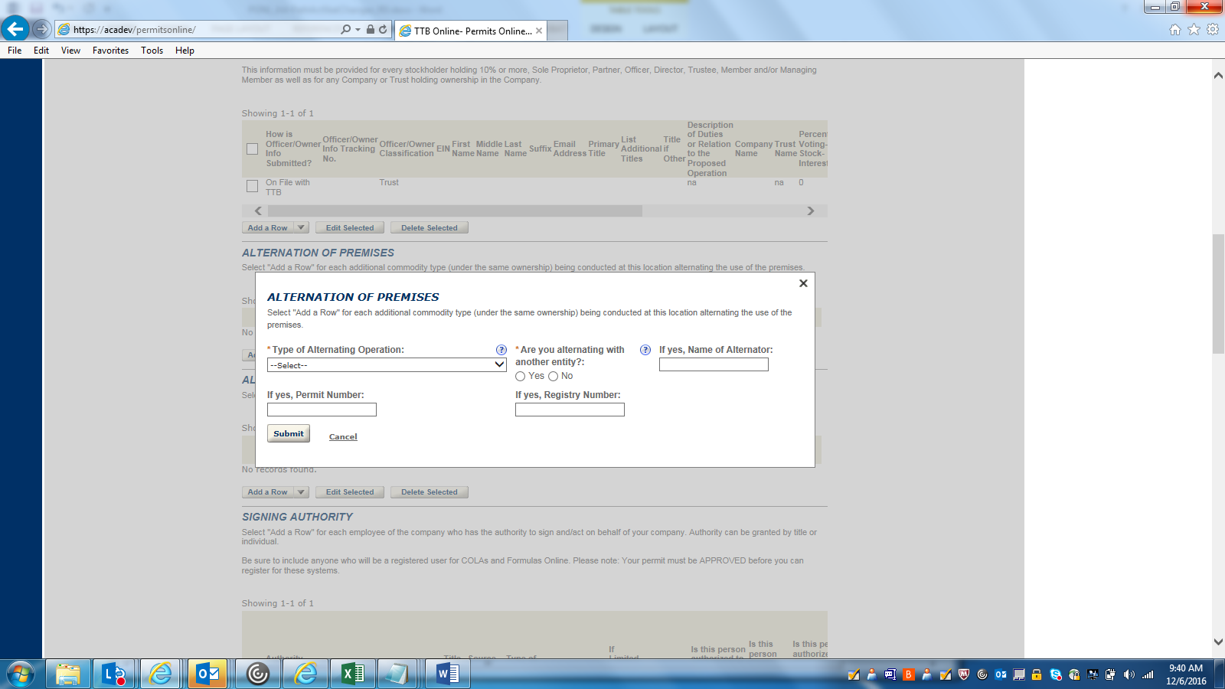

ALTERNATION OF PROPRIETORS (DETAILS):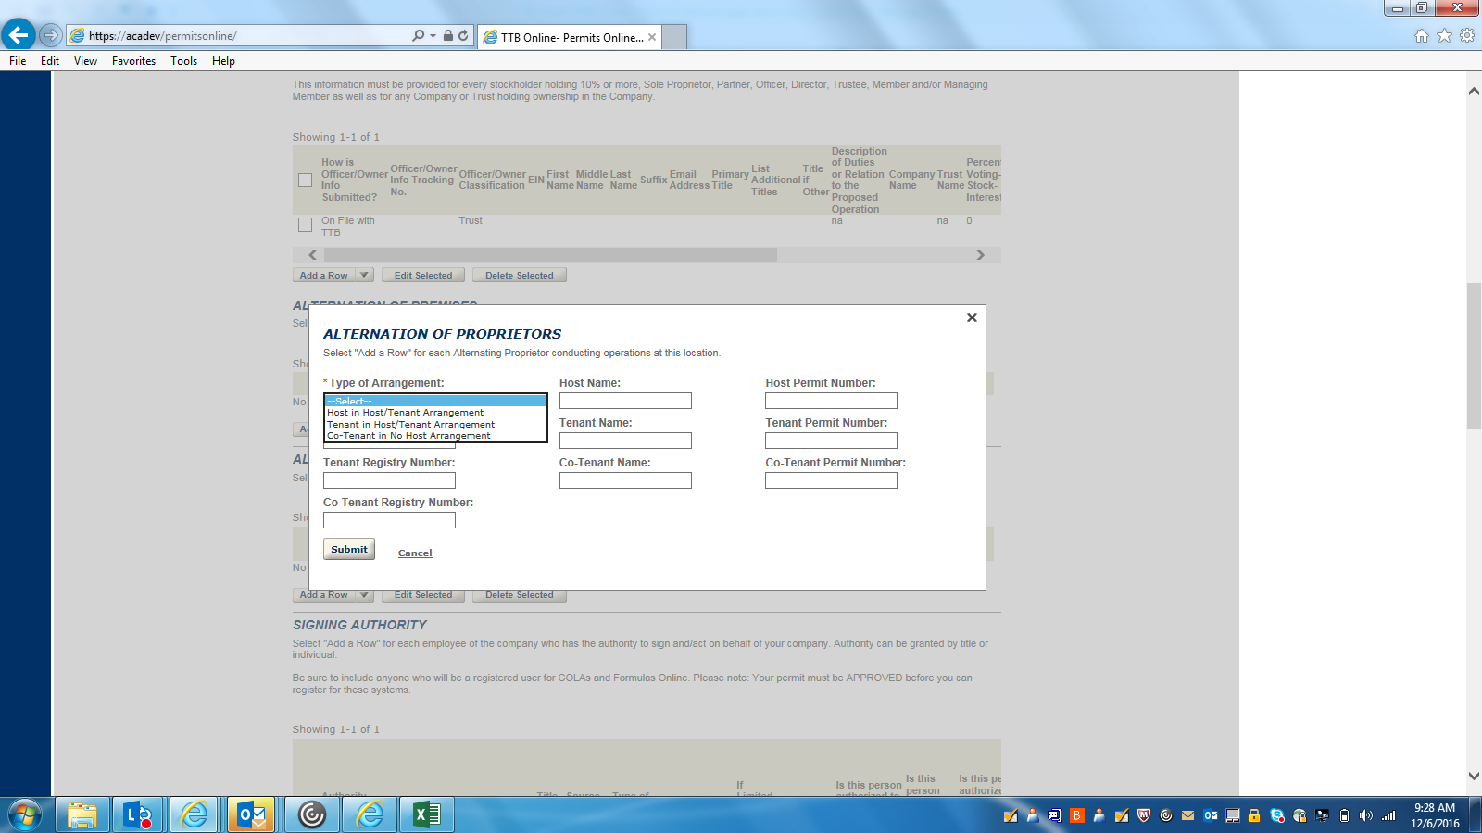

SIGNING AUTHORITY (DETAILS):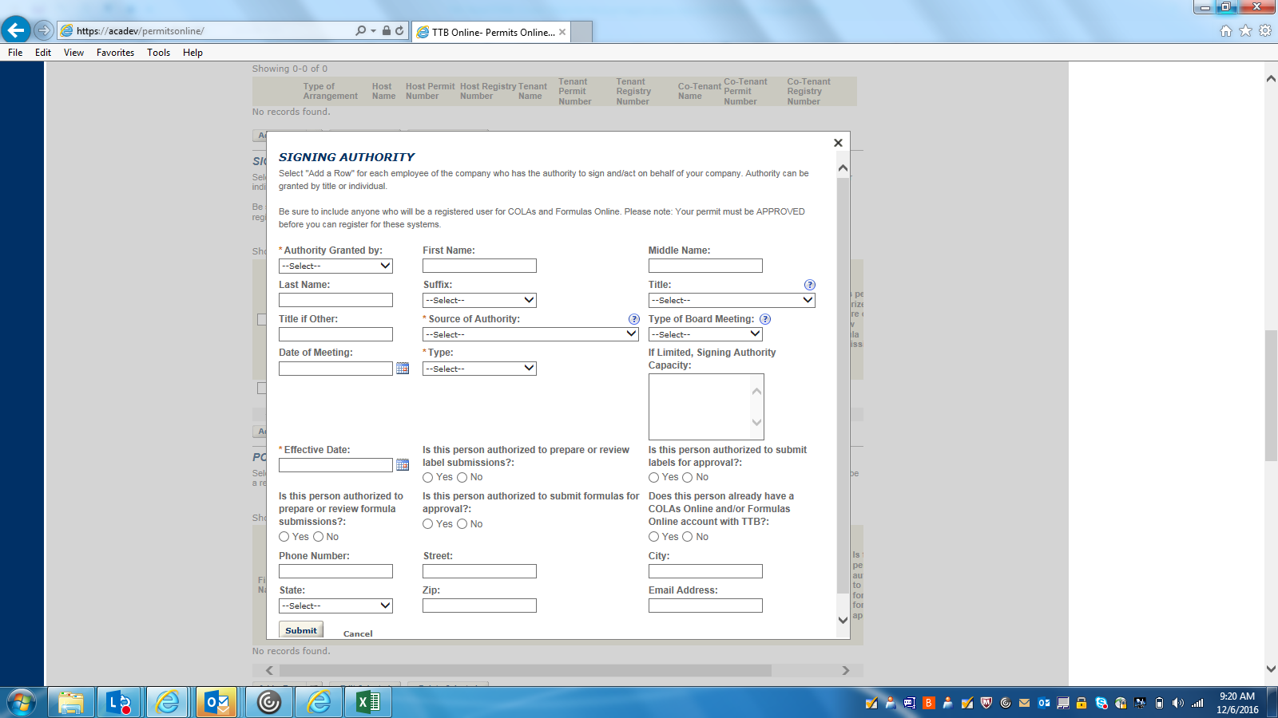

OFFICER-OWNER INFORMATION--2: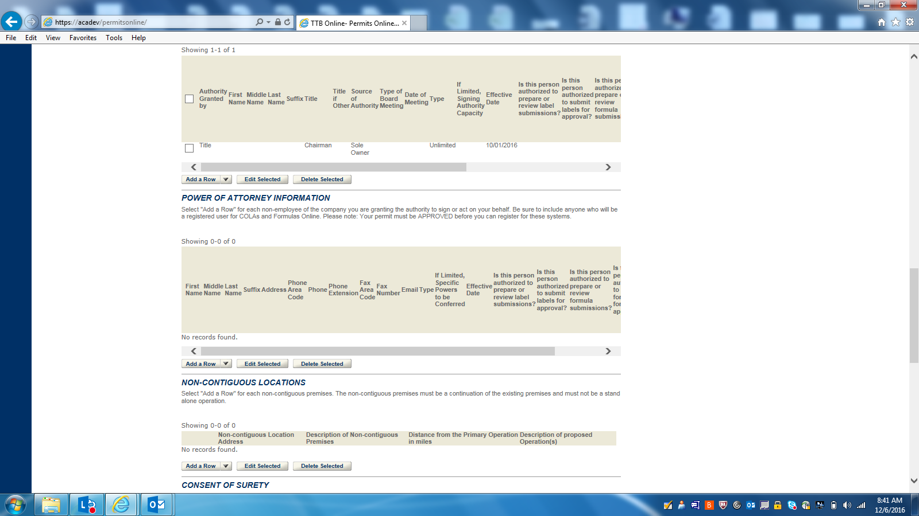

POWER OF ATTORNEY (DETAILS):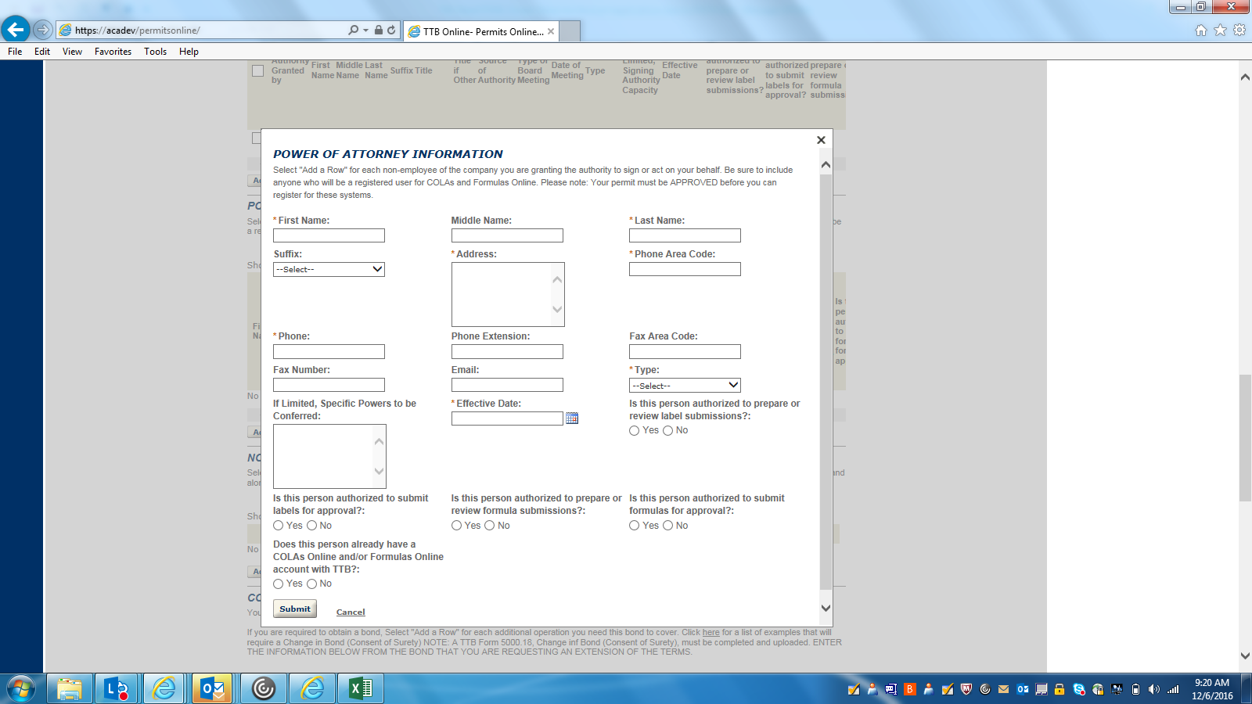

NON-CONTIGUOUS LOCATION (DETAILS):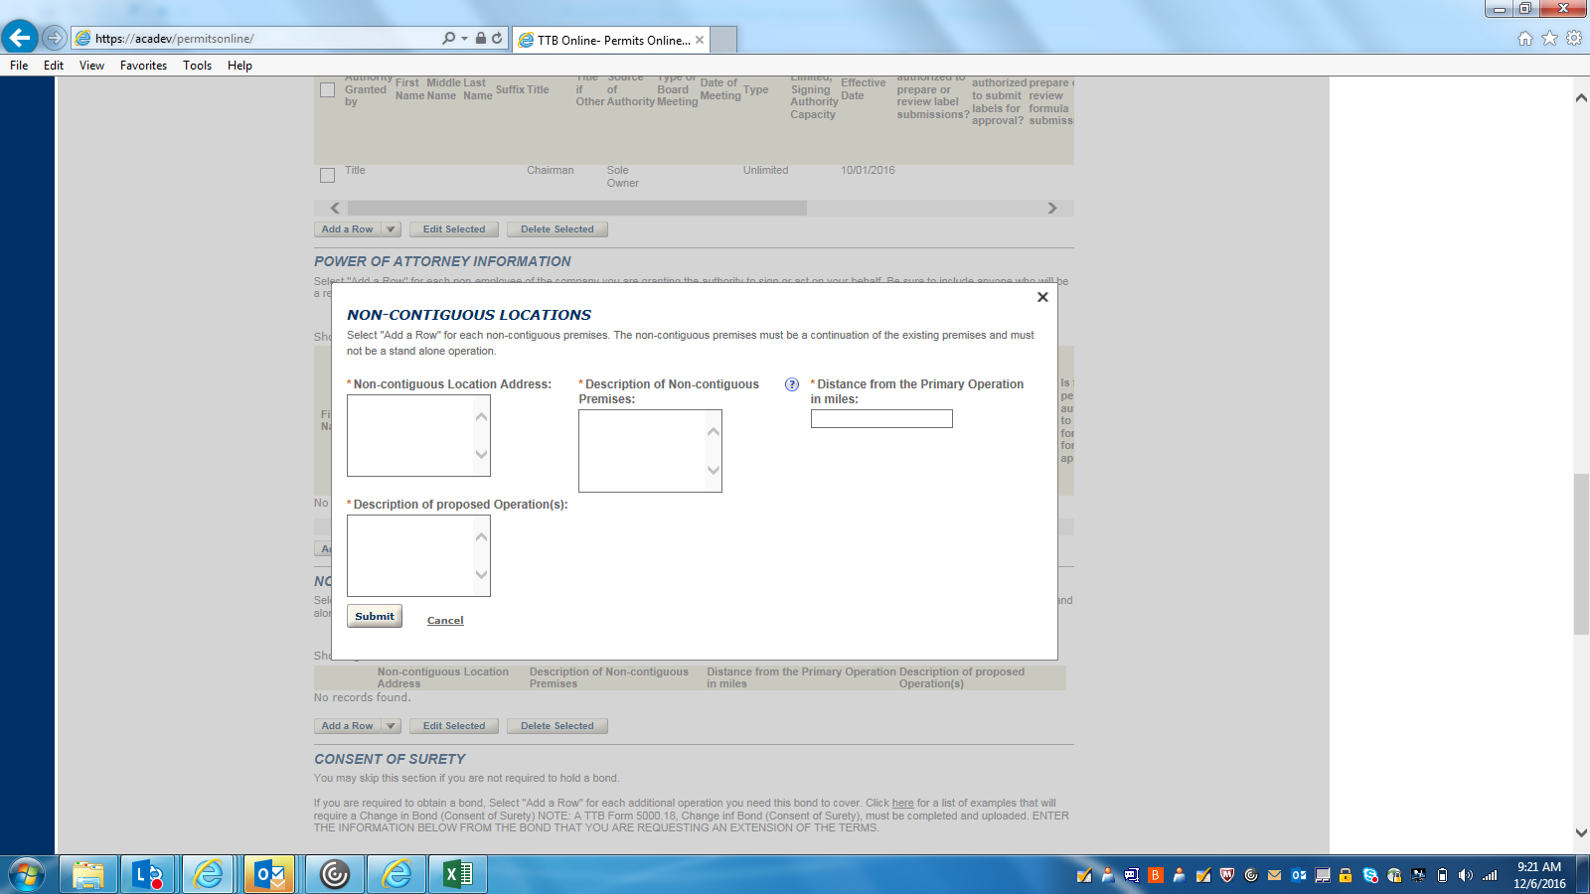

OFFICER-OWNER INFORMATION--3: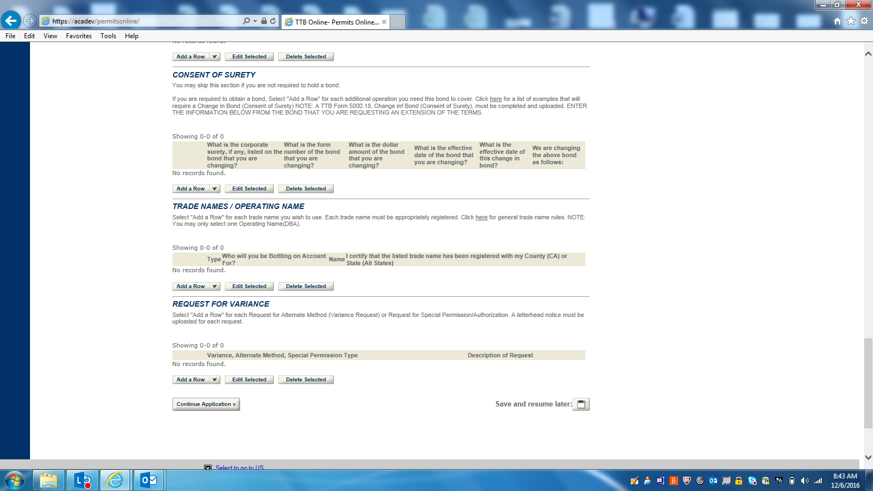

CONSENT OF SURETY (DETAILS):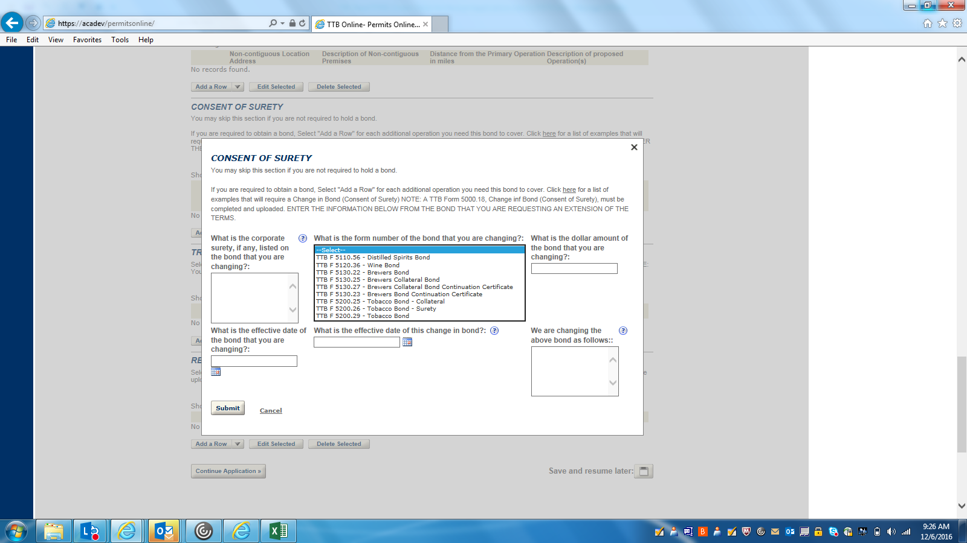

TRADE NAMES/ OPERATING NAME (DETAILS):
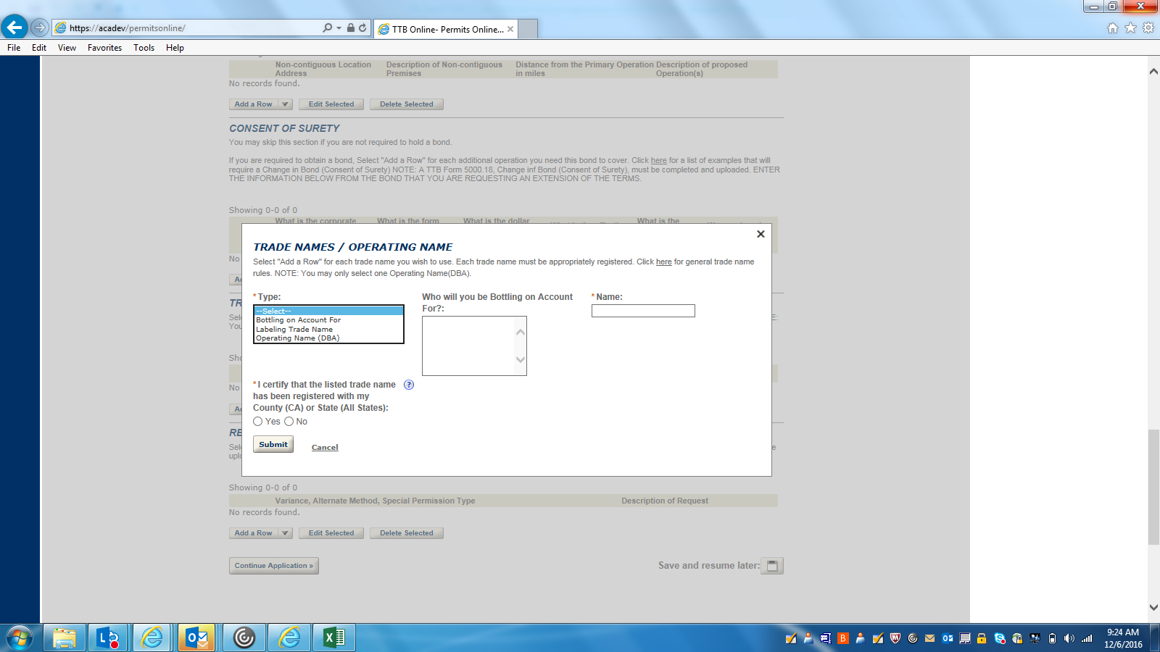

REQUEST FOR VARIANCE (DETAILS):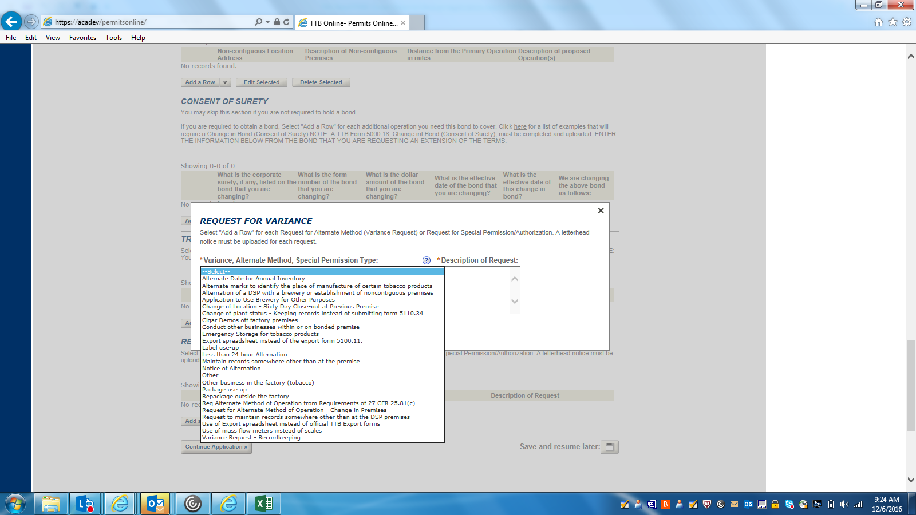

WINERY BUSINESS INFORMATION--1: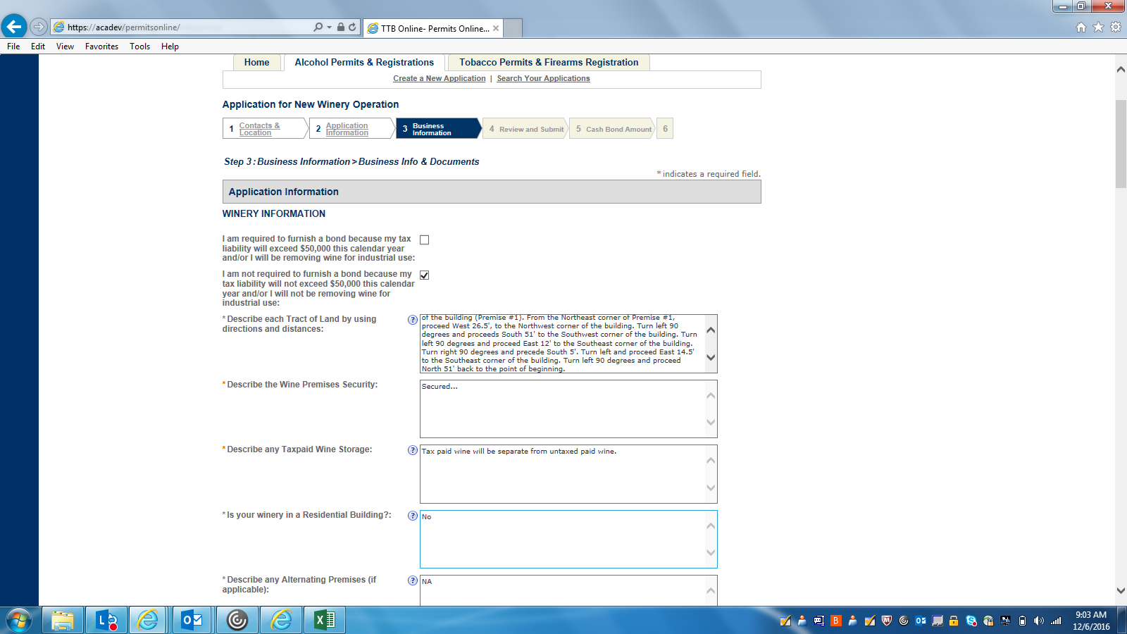

WINERY BUSINESS INFORMATION--2: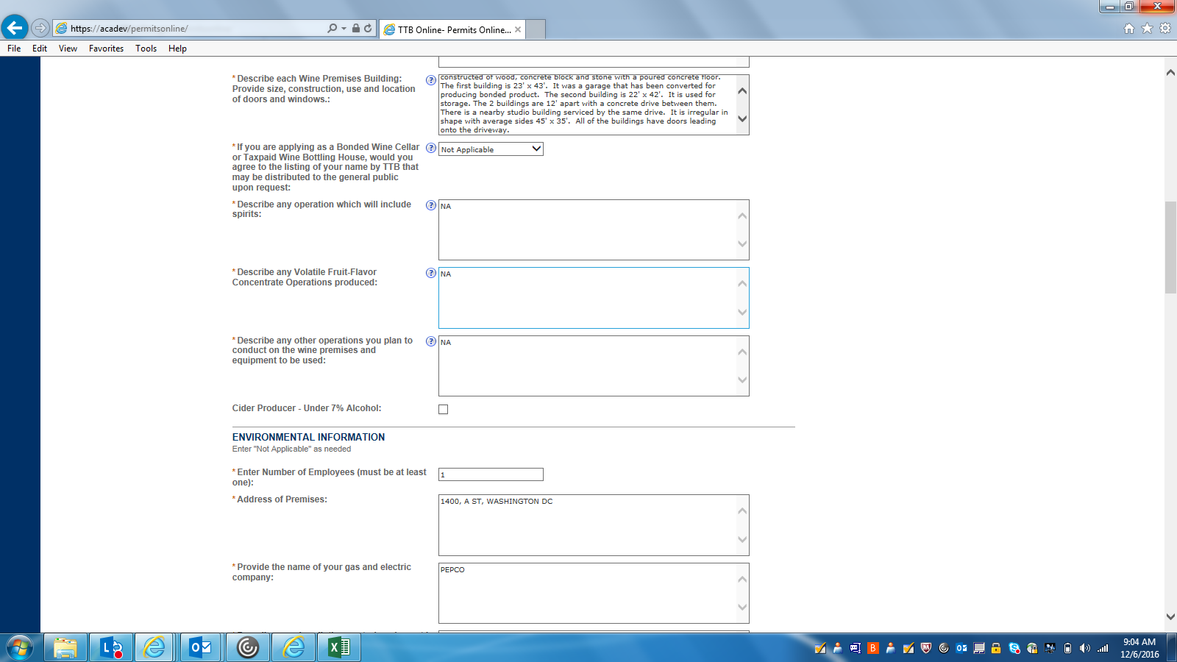

WINERY BUSINESS INFORMATION--3: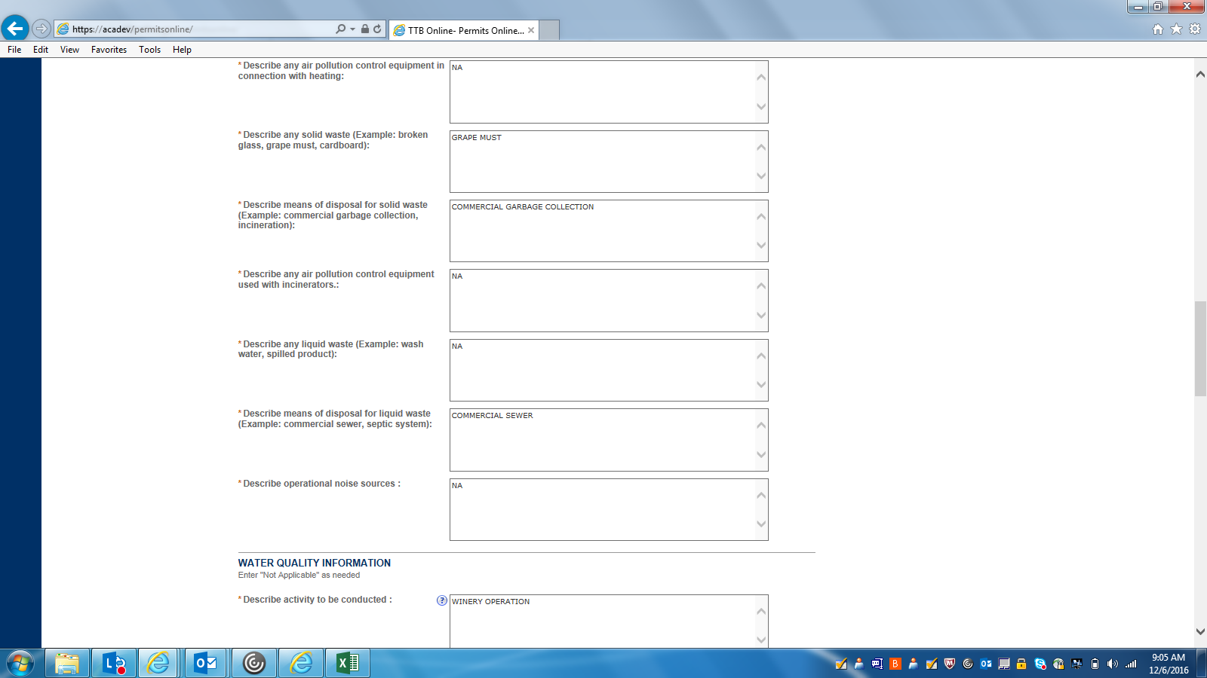

WINERY BUSINESS INFORMATION 4: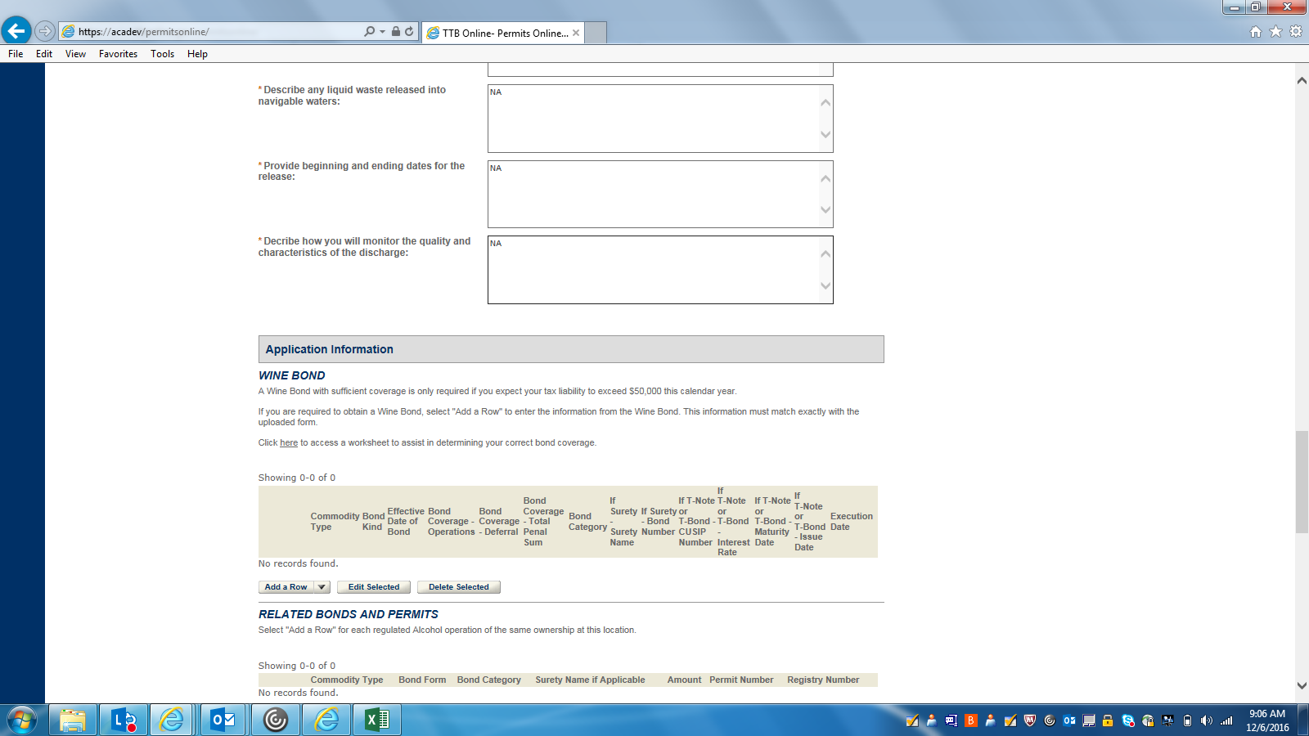

WINE BOND (DETAIL)
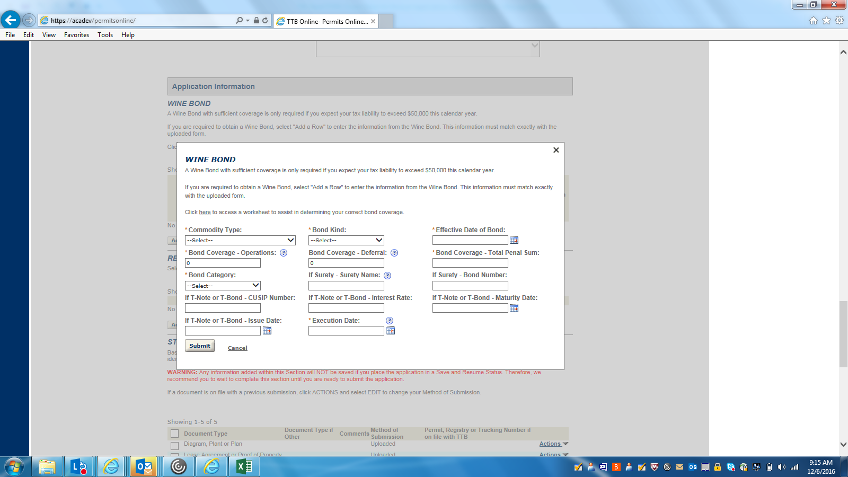

RELATED BOND AND PERMITS (DETAIL):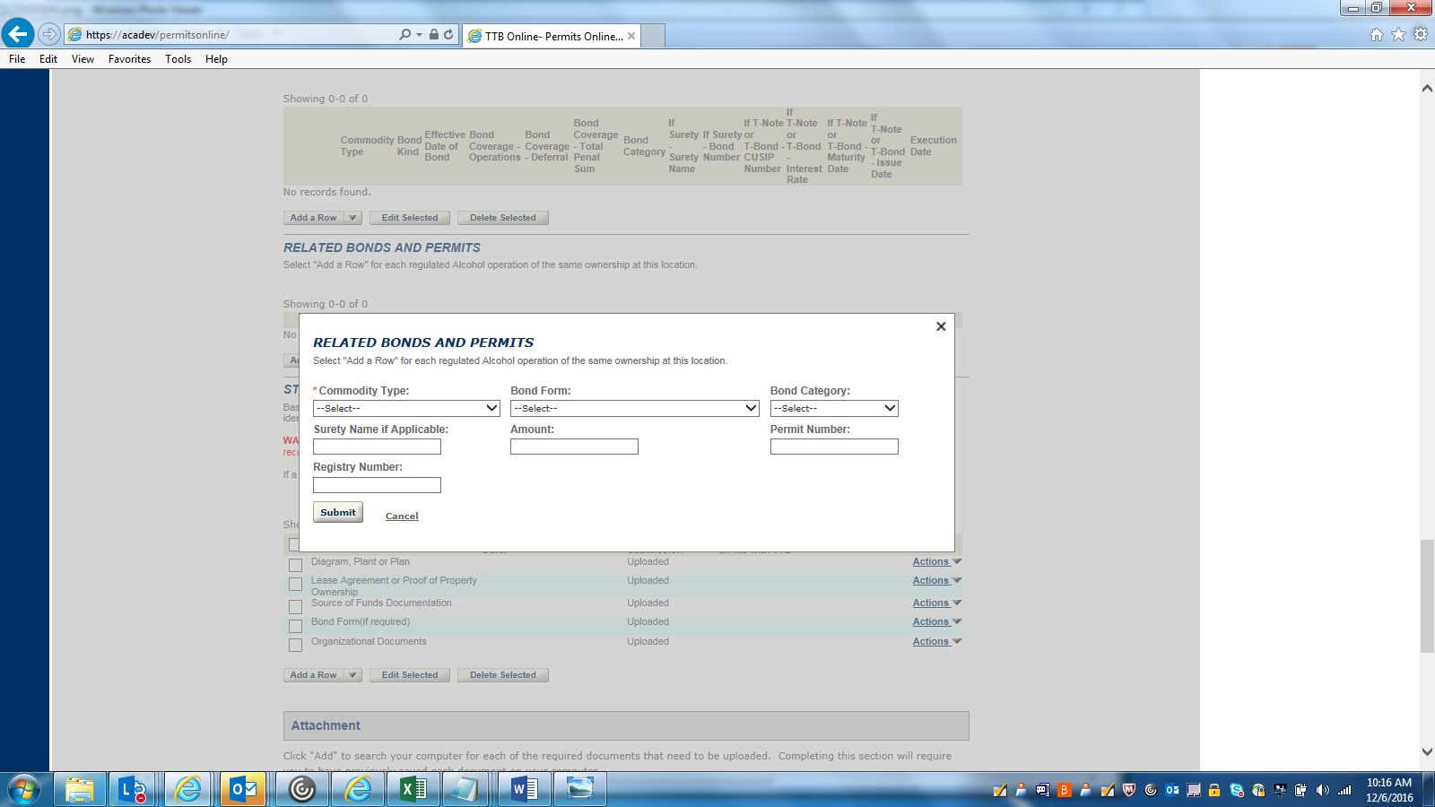

WINERY BUSINESS INFORMATION--5: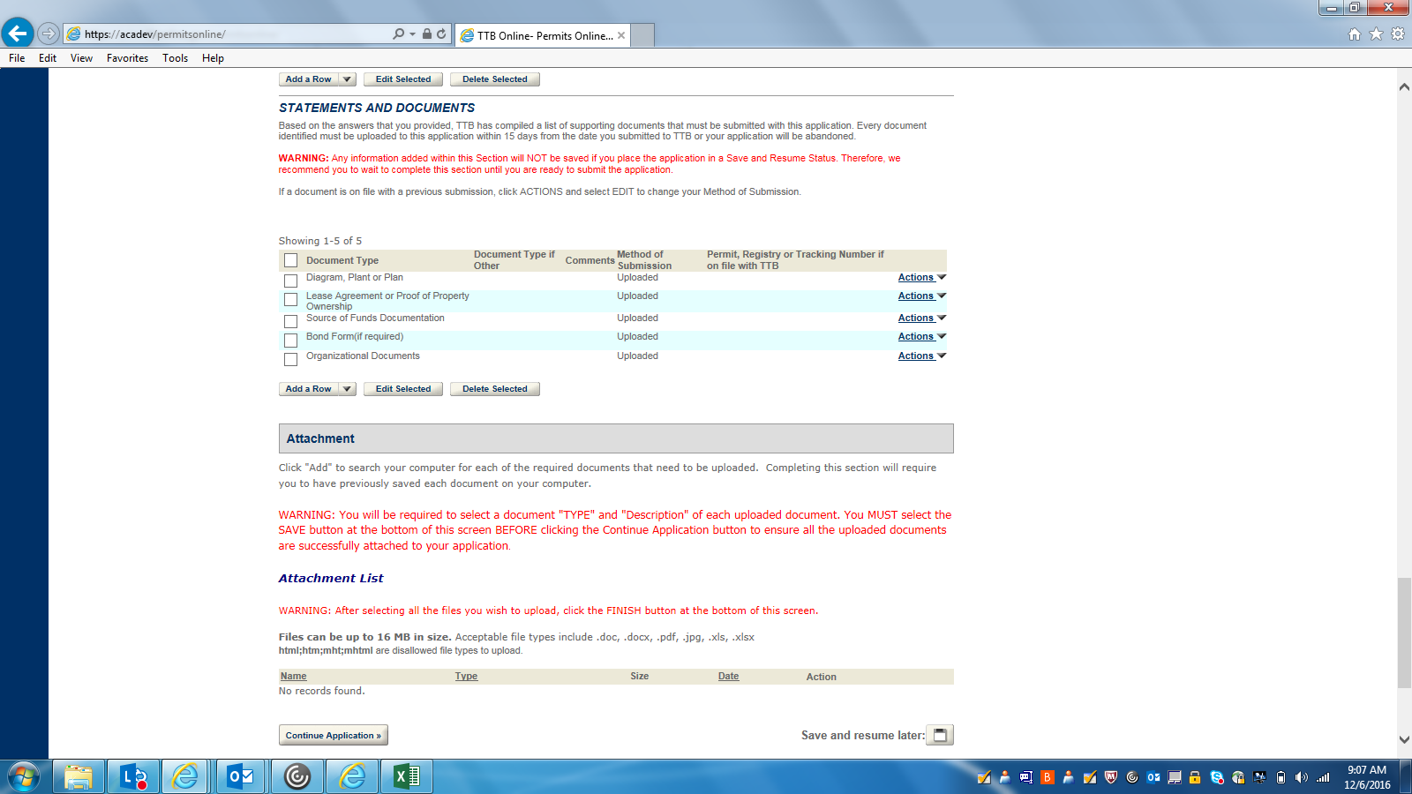

DECLARATION
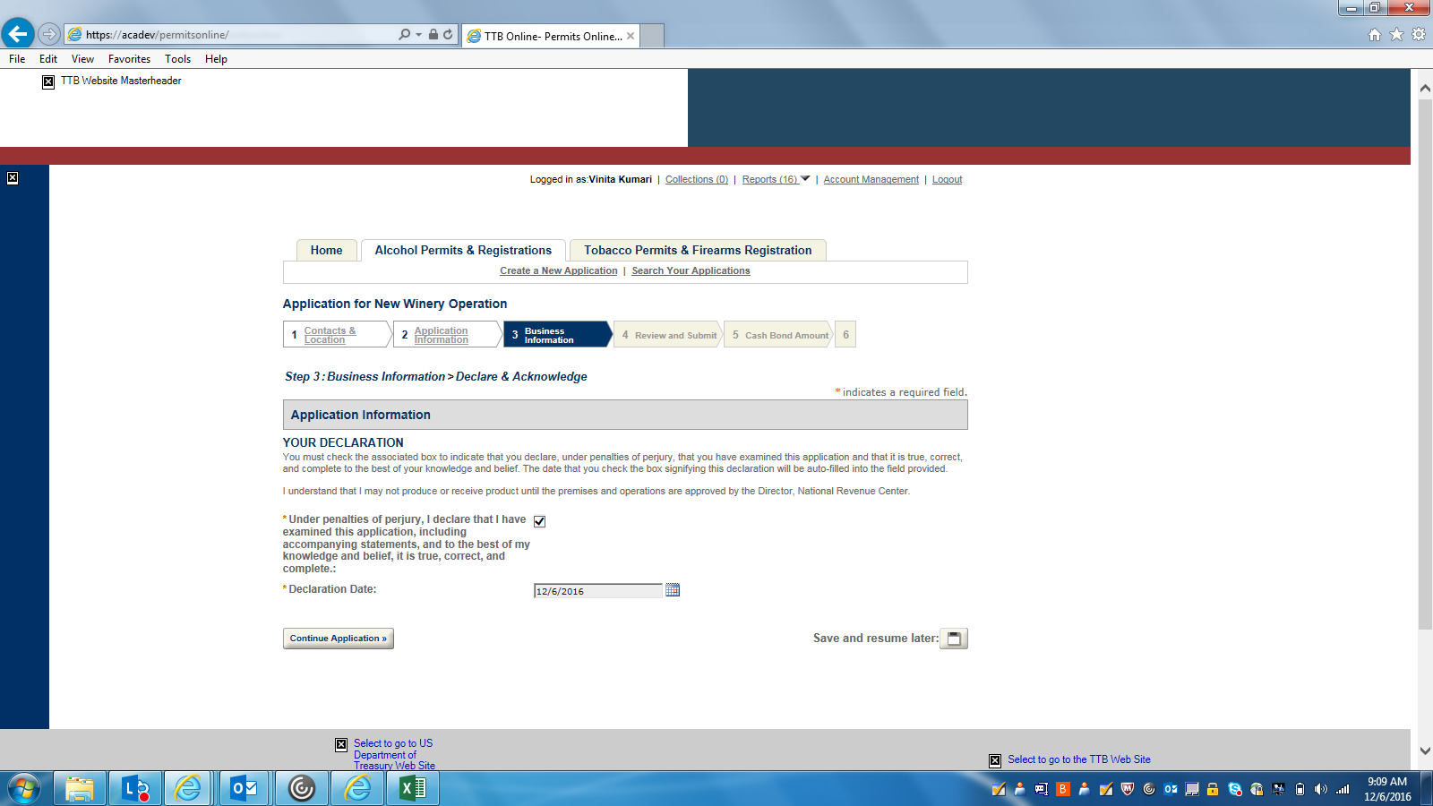

REVIEW AND SUBMIT—1
: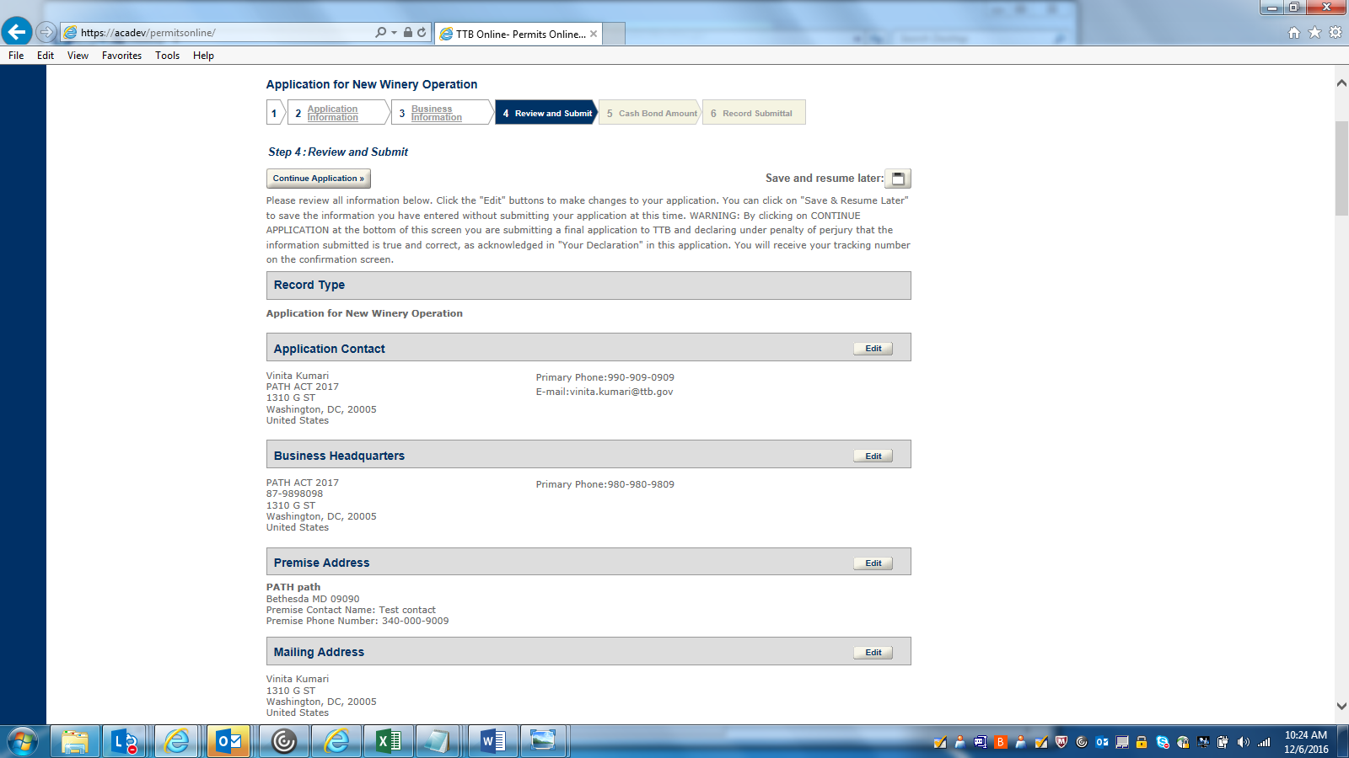

REVIEW AND SUBMIT--2:
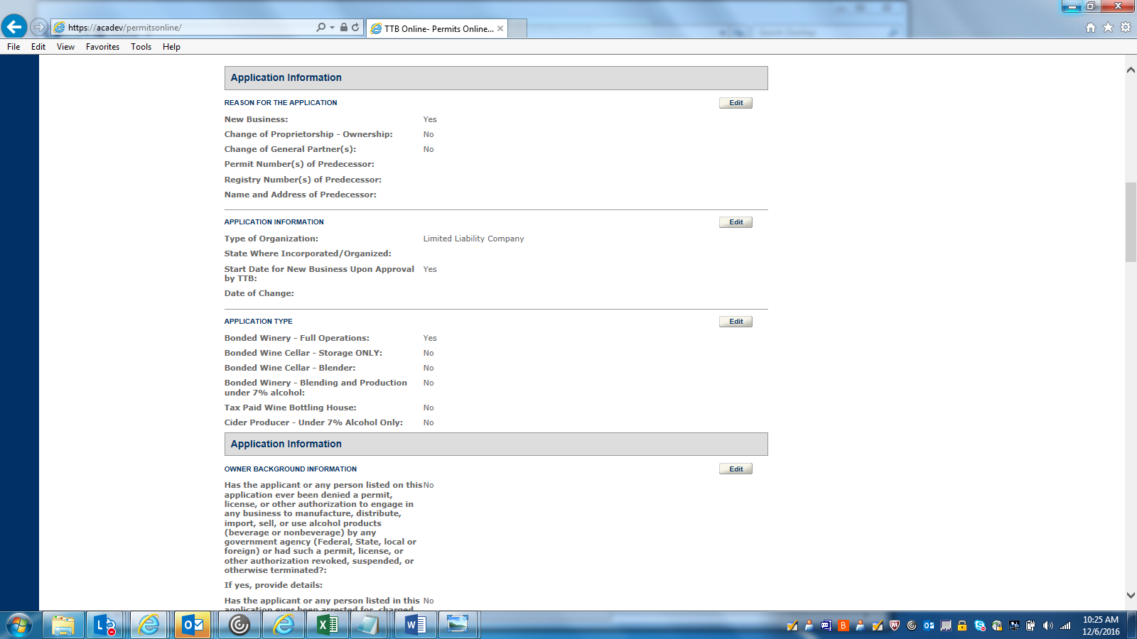

REVIEW AND SUBMIT—3
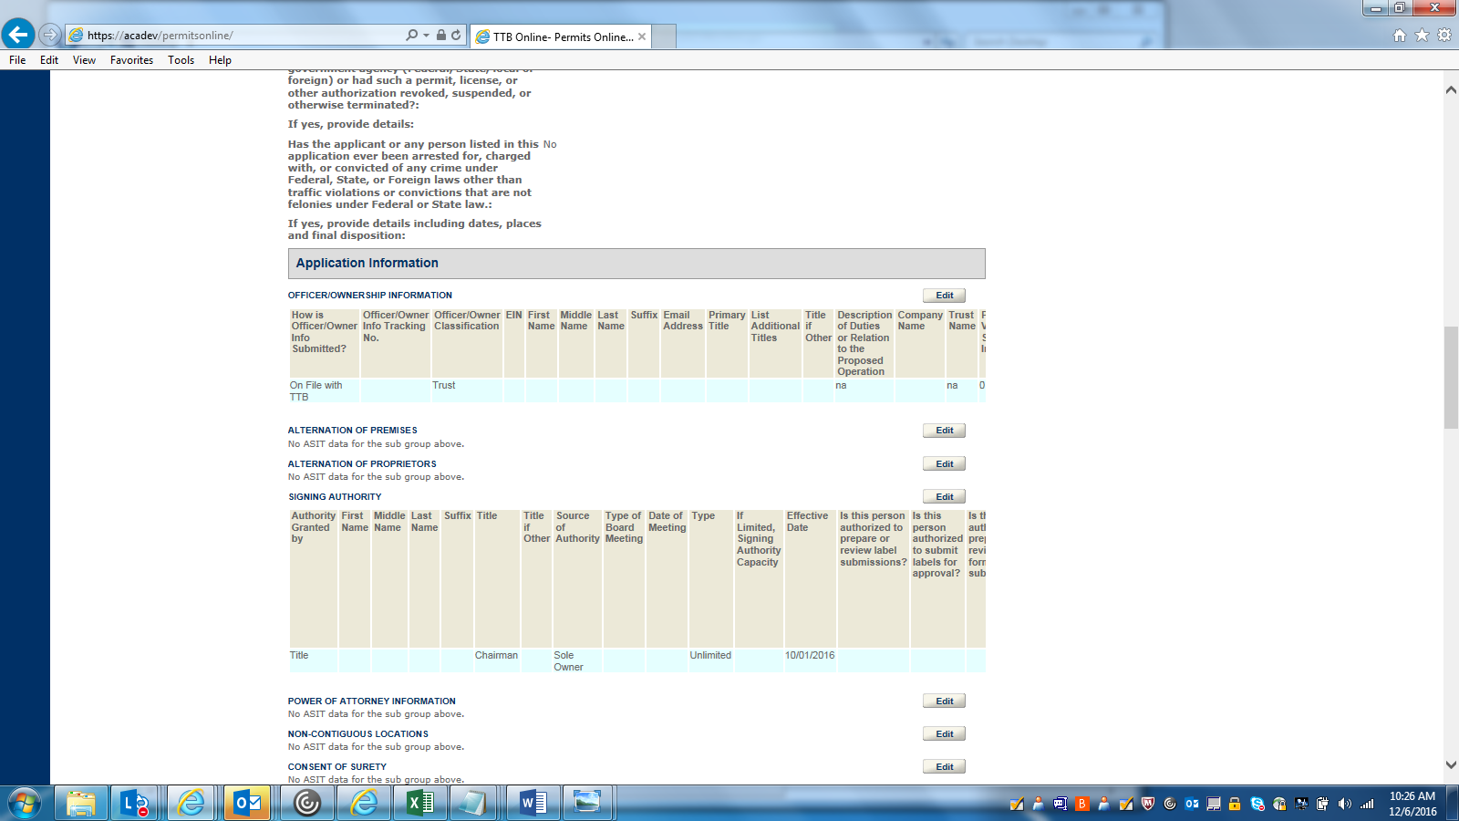

REVIEW AND SUBMIT—4
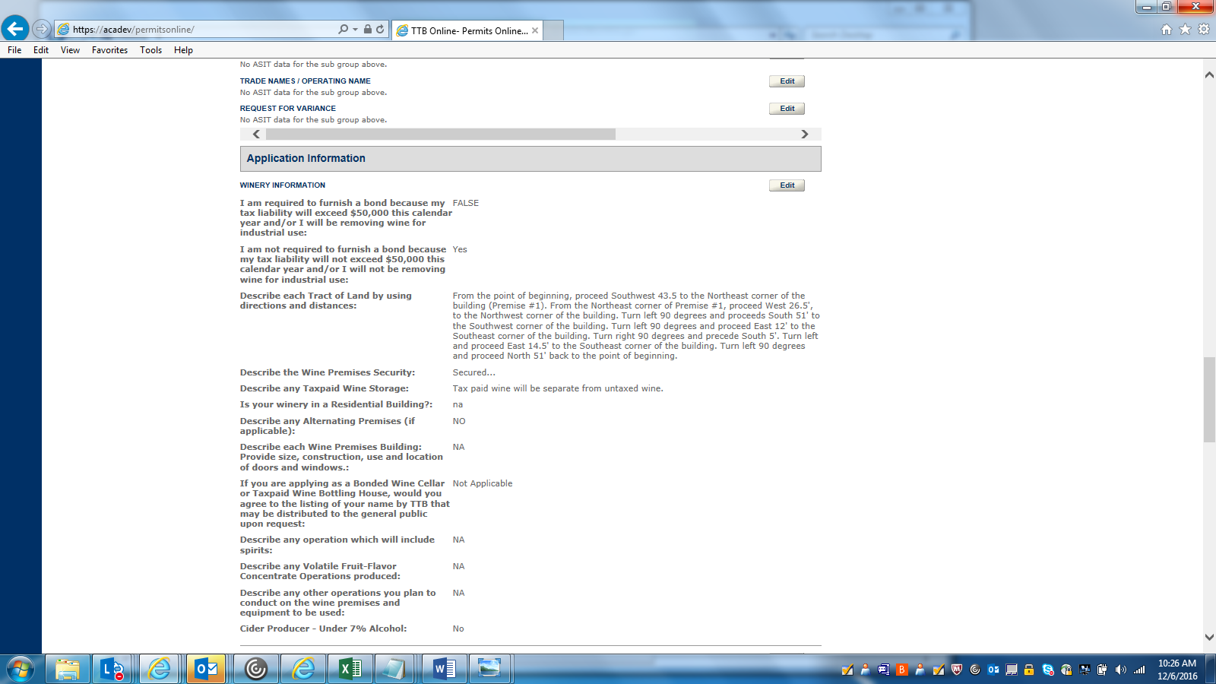

REVIEW AND SUBMIT—5
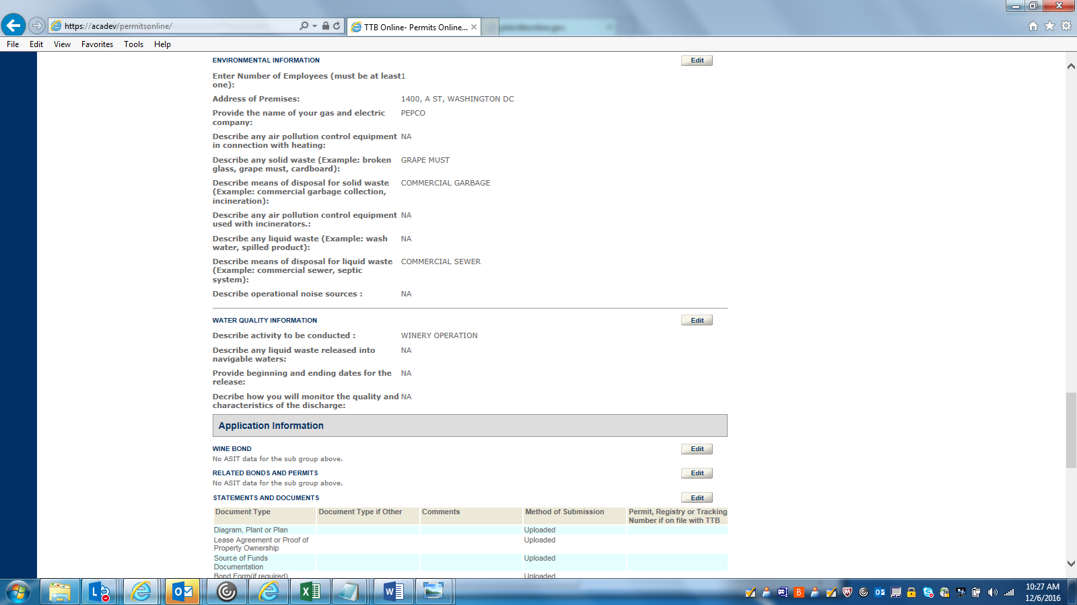

REVIEW AND SUBMIT--6
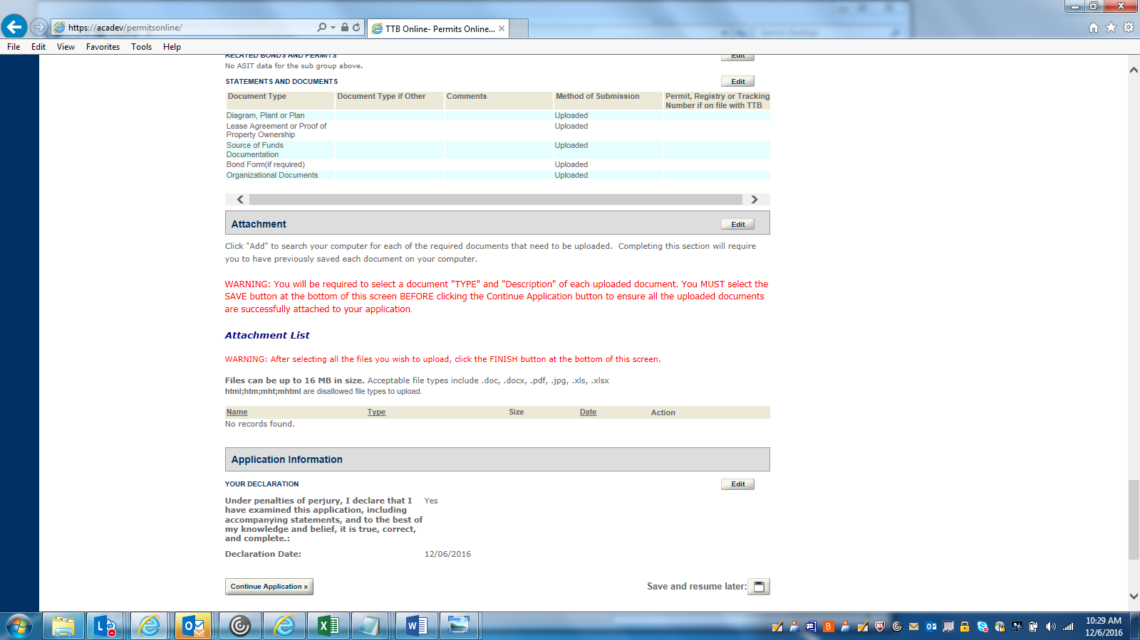

RECORD SUBMITTAL--1
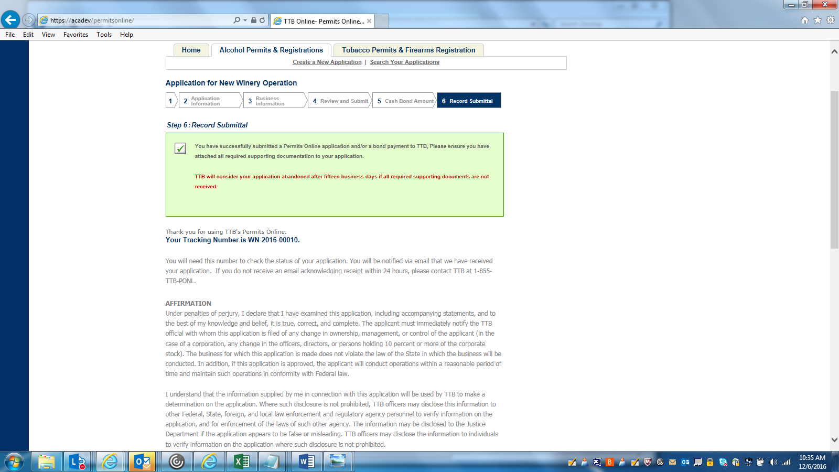

RECORD SUBMITTAL--2
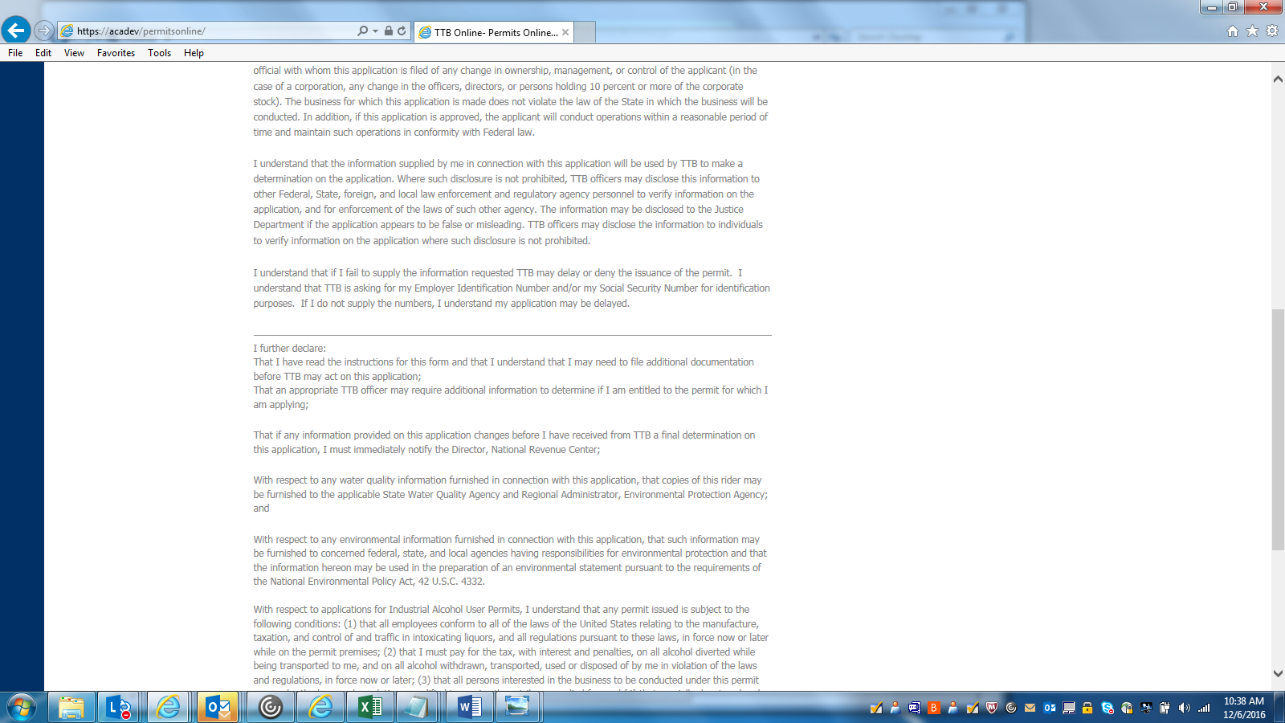

RECORD SUBMITTAL-- 3
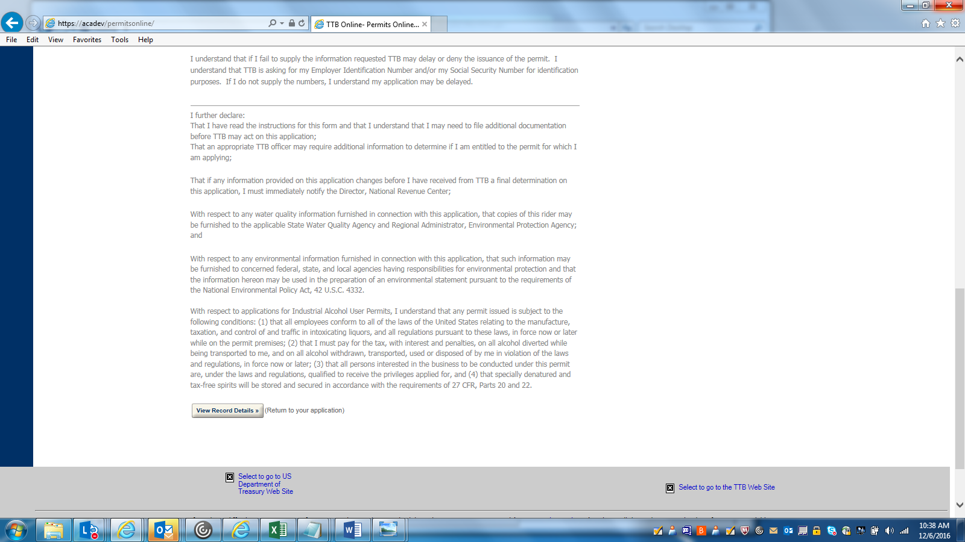

=== END ===

