2012/17 Beginning Postsecondary Students Longitudinal Study: (BPS:12/17)

Full Scale Interview and Administrative Record Collections

OMB# 1850-0631 v.16

revised August 2017

Appendix E
Communication Materials for Survey Respondents

Contents
BPS:12/17 Brochure Text 3
BPS:12/17 Student Survey Website Text 5
Contact Information Update Letter – Parent 10
Contact Information Update Form – Parent 12
Initial Contact Letter – Student 14
Address Update Web Form 16
Confidentiality Procedures at https://surveys.nces.ed.gov/bps/confidentiality.aspx 18
Confidentiality 18
Data Collection Announcement Letter 19
Reminder Letter/Targeted Experiment Announcement Letter 21
Reminder Postcard 1 - Example 23
Reminder Postcard 2 - Example 25
Reminder Postcard 3 - Example 27
Reminder Postcard 4 - Example 29
Reminder Postcard 5 – Example 31
Thank You/Incentive Letter 33
Initial Contact E-mail 34
Data Collection Announcement E-mail 35
Data Collection Announcement E-mail – Prepaid 37
Data Collection Announcement E-mail – Prepaid 38
Reminder E-mail 1 – Example 39
Reminder E-mail 2 – Example 41
Reminder E-mail 3 – Example 42
Reminder E-mail 4 – Example 43
Reminder E-mail 5 – Example 44
Reminder E-mail 6 – Example 46
Reminder E-mail 7 – Example 47
Reminder E-mail 8 – Example 48
Reminder E-mail 9 – Example 49
Reminder E-mail 10 – Example 50
Reminder E-mail 11 – Example 51
Reminder E-mail 12 – Example 52
Reminder E-mail 13 – Example 53
Reminder E-mail 14 – Example 54
Reminder E-mail 15 – Example 55
Reminder E-mail 16 – Example 56
Last Chance Email 57
NCES Email 58
Thank You E-mail 59
BPS:12/17 CATI Consent Text 61
Text Message Reminder – Examples 63

Note: Emails and letters providing similar content to those shown in this appendix will be sent throughout data collection to encourage participation. In addition, sample members that request follow-up reminders via text message will receive text message prompts to complete the survey. The materials included in this appendix reference the full-scale study to be conducted in 2017.
BPS:12/17 Brochure Text
What is BPS?
The 2012/17 Beginning Postsecondary Students Longitudinal Study (BPS) follows students who started postsecondary education in the 2011–12 academic year. BPS will survey about 34,000 students in 2017 to collect information about their educational progress and plans, experience in the workforce, earnings and expenses, family status, and personal and professional goals.

Why am I being asked to participate?
You are being asked to participate in BPS because you were enrolled in postsecondary education for the first time during the 2011–12 academic year. Postsecondary education is any education beyond high school, including career and technical school, college, and graduate school. Most study participants were first surveyed in 2012 as part of the National Postsecondary Student Aid Study and then again in 2014 for the first BPS follow-up.

What happens to the results?
Results from the current study are scheduled to be released in 2018 and will be posted on the NCES website (http://nces.ed.gov/surveys/bps/) along with results from previous BPS studies. Your responses will be combined with those of other students and will be presented in summary form only. No individually-identifiable information will be published. Researchers will use BPS data to explore a wide variety of topics, such as how financial aid influences persistence in and completion of postsecondary education.

Why is my participation important?
Your survey responses help educators, researchers, and policymakers at the local, state, and national levels understand national trends in enrollment patterns, education goals, employment, and backgrounds of students who pursue education after high school. Your experiences are unique, and, if you choose not to participate in BPS, no one else can be substituted for you.

Did you know?
The most recent BPS follow-up occurred in 2014 and about 25,000 students who began their postsecondary education in the 2011–12 academic year completed an interview. More than half of these first-time beginning postsecondary students were pursuing a certificate (10 percent) or associates degree (42 percent) during their first year. Two years later in 2014, about 16 percent had earned a degree or certificate, 54 percent were still enrolled, and 30 percent were not enrolled.

Source: U.S. Department of Education, National Center for Education Statistics. 2012/14 Beginning Postsecondary Students Longitudinal Study (BPS:12/14).

Who is conducting BPS?
The 2012/17 Beginning Postsecondary Students Longitudinal Study (BPS:12/17) is being conducted by the National Center for Education Statistics (NCES), in the U.S. Department of Education’s Institute for Education Sciences, with data collection being carried out under contract by RTI International, a nonprofit research organization based in North Carolina.

NCES is authorized to conduct BPS by the Education Sciences Reform Act (ESRA) of 2002 (20 U.S.C. §9543), and to collect students’ education records from educational agencies or institutions for the purposes of evaluating Federally supported education programs under the Family Educational Rights and Privacy Acts (FERPA, 34 CRF §§ 99.31(a)(3) and 99.35).

How will my information be protected?
NCES is required to follow strict procedures to protect personal information in the collection, reporting, and publication of data. Data collected from or about individual students are used only for statistical purposes and may not be disclosed or used in identifiable form for any other purpose except as required by law (ESRA 2002, 20 U.S.C., §9573).

Data security procedures for BPS are reviewed and approved by NCES data security staff. Your answers are secured behind firewalls and are encrypted during internet transmission using Secure Sockets Layer (SSL) protocol. All data entry modules are password protected and require the user to log in before accessing confidential data. Project staff is subject to large fines or imprisonment if individual responses are disclosed.
*RTI International is a registered trademark and a trade name of Research Triangle Institute.
How do I participate?
You can complete the BPS survey online or over the phone
ONLINE
Log onto the study website at https://surveys.nces.ed.gov/bps/ using the Study ID and password provided in your welcome letter.
The survey is mobile-optimized, so it can be easily completed on a mobile device.
PHONE
Call our Help Desk at (800) 334-2321 to speak to one of our professional interviewers.
BPS HELP DESK

(800) 334-2321
bps@rti.org
https://surveys.nces.ed.gov/bps/

David Richards
BPS Project Officer (NCES)
David.Richards@ed.gov
(202) 245-6202
Jason Hill
BPS Project Director (RTI)
jahill@rti.org
(800) 647-9657

BPS:12/17 Student Survey Website Text
Welcome to the 2012/17 Beginning Postsecondary Students Longitudinal Study (BPS:12/17)

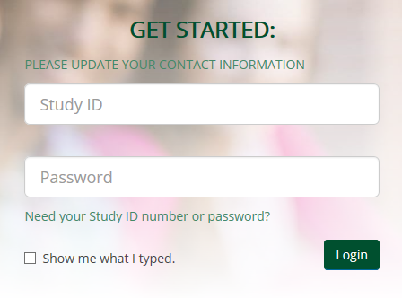
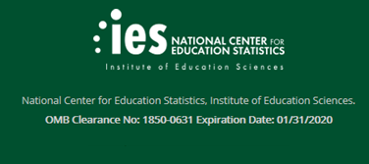

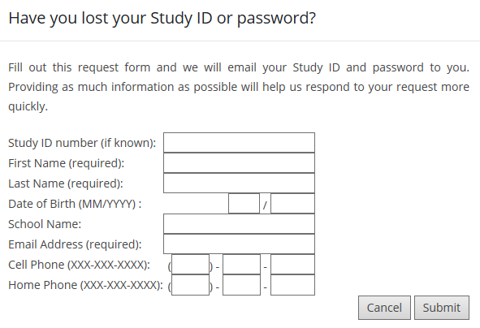
Paperwork Reduction Act

NCES is authorized to conduct BPS:12/17 by the Education Sciences Reform Act of 2002 (ESRA 2002, 20 U.S.C. §9543) and to collect students’ education records from education agencies or institutions for the purposes of evaluating federally supported education programs under the Family Educational Rights and Privacy Act (FERPA, 34 CFR §§ 99.31(a)(3)(iii) and 99.35). The data are being collected for NCES by RTI International, a U.S.-based nonprofit research organization.

All of the information you provide may be used only for statistical purposes and may not be disclosed, or used, in identifiable form for any other purpose except as required by law (20 U.S.C. §9573 and 6 U.S.C. §151).

According to the Paperwork Reduction Act of 1995, no persons are required to respond to a collection of information unless it displays a valid OMB control number. The valid OMB control number for this voluntary information collection is 1850-0631. The time required to complete this information collection is estimated to average approximately 30 minutes per response, including the time to review instructions, gather the data needed, and complete and review the information collection. If you have any comments concerning the accuracy of the time estimate, suggestions for improving this survey, or any comments or concerns regarding the status of your individual submission of this survey, please write directly to: The 2012/17 Beginning Postsecondary Students Longitudinal Study (BPS:12/17), National Center for Education Statistics, Potomac Center Plaza, 550 12th St, SW, Room 4004, Washington, DC 20202. OMB Clearance No: 1850–0631 Expiration Date: 1/31/2020

About BPS
The 2012/17 Beginning Postsecondary Students Longitudinal Study (BPS) follows students who started postsecondary education in the 2011–12 academic year. The study collects information about their education progress and plans, experience in the workforce, earnings and expenses, family status, and personal and professional goals. Data for BPS are collected through a web or telephone survey, as well as through links to college records and other data sources. The information collected will provide researchers, educators, and policymakers with a better understanding of enrollment in postsecondary education, school expenses and financial aid, employment during and after school, demographics, and living expenses.
The BPS:12/17 is the second follow-up survey of a cohort of students who were enrolled in college or another postsecondary institution for the first time during the 2011–12 academic year. Most study participants were first surveyed in 2012 as part of the National Postsecondary Student Aid Study (NPSAS) and then again in 2014 for the first BPS follow-up.
Congress has authorized the National Center for Education Statistics (NCES) of the U.S. Department of Education's Institute of Education Sciences to collect data about the costs of postsecondary education because policymakers at all levels need reliable and current national data in order to make policy decisions about postsecondary education.
BPS is being administered for NCES by RTI International*, a U.S.-based nonprofit research organization. RTI is affiliated with Duke University, the University of North Carolina at Chapel Hill, and North Carolina State University.
*RTI International is a registered trademark and a trade name of Research Triangle Institute.
To learn more about the data from previous BPS cycles, visit NCES’ BPS website.
What to Expect
Why am I being asked to participate?
You are being asked to participate in BPS because you were enrolled in postsecondary education for the first time during the 2011–12 academic year. Postsecondary education is any education beyond high school, including career and technical school, college, and graduate school. Most study participants were first surveyed in 2012 as part of the National Postsecondary Student Aid Study (NPSAS) and then again in 2014 for the first BPS follow-up.
How can I complete the BPS survey?

You may complete the BPS survey on the Web – simply log in from the home page by entering your Study ID and password, which are provided in the BPS letter or e-mail you received. You can even complete it on your mobile device. If you need assistance accessing the survey on the website, or if you want to complete the survey by telephone, contact the BPS Help Desk by calling (800) 334-2321 or send an e-mail to bps@rti.org.
How long will the survey take?
For most people, we expect the survey will take about 30 minutes, depending on your answers. You do not have to complete the survey in one session. You can get started and, if you choose, you can easily log out and resume at a later time.
Do I have to participate?
Participation in this study is voluntary; however, your involvement is very important to the success of this study. By participating, you have the opportunity to help researchers, educators, and policymakers gain a better understanding of enrollment in postsecondary education, school expenses and financial aid, employment during and after school, demographics, and living expenses.
Can I refuse to answer a question?
You may refuse to answer any question at any time. If you choose not to answer or are unable to answer a particular question, you may still continue with the rest of the survey. However, your answers to particular questions may determine subsequent questions you are asked.
I’m registered on the National Do Not Call Registry. That means you can’t contact me, right?
The National Do Not Call Registry restrictions exempt survey research organizations. Because our sole purpose is to encourage you to participate in a survey, not to sell you anything, we are permitted to contact you about your participation. For more information, please refer to consumer information regarding the National Do Not Call Registry.
Who is conducting BPS?
The 2012/17 Beginning Postsecondary Students Longitudinal Study (BPS:12/17) is being conducted by the National Center for Education Statistics (NCES), in the U.S. Department of Education’s Institute for Education Sciences, with data collection being carried out under contract by RTI International*, a U.S.-based nonprofit research organization. NCES is authorized to conduct BPS by the Education Sciences Reform Act (ESRA 2002, 20 U.S.C. §9543), and to collect students’ education records from education agencies or institutions for the purposes of evaluating federally supported education programs under the Family Educational Rights and Privacy Act (FERPA, 34 CFR §§ 99.31(a)(3) and 99.35). All of the information provided by individuals or institutions may be used only for statistical purposes and may not be disclosed, or used, in identifiable form for any other purpose except as required by law (20 U.S.C. §9573 and 6 U.S.C. §151).
*RTI International is a registered trademark and a trade name of Research Triangle Institute.
How do I know your website is secure?
The BPS website is protected by Secure Sockets Layer (SSL; 128-bit encryption) technology. Your survey responses are collected over a secure server and connection also protected by SSL.
Should I use a particular web browser to take the survey?
The survey requires a browser that supports HTML5 and JavaScript. The latest versions of Firefox, Chrome, and Safari will work, as will Internet Explorer 9 and later. If you are having any trouble completing the survey, please call our Help Desk at (800) 334-2321 and we will be happy to assist you.
Previous Results
As with all prior BPS studies, the results will be presented in summary form only; no individually identifiable information will be published. Data collected from BPS will enable researchers, educators, and policymakers to gain a better understanding of enrollment in postsecondary education, school expenses and financial aid, employment during and after school, demographics, and living expenses.
Here’s what we’ve learned from BPS so far…
The most recent BPS follow-up occurred in 2014. About 25,000 students who began their postsecondary education in the 2011–12 academic year completed an interview. More than half of these first-time beginning postsecondary students were pursuing a certificate (10 percent) or an associate’s degree (42 percent) during their first year. Two years later in 2014, about 16 percent had earned a degree or certificate, 54 percent were still enrolled, and 30 percent were not enrolled.
SOURCE: U.S. Department of Education, National Center for Education Statistics. 2012/14 Beginning Postsecondary Students Longitudinal Study (BPS:12/14). To see more results, go to http://nces.ed.gov/pubs2016/2016401.pdf.
Confidentiality
The National Center for Education Statistics (NCES) is required to follow strict procedures to protect personal information in the collection, reporting, and publication of data. All of the information you provide may be used only for statistical purposes and may not be disclosed, or used, in identifiable form for any other purpose except as required by law (20 U.S.C. §9573 and 6 U.S.C. §151).
Data security procedures for BPS are reviewed and approved by NCES data security staff. Your answers are secured behind firewalls and are encrypted during internet transmission using Secure Sockets Layer (SSL) protocol. All data entry modules are password protected and require the user to log in before accessing confidential data. Project staff are subject to large fines or imprisonment if they knowingly publish or communicate any individually identifiable information.
Congress has authorized the National Center for Education Statistics (NCES) of the U.S. Department of Education’s Institute of Education Sciences to collect data about the costs of postsecondary education because policymakers at all levels need reliable and current national data in order to make policy decisions about postsecondary education.
NCES is authorized to conduct BPS:12/17 by the Education Sciences Reform Act of 2002 (ESRA 2002, 20 U.S.C. §9543) and to collect students’ education records from education agencies or institutions for the purposes of evaluating federally supported education programs under the Family Educational Rights and Privacy Act (FERPA, 34 CFR §§ 99.31(a)(3)(iii) and 99.35). The data are being collected for NCES by RTI International, a U.S.-based nonprofit research organization.
The study has been approved by the U.S. Office of Management and Budget (OMB). The valid OMB control number for this information collection is 1850-0631. The expiration date is 01/31/2020.

Contact Us
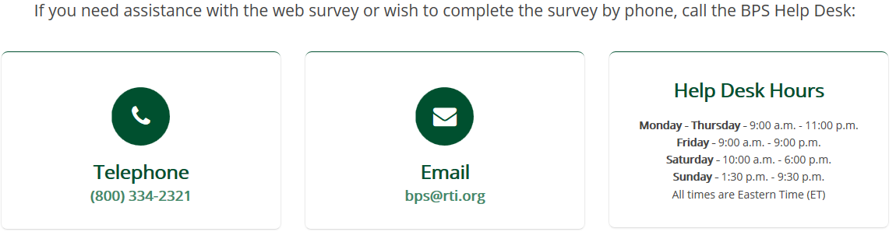
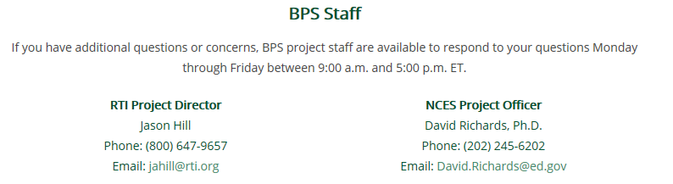

Update Contact Information
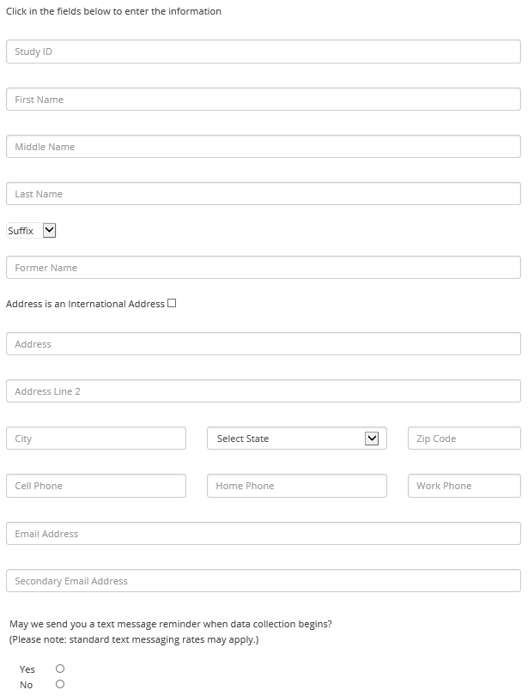

Contact Information Update Letter – Parent

<<date>>

<<name>>
<<addr1>>
<<addr2>>
<<city>>, <<st>> <<zip>>

Dear «Parentfname» «Parentlname»:
The U.S. Department of Education’s National Center for Education Statistics (NCES) is conducting an important study that follows up with students who first enrolled in postsecondary education during the 2011–12 school year. The Beginning Postsecondary Students Longitudinal Study (BPS) will provide researchers, educators, and policymakers with a better understanding of enrollment in postsecondary education, school expenses and financial aid, employment during and after school, demographics, and living expenses. Out of all the students who began their postsecondary education in the 2011–12 academic year in the United States, <<fname>> was selected to participate in BPS. The enclosed brochure provides information about the study and our confidentiality procedures.
We will be contacting «fname» and other study participants to complete the survey in <<month>> 2017, but before data collection can begin, we need your help to update our records. Please take a few minutes to update the contact information online, or complete the enclosed Contact Information Update Form and return it in the enclosed postage-paid envelope.
To update contact information for <<fname>> online:
Go to https://surveys.nces.ed.gov/bps/update-contact.aspx
Enter Study ID number «caseid»
If you would like more information about BPS, please review the enclosed brochure, visit http://surveys.nces.ed.gov/bps/update-contact.aspx, or call the RTI study director, Jason Hill, at (800) 647-9657.
We sincerely appreciate your assistance and thank you in advance for helping us conduct this important study.
Sincerely,

Dr. Peggy Carr, Ph.D.
Acting Commissioner
National Center for Education Statistics
Enclosure

NCES is authorized to conduct the 2012/17 Beginning Postsecondary Students Longitudinal Study by the Education Sciences Reform Act of 2002 (ESRA 2002, 20 U.S.C., §9543), and to collect students’ education records from educational agencies or institutions for the purposes of evaluating Federally supported education programs under the Family Educational Rights and Privacy Act (FERPA, 34 CFR §§ 99.31(a)(3) and 99.35). Data collected from or about individual students are used only for statistical purposes and may not be disclosed or used, in identifiable form, for any other purpose except as required by law (ESRA 2002, 20 U.S.C., §9573). These data are being collected for NCES by RTI International, a nonprofit research organization based in North Carolina.

According to the Paperwork Reduction Act of 1995, no persons are required to respond to a collection of information unless it displays a valid OMB control number. The valid OMB control number for this voluntary information collection is 1850-0631. The time required to complete this information collection is estimated to average approximately <<time>> minutes per response, including the time to review instructions, gather the data needed, and complete and review the information collection. If you have any comments concerning the accuracy of the time estimate, suggestions for improving this survey, or any comments or concerns regarding the status of your individual submission of this survey, please write directly to: The 2012/17 Beginning Postsecondary Students Longitudinal Study, National Center for Education Statistics, Potomac Center Plaza, 550 12th St, SW, Room 4037, Washington, DC 20202.

Contact Information Update Form – Parent
- Please review the current address and phone numbers for <<casename>> displayed in the box below.
Please make corrections in the space provided on the right side of the box.
If you prefer to update this information online, visit our secure website at https://surveys.nces.ed.gov/bps/update-contact.aspx and refer to the Study ID number «caseid».

Current contact information for <<casename>>: | Please make corrections below:
<<casename>> | Name:
«addr1» | Address:
«addr2»
«city», «state» «zip» «zip4»
(«area1») «phone1» | Home phone: | ( ) —
 | Work phone: | ( ) —
 | Cell phone: | ( ) —
Check here if this information is completely current and no corrections are needed. Please return this form even if no edits are needed.
2. We will send an e-mail to <<casename>> to announce that data collection has begun. Please provide an e-mail address that we can use to contact <<fname>>.
Primary e-mail address:
Alternate e-mail address:

3. May we send a text message to <fname>’s cell phone when data collection begins?
Please check one: Yes No

If yes, what cell number should we use? _________________________________________________

What is <fname>’s cell phone service provider (e.g. AT&T, Verizon, etc.)? _____________________

We ask for the cell phone service provider to enable us to identify the format of the text message we send.
Thank you for your assistance.
Please return this page in the enclosed postage-paid envelope or return to:
RTI International
PO Box 12194
Research Triangle Park, NC 27709-9935
For office use only:
Study ID: <<caseID>>
<<panelinfo>>/<<CTRLNUM>>

NCES is authorized to conduct the 2012/17 Beginning Postsecondary Students Longitudinal Study by the Education Sciences Reform Act of 2002 (ESRA 2002, 20 U.S.C., §9543), and to collect students’ education records from educational agencies or institutions for the purposes of evaluating Federally supported education programs under the Family Educational Rights and Privacy Act (FERPA, 34 CFR §§ 99.31(a)(3) and 99.35). Data collected from or about individual students are used only for statistical purposes and may not be disclosed or used, in identifiable form, for any other purpose except as required by law (ESRA 2002, 20 U.S.C., §9573). These data are being collected for NCES by RTI International, a nonprofit research organization based in North Carolina.

According to the Paperwork Reduction Act of 1995, no persons are required to respond to a collection of information unless it displays a valid OMB control number. The valid OMB control number for this voluntary information collection is 1850-0631. The time required to complete this information collection is estimated to average approximately <<time>> minutes per response, including the time to review instructions, gather the data needed, and complete and review the information collection. If you have any comments concerning the accuracy of the time estimate, suggestions for improving this survey, or any comments or concerns regarding the status of your individual submission of this survey, please write directly to: The 2012/17 Beginning Postsecondary Students Longitudinal Study, National Center for Education Statistics, Potomac Center Plaza, 550 12th St, SW, Room 4037, Washington, DC 20202.

Initial Contact Letter – Student

<<date>>

<<name>>
<<addr1>>
<<addr2>>
<<city>>, <<st>> <<zip>>

Dear <<fname>>,

I am pleased to inform you that you have been selected to participate in the Beginning Postsecondary Students Longitudinal Study (BPS), an important study that follows up with students who first enrolled in postsecondary education during the 2011–12 school year. <<You may recall participating in the National Postsecondary Student Aid Study (NPSAS), a related study, in 2012./You may recall participating in BPS in 2014./You may recall being contacted about BPS in 2014.>>
When BPS data collection begins in <<month>> 2017, we will contact you again with specific information about how to participate. After you complete the survey, you will receive $<<inc_amount>> as a token of our appreciation, payable by PayPal or check. In the meantime, we need to update our contact information for you. Please help us now by providing your mailing address, telephone number(s), and e-mail address(es) online at https://surveys.nces.ed.gov/bps/update-contact.aspx..
To update your contact information online:
Go to https://surveys.nces.ed.gov/bps/update-contact.aspx/
Enter Study ID number <<caseid>>

The enclosed brochure provides more information about BPS. If you have additional questions or concerns about the study after reviewing this material, please call the RTI study director, Jason Hill at (800) 647-9657.
We thank you in advance for your participation in this important study. Your cooperation is greatly appreciated.
Sincerely,

Dr. Peggy Carr, Ph.D.
Acting Commissioner, National Center for Education Statistics

Enclosure «panelinfo»/«ctrl»
NCES is authorized to conduct the 2012/17 Beginning Postsecondary Students Longitudinal Study by the Education Sciences Reform Act of 2002 (ESRA 2002, 20 U.S.C., §9543), and to collect students’ education records from educational agencies or institutions for the purposes of evaluating Federally supported education programs under the Family Educational Rights and Privacy Act (FERPA, 34 CFR §§ 99.31(a)(3) and 99.35). Data collected from or about individual students are used only for statistical purposes and may not be disclosed or used, in identifiable form, for any other purpose except as required by law (ESRA 2002, 20 U.S.C., §9573). These data are being collected for NCES by RTI International, a nonprofit research organization based in North Carolina.

According to the Paperwork Reduction Act of 1995, no persons are required to respond to a collection of information unless it displays a valid OMB control number. The valid OMB control number for this voluntary information collection is 1850-0631. The time required to complete this information collection is estimated to average approximately <<time>> minutes per response, including the time to review instructions, gather the data needed, and complete and review the information collection. If you have any comments concerning the accuracy of the time estimate, suggestions for improving this survey, or any comments or concerns regarding the status of your individual submission of this survey, please write directly to: The 2012/17 Beginning Postsecondary Students Longitudinal Study, National Center for Education Statistics, Potomac Center Plaza, 550 12th St, SW, Room 4037, Washington, DC 20202.

Address Update Web Form
1. [SAMPLE MEMBERS ONLY] May we send you a text message reminder when data collection begins?
- Yes Please give us the name of your cell phone service provider (e.g. AT&T, Verizon, Sprint, etc.) to ensure the message is sent to the correct carrier. __________________________________________
- No

- Click in the fields below to enter the information.
Study ID:
First Name:
Middle Name:
Last Name:
Suffix:
Former Name:
Address is an International Address

Address:
Address Line 2:
City:
State:
Zip Code:

Cell Phone:
Home Phone:
Work Phone:
E-mail Address:
Secondary E-mail Address:

- Please provide the contact information for [your/Casename’s] parent and one additional person who will always know how to get in touch with [you/Casename].

Parent Contacting Information
Name:
Address:
City:
State:
Zip:
Home Phone:
Work Phone:
Cell Phone:
Primary E-mail Address:
Secondary E-mail Address:

One Additional Person
Name:
Address:
City:
State:
Zip:
Home Phone:
Work Phone:
Cell Phone:
Primary E-mail Address:
Secondary E-mail Address:

OMB Control Number: 1850-0631
Learn more about our confidentiality procedures at https://surveys.nces.ed.gov/bps/confidentiality.aspx

Confidentiality Procedures at https://surveys.nces.ed.gov/bps/confidentiality.aspx

Confidentiality
The National Center for Education Statistics (NCES) is required to follow strict procedures to protect personal information in the collection, reporting, and publication of data. All of the information you provide may be used only for statistical purposes and may not be disclosed, or used, in identifiable form for any other purpose except as required by law (20 U.S.C. §9573 and 6 U.S.C. §151).
Data security procedures for BPS are reviewed and approved by NCES data security staff. Your answers are secured behind firewalls and are encrypted during internet transmission using Secure Sockets Layer (SSL) protocol. All data entry modules are password protected and require the user to log in before accessing confidential data. Project staff are subject to large fines or imprisonment if they knowingly publish or communicate any individually identifiable information.
Congress has authorized the National Center for Education Statistics (NCES) of the U.S. Department of Education’s Institute of Education Sciences to collect data about the costs of postsecondary education because policymakers at all levels need reliable and current national data in order to make policy decisions about postsecondary education.
NCES is authorized to conduct BPS:12/17 by the Education Sciences Reform Act of 2002 (ESRA 2002, 20 U.S.C. §9543) and to collect students’ education records from education agencies or institutions for the purposes of evaluating federally supported education programs under the Family Educational Rights and Privacy Act (FERPA, 34 CFR §§ 99.31(a)(3)(iii) and 99.35). The data are being collected for NCES by RTI International, a U.S.-based nonprofit research organization.
The study has been approved by the U.S. Office of Management and Budget (OMB). The valid OMB control number for this information collection is 1850-0631. The expiration date is 1/31/2020.

Data Collection Announcement Letter

<<date>>

«casename»
«addr1» «addr2»
«city», «state» «zip»

Dear «fname»:

Recently, we contacted you about your selection for the Beginning Postsecondary Students Longitudinal Study (BPS), a survey of students who first enrolled in postsecondary education during the 2011–12 school year. Data collection for BPS is now underway, and we would like to invite you to complete the survey by <earlycompdate>.

<<We sent you $10 via PayPal to <<emailaddress>> in gratitude for your <<continued>> participation in BPS. >>After you complete the survey, you will receive <<an additional>> $<<inc_amount>> as a token of our appreciation, payable by PayPal or check. <<The survey will take approximately <<time>> minutes/On average, the survey only takes <<time>> minutes>> to complete and can even be completed on your mobile device.

To complete the survey, log on to our secure website at https://surveys.nces.ed.gov/bps/ using the Study ID and password below:

Study ID = «caseid»
Password = «password»m (password is case sensitive)
You represent many students like you who were not selected for BPS and your participation is important to the success of the study. If you have questions, problems completing your survey online, or prefer to complete the survey over the telephone, simply call the BPS Help Desk at (800) 334-2321.
If you have any other questions or concerns about the study, please contact the BPS Project Director, Jason Hill, at (800) 647-9657, jahill@rti.org, or the NCES Project Officer, David Richards, at (202) 245-6202, David.Richards@ed.gov.

Thank you in advance for making BPS a success.

Sincerely,

Jason Hill David Richards
BPS Project Director NCES Project Director
Education and Workforce Development National Center for Education Statistics
RTI International U.S. Department of Education

Enclosure «panelinfo»/«controlID»

NCES is authorized to conduct the 2012/17 Beginning Postsecondary Students Longitudinal Study by the Education Sciences Reform Act of 2002 (ESRA 2002, 20 U.S.C., §9543), and to collect students’ education records from educational agencies or institutions for the purposes of evaluating Federally supported education programs under the Family Educational Rights and Privacy Act (FERPA, 34 CFR §§ 99.31(a)(3) and 99.35). Data collected from or about individual students are used only for statistical purposes and may not be disclosed or used, in identifiable form, for any other purpose except as required by law (ESRA 2002, 20 U.S.C., §9573). These data are being collected for NCES by RTI International, a nonprofit research organization based in North Carolina.

According to the Paperwork Reduction Act of 1995, no persons are required to respond to a collection of information unless it displays a valid OMB control number. The valid OMB control number for this voluntary information collection is 1850-0631. The time required to complete this information collection is estimated to average approximately <<time>> minutes per response, including the time to review instructions, gather the data needed, and complete and review the information collection. If you have any comments concerning the accuracy of the time estimate, suggestions for improving this survey, or any comments or concerns regarding the status of your individual submission of this survey, please write directly to: The 2012/17 Beginning Postsecondary Students Longitudinal Study, National Center for Education Statistics, Potomac Center Plaza, 550 12th St, SW, Room 4037, Washington, DC 20202.

Reminder Letter/Targeted Experiment Announcement Letter

<<date>>

«casename»
«addr1» «addr2»
«city», «state» «zip»

Dear «fname»:

[INSERT MERGE FIELD FROM TABLE IF ABBREVIATED INTERVIEW OR INCENTIVE BOOST]

Only a limited number of people were selected for the study, so each person represents many others who were not selected. Therefore, it is extremely important that you complete the interview so that educators and policymakers better understand the rate at which beginning students are completing degree programs, the factors preventing them from continuing their education, and the experiences of students as they transition into employment. Because the results from this study will help develop policy regarding participation in higher education, your experiences and opinions will help determine how future tax dollars are spent.

<<For participating in BPS, you will receive a $<<inc_amount>> check as a token of our appreciation. The survey will take, on average, about <<time>> minutes to complete. >>Please log on to our secure website to participate:

https://surveys.nces.ed.gov/bps/
Study ID = <<caseid>>
Password = <<password>>u
Note: The password is case sensitive; you will need to enter it exactly as it appears here.

If you have questions, problems completing your survey online, or prefer to complete the survey over the telephone, simply call the BPS Help Desk at (800) 334-2321.

Thank you, in advance, for your participation.

Sincerely,

Jason Hill
Director, Beginning Postsecondary Students Longitudinal Study

NCES is authorized to conduct the 2012/17 Beginning Postsecondary Students Longitudinal Study by the Education Sciences Reform Act of 2002 (ESRA 2002, 20 U.S.C., §9543), and to collect students’ education records from educational agencies or institutions for the purposes of evaluating Federally supported education programs under the Family Educational Rights and Privacy Act (FERPA, 34 CFR §§ 99.31(a)(3) and 99.35). Data collected from or about individual students are used only for statistical purposes and may not be disclosed or used, in identifiable form, for any other purpose except as required by law (ESRA 2002, 20 U.S.C., §9573). These data are being collected for NCES by RTI International, a nonprofit research organization based in North Carolina.

According to the Paperwork Reduction Act of 1995, no persons are required to respond to a collection of information unless it displays a valid OMB control number. The valid OMB control number for this voluntary information collection is 1850-0631. The time required to complete this information collection is estimated to average approximately <<time>> minutes per response, including the time to review instructions, gather the data needed, and complete and review the information collection. If you have any comments concerning the accuracy of the time estimate, suggestions for improving this survey, or any comments or concerns regarding the status of your individual submission of this survey, please write directly to: The 2012/17 Beginning Postsecondary Students Longitudinal Study, National Center for Education Statistics, Potomac Center Plaza, 550 12th St, SW, Room 4037, Washington, DC 20202.

MERGE FIELD OPTIONS
Abbreviated Interview | Congratulations! You are now eligible to complete a shortened BPS survey. Your BPS survey now takes only <<time>> minutes and upon completion, you will receive a $<<inc_amount>> token of our appreciation, payable by PayPal or check.
Incentive Boost | Congratulations! You have been selected to receive an additional $<<inc_amount>> for completing your BPS survey—that’s a total of $75! If you complete your <<time>> minute BPS survey, you will receive a $75 token of our appreciation, payable by PayPal or check.

Reminder Postcard 1 - Example
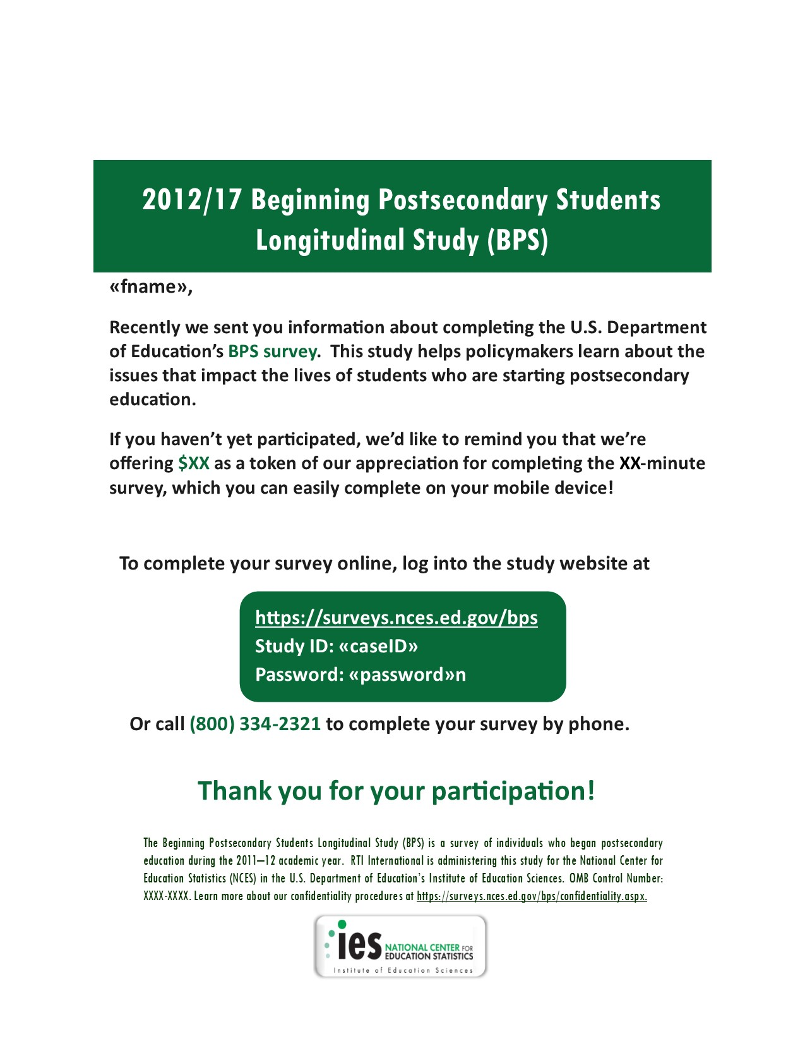
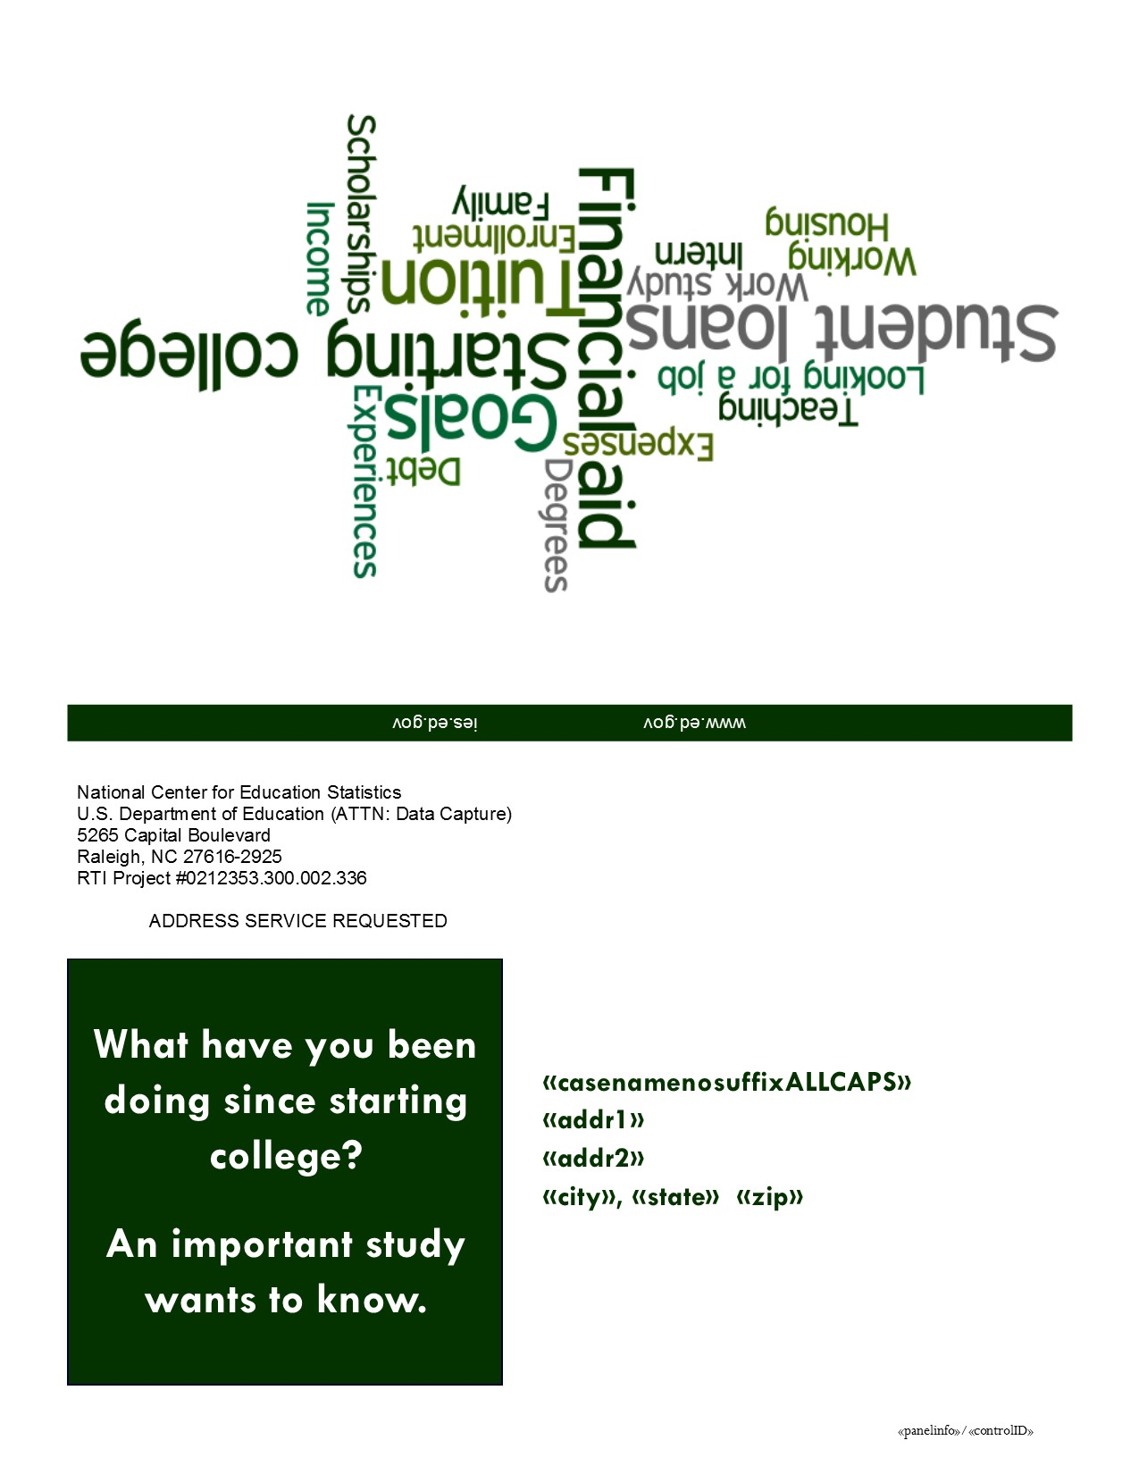

Reminder Postcard 2 - Example
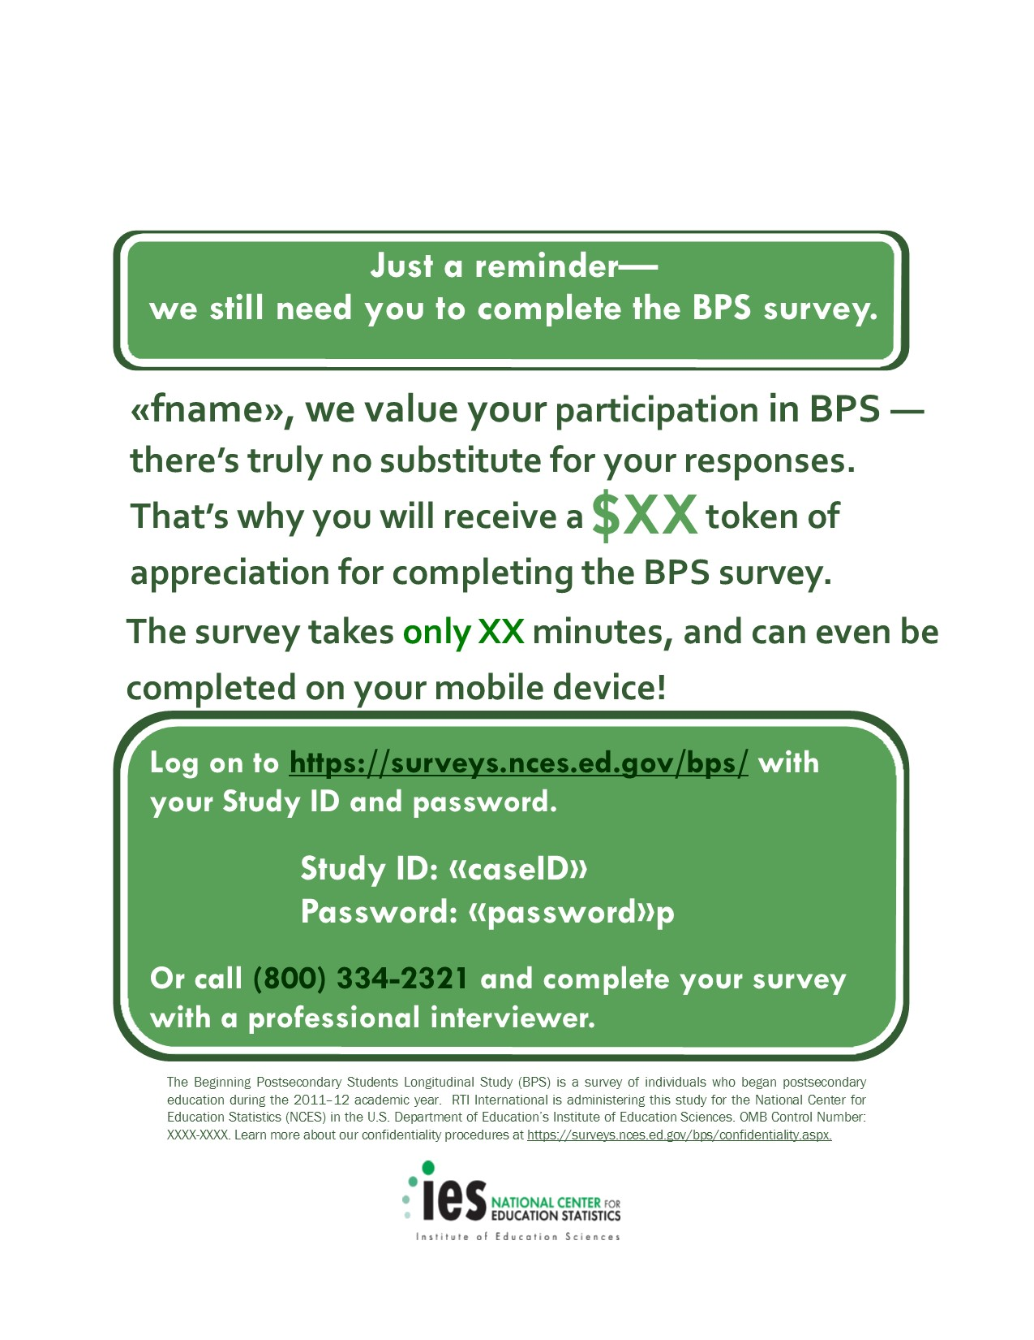
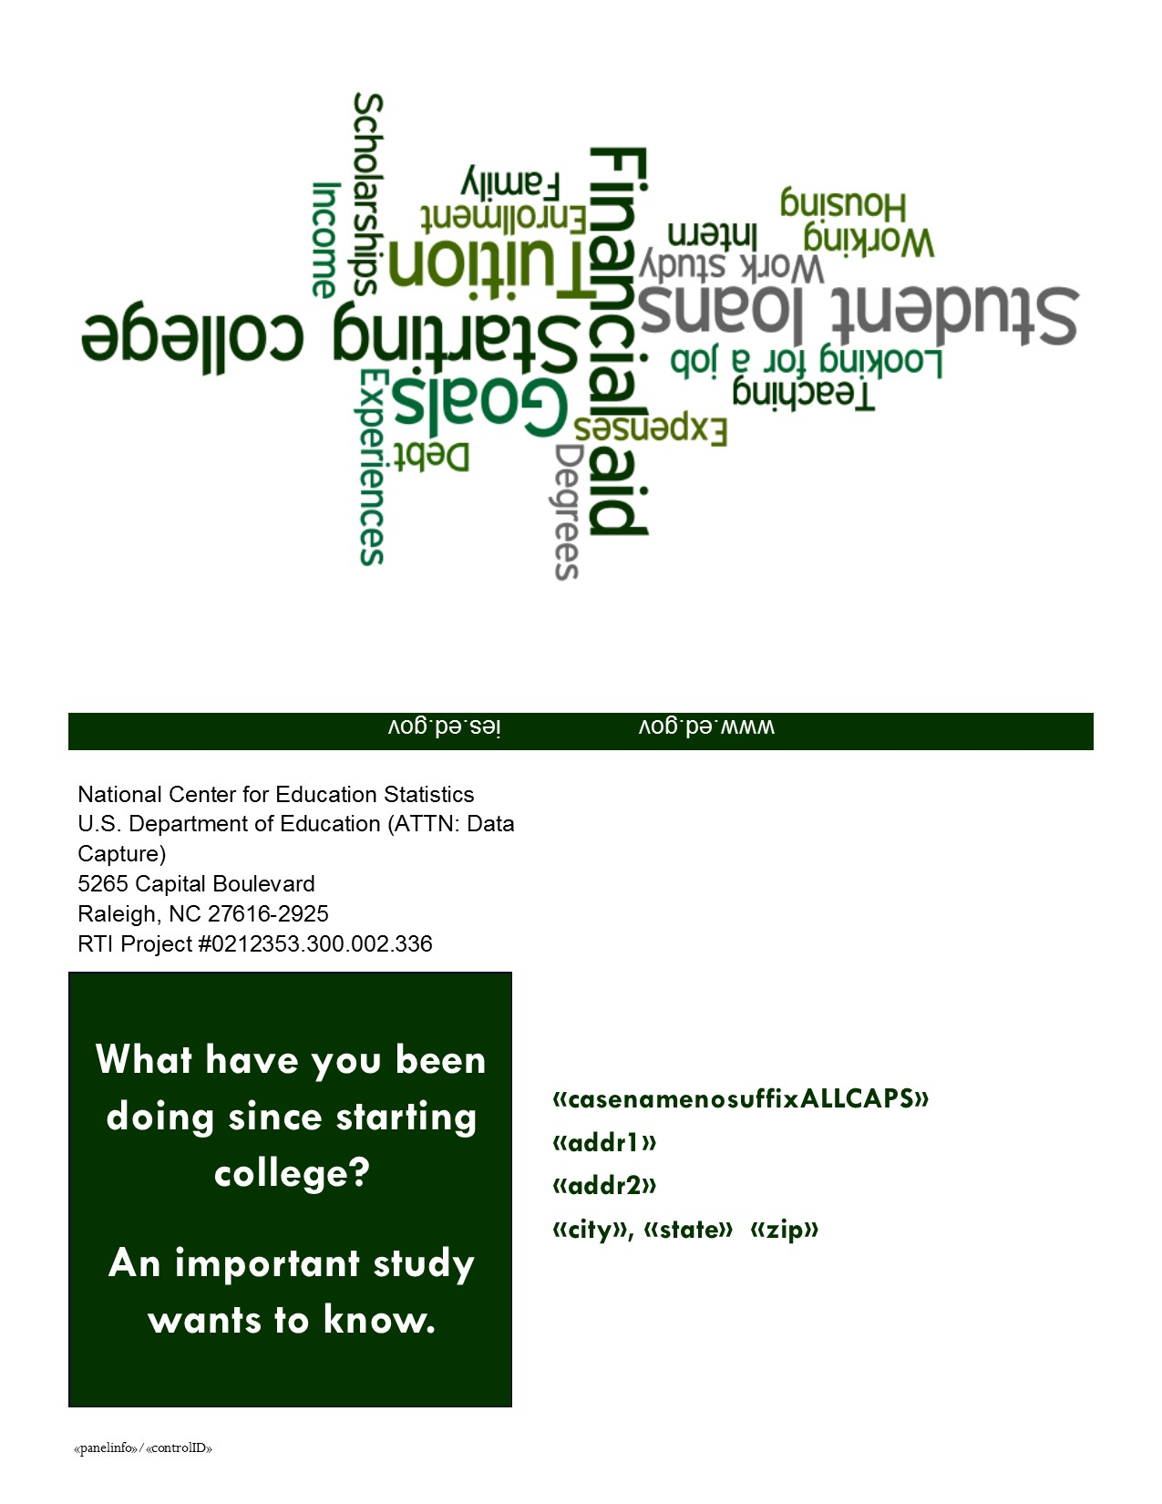

Reminder Postcard 3 - Example
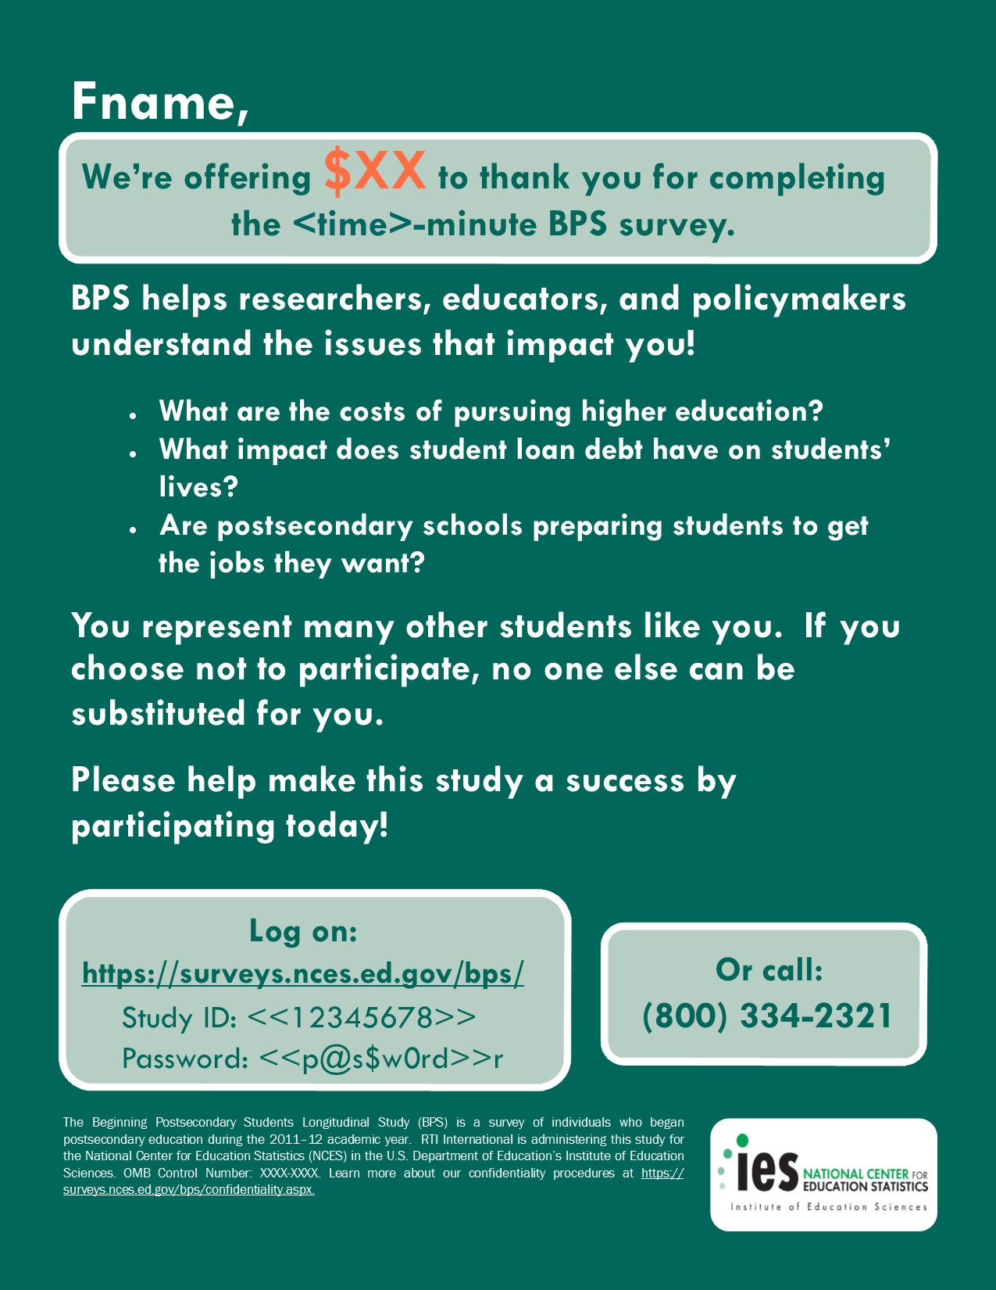
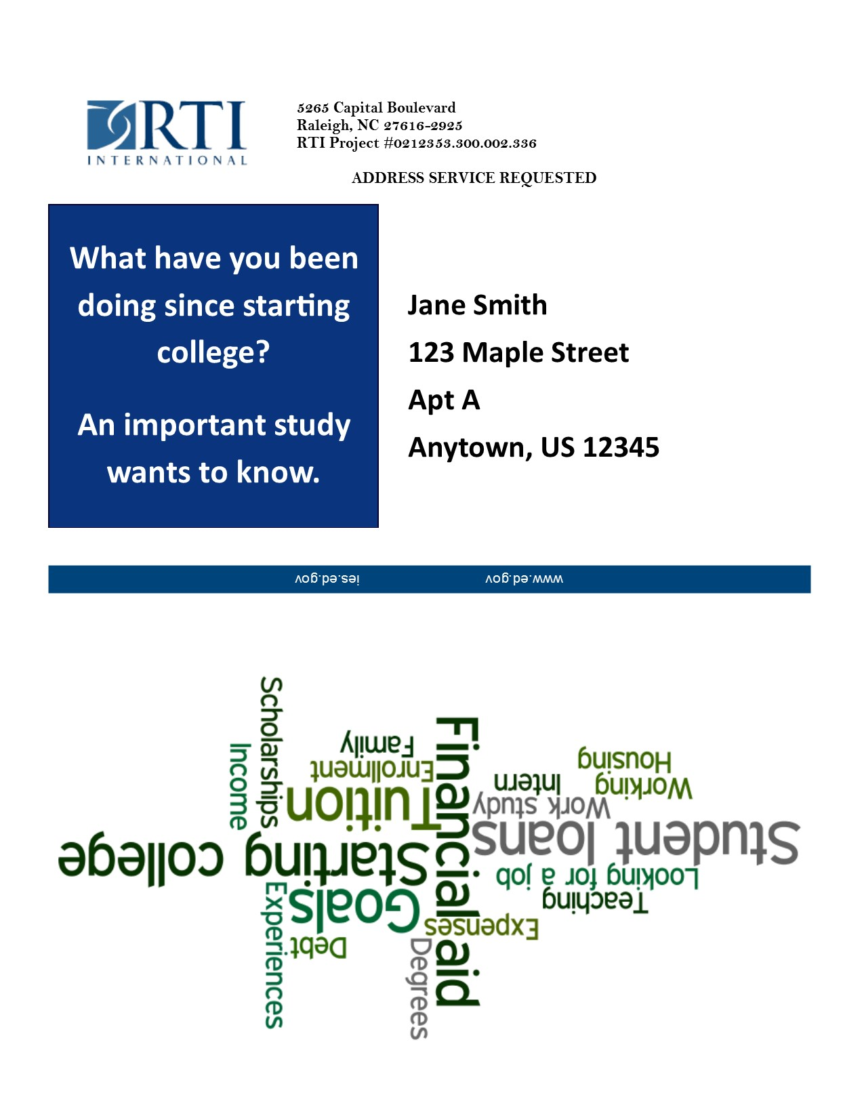

Reminder Postcard 4 - Example
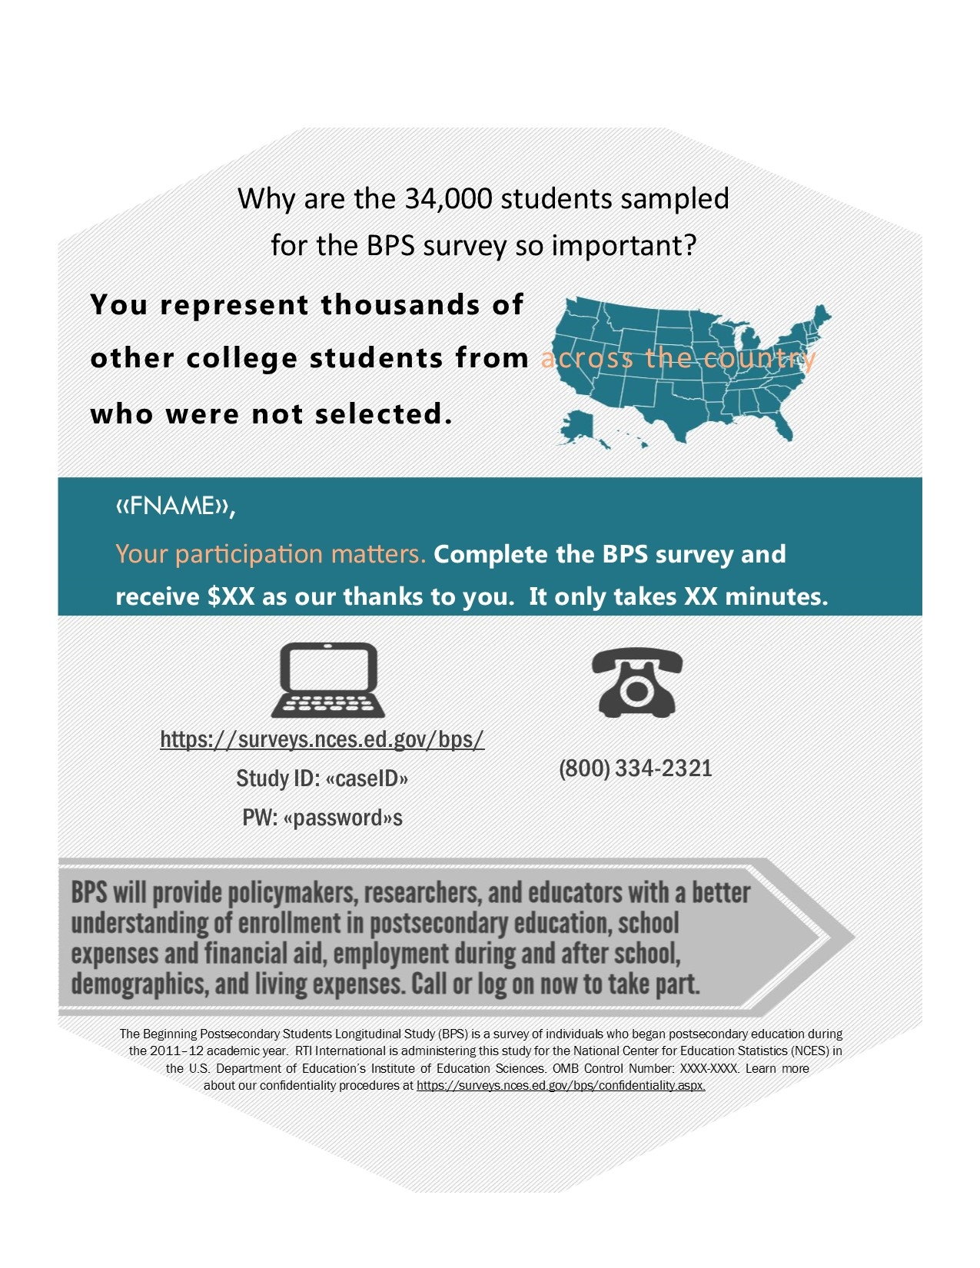
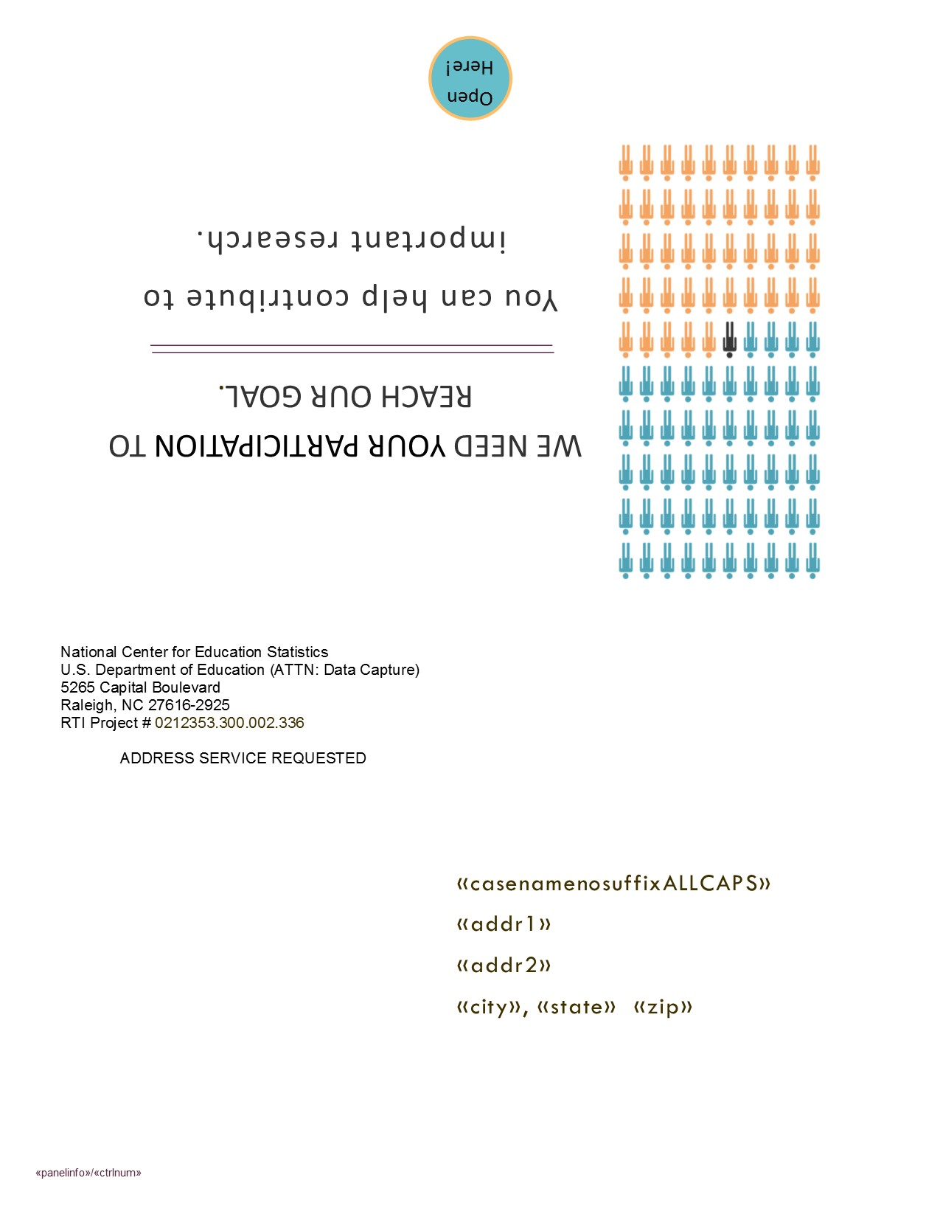

Reminder Postcard 5 – Example
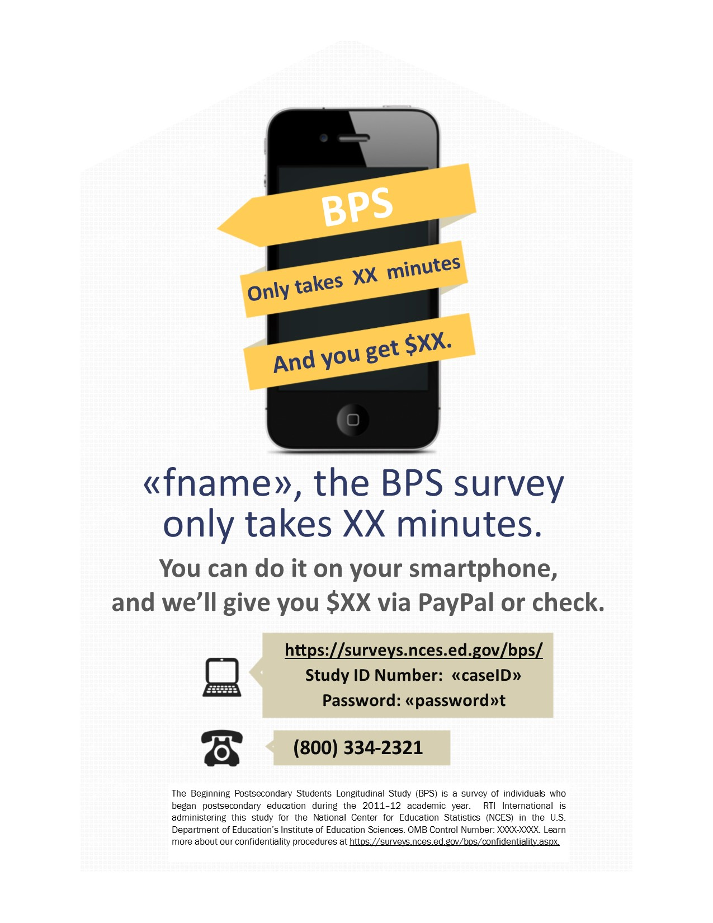
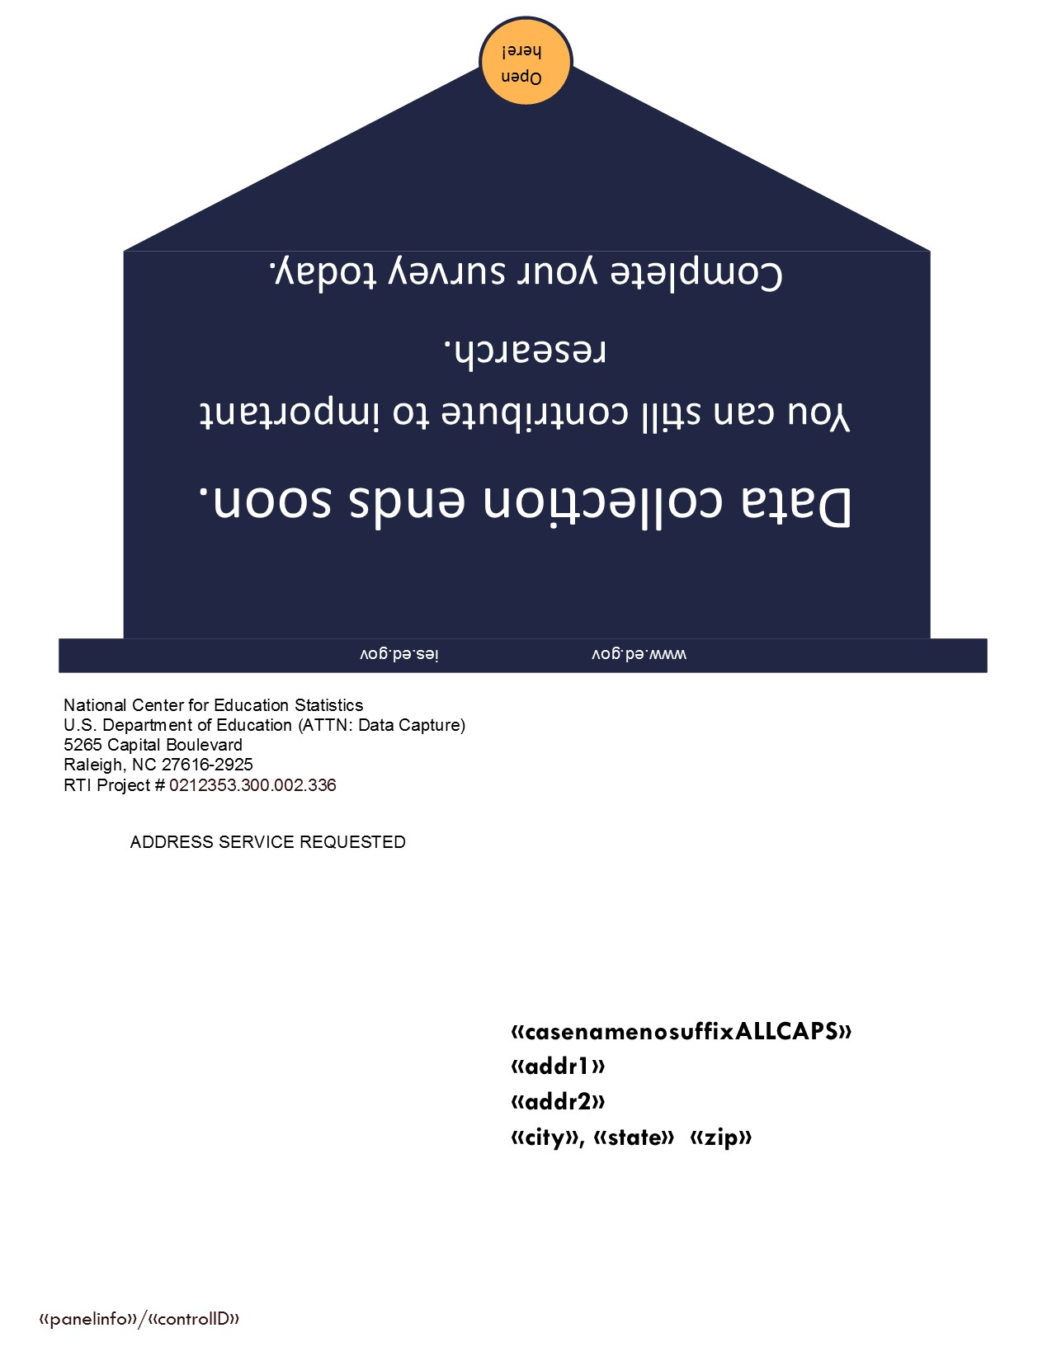

Thank You/Incentive Letter
(Applies only to SMs who opt to receive their incentive via check.)
<<date>>

<<name>>
<<addr1>>
<<addr2>>
<<city>>, <<st>> <<zip>>

Dear «casename»:
On behalf of the National Center for Education Statistics in the U.S. Department of Education’s Institute of Education Sciences and the staff of the 2012/17 Beginning Postsecondary Students Longitudinal Study (BPS), we would like to thank you for completing your BPS survey. Your participation in this study is very important to its success. Enclosed you will find a check for $<<inc_amount>>.

If you are unable to cash this check without incurring a fee, you may cash it at any Wells Fargo location for free. If the teller informs you there is a fee for cashing the check, ask them to refer to the account notes, as all fees should be waived. If the teller insists on charging a fee, please do not cash the check. Contact us immediately at (800) 647-9657.

Please do not hesitate to contact us directly at (800) 647-9657 if we can provide any additional information or assistance.

Again, thank you for your time and willingness to participate.

Sincerely,

Jason Hill David Richards
BPS Project Director NCES Project Director
Education and Workforce Development National Center for Education Statistics
RTI International U.S. Department of Education

Initial Contact E-mail

SUBJ: You have been selected for the BPS study!

Dear <<FirstName>>,
Congratulations, you have been selected for the Beginning Postsecondary Students Longitudinal Study (BPS). You may remember <<being contacted about/participating in>> <<BPS three years ago/the National Postsecondary Student Aid Study (NPSAS) five years ago>> for the U.S. Department of Education's National Center for Education Statistics (NCES). BPS will update education, employment, and other information for you and others like you who first enrolled in higher education during the 2011–12 school year. Your continued participation is important because BPS results will help develop education policies that can affect how future tax dollars are spent.
To ensure that we have the most up-to-date contact information, we are requesting that you click here to log onto our secure website and update your current contact information.
https://surveys.nces.ed.gov/bps/update-contact.aspx
Study ID: <XXXXXXX>
When BPS data collection begins in <<month>> 2017, you will receive an email and a letter with specific information about how to participate. If you complete the approximately <<time>> minute survey, you will receive $<<inc_amount>> as a token of our appreciation.
If you have trouble accessing the website, have questions or concerns about the study, or would rather update your information by phone, please contact us at (800) 334-2321. You may also provide your contact information in a reply to this email. For more information about the study, please see our study website or study brochure.
Thank you in advance for your participation in this important study. Your cooperation is greatly appreciated.
Sincerely,
Jason Hill David Richards
Project Director, BPS NCES Project Officer, BPS
RTI International National Center for Education Statistics
(800) 647-9657 (202) 245-6202

OMB Control Number: 1850-0631
Learn more about our confidentiality procedures at https://surveys.nces.ed.gov/bps/confidentiality.aspx

Data Collection Announcement E-mail

SUBJ: It’s time to complete your BPS survey!
Dear <<fname>>,
[INSERT FIRST MERGE FIELD FROM TABLE] BPS is a survey of students who, like you, first enrolled in postsecondary education during the 2011–12 school year. Data collection for BPS is now underway, and we would like to invite you to complete the survey by <<earlycompdate>>.
[INSERT SECOND MERGE FIELD FROM TABLE]
Click here to complete your survey on your computer, smartphone or tablet:
https://surveys.nces.ed.gov/bps/
Study ID = [caseid]
Password = [password]e
The BPS survey will ask about your experiences since enrolling in higher education. Your participation, while voluntary, is important to the success of the study. If you would like to complete the survey over the telephone, please call the BPS Help Desk at (800) 334-2321.
If you have any questions about the study, please contact me at (800) 647-9657 or jahill@rti.org, or the NCES Project Officer, David Richards, at (202) 245-6202 or David.Richards@ed.gov.
Thank you for helping to make BPS a success.
Sincerely,
Jason Hill
Project Director, BPS
RTI International
(800) 647-9657

OMB Control Number: 1850-0631
Learn more about our confidentiality procedures at https://surveys.nces.ed.gov/bps/confidentiality.aspx

*If you prefer to receive $10 via check, please call us at (800) 647-9657 or email us at bps@rti.org to provide your mailing address. Please reference your Study ID listed above. The check will take approximately 4 weeks to process.

MERGE FIELD OPTIONS
Prepaid | - We just sent you $10 to [emailaddress] via PayPal* to express the importance of your participation in the Beginning Postsecondary Students Longitudinal Study (BPS)!  - Please check your email—[emailaddress]—for a notification from PayPal* that states “RTI International sent you money”. Your participation is so important, we’re offering you $10, whether or not you decide to participate! Once you complete the <<only <<time>>-/<<time>>->> minute survey, we will send you an additional $«inc_amount», payable by PayPal or check.
Non-Prepaid | - Recently, we contacted you about your selection for the Beginning Postsecondary Students Longitudinal Study (BPS).  - If you complete the survey, you will receive $<<inc_amount>> as a token of our appreciation payable by PayPal or check. The survey <<takes only <<time>>/ will take about <<time>>>> minutes to complete and can easily be completed on your mobile device.

Data Collection Announcement E-mail – Prepaid
Below is the email SMs who have a PayPal account will see from PayPal:
SUBJ: RTI International sent you $10.00 USD.

Hello <<name>>,
Just thought you’d like to know RTI International sent you $10.00 USD.

Note from RTI International:

You are receiving $10 from RTI International for an education-related study. You will receive another email from Jason Hill (bps@rti.org) today explaining the details of this study. By participating in this study, you will have the opportunity to receive an additional $<inc_amount>!

If you have any questions about the study, please contact our Help Desk at (800) 647-9657 or email bps@rti.org.

Once the money's there you can:

Spend the money online at thousands of stores that accept PayPal.
Transfer it to your bank account (takes 2-3 days).
Get a PayPal Debit MasterCard.

Don't see the money in your account?
If you haven't confirmed your email address with us yet, you won't see the money in your account until you do. Confirm your email address now (You'll need your confirmation code: xxxx-xxxx-xxxx-xxxx-xxxx)
When that's done, the money will show up in your PayPal account and you'll be able to see the complete payment details. (It sometimes takes a few minutes.)

Data Collection Announcement E-mail – Prepaid
Below is the email SMs who do not have a PayPal account will see from PayPal:

Subject: $10.00 from RTI International
NICOLE TATE sent you money! $2.00 From NICOLE TATE: Recently, we contacted you about the Baccal...
RTI International sent you money!
$10.00
From RTI International:
You are receiving $10 from RTI International for an education-related study. You will receive another email from Jason Hill (bps@rti.org) today explaining the details of this study. By participating in this study, you will have the opportunity to receive an additional $<inc_amount>!
If you have any questions about the study, please contact our Help Desk at (800) 647-9657 or email bps@rti.org.
Get your money in just a few easy steps. Click the button below to get started.
Claim Your Money

Claim your $10.00 by <<date>> or it will be returned to the sender.

Reminder E-mail 1 – Example
[Will be sent from bps@rti.org inbox]

SUBJ: Don’t Forget to Complete Your BPS Survey!

Dear <<FirstName>>,

I would like to remind you that your participation in the Beginning Postsecondary Students Longitudinal Study (BPS) is still needed, and that I hope that you will participate soon.

[INSERT MERGE FIELD FROM TABLE]

To access the online survey, just click here or log in to our secure website:

https://surveys.nces.ed.gov/bps
Study ID: <caseid>
Password: <password>a

If you need help accessing the online survey, or if you prefer to complete the survey by telephone, please call our Help Desk at (800) 334-2321.

Thank you in advance for your participation in this very important study.

Sincerely,

Jason Hill
Project Director, BPS
RTI International
(800) 647-9657

OMB Control Number: 1850-0631
Learn more about our confidentiality procedures at https://surveys.nces.ed.gov/bps/confidentiality.aspx

*If you prefer to receive $10 via check, please call us at (800) 647-9657 or email us at bps@rti.org to provide your mailing address. Please reference your Study ID listed above. The check will take approximately 4 weeks to process.

MERGE FIELD OPTIONS
Prepaid  (1) = Prepaid Accepted  (2) = Prepaid Pending | - You received $10 via PayPal for your <<continued/anticipated>> participation in BPS. If you complete the BPS survey, you will receive an additional $<<inc_amount>> as a token of our appreciation—payable by PayPal or check! The survey—which can be easily completed on your mobile device—takes <<only <<time>>/approximately <<time>>>> minutes to complete.  - We sent you $10 via PayPal in gratitude for your <<continued/anticipated>> participation in BPS. Please check your email—[emailaddress]—for a notification from PayPal* that states “RTI International sent you money”. Your participation is so important, we’re offering you $10, whether or not you decide to participate! If you complete the BPS survey, you will receive an additional $<<inc_amount>> as a token of our appreciation—payable by PayPal or check! The survey—which can be easily completed on your mobile device—takes <<only <<time>>/approximately <<time>>>> minutes to complete.
Non-Prepaid | If you complete the BPS survey, you will receive $<<inc_amount>> as a token of our appreciation—payable by PayPal or check! The survey—which can be easily completed on your mobile device—takes <<only <<time>>/approximately <<time>>>> minutes to complete.

Reminder E-mail 2 – Example
[Will be sent from bps@rti.org inbox]

SUBJ: Don’t Delay - Complete Your BPS Survey Today!

Dear <<FirstName>>,

Data collection for the Beginning Postsecondary Students Longitudinal Study (BPS) continues, and it won’t be a success without your participation! The survey takes <<only <<time>>/approximately <<time>>>> minutes to complete and can easily be completed on your mobile device. [INSERT MERGE FIELD FROM TABLE]

To access the online survey on our secure website, click here or log in:
https://surveys.nces.ed.gov/bps/
Study ID: <caseid>
Password: <password>b

If you need help, or if you prefer to complete the survey by telephone, please call our Help Desk at (800) 334-2321.

Thank you in advance for your participation in this very important study.

Sincerely,

Jason Hill
Project Director, BPS
RTI International
(800) 647-9657

OMB Control Number: 1850-0631
Learn more about our confidentiality procedures at https://surveys.nces.ed.gov/bps/confidentiality.aspx

MERGE FIELD OPTIONS
Prepaid  (1) = Prepaid Accepted  (2) = Prepaid Pending | - You’ve already received $10 via PayPal in gratitude for your <<continued/anticipated>> participation in BPS. When you complete your survey, you will receive an additional $<<inc_amount>> token of our appreciation—payable by PayPal or check.  - We’ve already sent you $10 via PayPal to [emailaddress] in gratitude for your <<continued/anticipated>> participation in BPS. When you complete your survey, you will receive an additional $<<inc_amount>> token of our appreciation—payable by PayPal or check.
Non-Prepaid | When you complete your survey, you will receive a $<<inc_amount>> token of our appreciation—payable by PayPal or check.

Reminder E-mail 3 – Example
[Will be sent from bps@rti.org inbox]

SUBJ: The BPS Survey Needs YOUR Participation!

<<FirstName>>,

[INSERT MERGE FIELD FROM TABLE]

It’s easy to participate in BPS on our secure website. Just click here to get started right away!

https://surveys.nces.ed.gov/bps/
Study ID: <caseid>
Password: <password>c

Or, you can complete the survey by phone by calling (800) 334-2321.
If you have questions or problems completing your survey, please call the BPS Help Desk at (800) 334-2321 or visit the study website at https://surveys.nces.ed.gov/bps/.
Thanks!

Jason Hill
Project Director, BPS
RTI International
(800) 647-9657

OMB Control Number: 1850-0631
Learn more about our confidentiality procedures at https://surveys.nces.ed.gov/bps/confidentiality.aspx

MERGE FIELD OPTIONS
Prepaid | Don’t forget to complete your Beginning Postsecondary Students (BPS) Survey and receive an additional $<<inc_amount>> token of appreciation—payable by PayPal or check! The survey <<only takes <<time>>/takes about <<time>>>> minutes and can be completed online or over the phone. <<We already sent you $10 via PayPal on [prepaid_date] to [emailaddress] to express the importance of this study!>>
Non-Prepaid | Don’t forget to complete your Beginning Postsecondary Students (BPS) Survey and receive your $<<inc_amount>>! The survey <<only takes <<time>>/takes <<time>>>> minutes and can be completed online or over the phone.

Reminder E-mail 4 – Example
[Will be sent from bps@rti.org inbox]

SUBJECT LINE (Non-Prepaid): Participating in BPS is Easy And You’ll Receive $<<incamt>>!
SUBJECT LINE (Prepaid): Participating in BPS is Easy And You’ll Receive $<<incamt>> More!

<<FirstName>>,

We still need your participation in the Beginning Postsecondary Students (BPS) Survey. Participating is easy: it takes <<only <<time>>/about <<time>>>> minutes and can be completed online or over the phone. Plus, we’ll send you <<an additional>> $<<inc_amount>> via PayPal or check to thank you for participating!
You can participate in BPS on our secure website. Just click here to get started right away!
https://surveys.nces.ed.gov/bps/
Study ID: <caseid>
Password: <password>d

Or, complete the survey by phone by calling (800) 334-2321.
Please call the BPS Help Desk at (800) 334-2321 or visit the study website at https://surveys.nces.ed.gov/bps/ if you have questions or problems completing your survey.
Thanks!

Jason Hill
Project Director, BPS
RTI International
(800) 647-9657

OMB Control Number: 1850-0631
Learn more about our confidentiality procedures at https://surveys.nces.ed.gov/bps/confidentiality.aspx

Reminder E-mail 5 – Example
[Will be sent from bps@rti.org inbox]

If the SM is not part of an Experimental Group:

SUBJ: Make BPS a Success and Receive <<an Additional>> $<<inc_amount>>!

<FirstName>,

We are still collecting data for the Beginning Postsecondary Students (BPS) Longitudinal Study and, because your participation is so important to us, we are offering you <<an additional>> $<<inc_amount>> for completing the survey!
To get started, click here!
Please call the BPS Help Desk at (800) 334-2321 or visit the study website at https://surveys.nces.ed.gov/bps/ if you have questions or problems completing your survey.
Thanks!

Jason Hill
Project Director, BPS
RTI International
(800) 647-9657
https://surveys.nces.ed.gov/bps/
Study ID: <caseid>
Password: <password>f

OMB Control Number: 1850-0631
Learn more about our confidentiality procedures at https://surveys.nces.ed.gov/bps/confidentiality.aspx

If the SM is part of an Experimental Group:

Subject Line (Abbreviated Interview): Your BPS Survey Now Only Takes <<time>> Minutes!
Subject Line (Incentive Boost): Complete your BPS Survey and Receive $75!

Dear «fname»:

[INSERT MERGE FIELD FROM TABLE]

Students who recently began their postsecondary education face many opportunities and challenges as they transition into the next phase of their lives. To better understand beginning students’ experiences, the Beginning Postsecondary Students Longitudinal Study (BPS) collects information from students about their lives, careers, and further education. You represent many other students like you, and although participation in BPS is voluntary, we hope you will decide to complete the survey about your experiences.

Please log on to our secure website to participate:
https://surveys.nces.ed.gov/bps/
Study ID = <<caseid>>
Password = <<password>>f

If you need help accessing the online survey, or if you prefer to complete the survey by telephone, please call our Help Desk at (800) 334-2321.

Thank you in advance for your participation in this very important study.

Sincerely,

Jason Hill
Project Director, BPS
RTI International
(800) 647-9657

OMB Control Number: 1850-0631
Learn more about our confidentiality procedures at https://surveys.nces.ed.gov/bps/confidentiality.aspx

MERGE FIELD OPTIONS
Abbreviated Interview | Congratulations! You are now eligible to complete a shortened BPS survey. Your BPS survey now takes only <<time>> minutes and upon completion, you will receive a $<<inc_amount>> token of our appreciation, payable by PayPal or check.
Incentive Boost | Congratulations! You have been selected to receive an additional $<<inc_amount>> for completing your BPS survey—that’s a total of $75! If you complete your <<time>>minute BPS survey, you will receive a $75 token of our appreciation, payable by PayPal or check.

Reminder E-mail 6 – Example
[Will be sent from bps@rti.org inbox]

Subject Line: Only You Can Make BPS A Success

BPS is easy to complete, <<fname>>!
[INSERT MERGE FIELD FROM TABLE]

Click here to get started right away!

You can complete the survey by phone by calling (800) 334-2321, and find more information on the study website at https://surveys.nces.ed.gov/bps/.

Thanks!
Jason Hill
Project Director, BPS
RTI International
(800) 647-9657
YOUR SECURE LOGIN CREDENTIALS:
https://surveys.nces.ed.gov/bps/
Study ID: <<caseid>>
Password: <<password>>g

OMB Control Number: 1850-0631
Learn more about our confidentiality procedures at https://surveys.nces.ed.gov/bps/confidentiality.aspx

MERGE FIELD OPTIONS
No Experiment | BPS can be completed on your mobile device! The survey only takes about <<time>> minutes. And, when you complete the survey, you’ll receive $<<inc_amount>>, payable by PayPal or check!
Abbreviated Interview | BPS can be completed on your mobile device! Your survey was recently shortened and now takes only <<time>> minutes to complete. And, when you complete the survey, you’ll receive <<an additional>> $<<inc_amount>>, payable by PayPal or check!
Incentive Boost | BPS can be completed on your mobile device! The survey only takes about <<time>> minutes. And now you will receive $<<inc_amount>> when you complete your BPS survey!

Reminder E-mail 7 – Example
[Will be sent from jwf@rti.org inbox]

Subject: The BPS Survey: Your Questions Answered

<<Fname>>, we’re offering $<<inc_amount>> for your participation in the BPS survey, which takes <<only <<time>>/about <<time>>>> minutes and can be completed on a phone or tablet. You can receive your incentive via PayPal or check.

We can’t replace you with anyone else, so it’s very important that you participate!

If you have questions about the study, we’re here to help!

How do I participate?
Just click here to get started now, or log in at https://surveys.nces.ed.gov/bps/. It only takes about <<time>> minutes to complete.
Study ID: <caseid>
Password: <password>i
Why am I being asked to participate?
You are being asked to participate in BPS because you were enrolled in higher education for the first time during the 2011–12 academic year. Most study participants were first surveyed in 2012 as part of the National Postsecondary Student Aid Study (NPSAS) and then again in 2014 for the first BPS follow-up.

How long will the survey take?
[INSERT MERGE FIELD FROM TABLE]

How will my information be protected?
Federal law requires that we respect your privacy. NCES is required to follow strict procedures to protect the confidentiality of persons in the collection, reporting, and publication of data. Read more about our confidentiality procedures at: https://surveys.nces.ed.gov/bps/confidentiality.aspx.

If you need help accessing the survey or you want to complete it over the phone, please call our Help Desk at (800) 334-2321. Your participation in BPS is very important and we hope you choose to complete the survey.

Thank you!

Sincerely,
Jeff Franklin
BPS Data Collection Task Leader
(800) 647-9657

OMB Control Number: 1850-0631
Learn more about our confidentiality procedures at https://surveys.nces.ed.gov/bps/confidentiality.aspx

MERGE FIELD OPTIONS
No Experiment or Incentive Boost | For most people, we expect the survey will take about <<time>> minutes, depending on your answers. You do not have to complete the survey in one session. You can get started and, if you choose, you can easily log out and resume at a later time.
Abbreviated Interview | Your survey was recently shortened and now only takes about <<time>> minutes. You do not have to complete the survey in one session. You can get started and, if you choose, you can easily log out and resume at a later time.

Reminder E-mail 8 – Example
[Will be sent from bps@rti.org inbox]
Subject: Share YOUR Experiences with BPS for $<<inc_amount>>!

Hello, <<Fname>>!
When you complete your survey for the Beginning Postsecondary Students Longitudinal Study (BPS), you will receive $<<inc_amount>> via PayPal or check.

To get started right away, you’ll need:
- to click here
- <<only <<time>>/about <<time>>>> minutes (<<and/but>> you don’t have to finish it all at once)!

https://surveys.nces.ed.gov/bps/
Study ID: <<caseid>>
Password: <<password>>j

You can call the BPS Help Desk at (800) 334-2321 if you have any questions or problems completing your survey or would like to participate over the phone.

Thanks in advance for sharing your experiences with us!

Jason Hill
Project Director, BPS
RTI International
(800) 647-9657

OMB Control Number: 1850-0631
Learn more about our confidentiality procedures at https://surveys.nces.ed.gov/bps/confidentiality.aspx

Reminder E-mail 9 – Example
[Will be sent from bps@rti.org inbox]
SUBJECT: Complete Your BPS Survey Today!

<<Fname>>, you can take the BPS survey on your mobile device!

We still need you to participate in the 2012/17 Beginning Postsecondary Students Longitudinal Study (BPS) for the U.S. Department of Education.

It only takes <<time>> minutes to complete and, once you’re done, you’ll receive $<<inc_amount>>, payable by PayPal or check.

Click here to get started right away!

Alternatively, you can complete the survey by phone with one of our professional interviewers by calling (800) 334-2321. More information on BPS can be found at the study website here: https://surveys.nces.ed.gov/bps/.

Thanks!

Jason Hill
Project Director, BPS
RTI International
(800) 647-9657

YOUR SECURE LOGIN CREDENTIALS:
https://surveys.nces.ed.gov/bps/
Study ID: [caseid]
Password: [password]k

OMB Control Number: 1850-0631
Learn more about our confidentiality procedures at https://surveys.nces.ed.gov/bps/confidentiality.aspx

Reminder E-mail 10 – Example
[Will be sent from bps@rti.org inbox]

SUBJECT: Don’t Delay! Participate in BPS Today!

We’ve been contacting you about participating in BPS, <<fname>>!

BPS is an important study that will help researchers, educators, and policymakers gain a better understanding of enrollment in postsecondary education, school expenses and financial aid, employment during and after school, demographics, and living expenses.

We know that you have demands on your time, but we need your help to make sure that the study is representative of all types of students. The survey <<only>> takes about <<time>> minutes to complete, and we will send you $<<inc_amount>> (payable by PayPal or check) for completing it -- click here to get started!

You can also log in to the survey at our secure website:
https://surveys.nces.ed.gov/bps/
Study ID: <<caseid>>
Password: <<password>>q

Or, you can call (800) 334-2321 to get more information about BPS or to complete the survey by phone with one of our trained interviewers.

We hope you will decide to participate – BPS won’t be the same without you.

Thanks!
Jason Hill
Project Director, BPS
RTI International
jahill@rti.org

OMB Control Number: 1850-0631
Learn more about our confidentiality procedures at https://surveys.nces.ed.gov/bps/confidentiality.aspx

Reminder E-mail 11 – Example
[Will be sent from bps@rti.org inbox]

Subject Line: Only You Can Make BPS A Success

BPS is easy to complete, <<fname>>!
[INSERT MERGE FIELD FROM TABLE]

Click here to get started right away!

You can complete the survey by phone by calling (800) 334-2321, and find more information on the study website at https://surveys.nces.ed.gov/bps/.

Thanks!
Jason Hill
Project Director, BPS
RTI International
(800) 647-9657
YOUR SECURE LOGIN CREDENTIALS:
https://surveys.nces.ed.gov/bps/
Study ID: <<caseid>>
Password: <<password>>A

OMB Control Number: 1850-0631
Learn more about our confidentiality procedures at https://surveys.nces.ed.gov/bps/confidentiality.aspx

MERGE FIELD OPTIONS
No Experiment | BPS can be completed on your mobile device! The survey only takes about <<time>> minutes. And, when you complete the survey, you’ll receive $<<inc_amount>>, payable by PayPal or check!
Abbreviated Interview | BPS can be completed on your mobile device! Your survey was recently shortened and now takes only <<time>> minutes to complete. And, when you complete the survey, you’ll receive $<<inc_amount>>, payable by PayPal or check!

Reminder E-mail 12 – Example
[Will be sent from bps@rti.org inbox]

SUBJ: Make BPS a Success and Receive $<<inc_amount>>!

<FirstName>,

We are still collecting data for the Beginning Postsecondary Students (BPS) Longitudinal Study and, because your participation is so important to us, we are offering you $<<inc_amount>> for completing the survey! Participating is easy: it takes <<only/about>> <<time>> minutes and can be completed online or over the phone.
To get started, click here!
Please call the BPS Help Desk at (800) 334-2321 or visit the study website at https://surveys.nces.ed.gov/bps/ if you have questions or problems completing your survey.
Thanks!

Jason Hill
Project Director, BPS
RTI International
(800) 647-9657
https://surveys.nces.ed.gov/bps/
Study ID: <caseid>
Password: <password>B

OMB Control Number: 1850-0631
Learn more about our confidentiality procedures at https://surveys.nces.ed.gov/bps/confidentiality.aspx

Reminder E-mail 13 – Example
[Will be sent from bps@rti.org inbox]

SUBJ: Don’t Forget to Complete Your BPS Survey!

Dear <<FirstName>>,

I would like to remind you that your participation in the Beginning Postsecondary Students Longitudinal Study (BPS) is still needed, and that I hope that you will participate soon.

If you complete the BPS survey, you will receive $<<inc_amount>> as a token of our appreciation—payable by PayPal or check! The survey—which can be easily completed on your mobile device—takes <<only <<time>>/approximately <<time>>>> minutes to complete.

To access the online survey, just click here or log in to our secure website:

https://surveys.nces.ed.gov/bps
Study ID: <caseid>
Password: <password>C

If you need help accessing the online survey, or if you prefer to complete the survey by telephone, please call our Help Desk at (800) 334-2321.

Thank you in advance for your participation in this very important study.

Sincerely,

Jason Hill
Project Director, BPS
RTI International
(800) 647-9657

OMB Control Number: 1850-0631
Learn more about our confidentiality procedures at https://surveys.nces.ed.gov/bps/confidentiality.aspx

Reminder E-mail 14 – Example
[Will be sent from bps@rti.org inbox]

SUBJ: Don’t Delay - Complete Your BPS Survey Today!

Dear <<FirstName>>,

Data collection for the Beginning Postsecondary Students (BPS) continues, and it won’t be a success without your participation! The survey takes <<only approximately>> time>> minutes to complete and can easily be completed on your mobile device. When you complete your survey, you will receive a $<<inc_amount>> token of our appreciation—payable by PayPal or check.

To access the online survey on our secure website, click here or log in:
https://surveys.nces.ed.gov/bps/
Study ID: <caseid>
Password: <password>D

If you need help, or if you prefer to complete the survey by telephone, please call our Help Desk at (800) 334-2321.

Thank you in advance for your participation in this very important study.

Sincerely,

Jason Hill
Project Director, BPS
RTI International
(800) 647-9657

OMB Control Number: 1850-0631
Learn more about our confidentiality procedures at https://surveys.nces.ed.gov/bps/confidentiality.aspx

Reminder E-mail 15 – Example
[Will be sent from bps@rti.org inbox]

SUBJECT LINE: Participating in BPS is Easy And You’ll Receive $<<incamt>>!

<<FirstName>>,

We still need your participation in the Beginning Postsecondary Students (BPS) Survey. Participating is easy: it takes <<only/about>> <<time>> minutes and can be completed online or over the phone. Plus, we’ll send you $<<inc_amount>> via PayPal or check to thank you for participating!
You can participate in BPS on our secure website. Just click here to get started right away!
https://surveys.nces.ed.gov/bps/
Study ID: <caseid>
Password: <password>E

Or, complete the survey by phone by calling (800) 334-2321.
Please call the BPS Help Desk at (800) 334-2321 or visit the study website at https://surveys.nces.ed.gov/bps/ if you have questions or problems completing your survey.
Thanks!

Jason Hill
Project Director, BPS
RTI International
(800) 647-9657

OMB Control Number: 1850-0631
Learn more about our confidentiality procedures at https://surveys.nces.ed.gov/bps/confidentiality.aspx

Reminder E-mail 16 – Example
[Will be sent from bps@rti.org inbox]
Subject: Share YOUR Experiences with BPS for $<<inc_amount>>!

Hello, <<Fname>>!
When you complete your survey for the Beginning Postsecondary Students Longitudinal Study (BPS), you will receive $<<inc_amount>> via PayPal or check.

To get started right away, you’ll need:
- to click here
- <<only <<time>>/about <<time>>>> minutes (<<and/but>> you don’t have to finish it all at once)!

https://surveys.nces.ed.gov/bps/
Study ID: <<caseid>>
Password: <<password>>F

You can call the BPS Help Desk at (800) 334-2321 if you have any questions or problems completing your survey or would like to participate over the phone.

Thanks in advance for sharing your experiences with us!

Jason Hill
Project Director, BPS
RTI International
(800) 647-9657

OMB Control Number: 1850-0631
Learn more about our confidentiality procedures at https://surveys.nces.ed.gov/bps/confidentiality.aspx

Last Chance Email
[Will be sent from bps@rti.org inbox]

SUBJECT LINE: This is IT! Don’t Miss Out! BPS data collection ends on <date>!

<<fname>>, this is the last e-mail message you’ll receive from us. We want you to know how very important your participation is to the success of the Beginning Postsecondary Students Longitudinal Study (BPS) – that’s why we’ve been so persistent in reminding you to complete your survey.
Before the study comes to a close, please reconsider logging in to participate – just click here to start the survey right away! It takes only <<time>> minutes, can be completed on a phone or tablet, and you’ll receive $<inc_amount> via PayPal or check when you finish!
If you have questions, or if you would prefer to complete the survey over the phone, call 800-334-2321.
Thanks in advance for participating! Have a great day.
Jason Hill
BPS Project Director
bps@rti.org
(800) 647-9657
Your manual login credentials are:
https://surveys.nces.ed.gov/bps
Study ID: <<caseid>>
Password: <<password>>G
OMB Control Number: 1850-0631
Learn more about our confidentiality procedures at https://surveys.nces.ed.gov/bps/confidentiality.aspx

NCES Email
[Will be sent by David Richards from Postsecondary.Surveys@ed.gov ]

SUBJECT LINE: Please Participate in BPS Soon.

Dear «fname» -
By now I’m sure that you’ve heard from us many times, but I am personally writing you to request your participation in a U.S. Department of Education study called the Beginning Postsecondary Students Longitudinal Study (BPS).
You are one of about 35,000 individuals selected at random to participate, and your answers will help researchers and policy makers better understand the costs and benefits of attending college and earning a degree or certificate, and why some people choose to leave college. I hope that you will take time out of your busy schedule to complete the study today.
Here are the important details:
- «mins» min. (approximately) survey on school and work experiences.
- $«incamount» if you complete the survey, payable by check or PayPal.
- Click here to access the survey, or login using: https://surveys.nces.ed.gov/bps/
o Your ID is «caseID»
o Your password is «password»
- Alternatively, you can complete the survey over the phone: 1-800-334-2321.

Your responses may be used only for statistical purposes and may not be disclosed, or used, in identifiable form for any other purpose, except as required by law. If you have questions or problems completing your interview, simply contact the BPS Help Desk at 1-800-334-2321 or BPS@rti.org
For more information on the study, please visit our information site at https://surveys.nces.ed.gov/bps/about.aspx
Thank you for helping make BPS a success!
Sincerely,
David Richards
BPS Project Officer
National Center for Education Statistics
(202) 245-6202
David.Richards@ed.gov
OMB Control Number: 1850-0631
Learn more about our confidentiality procedures at https://surveys.nces.ed.gov/bps/confidentiality.aspx

Thank You E-mail
[Will be sent from bps@rti.org inbox]

(If the sample member chooses PayPal)
Dear [fname]:
On behalf of the National Center for Education Statistics in the U.S. Department of Education's Institute of Education Sciences and the staff of the 2012/17 Beginning Postsecondary Students Longitudinal Study (BPS), we would like to thank you for your participation in the BPS survey. Your participation in this study is very important to its success! Your payment of ${inc_amount] is a token of our appreciation for your time and participation. Our records indicate that you chose to receive your incentive via PayPal. Please note it can take up to a full business day to process. Please look for an email from PayPal indicating that you have received $[inc_amount] from RTI International. (Don’t forget to check your SPAM folder!) Please contact us with any concerns about your incentive.
If you have additional questions, please do not hesitate to contact BPS project staff at (800) 647-9657.
Again, thank you for your time and willingness to participate.
BPS Data Collection Team
(800) 647-9657
[caseid]

(If the sample member chooses check)
Dear [fname]:
On behalf of the National Center for Education Statistics in the U.S. Department of Education's Institute of Education Sciences and the staff of the 2012/17 Beginning Postsecondary Students Longitudinal Study (BPS), we would like to thank you for your participation in the BPS survey. Your participation in this study is very important to its success! Your payment of $[inc_amount] is a token of our appreciation for your time and participation. Our records indicate that you selected a check payment. Your check is being processed and should arrive in a few weeks. Please contact us with any concerns about your incentive.
If you have additional questions, please do not hesitate to contact BPS project staff at (800) 647-9657.
Again, thank you for your time and willingness to participate.
BPS Data Collection Team
(800) 647-9657
[caseid]
(If the sample member declines an incentive)
Dear <<fname>>:
On behalf of the National Center for Education Statistics in the U.S. Department of Education's Institute of Education Sciences and the staff of the 2012/17 Beginning Postsecondary Students Longitudinal Study (BPS), we would like to thank you for your participation in the BPS survey. Your participation in this study is very important to its success! Our records indicate that you declined the ${inc_amount} incentive. If you declined in error, and would like to receive $[inc_amount] as a token of our appreciation, please reply to this email message and indicate whether you prefer PayPal or check. If you choose PayPal, provide an email address; if you prefer to receive a check, please provide a valid mailing address. (It takes about 4 weeks for delivery.)
If you have additional questions, please do not hesitate to contact BPS project staff at (800) 647-9657.
Again, thank you for your time and willingness to participate.
BPS Data Collection Team
(800) 647-9657
[caseid]

BPS:12/17 CATI Consent Text

IF OUTBOUND CALL AND NOT ALREADY MENTIONED:
Hello, this is_____________, calling about the Beginning Postsecondary Students Longitudinal Study of students who began their postsecondary education during the 2011-2012 school year. The study is being conducted by the National Center for Education Statistics/ U.S. Department of Education.
CONSENT SCREEN - READ VERBATIM:
Recently, we sent you material about a study we’re administering for the U.S. Department of Education to better understand the education and employment experiences of students who began their postsecondary education during the 2011-2012 academic year. The survey takes about <<time>> minutes, and may be monitored or recorded for quality assurance purposes. [INSERT MERGE FIELD FROM TABLE]. You may decline to answer any question or stop the survey at any time. If you would like to learn more about your rights as a participant, let me know.
If SM wants more information about the study or participant rights
READ VERBATIM UNTIL SM INTERRUPTS:

Your responses, combined with student record information (such as financial aid data), may be used only for statistical purposes and may not be disclosed, or used, in personally identifiable form for any other purpose, unless otherwise required by law. (You are one of approximately 34,000 students who will be taking part in this study.) In addition to your survey responses, we collect financial aid, student records and related information from your school and sources such as student loan databases and admissions testing agencies.
You participation is voluntary and will not affect any aid or other benefits that you may receive. You may decline to answer any question or stop the survey at any time. The risk of participating in this study is small and relates to data security. However, there are strict security procedures in place. If you would like us to re-mail the material to you, please let me know. May we begin the survey now?
(You may contact the study’s director, Jason Hill, at (800) 647-9657. For questions about your rights as a study participant, please contact RTI’s Office of Research Protection at (866) 214-2043.)
If SM does not want more information about the study or participant rights,
May we begin the survey now?
(You may contact the study’s director, Jason Hill, at (800) 647-9657. For questions about your rights as a study participant, please contact RTI’s Office of Research Protection at (866) 214-2043. At you request we can re-mail the material to you.)
DCI: IF ENTIRE CONSENT WASN’T READ AND THE INTERVIEW ISN’T STARTED, PRESS THE BREAK BUTTON.

MERGE FIELD OPTIONS
Prepaid Accepted/Check Sent | (You’ve already received $10 via PayPal or check.) The survey takes about <<time>> and as a token of our appreciation, you will receive (an additional) $<<inc_amount>> for participating.
Prepaid Pending/Check is Processing | (We’ve already sent you $10 via PayPal or check. If you have not received the $10, please check your email for notification from PayPal or call our Help Desk at (800) 334-2321 if you have not already requested a check.) The survey takes about <<time>> minutes and, as a token of our appreciation, you will receive (an additional) $<<inc_amount>> for participating.
Non-Prepaid | The survey takes about <<time>> minutes and, as a token of our appreciation, you will receive $<<inc_amount>> for participating.

Text Message Reminder – Examples

<Fname>, another round of BPS data collection begins soon! Please visit surveys.nces.ed.gov/bps/ to update your information.

<Fname>, you may now complete your only <<time>> min BPS survey for $<<inc_amount>>! Go to surveys.nces.ed.gov/bps or call (800) 334-2321 for your login info.

<Fname>, don't forget to complete your only <<time>> min BPS survey for $<<inc_amount>>! Go to surveys.nces.ed.gov/bps or call (800) 334-2321 for your login info.

<Fname>, go to surveys.nces.ed.gov/bps or call (800) 334-2321 to complete your only <<time>>>>-min BPS survey and receive $<<inc_amount>>!

<Fname>, you can complete your only <<time>> min BPS survey on your mobile phone and still receive $<<inc_amount>>! Go to surveys.nces.ed.gov/bps or call (800) 334-2321!

