# General Electronic AmeriCorps Application

**All AmeriCorps applicants, including AmeriCorps NCCC Team Leader applicants, complete the below online application, available at** [**https://my.americorps.gov/mp/login.do**](https://my.americorps.gov/mp/login.do)**.**

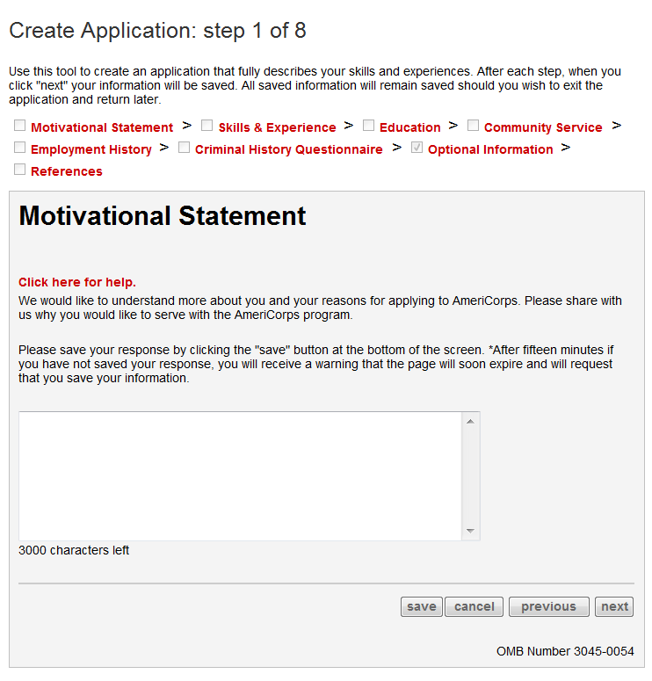

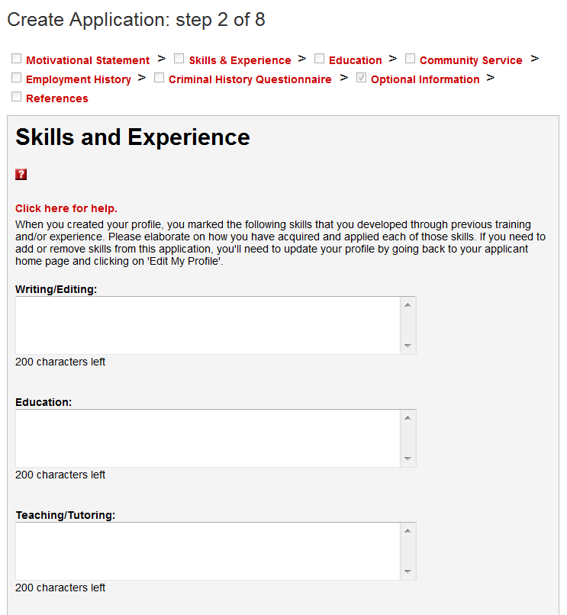

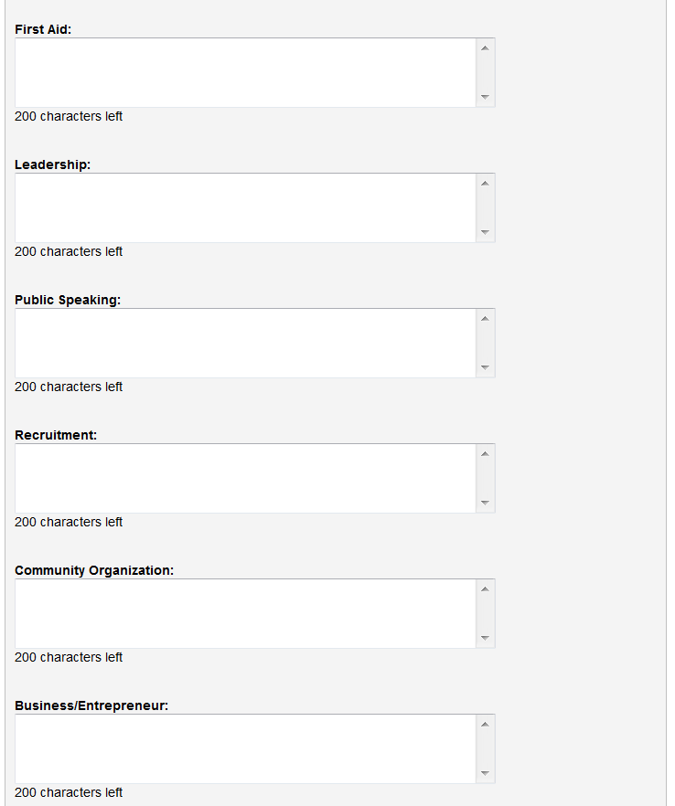

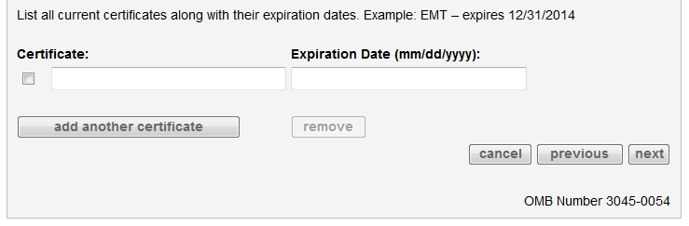

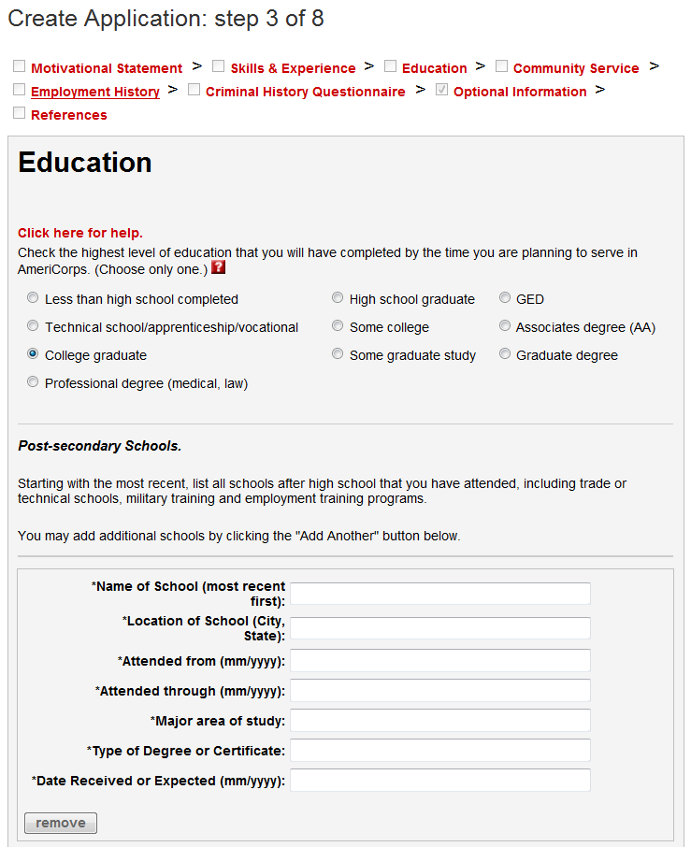

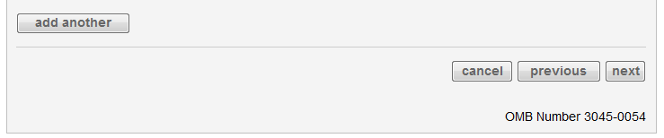

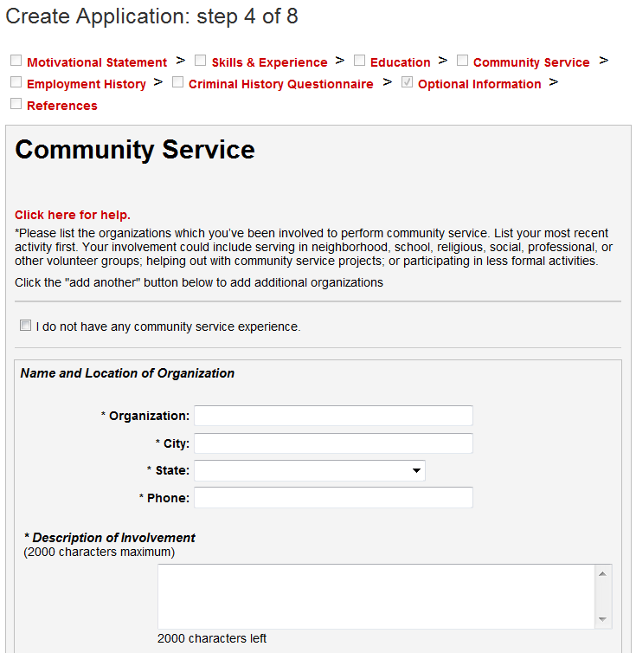

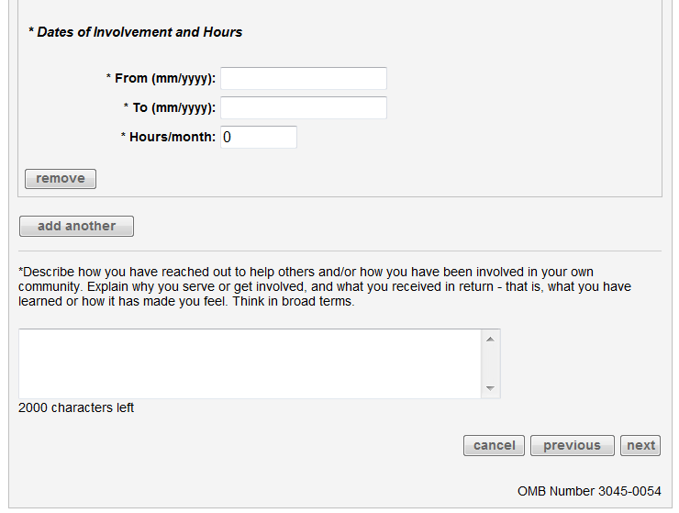

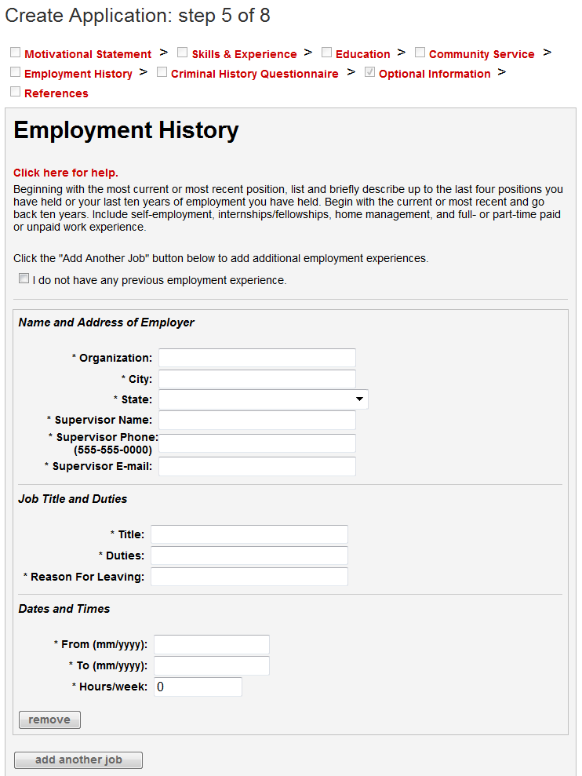

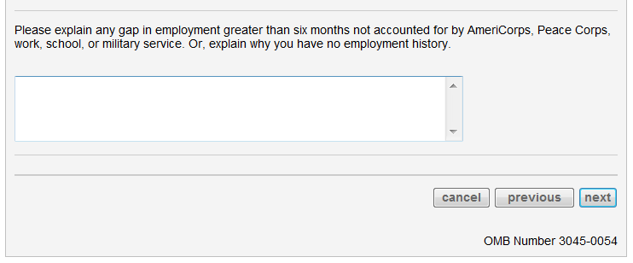

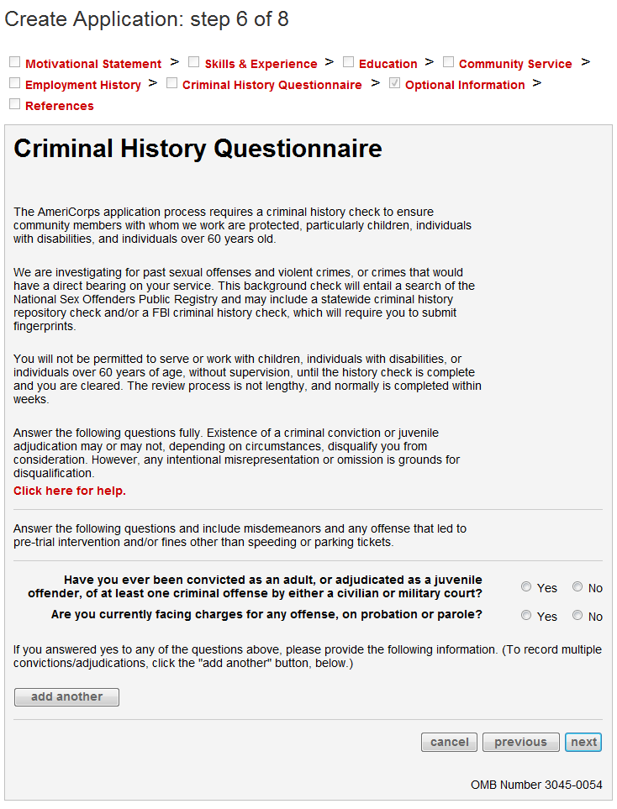

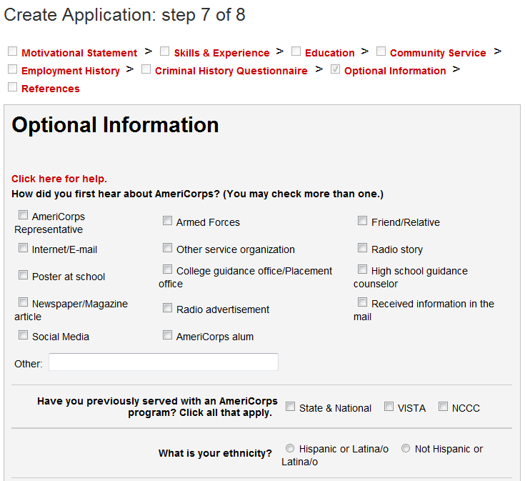

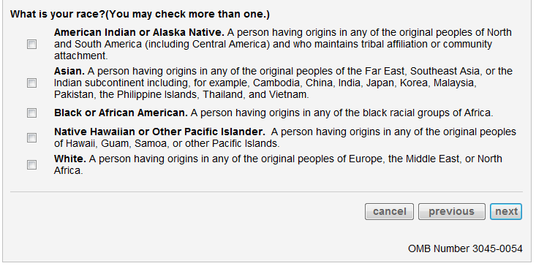

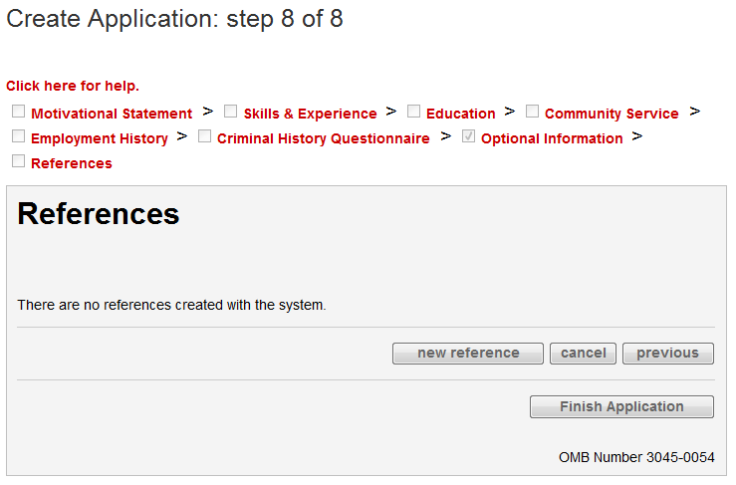

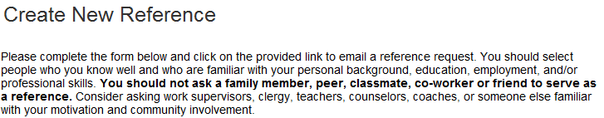

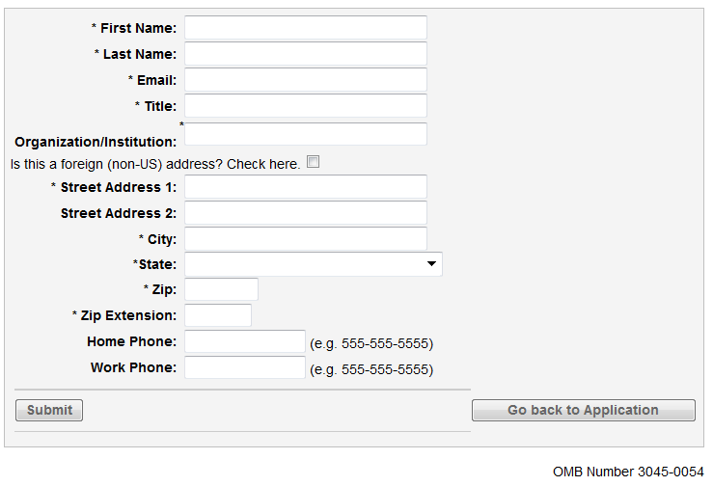

**Completing the above form sends the following automated email to the listed reference’s email address:**

Dear REFERENCEFIRSTNAME REFERENCELASTNAME:

AmeriCorps engages more than 70,000 Americans each year in results-driven service opportunities sponsored by thousands of local and national non-profits, public agencies, and faith-based community organizations.

APPLICANTFIRSTNAME APPLICANTLASTNAME is applying to be an AmeriCorps member. The applicant indicated that you would be able to evaluate his or her qualifications and provide us with a candid recommendation.

The success of AmeriCorps largely depends upon an appropriate match between programs and members. Considerable value is placed on personal references during the application review and selection process. To complete a reference form for this applicant, please click on the link provided below.

<http://my.americorps.gov/>...

Thank you for taking the time to fill out the AmeriCorps reference form. Your input is greatly appreciated.

Please do not reply to this message. If you have any questions or need further assistance please call 1-800-942-2677.

***PLEASE DO NOT REPLY TO THIS MESSAGE***

**When the reference clicks on the link in the above email, it brings them to the page for completing the reference form within the My AmeriCorps Portal.**

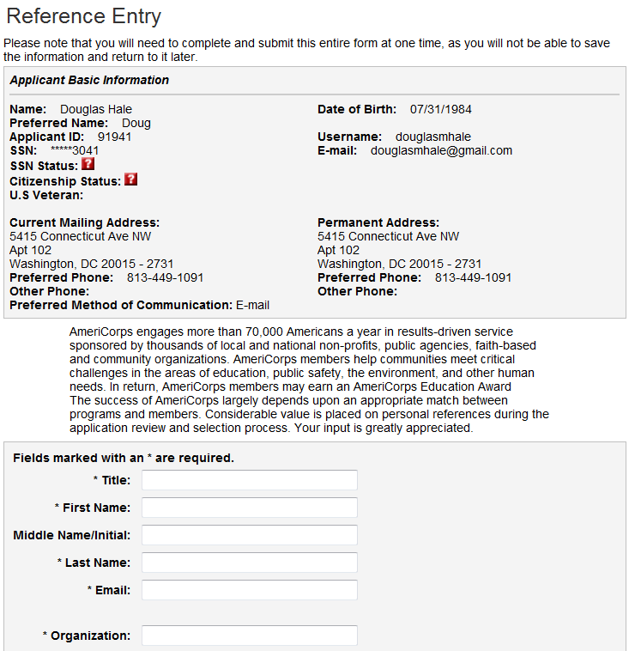

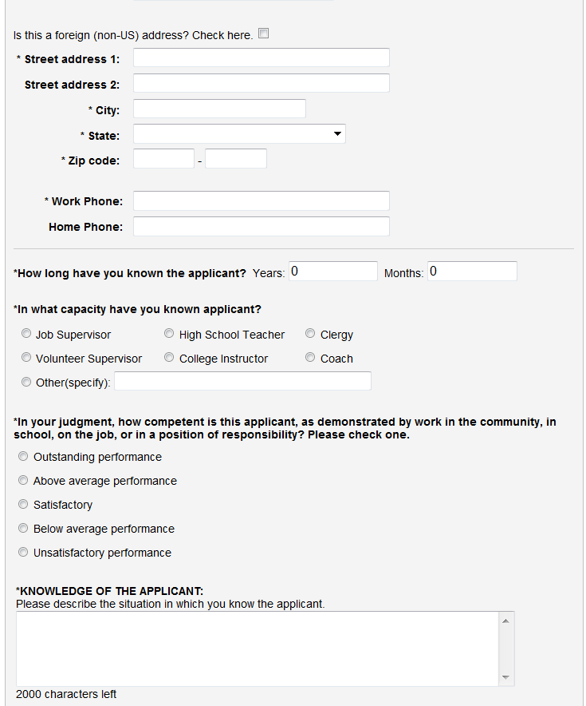

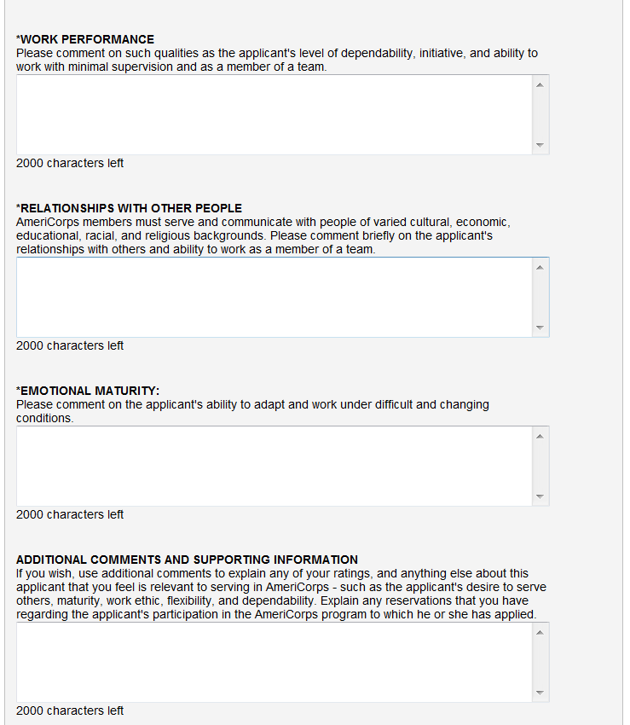

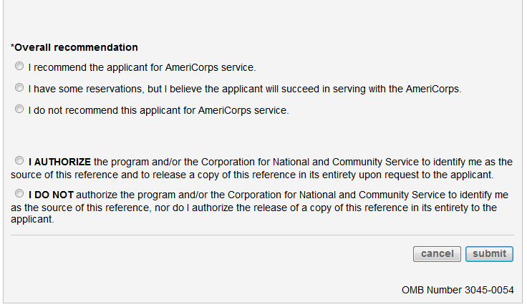

# AmeriCorps NCCC Team Leader Supplemental Questions

**AmeriCorps NCCC Team Leader applicants complete the below online questions when submitting their general AmeriCorps application (above) to an AmeriCorps NCCC Team Leader position posting:**

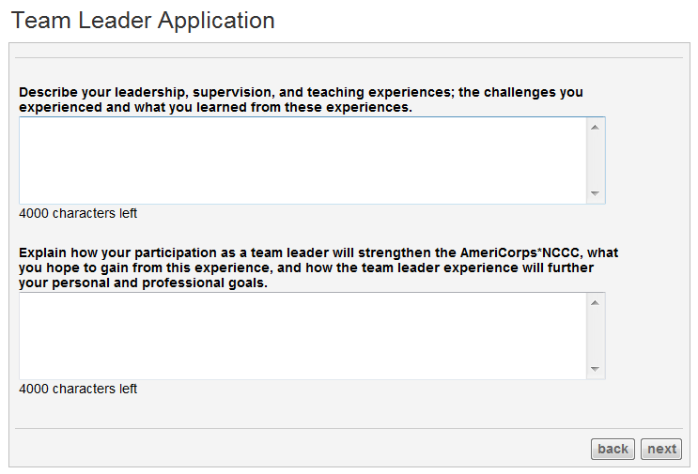

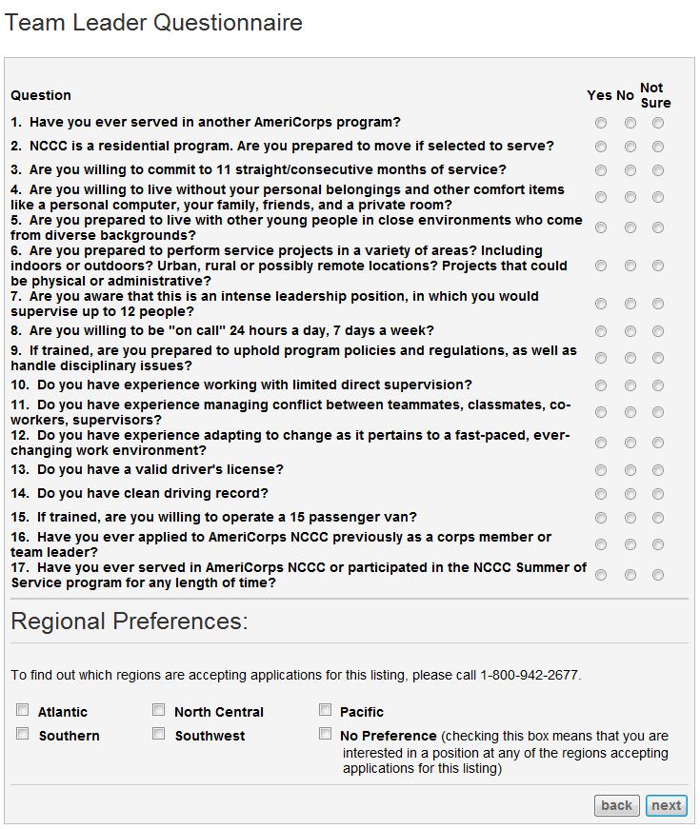

OMB Control Number: 3045-0005

Expiration Date: TBD

Privacy Notice

Information provided by this collection will not be shared with external parties in furtherance of CNCS’s mission. This could include, but is not limited to, sharing the information with Congress and other federal, state, local, or tribal governments.

If the collection is covered under the Privacy Act: the following Privacy Act Notice will be included on this information collection request: The information requested is collected pursuant to 42 U.S.C 12592 and 12615 of the National and Community Service Act of 1990 as amended, 42 U.S.C. 4953 of the Domestic Volunteer Service Act of 1973 as amended, and 42 U.S.C. 12639. Purposes and Uses - The information requested is collected for the purposes of reviewing grant applications and granting funding requests. Routine Uses - Routine uses may include disclosure of the information to federal, state, or local agencies pursuant to lawfully authorized requests. In some programs, the information may also be provided to federal, state, and local law enforcement agencies to determine the existence of any prior criminal convictions. The information may also be provided to appropriate federal agencies and Department contractors that have a need to know the information for the purpose of assisting the Department’s efforts to respond to a suspected or confirmed breach of the security or confidentiality or information maintained in this system of records, and the information disclosed is relevant and unnecessary for the assistance. The information will not otherwise be disclosed to entities outside of CNCS without prior written permission. Effects of Nondisclosure - The information requested is mandatory in order to receive benefits.