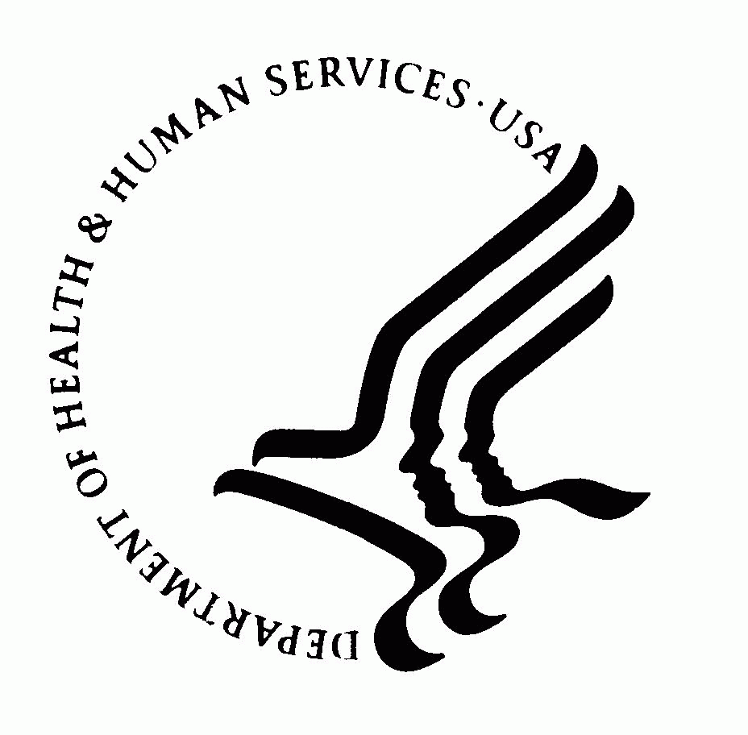 | DEPARTMENT OF HEALTH AND HUMAN SERVICES  Office of the Secretary  Washington DC 20201

MEMORANDUM

TO: Sherrette Funn, OS/OCIO-PRA Reports Clearance Officer

THROUGH: Darius Taylor, HHS/OCIO-PRA Report Clearance Officer

FROM: Ed Calimag, OS/ASFR/OGAPA/Division of Grants/Grants.gov Forms Manager

SUBJECT: Non-Substantial Change Request 4040-0001, Other Project Information IC

DATE: 08/22/2017

Grants.gov requests OMB approval on a non-substantial-modification to our Other Project Information form process. HHS Other Project Information IC collects research information used for grant applications.

This request is to add two additional checkboxes in the Exemption Section 1.a of the Other Project Information IC in compliance with updates to 45 CFR 46 Subpart A, The Federal Policy for the Protection of Subjects. The IC is currently approved and will remain in compliance with the PRA. This change does not reflect an increase to burden hours.

Please provide us with the Notice of Action upon OMB approval.

Thank you.

