**Offshore Wind Energy and the Carolina Coast: What Do They Mean to You?**

We are conducting this survey of residents in eight counties within North Carolina and South Carolina to understand:

* the importance of the Carolina coast to you,
* your level of support for offshore wind energy development, and
* your expectations about how offshore wind energy development would influence the region.

**Your participation in this survey is voluntary but extremely important.** Your answers will never be attributed to you as an individual. They will be protected. It will take about 20 minutes to take the survey. We appreciate your time.

# Importance of the Carolina Coast

The following questions will help us to understand how you feel about the Carolina coast. For purposes of this survey, “Carolina coast” means any land within one mile of the coastline and water extending X miles from shore, in either North Carolina or South Carolina. The enclosed map shows you the boundary of the Carolina coast.

1. To what extent do you agree or disagree with the following statements?

|  |  |  |  |  |  |
| --- | --- | --- | --- | --- | --- |
|  | Strongly  Disagree | Somewhat  Disagree | Neutral | Somewhat  Agree | Strongly  Agree |
| I feel a strong sense of community on the Carolina coast. |  |  |  |  |  |
| I think the economy is strong on the Carolina coast. |  |  |  |  |  |
| I feel connected to the other people who live on the Carolina coast. |  |  |  |  |  |
| The Carolina coast is a good place for the kind of work I do. |  |  |  |  |  |
| I think the natural parts of the Carolina coast are beautiful. |  |  |  |  |  |
| The Carolina coast says a lot about who I am. |  |  |  |  |  |
| The Carolina coast is the best place for what I like to do. |  |  |  |  |  |
| I like the Carolina coast’s mix of plants, animals, and landscapes. |  |  |  |  |  |

1. Could you tell us how important you think the Carolina coast is for_____?

|  |  |  |  |  |  |  |
| --- | --- | --- | --- | --- | --- | --- |
|  | Not  Important | Somewhat  Important | Important | Very  Important | Extremely  Important | Don’t  Know |
| Providing fish and shellfish for commercial harvest |  |  |  |  |  |  |
| Providing recreational activities |  |  |  |  |  |  |
| Enabling marine shipping, transportation and commerce |  |  |  |  |  |  |
| Production of oil and gas |  |  |  |  |  |  |
| Production of renewable energy |  |  |  |  |  |  |
| Protection of a variety of marine and coastal fish and wildlife |  |  |  |  |  |  |
| Protection of submerged maritime heritage sites, such as shipwrecks |  |  |  |  |  |  |
| Other, please specify: ______________________ |  |  |  |  |  |  |

1. For **ONLY** the recreational activities that you **ENGAGE IN** along the Carolina coast, please indicate how important each is to you.

|  |  |  |  |  |  |  |
| --- | --- | --- | --- | --- | --- | --- |
|  | Not  Important | Somewhat  Important | Important | Very  Important | Extremely  Important | Don’t Engage |
| Beach going |  |  |  |  |  |  |
| Nature or scenic photography |  |  |  |  |  |  |
| Birdwatching |  |  |  |  |  |  |
| Whale watching or viewing of other marine mammals |  |  |  |  |  |  |
| Fishing |  |  |  |  |  |  |
| Hunting |  |  |  |  |  |  |
| Swimming, wading or soaking in the ocean |  |  |  |  |  |  |
| Hiking, walking, jogging, or running |  |  |  |  |  |  |
| Boating or sailing |  |  |  |  |  |  |
| Kayaking or canoeing |  |  |  |  |  |  |
| Snorkeling or SCUBA diving |  |  |  |  |  |  |
| Other, please specify ______________ |  |  |  |  |  |  |

1. Please draw an arrow connecting each happy face to one favorite place in the area shown on this map. After drawing each arrow, please circle all of the reasons why you value that place, using the list shown in each square. Definitions for the values are provided below.

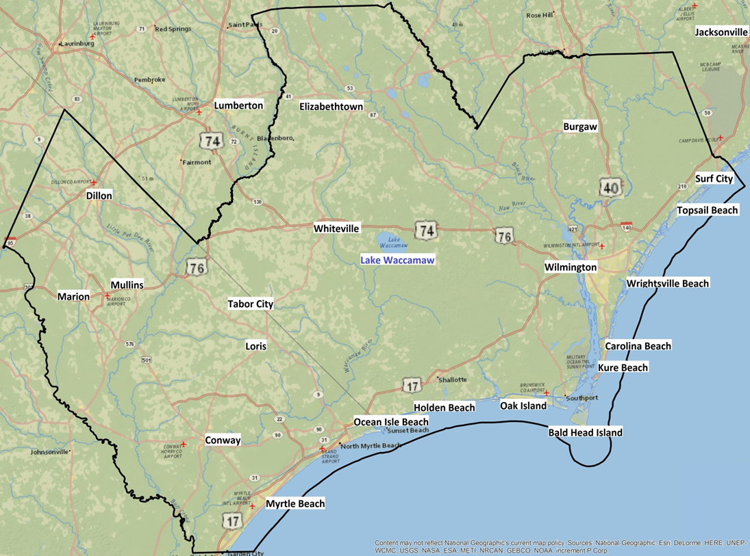

**Definitions for values:**

**Aesthetic**: I value this area because I enjoy the beauty, sights, sounds, and smells found here.

**Economic**: I value this area because it provides fisheries, minerals, and/or tourism opportunities such as outfitting and guiding.

**Historic**: I value this area because of the historic significance to our culture and communities.

**Recreation**: I value this area because it provides a place for my favorite outdoor recreation activities.

**Relaxation**: I value this area because it makes me feel better, physically and/or mentally; it is calming.

**Naturalness**: I value this area because it is undeveloped with minimal human impact and it provides a variety of fish, wildlife, plant life, etc.

1. Please answer each of these questions in terms of **THE WAY YOU GENERALLY FEEL**. There are no right or wrong answers simply select a response for each statement that represents what you generally feel as honestly and candidly as you can.

|  |  |  |  |  |  |
| --- | --- | --- | --- | --- | --- |
|  | Strongly  Disagree | Somewhat  Disagree | Neutral | Somewhat  Agree | Strongly  Agree |
| I often feel a sense of oneness with the natural world around me. |  |  |  |  |  |
| I think of the natural world as a community to which I belong. |  |  |  |  |  |
| I recognize and appreciate the intelligence of other living organisms. |  |  |  |  |  |
| I often feel disconnected from nature. |  |  |  |  |  |
| When I think of my life, I imagine myself to be part of a larger cyclical process of living. |  |  |  |  |  |
| I often feel a kinship with animals and plants. |  |  |  |  |  |
| I feel as though I belong to the Earth as equally as it belongs to me. |  |  |  |  |  |
| I have a deep understanding of how my actions affect the natural world. |  |  |  |  |  |
| I often feel part of the web of life. |  |  |  |  |  |
| I feel that all inhabitants of Earth, human, and nonhuman, share a common ‘life force.’ |  |  |  |  |  |
| Like a tree can be part of a forest, I feel embedded within the broader natural world. |  |  |  |  |  |
| When I think of my place on Earth, I consider myself to be a top member of a hierarchy that exists in nature. |  |  |  |  |  |
| I often feel like I am only a small part of the natural world around me, and that I am no more important than the grass on the ground or the birds in the trees. |  |  |  |  |  |
| My personal welfare is independent of the welfare of the natural world. |  |  |  |  |  |

# Support for Different Energy Production Options

The following questions will help us to understand your level of support for the development of offshore wind, both generally and in your region. Efforts are underway to pursue potential development of offshore wind energy production on the outer continental shelf of North Carolina and South Carolina. To date, three wind energy areas have been identified on the outer continental shelf of North Carolina. Officials are also considering potential areas along the outer continental shelf of South Carolina. The map included shows areas of consideration in both states.

1. By selecting “Yes” or “No” below for each item, please indicate whether you have **EVER** done any of the following activities to express your **SUPPORT FOR OR OPPOSITION TO:**
   1. an issue in **YOUR** city, county, or state.
   2. an environmental issue in **YOUR** city, county, or state.
   3. the potential foroffshore wind energy development in **YOUR** city, county or state**.**

|  |  |  |  |
| --- | --- | --- | --- |
|  | a. Any issue | b. An environmental issue | c. The potential for offshore wind energy development |
| Signed a petition | Yes No | Yes No | Yes No |
| Written, emailed or called a public official | Yes No | Yes No | Yes No |
| Written a letter to the editor | Yes No | Yes No | Yes No |
| Submitted written comments during a public comment period | Yes No | Yes No | Yes No |
| Joined a citizen-based advocacy group because of their position | Yes No | Yes No | Yes No |
| Attended public meetings sponsored by a government agency | Yes No | Yes No | Yes No |
| Attended public meetings, gatherings or demonstrations sponsored by an advocacy group | Yes No | Yes No | Yes No |
| Contributed money to an organization or campaign | Yes No | Yes No | Yes No |
| Displayed a bumper sticker or button/pin related to your position | Yes No | Yes No | Yes No |
| Other, please specify: ___________________ | Yes No | Yes No | Yes No |

1. In the **NEXT 12 MONTHS**, do you **PLAN** to do any of the activities listed above in Question 6 in response to the potential for **OFFSHORE WIND ENERGY** development **IN YOUR CITY, COUNTY OR STATE**?
   * Yes
   * No
2. Please rate your level of opposition or support to the following:

|  |  |  |  |  |  |
| --- | --- | --- | --- | --- | --- |
|  | Strongly  Oppose | Somewhat  Oppose | Neutral | Somewhat  Support | Strongly  Support |
| Development of offshore wind farms in the United States |  |  |  |  |  |
| Development of offshore wind farms in South Carolina |  |  |  |  |  |
| Development of offshore wind farms in North Carolina |  |  |  |  |  |
| Development of offshore wind farms near Wilmington, North Carolina |  |  |  |  |  |

1. Please rate your level of opposition or support to the following:

|  |  |  |  |  |  |
| --- | --- | --- | --- | --- | --- |
|  | Strongly  Oppose | Somewhat  Oppose | Neutral | Somewhat  Support | Strongly  Support |
| Development of offshore oil or natural gas wells in the United States |  |  |  |  |  |
| Development of offshore oil or natural gas wells in North Carolina |  |  |  |  |  |
| Development of offshore oil or natural gas wells in South Carolina |  |  |  |  |  |

1. Would your level of support for the development of offshore windfarms **IN YOUR STATE** increase, decrease or remain the same if you knew that the energy produced by the turbines would be used exclusively by residents:

|  |  |  |  |  |  |
| --- | --- | --- | --- | --- | --- |
|  | Decrease Substantially | Decrease Somewhat | Remain the Same | Increase Somewhat | Increase Substantially |
| Inside your state |  |  |  |  |  |
| Outside of your state |  |  |  |  |  |

1. How adequate do you feel the opportunities have been for members of public to participate in meetings or other parts of the planning process for potential offshore wind development **IN YOUR STATE**?

* Members of the public have had no opportunities to participate
* Members of the public have had some opportunities to participate, but too few
* Members of the public have had adequate opportunities to participate
* Members of the public have had more than adequate opportunity to participate
* No opinion

# Perceived Impacts of Offshore Wind Development

The following questions will help us to understand your expectations about how offshore wind energy development would influence the region.

1. Please indicate the **TYPE OF IMPACT** you think development of offshore wind along the Carolina coast would have on each of the following items.

|  |  |  |  |  |
| --- | --- | --- | --- | --- |
|  | Negative  Impact | No  Impact | Positive  Impact | Unsure |
| Tax revenues |  |  |  |  |
| Job opportunities |  |  |  |  |
| Affordability of electricity |  |  |  |  |
| Image of your community |  |  |  |  |
| Tourism |  |  |  |  |
| Shipwrecks and other submerged maritime heritage sites |  |  |  |  |
| Local property values |  |  |  |  |
| View of ocean from the shore during the day |  |  |  |  |
| View of ocean from the shore at night |  |  |  |  |
| Commercial fishing industry |  |  |  |  |
| Yachting and recreational boating |  |  |  |  |
| Recreational fishing |  |  |  |  |
| Habitat for birds |  |  |  |  |
| Habitat for fish |  |  |  |  |
| Habitat for marine mammals and sea turtles |  |  |  |  |

1. For the same items listed above, now please tell us **HOW IMPORTANT** each item is to you in terms of your quality of life on the Carolina coast.

|  |  |  |  |  |  |  |
| --- | --- | --- | --- | --- | --- | --- |
|  | Not  Important | Somewhat  Important | Important | Very  Important | Extremely  Important | Don’t  Know |
| Tax revenues |  |  |  |  |  |  |
| Job opportunities |  |  |  |  |  |  |
| Affordability of electricity |  |  |  |  |  |  |
| Image of your community |  |  |  |  |  |  |
| Tourism |  |  |  |  |  |  |
| Shipwrecks and other submerged maritime heritage sites |  |  |  |  |  |  |
| Local property values |  |  |  |  |  |  |
| View of ocean from the shore during the day |  |  |  |  |  |  |
| View of ocean from the shore at night |  |  |  |  |  |  |
| Commercial fishing industry |  |  |  |  |  |  |
| Yachting and recreational boating |  |  |  |  |  |  |
| Recreational fishing |  |  |  |  |  |  |
| Habitat for birds |  |  |  |  |  |  |
| Habitat for fish |  |  |  |  |  |  |
| Habitat for marine mammals and sea turtles |  |  |  |  |  |  |

# Background

To enable us to compare the responses of people with similar or different characteristics, in this final section we ask a few questions about you and your household. As with all answers, this information will be used on for grouped analysis involving responses from all survey participants – your responses will remain completely confidential.

1. What is your sex?
   * Male
   * Female
2. In what year were you born?

|  |  |  |  |
| --- | --- | --- | --- |
|  |  |  |  |

1. Which best describes your marital status?
   * Married
   * Widowed
   * Divorced
   * Separated
   * Never married
   * Other (specify) ____________________
2. Which best describes your ethnicity?

* Hispanic or Latino
* Not Hispanic or Latino

1. Which best describes your race (select one or more)?

* American Indian or Alaska Native
* Asian
* Black or African American
* Native Hawaiian or Other Pacific Islander
* White

1. What is the highest degree or level school you have completed?

* No schooling completed
* Some high school (no diploma)
* High school diploma or GED
* Some college (no degree)
* Associate’s degree
* Bachelor’s degree
* Master’s degree
* Professional degree (e.g., MD, DVM, JD)
* Doctoral degree (e.g., PhD, EdD)

1. What is your ZIP code of residence?

|  |  |  |  |  |
| --- | --- | --- | --- | --- |
|  |  |  |  |  |

1. What is your county of residence?

* Bladen, NC
* Brunswick, NC
* Columbus, NC
* New Hanover, NC
* Pender, NC
* Dillon, SC
* Horry, SC
* Marion, SC
* Other (please specify) ________________________

1. Would you describe yourself as a permanent, temporary or seasonal resident of this county?

* Permanent (i.e., you reside in the county full time, permanently)
* Temporary (i.e., you reside in the county full time, but for a limited period only)
* Seasonal (i.e., you reside in the county for one to four months annually or periodically, such as for vacation or holiday)

1. How long have you resided in this county as a permanent, temporary or seasonal resident?

* Less than 1 year
* 1 to 2 years
* 3 to 5 years
* 6 to 10 years
* 11 to 20 years
* More than 20 years

1. Which best describes the ownership status of your residence in this county?

* Owned or being bought by you or someone in your household
* Rented or leased for cash rent
* Occupied without payment of cash rent

1. How many people currently live in your household, including yourself?

|  |  |
| --- | --- |
|  |  |

1. How many people under the age of 18 currently live in your household?

|  |  |
| --- | --- |
|  |  |

1. What was the total income of your household during 2015 before taxes and other deductions?

* Less than $25,000
* $25,000 to $34,999
* $35,000 to $49,999
* $50,000 to $74,999
* $75,000 to $99,999
* $100,000 to $149,999
* $150,000 or more

1. Which best describes your current employment status?

* Unemployed
* Employed full-time
* Employed part-time
* Self-employed
* Retired
* Student
* Homemaker
* None of the above

The public reporting burden for this collection of information is estimated to average 20 minutes including the time for reviewing instructions, searching for existing data sources, gathering and maintaining the data needed, and completing and reviewing the collection of information. Send comments regarding this burden estimate or any other suggestions for reducing this burden to: Dr. Theresa L. Goedeke, NOAA National Ocean Service, National Centers for Coastal Ocean Science, 1305 East-West Highway, Silver Spring, MD 20910. Access to raw data collected during the data collection process will be restricted to project managers. In final datasets and products that are released, data provided by individual respondents will be aggregated and not linked to personally identifiable information. Notwithstanding any other provisions of the law, no person is required to respond to, nor shall any person be subjected to a penalty for failure to comply, with a collection of information subject to the requirements of the Paperwork Reduction Act unless that collection of information displays a currently valid OMB Control Number.