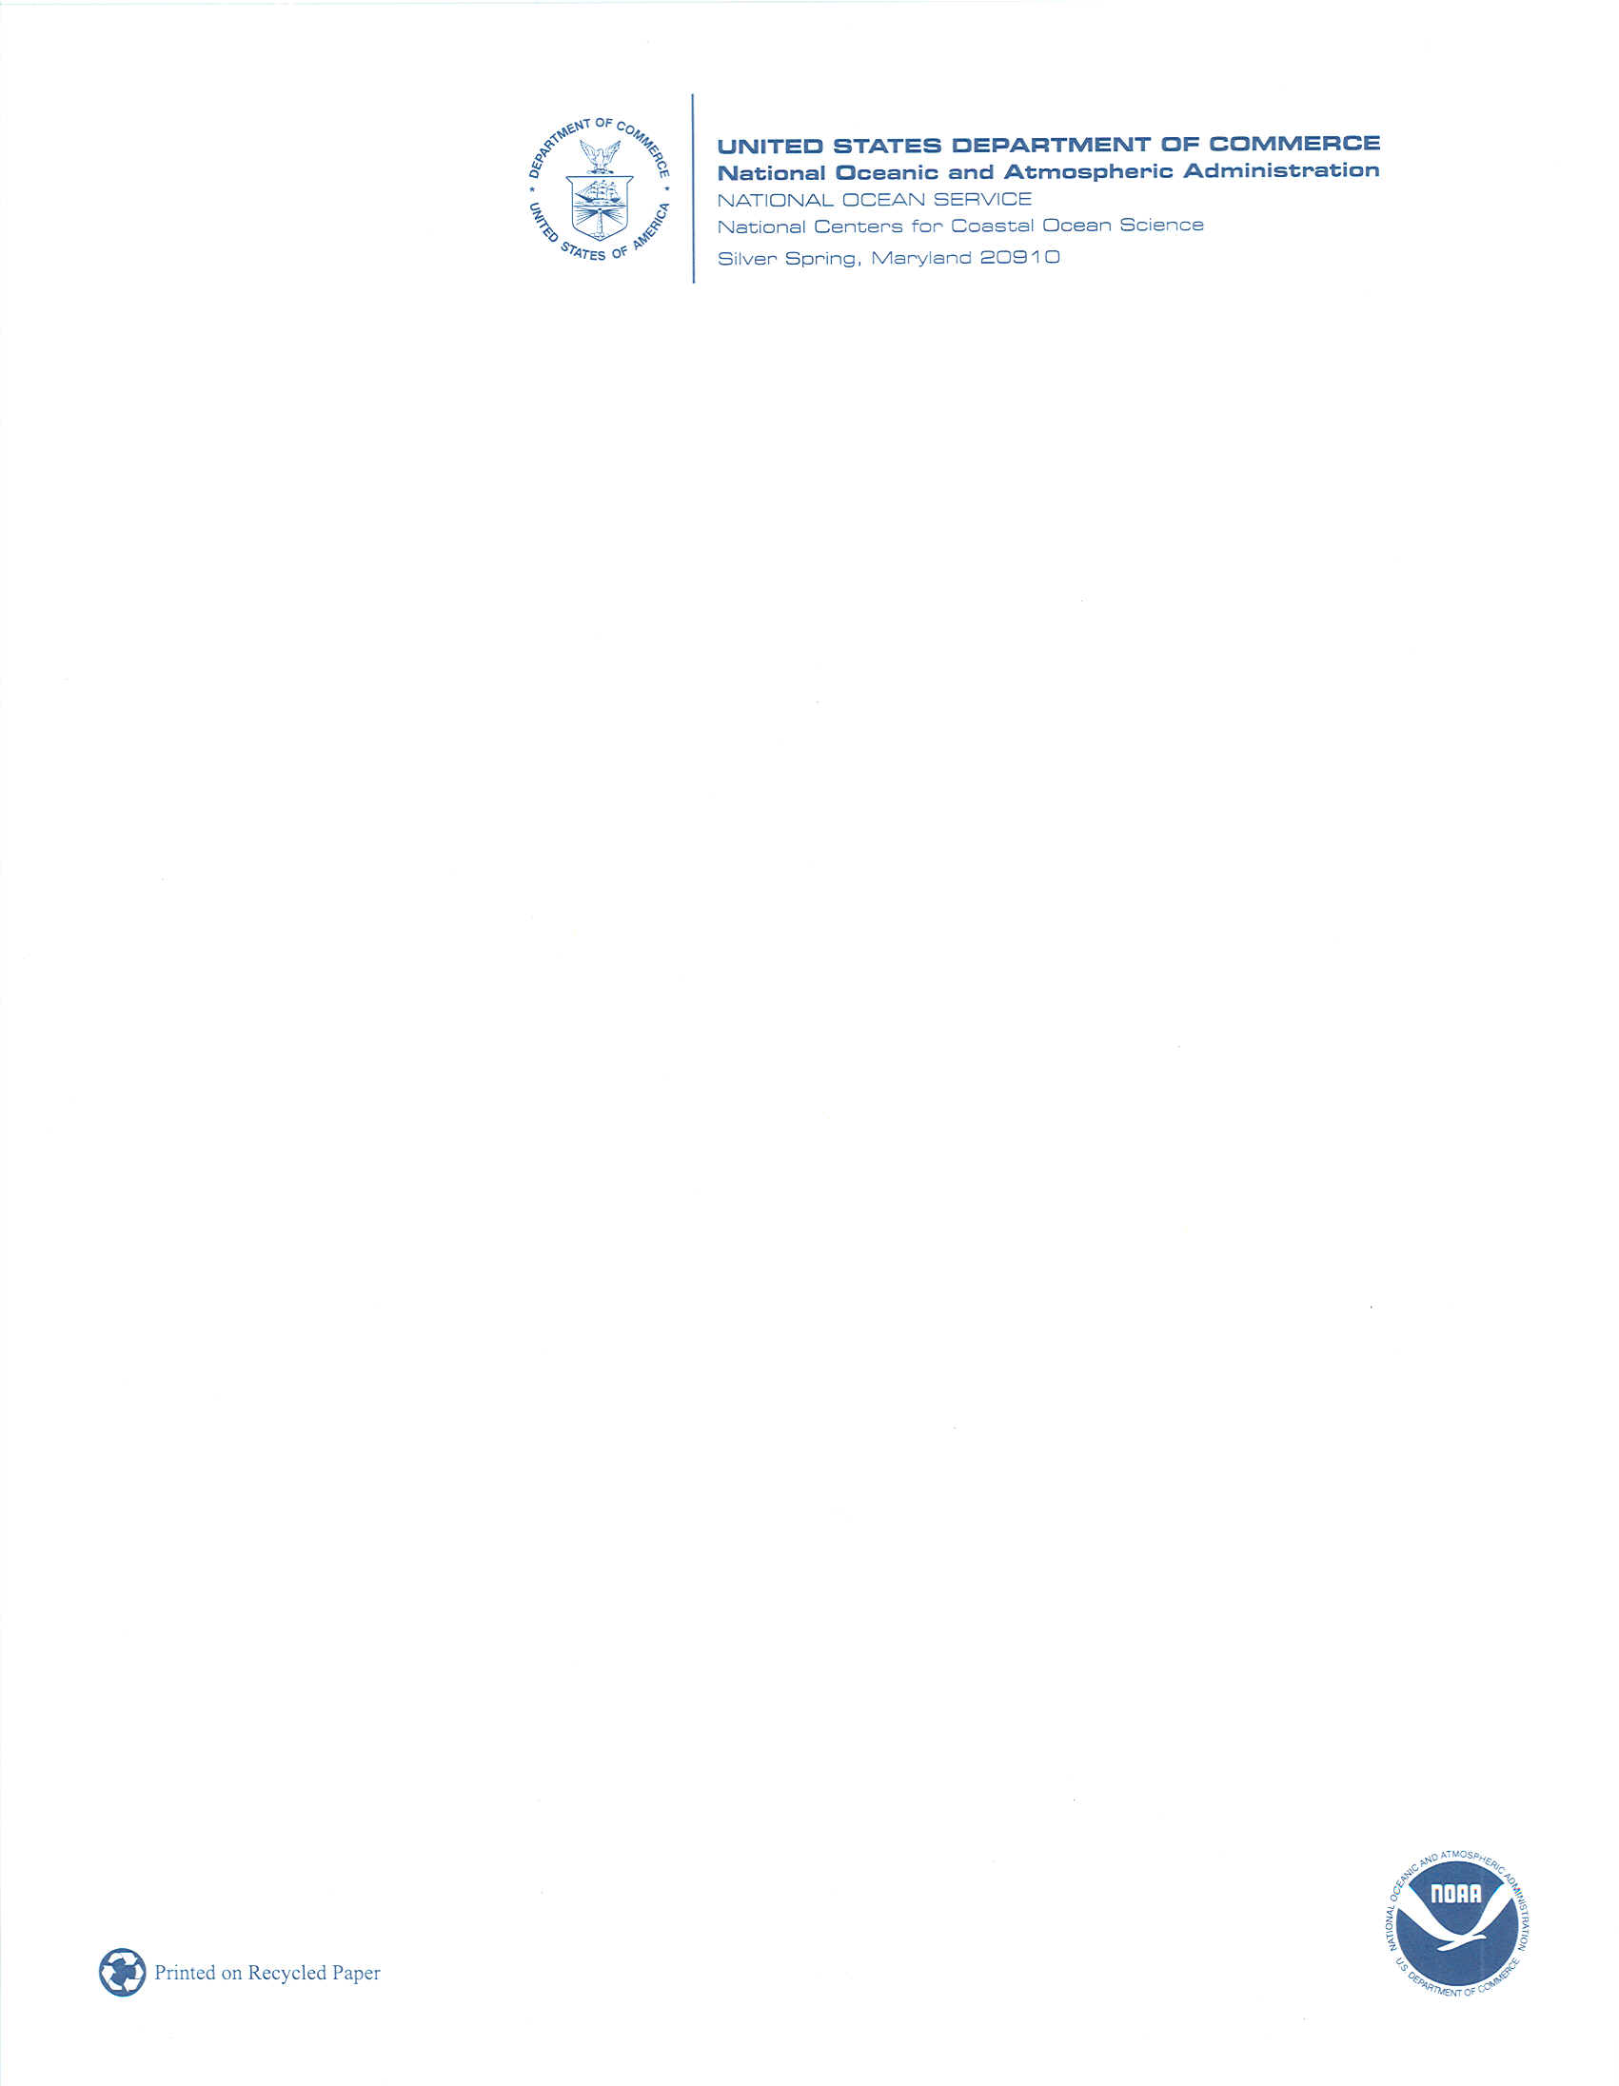

Dear Resident:

You recently received a survey inviting participation in a study of resident values, attitudes, and perceptions related to offshore wind energy development. We wanted to take just a minute to remind you that your participation in this study is extremely important!

For your convenience, we have enclosed a new survey. We would like to invite the person in the household over the age of 18 who most recently celebrated a birthday to complete the survey and return it to us within five business days. It will only take about XX minutes of your time to take the survey. Just complete the survey, place it into the self-addressed stamped envelope, and return it by regular postal service. Your participation is voluntary, but very important. Your answers will never be attributed to you as an individual. They will be confidential.

If you have questions about the survey or would like to be notified when the final report of study findings becomes available, please feel free to contact me using the information below.

Theresa L. Goedeke, Ph.D.
Social Scientist
NOAA NOS National Centers for Coastal Ocean Science
1305 East West Hwy
Building SSMC4, Rm 9326
Ph: 240-533-0383
Email: theresa.goedeke@noaa.gov

Thank you in advance for participating in our survey. Your contributions are very valuable!

Sincerely,

Theresa L. Goedeke, Ph.D.
Enc.

