Catcher/processor Groundfish landing report in sealandings.
Fields that the vessel has to fill in are highlighted in yellow. Those that are not highlighted auto-fill based on the vessel operation that is established in the database.
FCP is for floating catcher processor so if they are acting as a CV, they would modify this field and enter the appropriate port code.

Vessel/Location/Status Tab
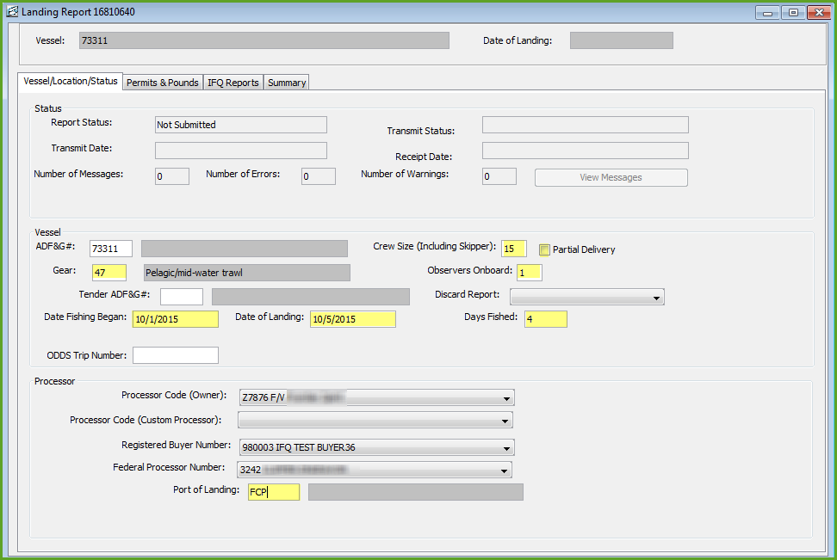

Permits & Pounds Tab
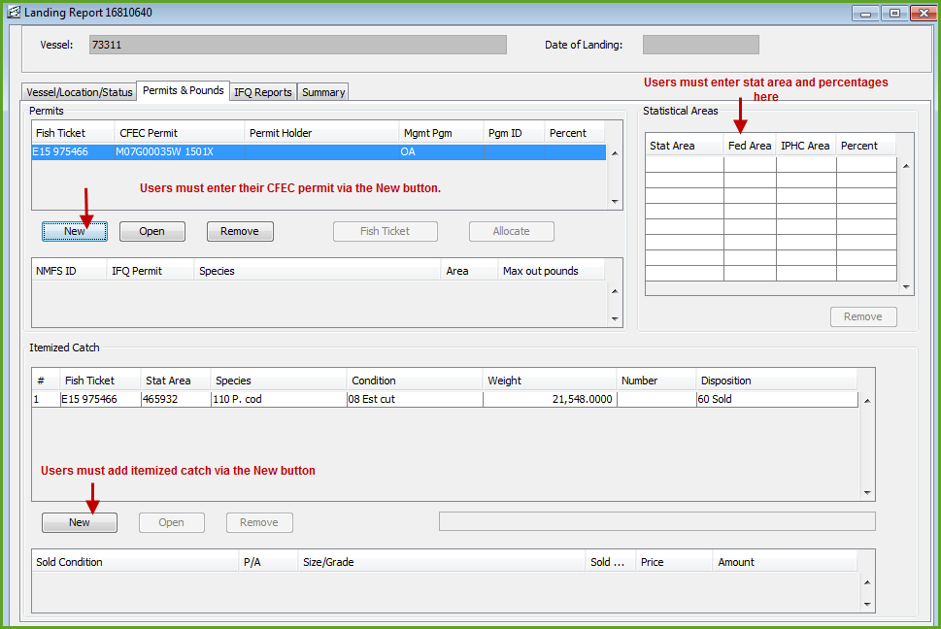

Permit entry dialog box
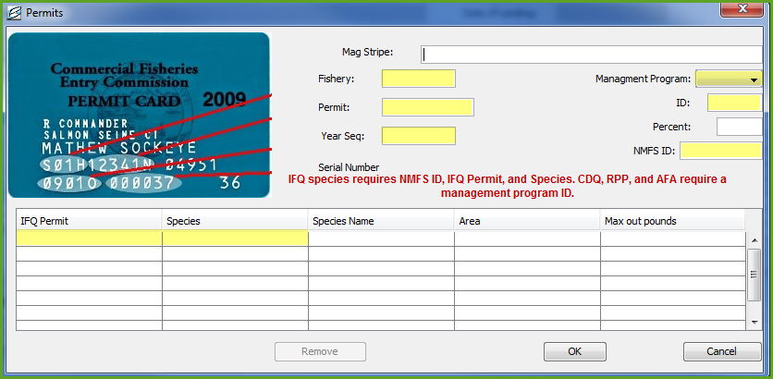

Itemized catch entry dialog box
Stat area can be filled in here or in the stat area worksheet as displayed in the overall screenshot of the Permits & Pounds tab
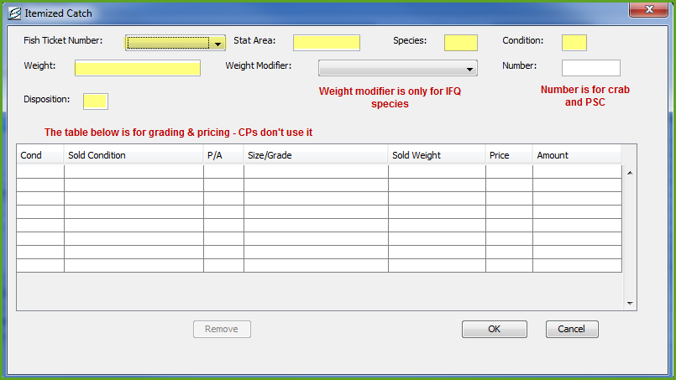

IFQ Reports