1. The DoD Postsecondary Education Complaint Intake is accessed online by visiting the following URL: http://www.militaryonesource.mil/voluntary-education?content_id=274604. Upon accessing the DoD Postsecondary Education Complaint Intake URL users are presented with a Notice and Consent Statement. From the Notice and Consent Statement complaint filers have the ability to access the User Agreement or click “OK” to advance.

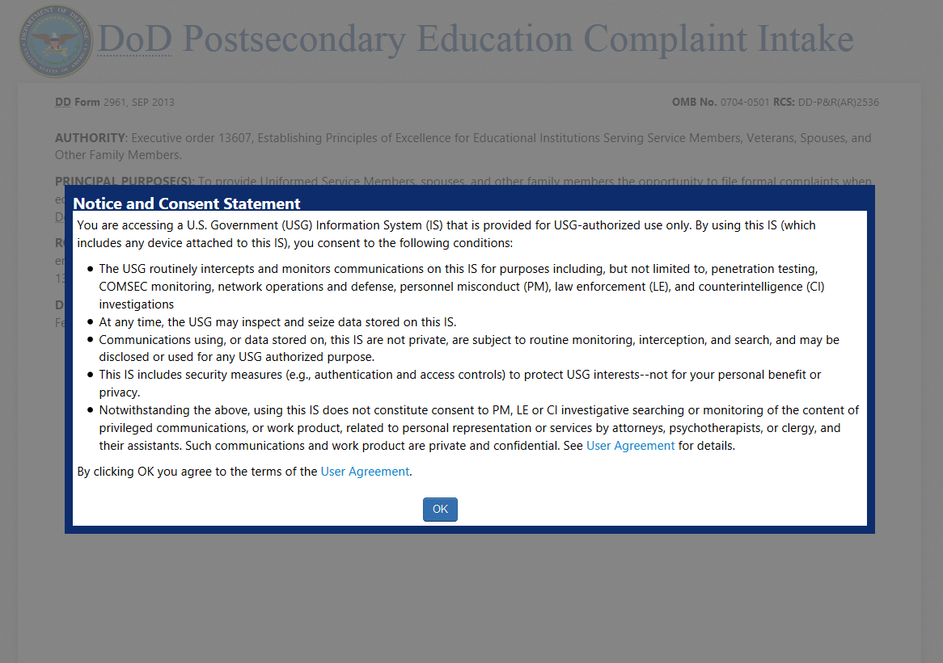

1. After agreeing to the Notice and Consent Statement complaint filers are presented with information regarding the Intake’s Authority, Principle Purpose(s), Routine Use(s) and Disclosure.

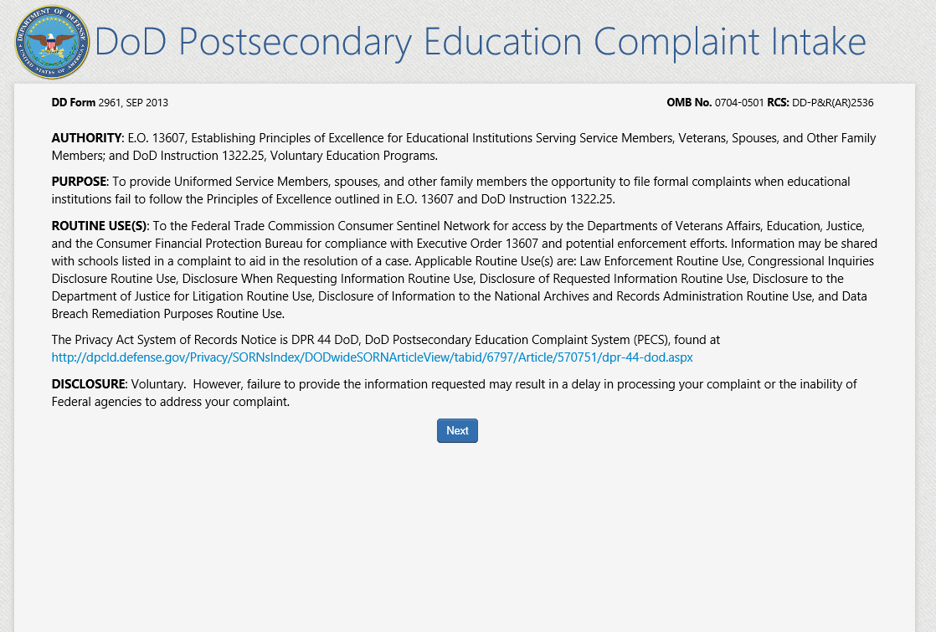

1. Upon clicking “Next“ the complaint filer advances to the Welcome Page. This is a content managed page that permits a Level 3 (OSD) user to edit the text via the PECS management system. **NOTE**: The text highlighted in red is NEW TEXT THAT IS BEING ADDED to the live PECS Intake Welcome Page.

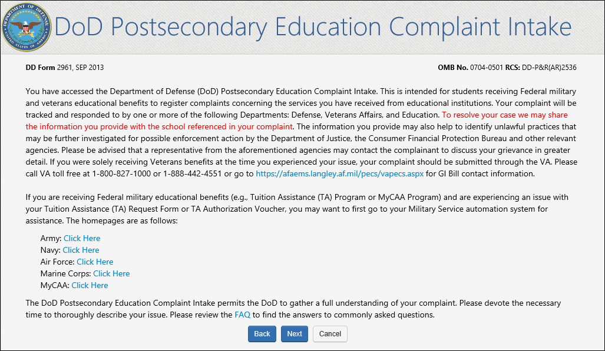

Upon clicking “Next” the complainant is presented with a Veterans Benefits question.

1. If the complaint filer selects “Yes” to the Veterans Benefits question, a message displays on the screen stating they will be navigated to the Veterans Affairs Principles of Excellence Complaint Intake Questionnaire.

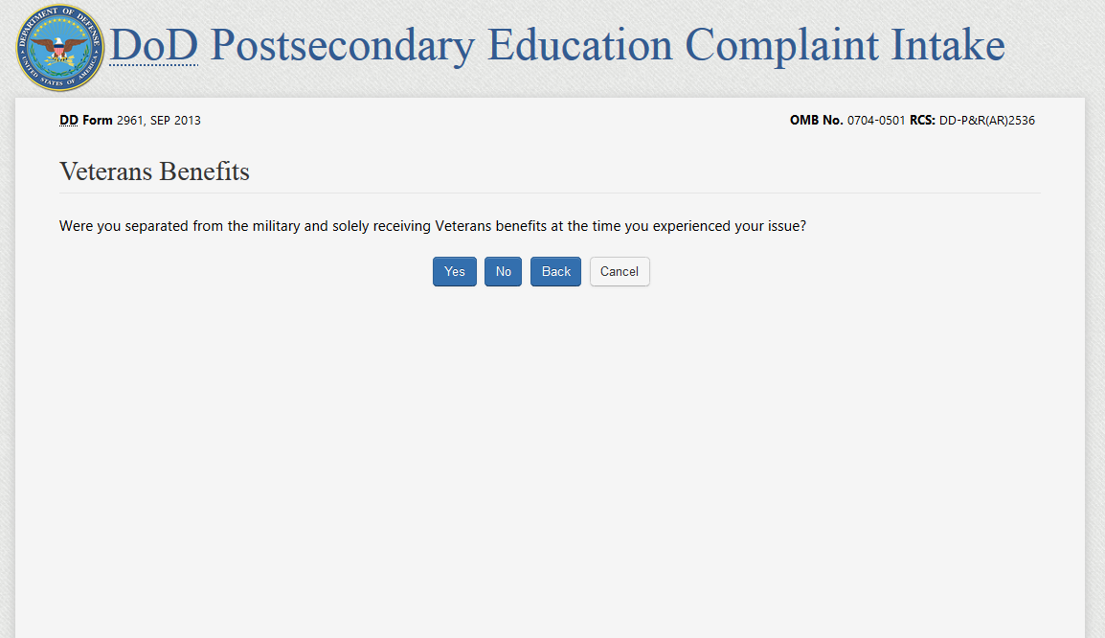

If the complaint filer answers “No” to the Veterans Benefits question, they will be required to acknowledge the statement contained in the pop-up. Acknowledging the statement will allow the user to advance to the DS Logon page and authenticate. 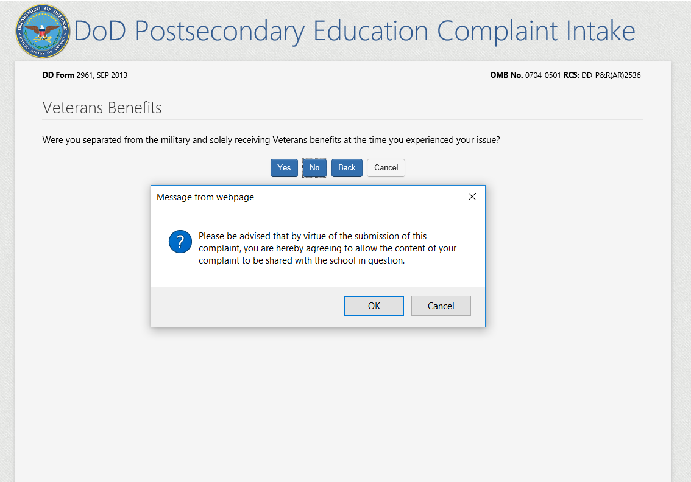

**DS LOGON PAGE: DS LOGON IS A NEW AUTHENTICATION METHOD BEING INTEGRATED INTO THE DOD INTAKE.** This page is developed and managed by DS Logon; and though DS Logon is a separate application, its integration into the PECS Intake will be seamless to the user. DS Logon requires the user to authenticate either by Common Access Card (CAC) or by DS Logon username/password.

1. Complaint filers will have the option to authenticate via username and password or Common Access Card.

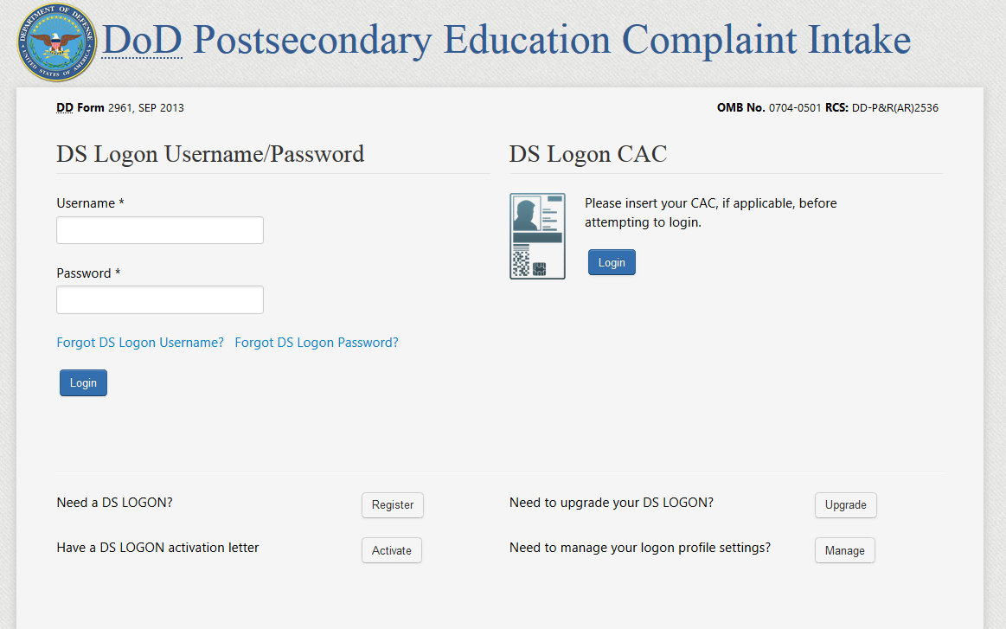

**USER FILES COMPLAINT ON BEHALF OF THEMSELVES**

**CONTACT & COMPLAINANT PAGE (FILE ON BEHALF OF MYSELF – SERVICE MEMBER)**

1. Once the complainant authenticates via DS Logon they are presented with Section 1 - the Contact and Complainant data collection page. When the complaint filer indicates they are filing on behalf of themselves and selects “Service Member” as their **Service Affiliation** they are asked to provide their Service information.

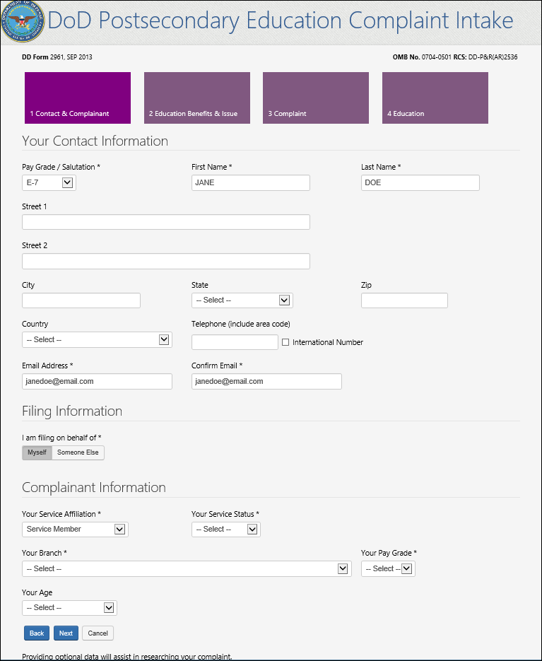

Step 1

Filing option selection

Figure 1: Service Member filing on behalf of themselves

**CONTACT & COMPLAINANT PAGE (FILE ON BEHALF OF MYSELF – SPOUSE OR FAMILY MEMEBER)**

6a. When the complaint filer indicates they are filing on behalf of themselves and selects “Spouse or Family Member” as the **Service Affiliation** they are required to identify if they are a My Career Advancement Account student and the Complainant data collection field labels then asks for their sponsor’s information.

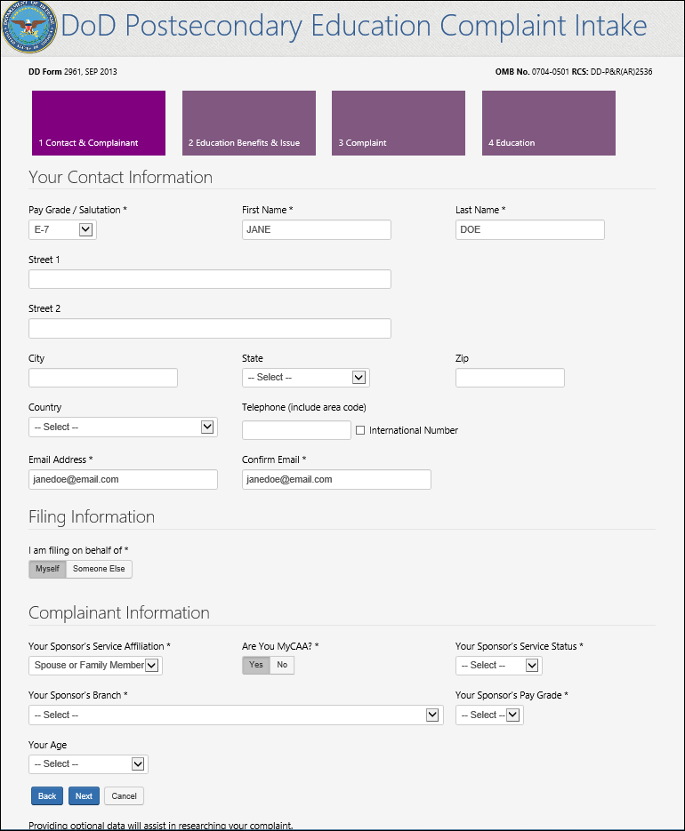

User must indicate if they are a My Career Advancement Account user

Complainant section labels update to asking for Sponsor’s information

Figure 2: Spouse or Family Member submitting on behalf of themselves

**CONTACT & COMPLAINANT PAGE (FILE ON BEHALF OF MYSELF – VETERAN)**

6b. When the complaint filer indicates they are filing on behalf of themselves and selects “Veteran” as the **Service** **Affiliation** they are NOT asked to provide their Service Status (Reserve, National Guard).

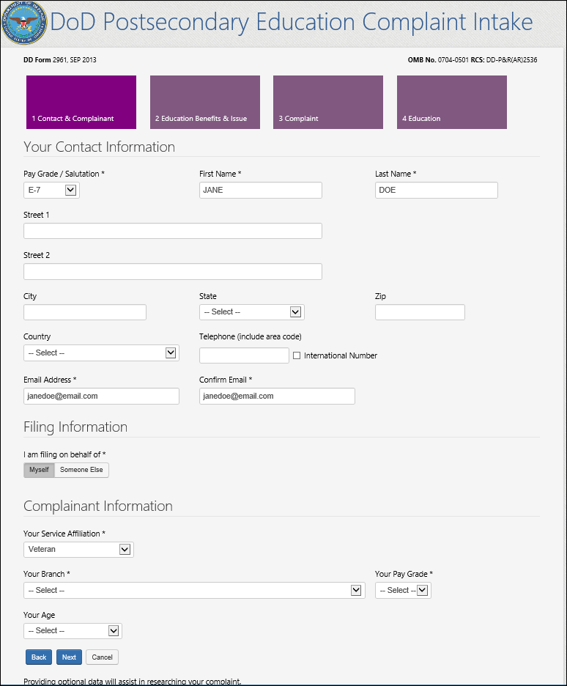

**USER FILES COMPLAINT ON BEHALF OF SOMEONE ELSE**

**CONTACT & COMPLAINANT PAGE (FILE ON BEHALF OF SOMEONE ELSE)**

1. If a user elects to file on behalf of *someone else,* the individual(s) they are authorized to file on behalf of (information available from DEERS record authenticated via DS Logon) will appear in the “Complainant’s Name” dropdown list (these names will not be visible to any other user). NOTE: Under the Complainant Information section the following are new fields being added to the DoD Complaint Intake: Name, Street 1, Street 2, City, State, Zip, Country, Telephone and Email Address, Confirm Email.

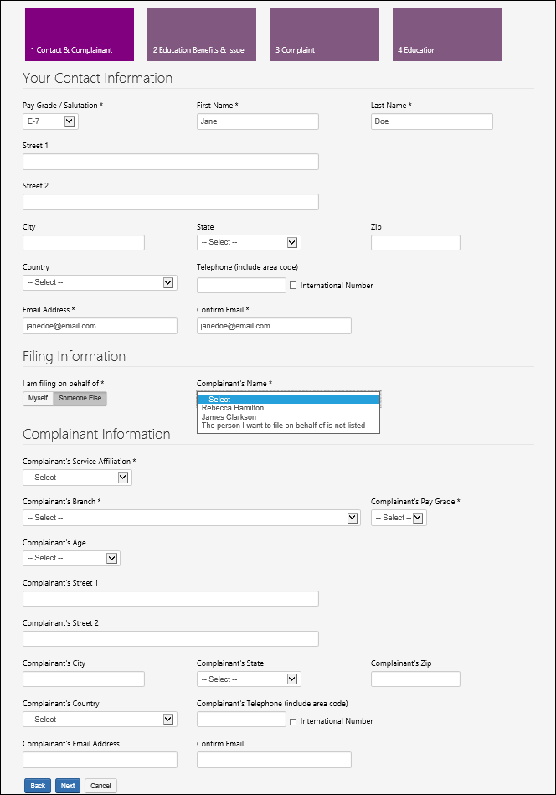

The names of individuals the complaint filer is authorized to “file on behalf of” displays in the dropdown list

This is the contact information of the complaint filer

**CONTACT & COMPLAINANT PAGE (ON BEHALF OF SOMEONE ELSE – USER NOT LISTED)**

7a. If the user elects to file on behalf of *someone else* and the DEERS record does not identify them as being authorized to file a complaint on the individual’s behalf, a message will display on the page directing them to the DEERS office. NOTE: The message “cannot submit complaint” stopper is a new addition to the DoD PECS Intake behavior.

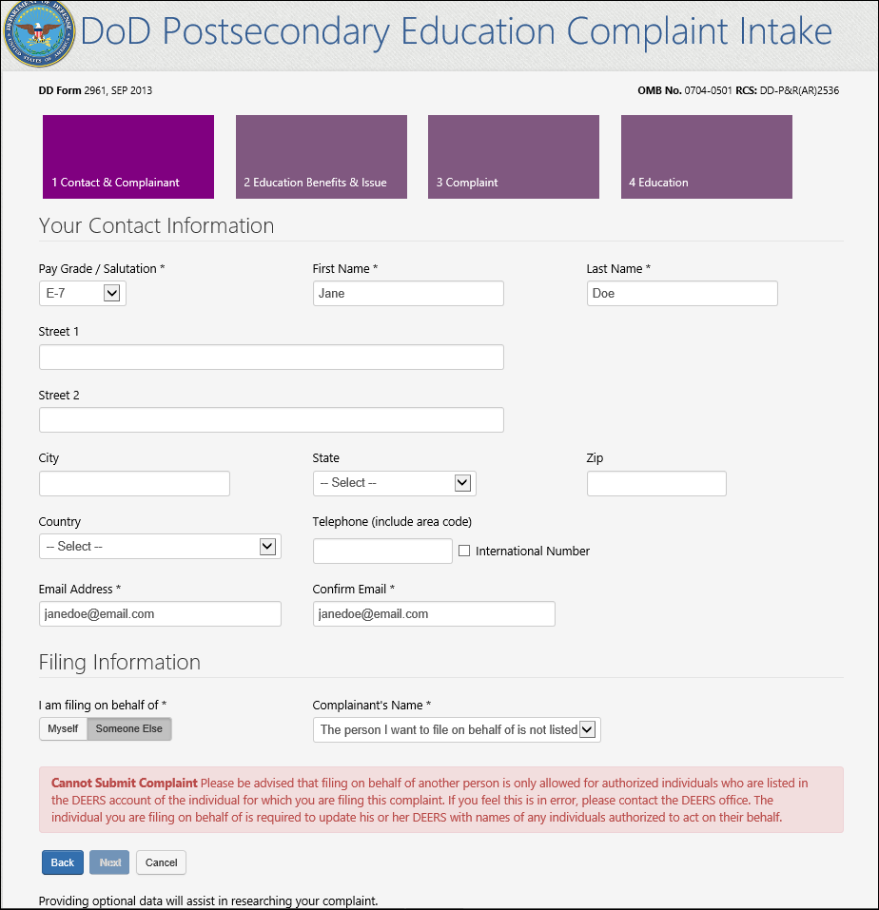

**CONTACT & COMPLAINANT PAGE (FILING ON BEHALF OF SOMEONE ELSE –**

**SPOUSE OR FAMILY MEMBER)**

7b. When the complaint filer indicates they are filing on behalf of *someone else* and selects “Spouse or Family Member” as the **Service Affiliation** they are required to identify if the complainant is a My Career Advancement Account student and the Complainant data collection field labels ask for the complainant’s sponsor’s information.

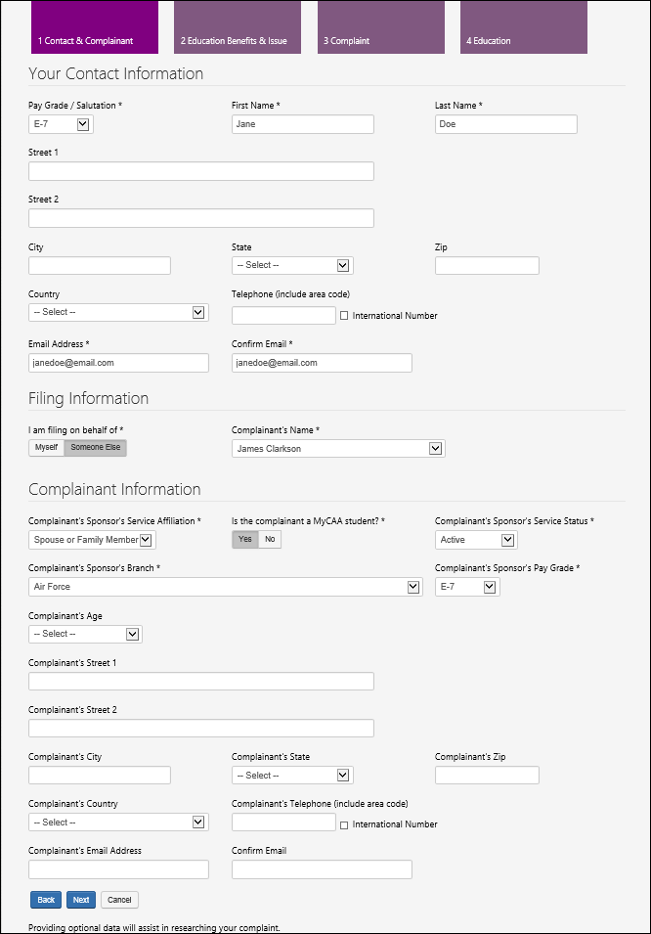

This is the contact information of the complaint filer

Complainant Information section labels update to ask for complainant’s sponsor’s information

My Career Advancement Account question appears here

**CONTACT & COMPLAINANT PAGE (FILING ON BEHALF OF SOMEONE ELSE – VETERAN)**

7C. When the complaint filer indicates they are filing on behalf of *someone else* and selects “Veteran” as the **Service Affiliation** they are NOT asked to provide their Service Status (Reserve, National Guard).

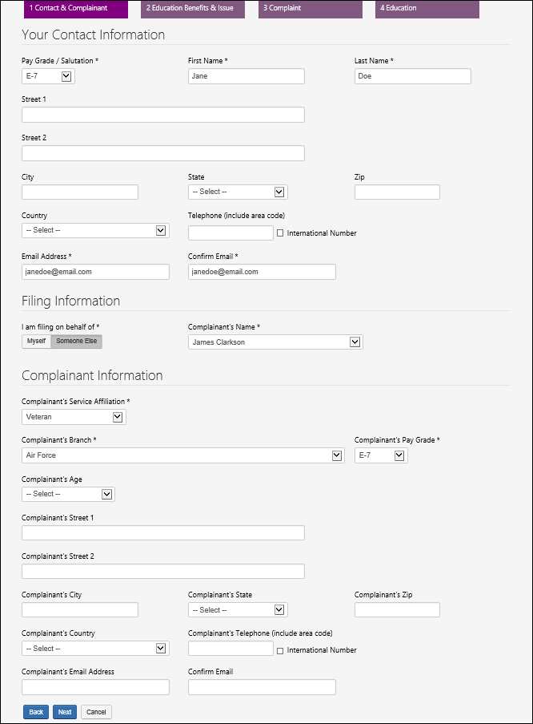

This is the contact information of the complaint filer

1. After clicking “Next” the complaint filer advances to Section 2 - the “Education Benefits & Issue” data collection page.

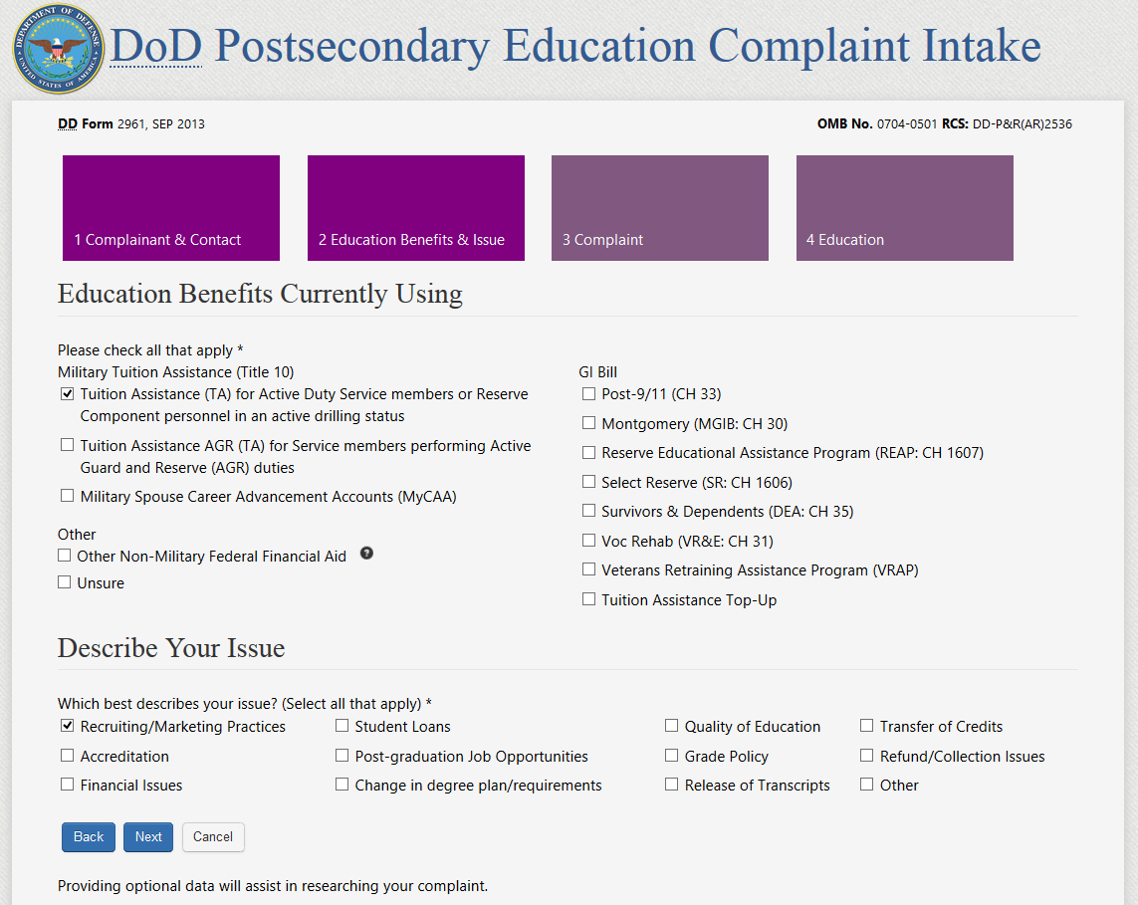

User must manually enter the issue when “Other” is selected

1. After clicking “Next” the complaint filer advances to Section 3 - the “Complaint Information” page. NOTE: The “Describe what happened…” text has been truncated to no longer ask for the complainant’s name when the complaint is filed on behalf of someone else.

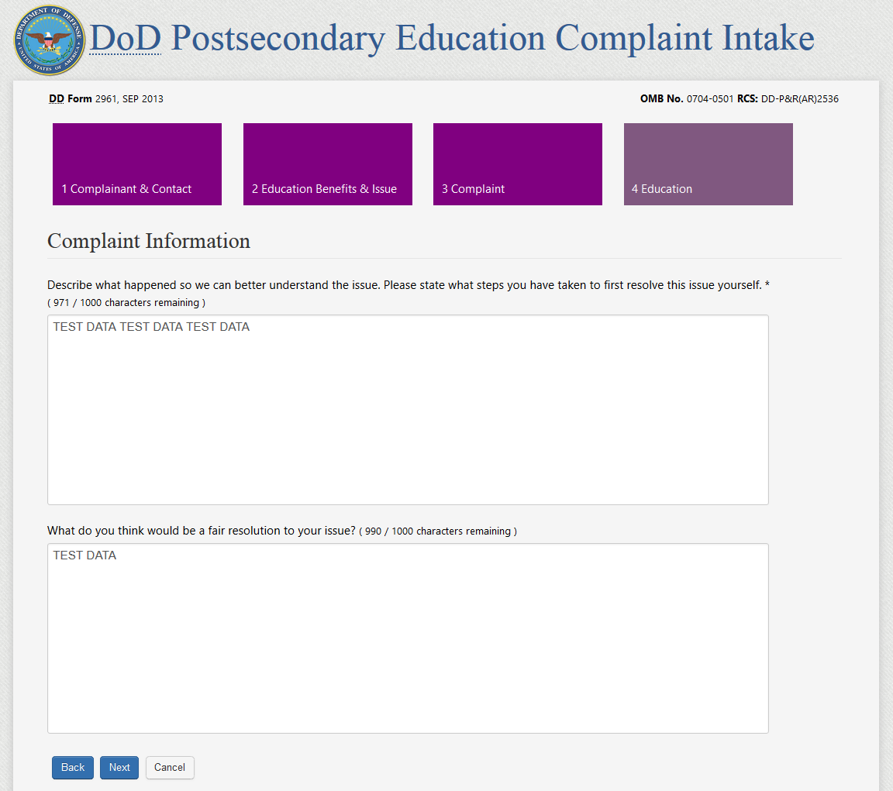

9a. After clicking “Next” the complaint filer is presented with Section 4 - the School and Education Center data collection page.

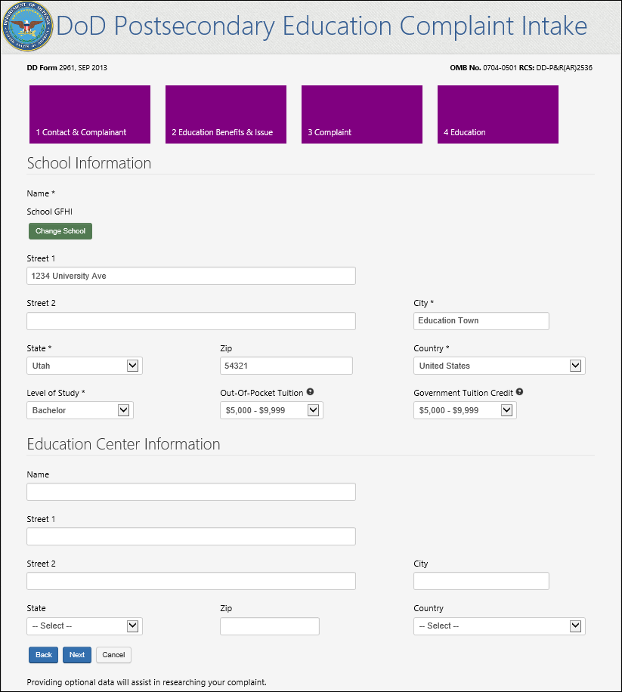

10. After entering the Education information a Summary page displays all the data entered by the complaint filer. The user has the option to either go back and edit their entries or submit the complaint. To submit the complaint, the user must successfully pass a CAPTCHA. NOTE: The Contact Information display has been reordered on the Summary Page. This is a new change to the DoD PECS Intake.

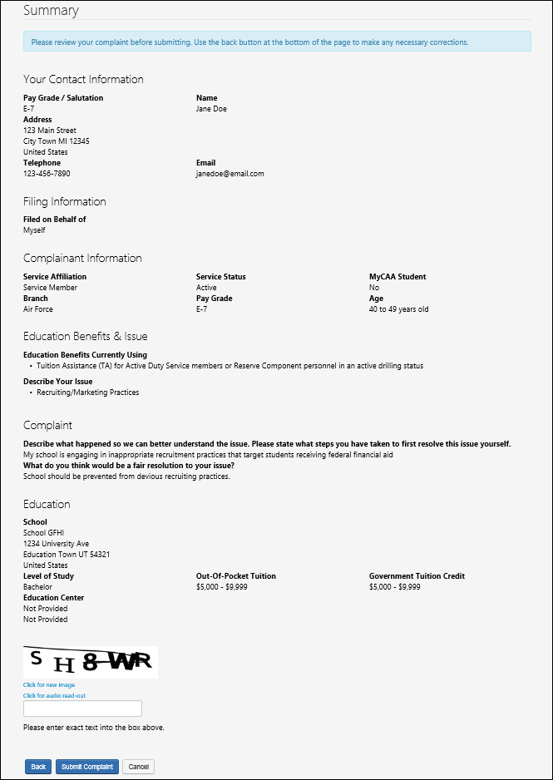

Figure 3: Summary Page of user filing on behalf of self

11a. Summary page of a user filing a complaint on behalf of someone else.

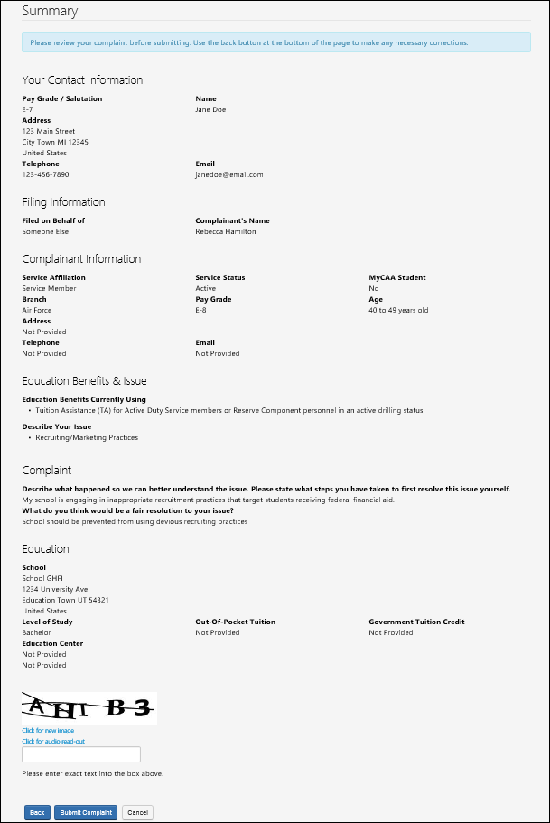

This is the contact information of the complainant

This is the contact information of the filer

Figure 4: Summary page of user filing on behalf of someone else

**DoD POST SECONDARY EDUCTION COMPLAINT INTAKE DROPDOWN SELECTION VALUES:**

**SECTION**: “YOUR CONTACT INFORMATION”:

**FIELD NAME**: Pay Grade / Salutation

**Dropdown Values**:

* Mrs
* Ms
* Mr
* Dr
* E-1
* E-2
* E-3
* E-4
* E-5
* E-6
* E-7
* E-8
* E-9
* W-1
* W-2
* W-3
* W-4
* W-5
* O-1
* O-2
* O-3
* O-4
* O-5
* O-6
* O-7
* O-8
* O-9
* O-10

**SECTION**: “COMPLAINANT INFORMATION”:

**FIELD NAME**: Service Affiliation

**Dropdown Values**:

* Service Member
* Spouse or Family Member
* Veteran

**SECTION**: “COMPLAINANT INFORMATION”:

**FIELD NAME**: Service Status

**Dropdown Values**:

* Active
* National Guard
* Reserve

**SECTION**: “COMPLAINANT INFORMATION”:

**FIELD NAME**: Branch

**Dropdown Values**:

* Army
* Navy
* Marines
* Air Force
* Coast Guard
* VA NOAA (National Oceanic and Atmospheric Administration/VA PHS (Public Health Service)

**SECTION**: “COMPLAINANT INFORMATION”:

**FIELD NAME**: Complainant’s/Complainant’s Sponsor’s Pay Grade

**Dropdown Values**:

* E-1
* E-2
* E-3
* E-4
* E-5
* E-6
* E-7
* E-8
* E-9
* W-1
* W-2
* W-3
* W-4
* W-5
* O-1
* O-2
* O-3
* O-4
* O-5
* O-6
* O-7
* O-8
* O-9
* O-10

**SECTION**: “COMPLAINANT INFORMATION”:

**FIELD NAME**: Age

**Dropdown Values**:

* Less than 20 years old
* 20 – 29 years old
* 30 – 39 years old
* 40 – 49 years old
* 50 – 59 years old
* 60 years old and over
* Do not wish to disclose

**REQUIRED DOD POSTSECONDARY EDUCATION COMPLAINT INTAKE FIELDS**

**SECTION**: “YOUR CONTACT INFORMATION”:

**REQUIRED FIELD NAME**:

* Pay Grade / Salutation
* First Name (populated by DEERS record and not able to be edited)**
* Last Name (populated by DEERS record and not able to be edited)**
* Email Address
* Confirm Email

**Populating the First Name and Last Name from the DEERS record and disabling the field is new behavior

**SECTION**: “FILING INFORMATION”:

**REQUIRED FIELD NAME**:

* I am Filing on behalf of

**SECTION**: “COMPLAINANT INFORMATION”:

**REQUIRED FIELD NAME**:

* Service Affiliation
* Service Status (Does not display if “Veteran” is selected as the Service Affiliation.
* Branch
* Pay Grade
* MyCAA (Only appears if “Spouse or Family Member” is selected as the Service Affiliation.

**SECTION**: “EDUCATION BENEFITS CURRENTLY USING”:

* User must select at least one option

**SECTION**: “DESCRIBE YOUR ISSUE”:

* User must select at least one option

**SECTION**: “COMPLAINT INFORMATION”:

* User must enter a description of what happened into a text box (restricted to 1,000 characters)

**SECTION**: “SCHOOL INFORMATION”:

**REQUIRED FIELD NAME**:

* School Name
* City
* State
* Country
* Level of Study

**OPTIONAL DOD POSTSECONDARY EDUCATION COMPLAINT INTAKE FIELDS**

**SECTION**: “YOUR CONTACT INFORMATION”:

**OPTIONAL FIELD NAME**:

* Street 1
* Street 2
* City
* State
* Zip
* Country
* Telephone

**SECTION**: “COMPLAINANT INFORMATION”:

**OPTIONAL FIELD NAME**:

* Age

**SECTION**: “COMPLAINT INFORMATION”:

**OPTIONAL FIELD NAME**:

* What do you think would be a fair resolution to your issue (restricted to 1,000 characters)

**SECTION**: “SCHOOL INFORMATION”:

**OPTIONAL FIELD NAME**:

* Street 1
* Street 2
* Zip
* Out-of-Pocket Tuition
* Government Tuition Credit

**SECTION**: “EDUCATION CENTER INFORMATION”:

**OPTIONAL FIELD NAME**:

* Name
* Street 1
* Street 2
* City
* State
* Zip
* Country