OCSE O&M and Continuous Improvements
Federally Assisted State Transmitted (FAST) Levy
Software Interface Specification
Version 3.0
March 27, 2017
Administration for Children and Families
Office of Child Support Enforcement
330 C Street, SW, 5th Floor
Washington, DC 20201

This document was prepared for the United States Department of Health and Human Services, Office of Child Support Enforcement under Contract Number HHSN316201200034W by Leidos Innovations Corporation. The work was authorized in compliance with the following specific prime task order:
Delivery Order Number: C-34668-O
Delivery Order Title: Federally Assisted State Transmitted (FAST) Levy
Document Date: March 27, 2017
Document Number: C2-C0211J.84.01

Table of Contents
1. Introduction 1-1
1.1 Overview 1-1
1.2 Purpose of Document 1-1
2. FAST Levy Files 2-1
2.1 Connectivity 2-1
2.2 Financial Institution Connectivity 2-2
2.3 State Connectivity 2-2
2.4 File Types 2-2
2.5 File Format 2-3
2.6 File Extensions 2-3
2.7 File Structure 2-3
2.8 File Names 2-4
2.9 E-mail Notification 2-6
3. FAST Levy Input Transaction Layouts 3-1
3.1 Electronic Withhold Request 3-1
3.1.1 One-Step/Two-Step Process 3-1
3.1.2 Customer Level/Account Level Request 3-2
3.2 Electronic Withhold Response 3-2
A. Electronic Withholding Request Record (State To FI) A-1
B. Electronic Wittholding Response Record (FI to State) B-1
C. Summary of Changes C-1
List of Figures and Charts
Figure 1-1: Process Diagram 1-2
Figure 2-1: Connectivity 2-1
Figure 2-2: State Request File Structure 2-3
Figure 2-3: FI Response File Structure 2-3
Figure 2-4: State Request File Naming Convention 2-4
Figure 2-5: FI Response File Naming Convention 2-4
Figure 2-6: E-mail Notification (State) 2-6
Figure 2-7: E-mail Notification (FI) 2-6

Chart 2-1: FAST Levy Standard File Name 2-4
Chart 2-2: Examples Of File Names and Naming Conventions 2-5

Chart A-1: Electronic Withholding Request Header Record A-1
Chart A-2: Electronic wittholding Request Detail Record A-3
Chart A-3: Electronic Withholding Request Trailer Record A-14
Chart A-4: Electronic Withholding Request Notice Record A-16
Chart B-1: Electronic Withholding Response Header Record B-1
Chart B-2: Electronic Wittholding Response Detail Record B-3
Chart B-3: Electronic Withholding Response Trailer Record B-10
Chart C-1: Summary of Changes C-1

Introduction

Overview
The Multistate Financial Institution Data Match (MSFIDM) Federally Assisted State Transmitted (FAST) Levy initiative provides a transport delivery mechanism that allows states and financial institutions (FIs) to exchange information about levy actions through a single, centralized location. The goal of centralizing the FAST Levy process is to reduce costs and increase efficiency and collections by using the federal Office of Child Support Enforcement’s (OCSE) Child Support Portal (Portal) to transmit levy actions electronically between FIs and states.
Currently, states send levy actions to multiple FIs and FIs receive levy actions from multiple states – all on paper. The centralized transport process allows states to send levy actions to a single location for distribution to multiple FIs. It also allows FIs to receive and respond to levy actions from multiple states from a single location, thus minimizing communication setups with individual FIs and states.

Purpose of Document
This document describes the process required for states and FIs to exchange requests for and respond to FAST Levy. The file naming convention, file type, connectivity, e-mails, and transaction record layouts of the FAST Levy system are included. The transaction record layouts include the following:
- Electronic Withholding Request Record from state to FI
- Electronic Withholding Response Record from FI to state
Figure 1-1 shows the FAST Levy process.

Figure 1-1: Process Diagram
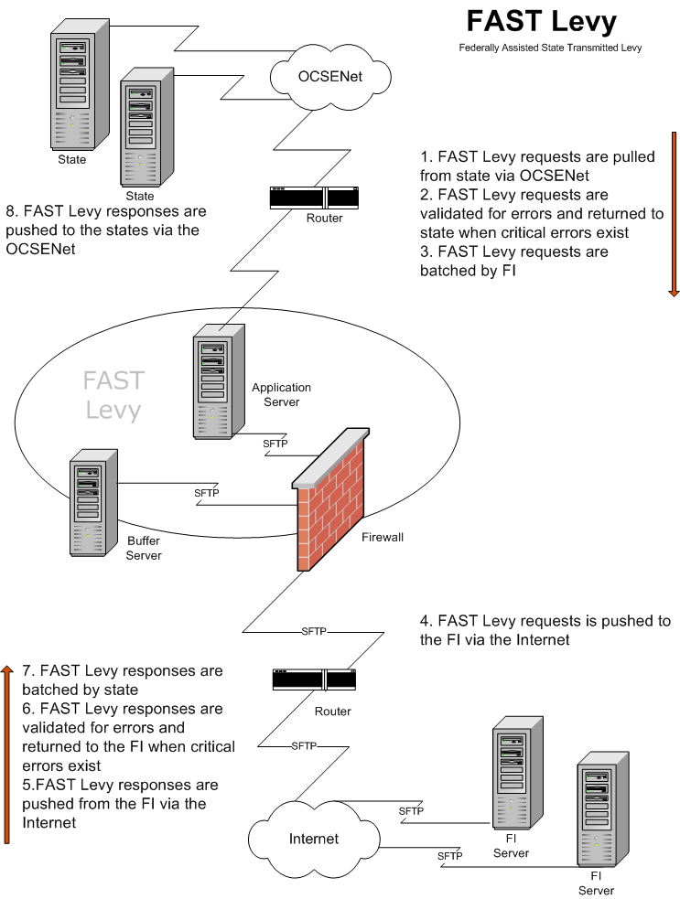

FAST Levy Files
The Portal houses the FAST Levy system. The FAST Levy system is capable of transmitting standard fixed length text files between states and FIs.
The sections below describe the connectivity, file types, file extensions, and formats submitted to the FAST Levy system. The e-mail notification process is also discussed.

Connectivity
Figure 2-1 shows the site architecture that supports the file transmission and connections needed to facilitate the exchange between states and FIs.
Figure 2-1: Connectivity
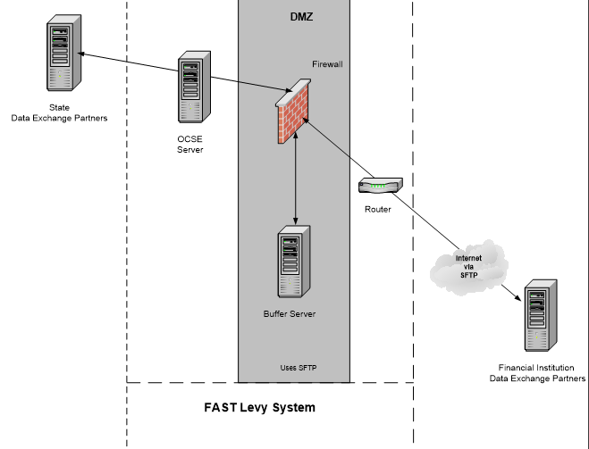

Financial Institution Connectivity
OCSE connects to FIs via the Internet with Secure File Transfer Protocol (SFTP). The FI generally uses the existing transfer connection the MSFIDM process uses. If the FI does not have an MSFIDM connection, we will discuss other options in a connectivity meeting with the FI to determine the best option for connecting to the FAST Levy application.

State Connectivity
States connect to the OCSE network through IPsec site-to-site VPNs. FAST Levy data is exchanged through this connection to an SFTP or FTP server at the state. An IPsec site-to-site VPN has to be established between the OCSENet and the state if one isn’t already in place.
All FAST Levy files require a designated location on the state SFTP or FTP server for pick-up and delivery. This requires that a user ID and password be used to log on to the state server. SSH key authentication can be used instead of a password if the state requests or requires it. Read and write privileges on files need to be granted to the user ID used by OCSE to log on to the state server. If SFTP is used, the standard TCP port (22) can be used or another TCP port can also be used if the state requests or requires it.
The process for setting up SFTP without a password, using public-private keys includes:
- Create a public-private key pair for a user on the server by running the following command: ssh-keygen -t rsa
- The public-private key pair default location is: /home/xx/.ssh/id_rsa.pub and /home/xx/.ssh/id_rsa
- OCSE sends its SSH public key to FIs via e-mail.
- The FI has to append OCSE’s SSH public key to the /home/xx/.ssh/authorized_keys2 file on its SFTP server. If this file is not there, it must be created.

File Types
The various files transmitted via the FAST Levy system include:
State Request File (REQ) – A file generated by the state and sent to the FI that contains requests to levy an account.
FI Response File (RSP) – A file generated by the FI and returned to the state. The file contains records for each request and indicates whether the request is accepted or rejected and, if rejected, the reason for the rejection.
State Error File (ERQ) – Generated by the FAST Levy system in response to the receipt and validation of a state request. This contains the errors found in these files.
FI Error File (ERS) – Generated by the FAST Levy system in response to the receipt and validation of an FI response. This contains the errors found in these files.

File Format
The FAST Levy process accepts the following file format:
- Text file

File Extensions
States and FIs must include file extensions for all files they are providing. A file extension is a three-digit code at the end of the file name to distinguish the type of file (for example, file.txt informs the user the file is a text file). Text (.txt) files are the recommended extension for all test file transmissions. The file is returned if the extension is not included. Files with the extensions .zip or .exe will not be accepted.

File Structure
Each file must contain a header record, detail records, and a trailer record. These record layouts are presented in section 3, “FAST Levy Input Transaction Layouts.”
The files must adhere to the file structure below. Figure 2-2 shows the file structure for the state request. Figure 2-3shows the file structure for the FI response.
Figure 2-2: State Request File Structure
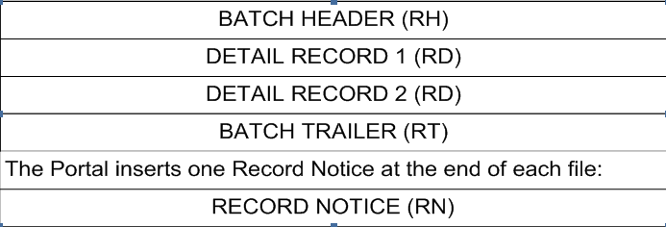
Figure 2-3: FI Response File Structure

- Each file must contain at least one batch header and a batch trailer
- A file containing only detail records is invalid
- All files must include at least one detail record within a batch
- All records start with a two-digit document code that identifies the type of record. Document code values are shown in the record layouts in Appendices A and B.
- State requests are batched by FI
- FI responses are batched by state

File Names
States and FIs provide file names for files via the FAST Levy Profile form. States and FIs can either use a predefined naming standard that is unique to their organization (must be a unique constant name and cannot be variable) or the FAST Levy system’s “standard file name.” The preferred method is to use the standard proposed by the FAST Levy system in the profile form. File names are not case sensitive.
Figure 2-4 shows the file naming convention for the state request. Figure 2-5 shows the file naming convention for the FI response.
Figure 2-4: State Request File Naming Convention
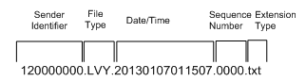
Figure 2-5: FI Response File Naming Convention
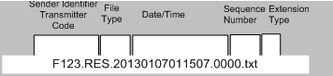
Chart 2-1 describes the values of each section of the FAST Levy standard file name.
Chart 2-1: FAST Levy Standard File Name
Field Name | Value
Identifier | FIPS + 0000000  FXXX + 00000  (If a state, the nine digits are a two-digit FIPS code plus seven zeroes; if an FI, it is the four digit Transmitter Code and five zeros)
Separator | Period (.)
File Type | State:  LER – Error files to state  LRS – Response file to states  LVY – Request file from state  Financial Institution:  RER – Error files to FI  RES – Response file from FI  VLY – Levy request file to FIs
Separator | Period (.)
Date - Timestamp | CCYYMMDDHHMMSSS
Separator | Period (.)
Sequence Number | 0000 – Used by the FAST Levy system to incrementally account for files being created. Not used for a .zip file.
Separator | Period (.)
Extension Type | txt – Text
Chart 2-2 shows examples of different files and naming conventions.
Chart 2-2: Examples Of File Names and Naming Conventions
Sample State Detail File Name | Description
180000000.LER.200708060115087.txt | Error record to the state
180000000.LRS.200708060115087.txt | Response file to state
180000000.LVY.200708060115087.txt | Request file from state
180000000.LRJ.200708060115087.txt | Error file to the state
Financial Institution Response File | Description
123456789.RER.200708060115087.txt | Error record to the FI
F123.RES.200708060115087.0001.txt | Response file from the FI
123456789.VLY.200708060115087.0001.txt | Levy file to the FI
123456789.RRJ.200708060115087.txt | Error file to the FI

E-mail Notification
The FAST Levy process sends an e-mail notification to the state or FI for successful processing and errors in the processing or transferring of the file. Figure 2-6 is an example of an e-mail sent to the states. Figure 2-7 is an example of an e-mail sent to the FI.
Figure 2-6: E-mail Notification (State)
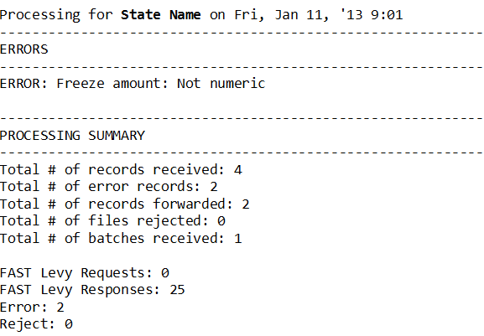
Figure 2-7: E-mail Notification (FI)
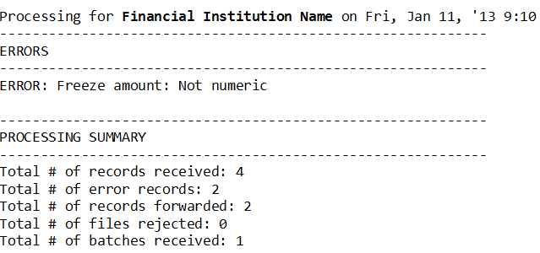

FAST Levy Input Transaction Layouts
Appendices A and B include the layouts for the records that are accepted by the FAST Levy system. Each record layout in this section includes:
- * Field Name
- * Field Length
- * Location
- * Field Types (alphabetic, numeric, or alphanumeric)
- * Field Comments
The comment section in the record layouts indicates whether the field is required for the transaction. Fields defined as “Conditionally Required,” need to be present on the input record, based on the conditions described in the comment field. Comments also provide an explanation of the field and its relationship to other fields or records. Optional fields must be filled with spaces if not used or data is not available.
The file structure for the Electronic Withhold Request and Response are the same. Each file can consist of one or more batches. Each batch contains at least one header record, followed by one or more detail records, and then a trailer record to complete the batch.

Electronic Withhold Request
The Electronic Withhold Request is batched by the Federal Employer Identification Number (FEIN). If a request from a state is being made to multiple FIs, there will be a batch for each FEIN included in the file being sent to the FAST Levy Portal. A header will exist for each FI with its FEIN and the state’s Federal Information Processing Standards (FIPS) code in that header.
States may send either one-step or two-step levy requests and direct the FIs to attach assets at the customer level or at a specific account level (customer’s account and type of account are required for freezing and seizing assets).
Following the Withhold Request batches is the Notice of Right to Garnish Federal Benefits record. Each file sent will include one record at the end of the file.

One-Step/Two-Step Process
A one-step levy process allows a state to send a request that will freeze and seize account assets at the same time. A two-step levy process requires the state to make an initial request to freeze the assets followed by a second request to seize the assets.

Customer Level/Account Level Request
Customer level requests instruct the FI to freeze and seize accounts belonging to the obligor. This allows the FI to determine which accounts to freeze and seize when the obligor has more than one account at an FI. Based on internal polices, the FI will determine which accounts to freeze and seize based on a FAST Levy request. Account level requests instruct the FI to freeze and seize specific accounts and amounts in those accounts, consistent with state law.

Electronic Withhold Response
The Electronic Withhold Response is batched from an FI by a state. If an FI is responding to several state requests, there will be one header with the FI’s FEIN for each state in the file. The file will also contain the state’s FIPS code for each batch in the file.

Electronic Withholding Request Record (State To FI)
Chart A-1: Electronic Withholding Request Header Record
No. | Field Name | Length | Location | A/N | Comments
1 | Record Identifier | 2 | 1-2 | A | Required  The characters ‘RH,’ which identifies the record as a Request Header.
2 | FEIN | 9 | 3-11 | N | Required  The FI’s FEIN.
3 | Filler | 1 | 12-12 | A/N | For future versions. For this version, fill with spaces.
4 | FIPS Code | 2 | 13-14 | N | Required  The two-digit numeric FIPS code of the requesting state.
5 | Local County Code | 3 | 15-17 | A/N | Optional  A three-digit local county code or is filled with spaces.
6 | Processing Date | 8 | 18-25 | N | Required  The run date for the batch. Must be in CCYYMMDD format.
7 | Batch ID | 6 | 26-31 | A/N | Required  A unique identifier for each batch sent to the Portal daily. Use the unique Batch ID only once per day.
8 | Batch Type Code | 2 | 32-33 | A | Required  The type of request for the batch. Valid values are:  AG = Group account request – All requests contained in the batch will have the same SSN for different account numbers. FIs will handle a group account request as a single request and one fee will apply.  AS = Single account request – All requests contained in the batch are single account requests and will be handled by the FI at the account level. Each request will be for one SSN and one account number.  CL = Customer level request – All requests contained in the batch will be handled by the FI at a customer level and not by specific account for the customer.
9 | Portal Error Message Text | 3 | 34-63 | A/N | Portal Use  The field number that was in error, along with the error code, when the Portal performed its validation. Header records with errors will return the entire batch. The returned batch will contain all requests originally sent. Filled with spaces by the requestor. Up to six errors are returned.  The format is NN:CD, NN:CD, NN:CD, NN:CD, NN:CD, NN:CD where ‘NN’ is equal to the field number and ‘CD’ is equal to the error code.  Valid CD values are:  IN = Invalid data  RQ = Missing required data  NU = Not numeric
10 | Filler | 537 | 64-600 | A/N | For future versions. For this version, fill with spaces.

Chart A-2: Electronic wittholding Request Detail Record
No. | Field Name | Length | Location | A/N | Comments
1 | Record Identifier | 2 | 1-2 | A | Required  The characters ‘RD,’ which identifies the record as a Request Detail.
2 | Action Code | 2 | 3-4 | N | Required  The code of the action to be taken.  Valid values are:  Original Requests:  01 = Execute lien and levy, used for one-step process  03 = Execute lien, used for two-step process  Maintenance/Subsequent Requests:  02 = Release withhold  04 = Amend levy amount  05 = Execute levy, used for two-step process  06 = Extend freeze number of days
3 | SSN | 9 | 5-13 | N | Required  The Social Security number (SSN) of the obligor.
4 | Last Name | 20 | 14-33 | A/N | Required  The obligor’s last name.  Valid special characters are:  - Hyphens (-)  - Apostrophes (’)  - Periods (.)  - Space  The first character must not be a space.
5 | First Name | 15 | 34-48 | A/N | Required  The obligor’s first name.  Valid special characters are:  - Hyphens (-)  - Apostrophes (’)  - Periods (.)  - Space  The first character must not be a space.
6 | Middle Name | 15 | 49-63 | A/N | Optional  The obligor’s middle name.  Valid special characters are:  - Hyphens (-)  - Apostrophes (’)  - Periods (.)  The first character must not be a space if middle name is populated. Fill with spaces if no middle name is available.
7 | Name Suffix | 4 | 64-67 | A/N | Optional  The obligor’s suffix name. Example: Jr, Sr, III.  Valid special characters are:  - Hyphens (-)  - Apostrophes (‘)  - Periods (.)  The first character must not be a space. Fill with spaces if no suffix name is available.
8 | DOB | 8 | 68-75 | A/N | Optional  The obligor’s date of birth (DOB), in CCYYMMDD format. Fill with spaces if no DOB is available.
9 | Account Type Code | 2 | 76-77 | A/N | Conditionally Required  The type of account for the withhold request. Required when the Batch Type Code = ‘AS’ or ‘AG.’  Valid values are:  01 = Savings account  04 = Checking/demand deposit account  05 = Term deposit certificate  06 = Collateral account  11 = Money market account  12 = IRA/KEOGH  14 = ERISA Plan account  16 = Cash balances  17 = Compound account  18 = Other  Fill with spaces if Batch Type Code is ‘CL.’
10 | Account Number | 20 | 79-97 | A/N | Conditionally Required  The Account Number the state is requesting funds to be withheld, if the Batch Type Code is ‘AS’ or ‘AG.’  Fill with spaces if the Batch Type Code is ‘CL.’  Left justified padded with spaces to the right; hyphens and embedded spaces are allowed. This should reflect the manner returned on the MSFIDM quarterly match.
11 | Withhold Amount | 10 | 98-107 | N | Conditionally Required  The maximum dollar amount and cents to withhold. Action Codes ‘01’ execute lien and levy (one-step), ‘03’ execute lien (two-step), and ‘04’ amend levy amount must be greater than all zeroes.  Action Codes ‘02’ release withhold, ‘05’ execute levy (two-step), and ‘06’ extend freeze number of days can be equal to or greater than all zeroes. Two-digit decimal is assumed.  The field must be formatted as follows:  - Numeric  - Decimal Assumed  - Unsigned  - Right Justify  - Zero Fill to Left  - Zero Fill if N/A
12 | Threshold Amount | 6 | 108-113 | N | Required  The minimum dollar amount and cents that must be in the accounts after the fees and exemptions are deducted. Two-digit decimal is assumed. Fill with zeroes when there is no threshold amount. For example, the account balance is $500. The FI fee is $50. The amount in the account after fees and exemptions is $450. The state threshold amount is $500. This would not meet the threshold amount the state submitted for the request.  The field must be formatted as follows:  - Numeric  - Decimal Assumed  - Unsigned  - Right Justify  - Zero Fill to Left  - Zero Fill if N/A
13 | Request Date | 8 | 114-121 | N | Required  The date the withhold was requested, in CCYYMMDD format. Maintenance/Subsequent requests with Action Codes equal to ‘02’ release withhold, ‘04’ amend levy amount, ‘05’ execute levy, used for the two-step process, and ‘06’ extend freeze number of days, must contain the request date from the original withhold request.
14 | Passback Text | 40 | 122-161 | A/N | Optional  Allows the state to capture information pertaining to the request.  Returned by the FI in the response.  Fill with spaces if not used.
15 | Freeze Number Days | 4 | 162-165 | N | Required  The additional number of days the accounts must be frozen beyond the submitting state’s standard timeframe. If no additional days are needed, fill with zeroes. Value cannot be zeroes if Action Code is equal to ‘06’ extend freeze number of days.  Note: FI will follow the rules for the state to determine business versus calendar days.  The field must be formatted as follows:  - Numeric  - Unsigned  - Right Justify  - Zero Fill to Left  - Zero Fill if N/A
16 | Exemption Amount | 10 | 166-175 | N | Required  The dollar amount and cents to be excluded from the levy action. Any amount over the exemption amount is available for freeze and seize.  Two digit decimal is assumed.  Fill with zeroes if no exemption amount is required.  The field must be formatted as follows:  - Numeric  - Decimal Assumed  - Unsigned  - Right Justify  - Zero Fill to Left  - Zero Fill if N/A
17 | Legal Attachment Code | 2 | 176-177 | A/N | Required  The type of legal document for the withhold request.  Default Value is ‘CS’ for Child Support Order.
18 | Legal Attachment Action Code | 2 | 178-179 | A/N | Optional  The type of attachment for the withhold request. Fill with spaces if not needed. Spaces in this field will default to ‘PT’.  Valid values are:  OL = Continuous or ongoing levy  PT = Point in time levy
19 | Contact Name | 50 | 180-229 | A/N | Required  The first and last name of the person or a point of contact (POC) who the FI will refer the customer to for additional information.
20 | Contact Phone Number | 10 | 230-239 | N | Required  The phone number of the person or a POC for which the FI will refer the customer to for additional information.
21 | Contact Phone Extension | 5 | 240-244 | A/N | Optional  A phone extension for the person or a POC the FI should contact for additional information.  Can be 1-5 positions.  Fill with spaces if no extension is available.
22 | Contact E-mail Text | 50 | 245-294 | A/N | Optional  An e-mail address for the person or a POC the FI should contact for additional information.  Fill with spaces if no e-mail is available.
23 | Agency Name | 50 | 295-344 | A/N | Required  The name of the child support agency.
24 | Payment Type Code | 1 | 345-345 | A | Required  The method the state would prefer to receive the payment from the FI if the FI has the capability to send per the state’s request.  Valid values are:  E = Electronic request  M = Check request
25 | Address Line 1 Text | 50 | 346-395 | A/N | Required  The street address of the child support agency where the FI should mail the payment.
26 | Address Line 2 Text | 50 | 396-445 | A/N | Optional  The street address of the child support agency where the FI should mail the payment.
27 | Address Line 3 Text | 50 | 446-495 | A/N | Required  The city, state, and zip of the child support agency where the FI should mail the payment.
28 | Request Timestamp | 12 | 496-507 | A/N | Required  Must contain spaces.  The FAST Levy Portal will populate this field. The timestamp format is HH:MM:SS:SSS.
29 | Portal Error Message Text | 30 | 508-537 | A/N | Portal Use  The field number that was in error, along with the error code, when the Portal performed its validation. Request records with errors will be returned in their original batch if a request did not pass validation. The returned batch will only contain requests that did not pass validation. All requests that pass validation will be sent to the FI. Filled with spaces by the requestor. Up to six errors are returned.  The format is NN:CD, NN:CD, NN:CD, NN:CD, NN:CD, NN:CD where ‘NN’ is equal to the field number and ‘CD’ is equal to the error code.  Valid CD values are:  IN = Invalid data  RQ = Missing required data  NU = Not numeric
30 | Agency Identifier | 20 | 538-557 | A/N | Required  A unique identifier assigned by the agency. Maintenance/Subsequent requests with Action Codes equal to ‘02’ release withhold, ‘04’ amend levy amount, ‘05’ execute levy, used for the two-step process, and ‘06’ extend freeze number of days, must contain the Agency Identifier from the original withhold request. All information recorded in this field will appear on the ACH response.
31 | OCSE Processing Date | 8 | 558-565 | N | Required  Must contain spaces.  The FAST Levy Portal will populate this field. This field must contain the date OCSE received the request in CCYYMMDD format.
32 | Filler | 43 | 566-600 | A/N | For future versions. For this version, fill field with spaces.

Chart A-3: Electronic Withholding Request Trailer Record
No. | Field Name | Length | Location | A/N | Comments
1 | Record Identifier | 2 | 1-2 | A | Required  The characters ‘RT,’ which identifies the record as a Request Trailer.
2 | FEIN | 9 | 3-11 | N | Required  The FI’s FEIN.
3 | Filler | 1 | 12-12 | A/N | For future versions. For this version, fill with spaces.
4 | FIPS Code | 2 | 13-14 | N | Required  The two-digit numeric FIPS code of the requesting state.
5 | Local County Code | 3 | 15-17 | A/N | Optional  A three-digit local county code or is filled with spaces.
6 | Record Count | 6 | 18-23 | N | Required  The total number of records submitted in this batch.  The field must be formatted as follows:  - Numeric  - Unsigned  - Right Justify  - Zero Fill to Left  - Zero Fill if N/A
7 | Portal Error Message Text | 30 | 24-53 | A/N | Portal Use  The field number that was in error, along with the error code, when the Portal performed its validation. Trailer records with errors will return the entire batch. The returned batch will contain all requests originally sent. Filled with spaces by the requestor. Up to six errors are returned.  The format is NN:CD, NN:CD, NN:CD, NN:CD, NN:CD, NN:CD where ‘NN’ is equal to the field number and ‘CD’ is equal to the error code.  Valid CD values are:  IN = Invalid data  RQ = Missing required data  NU = Not numeric
8 | Filler | 547 | 54-600 | A/N | For future versions. For this version, fill with spaces.

Chart A-4: Electronic Withholding Request Notice Record
No. | Field Name | Length | Location | A/N | Comments
1 | Record Identifier | 2 | 1-2 | A | Required  The characters ‘RN,’ which identifies the record as a Request Notice.
2 | Notice of Right to Garnish Federal Benefits Text | 598 | 3-600 | A/N | Required  The Notice of Right to Garnish Federal Benefits text. The Notice of Right to Garnish Federal Benefits is created by the FAST Levy Portal. Each file will have one Notice Record at the end of the file.  Proposed Notice of Right to Garnish Federal Benefits  State child support agencies (CSA) issued these orders pursuant to authority to attach or seize obligors’ assets in financial institutions (FI) [42 USC §666]. The garnishee is notified that procedures established by 31 CFR 212 to identify and protect federal benefits deposited to FI accounts do not apply to these orders. The garnishee must comply with the terms of these orders including instructions for withholding and retaining funds in any account(s) covered by these orders pending further state CSA notice.

Electronic Wittholding Response Record (FI to State)
Chart B-1: Electronic Withholding Response Header Record
No. | Field Name | Length | Location | A/N | Comments
1 | Record Identifier | 2 | 1-2 | A | Required  The characters ‘AH,’ which identifies the record as a Response Header.
2 | FEIN | 9 | 3-11 | N | Required  The FI’s FEIN.
3 | Filler | 1 | 12-12 | A/N | For future versions. For this version, fill with spaces.
4 | FIPS Code | 2 | 13-14 | N | Required  The two-digit numeric FIPS code of the requesting state.
5 | Local County Code | 3 | 15-17 | A/N | Optional  A three-digit local county code or is filled with spaces.
6 | Processing Date | 8 | 18-25 | N | Required  The run date for the batch in CCYYMMDD format.
7 | Batch ID | 6 | 26-31 | A/N | Required  The state’s unique identifier submitted for this batch of records. Return the state’s Batch ID sent in the Withhold Request file.
8 | Batch Type Code | 6 | 26-31 | A/N | Required  The type of request submitted for this batch of records. Return the state’s Batch Type Code sent in the Withhold Request file.
9 | Contact Name | 50 | 34-83 | A/N | Optional  The first and last name of the person the state should contact for additional information. Fill with spaces if no Contact Name is available.
10 | Contact Phone Number | 10 | 84-93 | N | Required  The phone number for the person the state should contact for additional information.
11 | Contact Phone Extension Number | 5 | 94-98 | A/N | Optional  A phone extension for the person the state should contact for additional information.  Can be 1-5 positions.  Fill with spaces if no extension is available.
12 | Contact E-mail Text | 50 | 99-148 | A/N | Optional  An e-mail address for the person the state should contact for additional information. Fill with spaces if no e-mail address is available.
13 | Portal Error Message Text | 30 | 149-178 | A/N | Portal Use  The field number that was in error, along with the error code, when the Portal performed its validation. Header records with errors will return the entire batch. The returned batch will contain all requests originally sent. Filled with spaces by the requestor. Up to six errors are returned.  The format is NN:CD, NN:CD, NN:CD, NN:CD, NN:CD, NN:CD where ‘NN’ is equal to the field number and ‘CD’ is equal to the error code.  Valid CD values are:  IN = Invalid data  RQ = Missing required data  NU = Not numeric
14 | Filler | 222 | 179-400 | A/N | For future versions. For this version, fill with spaces.

Chart B-2: Electronic Wittholding Response Detail Record
No. | Field Name | Length | Location | A/N | Comments
1 | Record Identifier | 2 | 1-2 | A | Required  The characters ‘AD,’ which identifies the record as a Response Detail.
2 | Response code | 2 | 3-4 | N | Required  The response type code. Valid values are:  04 = Bypassed accounts did not meet minimum balance requirement or  account balance was less than or equal to $0.00  05 = Accounts satisfy part or all of the levy and account is frozen  06 = Match is good but no attachable accounts  07 = Manual review  10 = Customer not found  12 = Match good, closed account  20 = Full or partial amount released from withhold (in response to Action Code equal to ‘02’ release withhold, ‘04’ amend levy amount, from Request Record)  50 = Reject, FI could not process request, for example, if the noncustodial parent is in a bankruptcy status  You may receive the following responses after a bank sends a response code of ‘05’ to a state's original request:  22 = FI Initiated Response (FIR) – FI released the freeze or restraint on the account and reduced the freeze amount to zero dollars  24 = FIR – FI reduced the original amount of the freeze or restraint to an  amount greater than zero dollars
3 | SSN | 9 | 5-13 | N | Required  The Social Security number (SSN) of the obligor for the FI to initiate an action to withhold.
4 | Last Name | 20 | 14-33 | A/N | Required  The obligor’s last name.  Valid special characters are:  - Hyphens (-)  - Apostrophes (’)  - Periods (.)  - Space  The first character must not be a space.
5 | First Name | 15 | 34-48 | A/N | Required  The obligor’s first name.  Valid special characters are:  - Hyphens (-)  - Apostrophes (’)  - Periods (.)  - Space  The first character must not be a space.
6 | Middle Name | 15 | 49-63 | A/N | Optional  The obligor’s middle name.  Valid special characters are:  - Hyphens (-)  - Apostrophes (’)  - Periods (.)  The first character must not be a space if middle name is populated. Fill with spaces if no middle name is available.
7 | Name Suffix | 4 | 64-67 | A/N | Optional  The obligor’s suffix name. Example: Jr, Sr, III.  Valid special characters are:  - Hyphens (-)  - Apostrophes (’)  - Periods (.)  Fill with spaces if no suffix is available.
8 | DOB | 8 | 68-75 | A/N | Optional  The obligor’s date of birth (DOB), in CCYYMMDD format. Fill with spaces if no DOB is available.
9 | Filler | 2 | 76-77 | A/N | For future versions. For this version, fill with spaces.
10 | Account Number | 20 | 78-97 | A/N | Conditionally Required  Any account number that the FI attached or froze. If the state submitted an Account Level request, ‘AS’ or ‘AG’ in the Batch Type Code, must be populated.  Fill with spaces if Batch Type Code is ‘CL’.  Left justified padded with spaces to the right.
11 | Freeze Amount | 10 | 98-107 | N | Conditionally Required  The dollar amount and cents attached or frozen before fees and penalties are deducted. Two-digit decimal is assumed. If no amount is attached or frozen, fill with zeroes. The field is required when the FI returns ‘05’ in the Response Code.  The field must be formatted as follows:  - Numeric  - Decimal Assumed  - Unsigned  - Right Justify  - Zero Fill to Left  - Zero Fill if N/A
12 | Filler | 4 | 108-111 | A/N | For future versions. For this version, fill with spaces.
13 | Withheld Date | 8 | 112-119 | A/N | Conditionally Required  The date the FI attached or froze the accounts. Action Code ‘05’, in CCYYMMDD format. Fill with spaces if no funds attached or frozen.
14 | Passback Text | 40 | 120-159 | A/N | Conditionally Required  Allows the state to capture information about the request. Must be returned by the FI in the response. Must contain spaces if not used.
15 | Filler | 31 | 60-162 | A/N | For future versions. For this version, fill with spaces.
16 | Fee Amount | 6 | 163-168 | N | Required  The dollar amount and cents of fees and penalties charged by the FI for the withheld amount. Two-digit decimal is assumed. Fill with zeroes if no fee applies.  The field must be formatted as follows:  - Numeric  - Decimal Assumed  - Unsigned  - Right Justify  - Zero Fill to Left  - Zero Fill if N/A
17 | Account Relationship Code | 1 | 169-169 | A/N | Required  Information about the obligor’s ownership of the accounts. Valid values are:  0 = Sole owner of the matched account  1 = Secondary owner of the matched account  2 = Primary owner with secondary owners listed to matched account  3 = At least one of the accounts is a joint account. Use this code when the state submits the request at the customer level.
18 | Safe Deposit Box Indicator | 1 | 170-170 | A | Required  Indicates whether the account holder has a safe deposit box at the FI.  Valid values are:  Y = Yes  N = No
19 | Returned Timestamp | 12 | 171-182 | A/N | Required  The timestamp for the record sent by the state. FIs use this field to determine “first come, first serve.” The timestamp format is HH:MM:SS:SSS. Return the Request Timestamp in this field.
20 | Error Message Text | 30 | 183-212 | A/N | Portal Use  The field number that was in error, along with the error code, when the Portal performed its validation. Response records with errors will be returned in their original batch if a response did not pass validation. The returned batch will only contain responses that did not pass validation. All responses that passed validation records will be passed to the state. Filled with spaces by the responder. Up to six errors are returned.  The format is: NN:CD, NN:CD, NN:CD, NN:CD, NN:CD, NN:CD  Valid CD values are:  IN = Invalid data  RQ = Missing required data  NU = Not numeric
21 | FI Message Text | 100 | 213-312 | A/N | Conditionally Required  A text message that provides a reason for which the FI rejected the request. If the FI uses code ‘50’ for the Response Code, this field must contain a reason.
22 | Agency Identifier | 20 | 313-332 | A/N | Required  The agency identifier provided in the withhold request record. Maintenance/Subsequent requests with Action Codes equal to ‘02’ release withhold, ‘04’ amend levy amount, ‘05’ execute levy, used for the two-step process, and ‘06’ extend freeze number of days, must contain the Agency Identifier from the original withhold request. All information recorded in this field will appear on the ACH response.
23 | Filler | 68 | 333-400 | A/N | For future versions. For this version, fill with spaces.

Chart B-3: Electronic Withholding Response Trailer Record
No. | Field Name | Length | Location | A/N | Comments
1 | Record Identifier | 2 | 1-2 | A | Required  The characters ‘AT,’ which identifies the record as a Response Trailer.
2 | FEIN | 9 | 3-11 | N | Required  The FI’s FEIN.
3 | Filler | 1 | 12-12 | A/N | For future versions. For this version, fill with spaces.
4 | FIPS Code | 2 | 12-14 | N | Required  The two-digit numeric FIPS code of the requesting state.
5 | Local County Code | 3 | 15-17 | A/N | Optional  A three-digit local county code or is filled with spaces.
6 | Record Count | 6 | 18-23 | N | Required  The total number of records submitted in this batch.
7 | Portal Error Message Text | 30 | 24-53 | A/N | Portal Use  The field number in error, along with the error code, when the Portal performed its validation. Trailer records with errors will return the entire batch. The returned batch will contain all requests originally sent. Filled with spaces by the requestor. Up to six errors are returned.  The format is NN:CD, NN:CD, NN:CD, NN:CD, NN:CD, NN:CD where ‘NN’ is equal to the field number and ‘CD’ is equal to the error code.  Valid CD values are:  IN = Invalid data  RQ = Missing required data  NU = Not numeric
8 | Filler | 347 | 54-400 | A/N | For future versions. For this version, fill with spaces.

Summary of Changes
Lists the locations of changes in this document.
Chart C-1: Summary of Changes
Location | Change
Cover pages | Updated to reflect new contract.
B-2, Response Code | Added information about two new codes.

