MEMORANDUM

Date: August 18, 2017

To: Robert Sivinski, OMB

From: Andrew Zukerberg, NCES

Through: Kashka Kubzdela, NCES
Re: 2017–18 National Teacher and Principal Survey (NTPS 2017-18) Screener Email Change Request (OMB# 1850-0598 v.19)

The National Teacher and Principal Survey (NTPS), conducted biennially by the National Center for Education Statistics (NCES), is a system of related questionnaires that provides descriptive data on the context of elementary and secondary education. Redesigned from the Schools and Staffing Survey (SASS) with a focus on flexibility, timeliness, and integration with other ED data, the NTPS system allows for school, principal, and teacher characteristics to be analyzed in relation to one another. NTPS is an in-depth, nationally representative survey of first through twelfth grade public school teachers, principals, and schools. Kindergarten teachers in schools with at least a first grade are also surveyed. NTPS utilizes core content and a series of rotating modules to allow timely collection of important education trends as well as trend analysis. Topics covered include characteristics of teachers, principals, schools, teacher training opportunities, retention, retirement, hiring, and shortages. NTPS 2017-18 was approved in June 2017 (OMB# 1850-0598 v.18-19). This request updates the approved NTPS 2017-18 procedures and materials with an addition of a reminder email to principals urging completion of the on-line screener instrument.
NTPS is currently in the process of reaching out to the principals of sampled NTPS schools to complete a short screener survey. The screener survey is included in the NTPS Respondent Portal instrument (Appendix C of the approved package) and (1) determines whether the sampled school is in scope for NTPS, and (2) asks the principal to designate a survey coordinator.
We mailed the screener letters to sampled principals on Friday, July 28th, and we sent an email invitation to principals (containing the relevant log-in information to access the screener) on Monday, July 31st. This operation was relatively successful, with a completion rate of approximately 15% as of August 8th. On August 9th, we began a telephone follow up operation in which we call the principal to ask them to complete the screener by phone. This operation has been less successful. We are receiving an average of approximately 260 completed screeners per day during the telephone operation (outgoing calls made to school principals at their school Monday - Friday). The operation only has 6 working days remaining and ends on August 25th. An average of 18 calls per interviewer per hour are being made, with only 3 schools successfully reached per hour per interviewer. At the current daily average, we can expect to receive about 1,560 more screener interviews or approximately 37% of sampled schools. Ideally, we want to establish as many survey coordinators as possible, because having a survey coordinator is an effective way to boost response rates at the school level and will save in non-response follow up cost during the main study data collection.
Please note that, as planned, based on past experience, we have adjusted the NTPS data collection schedule to begin earlier this year, and are monitor the success of operations so that we can adjust the schedule to an optimal start time for future rounds of the study.
Given that the initial email operation was successful, we would like to send, next Tuesday or Wednesday (8/22 or 8/23), a reminder email to principals who have not yet responded to the screener in an attempt to boost self-screening response. This request does not introduce changes to respondent burden or the cost to the federal government. The following changes were made to the approved package materials as part of this change request.
Part B

The text and in Exhibit 1 of Section B.2.2 were updated to indicate that a reminder email will be sent to principals in August.

B.2.2 School-level Data Collection Procedures
School-level data collection procedures for NTPS 2017-18 are summarized in Exhibit 1.
In July, all schools will receive an advance letter addressed to the principal at the school address. The letter includes instructions for completing a brief screener interview online using the NTPS Respondent Portal. The purpose of the screener interview is to determine the school’s eligibility for the NTPS and establish a survey coordinator. The survey coordinator will be asked to facilitate the completion of NTPS questionnaires within their school, and materials will be mailed to him or her throughout data collection. Principals who do not self-screen will be contacted by telephone. A reminder email will be sent to non-responding school principals in August.
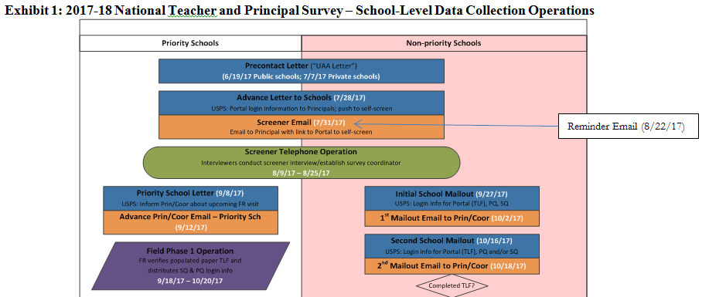

Appendix A – Communication Materials
- We added the “reminder email to principal” on page 37 and information about this email to the summary table on page 24:
Data Collection Activity/Operation | Correspondence Identifier(s) | Description
Screener Mailout
Screener Letter to Principal | NTPS-9L(E) | The letter introduces the NTPS and asks principal to login to the NTPS Respondent Portal to complete the screener survey.  Two versions:  NTPS-9L – Letter does not reference an e-mail being sent to the principal.  NTPS-9L(E) – Letter references an e-mail being sent to the principal.
Screener E-mail to Principal | NTPS-9E | The e-mail introduces the NTPS and asks principal to login to the NTPS Respondent Portal to complete the screener survey.
Reminder E-mail to Principal | NTPS-9E2 | This email reminds principals to login to the NTPS Respondent Portal to complete the screener survey.

Reminder E-mail to Principal
NTPS-9E2
Subject: NTPS Screener Survey Reminder
Body:
Dear <Principal Name>:
Welcome to the 2017–18 school year. We hope you enjoyed your summer break. A few weeks ago, we sent you a letter and an email requesting your assistance in completing a short screener survey for the National Teacher and Principal Survey (NTPS). The screener survey asks basic information about your school to determine its eligibility for the NTPS. According to our records, your school’s screener survey has not yet been completed. If you have recently completed the screener survey, thank you. If you have not yet completed it, please complete it as soon as possible. Your survey responses will be collected on a secure website. The survey will take approximately 5 minutes to complete. Please complete the survey within one week.
To complete the screener survey, go to: https://respond.census.gov/ntpsrsc
Log in using this User ID: <USER ID>
The NTPS is a nationwide sample survey of the teaching and working conditions in the United States, and of characteristics of the teachers and principals who staff them. The NTPS will provide critical data to policy makers and researchers on school organization, staff evaluations, professional development, and other important education topics. The National Center for Education Statistics (NCES), within the U.S. Department of Education, is authorized to conduct this survey by the Education Sciences Reform Act of 2002 (ESRA 2002, 20 U.S.C. §9543). The survey will be administered this fall by the U.S. Census Bureau on behalf of NCES.
All of the information you provide may be used only for statistical purposes and may not be disclosed, or used, in identifiable form for any other purpose except as required by law (20 U.S.C. §9573 and 6 U.S.C. §151). If you have any questions about the survey or you would like to complete the screener survey over the telephone, please contact the U.S. Census Bureau at 1-888-595-1338 between 8:00 a.m. and 8:00 p.m. (Eastern Time) Monday through Friday.
Thank you in advance for your participation in this important survey.

Sincerely,
National Teacher and Principal Survey Team
U.S. Census Bureau, on behalf of the
National Center for Education Statistics (NCES)

