Found at http://www.cpsc.gov/award

Chairman’s Commendation Circle Award Program
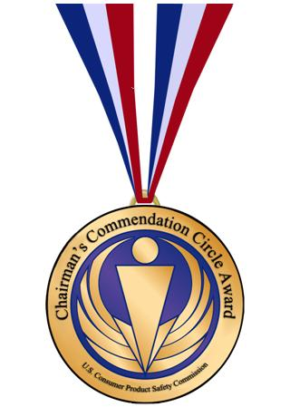
The Program: The Chairman’s Commendation Circle Award recognizes people and groups who have contributed in an important way to the benefit of consumers by directly and significantly reducing deaths, preventing injuries, and improving consumer product safety. The award program focuses on individuals in organizations, businesses, state and local government and other groups. Awards will be presented annually, and nominations will be accepted from members of the public as well as CPSC employees. Self nominations and anonymous nominations will not be accepted.
Nominations: Those submitting nominations are asked to consider the following questions when selecting a nominee:
- How, and to what extent, has the individual, organization or business contributed to improving consumer product safety?
- What are the recent and past accomplishments of the nominee in the advancement of consumer product safety?
- In what ways have consumers benefitted from the efforts of the nominee to advance consumer product safety?
- Has the nominee made contributions in support of CPSC’s mission?
- What additional, relevant information should be considered by the panel?
Number of awardees: The Chairman, at her sole discretion, may present awards to one or more of the candidates nominated.
The Process: Please complete the nomination packet clearly in black or blue ink. The packet consists of a form (pdf), descriptions of the nominee and the nominee’s work and other supporting materials. Then send the packet to CPSC.
Deadline: Nominations must be received on or before July 11, 2014. Submissions will be considered by a panel of CPSC staff. Recommendations for finalists will be presented to the Chairman by the review panel. The Chairman will assess the recommendations and make final selections for the award. Award recipients will be announced and the awards will be presented at a date to be determined.
The CPSC Chairman’s Commendation Circle Award is not an endorsement of any individual, organization, company, service or product.
Nominations: Submit nominations to:
Chairman’s Commendation Circle Award
U.S. Consumer Product Safety Commission
4330 East West Highway, Suite 724
Bethesda, Maryland 20814
Applications also can be submitted by e-mail to chairmansaward@cpsc.gov or by fax to (301) 504-0768.
Chairman’s Commendation Circle Award FAQ’s
Chairman’s Commendation Circle Award Flyer (pdf)
2012 Chairman’s Commendation Circle Awardees
2011 Chairman’s Commendation Circle Awardees

