Request for Approval under the “Generic Clearance for the Collection of Routine Customer Feedback” (OMB Control Number: 3045-0137)

TITLE OF INFORMATION COLLECTION: Recruitment Webinar Follow-up Survey

PURPOSE: To collect feedback from participants on the delivery of the team’s recruitment webinars. Responses to the survey will inform revisions and the team’s future webinars. The overall objective is to provide the most useful and relevant information for prospective applicants considering service with AmeriCorps NCCC.

DESCRIPTION OF RESPONDENTS: Attendees of the recruitment webinars. Ideally, these individuals will be 17-24 year olds who have an interest in learning more about AmeriCorps NCCC and potentially applying to serve. These individuals may also have been receiving information in the form of weekly email bulletins from the NCCC brand for a period of time.

TYPE OF COLLECTION: (Check one)

[ ] Customer Comment Card/Complaint Form [ X ] Customer Satisfaction Survey [ ] Usability Testing (e.g., Website or Software [ ] Small Discussion Group

[] Focus Group [ ] Other:

CERTIFICATION:

I certify the following to be true:

1. The collection is voluntary.
2. The collection is low-burden for respondents and low-cost for the Federal Government.
3. The collection is non-controversial and does not raise issues of concern to other federal agencies.
4. The results are not intended to be disseminated to the public.
5. Information gathered will not be used for the purpose of substantially informing influential policy decisions.
6. 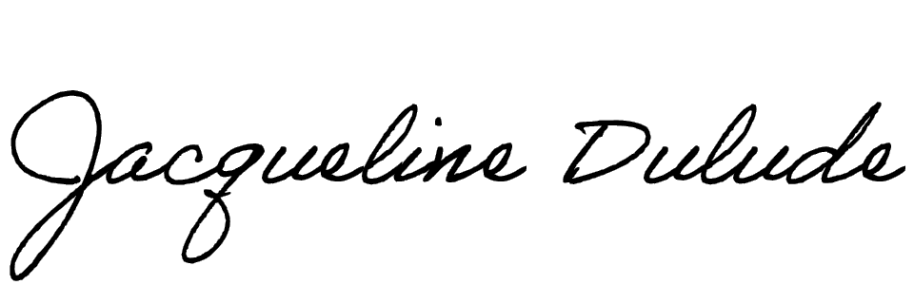The collection is targeted to the solicitation of opinions from respondents who have experience with the program or may have experience with the program in the future.

Name: Jacqueline Dulude

To assist review, please provide answers to the following question:

Personally Identifiable Information:

1. Is personally identifiable information (PII) collected? [ X ] Yes* [] No
2. If Yes, will any information that is collected be included in records that are subject to the Privacy Act of 1974? [ ] Yes [ X ] No
3. If Yes, has an up-to-date System of Records Notice (SORN) been published? [ ] Yes [ ] No N/A

If a participant indicates they would like to speak with someone individually about their candidacy for NCCC or program specifics, that individual’s phone number/email address will be collected for the purposes of reaching out. After the individual has been contacted and had their questions sufficiently answered, their PII will no longer be retained.

Gifts or Payments:

Is an incentive (e.g., money or reimbursement of expenses, token of appreciation) provided to participants? [] Yes [ X ] No

BURDEN HOURS

|  |  |  |  |
| --- | --- | --- | --- |
| Category of Respondent | No. of Respondents | Participation Time | Burden |
| Individuals or households | 200 annually | 5 min | 16.67 hrs. annually |
| Totals | 200 | 5 min. | 16.67 hrs. |

FEDERAL COST: The estimated annual cost to the Federal government is $725

If you are conducting a focus group, survey, or plan to employ statistical methods, please provide answers to the following questions:

The selection of your targeted respondents

1. Do you have a customer list or something similar that defines the universe of potential respondents and do you have a sampling plan for selecting from this universe?

[] Yes [ X ] No

If the answer is yes, please provide a description of both below (or attach the sampling plan)? If the answer is no, please provide a description of how you plan to identify your potential group of respondents and how you will select them?

We will utilize the final attendance report for each webinar. The platform Zoom takes this list and automatically links participants to a feedback survey in the follow-up message sent shortly after the webinar. The message with survey link will be sent to 100% of participants.

Administration of the Instrument

1. How will you collect the information? (Check all that apply) [ X ] Web-based or other forms of Social Media

[ ] Telephone [ ] In-person [ ] Mail

[ ] Other, Explain

1. Will interviewers or facilitators be used? [ ] Yes [ X ] No

Please make sure that all instruments, instructions, and scripts are submitted with the request.