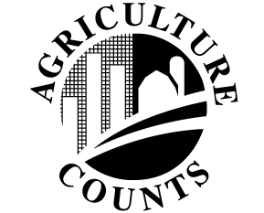 | Commercial  Floriculture Survey
United States Department of Agriculture |  | National Agricultural Statistics Service
 |  | January 2016

USDA’s National Agricultural Statistics Service (NASS) conducts the Commercial Floriculture Survey each year to collect data on floriculture production, area of production, prices and sales of floriculture commodities, and number of agricultural workers per farm. The results of the survey provide a critical decision-making and educational tool for growers, consumers, international buyers, and USDA and other agencies. NASS will publish the survey findings in May 2016 in the annual report Floriculture Crops.

HOW DOES NASS COLLECT THE DATA?

In January 2016, NASS will mail the Commercial Floriculture Survey questionnaire to growers in 15 states, covering all commercial floriculture operations that produce and sell at least $10,000 per year of fresh cut flowers, potted flowering plants, potted herbaceous perennials, annual bedding and garden plants, foliage plants, cut cultivated greens, and unfinished plants.

To respond, please complete the survey questionnaire and mail it back in the return envelope provided. A NASS representative will contact producers who have not responded by the third week of February to offer the option of a telephone or personal interview.

WHO USES THE INFORMATION?

The floriculture industry is changing rapidly as technology changes result in new production practices and new products. The survey findings help various industry segments in making plans for the future and gauging trends, value and impact.

- Government agencies use the data to measure the economic impact of the industry, which is making a significant contribution to farm incomes and to the gross domestic product.
- Growers use the information to identify market trends and future needs, to compare how they are doing relative to others, and to make their business plans.
- Analysts and industry researchers rely on the data in submitting proposals and requests for funding.
- Industry representatives and others rely on the data in trade negotiations and in resolving cases about unfair trade practices.

The information provided by survey respondents is confidential by law. NASS safeguards the privacy of all responses and publishes data only in aggregate form, ensuring that no individual operation or producer can be identified.

All reports are available through the NASS web site: www.nass.usda.gov. For more information on NASS surveys and reports, call the NASS Agricultural Statistics Hotline at (800) 727-9540.

