**Entry Screens for Freight Invoices in WBSCM**

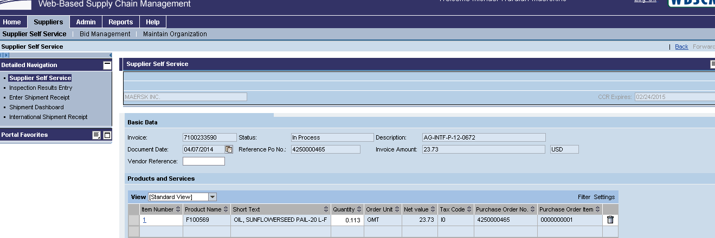

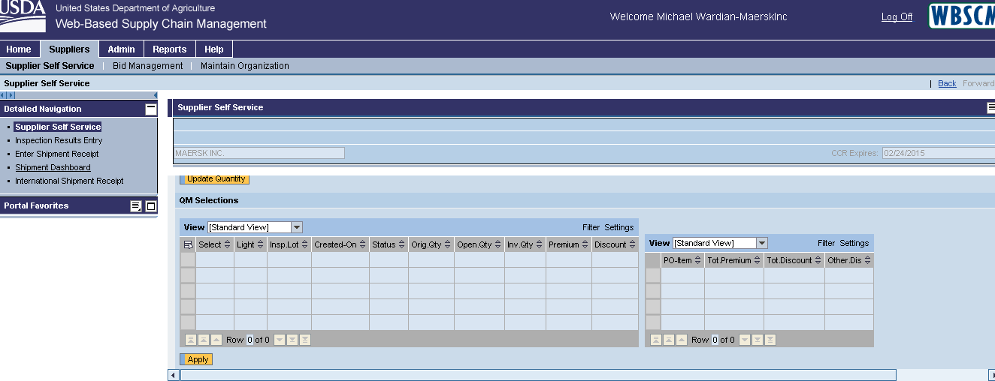

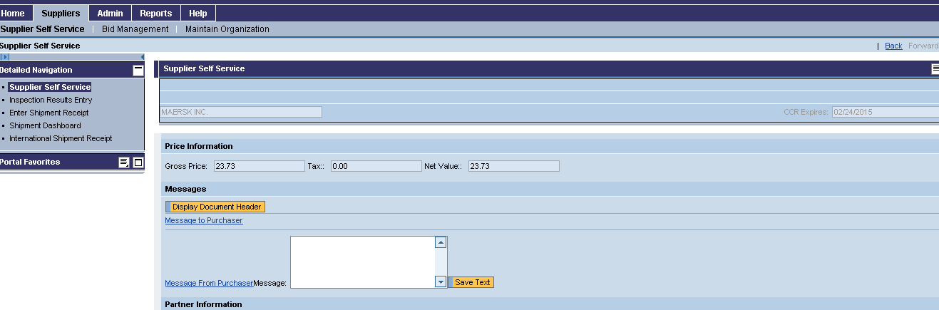

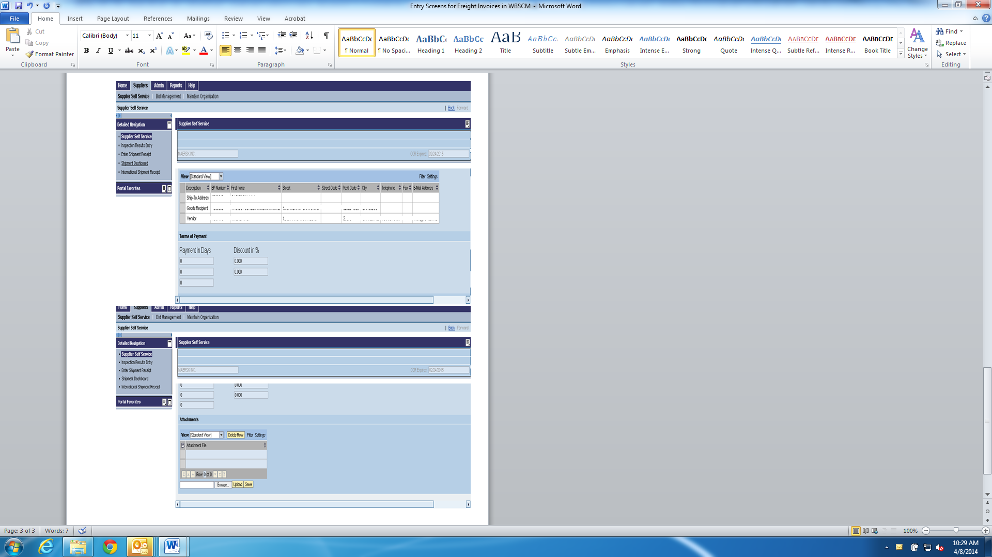

The public reporting burden for this information collection is estimated to be 30 minutes. This burden estimate includes time for reviewing instructions, researching existing data sources, gathering and maintaining the needed data, and completing and submitting the information. Send comments regarding the accuracy of this burden estimate and any suggestions for reducing the burden to: U.S. Department of Agriculture, Foreign Agricultural Service, Office of Capacity Building and Development, Food Assistance Division, Attn: OMB Number (0551-0035), 1400 Independence Avenue., S.W., Washington, DC 20250-1034. You are not required to respond to this collection of information unless a valid OMB control number is displayed.