**Register for a USDA EAuthentication Account**

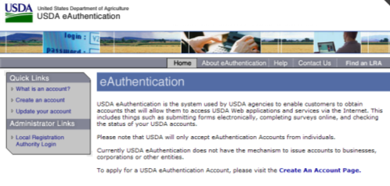

**Organization Registration**

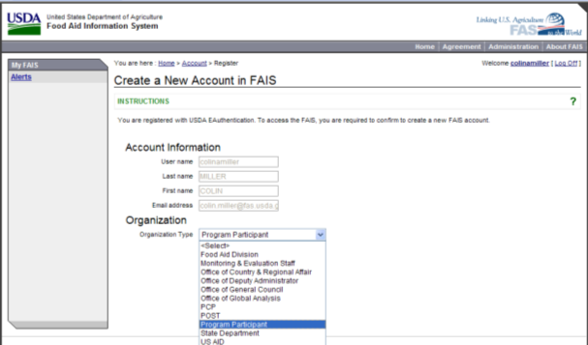

**How to Initiate a Proposal**

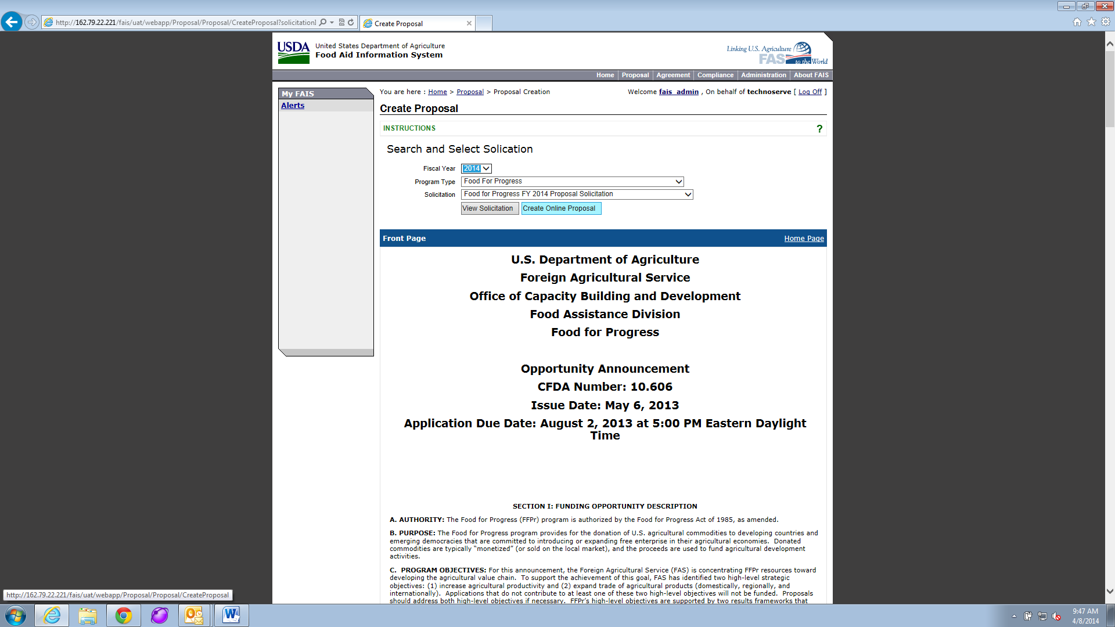

**Assign Contact Information**

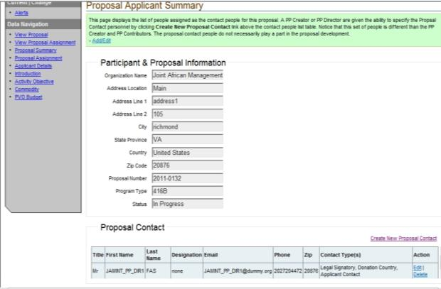

**Assign User Roles in a Proposal**

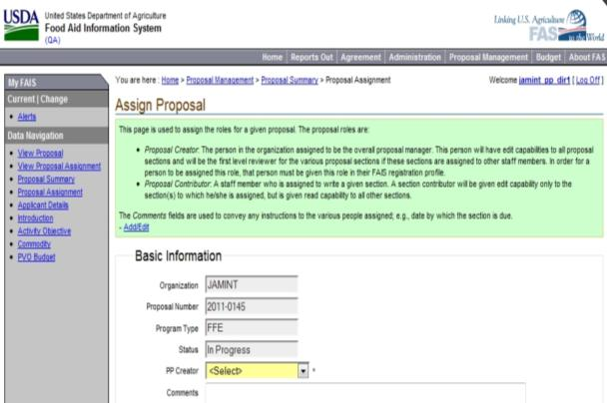

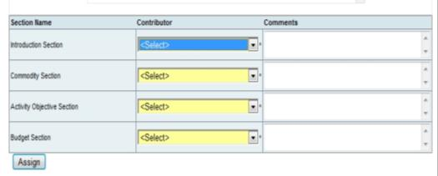

**User Delegation**

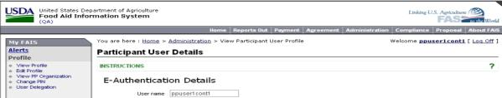

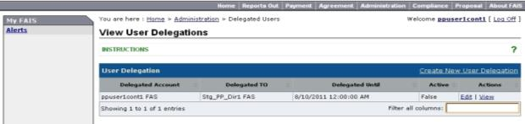

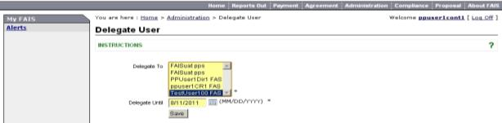

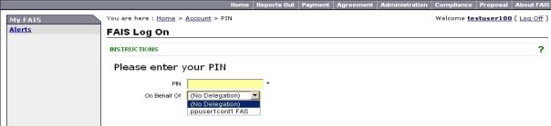

**Proposal Summary**

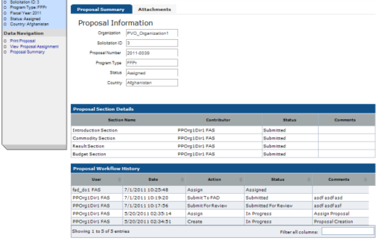



**Attachments Tab**

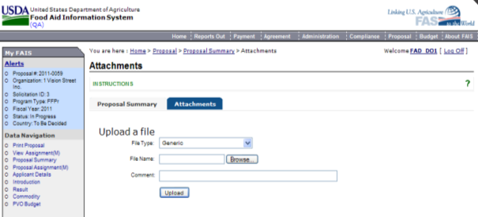

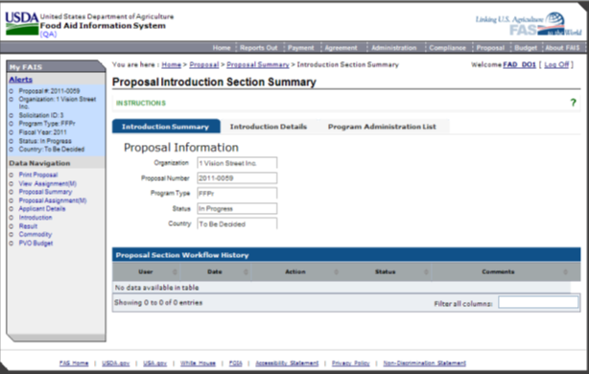

**Introduction Details**

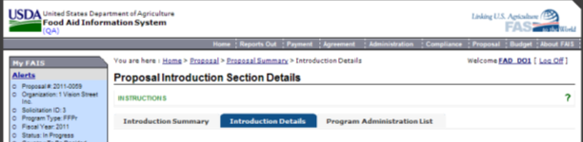

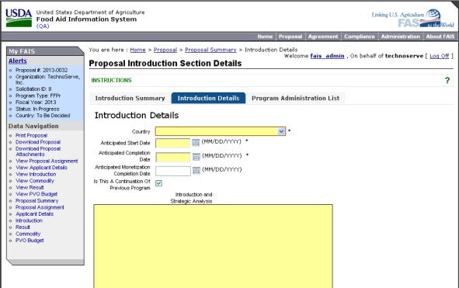

**Program Administration List**

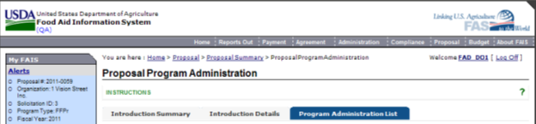

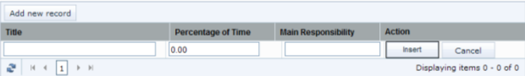

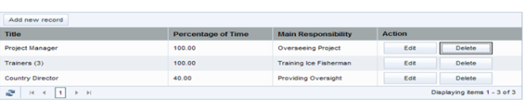

**Selecting Results**

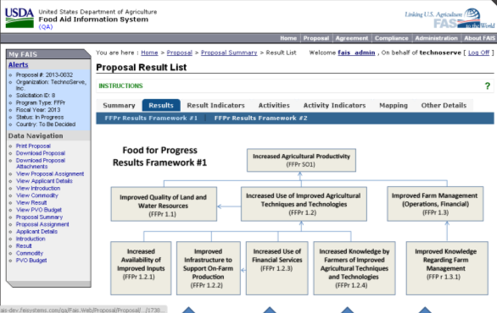

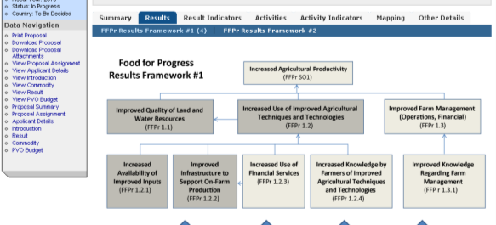

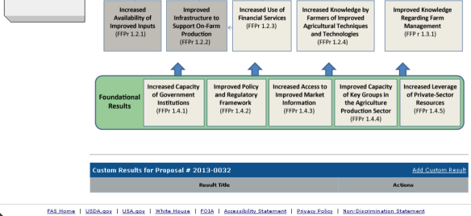

**Adding Performance Indicators**

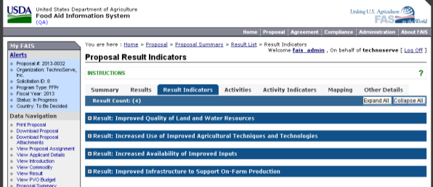

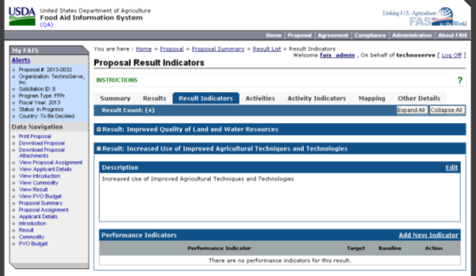

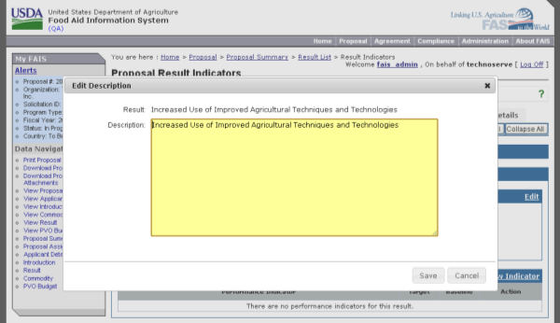

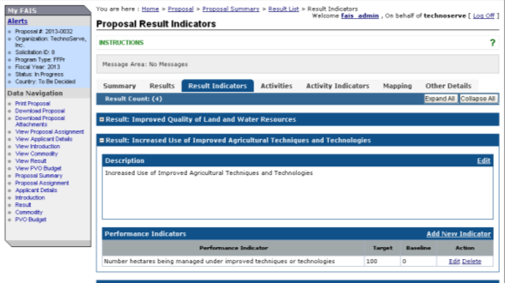

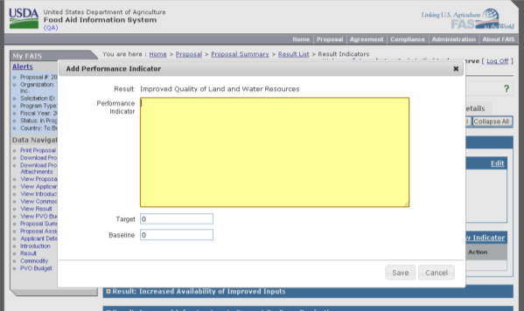

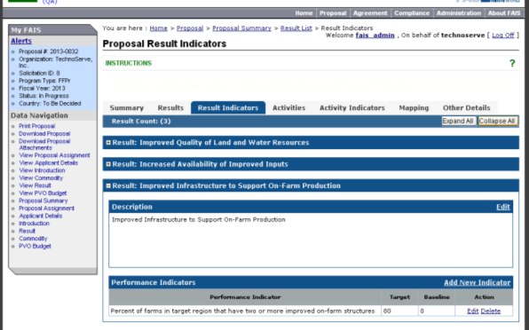

**Activities**

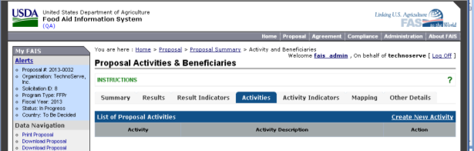

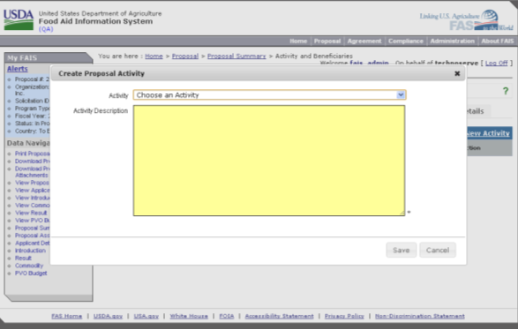

**Activity Indicators**

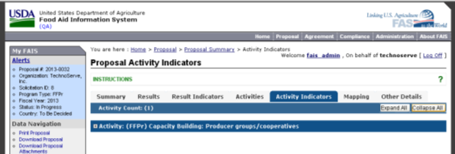

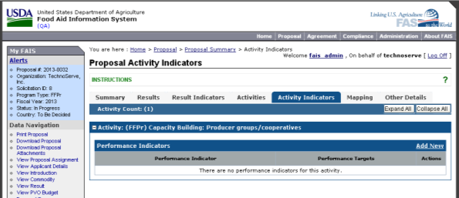

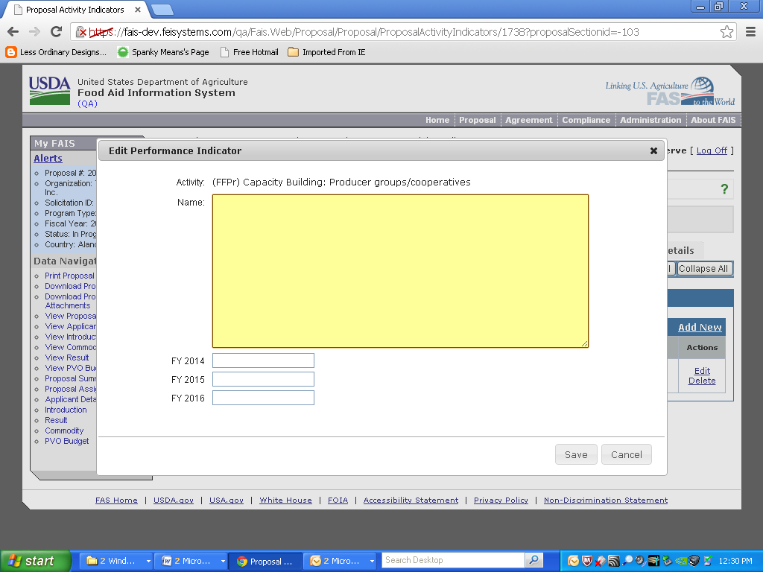

.

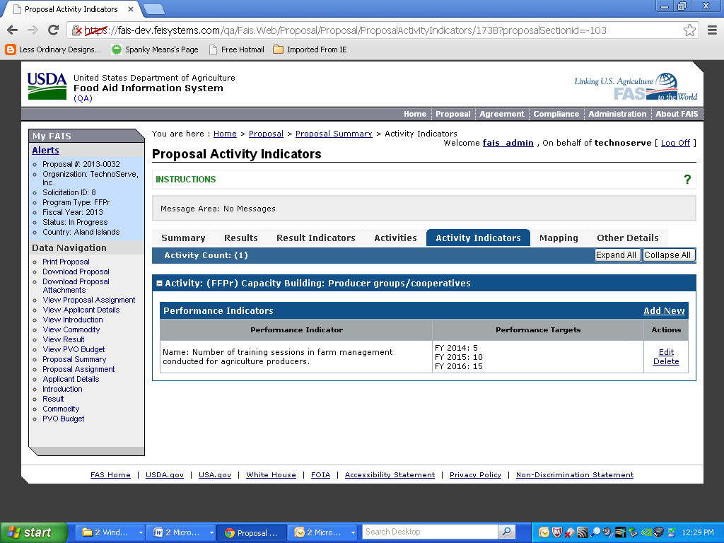 **Mapping**

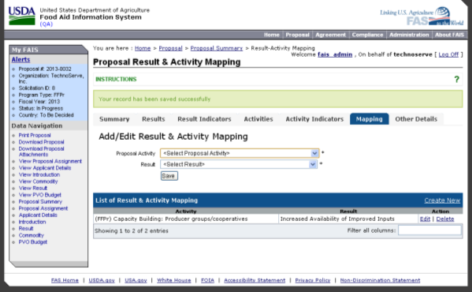

**Other Details**

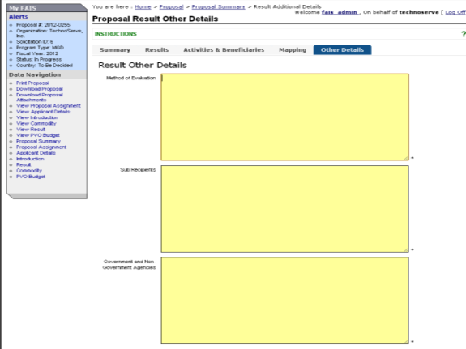

Cash or Non-cash Contributions:

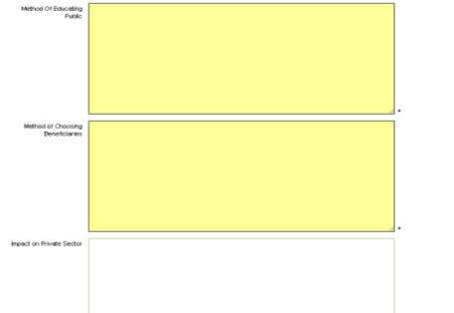

Target Geographic Area:

**Commodity Summary**

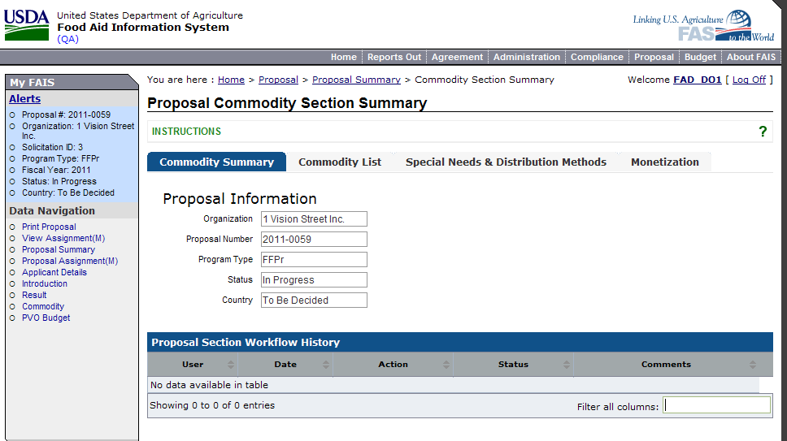

.

**Commodity List**

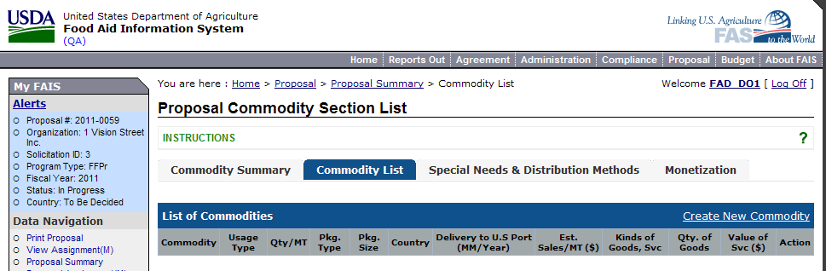

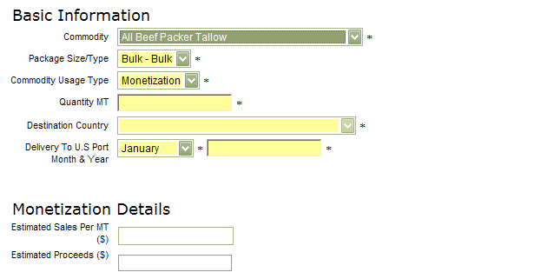

**Special Needs & Distribution Methods**

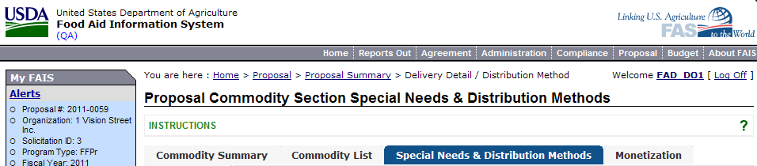

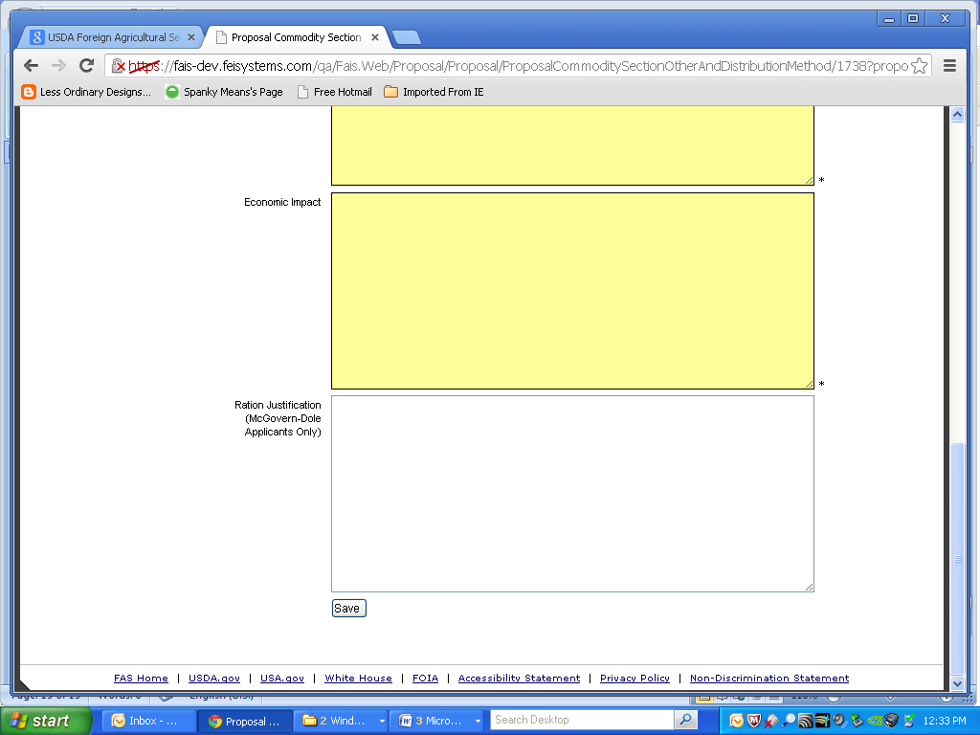

**Monetization**

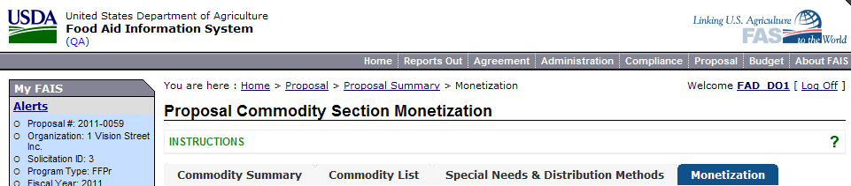

**PVO Budget Summary**

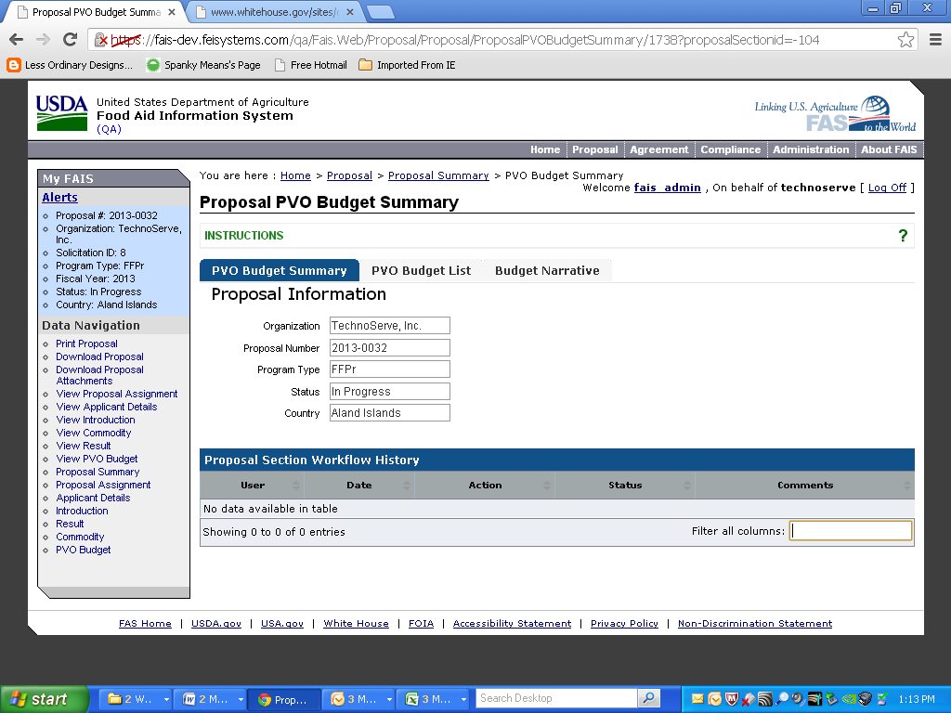

**PVO Budget List**

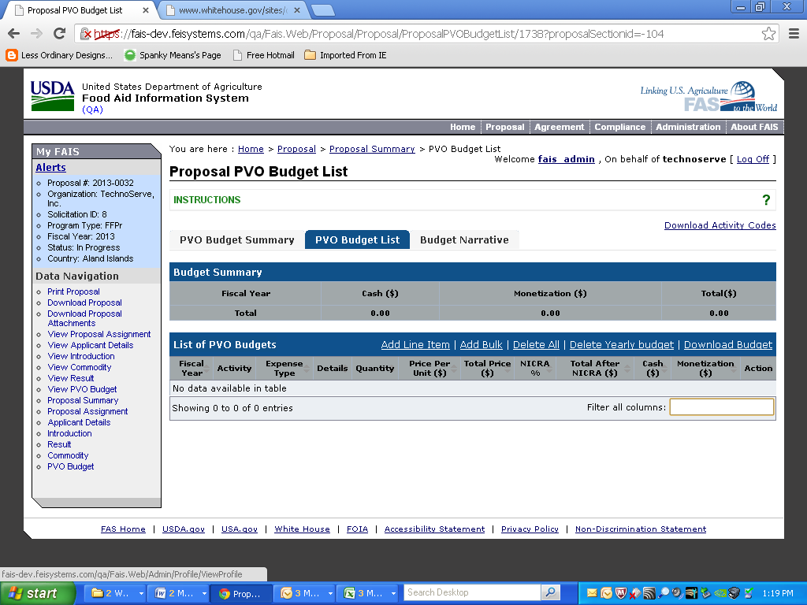

**Adding Bulk Budget Lines: Downloading Activity Codes**



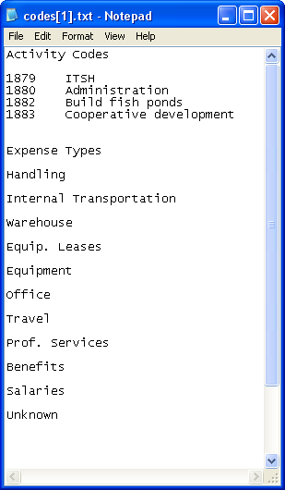

**Adding Bulk Budget Lines: Compiling Budget in Excel and FAIS**

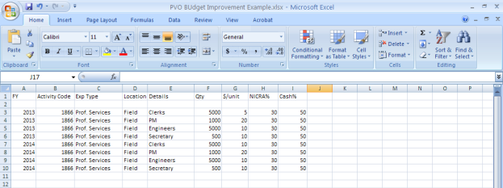

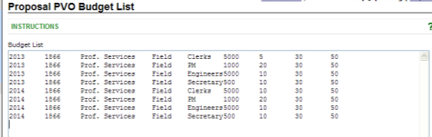

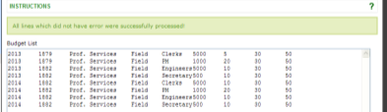

**Adding Single Line Budget Entries**

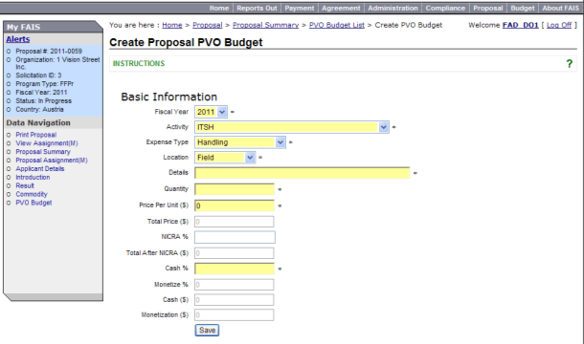

**PVO Budget Narrative**

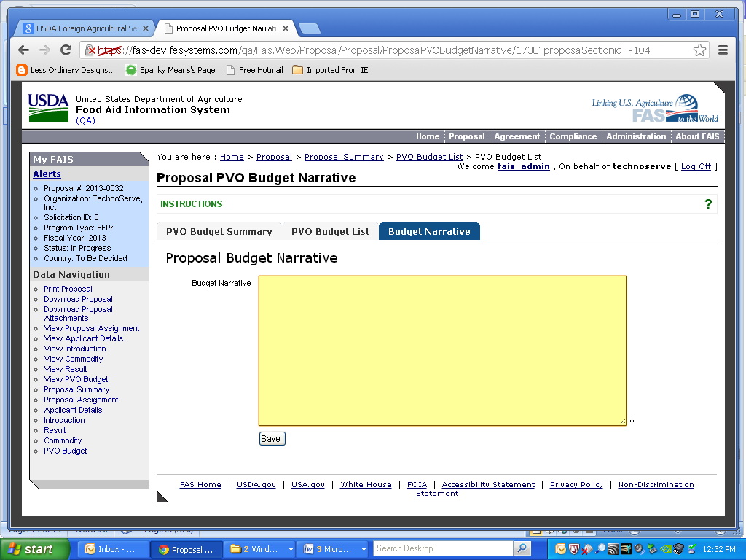

# SUBMITTING PROPOSALS IN FAIS

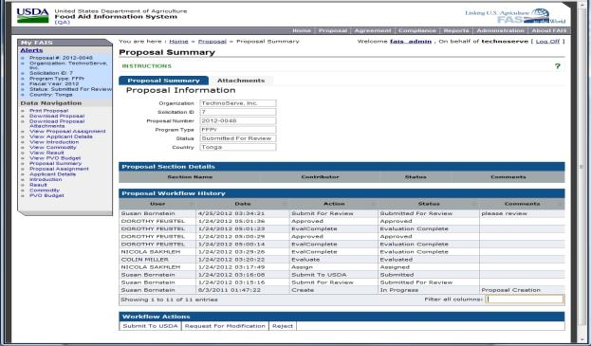

The public reporting burden for this information collection is estimated to be 180 minutes. This burden estimate includes time for reviewing instructions, researching existing data sources, gathering and maintaining the needed data, and completing and submitting the information. Send comments regarding the accuracy of this burden estimate and any suggestions for reducing the burden to: U.S. Department of Agriculture, Foreign Agricultural Service, Office of Capacity Building and Development, Food Assistance Division, Attn: OMB Number (0551-0035), 1400 Independence Avenue., S.W., Washington, DC 20250-1034. You are not required to respond to this collection of information unless a valid OMB control number is displayed.