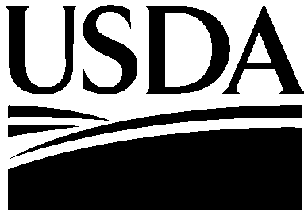
United States Department of Agriculture

Farm and Foreign
Agricultural
Services

Farm Service Agency

1400 Independence Avenue, SW
Stop 0540
Washington, DC
20250-0540



DATE: October 17, 2017

TO: Cortney Higgins
OMB Desk Officer

THROUGH: Ruth Brown
USDA Information Collection Officer

FROM: Steven J. Peterson
Acting FSA Administrator

SUBJECT: Request for Emergency Approval for a New Information Collection Package—Dairy Assistance Program for Puerto Rico (DAP-PR) in Response to 2017 Hurricanes

This request is for OMB review and emergency approval of a collection of information necessary to implement DAP-PR in Response to 2017 hurricanes to avoid livestock deaths. It is also essential to the mission of the agency to provide payments to feed vendors. The Farm Service Agency (FSA), on behalf of Commodity Credit Corporation (CCC), will provide assistance to dairy representatives (producers) and make payments to feed vendors under DAP-PR. The Notice of Fund Availability (NOFA) to provide DAP-PR assistance will be published in the Federal Register and will be on public display on Thursday, October 19, 2017. The use of normal clearance procedures would delay the payment process to Puerto Rice due causing more harm to the dairy producer and delaying payments. Therefore, we need OMB approval by October 18, 2017 for the reasons below.

The USDA Secretary requested that FSA immediately assist Puerto Rican dairy operations affected by the 2017 hurricanes; in response to a request from the Governor of Puerto Rico, who also asked USDA to assist dairy farmers for the purchase of generators, diesel, and feed. DAP-PR would provide assistance in meeting feed costs at this time to maintain dairy operations in Puerto Rico during the recovery from the 2017 hurricanes. The authority for DAP-PR is covered in the section 5(b) of the CCC Charter Act, which authorizes USDA to make available materials and facilities required in connection with production and marketing of agricultural commodities (other than tobacco). Therefore, FSA will assist dairy operations in Puerto Rico in procuring feed and fuel.
USDA is an Equal Opportunity Employer

When published, the NOFA will provide guidance and notify dairy operations of the availability of the assistance. The DAP-PR will be starting immediately upon the NOFA’s publication date. The 277 dairy operations on Puerto Rico are expected to apply for vouchers to use at any of the 3 feed vendors on Puerto Rico. FSA will have employees on-site with the information to pre-fill the applications, the dairy representatives will certify and sign the application, the vendors and dairy representatives will sign the vouchers as they are used; vendor receipts will be attached to the voucher. The dairy operation will have an FSA-calculated total value for a voucher, to be used up to 4 times to draw down the total value to obtain the approved amount for the feed.

If there are any questions or concerns, please call Deirdre Holder at 202-205-5851 or Mary Ann Ball at 202-720-4283.

