APPENDIX A.
Sections of Authorizing Statues

Section 28 of the Richard B Russell National School Lunch Act as Amended by HHFKA of 2010

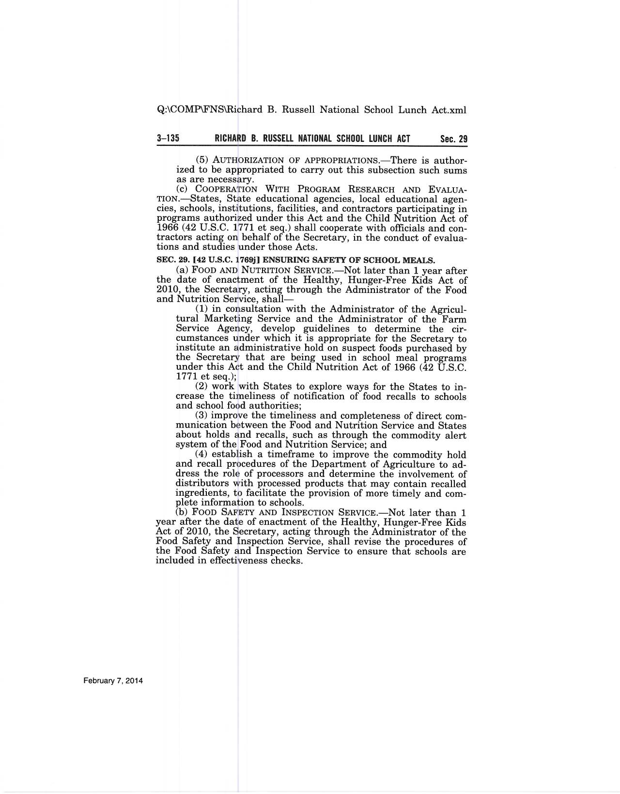
Section 17 (7 U.S.C.) (a)(1) of the Food and Nutrition Act of 2008

