Attachment 8b: Screenshots from PERS
Local Education Agency (LEA) Screenshots

The data will be collected from funded agencies via the Program Evaluation and Reporting System (PERS). Screenshots for the Local Education Agency (LEA) questionnaires are provided below in the order presented in the Burden Table (Table A.12-1) in Supporting Statement A. The questionnaires for the State Education Agencies (SEA) and Non-governmental organizations (NGO) are included in Attachment 8a and 8c, respectively.
The questionnaires in PERS cover the following topics: exemplary sexual health education (ESHE); sexual health services (SHS); and safe and supportive environments (SSE). The burden statement and OMB form approval information are reflected on the initial page of each group of screenshots that correspond to the questionnaires. To view the measures and the list of questions in text format, see Attachments 3a, b &c – 5a, b, &c.
Contents
Local Education Agency (LEA) Screenshots 2
Introductory Instruction Slides 2
LEA ESHE Items 4
LEA SHS Items 18
LEA SSE Items 23

Local Education Agency (LEA) Screenshots

Introductory Instruction Slides
Log-in screen
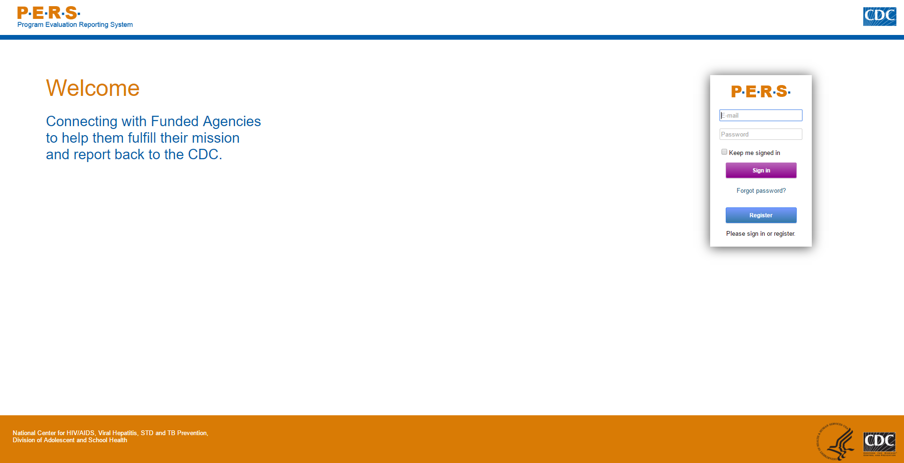
Screen that appears after logging in with username and password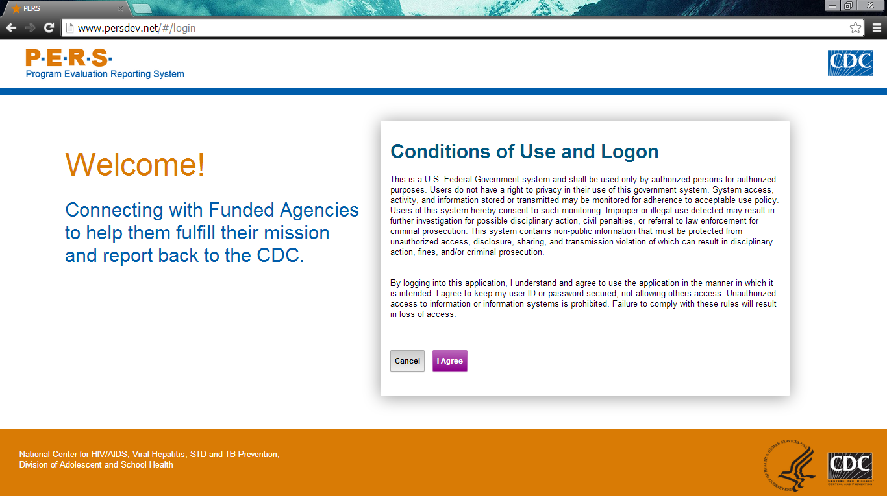

Main page. Questionnaires located in “Evaluation Measures Reporting” tab.
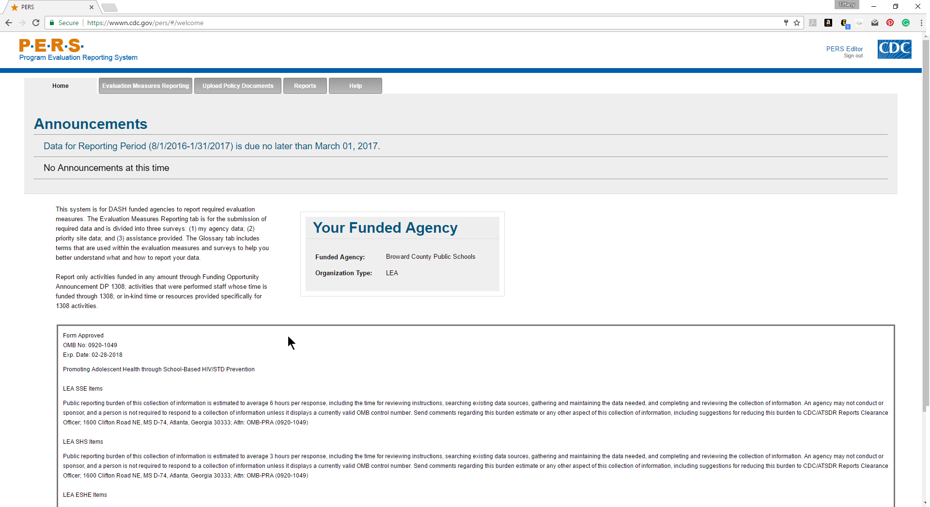

Main screen with links to questionnaires. ESHE, SHS, SSE questions are organized in the three categories for ease of data entry.
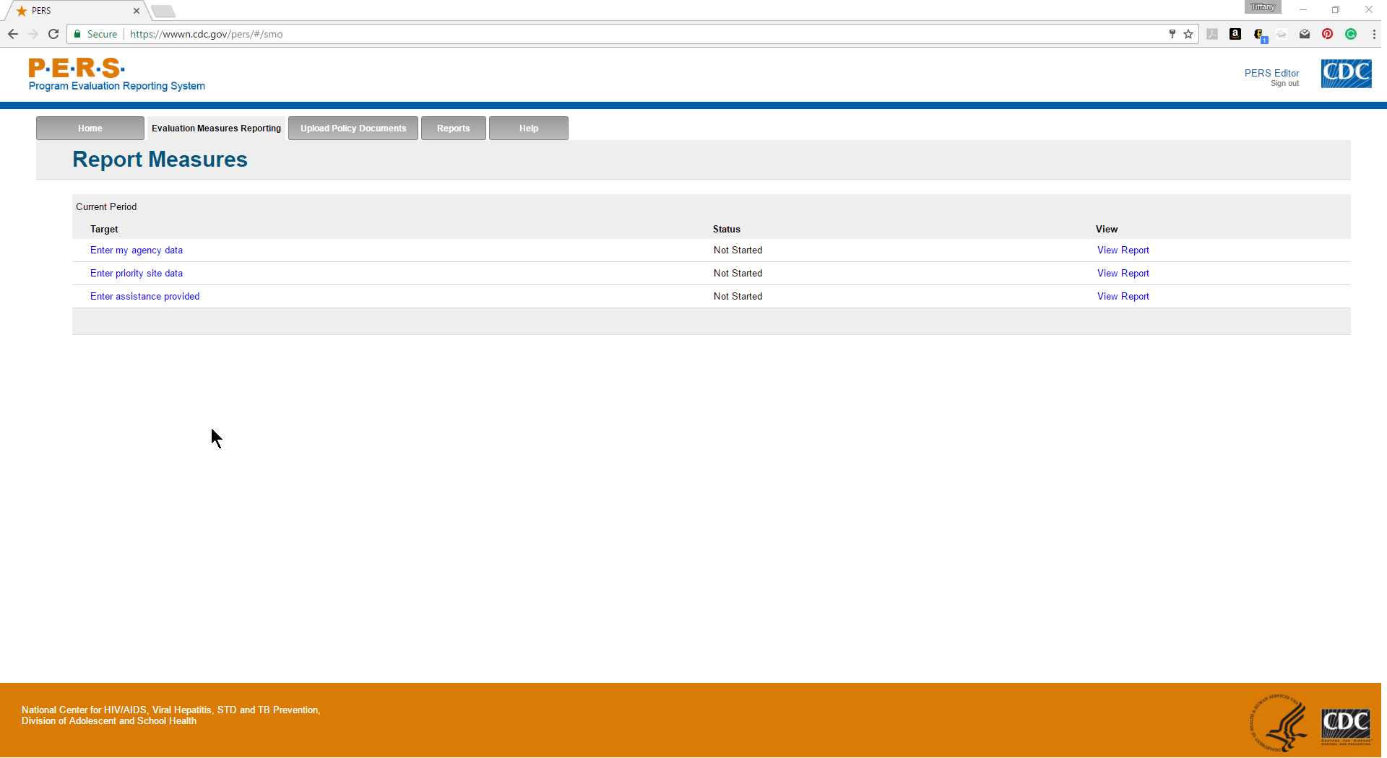

Form Approved
OMB No: 0920-1049
Exp. Date: 02/28/2018

“Promoting Adolescent Health through School-Based HIV/STD Prevention”

Att. 5c

LEA ESHE Items

Public reporting burden of this collection of information is estimated to average 6 hours per response, including the time for reviewing instructions, searching existing data sources, gathering and maintaining the data needed, and completing and reviewing the collection of information. An agency may not conduct or sponsor, and a person is not required to respond to a collection of information unless it displays a currently valid OMB control number. Send comments regarding this burden estimate or any other aspect of this collection of information, including suggestions for reducing this burden to CDC/ATSDR Reports Clearance Officer; 1600 Clifton Road NE, MS D-74, Atlanta, Georgia 30333; Attn: OMB-PRA (0920-1049)

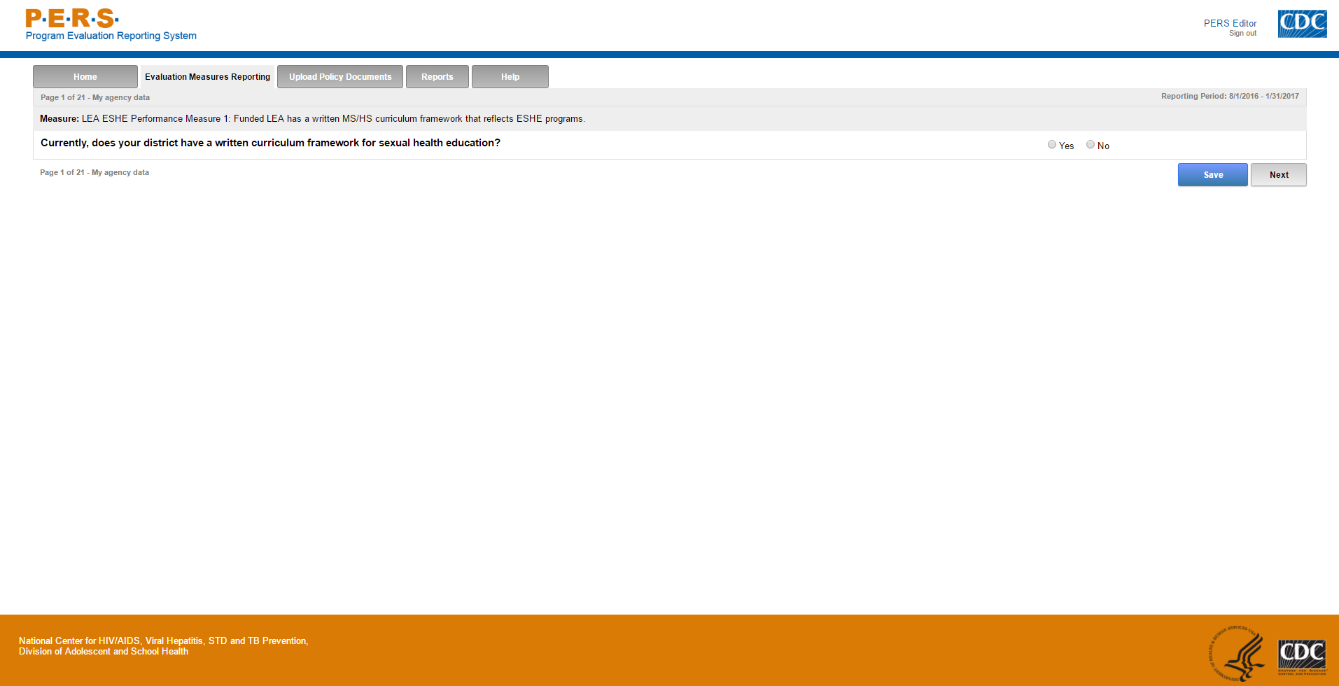
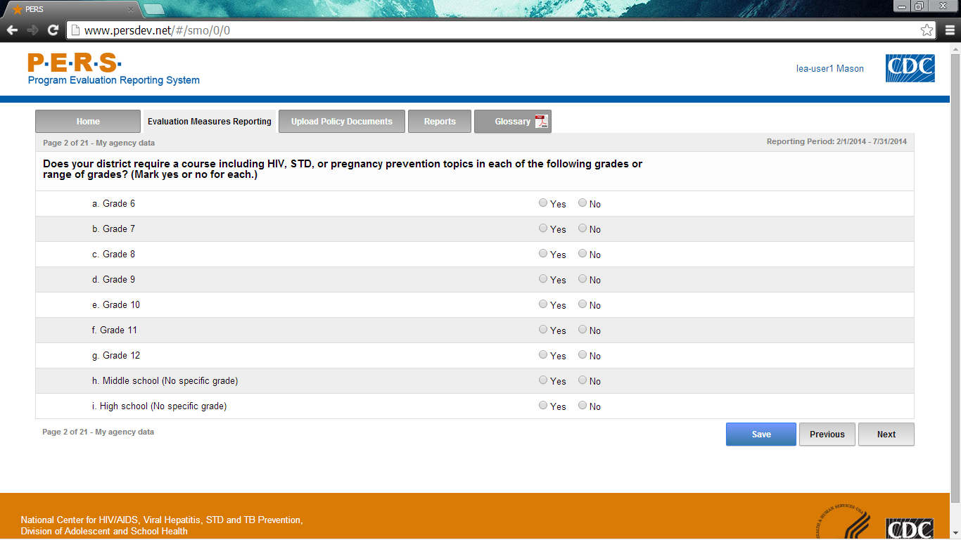
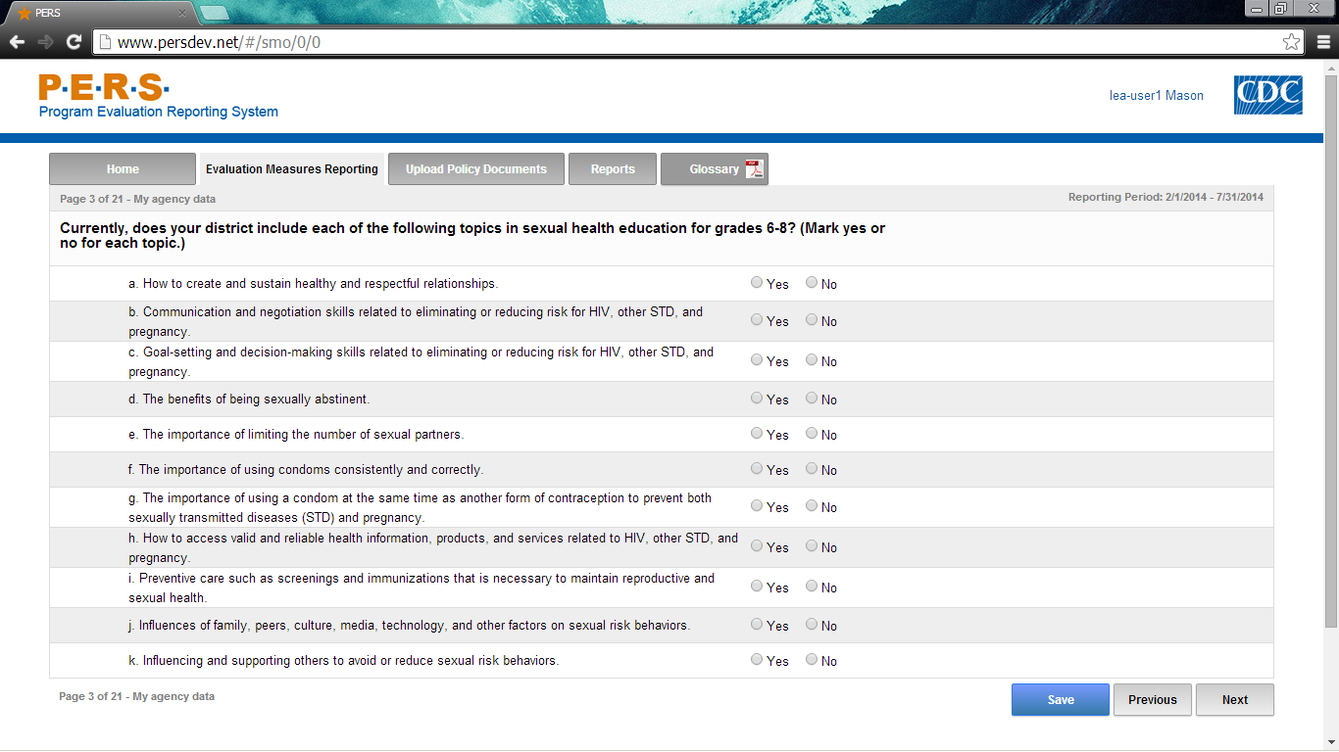
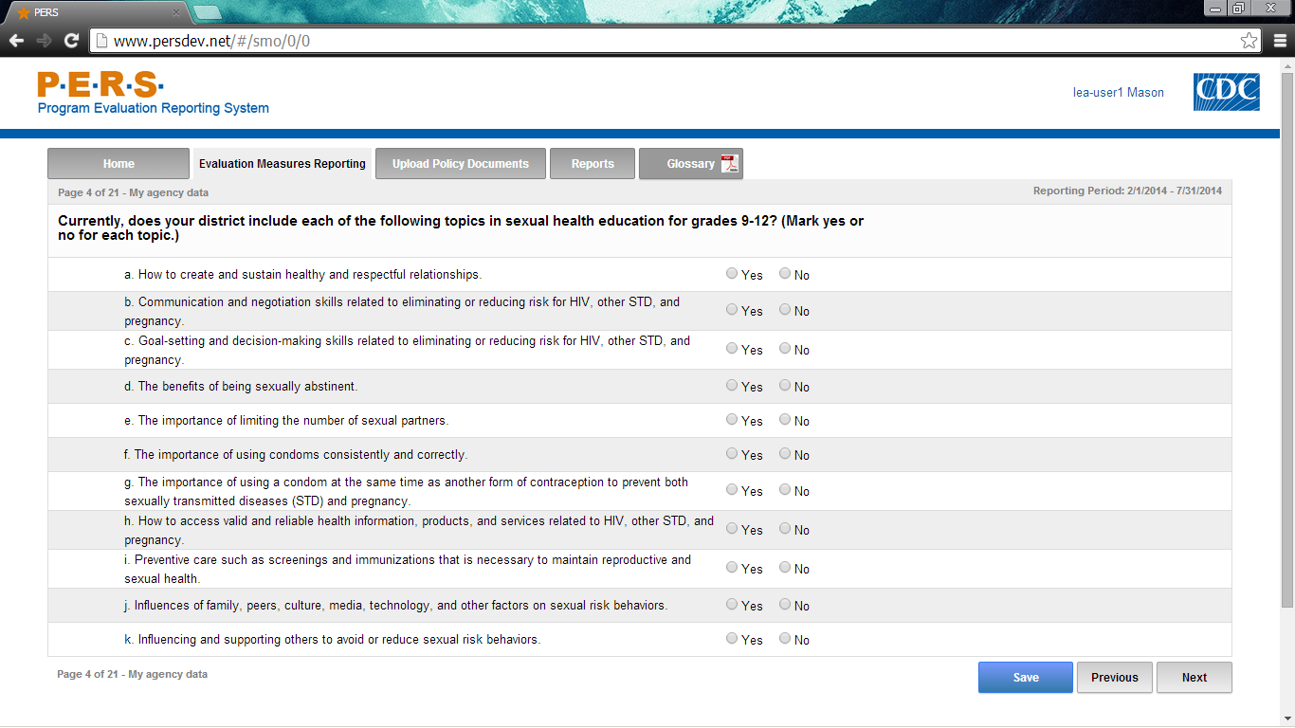
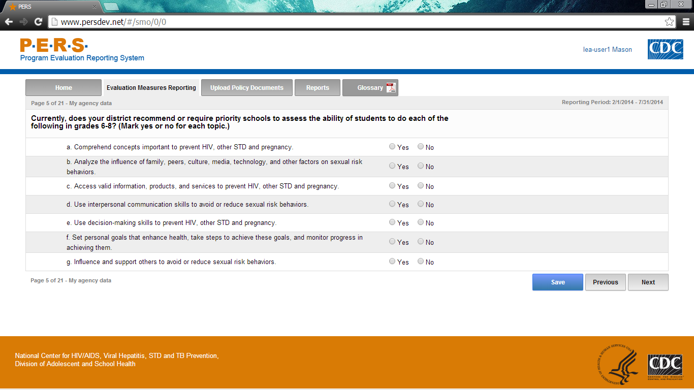
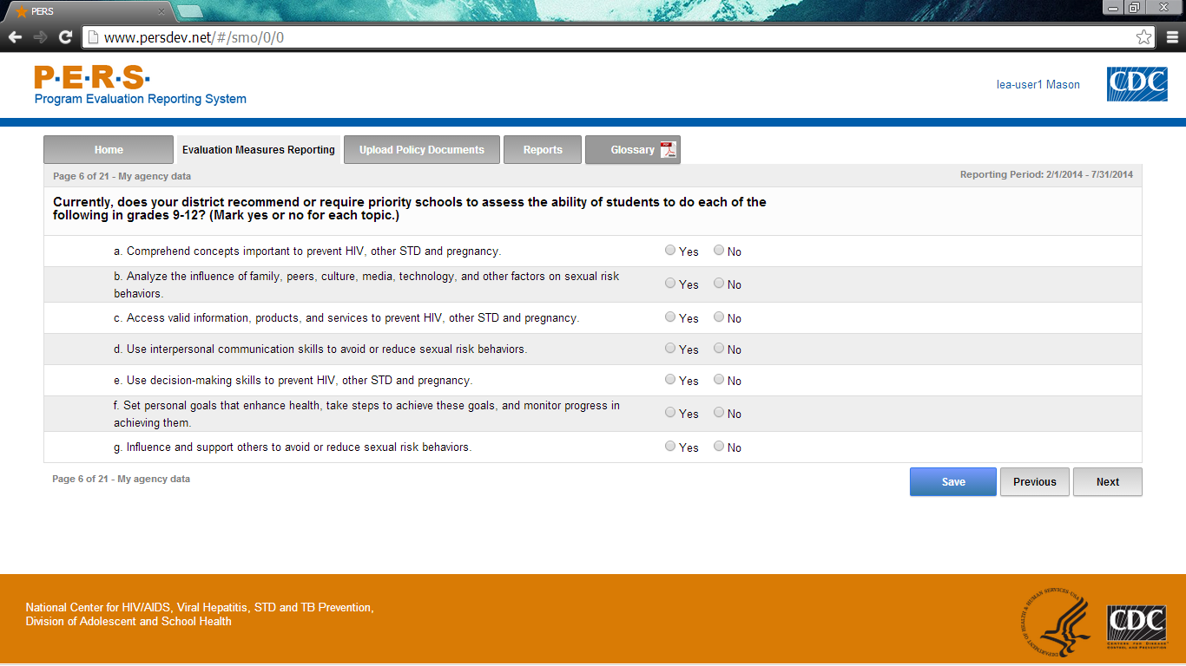
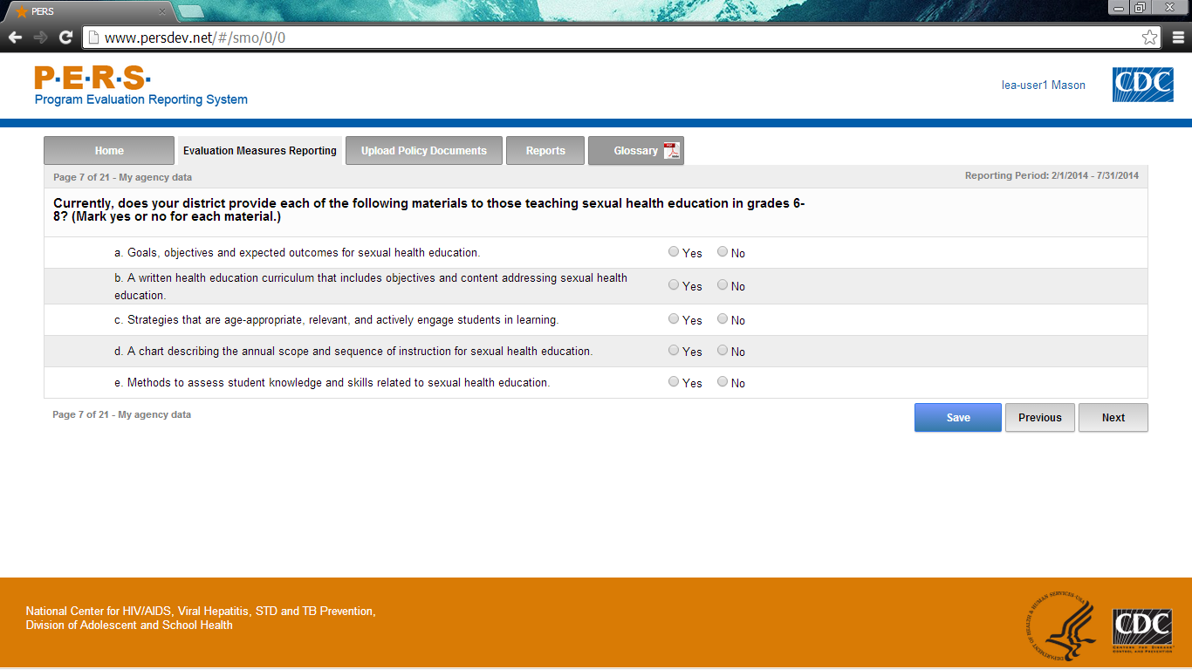
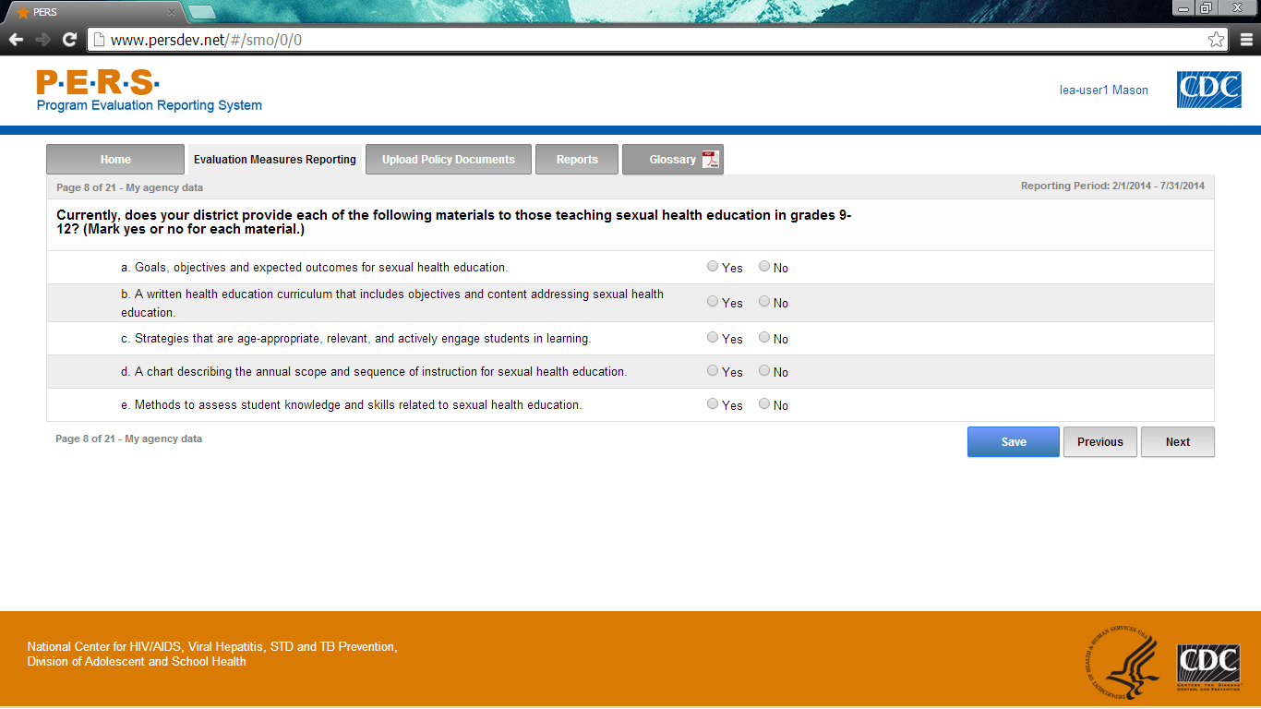

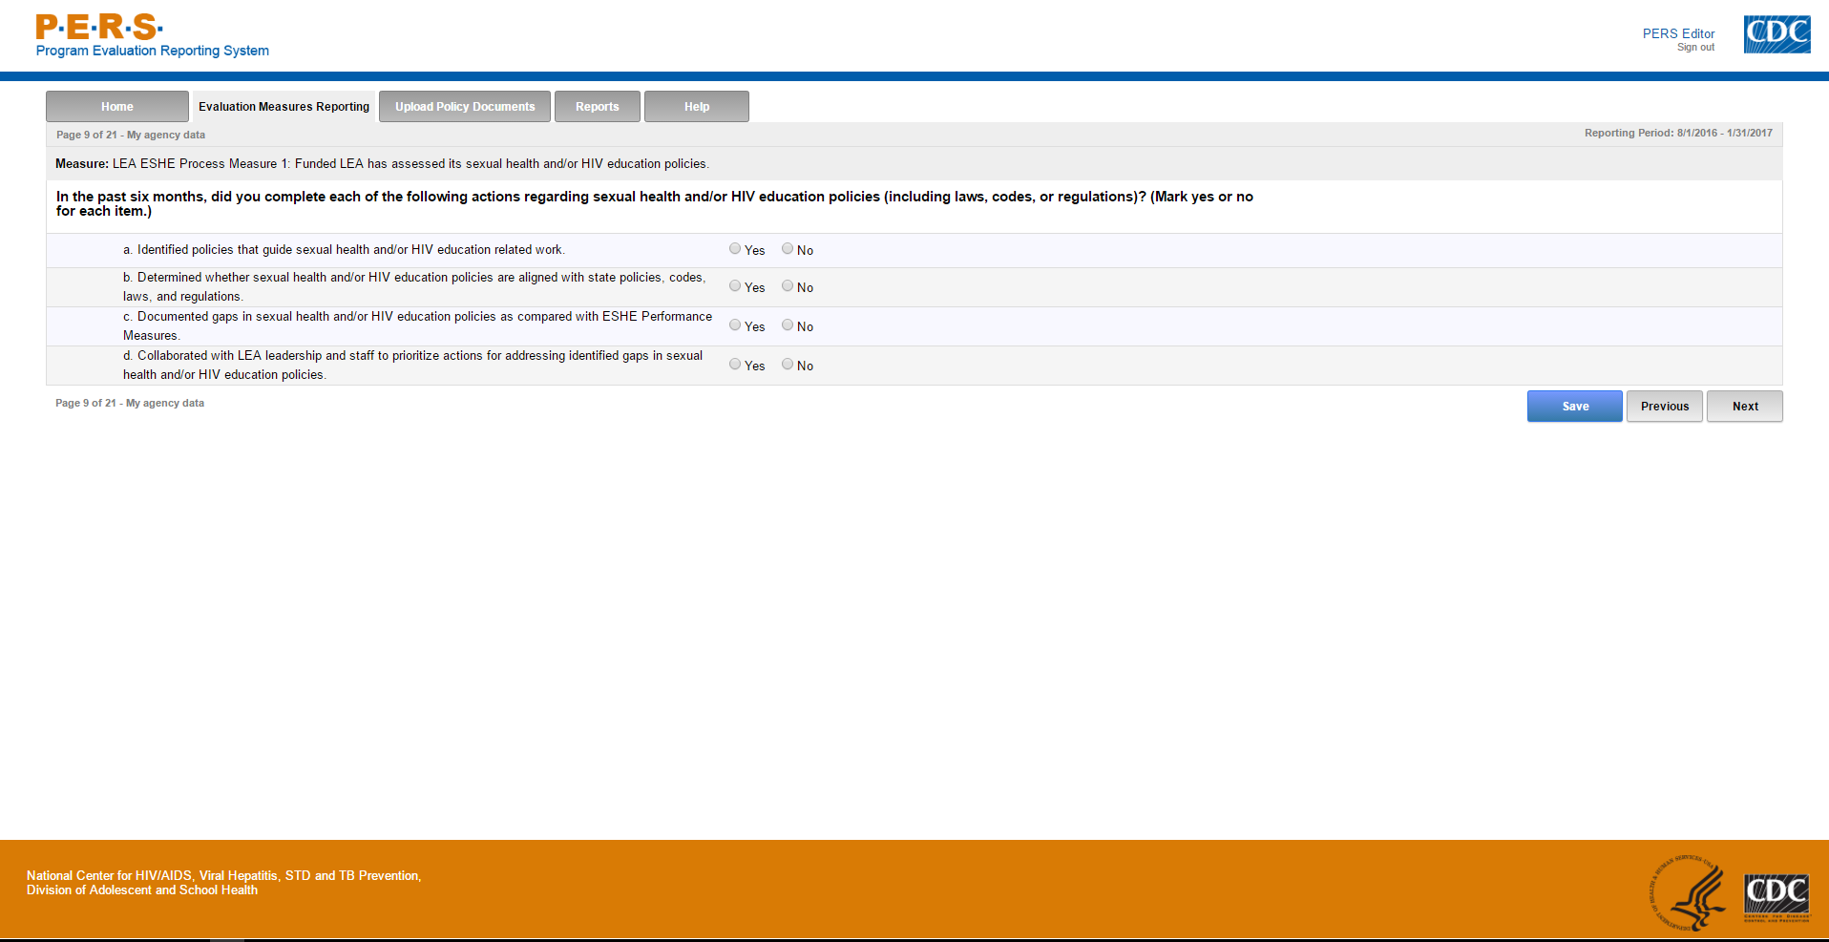

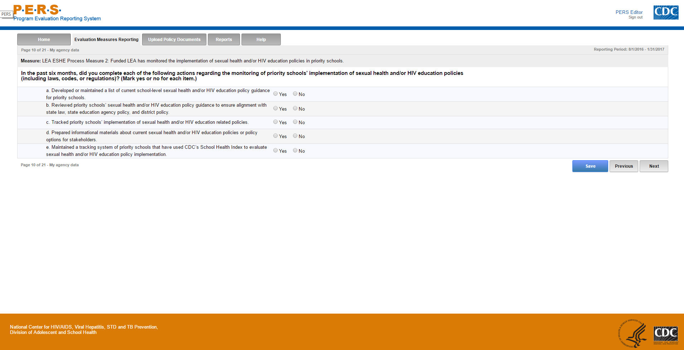

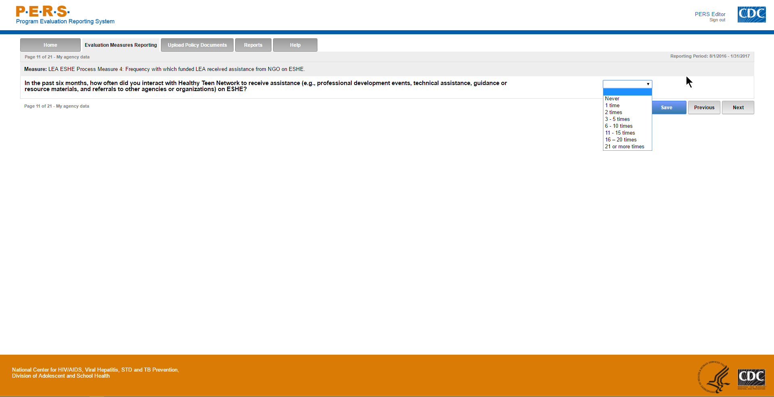

Part A of screenshot. This screen is scrolling enabled.
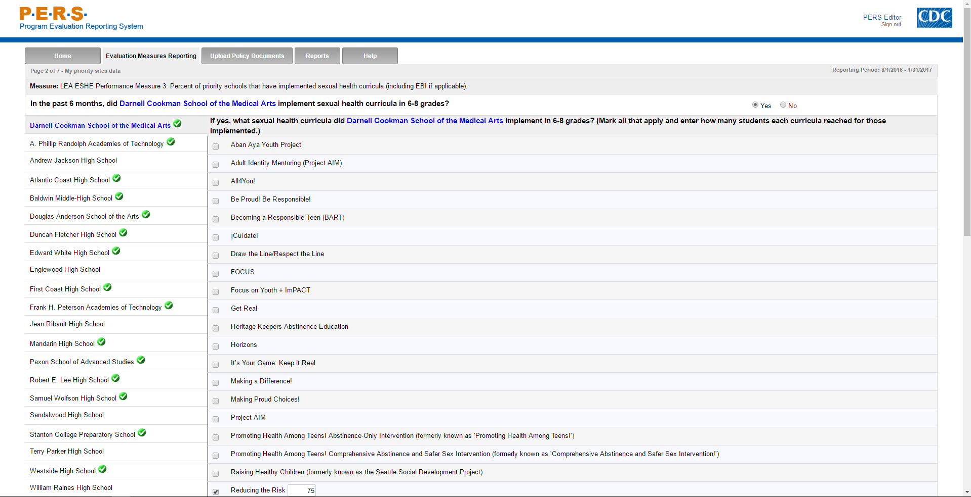
*Note: The highlighted part in the screenshot will be tailored to the Priority School Name of interest for each LEA respondent. The left-hand side of the screenshot shows where the potential Priority Schools will be listed. Each can be selected to answer this question.
**Note: As shown in the screenshot, if a respondent selects a curriculum, a box appears that allows them to enter the number of students reached for that curriculum. If the curriculum is not selected, no entry box appears.

Part B of screenshot. This screen is scrolling enabled.
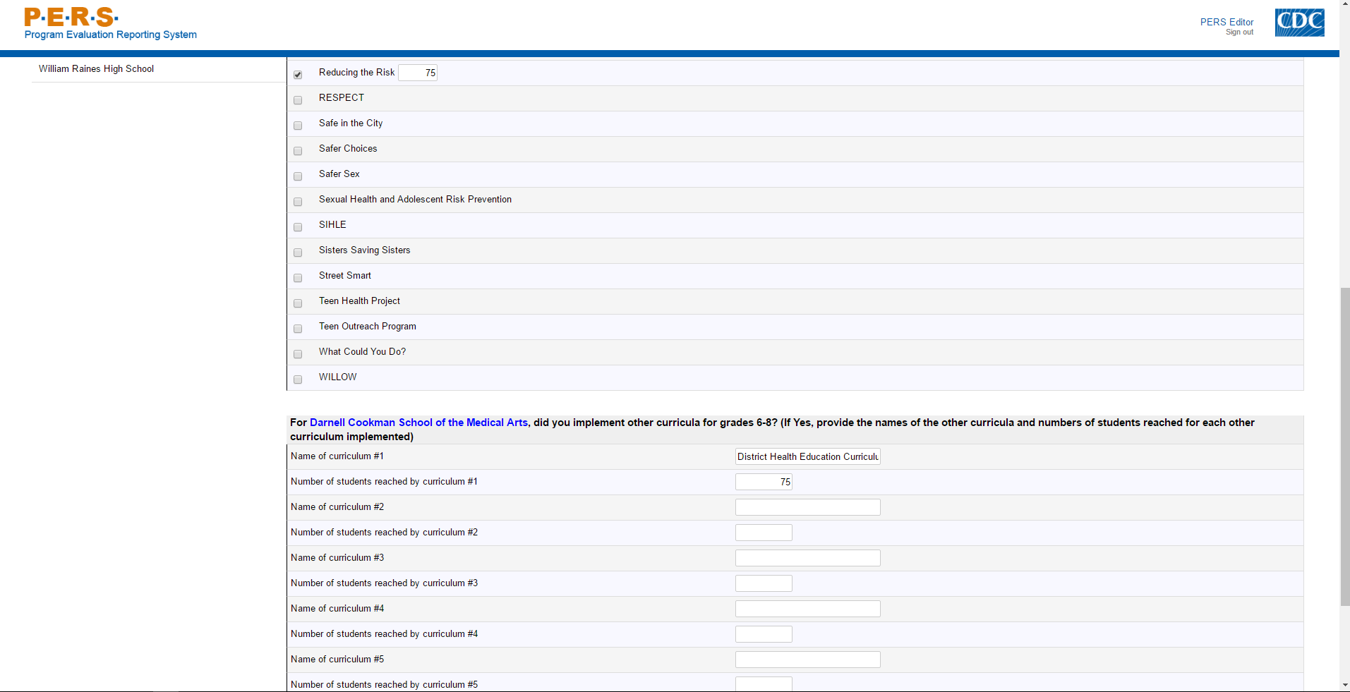
Part C of screenshot. This screen is scrolling enabled.
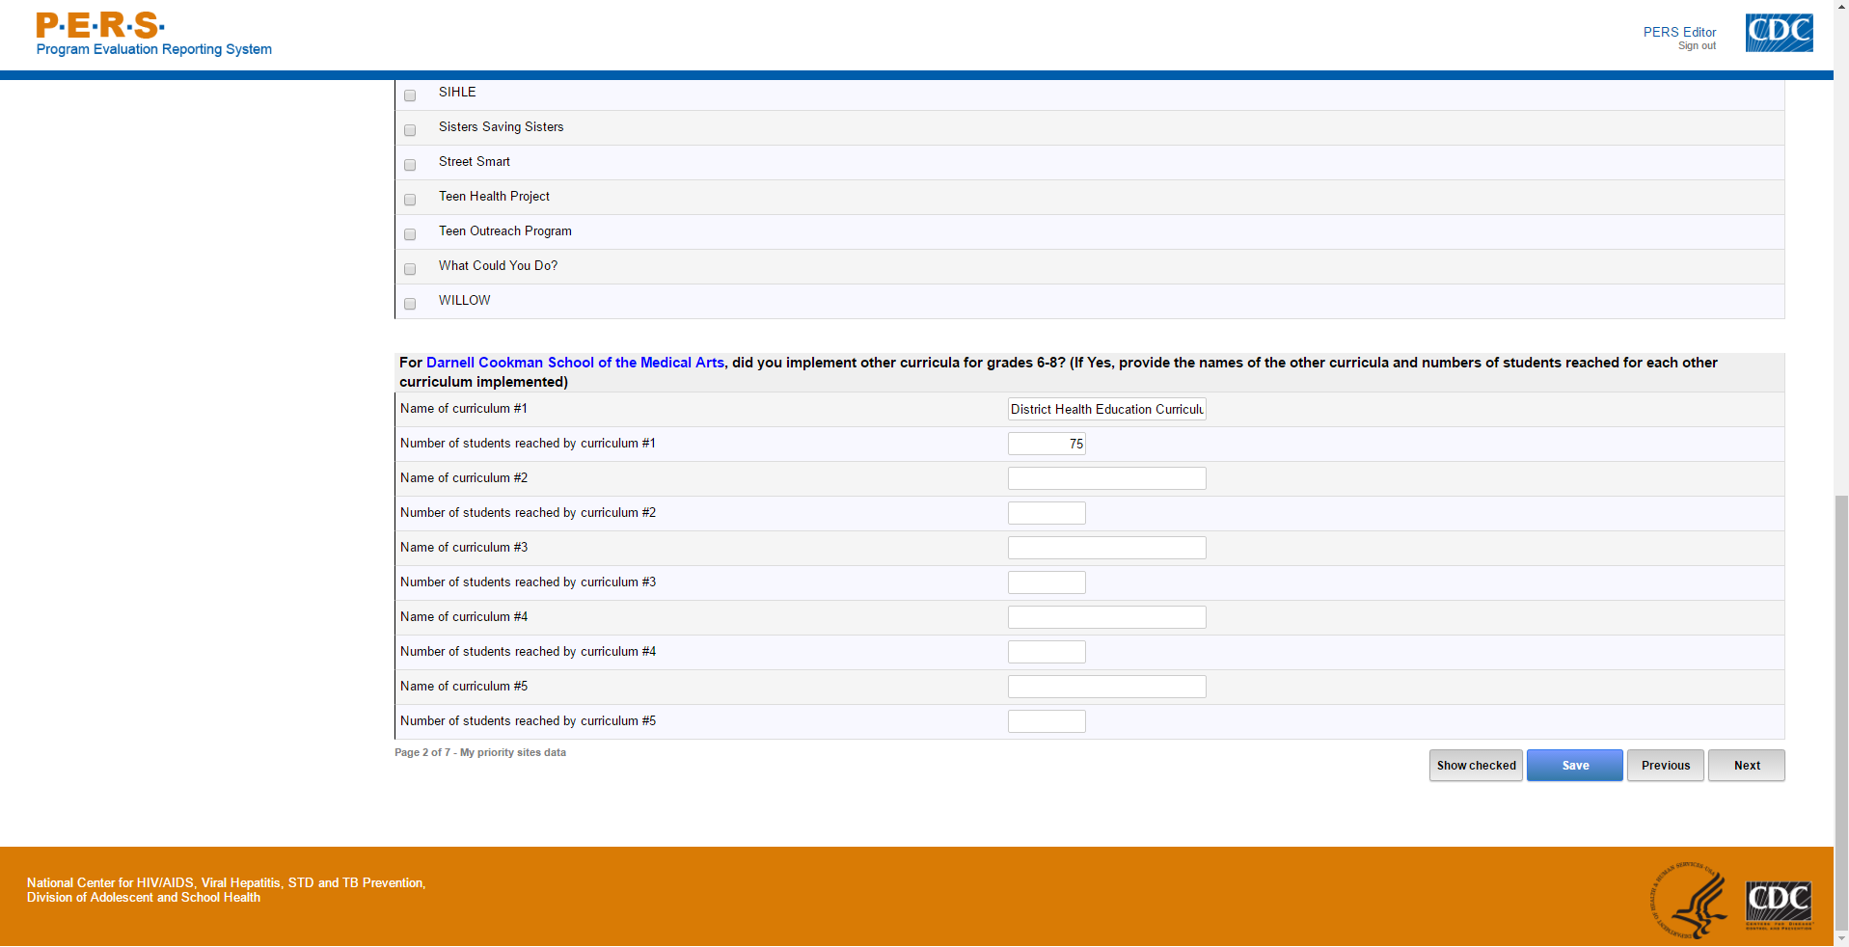

Part A of screenshot. This screen is scrolling enabled.
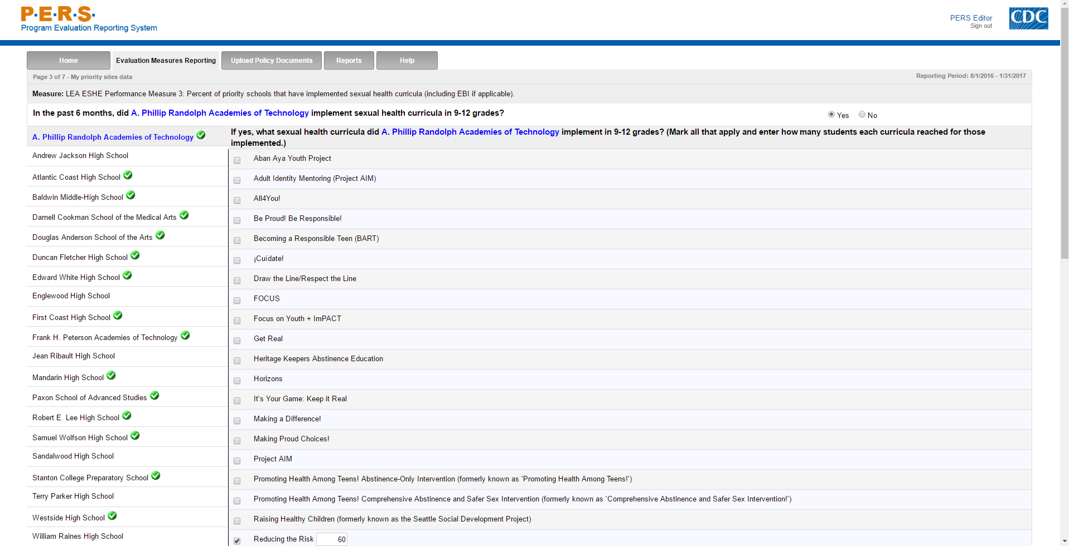
*Note: The highlighted part in the screenshot will be tailored to the Priority School Name of interest for each LEA respondent. The left-hand side of the screenshot shows where the potential Priority Schools will be listed. Each can be selected to answer this question.
**Note: As shown in the screenshot, if a respondent selects a curriculum, a box appears that allows them to enter the number of students reached for that curriculum. If the curriculum is not selected, no entry box appears.

Part B of screenshot. This screen is scrolling enabled.
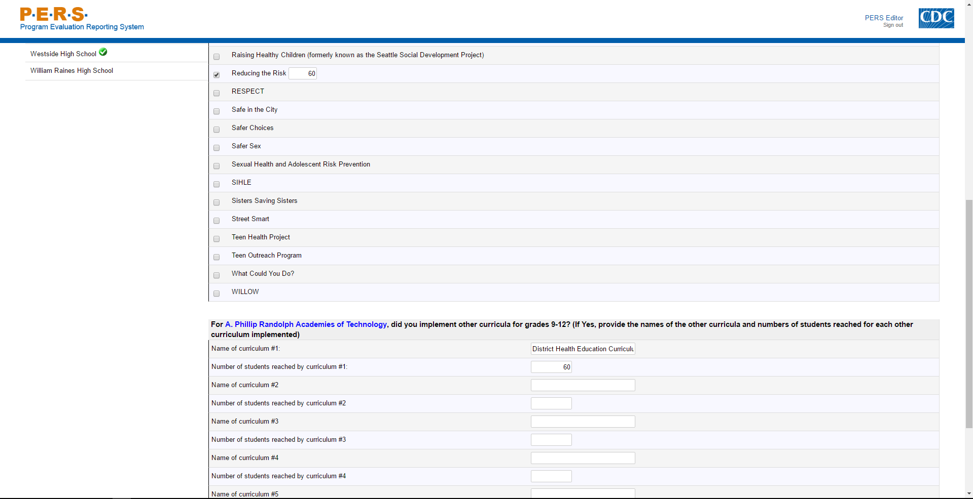
Part C of screenshot. This screen is scrolling enabled.
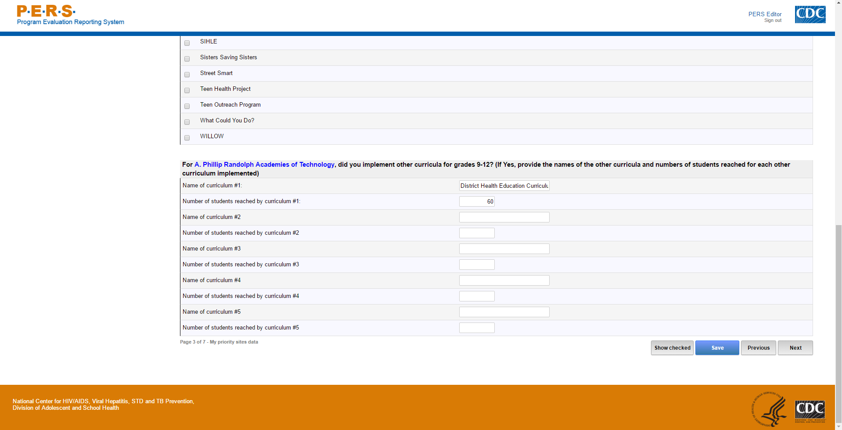

Part A of screenshot. This screen is scrolling enabled.
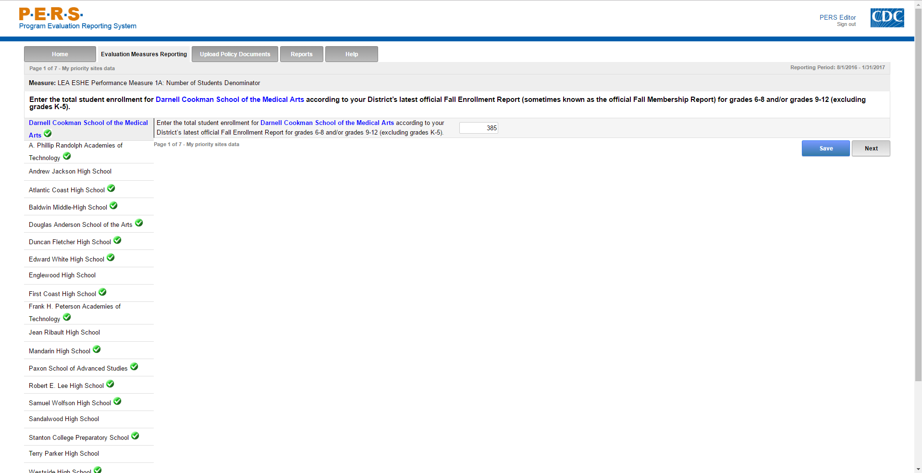
*Note: The highlighted part in the screenshot will be tailored to the Priority School Name of interest for each LEA respondent. The left-hand side of the screenshot shows where the potential Priority Schools will be listed. Each can be selected to answer this question.
Part B of screenshot. This screen is scrolling enabled.
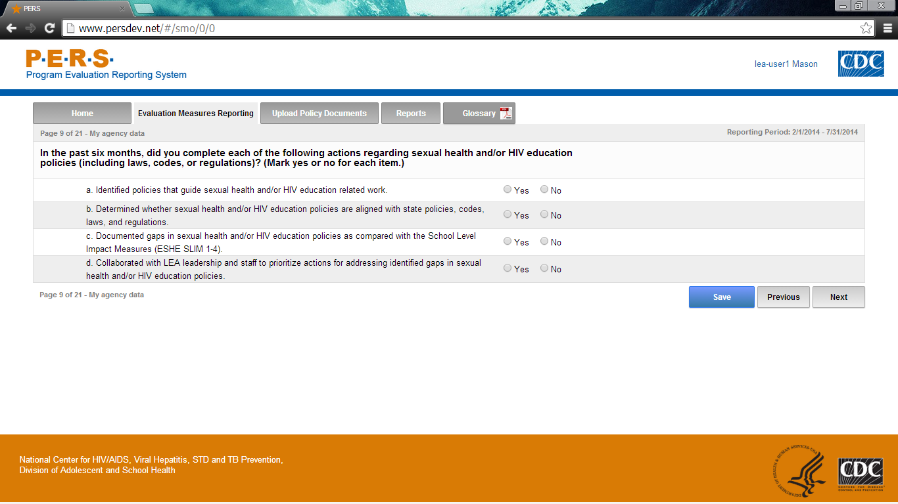

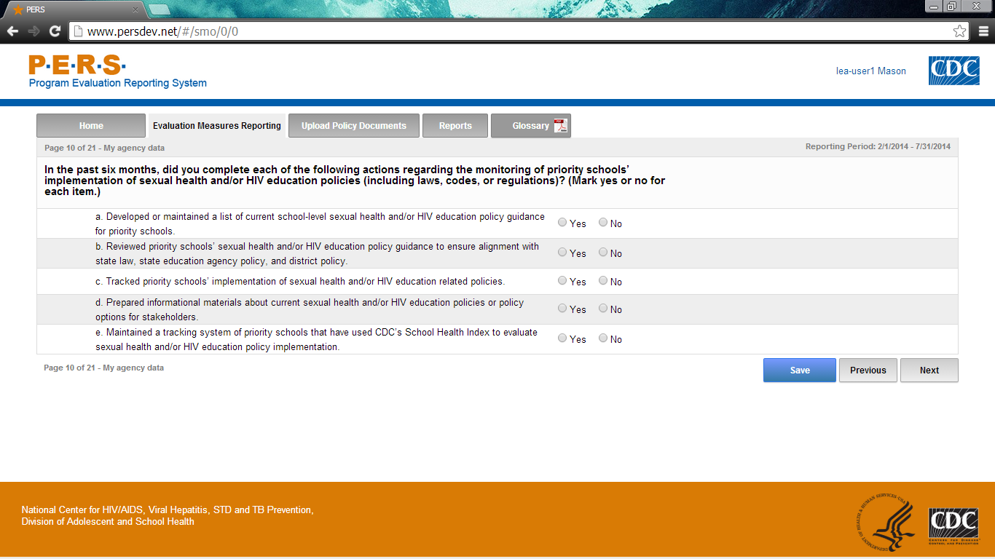

Part A of screenshot. This screen is scrolling enabled.
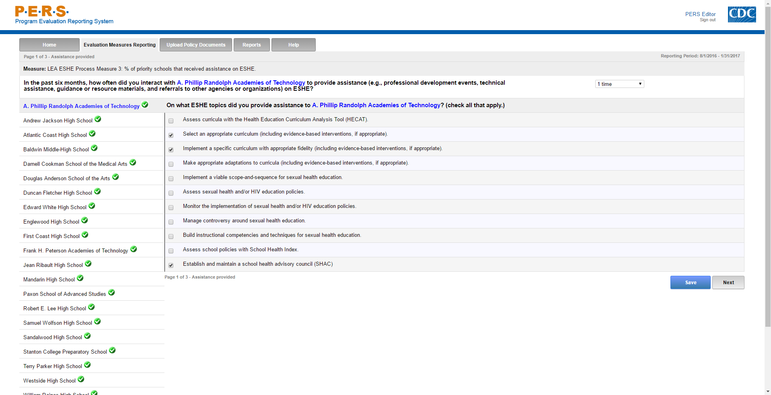
*Note: The highlighted part in the screenshot will be tailored to the Priority School Name of interest for each LEA respondent. The left-hand side of the screenshot shows where the potential Priority Schools will be listed. Each can be selected to answer this question.
Part B of screenshot. This screen is scrolling enabled.
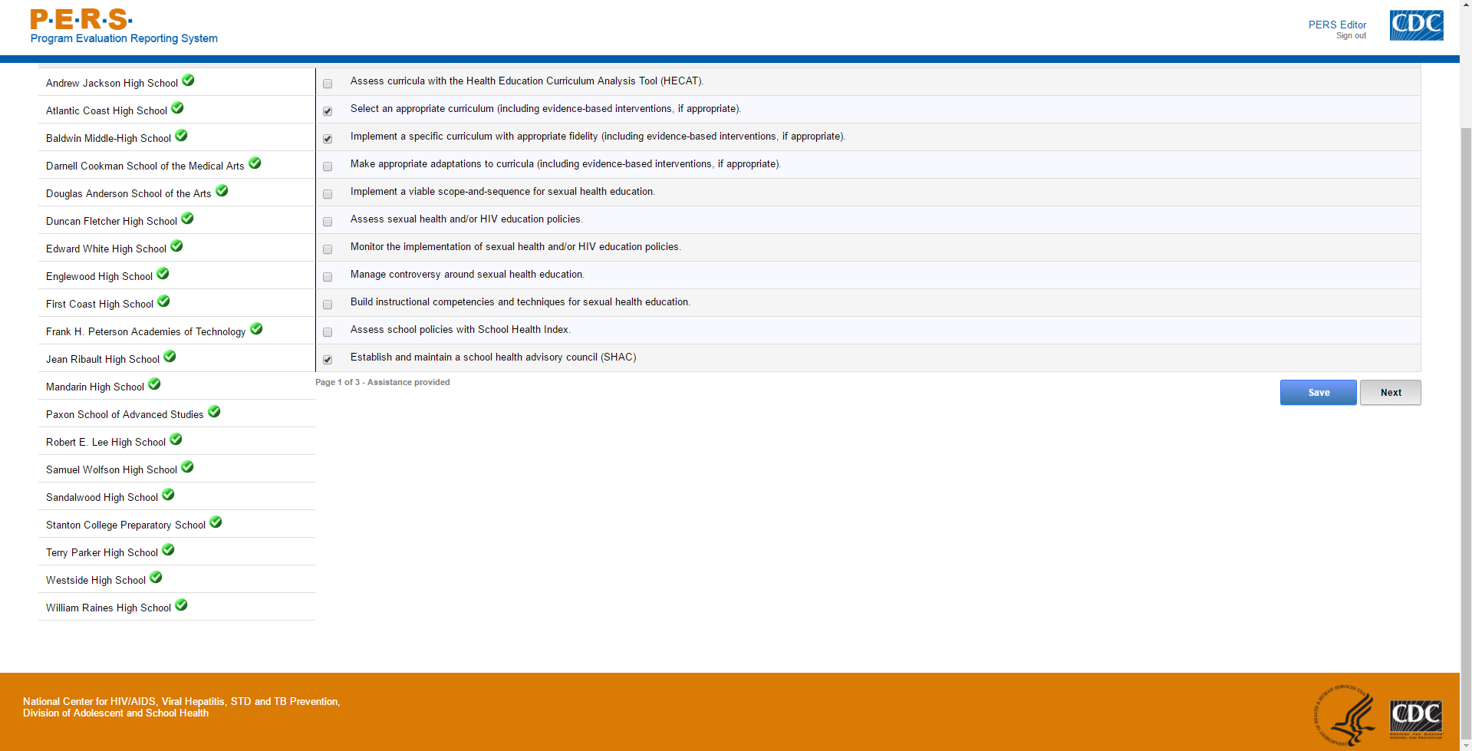
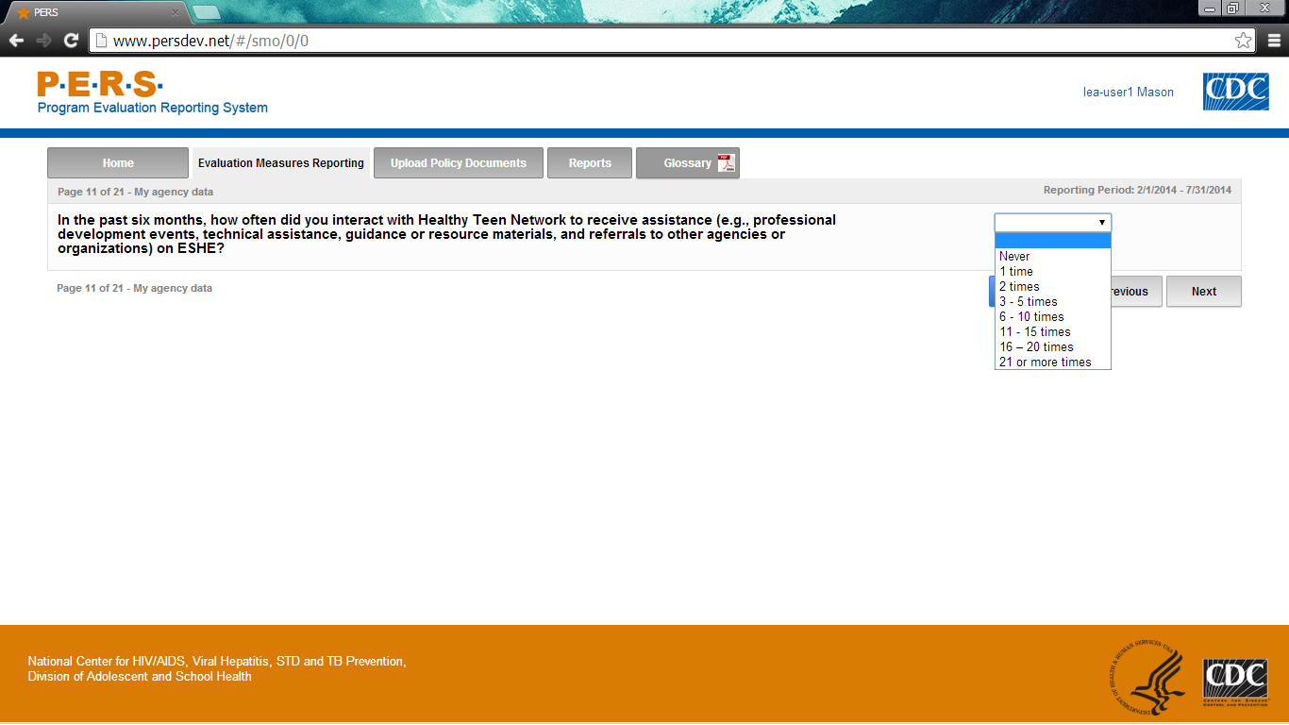

Form Approved
OMB No: 0920-1049
Exp. Date: 02/28/2018

“Promoting Adolescent Health through School-Based HIV/STD Prevention”

Att. 5b

LEA SHS Items

Public reporting burden of this collection of information is estimated to average 3 hours per response, including the time for reviewing instructions, searching existing data sources, gathering and maintaining the data needed, and completing and reviewing the collection of information. An agency may not conduct or sponsor, and a person is not required to respond to a collection of information unless it displays a currently valid OMB control number. Send comments regarding this burden estimate or any other aspect of this collection of information, including suggestions for reducing this burden to CDC/ATSDR Reports Clearance Officer; 1600 Clifton Road NE, MS D-74, Atlanta, Georgia 30333; Attn: OMB-PRA (0920-1049)

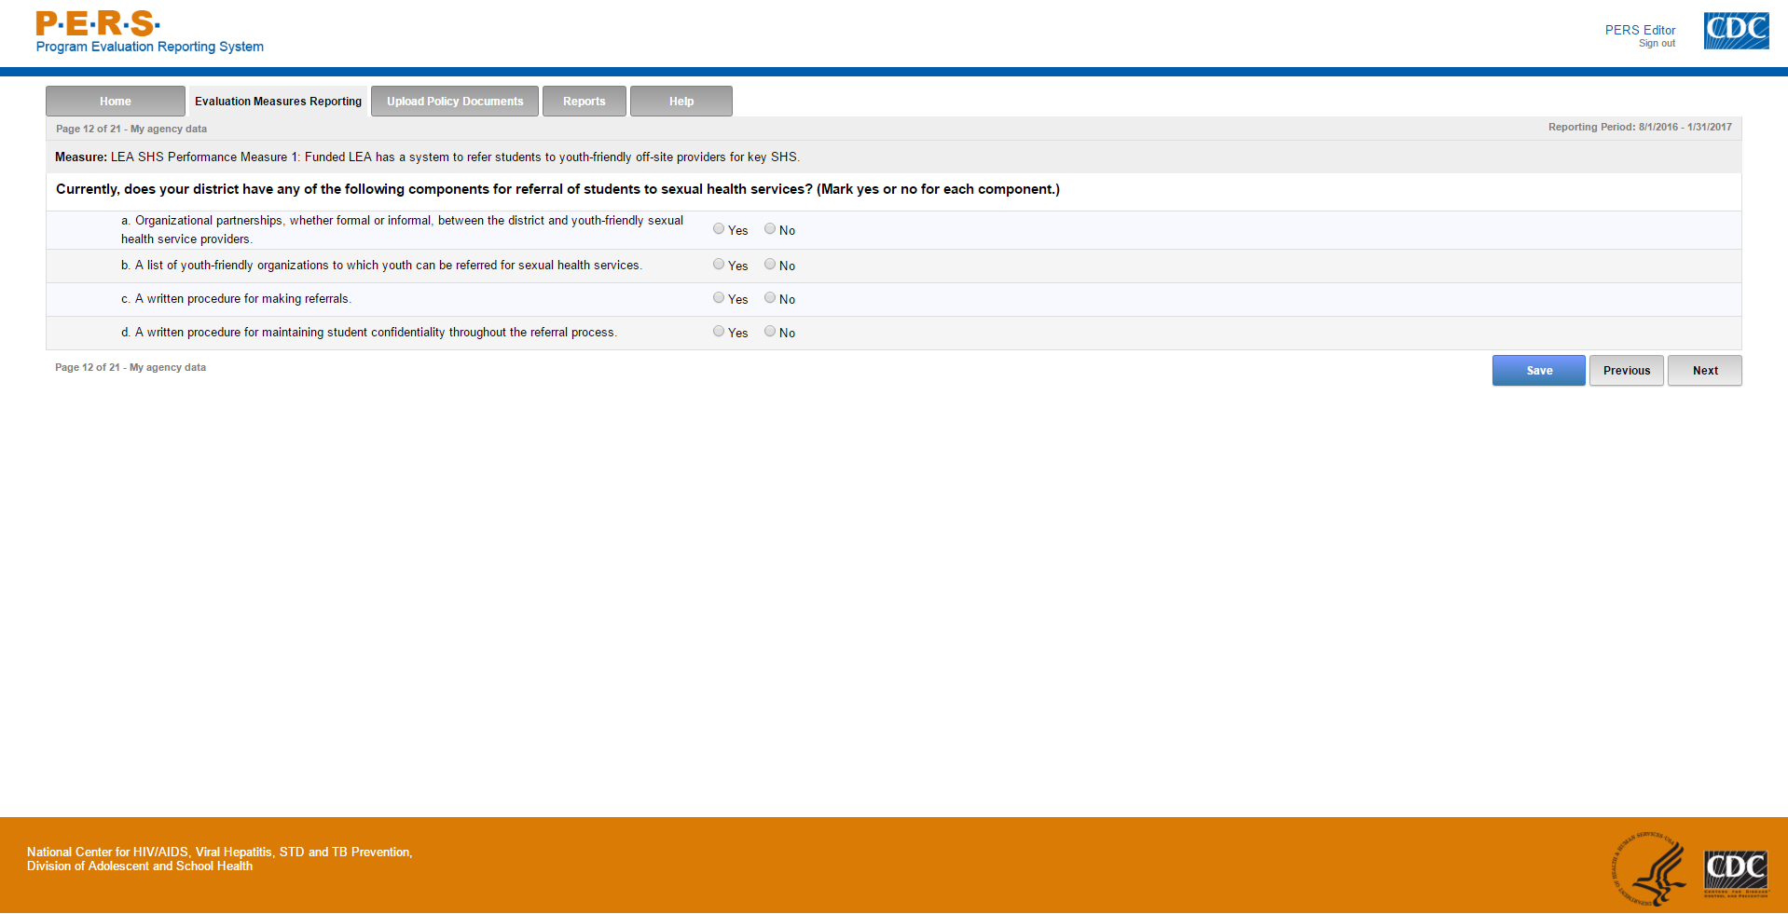

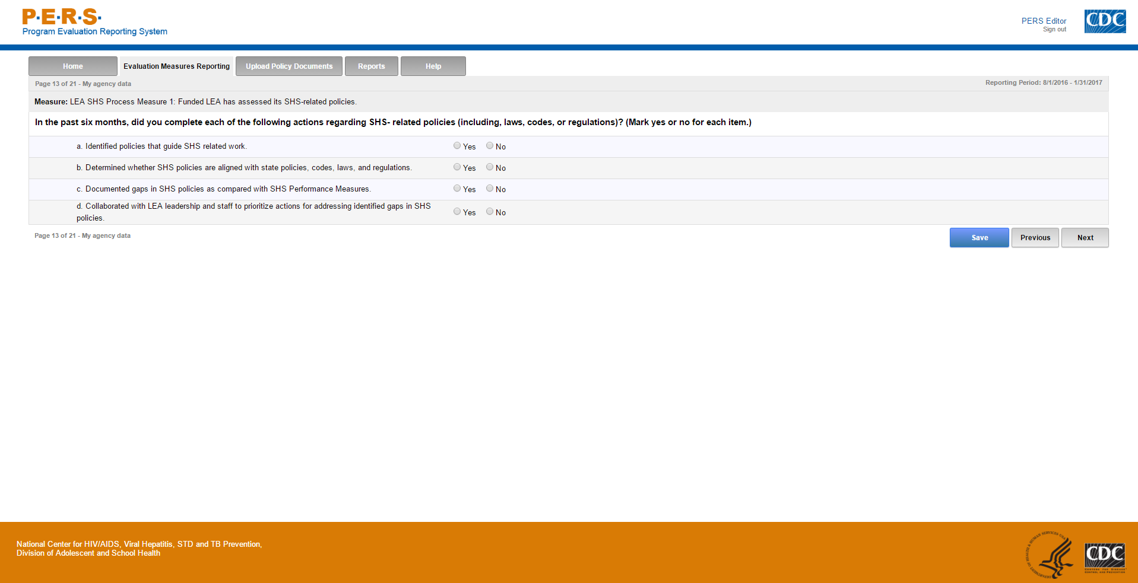

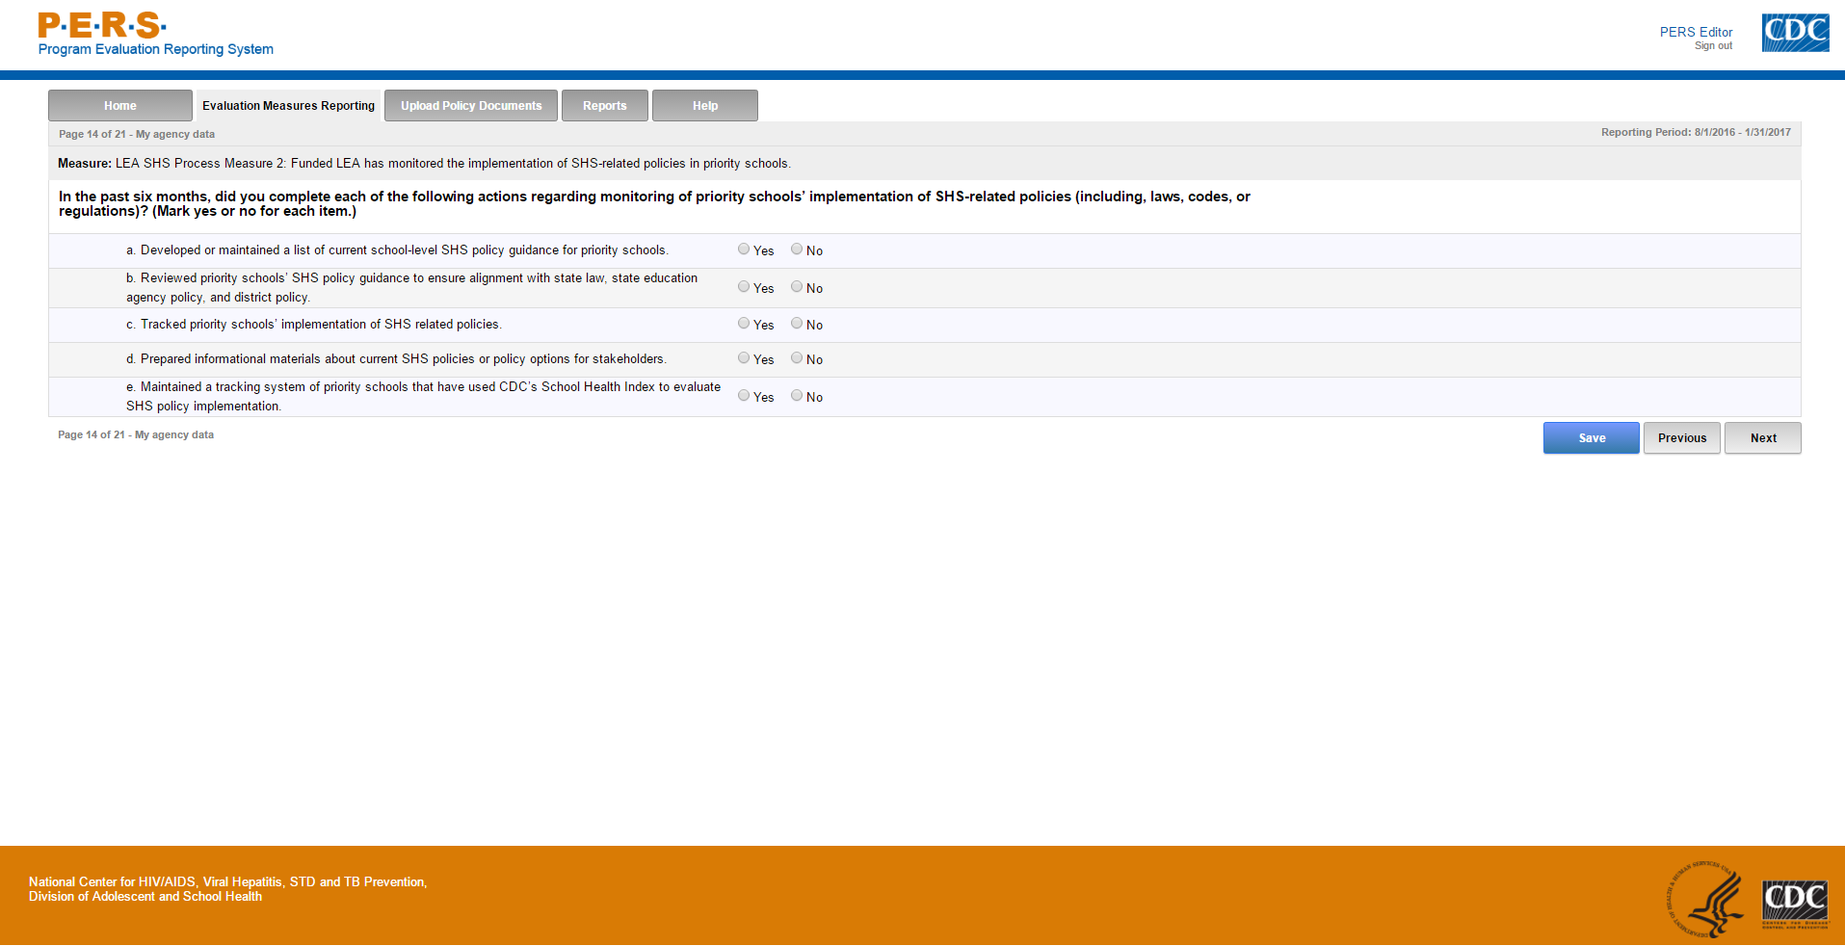
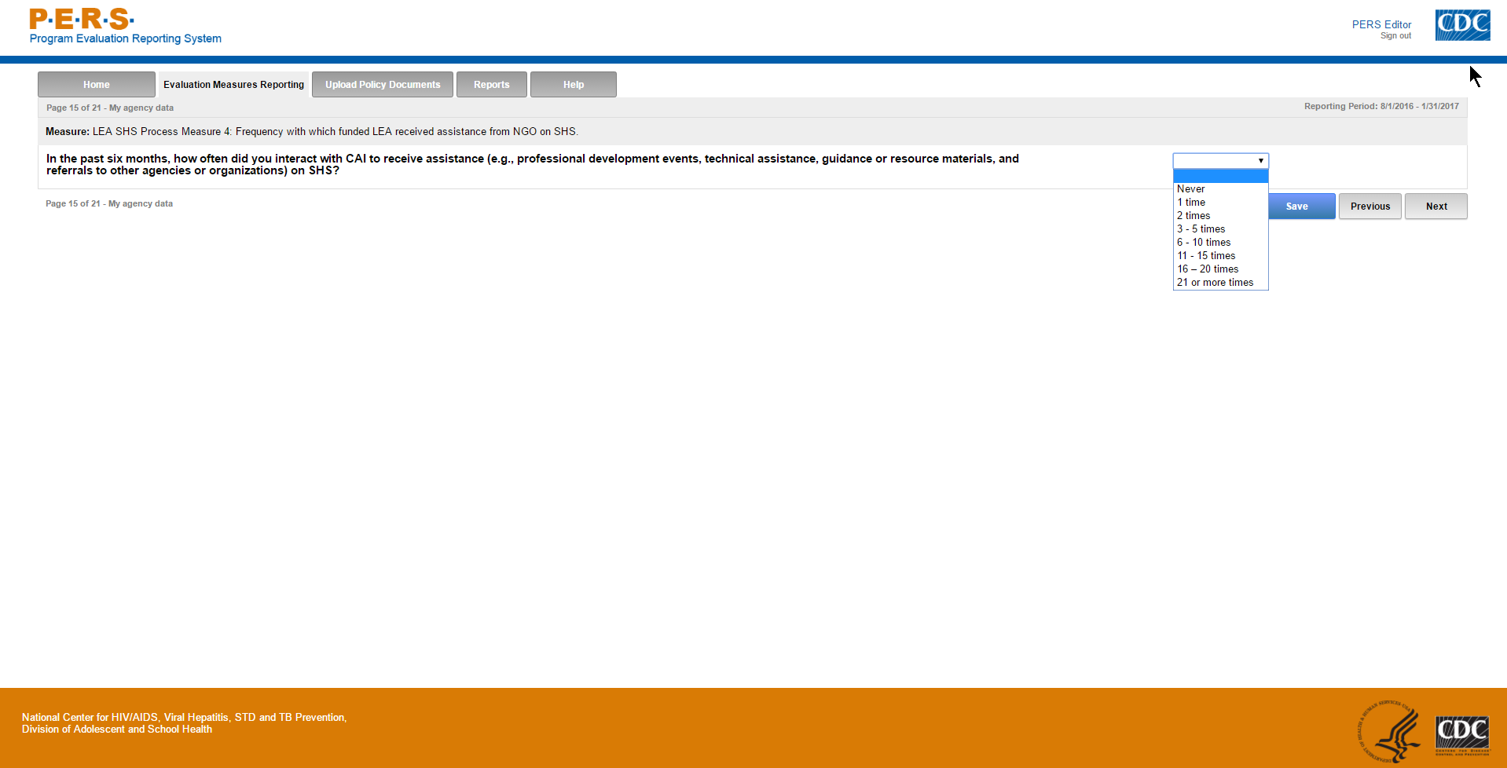
Part A of screenshot. This screen is scrolling enabled.
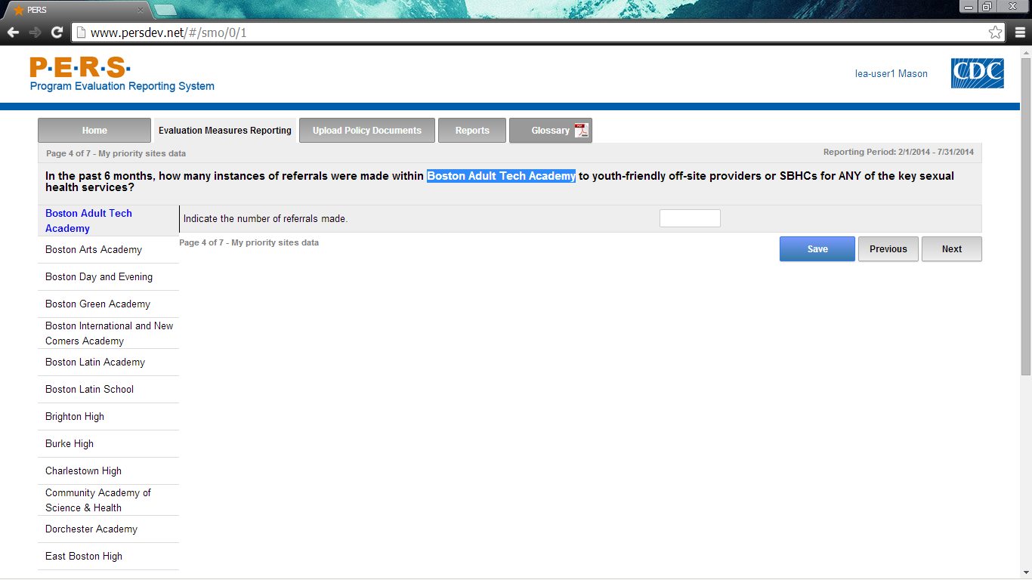*Note: The highlighted part in the screenshot will be tailored to the Priority School Name of interest for each LEA respondent. The left-hand side of the screenshot shows where the potential Priority Schools will be listed. Each can be selected to answer this question.
Part B of screenshot. This screen is scrolling enabled.
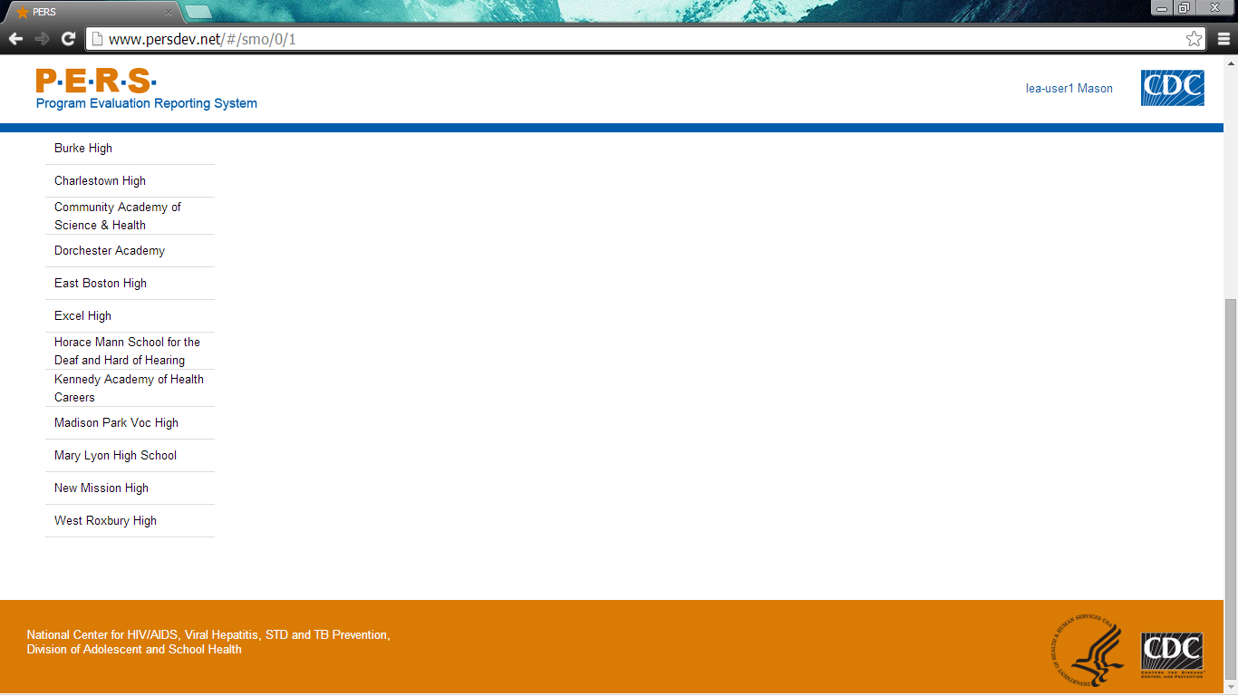
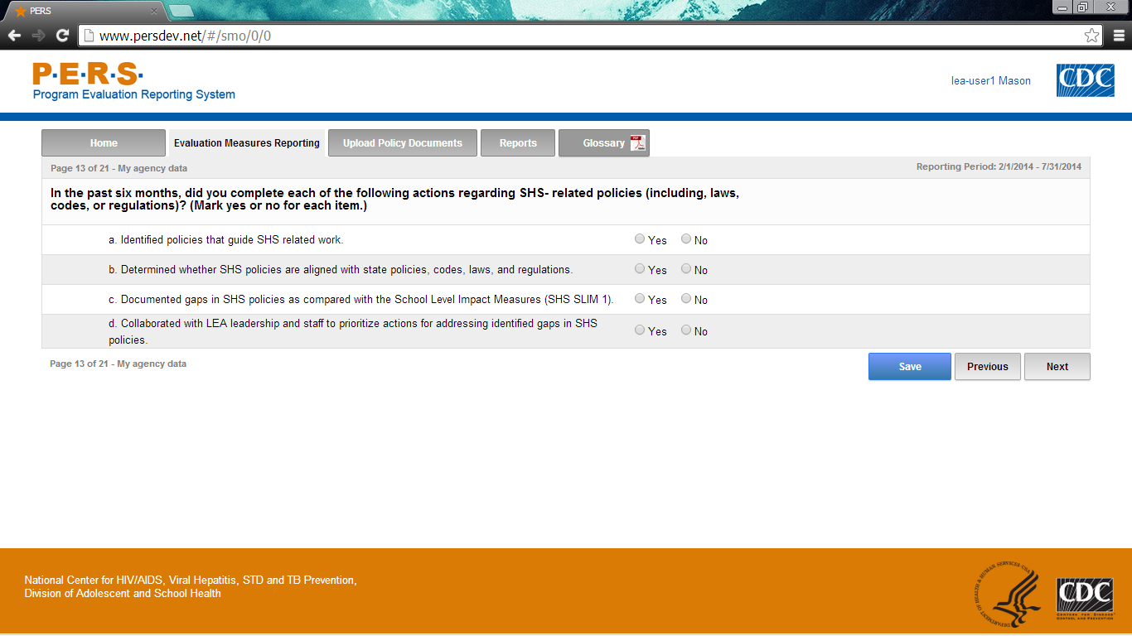

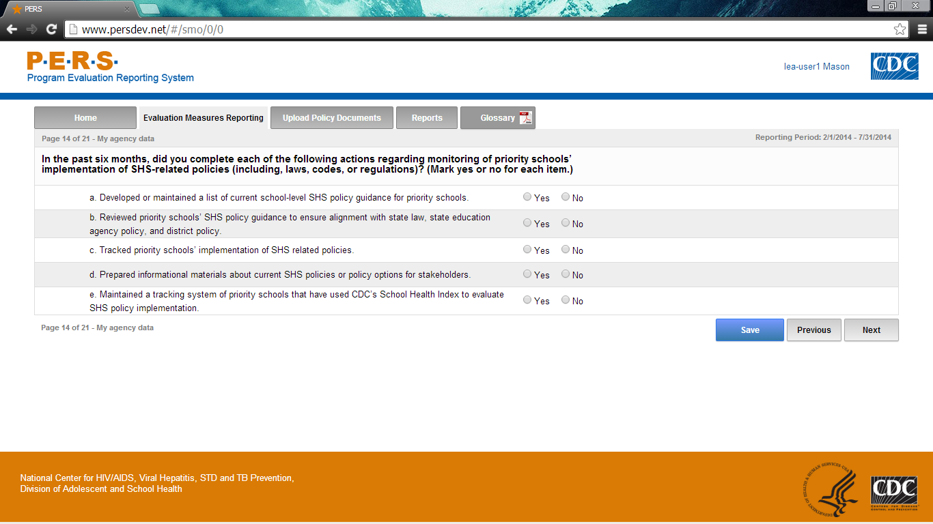

Part A of screenshot. This screen is scrolling enabled.
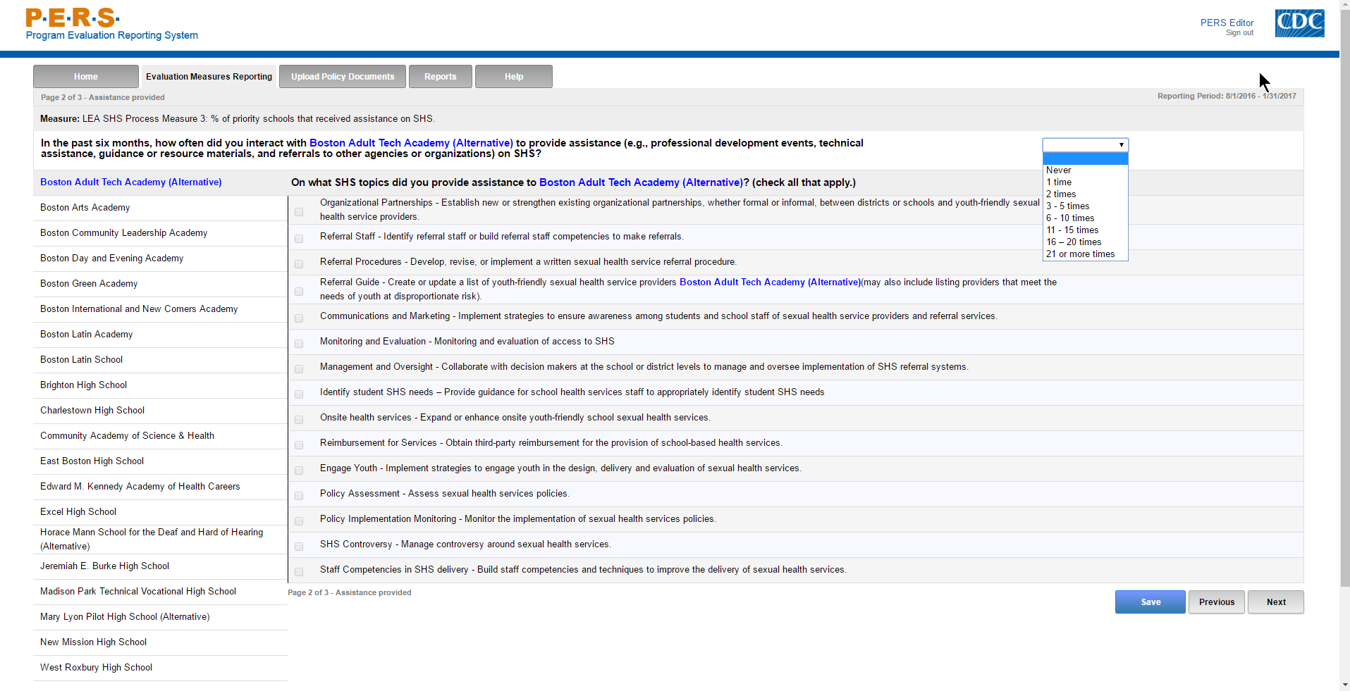
*Note: The highlighted part in the screenshot will be tailored to the Priority School Name of interest for each LEA respondent. The left-hand side of the screenshot shows where the potential Priority Schools will be listed. Each can be selected to answer this question.
Part B of screenshot. This screen is scrolling enabled.
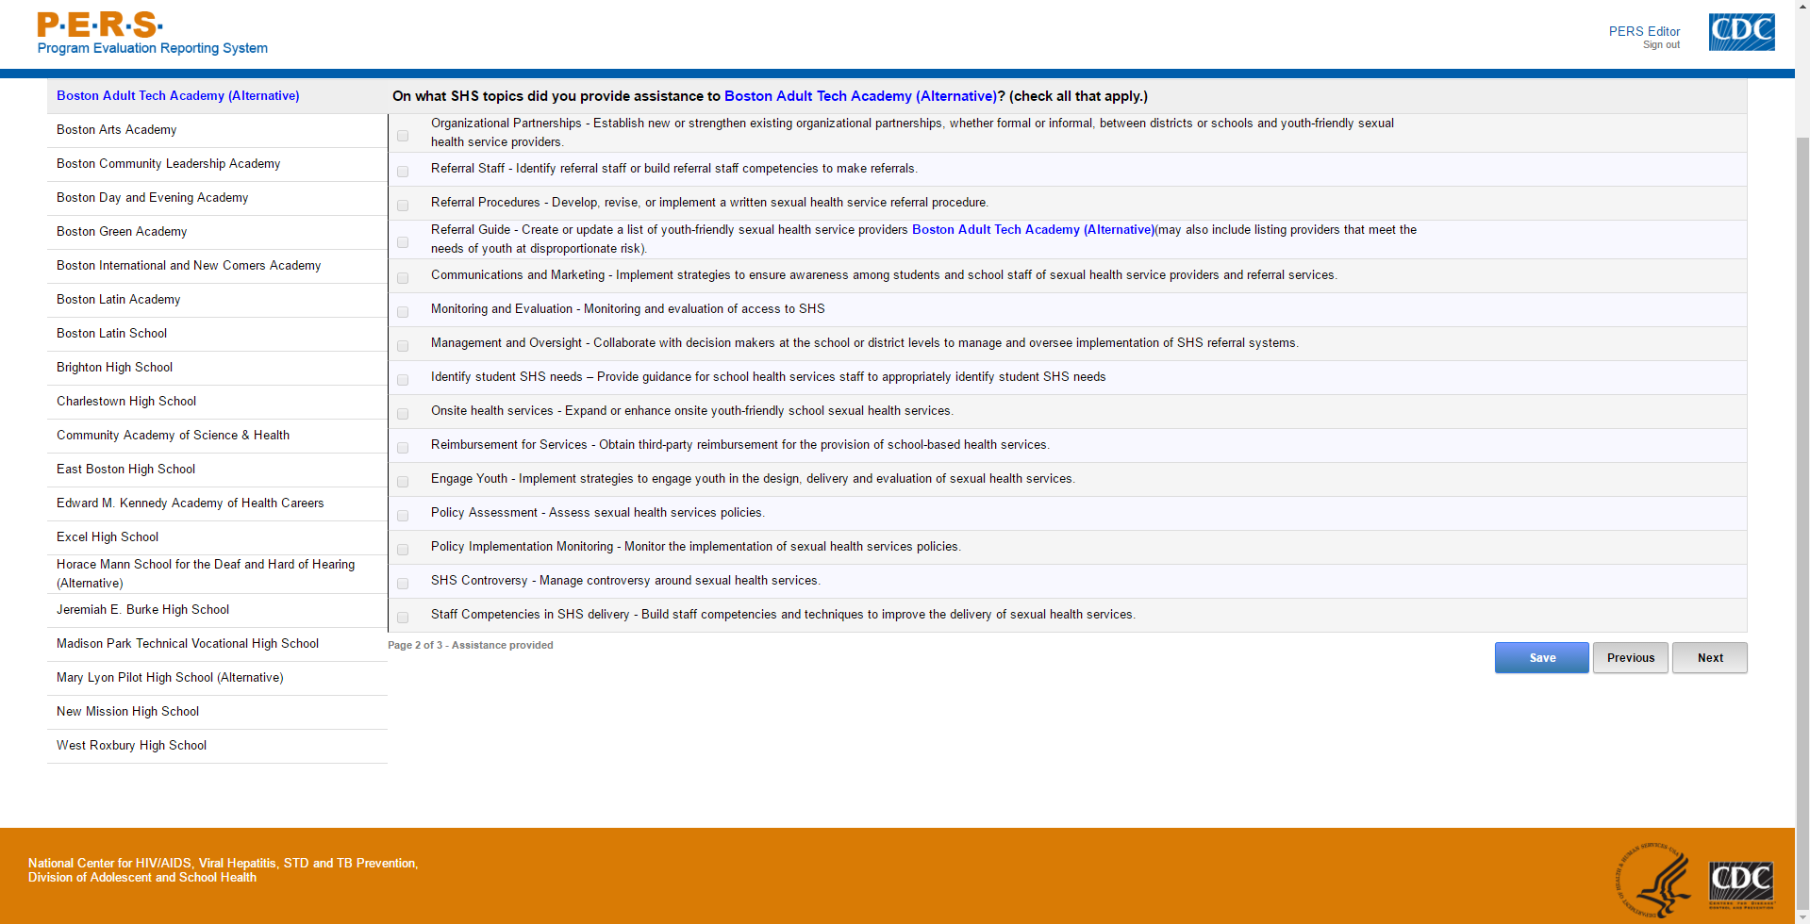
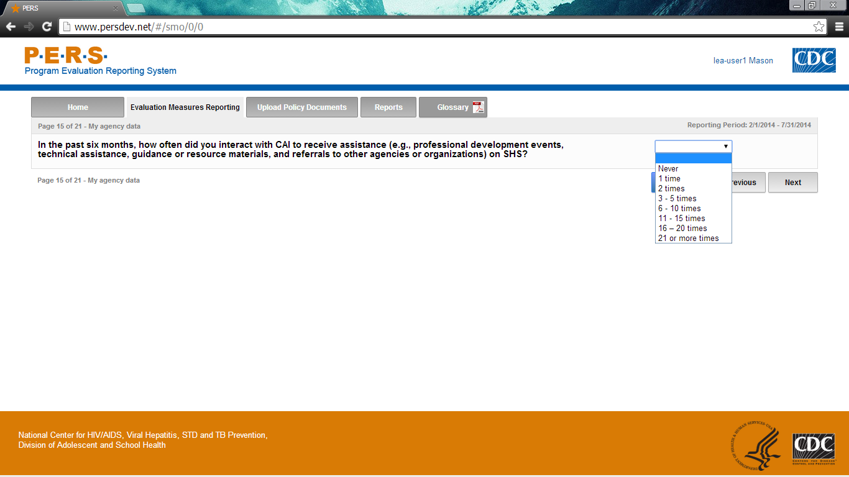

Form Approved
OMB No: 0920-1049
Exp. Date: 02/28/2018

“Promoting Adolescent Health through School-Based HIV/STD Prevention”

Att. 5a

LEA SSE Items

Public reporting burden of this collection of information is estimated to average 6 hours per response, including the time for reviewing instructions, searching existing data sources, gathering and maintaining the data needed, and completing and reviewing the collection of information. An agency may not conduct or sponsor, and a person is not required to respond to a collection of information unless it displays a currently valid OMB control number. Send comments regarding this burden estimate or any other aspect of this collection of information, including suggestions for reducing this burden to CDC/ATSDR Reports Clearance Officer; 1600 Clifton Road NE, MS D-74, Atlanta, Georgia 30333; Attn: OMB-PRA (0920-1049)

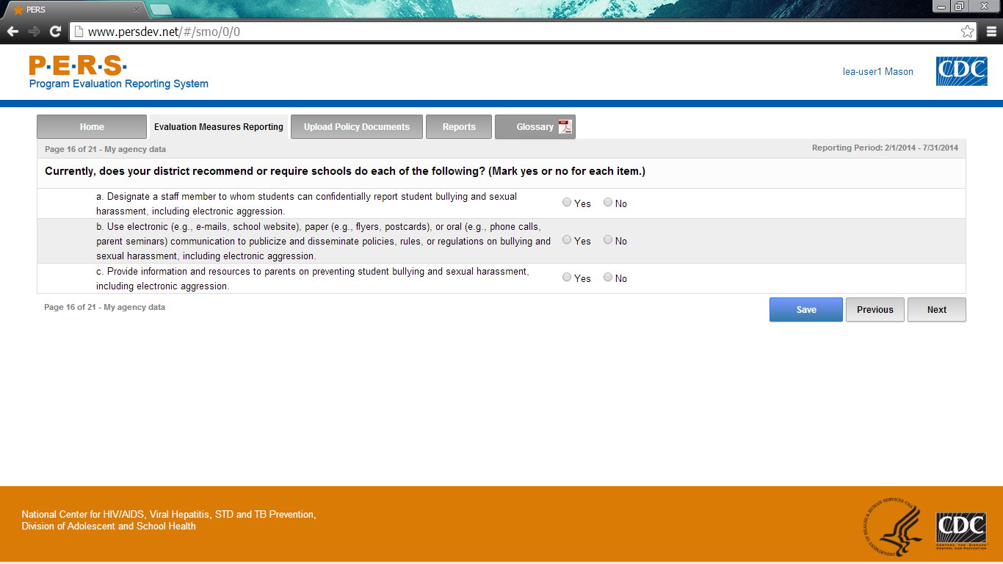
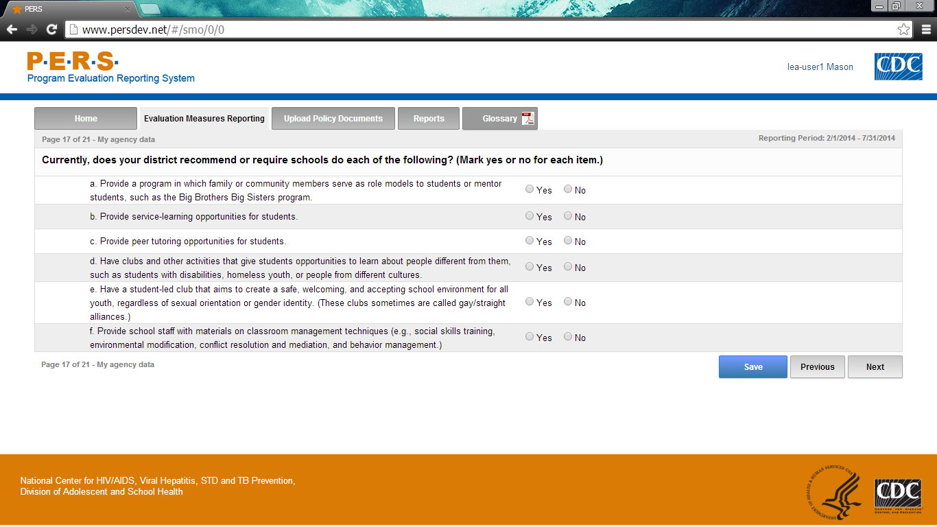

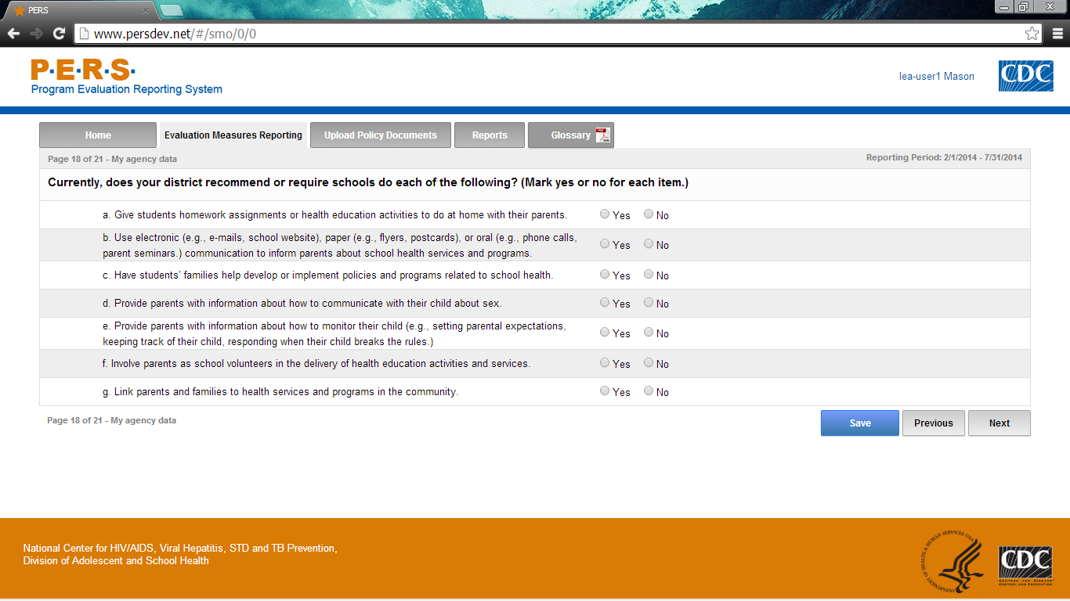
Part A of screenshot. This screen is scrolling enabled.
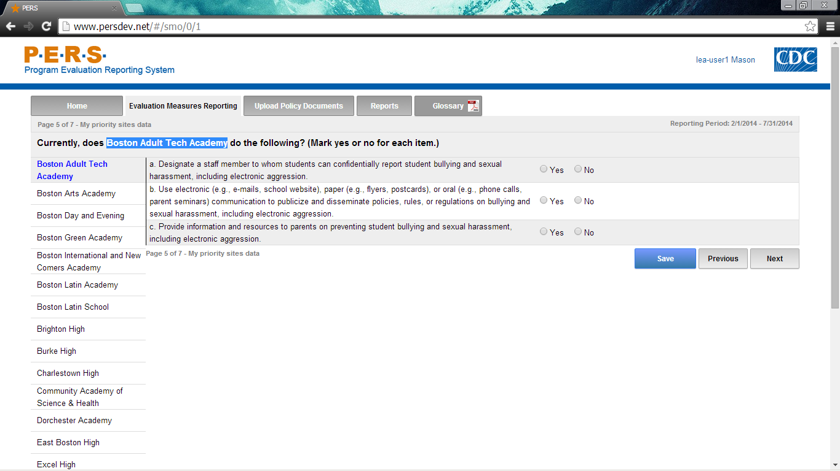
*Note: The highlighted part in the screenshot will be tailored to the Priority School Name of interest for each LEA respondent. The left-hand side of the screenshot shows where the potential Priority Schools will be listed. Each can be selected to answer this question.
Part B of screenshot. This screen is scrolling enabled.
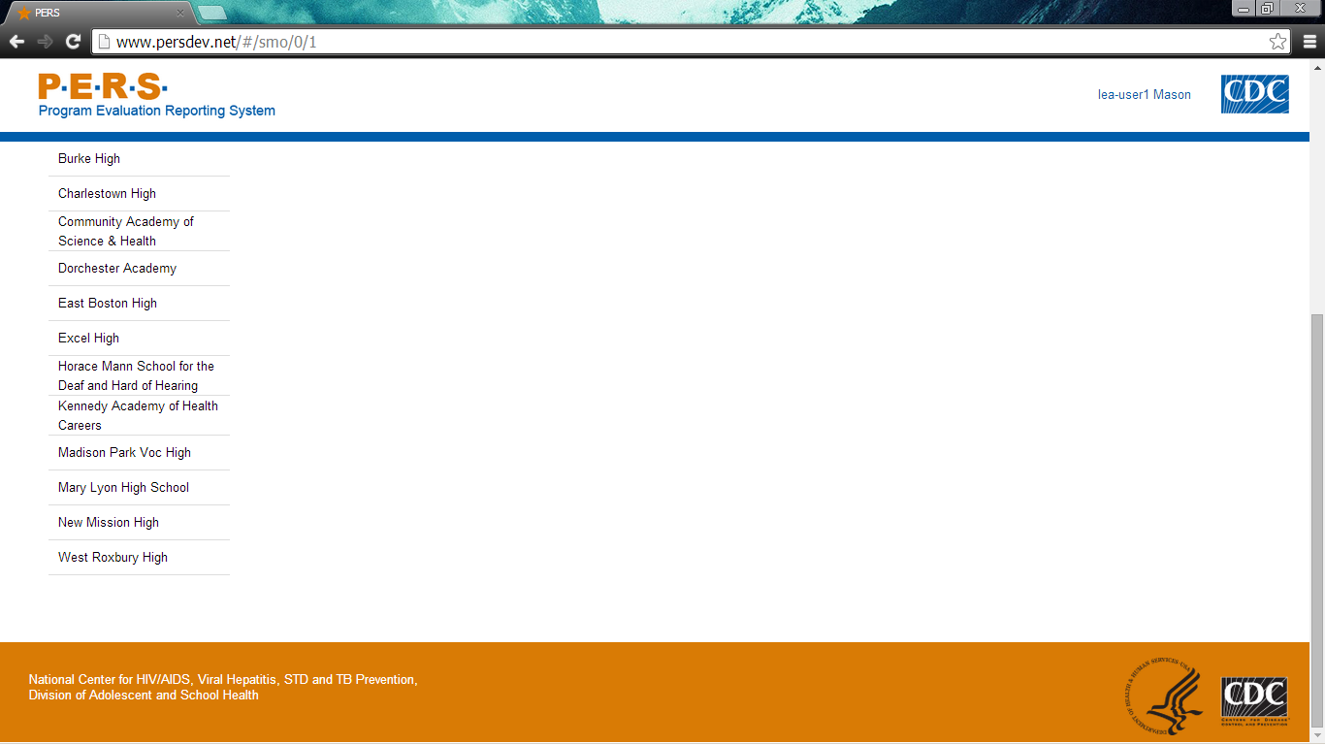
Part A of screenshot. This screen is scrolling enabled.
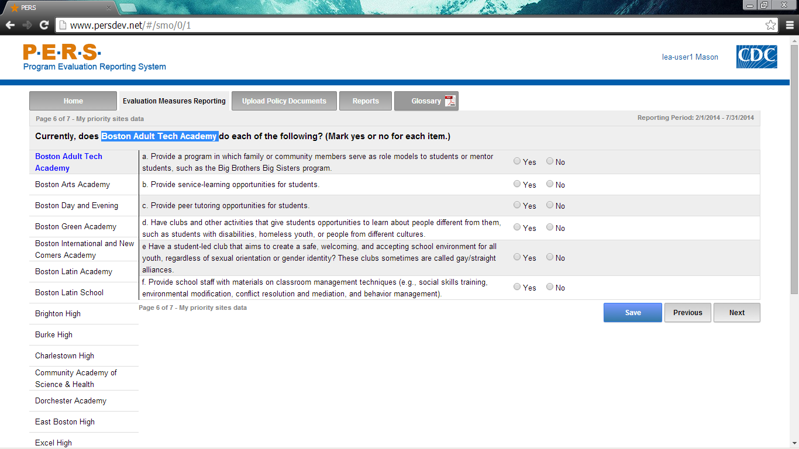
*Note: The highlighted part in the screenshot will be tailored to the Priority School Name of interest for each LEA respondent. The left-hand side of the screenshot shows where the potential Priority Schools will be listed. Each can be selected to answer this question.
Part B of screenshot. This screen is scrolling enabled.
Part A of screenshot. This screen is scrolling enabled.
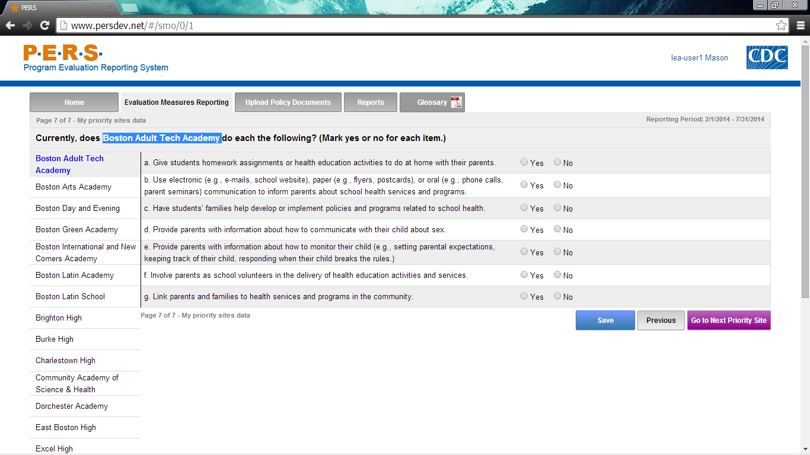
*Note: The highlighted part in the screenshot will be tailored to the Priority School Name of interest for each LEA respondent. The left-hand side of the screenshot shows where the potential Priority Schools will be listed. Each can be selected to answer this question.
Part B of screenshot. This screen is scrolling enabled.
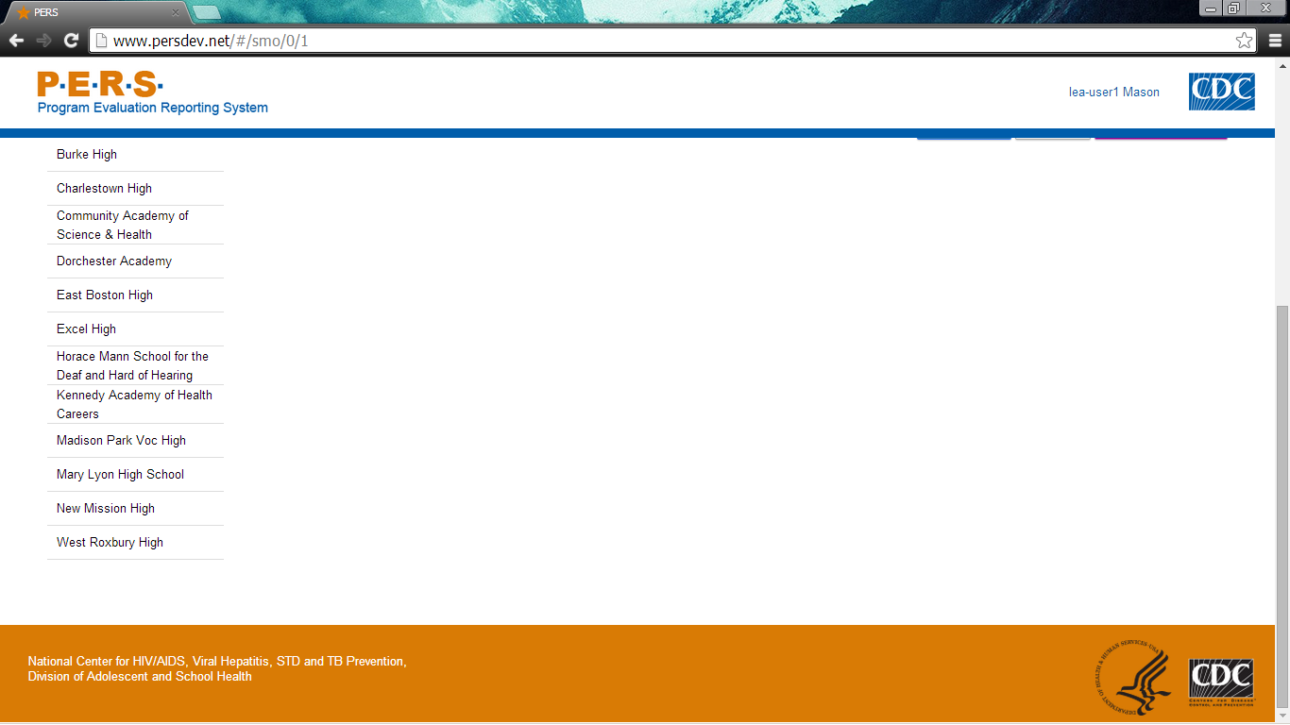

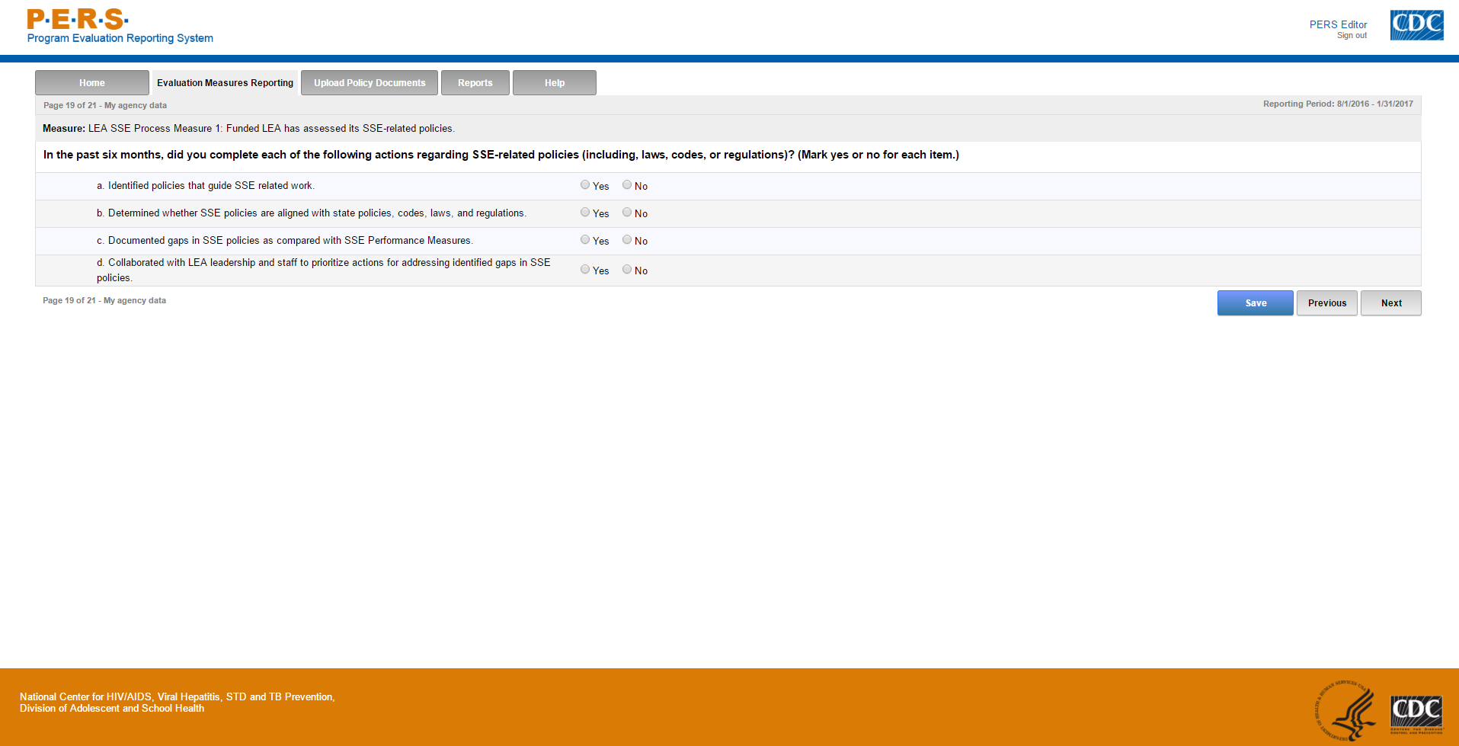
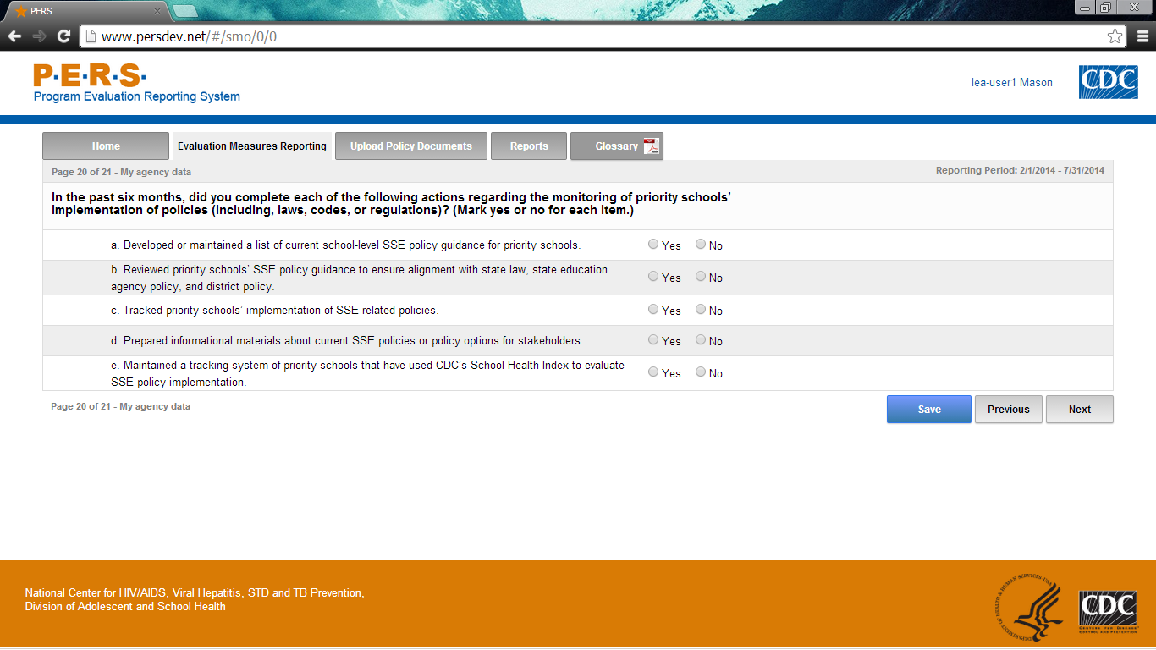
Part A of screenshot. This screen is scrolling enabled.
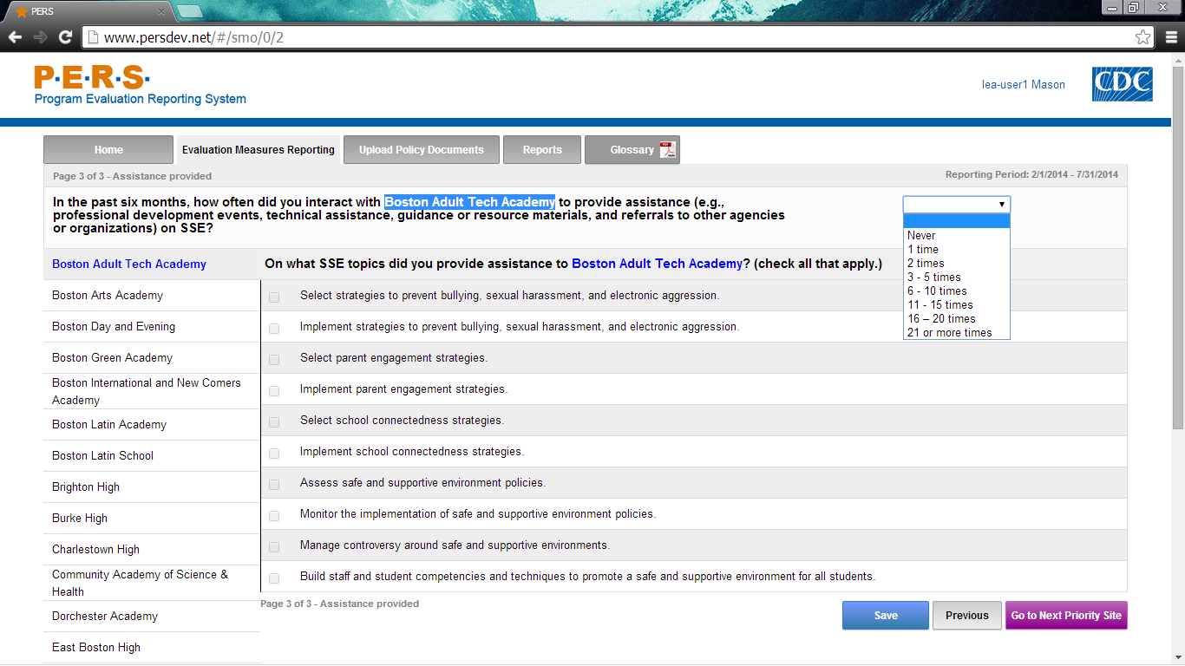
*Note: The highlighted part in the screenshot will be tailored to the Priority School Name of interest for each LEA respondent. The left-hand side of the screenshot shows where the potential Priority Schools will be listed. Each can be selected to answer this question.
Part B of screenshot. This screen is scrolling enabled.
