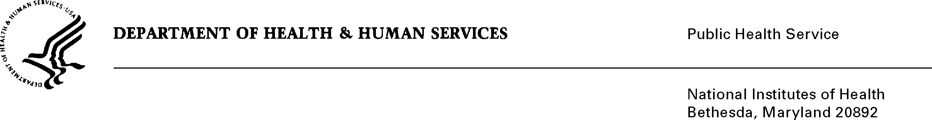

DATE: March 28, 2014

TO: Joanne Demchok, Director
Cancer Diagnosis Program, Division of Cancer Treatment and Diagnosis
National Cancer Institute

FROM: NIH Privacy Act Officer

SUBJECT: Applicability of the Privacy Act: Specimen Resource Locator (SRL)

I have reviewed the NCI submission to OMB to use the SRL database to increase its knowledge of cancer biology, and translate important research discoveries to clinical application.

The SRL will catalogue NCI’s specimen resources. The database will allow NCI and scientists in the research community to search and locate specimens needed for research. It will list all NCI-supported specimen repositories and a link to those repositories that can be shared with the scientific community. The information collected from participating resources (i.e., cooperative groups, networks, consortiums, universities, and projects) will be used to characterize the inventory and allow scientists to query the SRL database by category, to retrieve the bio specimens and annotations that may be needed for research:

- Specimen Type: tissue, blood, DNS, RNA and more
- Preservation Method: Formalin-fixed Paraffin-embedded
- Tumor Type: carcinoma, malignant tumor, sarcoma
- Annotation Type: demography, risk factor, treatment, family history
- Organization: academia, commercial, non-profit
- Number of specimens
- Collection Type: cancer clinical trial, collaboration, NIH/NCI

I have determined the Privacy Act will not apply to this information collection. The name and contact information of the specimen resource company/institution participants will be collected via a short, online information form. The form will facilitate the entry of specimen resource information while creating a comprehensive database for the SRL. Meta data will be collected to describe the specimen collections. However, no individual level data will be collected.

If you have any questions, please contact my office at (301) 402-6201.

Karen M. Plá

cc: Vivian Horovitch-Kelley, NCI PRA Liaison

