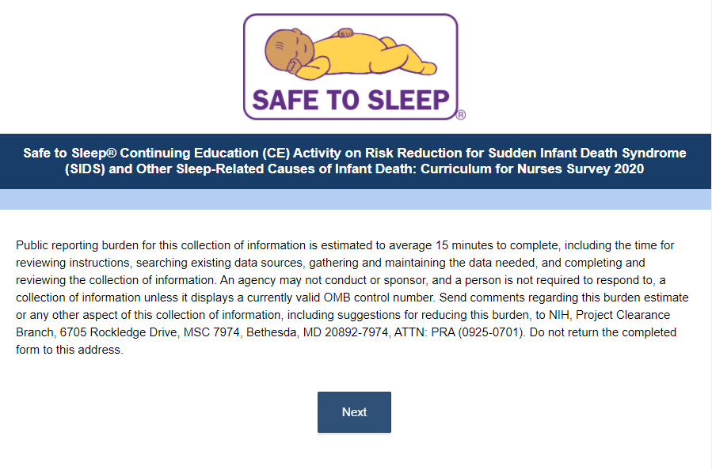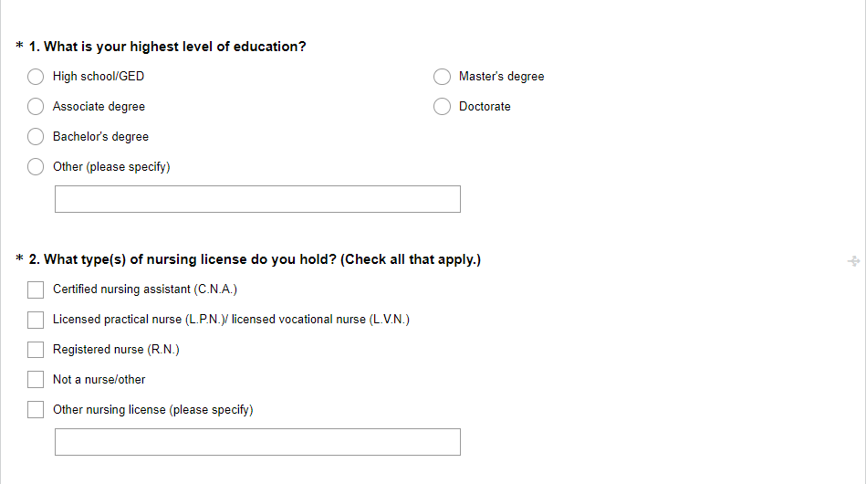
*If “Not a nurse/other” is selected the participant skips to Question 5.
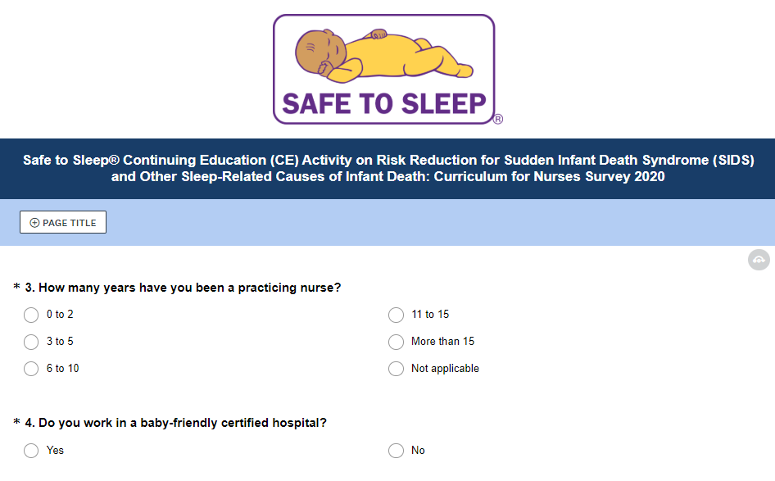
*If “Not a nurse/other” was selected in Question 2, Questions 3 and 4 are skipped
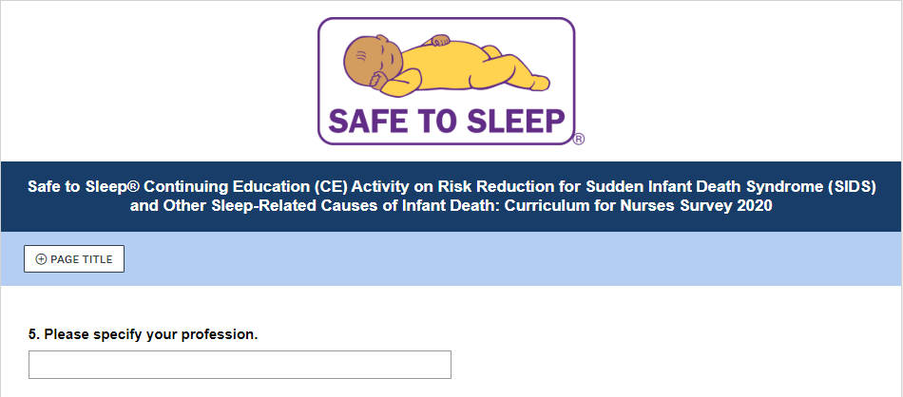
*This question only appears if “Not a nurse/other” is selected in Question 2.

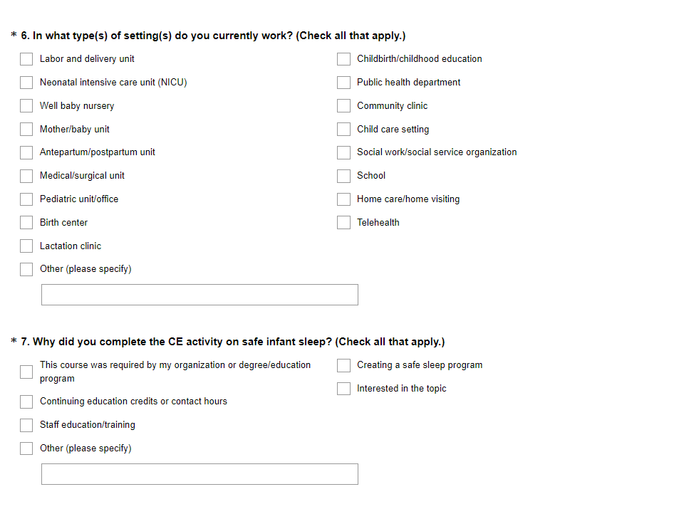*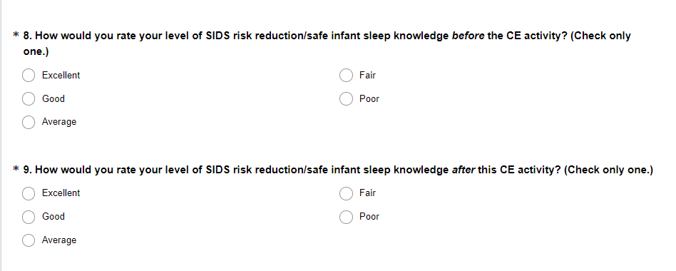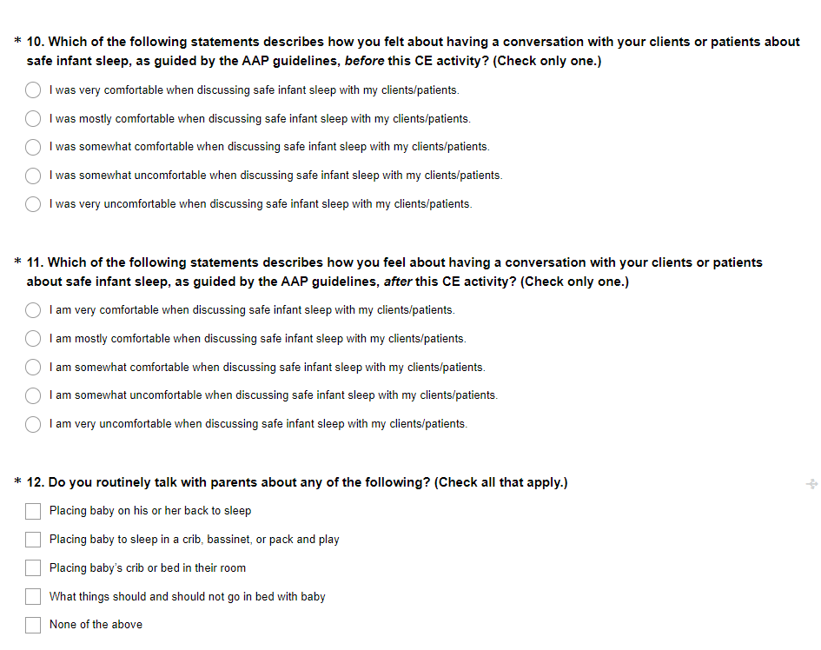
*If any answer other than “None of the above” is selected, the participant skips to Question 14.
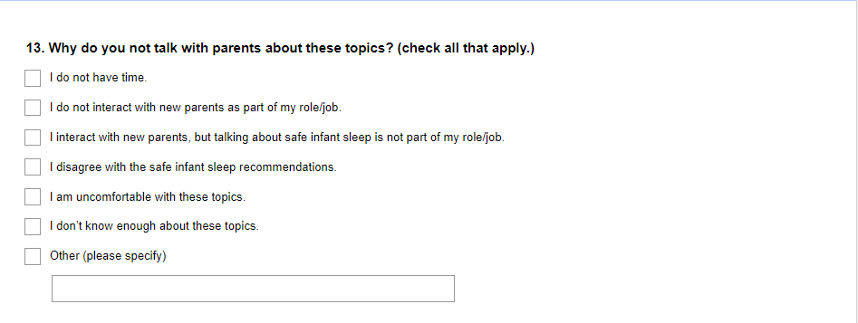
*This question is only displayed if the participant selects “None of the above” in question 12.
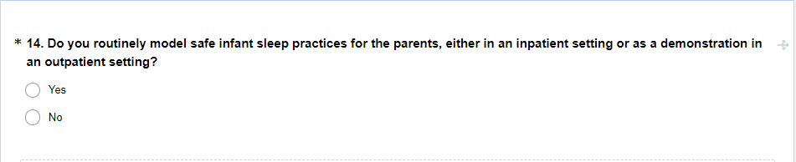
*If “Yes” is selected, the participant skips to Question 16. 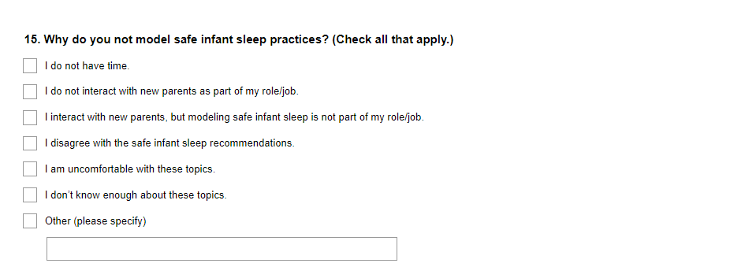
*This question is only displayed if the participant selects “No” in Question 14.
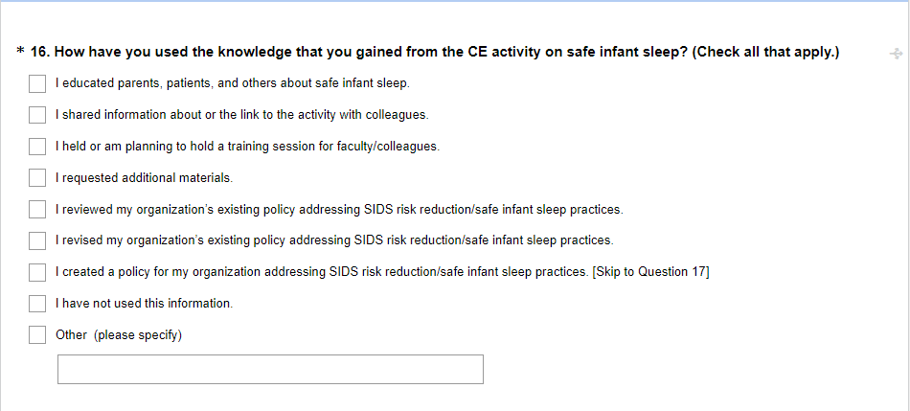
*If any answer other than “I have not used this information” is selected, the participant skips to Question 18.
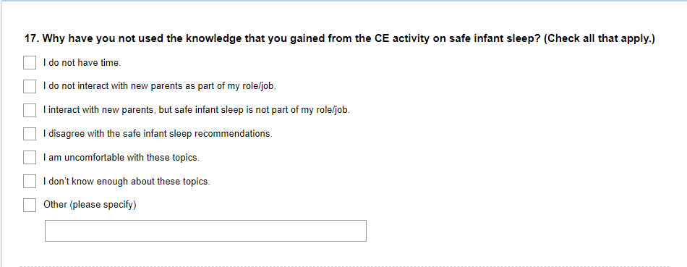
*This question is only displayed if “I have not used this information” is selected in Question 16.
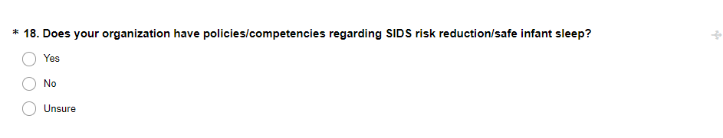
*If “No” is selected, the participant skips to Question 21.

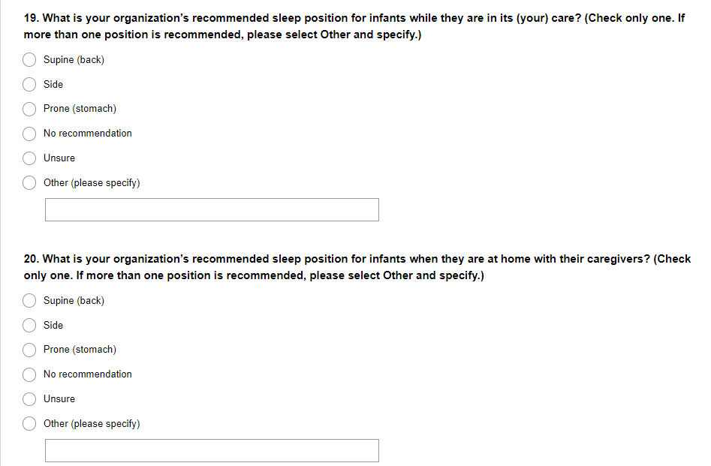
*Questions 19 and 20 are only displayed if the participant selects “Yes” or “Unsure” in Question 18.
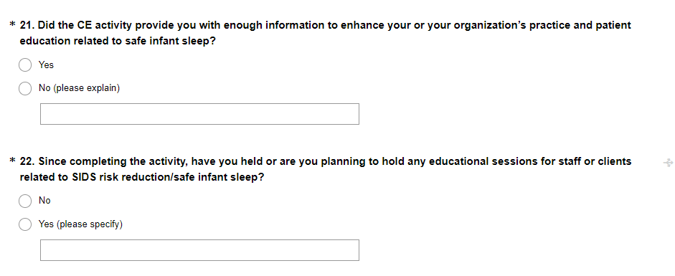
*If “Yes” is selected, the participant skips to Question 24.

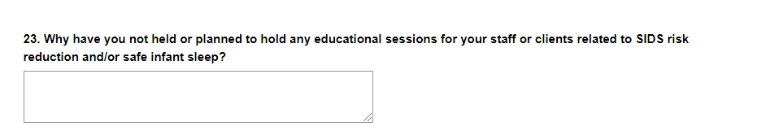
*This question is only displayed if the participant selects “No” in Question 22.

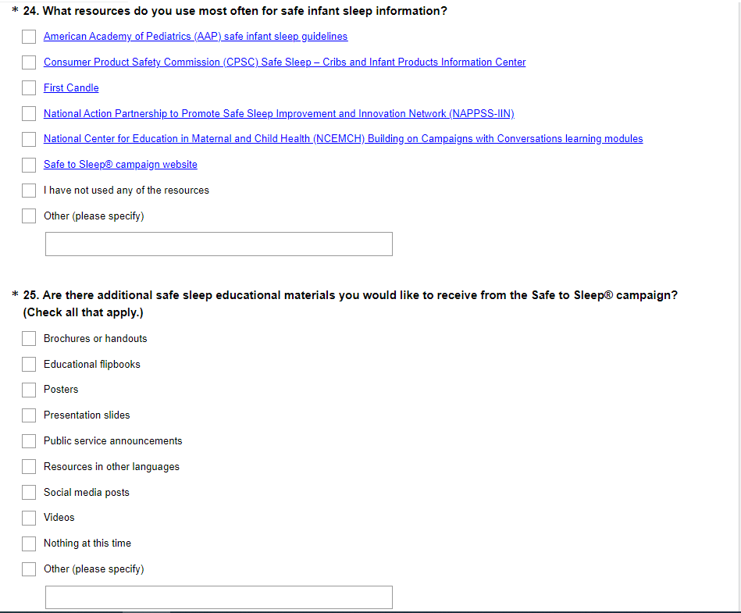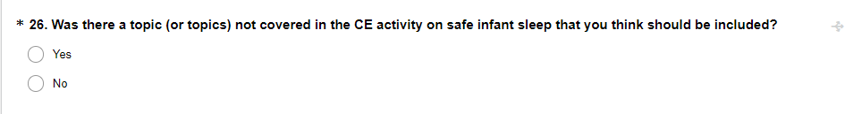
*If “No” is selected, the participant skips to Question 28.

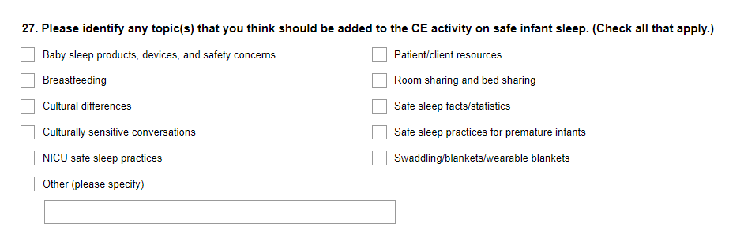
*This question is only displayed if the participant selects “Yes” in Question 26.
