# Safe to Sleep® Risk Reduction for Sudden Infant Death Syndrome (SIDS) and Other Sleep-Related Causes of Infant Death: Curriculum for Nurses Survey

## Screenshots of SurveyMonkey

The survey below will be emailed to those who take the CE. The information gathered will help improve the course completion process.

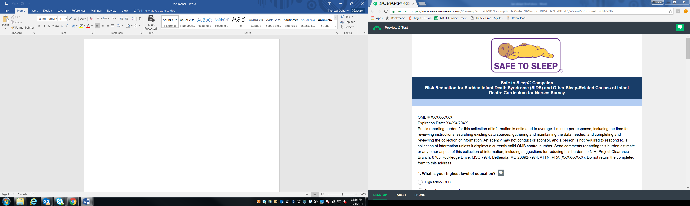

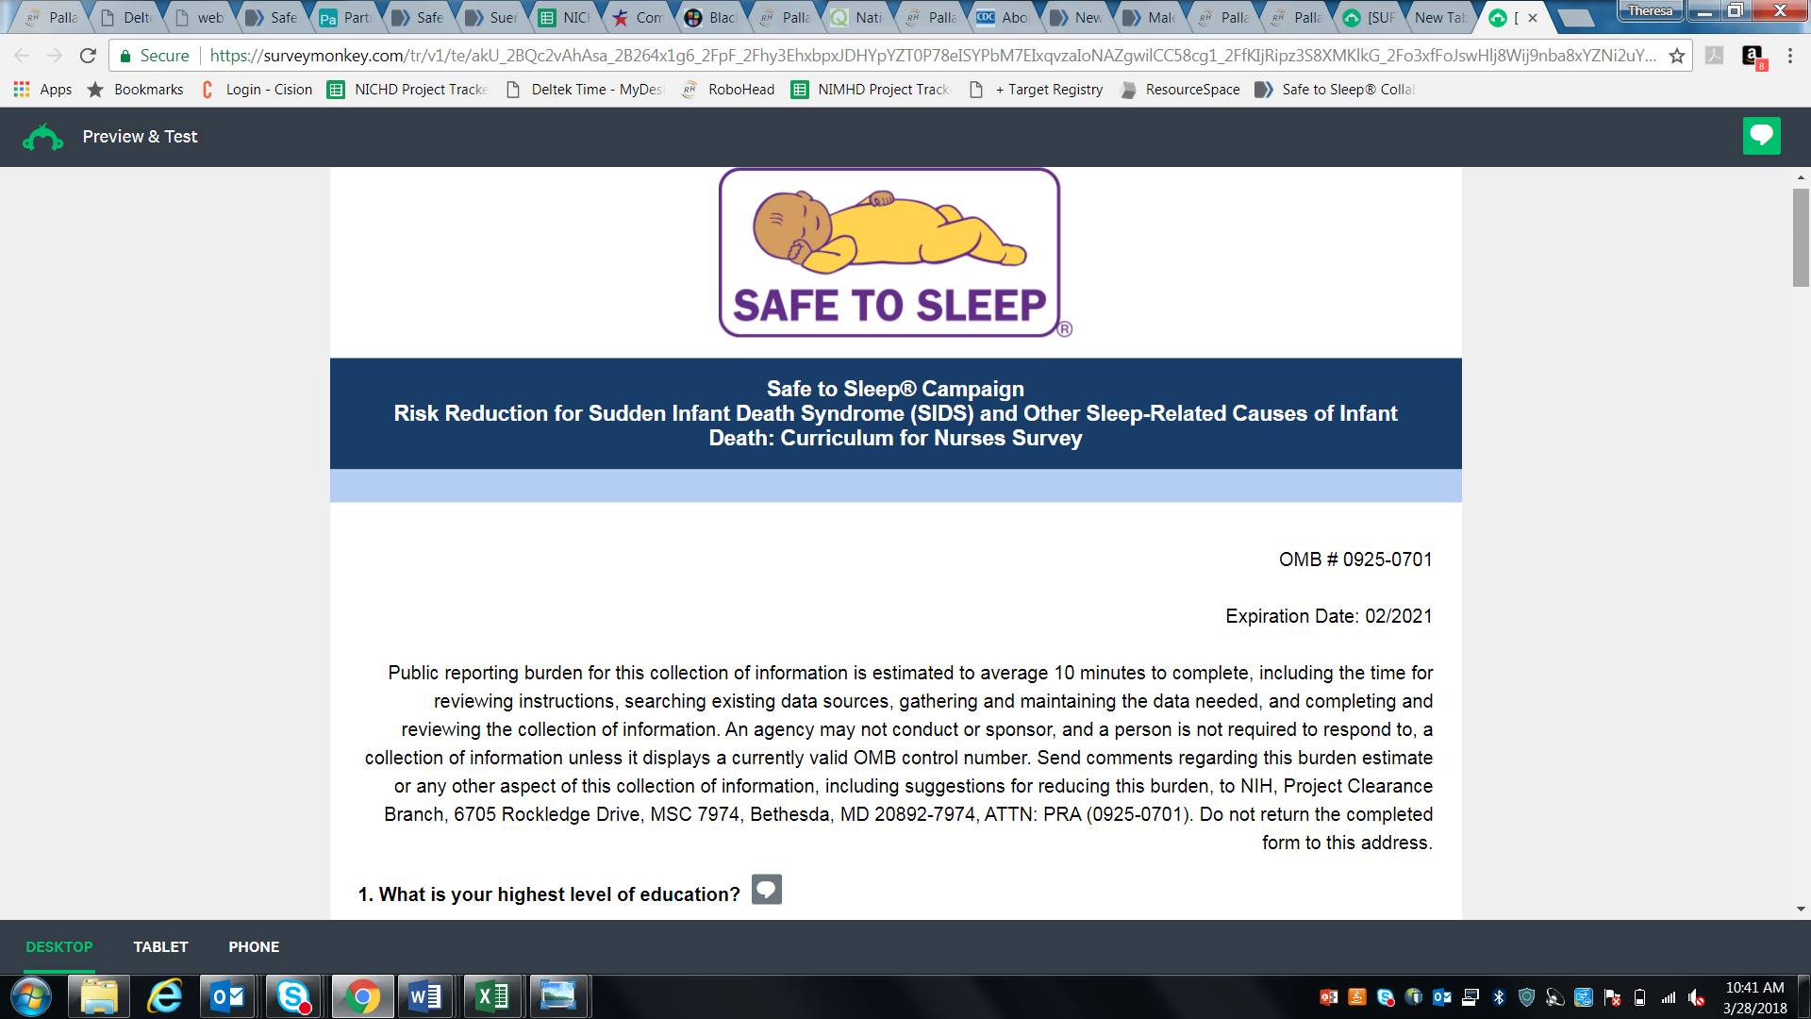

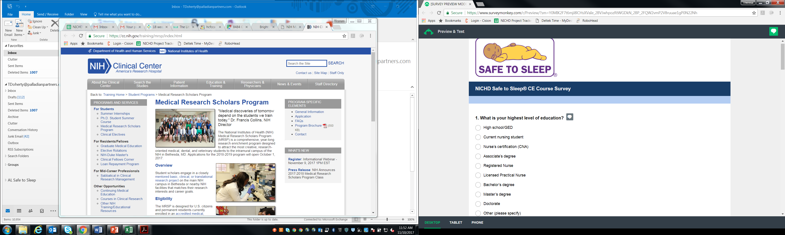

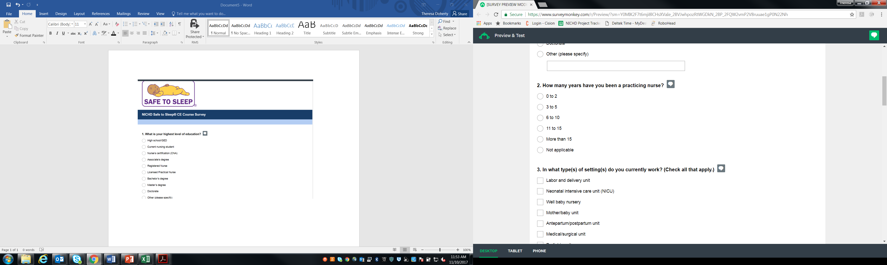

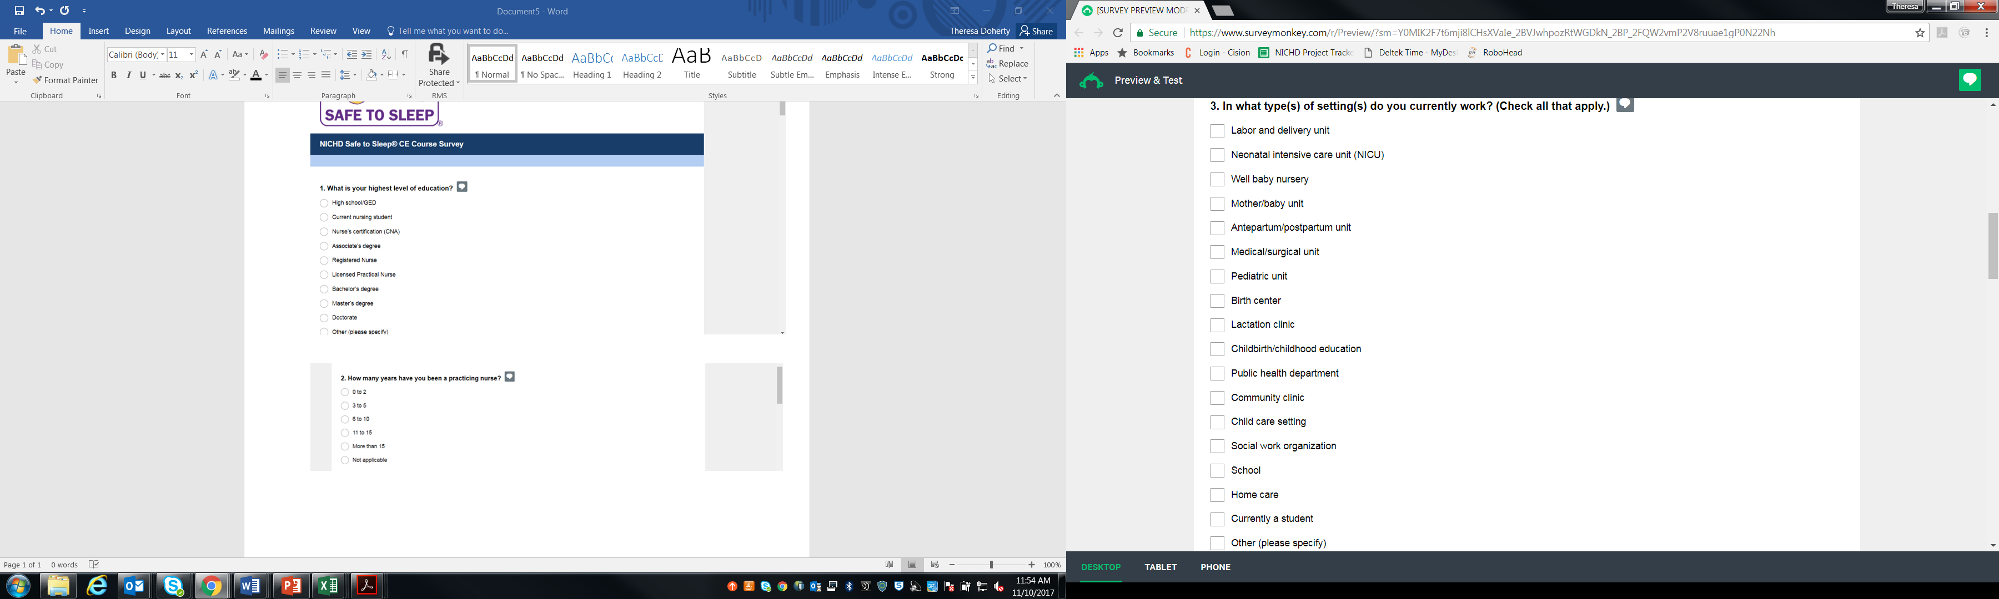

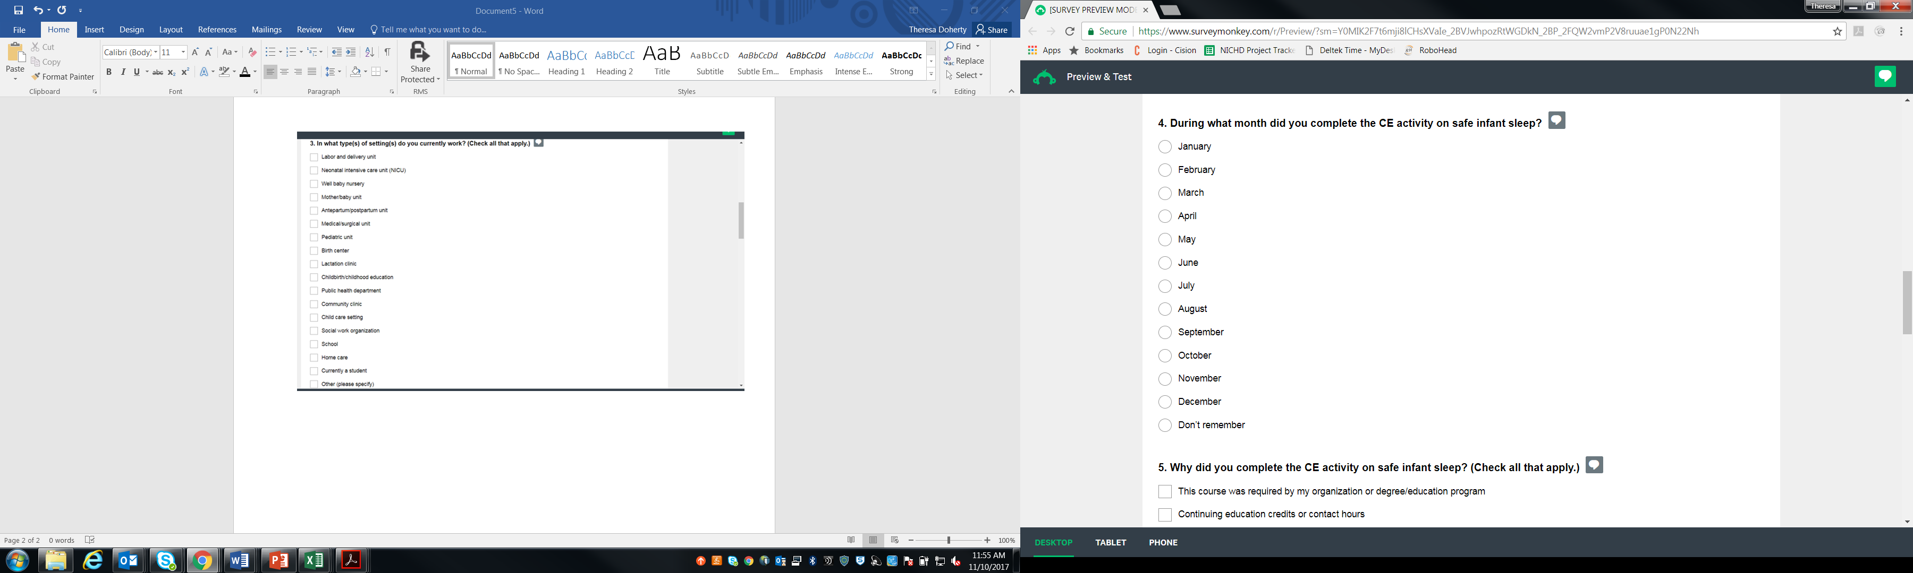

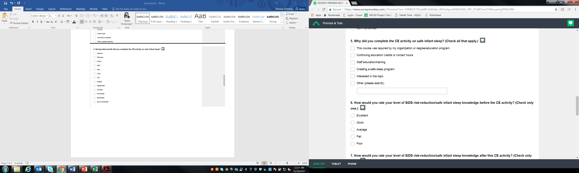

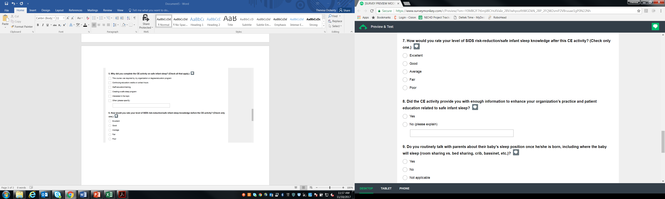

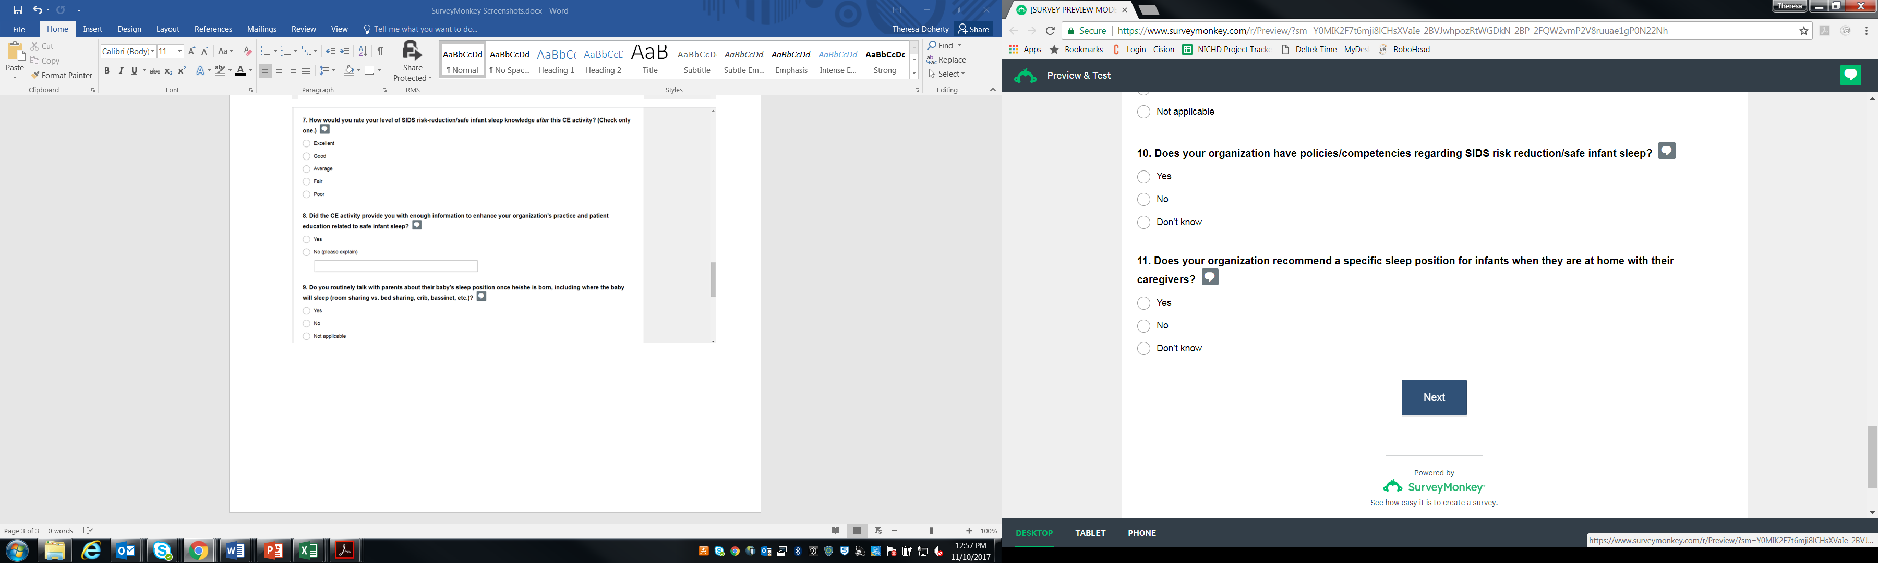

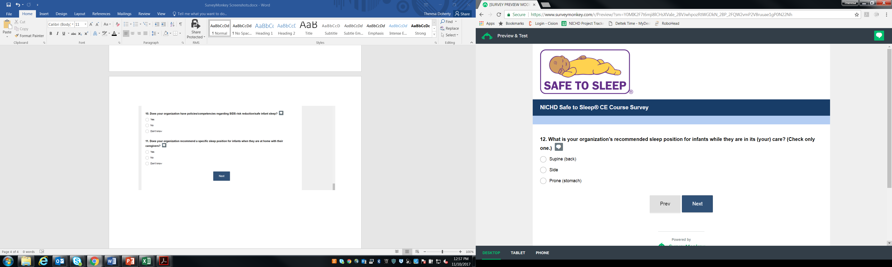

*The answer to this question determines what question is served next. If “supine” is selected, then the user skips question 13. If “side” or “supine” is selected, then the user is asked these questions.

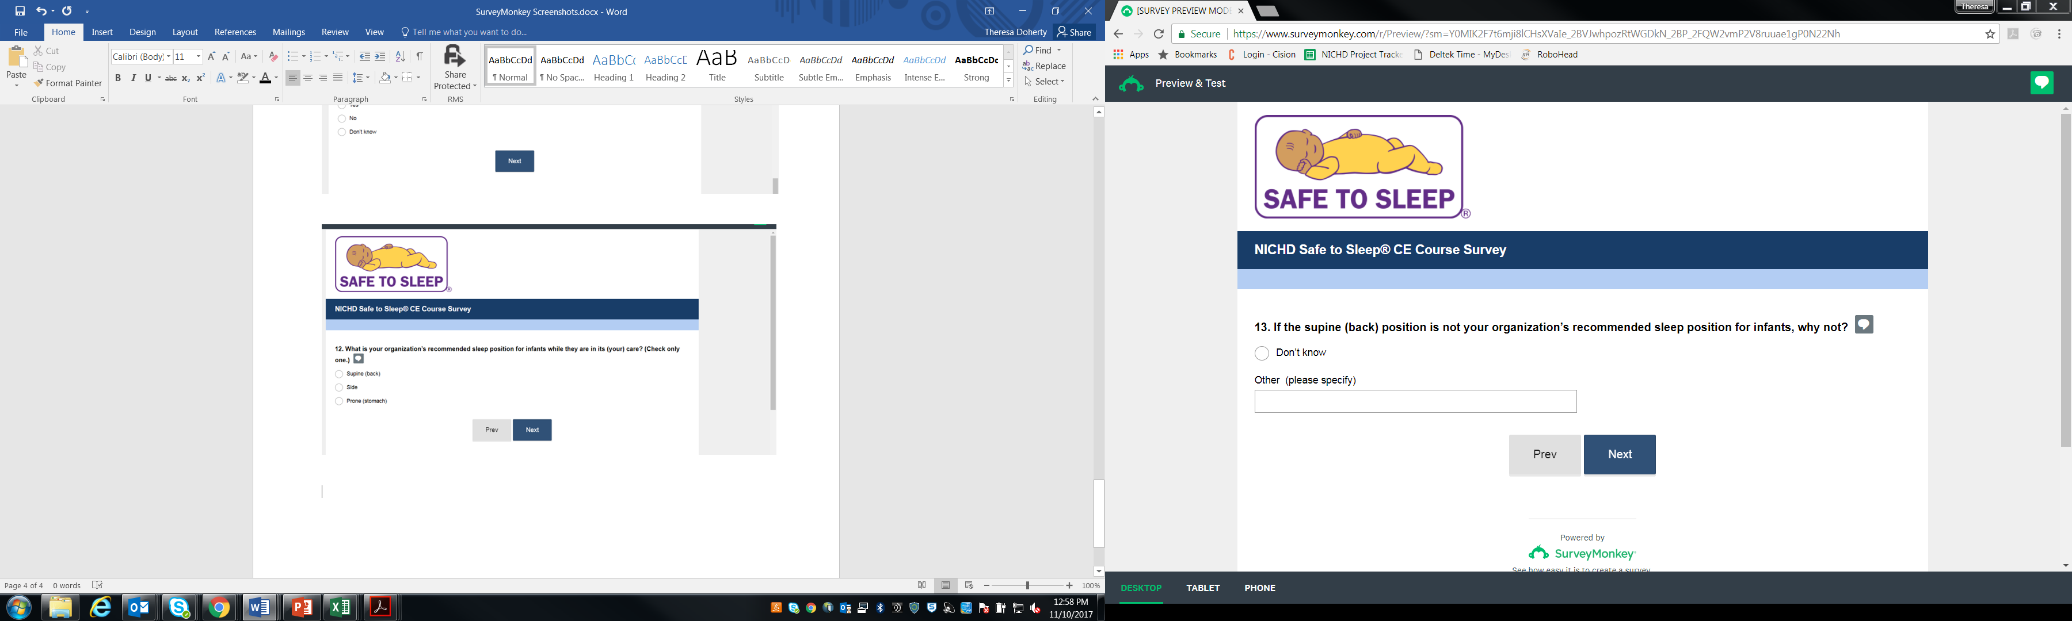

*This question is skipped if the user selected “supine” for question 12.

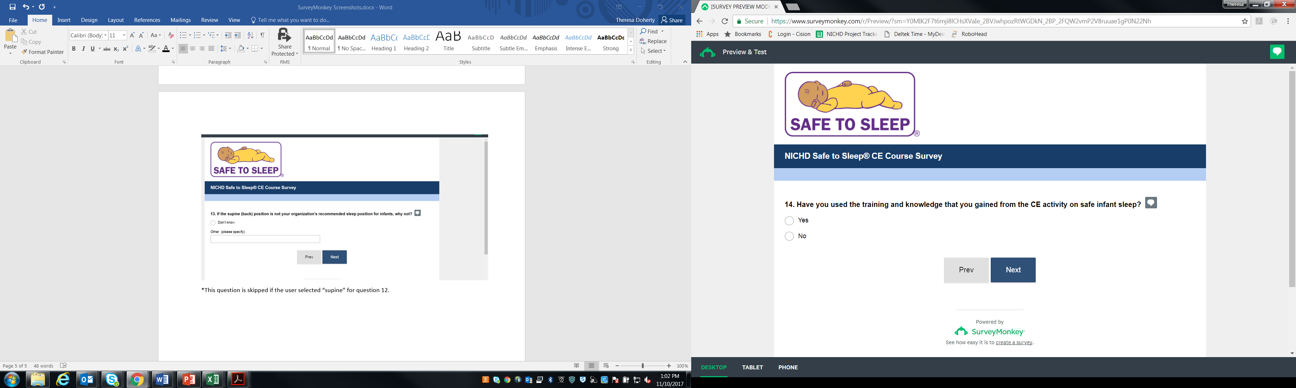

*If the user answers “yes” for this question, then s/he receives question 15. If the user answers “no,” then s/he skips to question 16.

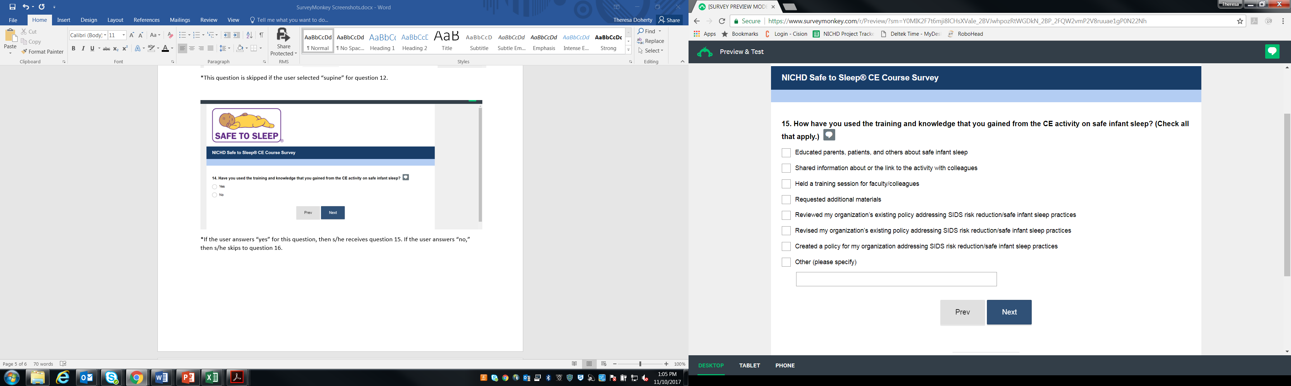

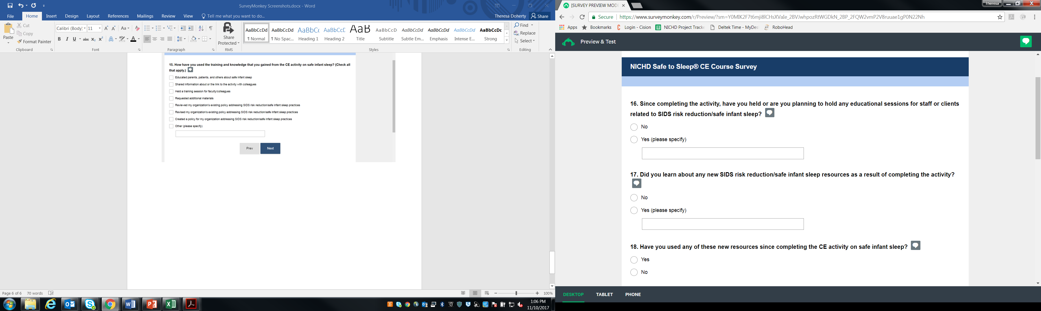

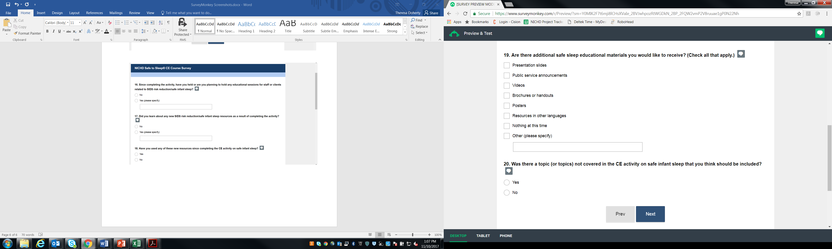

*If the user answers “yes” for this question, then s/he receives question 21. If the user answers “no,” then s/he skips to question 22.

