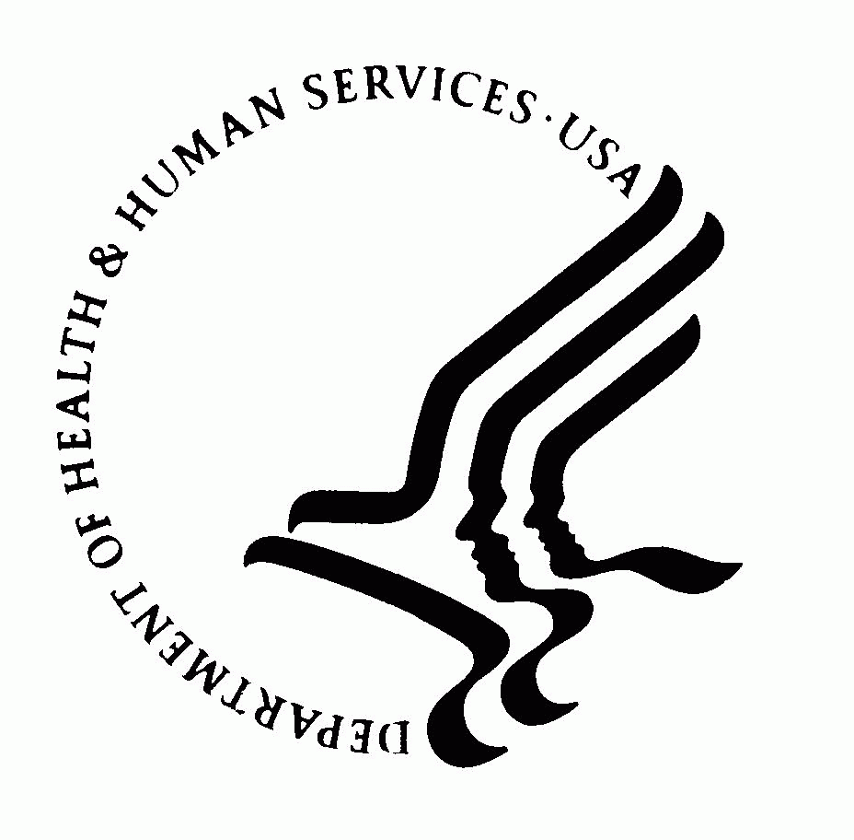 | DEPARTMENT OF HEALTH AND HUMAN SERVICES  Office of the Secretary  Washington DC 20201

MEMORANDUM

TO: Sherette Funn, OS/OCIO-PRA Reports Clearance Officer

THROUGH: Darius Taylor, HHS/OCIO-PRA Report Clearance Officer

FROM: Office of Civil Rights

SUBJECT: Non-Substantial Change Request 0945-0003, Standards for Privacy of Individually Identifiable Health Information and Supporting Regulations at 45 CFR Parts 160 and 164

DATE: October 11, 2017

Office of Civil Rights requests OMB approve a modification to our Standards for Privacy of Individually Identifiable Health Information and Supporting Regulations at 45 CFR Parts 160 and 164. Correct the error of number of respondents 200,000 to make it 20,000 to the instrument named “HHS Rights to request privacy protection for protected health information” as a result of correcting, the burden hour should adjust to a total of 921,813,702 versus 921,822,708.

This request for correction in number of respondents and total burden hour as currently approved and will remain in compliance with the PRA.
.

Please provide us with the Notice of Action upon OMB approval.

Thank you.

