OMB Control Number: 1670-NEW
OMB Expiration Date: MM/DD/YYYY

Paperwork Reduction Act
The public reporting burden to complete this information collection is estimated at 1 minutes per response, including the time for reviewing instructions, searching existing data sources, gathering and maintaining the data needed, and the completing and reviewing the collected information. The collection of information is voluntary. An agency may not conduct or sponsor, and a person is not required to respond to a collection of information unless it displays a currently valid OMB control number and expiration date. Send comments regarding this burden estimate or any other aspect of this collection of information, including suggestions for reducing this burden to DHS/NPPD/CS&C/NCCIC/US-CERT, 245 Murray Lane, SW, Mail Stop 0640, Arlington, VA 20598-0640 ATTN: PRA [OMB Control No. 1670-NEW].

Mail Lists (NCAS) Subscription Form
https://public.govdelivery.com/accounts/USDHSUSCERT/subscribers/qualify?email=name@email.com&submit=Subscribe

US-CERT Public Website Homepage and Footer:

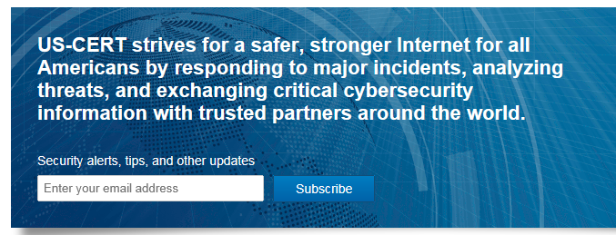

Subscription Type: Email

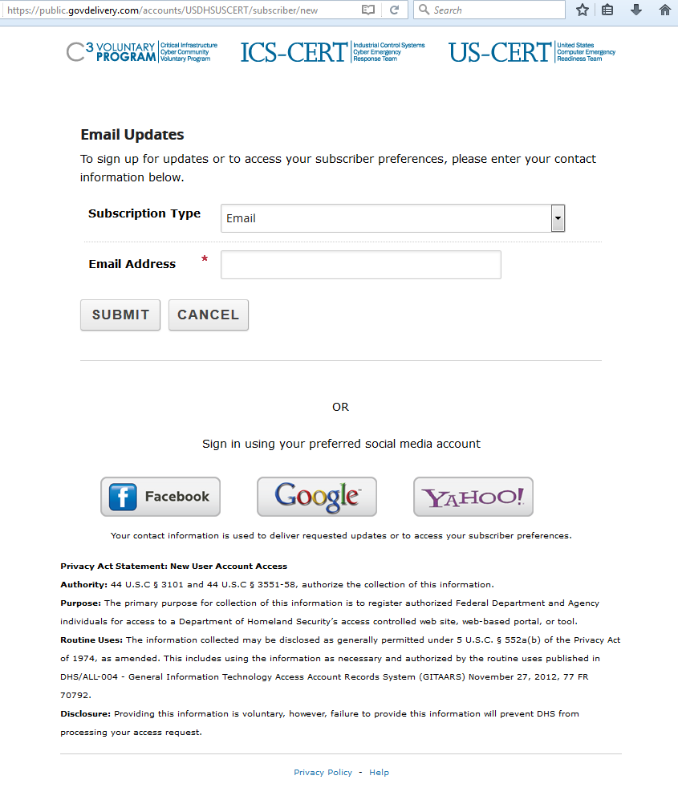

Subscription Type: SMS / Text Message

