Smartphone OMB Display text:

Public Burden Statement

A federal agency may not conduct or sponsor, and a person is not required to respond to, nor shall a person be subject to a penalty for failure to comply with a collection of information subject to the requirements of the Paperwork Reduction Act unless that collection of information displays a current valid OMB Control Number. The OMB Control Number for this information collection is XXXX-XXXX.

Public reporting for this collection of information is estimated to be approximately 30 minutes per day, including three or four PVT-Bs/day; three or four KSSs/day; sleep logs before and after each sleep period, including naps; and the caffeine log whenever drivers consume caffeine. All responses to this collection of information are voluntary. Send comments regarding this burden estimate or any other aspect of this collection of information, including suggestions for reducing this burden to: Information Collection Clearance Officer, Federal Motor Carrier Safety Administration, MC-RRA, 1200 New Jersey Avenue, SE, Washington, D.C. 20590.

Smartphone Home Screen text (background image):

Call us
(844) 885-6633
Call us for your weekly check in
Call any other time you have questions

Daily to-do list
Complete Reaction Time Tests
Work days: Just before the start, in the middle (on a break), and after the end of your shift.
When using the split sleep exemption: One additional test after your sleeper berth period before coming back on duty.
Days off: Within 2 hours after waking, midday, and within 2 hours before bed.
Fill out sleep diary & caffeine logs
Use StudyAdmin to sync watch data
Use study-provided electronic duty log.

Charge
Keep your devices charged
Phone: daily Watch: weekly

Smartphone Sleep Diary text:

Start sleeping
(driver documents the current date and time or the date and time of a previous sleep period, then selects options for):
- In sleeper berth
- Mid-duty nap using flexible sleeper berth allowance
(if driver selects using sleeper berth allowance, present options for):
Reason for using allowance:
- Sleepy
- Waiting to load/unload
- Avoiding heavy traffic
- Other: ____________

Stop sleeping
(driver documents the current date and time or the date and time of a previous sleep period, then select options for):
How would you rate your quality of sleep in the current sleep period?
- Excellent
- Good
- Average
- Fair
- Poor

Smartphone Caffeine Log text:

Log Caffeine
(driver documents the current date and time or the date and time of previously consumed caffeine, then select options for):
Source:
- Coffee
- Tea
- Soda
- Energy Drink
- Other: _______

Smartphone PVT Instructions and Comments Screens (before and after reaction time test)
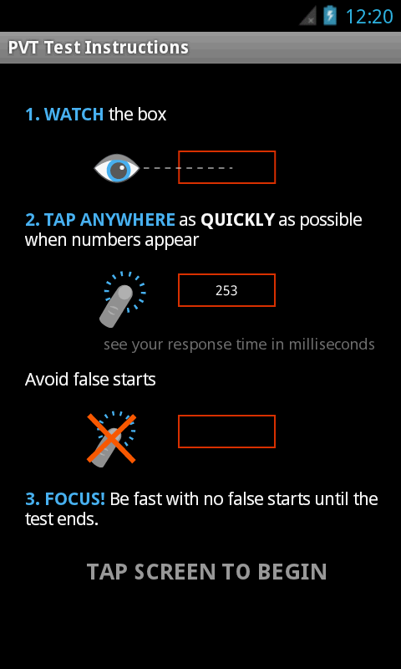
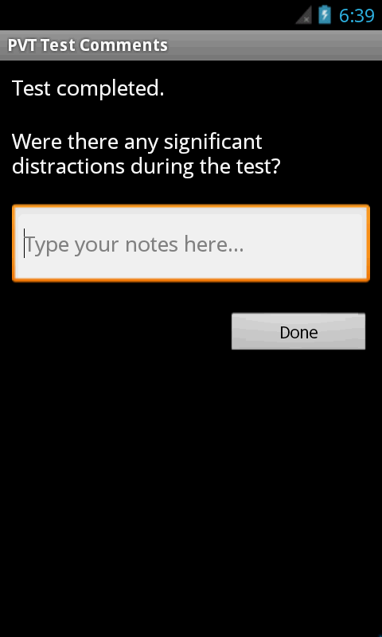
Smartphone KSS (shown immediately after PVT comments screen)
