DUE DATE REMINDER
Recently, the U.S. Census Bureau and the Department of Housing and Urban Development mailed you a letter asking you to complete the 2018 Rental Housing Finance Survey. If you have submitted your survey in the past few weeks, thank you. If you have not yet reported, please do so before the due date noted below. After the due date, a Field Representative from the Census Bureau will contact you to conduct a personal interview.
Address:

Please report online using the information below, and keep this letter for future reference:

Website:
User ID:
Password:
Due Date:

For assistance with completing this survey, visit us online at the website above or call our customer help line at 1-800-992-3530, Monday through Friday, 8:00 a.m. to 5:00 p.m. Pacific time.

Thank you in advance for your time and cooperation, and for helping the U.S. Census Bureau measure America’s people, places, and economy. Your response makes a difference.

Sincerely,

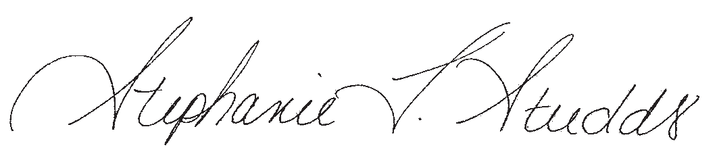

Stephanie L. Studds
Chief, Economic Indicators Division
U.S. Census Bureau

