Patient Satisfaction Survey: Network Consolidated Laboratory (NCL) Phlebotomy Service

OMB No. 2900-0770
Estimated Burden: 3 minutes

Expiration Date: 09/30/2020

The Paperwork Reduction Act of 1995: This information is collected in accordance with section 3507 of the Paperwork Reduction Act of 1995. Accordingly, we may not conduct or sponsor and you are not required to respond to, a collection of information unless it displays a valid OMB number. We anticipate that the time expended by all individuals who complete this survey will average 3 minutes. This includes the time it will take to follow instructions, gather the necessary facts and respond to questions asked. Customer satisfaction is used to gauge customer perceptions of VA services as well as customer expectations and desires. The results of this survey will lead to improvements in the quality of service delivery by helping to shape the direction and focus of services and the patient experience. Participation in this survey is voluntary and failure to respond will have no impact on benefits to which you may be entitled.

Patient Satisfaction Survey
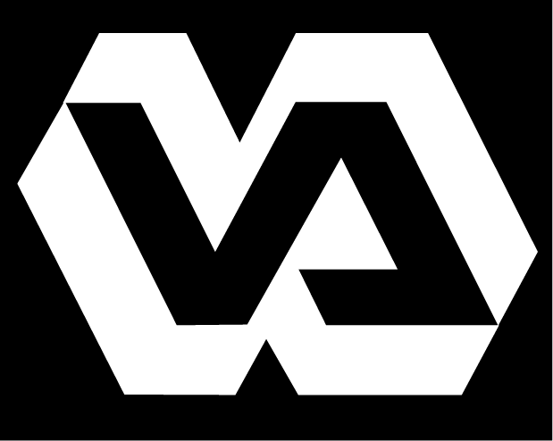
Department of Veterans Affairs

Network Consolidated Laboratory P&LMS VA New England Healthcare System

The VISN1 Network Consolidated Laboratory’s (NCL) goal is to serve New England’s Veterans with the highest quality of care possible. To that end, we seek your input. Periodic evaluation of this survey will help us identify areas within the clinical laboratory which may need improvement and allow us to strive toward providing our Veterans with “The Best Care Anywhere.”

Instructions: Participation in this survey is voluntary and anonymous. Using the pen or pencil provided, please fill in the present date and time. Thinking about your visit today at our blood drawing room, please check the response to the question or statement that most closely represents your impression of the service you received. Please place the completed questionnaire in the designated box or hand it to the phlebotomist. Thank you!

Date: ______________________ Time: ______________________

- Once you arrived at the laboratory blood drawing area, how long did you wait to have your blood drawn?
- Less than 15 minutes
- 15-30 minutes
- 30-45 minutes
- 45-60 minutes
- More than 1 hour
Comment:

- The laboratory blood drawing professional treated me with respect and in a courteous manner:
❒ Strongly Agree
❒ Agree
❒ Uncertain
❒ Disagree
❒ Strongly Disagree
Comment:

- I have confidence in the skill of the laboratory blood drawing professionals that collected my samples.
❒ Strongly Agree
❒ Agree
❒ Uncertain
❒ Disagree
❒ Strongly Disagree
Comment:

- Did you have problems entering or moving around the laboratory blood drawing area due to clutter, traffic, equipment placement or poor design?
❒ Yes  No
Comment:

- Were you asked to confirm your full name and full social security number before your specimen (blood, urine, or other) was collected by the laboratory blood drawing professional?
❒ Yes  No
Comment:

- Do you believe that the confidentiality of your personal health and identification information was protected during your time spent in the laboratory blood drawing area by the blood drawing professionals?
❒ Yes  No
Comment:

The Paperwork Reduction Act of 1995: This information is collected in accordance with section 3507 of the Paperwork Reduction Act of 1995. Accordingly, we may not conduct or sponsor, and you are not required to respond to, a collection of information unless it displays a valid OMB number. We anticipate that the time expended by all individuals who complete this survey will average 3 minutes. This includes the time it will take to follow instructions, gather the necessary facts and respond to questions asked. Customer satisfaction is used to gauge customer perceptions of VA services as well as customer expectations and desires. The results of this survey will lead to improvements in the quality of service delivery by helping to shape the direction and focus of services and the patient experience. Participation in this survey is voluntary and failure to respond will have no impact on benefits to which you may be entitled.

Comments concerning the accuracy of the survey burden estimate and suggestions for reducing this burden should be sent to:
Jacqueline Dang, NCL Quality Manager/Health System Specialist @ Jacqueline.Dang@va.gov

