# 

VA_BW_SEAL1.tif

# 

# Patient Satisfaction Questionnaire: Network Consolidated Laboratory (NCL) Phlebotomy Service

# OMB No. 2900-0770 Estimated Burden: 3 minutes

# Expiration Date: 9/30/2020

**The Paperwork Reduction Act of 1995:** This information is collected in accordance with section 3507 of the Paperwork Reduction Act of 1995. Accordingly, we may not conduct or sponsor and you are not required to respond to, a collection of information unless it displays a valid OMB number. We anticipate that the time expended by all individuals who complete this survey will average 3 minutes. This includes the time it will take to follow instructions, gather the necessary facts and respond to questions asked. Customer satisfaction is used to gauge customer perceptions of VA services as well as customer expectations and desires. The results of this survey will lead to improvements in the quality of service delivery by helping to shape the direction and focus of services and the patient experience. Participation in this survey is voluntary and failure to respond will have no impact on benefits to which you may be entitled.

**VA Form 10-0516**

OMB Number 2900-0770

Estimated burden: 3 minutes

Expiration: 9/30/2020

**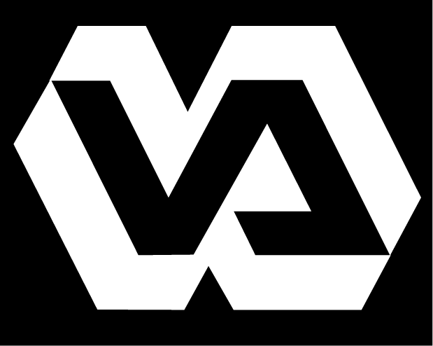**

**Department of Veterans Affairs**

**Patient Satisfaction Questionnaire**

Network Consolidated Laboratory P&LMS VA New England Healthcare System

The Network Consolidated Laboratory’s (NCL) goal is to serve New England’s Veterans with the highest quality of care possible. To that end we seek input from our most valued asset – you, our customer. Periodic evaluation of this questionnaire will help us identify areas which may need improvement and allow us to strive toward providing the veterans of New England “The Best Care Anywhere.”

Instructions: Participation in this questionnaire is voluntary and anonymous. Using the pen or pencil provided please fill in the present Date and Time. Thinking about your visit to our blood drawing room today, please mark the answer to the question or statement that most closely represents your impression of the service you received. Please place the completed questionnaire in the designated box or hand it to the phlebotomist. Thank you!

Date: \_\_\_\_\_\_\_\_\_\_\_\_\_\_\_\_\_\_\_\_\_\_ Time: \_\_\_\_\_\_\_\_\_\_\_\_\_\_\_\_\_\_\_\_\_\_

1. How long after the time you arrived at the blood drawing room did you wait to have your blood drawn?

❒ Less than 15 minutes

❒ 15-30 minutes

❒ 30-45 minutes

❒ 45-60 minutes

❒ More than 1 hour

Comment:

1. The blood drawing staff treated me in a courteous manner:

❒ Strongly Agree

❒ Agree

❒ Uncertain

❒ Disagree

❒ Strongly Disagree

Comment:

1. I had confidence in the skill of the people serving me.

❒ Strongly Agree

❒ Agree

❒ Uncertain

❒ Disagree

❒ Strongly Disagree

Comment:

1. Did you have problems entering or moving around the blood drawing area due to clutter, traffic, equipment placement or poor design?

❒ Yes  No Comment:

1. Were you asked to confirm your full name and full social security number when your specimen (blood, urine, or other) was collected by the phlebotomy (blood drawing) staff?

❒ Yes  No Comment:

1. Do you believe the confidentiality of your personal health and identification information was protected during your time spent with the phlebotomy staff?

❒ Yes  No Comment:

**Continued on next page**

Now think about your experiences with all the services provided by the Department of Veterans Affairs (which include healthcare, benefits programs, or memorial services). Please tell us how you feel about the following statements.

1. “I got the service I needed.”

❒ Strongly Agree

❒ Agree

❒ Neither Agree or Disagree

❒ Disagree

❒ Strongly Disagree

Comment:

1. “It was easy to get the service I needed.”

❒ Strongly Agree

❒ Agree

❒ Neither Agree or Disagree

❒ Disagree

❒ Strongly Disagree

Comment:

1. “I felt like a valued customer.”

❒ Strongly Agree

❒ Agree

❒ Neither Agree or Disagree

❒ Disagree

❒ Strongly Disagree

Comment:

1. “I trust VA to fulfill our country’s commitment to veterans.”

❒ Strongly Agree

❒ Agree

❒ Neither Agree or Disagree

❒ Disagree

❒ Strongly Disagree

Comment: