**Non-Substantive Change Request**

**WHITE PAPER**

**ISSUE: Veterans Experience (VE) VE Feedback Tool: eComment Card Non-substantive request**

**BACKGROUND:**   
  
The VE Feedback Tool: eComment Card obtained OMB approval (Agency ICR Tracking # 2900-0770) on March 27, 2017. This Digital Comment Card form will be used as a mechanism to allow Veterans to provide feedback on their respective experience at VHA facilities. Information gathered will be used internally for service improvement. Since VEO obtained OMB approval, there have been minor changes to the form, and as a result, VE is requesting approval for the non-substantive change, as there is no impact to the overall burden. Please note the highlighted changes below:

* Updated form has a summarized introduction
* Updated form asks Veteran to provide State and Medical facility
* Updated form asks Veteran to classify whether a comment is a compliment, recommendation, or concern, and removed the 13 choices that follow the open text box in the previous form

**Figure A** – Formerly Approved Form  
**Figure B** – Updated Form

**Figure A – Formerly Approved Form**

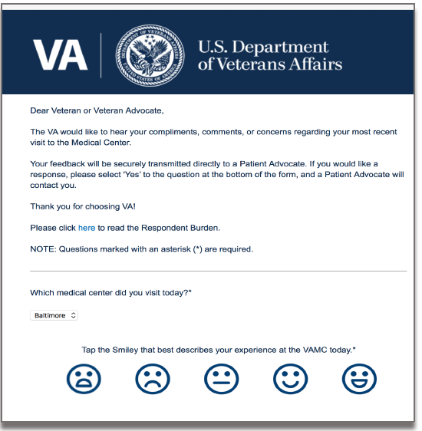  
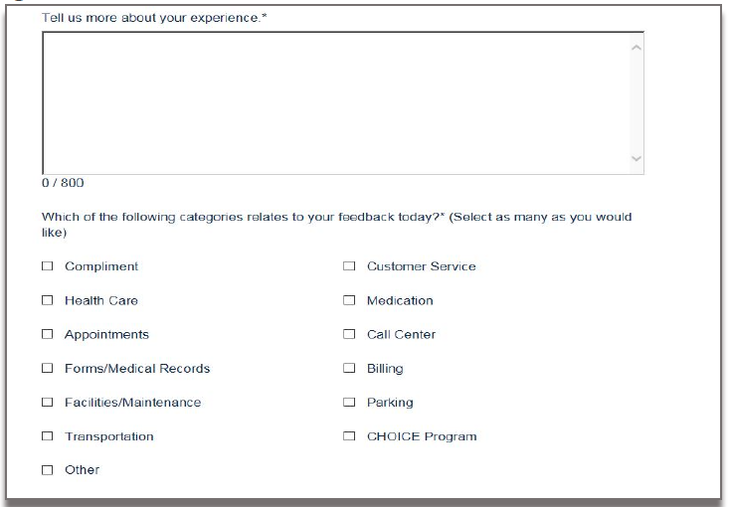  
**Figure A - Formerly Approved Form** (cont’d)  
 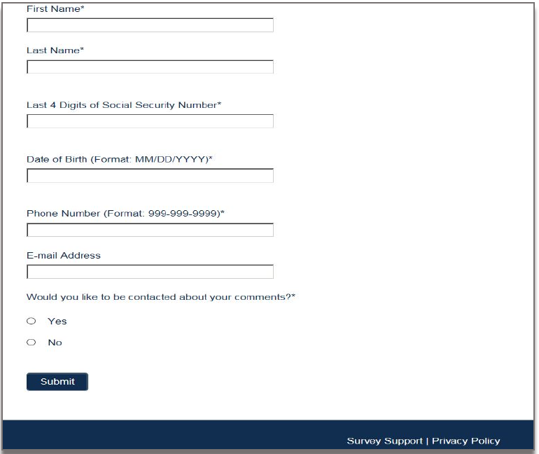

**Figure B** – Updated Form  
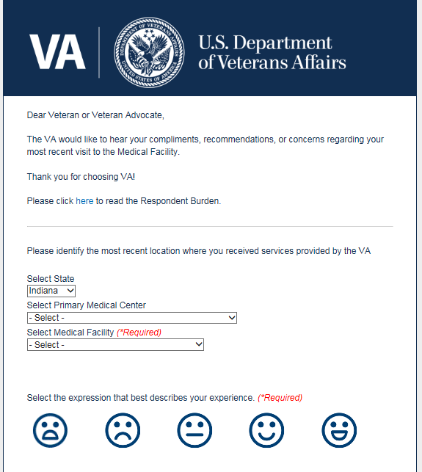

**Figure B** – Updated Form (cont’d)

