Request for Approval under the “Generic Clearance for the Collection of Routine Customer Feedback” (OMB Control Number: 2900-0770)

TITLE OF INFORMATION COLLECTION:

VA Community Care Network Provider Satisfaction Survey for Regions 1. 2. 3 and 4

PURPOSE:

Legal authority for this data collection is found in 38 USC, Part I, Chapter 5, Section 527 which authorizes the collection of data that will allow measurement and evaluation of the Department of Veterans Affairs Programs, the goal of which is improved health care for Veterans.

The survey will collect provider perceptions and qualitative feedback on VA/contractor communications and services. The data collected will be used to improve the health care of Veterans through the improvement of delivery of communications and services as needed and to assure VHA Office of Community Care (OCC) is providing timely and integrated care, consistently improving transparency and accountability while also focusing on efficient use of resources.

DESCRIPTION OF RESPONDENTS:

The pool of respondents for the VA Community Care Network (CNN) Provider Satisfaction Survey will consist of representation of the community providers who have been active in delivering health care services to Veterans through the survey.

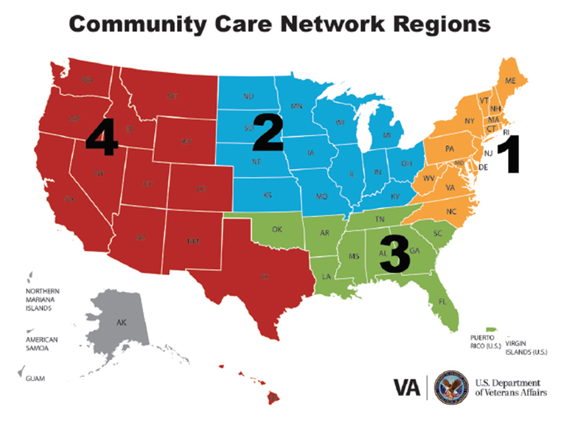

SPECIAL CIRCUMSTANCES:

One Third Party Administrator (TPA) per each of the CCN four regions will be administering a CCN Provider Satisfaction Survey every quarter on behalf of VA. The CCN survey contract, VA Solicitation VA791-16-R-0086 for all four regions requires each regional TPA to conduct voluntary provider satisfaction surveys at the end of every health care delivery quarter.

TPAs will be responsible for notification to providers as well as reminders about the survey and will bear any and all costs that may be associated therein. VA is responsible for providing survey questions and format only, per contracted agreements.

TYPE OF COLLECTION: (Check one)

[ ] Customer Comment Card/Complaint Form [✓] Customer Satisfaction Survey
[ ] Usability Testing (e.g., Website or Software [ ] Small Discussion Group
[ ] Focus Group [ ] Other: ______________________

CERTIFICATION:

I certify the following to be true:
- The collection is voluntary.
- The collection is low-burden for respondents and low-cost for the Federal Government.
- The collection is non-controversial and does not raise issues of concern to other federal agencies.
- The results are not intended to be disseminated to the public.
- Information gathered will not be used for the purpose of substantially informing influential policy decisions.
- The collection is targeted to the solicitation of opinions from respondents who have experience with the program or may have experience with the program in the future.

/s/ Carolyn Barbara Saveland____________________
Carolyn Barbara Saveland
Provider Education & Communications Lead
VHA Provider Relations & Services – Network Management

To assist review, please provide answers to the following question:

Personally Identifiable Information:
- Is personally identifiable information (PII) collected? [ ] Yes [✓] No
- If “Yes”, will any information that is collected be included in records that are subject to the Privacy Act of 1974? [ ] Yes [ ] No
- If “Yes”, has an up-to-date System of Records Notice (SORN) been published? [ ] Yes [ ] No

Gifts or Payments:
Is an incentive (e.g., money or reimbursement of expenses, token of appreciation) provided to participants? [ ] Yes [✓] No

BURDEN HOURS

Category of Respondent: Individuals & Households | No. of Respondents | Participation Time | Burden
VA Form 10-XXXXXX (VA Community Care Network Provider Satisfaction Survey); Region 1 | 2,000 | 10 minutes | 333
VA Form 10-XXXXXX (VA Community Care Network Provider Satisfaction Survey); Region 2 | 2,000 | 10 minutes | 333
VA Form 10-XXXXXX (VA Community Care Network Provider Satisfaction Survey); Region 3 | 2,000 | 10 minutes | 333
VA Form 10-XXXXXX (VA Community Care Network Provider Satisfaction Survey); Region 4 | 2,000 | 10 minutes | 333
Totals | 8,000 | 40 minutes | 1333

FEDERAL COST: The estimated annual cost to the Federal government is $0.

If you are conducting a focus group, survey, or plan to employ statistical methods, please provide answers to the following questions:

The selection of your targeted respondents
- Do you have a customer list or something similar that defines the universe of potential respondents and do you have a sampling plan for selecting from this universe? [✓ ] Yes [ ] No

If the answer is yes, please provide a description of both below (or attach the sampling plan)? If the answer is no, please provide a description of how you plan to identify your potential group of respondents and how you will select them?

Inclusion criteria:
Sampling will be from community providers contracted with region one TPA who provided healthcare services to Veterans through Community Care Network during the 3 months prior to quarterly data extraction.

Sample size:
The sample size will be a minimum of 10,000 community providers who provided health care services to Veterans through VA Community Care per regional survey. It is anticipated that there will be a response rate of approximately 20 percent. The provider names, email addresses, and services provided will be extracted from internal VA/Contractor databases in accordance with existing approved standards ensuring privacy and security of the data.

Administration of the Instrument
- How will you collect the information? (Check all that apply)
[✓] Web-based or other forms of Social Media
[ ] Telephone
[ ] In-person
[✓] Mail
[ ] Other, Explain

- Will interviewers or facilitators be used? [ ] Yes [✓] No

Contracted TPA will be responsible for sending survey invitations and reminders to community providers who provide healthcare services to Veterans through Community Care Network. VA will provide input suggesting that the survey be web-based and that an option to request a paper-copy of the survey-instrument in lieu of using the web-based option should be provided.

Because TPA will be administering all quarterly surveys, instructions and scripts of email invitations and reminder to respondents are the responsibility of the TPA. VA will provide suggested email invitation and reminder language as submitted below for TPAs to used.

Please make sure that all instruments, instructions, and scripts are submitted with the request.

