SPR Reporting System

User Documentation – SLAA View

Final OMB Submitted Version: 10/16/2017

OMB Control # 3137-0071 Expiration Date: 7/31/2018

Contents

1) System Overview 1
1.1) Login 2
1.2) State Library Dashboard (Home Screen) 3
1.3) Menus and Permissions 3
1.4) Search 3
1.5) Where to go for Help 4
2) Navigating State Program Reports 4
2.1) View Projects 4
2.2) Add Project 5
2.3) Edit Projects and Activities 10
2.3.1 Edit Activities 10
2.3.2 Copy Activities 10
2.3.3 Delete Activities 10
2.4) Print Projects 11
2.5) Delete Projects 11
2.6) Batch Upload Projects 11
3) Financial Status Report (FSR) and Interim Federal Financial Report (FFR) 12
3.1) Entering the FSR Data 12
3.2) Certifying the FSR 13
3.3) Entering the Interim FFR Data 13
3.4) Certifying the Interim FFR 14
4) Administrative Project 14
4.1) Entering the Administrative Project Data 14
4.2) Certifying the Admin Project 15
5) Account Management 15
5.1) User Info 15
5.2) State Info 15
5.3) State Goals 15
5.4) Subaward Info 15
5.5) Subrecipient User Access 16
5.5.1) Add Subrecipient User 16
5.5.2) View/Edit Subrecipient User 16
5.5.3) Delete Subrecipient User 16
5.6) Manage Subrecipient Institutions 16
5.6.1) View Subrecipient Institution List 16
5.6.2) Add Subrecipient Institution 16
5.6.3) Edit Subrecipient Institution 17
5.6.4) Delete Subrecipient Institution 17
6) Submitting the Full Report to IMLS 17
6.1) Validating the Report (LSTA Coordinator account only) 17
6.2) Certifying the Report (ACO account only) 18
7) IMLS Review of Report 18
8) User Reports 18
Appendices 20
Appendix 1: Government Security Notice 20
Appendix 2: Focal Areas and Intents 21
Appendix 3: Activity, Mode, Format, and Quantity 22
Appendix 4: Glossary of Terms 24
`

System Overview
The new IMLS State Program Report (SPR) system is designed to meet federal grant reporting requirements and the IMLS evaluation effort titled Measuring Success.

All recipients of Grants to States funds are required to report annually on the usage of their grant award. The system allows you to report on four detailed grant requirements including projects funded, amount of funds used to administer the program, the Financial Status Report, and the Interim Federal Financial Report. The goal is also to collect and analyze the activities taking place under this grant program in order to be more transparent and to share the knowledge gained by all.

The system is web-based and requires using a computer with an internet connection and a browser. The system has been tested with the latest versions of the following browsers:
- Google Chrome
- Mozilla Firefox
- Apple Safari

Microsoft Internet Explorer 9+ is not being supported. Note you may use it but some functionality may be lost.

IMLS will provide the Authorized Certifying Official (ACO), the LSTA Coordinator, and Financial Officer (upon request) in each SLAA (State Library Administrative Agency) with an account to access the system. The ACO and LSTA Coordinator may add accounts for additional SLAA staff and subrecipients (see Subrecipient User Access, section 5.5)

Login
- Open http://imls-spr.imls.gov/Login
- Enter your e-mail address and password
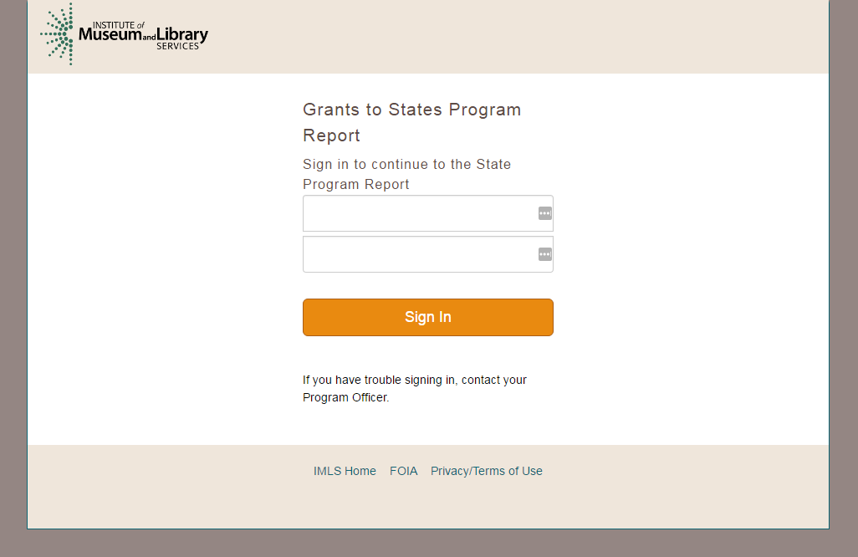

Enter your username – should be your email address
Enter your password

Figure 1: Logging in to the system

- Click Sign In.

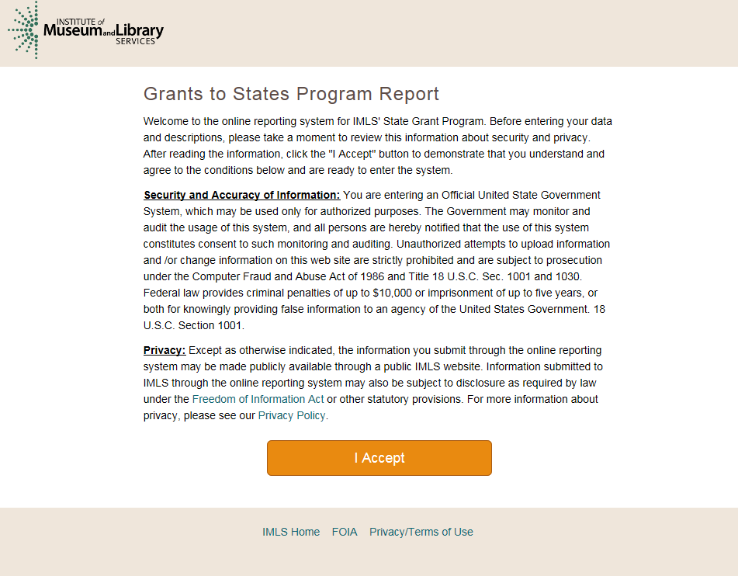
Figure 1a: Security and privacy statement

- Click I Accept.

State Library Dashboard (Home Screen)
The Home page is the State Library Dashboard page. Clicking Home on the navigation menu will return you to this screen.

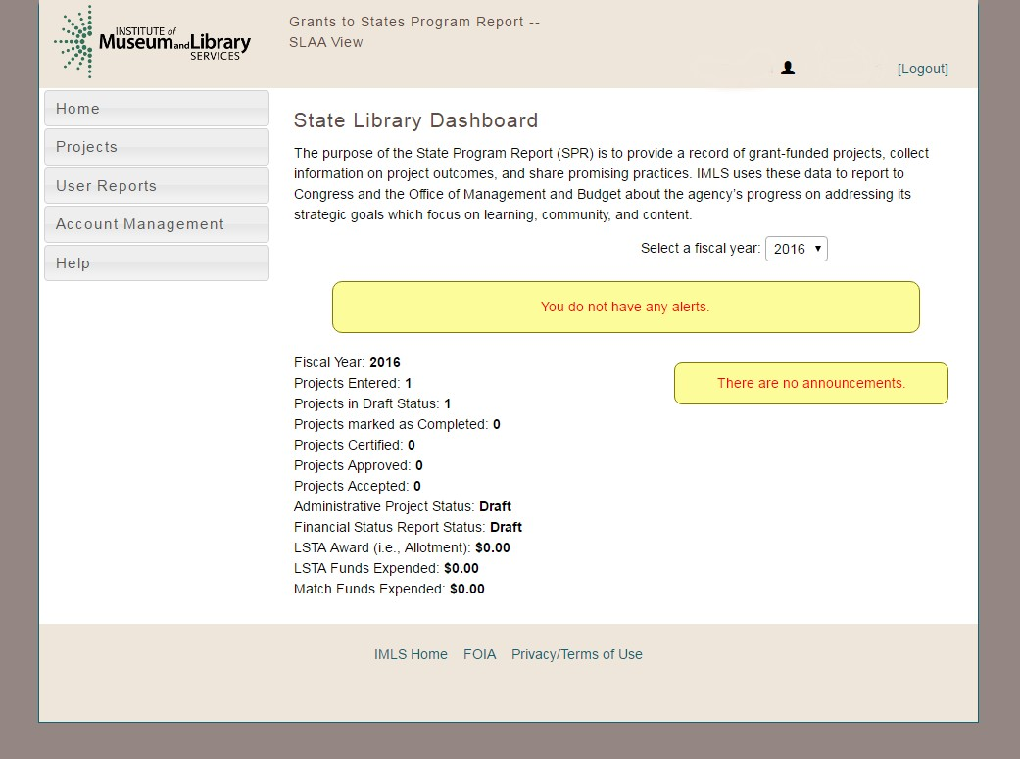
Figure 2: The SPR Home Page

Note: Navigation menu options are limited for Subrecipient users.

Menus and Permissions
The menu system is based on the permission level of the user.
- The ACO, LSTA Coordinator, and Financial Manager user accounts have permission to view all projects for a state and can access the Home, Projects, User Reports, Account Management, and Help menus.
- Subrecipients: Should you decide to provide Subrecipients access to the system they will have permission to see reports for their assigned institution and can access the Home, Projects, Account Management, and Help menus.

Search
You can search SPR projects that have been accepted by IMLS with the public user interface to the SPR at http://imls-spr.imls.gov/public/projects. There are two main options:
- Search Projects allows for keyword searching and filtering by various SPR fields.
- View Summaries returns high-level data for each state or territory.
Please note that certain project fields, such as budget details, are not viewable through this interface. It is separate from the SPR and will have its own documentation.

Where to go for Help
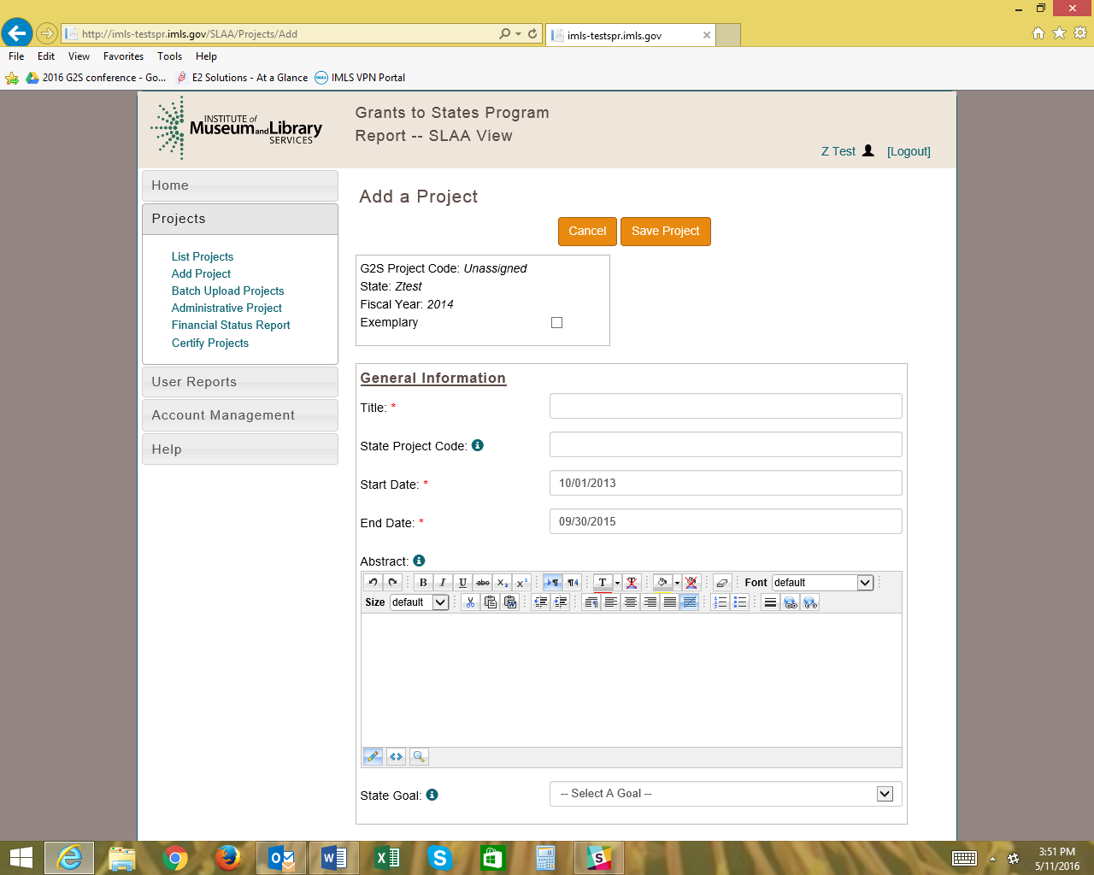
- Online help is available in the system menus and a printable copy of the help documentation is also available as a PDF via the website.
- Click on the information icon to view definitions.

Navigating State Program Reports
A project may be in one of five statuses:
- Draft - Initial project information has been entered and may be edited.
- Completed - Project has all its information entered and is ready to be certified.
- Certified - Project has been successfully submitted to IMLS for review.
- Approved - Project has been reviewed and approved by IMLS. Can only be assigned by IMLS.
- Accepted - Report has been approved and accepted by IMLS. Can only be assigned by IMLS.

Note: After all projects have been marked as “Completed”, the LSTA Coordinator may “Validate” (see p. 17) the report to confirm that all required data is present and the report is ready to be “Certified” by the ACO (see p. 19).

View Projects
- Click List Project under the Projects menu to view a list of the project reports entered for your state.
Note: You may change the sort order of the project list by clicking on a column heading.
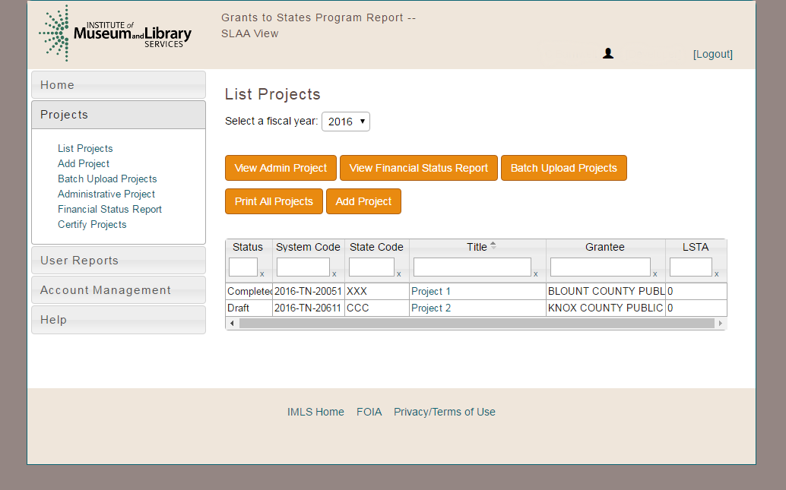



Click to Batch Upload, Print, and Add Projects
Click the project name to view a particular project.
Enter text to search the
table. Click the gray header to sort any column.
Click to view Admin Project and Financial Status Report.

Figure 3: The View Project Page

- Click on the title of a project to open the project detail page.

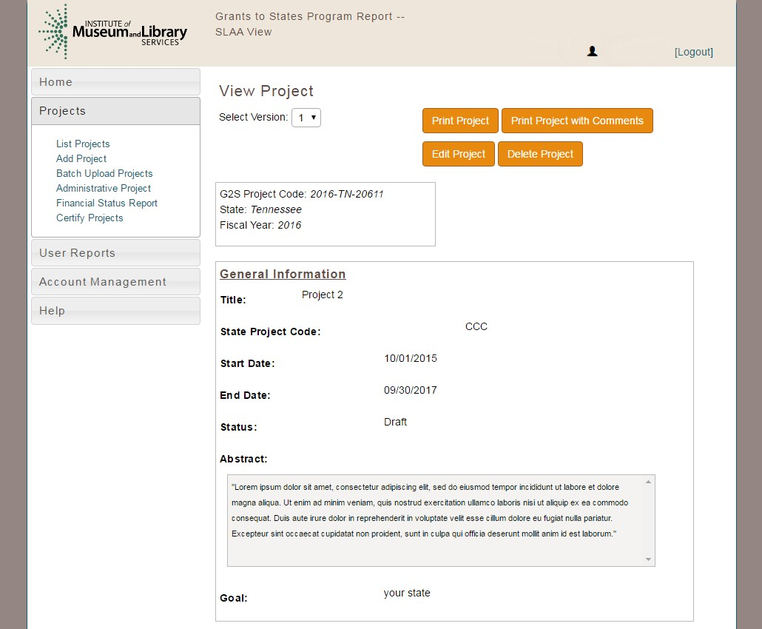
Figure 4: Project Detail Page

Add Project
- Click Add Project under the Projects menu or click the Add Project button from the List Projects view

  - Select Add a new project for a new project
OR

  - Select Continue a project from a prior fiscal year to copy a project from a prior fiscal year that is continuing (use this option to indicate that the project continues from a prior year)
    - Select Fiscal Year of project to be copied
    - Select Project Title of project to be copied
OR

  - Select Copy a project to duplicate a project from the current or a prior fiscal year (use this option to copy a project report as a shortcut for data entry)
    - Select Fiscal Year of project to be copied
    - Select Project Title of project to be copied

- Enter Project Information
Note: fields marked with a red asterisk * must be completed before a project can be saved. Use the Table of Contents links at the top to jump to any part of a project.

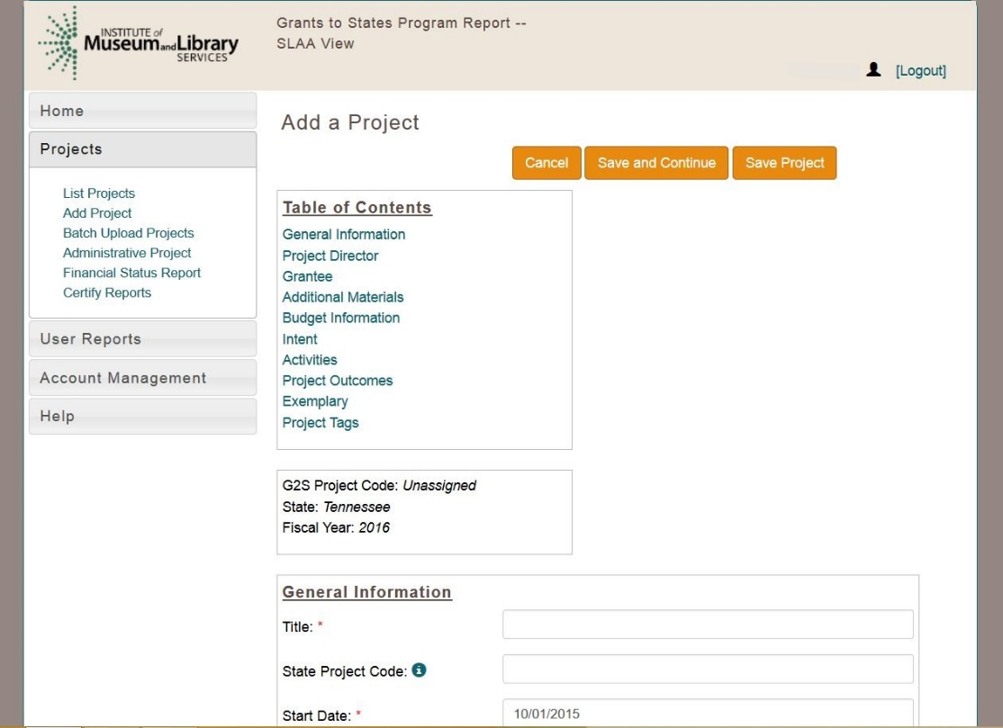

Figure 5: Add a Project

- Enter title (up to 75 characters), start date, end date, and abstract (90-160 words).
- Select a state goal from the drop down list (see section 5.3 to add/edit your state goals).
- Enter project Director information: name, phone and email.
- Grantee: select a grantee from drop down list (to add a grantee, see section 5.6.2).
- Add additional materials: enter URL for web site or click browse to upload a file (such as a survey, curriculum, or brochure) from your computer. Note: file names cannot include special characters (comma, dollar sign, plus sign, etc.).
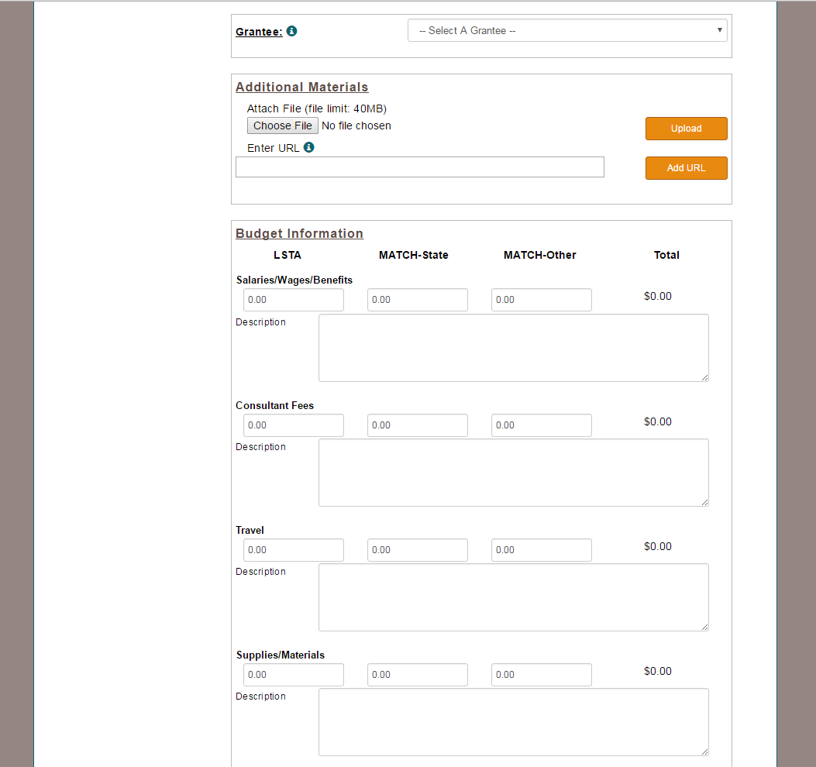
Figure 6: Grantees, Additional Materials, and Budget Information

- Enter Budget information.
Note: a description must be entered for any budget category that includes an expenditure.

- Click Add Intent.
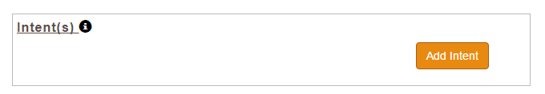
Figure 7a. Add Intent

- Select an Intent from the dropdown menu and click the Add button.
Note: Select only 1 intent per project (See Appendix 2: Focal Areas and Intents for the full list of Intents).
Figure 7b. Add Intent
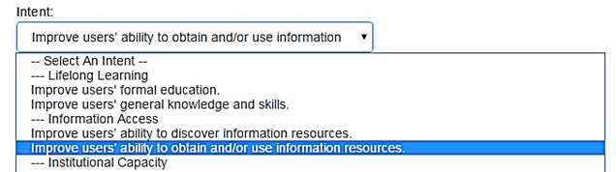

- Select 1 to 2 subjects and click the Add button
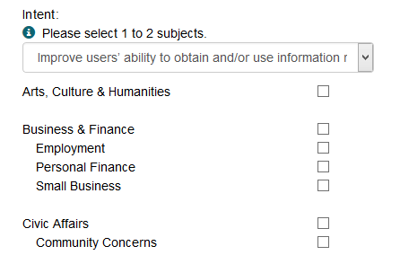

Figure 8. Add Subjects

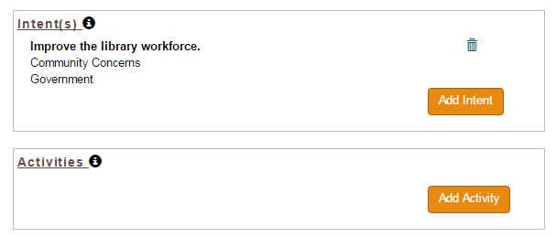
Figure 9. Add Activities

- Click Add Activity.
- Enter unique title and a basic abstract. Please note each project should have no more than 10 activities.
- Select intent from drop down menu for this particular activity.
- Select an activity type. Note: Options vary according to activity type; see Data Elements within the State Program Reporting Requirements document.
- Select appropriate mode and format.
- Quantity Information: Enter appropriate quantity information for activity (see Data Elements within the State Program Reporting Requirements document).
- Enter Partner Information.
Note: partnership requires a formal agreement where partner contributes material resources (materials/funds/staff). If there are partners, fill out both partner sections (area and legal type).
- Enter Beneficiaries.
Note: Options vary according to beneficiary type; see Data Elements within the State Program Reporting Requirements for detailed beneficiary information.
- Enter Locale Information (Select “Yes” or “No” for statewide project, then enter specific institution information or numbers by types of institution).
- Click Save Activity. You will be returned to “Add a Project” screen.
- Within the project, the Activities area will now display editing tools (copy activity, edit activity, and delete activity) and a button for Outcomes.

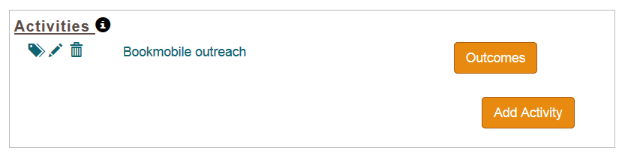
Figure 10. Add Outcomes data for Activities

- Enter Outcomes data for activities with the following “Activity – Mode – Beneficiary” combinations:
“Instruction – Program – Public”
“Instruction – Program – Workforce”
“Content – Acquisition/Creation – Workforce”
“Planning/Evaluation – Workforce”
Note: The Outcomes button will appear in orange (=active) for any activity that should include outcomes.
- Click the Outcomes button associated with the relevant activity.
- Enter the Total Number of Survey Responses.
- Enter the number of responses for each relevant outcomes statement (see the State Program Reporting Requirements document for additional information on Outcomes).
- Click Save.
- Below the Activities section, enter additional outcomes information using narrative and close-ended question fields.
- If you answer yes to “Do you anticipate continuing this project after the current reporting period ends?”, then you will be asked follow up questions to describe changes in the project.
- Enter up to 3 Project Tags separated by commas (unique terms describing the project for search and retrieval).
- Click Save Project. (Project will be saved as “Draft” status automatically and you will return to the List Projects page, unless you use the Save and Continue option.)

Edit Projects and Activities
- From the List Projects view, click title of project to edit.
- Click Edit Project button.
Note: if project status is Completed, you must first select “Draft” under Project Status and save the project before editing.
- Make any changes and click Save.
Note: All projects must be marked Completed before report can be validated or certified.

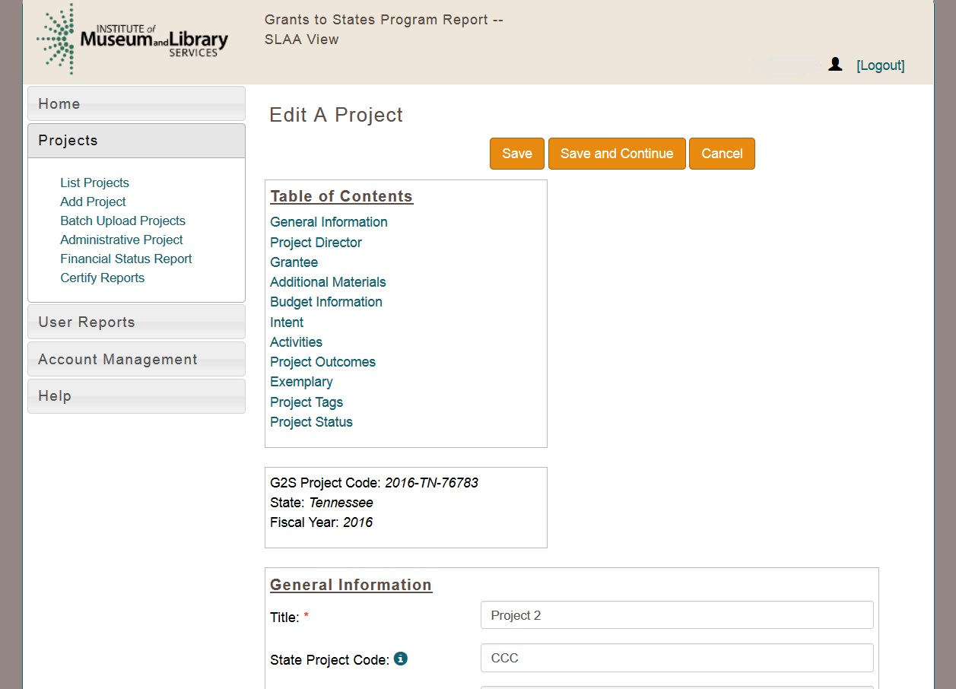
Figure 11: Edit a Project

2.3.1 Edit Activities
- In Edit A Project view, click the “Edit” icon 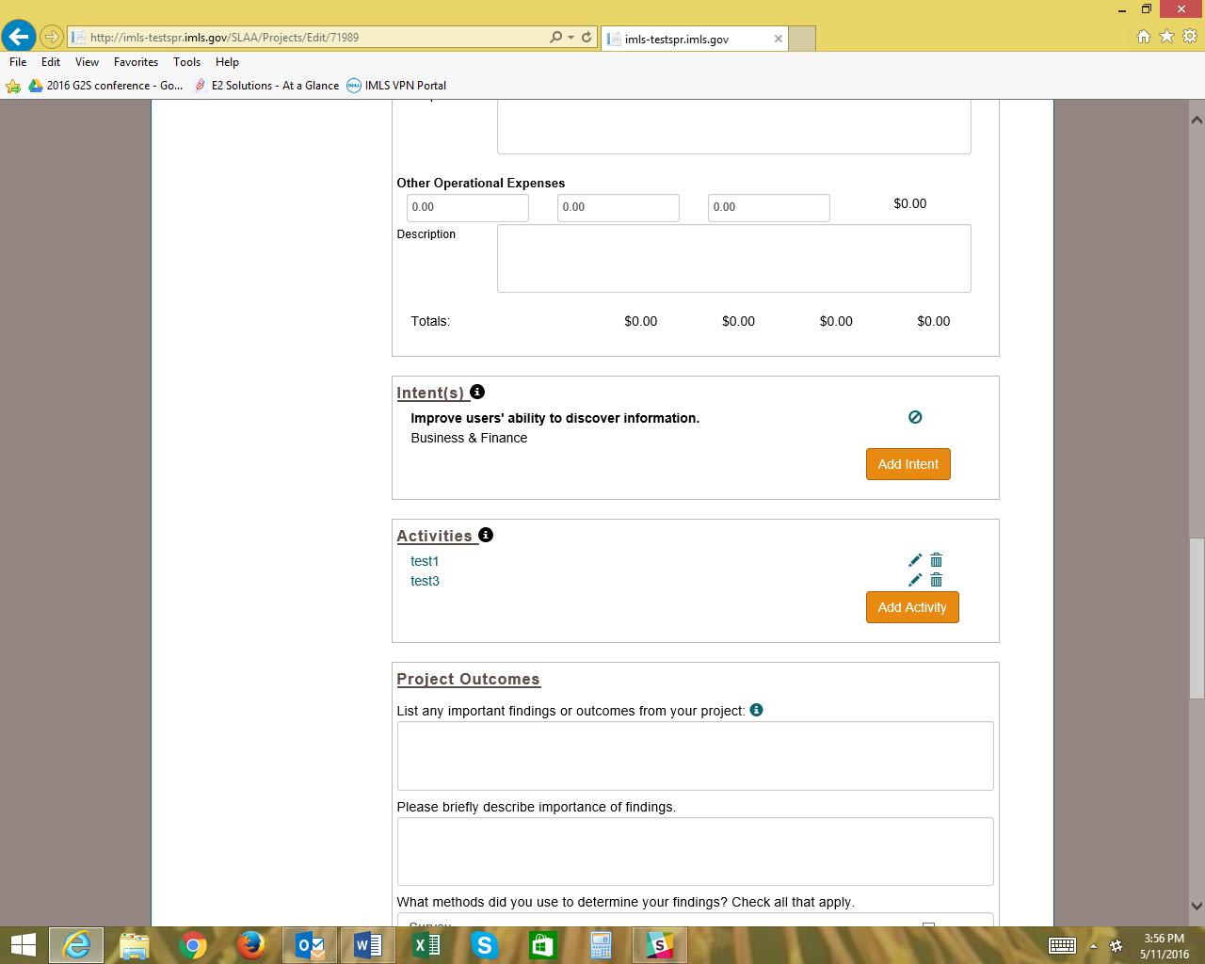 associated with a specific activity.
- Make changes and click Save Activity. System will return to Edit A Project view.

2.3.2 Copy Activities
- In Edit A Project view, click the “Copy” icon associated with a specific activity.
- Activity opens for editing and saving as above. (Change title of Activity to avoid confusion.)

2.3.3 Delete Activities
- In Edit A Project view, click the “Delete” icon associated with a specific activity.
- Click OK to confirm deletion.

Print Projects
- Individual Project (Including Administrative Project and FSR)
  - From View Project page, click Print Project.

- All Projects:
  - Select List Projects under Projects menu.
  - Click Print All Projects button.

Delete Projects
- Select List Projects under Projects menu
- Click title of project to be deleted.
- On View Project screen click Delete Project button.
- Confirm delete, by clicking OK.

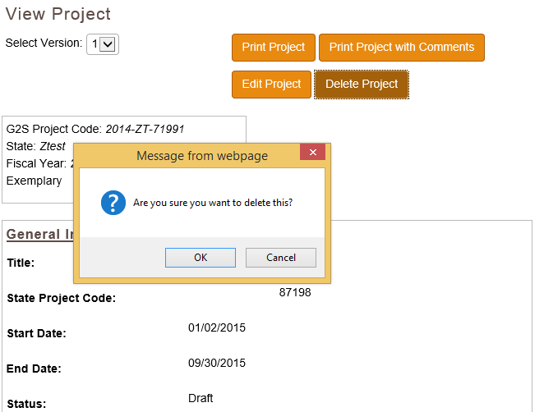
Figure 12: Delete Project

Batch Upload Projects
Projects may be added using the batch upload function to enter basic project-level data. The fields available for upload include: Project Title, Fiscal Year, Project Abstract, State Project Code, Start Date, End Date, Tags and Budget Amounts by Category.
- Click on Batch Upload Projects under Projects menu.
- Download appropriate Excel Template (seen in Figure 13).
- Enter data in the named fields for the projects to be added.
- Save file.
- On Batch Upload Projects page, click Browse and select saved Excel file.
- Click Upload.

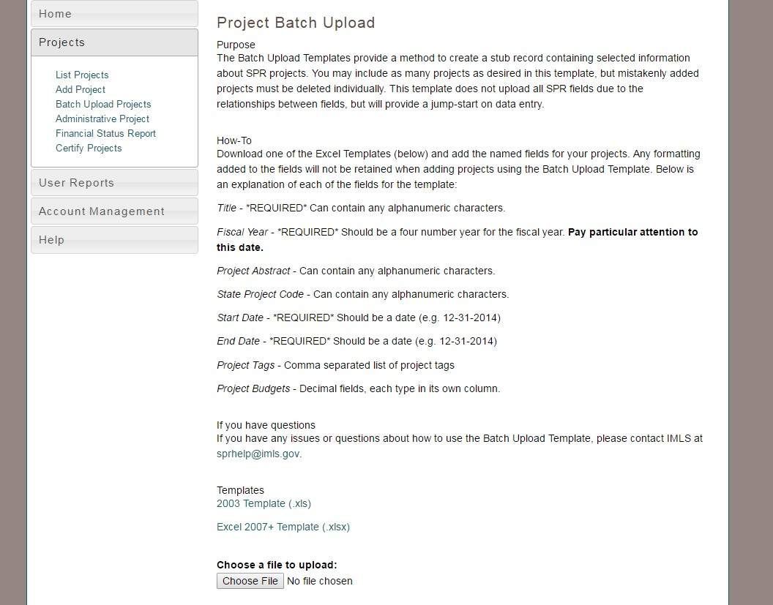
Figure 13: Project Batch Upload

Financial Status Report (FSR) and Interim Federal Financial Report (FFR)

Entering the FSR Data
FSR data should be entered for the two-year award period that has ended in September of the year in which you are reporting. The FSR corresponds to entered projects, which populate some FSR data.
- Click on Financial Status Report under Projects menu.
- Select Final.
- Enter Federal Grant Number (e.g., LS-00-XX-XXXX-XX; required to save record).
- Select Report Basis (required to save record).
- Enter Maintenance of Effort (MOE).
- Enter all other recipient outlays not previously reported (if applicable).
- Enter total unliquidated obligations (expected to clear by Dec. 30 or later IMLS-approved date):
- Enter IMLS-approved date unliquidated obligations are expected to clear (if applicable).

The following fields are system-generated and cannot be edited:
- Total Federal Funds Authorized for This Funding Period
- Funding Grant Period of Performance
- Period Covered By This Report
- Minimum MOE Required
- MATCH-State Funds expended specifically on the Five-Year-Plan (auto-populated from projects)
- MATCH-Other funds expended specifically on the Five Year-Plan (auto-populated from projects)
- Total Match (system calculated; must be at least $.01 to successfully validate report)
- Minimum Match Required (system calculated)
- Unobligated balance of Federal funds (these funds to be deobligated) (system calculated)
- Federal share of net outlays (system calculated)
- LSTA Administrative Costs
  - Allowed: This figure represents 4% of the federal allotment (system calculated)
  - Actual: Auto-populated from the Administrative Project.
  - Difference: The system-calculated difference between the allowed 4% and what the State Library spent to administer this grant program.

The following fields are system-generated upon certification by the Authorized Certifying Official (will appear blank until report has been submitted). Note: this information populates from the State Info section in the Account Management menu.
- Name of Authorized Certifying Official
- Title of Authorized Certifying Official
- Signature of Authorized Certifying Official
- Phone Number of Authorized Certifying Official
- Email of Authorized Certifying Official
- Report Status
- Date Report Certified
- Agency DUNS
- Agency EIN
- Agency Name

Click Save.

Certifying the FSR
See Section 6) Submitting the Full Report to IMLS for more information about how to certify and submit FSR and Project reports to IMLS.

Entering the Interim FFR Data
Interim FFR data should be entered for the open two-year award that will end the following year. Note: do not round this data – use exact figures.
- Click on Financial Status Report under Projects menu.
- Select Interim.
- Enter Federal Grant Number (e.g., LS-00-XX-XXXX-00; required to save record).
- Enter Recipient Account Number or Identifying Number, if any.
- Keep the default Report Type (should be Annual).
- Select Basis of Accounting (required to save record).
- Keep the default dates for Project/Grant Period (the full two years of the award) and Report Period End Date (September 30 of the first year of the award).
- Enter Cash Receipts (funds drawn down as of September 30 of the first year of the award).
- Enter Cash Disbursements (any funds paid out that you will be charging to the federal award; number should match “Federal share of expenditures”).
- Enter Federal share of expenditures (number should match “Cash Disbursements”).
- Enter Federal share of unliquidated obligations, if any.
- Enter Recipient share of expenditures, if any (Match funds).
- Enter Program Income, if any (typically will be 0).
- Leave the Indirect Expenses section blank.

The following fields are system-generated and cannot be edited:
- Recipient Organization, DUNS Number and EIN (populates from the State Info section in the Account Management menu)
- Cash on Hand
- Total Federal funds authorized
- Total Federal share
- Unobligated balance of Federal funds
- Total recipient share required
- Remaining recipient share to be provided

The following fields are system-generated upon certification by the Authorized Certifying Official (will appear blank until report has been submitted). Note: this information populates from the State Info section in the Account Management menu.
- Name of Authorized Certifying Official
- Title of Authorized Certifying Official
- Signature of Authorized Certifying Official
- Phone Number of Authorized Certifying Official
- Email of Authorized Certifying Official
- Report Status
- Date Report Certified

Click Save.

Certifying the Interim FFR
The Interim FFR is certified separately from the FSR, Administrative Project, and Project reports. There is no validation process.
- The Authorized Certifying Official will login to the system to certify the report.
- Click on Financial Status Report under Projects menu.
- Select Interim.
- Select Certify.

Administrative Project

Entering the Administrative Project Data
Each SLAA must submit an Administrative Project, even if no LSTA funds have been expended.
- Click Administrative Project under Projects menu.
- Enter title and abstract describing expenditure of funds (enter NA if no funds expended).
- Intent: Defaults to “Administer the LSTA Program.”
- Grantee: Defaults to name of SLAA.
- Start Date: Enter start date of Administrative Project.
- End Date: Enter end date of Administrative Project.
- Enter Budget information.
Note: a description must be entered for any budget category that includes an expenditure.
- Click Save.
Note: Administrative Project must be marked “Complete” to be certified.

Certifying the Admin Project
See Section 6) Submitting the Full Report to IMLS for more information about how to certify and submit Project reports and FSR to IMLS.

Account Management

User Info

- Click on User Info under Account Management menu.
- Enter user information (Title, address, etc.).
- Click Save.
Note: Users may change the password here.

State Info

- Select State Info under Account Management menu.
- Enter Agency information: EIN, DUNS, Address, Parent Organization (this information must match your SAM.gov registration).
- Enter contact information for the following officials:
  - Chief Officer (required)
  - Authorized Certifying Official (required)
  - LSTA Coordinator (required)
  - Library Development
  - Fiscal Officer

- Click Update.

State Goals

- Select State Goals under Account Management menu.
- Click Add State Goal.
- Enter name (brief version of goal that will appear in SPR reports).
- Enter description (complete goal).
- Click Save.

To Edit or Delete State Goals:
- Click goal.
- To edit, Click Edit Goal button.
- Edit goal and click Update.
- To delete goal, click Delete Goal.
- Confirm deletion.

Subaward Info

- Select Subaward Info under Account Management.
- Enter information regarding your subaward activity:
- Number of subaward applications
- Number of subawards funded
- Number of applicants
- Number of applicants receiving subawards
- Total amount of subaward funds requested
- Total amount of subaward funds awarded

If you have entered previous fiscal year information, you can view it by selecting a different fiscal year.

Subrecipient User Access
The LSTA coordinator and ACO accounts have permission to manage subrecipient user accounts in the system. They may establish user accounts as well as update lost/forgotten passwords for subrecipients. For subrecipient institutions (aka “subgrantees”), see Section 5.6) Manage Subrecipient Institutions.

Add Subrecipient User
- Under the Account Management menu, click Subrecipient Access.
- Click Add User.
- Enter contact information (email address will be used to log in).
- Enter and confirm password.
- Select assigned subrecipient (affiliated institution).
- Select Save User.

View/Edit Subrecipient User
- Under the Account Management menu, select Subrecipient Access.
- Click on username to view/edit user information.
- Edit the text fields and click Update User to save changes.

Delete Subrecipient User
Note: The system retains all user account information, but user accounts may be marked “Inactive” to prohibit access to the system.
- Under the Account Management menu, click Subrecipient Access.
- Click on username of account to be deleted.
- Under User Status, select “Inactive.”
- Click Update User.

Manage Subrecipient Institutions
This section is designed to manage the list of subrecipient institutions (formerly subgrantees) for the SLAA. Subrecipient user access is explained above in Section 5.5) Subrecipient User Access. Note: A list of subrecipients has been prepopulated from data sources such as the Public Library Survey, IPEDS, and the Common Core Database.

View Subrecipient Institution List
- Under the Account Management menu, click Manage Subrecipients.
- Click subrecipient name to view complete subrecipient record.

Add Subrecipient Institution
- Under the Account Management menu, click Manage Subrecipients. Click Add Subrecipient.
- Enter institution information (fields marked with red asterisk are required to save record)
- Click Save.

Edit Subrecipient Institution
- Under the Account Management menu, click Manage Subrecipients.
- Click subrecipient name to view complete subrecipient record.
- Click Edit Subrecipient.
- Edit as needed and click Save.

Delete Subrecipient Institution
- Under the Account Management menu, click Manage Subrecipients.
- Click subrecipient name to view complete subrecipient record.
- Click Delete Subrecipient.
- Confirm deletion.

Submitting the Full Report to IMLS
The LSTA Coordinator should “validate” the report prior to certification by the Authorized Certifying Official.

Validating the Report (LSTA Coordinator account only)
- Under the Projects menu, click Certify Projects.
- Click Validate Reports button.
- If no errors, system will indicate “The report successfully validates.”
- If errors exist, project reports must be corrected before validating again.

The list of errors will include project numbers with associated issues. The following table provides the list of possible error messages and where in the report they are located:

Error Message | Error Location
A project must have a Start Date that falls within the reporting period. | Project
A project must have an End Date that falls within the reporting period. | Project
A project must have an abstract (field cannot be null). | Project
A project must have a Project Director’s name, phone, and email (fields cannot be null). | Project
An activity must have an abstract (field cannot be null). | Project Activity
User must select at least one item (Urban, Suburban, Rural) if user selected "Targeted Group" for "Is the activity for a targeted group or for the general population?" | Project Activity
User must select one item for the question “Select one or more of the following activity target age groups” if user selected “Targeted Group” for “Is the activity for a targeted group or for the general population?” | Project Activity
User must select one item from “If the activity is directed at those in one or more of the following economic situations, select one or more” if user selected “Targeted Group” for “Is the activity for a targeted group or for the general population?” | Project Activity
User must select one item from “If the activity is directed at ethnic or minority populations, select one or more” if user selected “Targeted Group” for “Is the activity for a targeted group or for the general population?” | Project Activity
A description is required if user selects "Yes" to “Is the activity directed at groups that fall into a category not already captured?” | Project Activity
A project must have a Start Date that falls within the reporting period. | Admin Project
A project must have an End Date that falls within the reporting period. | Admin Project
The Funding Grant Period must fall within the reporting period. | FSR
The “Period Covered By This Report” must fall within the reporting period. | FSR
If the value of “Unliquidated obligations” is not null, a date is required for “IMLS-approved date unliquidated obligations are expected to clear.” | FSR
The SLAA must have a name (field cannot be null) | State Info  State Info  (continued)
The address, city and zip code must have a description (fields cannot be null). | State Info  State Info  (continued)
The DUNS cannot be null | State Info  State Info  (continued)
The EIN cannot be null | State Info  State Info  (continued)
The Parent Organization must have a description (fields cannot be null) | State Info  State Info  (continued)
The Name of Chief Officer cannot be null. | State Info  State Info  (continued)
The Chief Officer Title cannot be null. | State Info  State Info  (continued)
The Chief Officer phone number cannot be null. | State Info  State Info  (continued)
The Chief Officer fax number cannot be null. | State Info  State Info  (continued)
The Chief Officer email cannot be null. | State Info  State Info  (continued)
If “No” is selected for “Is the Chief Officer also the Authorized State Agency Official” the Name, Title, Address, City, State, and Zip code of the Authorized State Official is required (fields cannot be null). | State Info  State Info  (continued)
The Name of the LSTA Coordinator cannot be null. | State Info  State Info  (continued)
The LSTA Coordinator Title cannot be null. | State Info  State Info  (continued)
The LSTA Coordinator phone number cannot be null. | State Info  State Info  (continued)
The LSTA Coordinator email cannot be null. | State Info  State Info  (continued)

Certifying the Report (ACO account only)
Upon successful validation (by Coordinator), the Authorized Certifying Official will login to the system to certify the report.
- Under the Projects menu, click Certify Projects.
- Click the Certify Reports button.
- The system will indicate if report was successfully submitted. (See Section 6.1) Validating the Report if there are error messages).
- Note: the Interim FFR must be certified separately (see Section 3.4) Certifying the Interim FFR).

7) IMLS Review of Report
Once certified, IMLS will begin its review. If IMLS has questions regarding the content, then the SLAA will be contacted by an IMLS Program Officer. Should any changes need to be made, IMLS will return the report for revision. Projects to be revised will be returned to Draft status for editing. Once edits are complete, the LSTA Coordinator will need to revalidate the report and the Authorized Certifying Official will need to recertify the report.

User Reports
User reports are available for project activities that report “Outcomes.” In the main navigation menu, click User Reports.
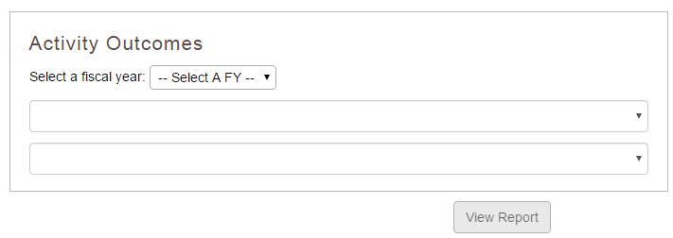

Figure 14: User Reports

- Select fiscal year from drop-down menu.
- Select project title and activity title from drop-down menus.
- Click View Report.
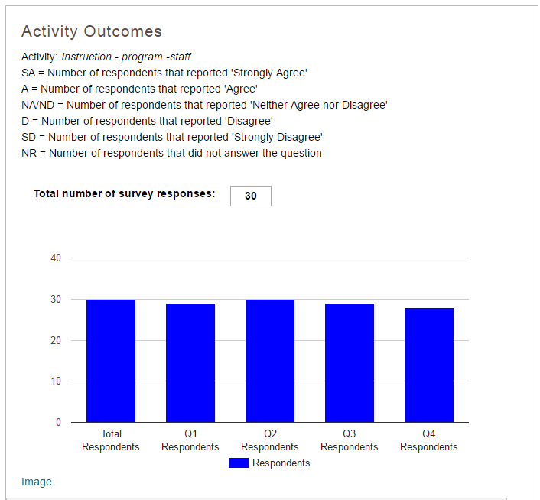
Figure 15: Activity Outcomes Report

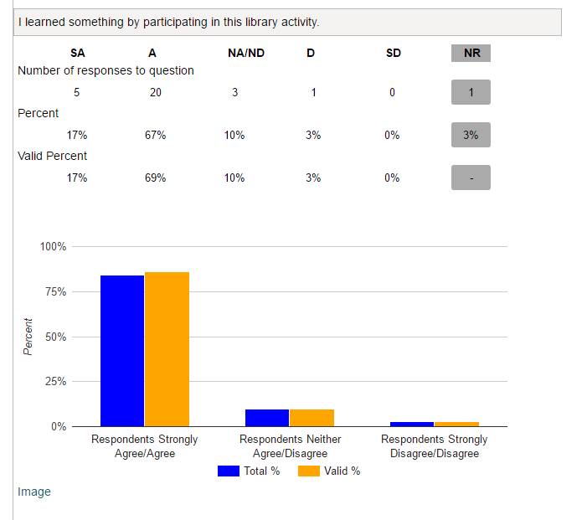
Figure 15a: Activity Outcomes Report

Note: A PNG image of each bar chart in the outcomes report is available by clicking the “Image” link below the
table: a new browser window will open with the graphic that can be copied or saved by right clicking the image.

Appendices

Appendix 1: Government Security Notice

Welcome to the online reporting system for IMLS' State Grant Program. Before entering your data and descriptions, please take a moment to review this information about security and privacy. After reading the information, click the "I Accept" button to demonstrate that you understand and agree to the conditions below and are ready to enter the system.

Security and Accuracy of Information: You are entering an Official United State Government System, which may be used only for authorized purposes. The Government may monitor and audit the usage of this system, and all persons are hereby notified that the use of this system constitutes consent to such monitoring and auditing. Unauthorized attempts to upload information and /or change information on this web site are strictly prohibited and are subject to prosecution under the Computer Fraud and Abuse Act of 1986 and Title 18 U.S.C. Sec. 1001 and 1030. Federal law provides criminal penalties of up to
$10,000 or imprisonment of up to five years, or both for knowingly providing false information to an agency of the United States Government. 18 U.S.C. Section 1001.

Privacy: Except as otherwise indicated, the information you submit through the online reporting system may be made publicly available through a public IMLS website. Information submitted to IMLS through the online reporting system may also be subject to disclosure as required by law under the Freedom of Information Act or other statutory provisions. For more information about privacy, please see our Privacy Policy.

Appendix 2: Focal Areas and Intents

Focal area | Intent
Institutional capacity | Improve the library workforce.
Institutional capacity | Improve library's physical and technology infrastructure.
Institutional capacity | Improve library operations.
Information access | Improve users' ability to discover information resources.
Information access | Improve users' ability to obtain and/or use information resources.
Lifelong learning | Improve users' formal education
Lifelong learning | Improve users' general knowledge and skills.
Human services | Improve users' ability to apply information that furthers their personal, family or household finances.
Human services | Improve users' ability to apply information that furthers their personal or family health & wellness.
Human services | Improve users' ability to apply information that furthers their parenting and family skills.
Employment &  economic development | Improve users' ability to use resources and apply information for employment support.
Employment &  economic development | Improve users' ability to use and apply business resources.
Civic engagement | Improve users’ ability to participate in their community.
Civic engagement | Improve users' ability to participate in community conversations around topics of concern.

Appendix 3: Activity, Mode, Format, and Quantity

Activity | Mode | Format | Quantities
Instruction | Program | Virtual
 |  | In-person | Program length (hours); # sessions in program; # times program administered
 |  | Combined in-person & virtual
 |  | Other
 | Presentation/performance | Virtual
 | Presentation/performance | In-person | Presentation/performance length (hours); # of presentations/performances administered
 | Presentation/performance | Combined in-person & virtual
 | Presentation/performance | Other
 | Consultation/drop-in/referral | Virtual
 | Consultation/drop-in/referral | In-person | # consultation/reference transactions
 | Consultation/drop-in/referral | Combined in-person & virtual | # consultation/reference transactions
 | Consultation/drop-in/referral | Other
 | Other | Virtual
 |  | In-person
 |  | Combined in-person & virtual
 |  | Other
Content | Acquisition | Digital | # hardware acquired; # software acquired; # licensed databases acquired; # print materials (books & government documents) acquired; # electronic materials acquired; # audio/visual units (audio discs, talking books, other recordings) acquired
 |  | Physical
 |  | Combined physical & digital
 | Creation | Digital | # items digitized; # items digitized and available to the public; # physical items; # open-source applications/software/systems; # proprietary applications/software/systems; # learning resources (e.g. toolkits, guides); # plans/frameworks
 |  | Physical
 |  | Combined physical & digital
 | Preservation | Digital | # of items conserved, relocated to protective storage, rehoused, or for which other preservation-appropriate physical action was taken; # items reformatted, migrated, or for which other digital preservation-appropriate action was taken; # preservation plans/frameworks produced/updated (i.e. preservation readiness plans, data management plans)
 |  | Physical
 |  | Combined physical & digital
 | Description | Digital | # items made discoverable to the public; # collections made discoverable to the public; # metadata plans/frameworks produced/updated
 |  | Physical
 |  | Combined physical & digital
Content (cont.) | Lending | Digital | # total items circulated; average # items circulated/month; # total ILL transactions; average # ILL transactions/month
 |  | Physical
 |  | Combined physical & digital
 | Other | Digital
 |  | Physical
 |  | Combined physical & digital
Planning & Evaluation | Prospective | In-house | # evaluations/plans funded; # funded evaluations/plans completed
 |  | Third party
 | Retrospective | In-house | # evaluations/plans funded; # funded evaluations/plans completed
 |  | Third party
Procurement (associated only with Institutional Capacity intents) | Mode is not applicable | Format is not applicable | # equipment acquired; # acquired equipment used; # hardware items acquired; # acquired hardware items used; # software items acquired; # acquired software items used; # materials/supplies acquired; # acquired materials/supplies used

Appendix 4: Glossary of Terms

Academic (institution type): A library that is attached to a higher education institution which supports the school's curriculum and supports the research of the university faculty and students

Acquisition: See Content
Activity: Action(s) involving instruction, content, planning and evaluation, and/or procurement directed towards achieving an intent.

Additional Materials: Attachments or links to products that were developed as part of the grant. For example, a trustee manual.

Administrative Data: See Methods (Evaluation)

All ages: See Beneficiary

Allotment: Total Federal funds authorized to a State Library Administrative Agency for a specific Federal fiscal year.

Audio/Visual units: A work in a medium that combines sound and images, for example, a motion picture or video recording with a sound track, or a slide presentation synchronized with audiotape.

Average (number of attendees per session, presentations): The statistical mean.

Beneficiary: The people who will use, visit, participate, or otherwise experience a project activity.

Intergenerational: Groups consisting of unrelated members comprised of different generations; this excludes family groups (e.g. parent-child; grandparent-grandchild; aunt/uncle-nephew/niece).

Urban: As adopted from the framework of the National Center for Education Statistics, an area that contains 50,000 or more people within a principal city.

Suburban: As adopted from the framework of the National Center for Education Statistics, an area that contains 50,000 or more people but outside the principal city.

Rural: Neither an urban or suburban area using the definitions from the National Center for Education Statistics.

All ages: Denotes an activity that is aimed at group of people, regardless of age.

Low income: Based on a definition of the U.S. Census Bureau, individuals with incomes that fall below 200 percent of the annual poverty threshold.

Unemployed: Based on a definition of the Bureau of Labor Statistics, individuals who are not working but who are looking for work.

Limited functional literacy/informational skills: Persons who minimally or less than minimally engage in all those activities in which literacy is required for effective participation of their group or community.

Buildings & Facilities: See Subject

Certification: See Subject

Civic Engagement Focal Area: See Focal Area

Collection Development & Management: See Subject

Collections: The accumulation of books and other materials owned by a library, cataloged, and arranged for ease of access, often consisting of several smaller collections (reference, circulating books, serials, government documents, rare books, special collections, etc.)

Community Concerns: See Subject

Consortia: Any local, statewide, regional, interstate, or international cooperative association of library entities which provides the systematic coordination of resources by school, public, academic, and special libraries and information centers in order to improve services for the clientele of such library entities.

Consultant Fees: All expenses related to acquiring the services of an external consultant for a specific activity. Costs may include fees, travel, accommodation, and support services hired directly by the consultant. Narrative should include description of expertise of consultant along with actions/contributions to project. Include consultant name.

Consultation/drop-in/referral: See Instruction

Content: An activity type involving the acquisition, development, or transfer of information.

Acquisition: A type of content activity mode that involves selecting, ordering, and receiving materials for library or archival collections by purchase, exchange, or gift, which may include budgeting and negotiating with outside agencies (e.g., publishers, vendors) to obtain resources.

Creation: A type of content activity mode that involves the design or production of an information tool or resource (e.g. digital objects, curricula, manuals). Includes digitization or the process of converting data to digital format for processing by a computer.

Items (Creation): Within the Content-Creation mode, a “work” that is digitized or developed, such as a book, newspaper, or an archival finding aid.

Description: A type of content activity mode that involves bibliographic description, subject analysis, assignment of classification notation, and other activities involved in physically preparing an item for the shelf. Also includes describing metadata to provide access via web, mobile, or other application to digital resources (catalogs, e-books and journal collections, subscription databases, archival collections). It may also include development of software or hardware for the purposes of storing and/or retrieving information or enabling the act of experiencing, manipulating, or otherwise interacting with an information resource.

Items (Description): Within the Content-Description mode, a “work” that is made discoverable, such as a book, newspaper, or an archival finding aid.

Digital: Computer-mediated experiences, programs, or products intended to support learning or other activities, locally or via the Internet. The term includes commercial or non-commercial hardware, software, data transfer connections and protocols, systems at any scale, and metadata.

Items (Digital): A single concrete exemplar of a manifestation of an expression of an intellectual or artistic work, such as a digitized copy of a single-volume monograph. In some cases, an item consists of more than one physical object, for example, a video recording released on more than one cassette.

Lending: A type of content activity mode that involves the provision of a library’s resources and collections through the circulation of materials (general circulation, reserves). May also refer to the physical or electronic delivery of documents from a library collection to the residence or place of business of a library user, upon request.

Physical: Medium in or on which information (data, sound, images, etc.) is stored (for example, paper, film, magnetic tape or disk, etc.). The medium may be encased in a protective housing made of another material (plastic, metal, etc.).

Items (Physical): a single concrete exemplar of a manifestation of an expression of an intellectual or artistic work, such as a corporeal copy of a single-volume monograph. In some cases, an item consists of more than one corporeal object, for example, a multivolume set of reference books.

Preservation: A type of content activity mode that involves the managerial and financial considerations, including storage and accommodation provisions, staffing, and policy decisions, as well as techniques and methods of maintaining materials in an optimal condition, either in their original format or in a form more durable, through retention under proper environmental conditions or actions taken after an object or collection item has been damaged to prevent further deterioration. Includes digital preservation or the process of maintaining, in a condition suitable for use, materials produced in digital formats, including preservation of the technical metadata and the continued ability to render or display the content represented or described by the metadata. May also refer to the practice of digitizing materials originally produced in non-digital formats (print, film, etc.) to prevent permanent loss due to deterioration of the physical medium.

Continuing Education & Staff Development: See Subject

Creation: See Content

Description: See Content

Digital: See Content

Digital Literacy: See Subject

Disaster Preparedness: See Subject

Discovery: See Content

Early Literacy: See Subject

Economic and Employment Development Focal Area: See Focal Area

Electronic materials: Materials that are distributed digitally and can be accessed via a computer, the Internet, or a portable device such as an e-book reader. Types of electronic materials include e-books and downloadable electronic video and audio files. Electronic materials packaged together as a unit and checked out as a unit are counted as one unit. A database is not a type of electronic material.

Employment support: Helping people to choose careers or search for work; workforce development.

Equipment: Tangible personal property (including information technology systems) having a useful life of more than one year and a per-unit acquisition cost which equals or exceeds the lesser of the capitalization level established by the non-Federal entity for financial statement purposes, or $5,000. 2 C.F.R. § 200.33

Evaluation: Research that systematically collects and interprets information to assess the worth of a project, program, service, operation, and/or resource.

Exemplary project: A project(s) the SLAA considers the best, worthy of imitation or having the most impact. Describe a project that shows innovation and vision, impact on targeted audience, service to a new population group, etc.

Federal Share of Net Outlays: The Total federal funds authorized (Allotment) minus Total Unliquidated Obligations and Unobligated Balance. The federal share may not exceed 66 percent. (20 U.S.C. §9133(b)).

Focal Area: Set of related intents (objectives). A focal area represents the foundation for the organization of evaluative reporting in the Grants to States Program. SPR reporting does not require user input of a focal area; it is implicitly applied by choosing an intent.

Institutional Capacity Focal Area: Add, improve or update a library function or operation in order to further its effectiveness.

Information Access Focal Area: Improve users’ access to information.

Lifelong Learning Focal Area: Improve users’ knowledge or abilities beyond basic access to information.

Human Services Focal Area: Improve users’ ability to apply information that furthers their personal, family or household circumstances.

Economic and Employment Development Focal Area: Improve users’ ability to apply information that furthers the status of their jobs and/or businesses.

Civic Engagement Focal Area: Improve user engagement through their library that furthers the common or community good; or improve users’ ability to engage in their communities.

Focus Group: See Methods (Evaluation)

Formal education: Education received by an accredited institution.

Format: Controlled vocabulary characteristic of an SPR mode that describes how an activity is delivered (such as in-person, virtual, both in-person and virtual).

Grantee: The SLAA or a qualified subrecipient that receives Grants to States funds to carry out a project.

Household finances: An intent within the Human Services focal area related to how a household manages expenses and how its money is spent or saved.

Hardware: Mechanical, electrical, electronic, or other physical equipment and machinery associated with a computer system or necessary for the playback or projection of nonprint media. Basic microcomputer hardware includes a central processing unit (CPU), keyboard, and monitor.

Human Services Focal Area: See Focal Area

Information Access Focal Area: See Focal Area

In-kind contribution: The value of goods and services provided by the grant recipient towards the project. For example, a library might contribute photocopying, telephone service, or allocate some staff time.

In-person: See Instruction

In-person and Virtual: See Instruction

Institutional Capacity Focal Area: See Focal Area

Instruction: An activity type involving an interaction for knowledge or skill transfer.

Consultation/drop-in/referral: A type of instruction mode involving informal interaction with an individual or group of individuals (library staff or other professional) who provide expert advice or reference services to individuals, units, or organizations.

In-person: A type of instructional format where a program, presentation/performance, or consultation is carried out face-to-face.

In-person and Virtual: A type of instructional format delivered both in-person and via a computer or computer network.

Presentation/performance: A type of instruction mode involving formal interaction and passive user engagement (for example, an author’s talk).

Program: A type of instruction mode involving formal interaction and active user engagement (for example, a class on computer skills).

Session (Program): A type of single occurrence of a class, workshop or clinic within an instruction program.

Virtual: An activity format where a program, presentation/performance, or consultation is mediated by a computer or computer network.

ILL transactions: Item borrowed from another library for a patron because that item is checked out, unavailable for some other reason, or not owned by the library.

Intent: An objective or expected result in a project. Each focal area has at least one associated intent.

Interview: See Methods (Evaluation)

Intergenerational: See Beneficiary

Items: See Content

Learning resources: Within the Content-Creation mode, materials made available to aid an individual or group in gaining knowledge or skills, such as toolkits or guides.

Lending: See Content

Lessons Learned: Knowledge gained from completing a project.

Library Skills: See Subject

Library workforce: Library staff, trustees and volunteers.

Library operations: An intent within the Institutional Capacity focal area pertaining to activities involved in running a library or library system.

Library physical and technology infrastructure: Physical and technological components that support library activities.

Licensed databases: Large, regularly updated files of digitized information (bibliographic records, abstracts, full-text documents, directory entries, images, statistics, etc.) related to a specific subject or field, consisting of records of uniform format organized for ease and speed of search and retrieval. Database content is leased by vendors (EBSCO, OCLC, etc.) that provide electronic access to the data, usually through proprietary search software.

Lifelong Learning Focal Area: See Focal Area

Limited functional literacy/informational skills: See Beneficiary

Low income: See Beneficiary

Maintenance of Effort (MOE): The total State funds that were appropriated to and expended by your SLAA to support the purposes of LSTA, including SLAA funds to support the state’s current Five-Year Plan. These funds must be in the SLAA Budget.

Match-Other: Local or private funds (including in-kind contributions) used to support any of the Grants to States program priorities included in the SLAA’s Five-Year Plan, Combined with Match-State, it should comprise at least 34 percent of the net outlays.

Match-State: SLAA funds used to support any of the eight Grants to States program priorities included in the SLAA’s Five‐Year Plan. Combined with all other non-federal sources (Match-Local), it should comprise at least 34 percent of net outlays.

Methods (Evaluation): The selected technique used to collect and interpret information.

Administrative Data: Data collected for administering an organization. The review of these data is a type of evaluation method.

Focus Group: A type of research method used in evaluation involving a small group of people whose opinions about something are studied in order to learn their opinions that may be expected from a larger group.

Interview: A type of evaluation method in which information is verbally interchanged between two or more persons.

Participant Observation: A type of evaluation method where the evaluator views an activity or set of activities and records what they see; researchers also may participate in the activity or set of activities.

Survey: A type of evaluation method involving a series of the uniform set of structured questions asked of respondents in collecting information.

Mode: Controlled vocabulary characteristic of an SPR activity that describes how it is delivered, created, or experienced (such as program, presentation, acquisition, or preservation).

Open-source applications/software/systems: A computer program or website for which the source code is made available without charge by the owner or licenser, usually via the Internet, to encourage the rapid development of a more useful and bug-free product through open peer review.

Other: See Subject

Outcomes (Evaluation):
Effect of programs and services, change in individuals’ lives and in communities. (change in knowledge, attitudes, skills, behavior or condition).

Outputs (Evaluation): Program and services libraries provide. Level of participation in those programs and services.

Outreach & Partnerships: See Subject

Participant Observation: See Methods (Evaluation)

Partner: A cooperating institution, designated through a formal agreement that contributes material resources (i.e., materials, funds, staff) to the activity.

Physical: See Content

Planning and Evaluation: A type of activity involving design, development, or assessment of a project, program, service, operation, resource and/or user group.

Prospective: A planning and evaluation mode for projecting or forecasting a future condition of a project, program, service, operation, resource, and/or user group.

Retrospective: A planning and evaluation mode involving historical assessments of the condition of a project, program, service, operation, resource and/or user group.

Presentation/performance: See Instruction

Preservation: See Content

Print materials: Books, serials, and other information resources in a physical format, purchased for the use of library patrons and staff.

Procurement: An activity type for purchasing facilities, equipment/supplies, hardware/software, or other materials (not content) that support general library infrastructure.

Program: See Instruction

Project: A set of discrete and interdependent activities carried out to achieve an intent.

Project Director: The main person responsible for carrying out a project.

Project Tag: User-created subject heading that can be used to categorize a project. The tag can be subsequently searched to identify similar projects.

Prospective: See Planning and Evaluation

Protective storage: The keeping of noncurrent records in a secure location, either temporarily until a decision can be made concerning disposition or permanently in the case of records to be retained indefinitely.

Public Relations: Includes community relations and refers to those efforts dedicated to maintaining the image of the non-Federal entity or maintaining or promoting understanding and favorable relations with the community or public at large or any segment of the public.

Public (institution type): Using the definition of the National Center for Education Statistics, a library that serves all residents of a given community, district, or region, and (typically) receives its financial support, in whole or in part, from public funds. A public library is identified in state law.

Quantity: The amount and frequency of an activity. In evaluation of Grants to States projects in the SPR, a quantity is similar to an output except that it is associated with one specific activity type.

Report Type: “Final” indicates the final Financial Status Report (FSR) for the federal fiscal year award. “Interim” indicates the mid-point Federal Financial Report (FFR) for an award.

Research & Statistics: See Subject

Retrospective: See Planning and Evaluation

Rural: See Beneficiary

Salaries/Wages/Benefits: Includes all salaries, wages, and fringe benefits paid to staff directly contributing to the project. Narrative should include position titles, not names of individuals, and number of full time equivalents (FTE) in description.

School (institution type): A library that is an integral part of the educational program of an elementary or secondary school with materials and services that meet the curricular information, and recreational needs of students, teachers, and administrators.

Scope (Project Scope): The range of activities of a project.

Services: Listing of the costs of project activities to be undertaken by a third-party contractor or vendor, including a formal partner.

Session: See Instruction

SLAA (institution type): A State Library Administrative Agency (SLAA) is the official agency of a State charged by the law of the State with the extension and development of public library services throughout the State pursuant to 20 USC § 9122 (4), The Library Services and Technology Act.

Software: A generic term for computer programs and their associated documentation. A software product consists of a set of instructions written by a programmer, distinct from the manufactured hardware used to run it. The term includes systems programs such as operating systems (OS), database management systems (DBMS), utilities that control the operation of the computer itself, and application programs designed to process data and accomplish specific tasks for the user.

Special (institution type): A library established, supported, and administered by a private company, government agency, not-for-profit organization or professional association.

State Goal: A goal established by the SLAA in their Five-Year Plan.

State MOE (Maintenance of Effort): See Maintenance of Effort

Subgrant/subaward: Award provided by a pass-through entity to a subrecipient for the subrecipient to carry out part of a Federal award received by the pass-through entity. It does not include payments to a contractor or payments to an individual that is a beneficiary of a Federal program. A subaward may be provided through any form of legal agreement, including an agreement that the pass-through entity considers a contract. (2 CFR 200.92).

Subject: Descriptor for an intent.

Buildings & Facilities: Does not include construction.

Certification: The process by which a state agency, or a nongovernmental agency or organization authorized by a state government, evaluates the qualifications of an individual, organization, or institution to perform a specific service or function for the purpose of granting a credential.

Collection Development & Management: The process of planning, building, and supervising a useful and balanced collection of library materials over a period of years, based on an ongoing assessment of the information needs of the library's clientele, analysis of usage statistics, and demographic projections, normally constrained by budgetary limitations.

Community Concerns: An issue of importance or interest to the local community.

Continuing Education & Staff Development: Formal instruction for persons who have completed an academic degree, moved into the workplace, and undertake further study, sometimes at the initiative of the employer but also through voluntary attendance at conferences, workshops, seminars, or enrollment in postgraduate courses.

Digital Literacy: The ability to find evaluate, utilize, share and create content using information technologies.

Disaster Preparedness: Steps taken by a library or archives to prepare for serious damage to facilities, collections, and/or personnel in the event of a major occurrence such as a fire, flood, or earthquake, including preventive measures, formulation of an effective disaster plan, maintenance of adequate insurance, etc.

Early Literacy: Reading by children ages birth to 8.

Library Skills: Ability to use the library effectively.

Other: Any other subject that is not defined in any of the subject areas described.

Outreach & Partnerships: Connecting with other organization outside the home institution.

Research & Statistics: Studies and data collected to improve all aspects of library work.

Systems & Technologies: Automated software and hardware.

Subrecipient: A qualified organization that receives Grants to States funds from the SLAA.

Suburban: See Beneficiary

Supplies/Materials: Include costs for supplies and materials including computing devices (if the acquisition cost per unit is less than the lesser of the capitalization level established by the governmental unit for financial statement purposes, or $5,000) purchased specifically for the project. (2 C.F.R. § 200.94). Narrative should include descriptions and quantities of supplies/materials acquired.

Survey: See Methods (Evaluation)

Systems & Technologies: See Subject

Total Percent: The percentage of total responses per survey question for Activity Outcome (i.e., includes missing responses).

Total Unliquidated Obligations: The amount of any LSTA funds that were obligated by Sep. 30 but will not be liquidated by Dec. 30. (Allowed beyond the 90-day liquidation period only with prior approval from Grants to States staff). These are funds that you fully expect will be spent.

Travel: Travel costs must be related to the project activities and must be incurred by the staff working on the project. The costs include airfare, ground transportation, accommodation (lodging), meals, etc. (See 2 C.F.R. §200.474). For airfare, economy class must be used, unless otherwise allowable by law (see 2 C.F.R. §200.474). Narrative should include number of travelers and description of types of travel expenditures.

Unemployed: See Beneficiary

Unobligated Balance: The total of LSTA funds that were not obligated before Sep. 30 or that your SLAA will not be able to liquidate within the Grant Award Period, including any extensions provided by Grants to States staff. These are funds that will not be spent and will have to be returned to the U.S. Treasury.

Urban: See Beneficiary

User (system term): Person authorized to have access to the State Program Report (SPR) for the purpose of adding, editing, deleting and updating data. Users include designated staff in each SLAA, as well as IMLS Grants to States staff.

Valid Percent: The percentage of total number of question response per survey response for Activity Outcome (i.e., excludes missing responses).

Virtual: See Instruction

