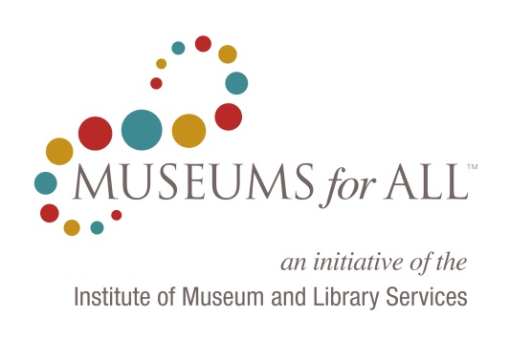
Register as a Museums For All Organization!
Name of Museum*
Type of Museum* |  | (drop menu)
 |  | (Art, history, science & technology, children's, historical societies, tribal museums, botanical gardens, planetariums, zoos, other)
Museum Website Address*
Museum Mailing Address:*
Street Address*
City*
State* |  | (drop menu)
ZIP Code*
Museum Contact – First Name*
Museum Contact – Last Name*
Museum Contact – Title*
Museum Contact – E-Mail*
Museum Contact – Phone number*
(Note: Personal contact information will not be released)
Museum Director/CEO (if different from contact)
Amount charged (planned) for admission for Museums For All visitors ($0-$3 USD)*
Amount charged for regular adult admission *
Museum operating budget (approx.)*
Total annual attendance (approx.)*
Do you plan to offer additional benefits to Museums For All visitors? Please describe.
By checking this box, you acknowledge that you must maintain the minimum requirements as laid out in the Museums For All guidelines in order to maintain the designation of a Museums For All museum. This designation will be renewed annually.* |  | □
By checking this box, you acknowledge that you must provide to IMLS and ACM, on a quarterly basis, the total numbers of visitors to your museum, and the number of visitors who utilized the Museums For All admission benefit.* |  | □
* = required field

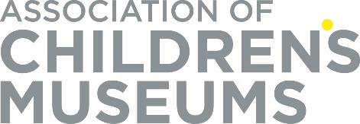

This information collection is being conducted in conformance with the Museum and Library Services Act of 2010, as amended. IMLS intends to make institutional participation information provided through this form publicly available. However, information specifically identifying any individual will be protected from public disclosure to the extent permitted by law.
The OMB control number, ####-###, expires on MM/DD/YYYY. The Institute of Museum and Library Services may not conduct or sponsor, and a person is not required to respond to, an information collection unless it displays a currently valid OMB control number.

