Museums For All Reporting
Museum Name*
Reporting Period* |  | (drop menu) |  |  | (Jan. 1 - Mar. 31, Apr. 1 - Jun. 30, Jul. 1 - Sep. 30, or Oct. 1 - Dec. 31)
Year* |  | (drop menu)
Number of Visitors - Total Museum*
Number of Visitors - Museums for All*
Do you have stories or testimonials about your Museums for All program or visitors? If so, please share them with us!
* required field

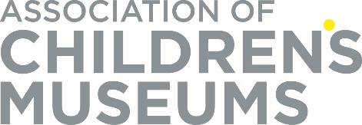

This information collection is being conducted in conformance with the Museum and Library Services Act of 2010, as amended. Visitor information provided through this form will be reported only in aggregate form or in a manner that will not specifically identify your organization. Information specifically identifying any individual will be protected from public disclosure to the extent permitted by law.
The OMB control number, ####-###, expires on MM/DD/YYYY. The Institute of Museum and Library Services may not conduct or sponsor, and a person is not required to respond to, an information collection unless it displays a currently valid OMB control number.

