**Non-substantive Change Request for the Census of Agriculture 0535-0226**

NASS is revising the process by which the OMB burden, confidentiality, and response statements are maintained and displayed in our web forms in conjunction with the release of our new Computer Assisted Web Interview (CAWI) platform. The three statements are now displayed automatically based on the survey metadata in our internal survey management system.

NASS would like to insert the OMB Expiration Date into the burden statement to consolidate the information and improve the user experience.

According to the Paperwork Reduction Act of 1995, an agency may not conduct or sponsor, and a person is not required to respond to a collection of information unless it displays a valid OMB control number. The valid OMB number is 0535-XXXX, which will expire on XX/XX/XXXX. The time required to complete this information collection is estimated to average XX minutes per response, including the time for reviewing instructions, searching existing data sources, gathering and maintaining the data needed, and completing and reviewing the collection of information.

With all printed versions of the questionnaires there will be no changes made the OMB control number or expiration date which will still be printed at the top of the front page.

1. Login Screen: Respondents will receive a pre-survey letter telling them the email address and access code to this system.

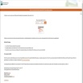

1. List of Available surveys: Once the respondent has logged into the system this screen will appear and tell the respondent which surveys they can complete.

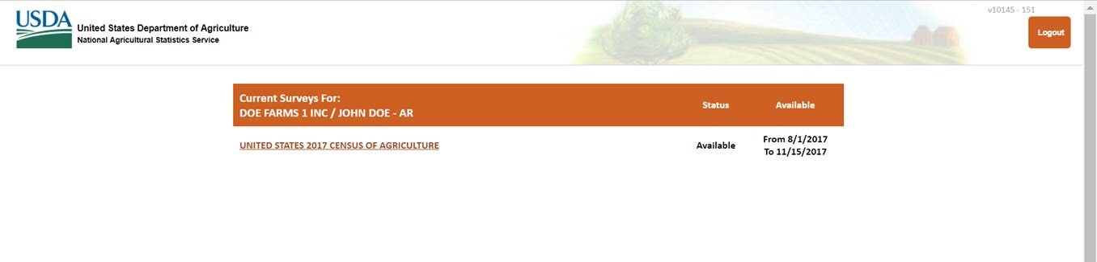

1. Address Verification Page: The respondent will then be asked to verify their name and address and they will see the burden statement, confidentiality statement and the voluntary/mandatory statement. The OMB number and expiration date will appear in the burden statement below.

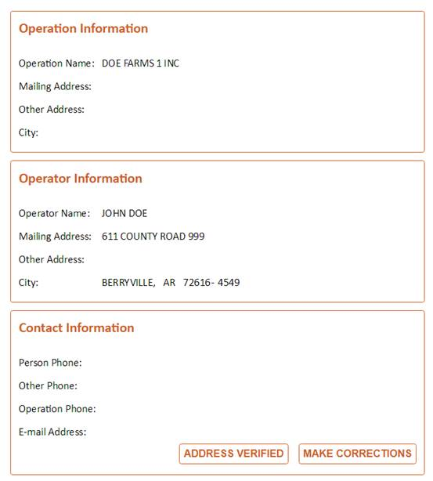

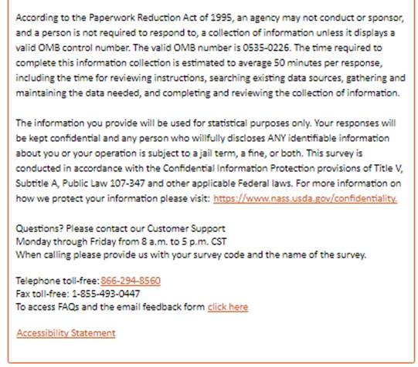

1. The respondent will then enter the questionnaire.