UNITED STATES DEPARTMENT OF AGRICULTURE
Farm Service Agency

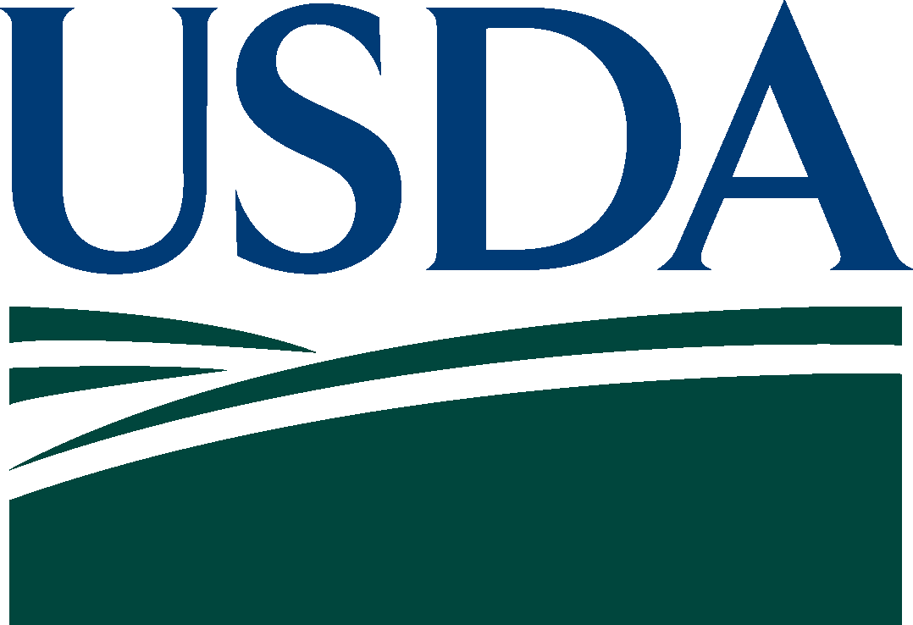

WA-502

LICENSING AGREEMENT
FOR
EXPORT FOOD AID COMMODITIES WAREHOUSE OPERATORS

WA-502 U.S. DEPARTMENT OF AGRICULTURE Form Approved – OMB No. 0560-0120
(proposal 3) Farm Service Agency
United State Warehouse Act

Contents
Licensing Agreement for Export Food Aid Commodities Warehouse Operators 3
Section A - Definitions 4
Section B - Qualifications 5
Section C - Duties of the Licensee 5
Section D - Inspection and Examination of Facilities 7
Section E - Temporary Suspension 8
Section F - Dispute Resolution and Arbitration 9
Section G - Fines and Penalties 9
Section H - Failures, Defaults – Remedies 9
Section I - Fees 10

Licensing Agreement for Export Food Aid Commodities Warehouse Operators

This Agreement applies exclusively to United States Government Export Food Aid Commodities (EFAC) stored or handled at a licensed port warehouse or transloading facility in the United States.

As a condition of initial licensing and continued licensing under the United States Warehouse Act (USWA), administered by the Deputy Administrator for Commodity Operations (DACO) for the United States Department of Agriculture (USDA), Farm Service Agency (FSA), the licensee agrees to the terms and conditions set forth in this Agreement and the regulations found at 7 CFR Part 735 and the statute found at 7 U.S.C. § 241 et seq.

No person may represent themselves as licensed under the USWA unless holding a valid (neither suspended nor revoked) license under the USWA.

Any person engaged in the business of handling EFAC, but not licensed under the USWA, is barred from participating in or benefiting from any USWA activity and any claimants against said person may not benefit from any of the USWA protections or coverage.

The USWA, regulations located at 7 CFR Part 735, and this Agreement prevail to the extent that the USWA, regulations located at 7 CFR Part 735, or this Agreement and any addenda conflict with the laws, regulations or practices of the various states, localities or municipalities. Additionally, as authorized by 7 CFR Part 735.2(b), and except as provided in this Agreement, the following USWA regulations are waived and do not apply to the Licensee under this Agreement:

7 CFR Part 735.14
7 CFR Part 735.110
7 CFR Part 735 Subpart E

As indicated by Department of Agriculture Civil Monetary Penalties Adjustment, 75 Fed. Reg. 17555 (April 7, 2010), the maximum civil penalty per violation located at 7 CFR Part 735.5(a) is $27,500.

The following is included by reference:

The United States Warehouse Act (7 U.S.C. § 241 et seq)

Section A - Definitions

Authorized Individual. An individual, including a warehouse examiner, designated by DACO to engage in activities authorized under the USWA.

Business Day. A calendar day excluding Saturday, Sunday, or legal holidays (unless business activity occurred).

Control of the Facility. The licensee’s ultimate responsibility for the operation and integrity of a facility by ownership, lease, or operating agreement.

Conveyance. The individual transportation unit (truck, railroad car, container, barge, or vessel) used in receiving or shipping EFAC.

Deliver. To move EFAC from the licensed facility and load the EFAC into a conveyance.

Deputy Administrator for Commodity Operations. The FSA designee under whose general direction and supervision all provisions and activities regulated under the USWA are administered.

Export Food Aid Commodities. For the purpose of this agreement, packaged or processed agricultural commodities received by a licensee under authorized U.S. government food aid programs for export.

Force Majeure. Those severe weather conditions, fire, explosion, flood, earthquake, nuclear incident, nuclear reaction, nuclear radiation, radioactive contamination, insurrection, riot, strike, labor dispute, acts of terrorism, act of civil or military authority, non-availability of transportation, or any other cause beyond the control of the licensee that renders performance virtually impossible, as determined by DACO.

Licensed Facility. Any facility designated by DACO for handling and/or storing EFAC under the USWA.

Licensee. A person licensed under the USWA that operates and has control of the licensed facility.

Persons. Individuals, corporations, companies, associations, firms, partnerships, societies, joint stock companies, a State or political subdivision of a State.

Port Warehouse. A structure or facility, as determined by DACO, for EFAC program use, in which any EFAC is stored or handled under the USWA.

Schedule of Fees. The fees charged and assessed by USDA for licensing and/or services furnished under the USWA to help defray the costs of administering the USWA.

Signature. Any name, mark or writing used with the intention of authenticating a document. It may be a hand-inscribed original, facsimile, digital, electronic or any other form of authentication as approved by DACO.

Transloading Facility. An area for transferring EFAC from one mode of transportation conveyance to another which may employ a temporary storage facility.

Section B - Qualifications

In general, EFAC licensees under the USWA must:

- be responsible persons, who:

- have knowledge of and experience in storing and/or handling packaged or processed agricultural commodities;

- are competent and willing to conduct the licensed facility in accordance with the USWA, Federal regulations, and this agreement; and

- have not committed a fraudulent or criminal offense indicating a lack of business integrity or business honesty that seriously or directly undermines the person’s responsibility as licensee.

- maintain facilities that:

- are physically and operationally suitable for the protection of stored and/or handled EFAC;

- allow for the accurate accounting and efficient handling of the stored and/or handled EFAC; and

- are under the licensee’s control.

- have personnel available who:

- have knowledge and experience in the storage and/or handling of packaged or processed agricultural commodities; and

- are able to assist authorized individuals with inspections and examinations.

Section C - Duties of the Licensee

In general, the licensee agrees, unless prevented from doing so by force majeure, to (each of the following):

1. exercise, at all times, such care in regard to EFAC as a reasonably prudent owner would exercise under the same circumstances and conditions and not handle and/or store such products in a manner that would cause or contribute to product loss, damage or contamination.

2. assure:

- all EFAC accepted for storage and handling are stored in licensed storage space;

B. all EFAC products are stored and handled with proper dunnage and pallets that are suitable for proper storage of EFAC; and

C. they are not currently delinquent or have not within three (3) years prior to executing this Agreement been delinquent for any Federal or State tax liability in an amount that exceeds $3,000.00.

3. provide:

- all necessary assistance in the execution of inspections and examinations by authorized individuals;

- to commodity suppliers and the consignee, or the consignee’s representative, detailed information of commodities received from the conveyance at the EFAC licensed facility. EFAC documentation acceptable to DACO must be signed by an authorized representative of the EFAC licensed facility, and shall include, but is not limited to, the name of the commodity, the quantity received, unloading date, and the commodity purchase order number;

- lighting;

- sanitary facilities for the use of employees; and

- security for EFAC to avoid tampering or adulteration.

4. maintain:

- records for a period of six (6) years for stored and/or handled EFAC and provide such reports with respect to receiving, storing, handling, and delivering EFAC as requested;

- at all times, legal and operational control of all licensed storage space and handling facilities;

- lot identity when receiving, handling, and delivering EFAC;

- the facilities in sound physical condition such that breaches in walls and floors are promptly repaired, doors are in good working order, and roof leaks are identified, controlled, and promptly repaired;

- the grounds such that:

- contamination of EFAC from adjacent properties is prevented;

- litter and waste are removed;

- tall grass and weeds are kept away from the licensed facility;

- equipment is stored such that it does not provide shelter for pests;

5) outside premises including yards, parking areas, and roads are well drained and maintained; and

6) adequate space is maintained between equipment and structures to allow cleaning and maintenance of the facility.

- EFAC to ensure that:

  - EFAC packages are kept clean and free of bird droppings, dust, rodent filth, and stains;

  - all chemicals or fertilizers, if any are stored in the warehouse, are stored in a separate area away from EFAC;

  - objectionable odors that could contaminate the EFAC are eliminated;

  - there are 18 inches of clearance between EFAC and ceilings/sprinkler heads; at least one main aisle or walkway a minimum of 24 inches wide, and 18 inches between walls and EFAC;
  - product stacking requirements are not exceeded;

  - storage areas are inspected for pest activity, moisture issues, and product quality on a regular basis (with results documented and records retained); and

  - DACO is promptly notified of any EFAC deterioration or condition which could adversely affect EFAC.

G. a reasonably clean facility at all times, free of materials that could create a hazard or interfere with the handling of EFAC, and provide a safe environment in and around the storage and/or handling facility;

H. records of salvaged EFAC and EFAC disposal;

I. a comprehensive pest control program that keeps the facility free of insects, rodents, birds and any other pests that may adversely affect the condition of EFAC, and ensure that:

  - such program is in writing, is available for review upon request, and is implemented by trained in-house personnel, or by registered, trained, or licensed contractors;

  - results of inspections and corrective actions in the pest control program are documented and records retained for three (3) years;

  - only pest management materials that meet all regulatory or contractual requirements and restrictions are used;

  - copies of credentials (certifications or registrations) of those who perform pest management services are retained on file for three (3) years;

  - copies of contracts with outside providers are retained on file for three (3) years; and

  - areas of the facility undergoing treatment are properly marked with signage and barriers to prevent exposure to hazardous materials.

J. a written security plan that includes measures to protect EFAC stored and/or handled under this Agreement.

5. report immediately to DACO:

- the occurrence of significant loss, damage, or contamination to EFAC, and the extent and cause, if known; and

- EFAC that has been in storage in excess of 30 days by shipper. The report should include commodity, date of delivery, contract number, lot number, and/or purchase order number.

6. not accept EFAC that are damaged, including torn packaging exposing the commodity, or EFAC otherwise not suitable for storage and/or handling.

7. deliver stored and/or handled EFAC without unnecessary delay unless prevented by force majeure.

8. conduct a facility risk assessment and establish procedures that address:

- general security of the physical structures and grounds of the facility;

- shipping and receiving procedures to ensure that EFAC are not subject to tampering;

- action to be taken in the event of a national emergency; and

- contact information for local security authorities.

9. post any certificates of licensing issued by DACO.

10. implement U.S. Coast Guard approved security plan as required.

Section D - Inspection and Examination of Facilities

The licensee agrees (each of the following):

  - that USDA has unrestricted access to the facility.

  - that authorized individuals are permitted to enter and inspect or examine, on any business day during the usual hours of business, any USWA licensed facility.

  - that the books, records, papers, accounts, and the contents thereof relating to the license are subject to inspection or examination.

  - to furnish to authorized individuals the assistance necessary to conduct an inspection or examination.

  - to promptly respond to violations noted on the examination. The response will include the corrective action on items completed and a corrective action plan on items to be completed, including a timetable for completion.

  - to immediately notify DACO of any additions or deletions of facilities, or any change in ownership or operational control of facilities.

Section E - Temporary Suspension

DACO may temporarily suspend the USWA EFAC license, prior to an opportunity for a hearing.

  - The grounds for temporary suspension by USDA include, but are not limited to:

- failure to perform the duties specified, failure to meet the requirements of the USWA and/or violations of the regulations or this Agreement;

- failure to maintain legal and operational control of the licensed facilities;

- indication or commission of a fraudulent act;

- incapacity or incompetence of the licensee;

- any action by the licensee that may place EFAC at risk;

- failure to provide a safe work environment;

- failure to ensure adequate security or protection of stored and/or handled EFAC from tampering or adulteration; and

- failure to pay fees required under this Agreement.

2. Upon temporary suspension, the licensee will:

- not receive additional EFAC products without approval of DACO;

- not remove or deliver from inventory any EFAC without prior approval of DACO;

- take corrective action within the time frame specified in the temporary suspension; and

- not represent themselves as licensed in good standing or perform the functions of a USWA licensee.

3. DACO will notify the licensee:

  - by mail, email, phone, or fax of the suspension;

  - of the reason for the suspension;

  - of an on-going review of the situation;

  - of the time period for expected compliance;

  - whether public notice will be made of a temporary suspension and of subsequent revocation of the USWA license;

  - that revocation of the USWA license may be anticipated for noncompliance; and

  - that progression from temporary suspension to revocation may be appealed as presented in Section H Failures, Defaults – Remedies.

Section F - Dispute Resolution and Arbitration

  - A person may initiate legal action in any district court of the United States concerning a claim for noncompliance or an unresolved dispute with respect to activities authorized under the USWA.

  - Any claim for noncompliance or an unresolved dispute between the licensee and another party with respect to activities authorized under the USWA may be resolved by the parties through mutually-agreed upon arbitration procedures.

  - In no case will USDA provide assistance or representation to parties involved in a court or arbitration proceeding arising with respect to activities authorized under the USWA and the regulations.

Section G - Fines and Penalties

The licensee and their employees are subject to the provisions of criminal and civil fraud statutes that apply to making a false certification or statement, fraudulent adjustments or corrections, and concealment of operational or financial condition and as such may be punishable by imprisonment, fines, and other penalties, including but are not limited to, the following: 18 U.S.C. § 286, 287, 371, 641, 651, 1001, and 1014; and 31 U.S.C. § 3729.

Section H - Failures, Defaults – Remedies

  - DACO may initiate a suspension or revocation of a license and initiate movement of EFAC to another licensed facility or alternate location as determined by DACO if licensee fails to:

- perform services required by this Agreement;

- maintain control of the facility;

- provide a safe work environment; or

- ensure adequate security or protection of stored or handled EFAC from tampering or adulteration.

2. DACO may initiate a suspension or revocation of a license and initiate movement of EFAC to another licensed facility or alternate location as determined by DACO if the licensee commits a fraudulent act related to the purposes of the storage or handling of EFAC under this agreement.

3. Upon suspension of the license, the licensee will:

  - not receive additional EFAC products without approval of DACO;

  - not remove or deliver from inventory any EFAC without prior approval of DACO;

  - take corrective action within the time frame specified in the suspension; and

  - not represent themselves as licensed in good standing or perform the functions of a licensed USWA licensee.

4. DACO will notify the licensee:

  - by mail, email, phone, or fax of the suspension;

  - of the reason for the suspension;

  - of an on-going review of the situation;

  - of the time period for expected compliance;

  - whether public notice will be made of a suspension and of subsequent revocation of the USWA license; and

  - that revocation of the USWA license may be anticipated for noncompliance.
5. Suspension, revocation, and liquidation are taken in accordance with the adverse determination rules in 7 CFR 735.8 which provide for a hearing before DACO.

6. The USWA licensee may request revocation of their license. In that case, the USWA license will be revoked pending administrative action, as appropriate.

7. Upon a finding of failure, at the licensee’s request, or the commission of a fraud, DACO may (take any of these actions):

  - seize and take possession of:

    - any EFAC within the licensed facilities; and

    - all books, papers and property used in the operation of the facility.

  - move the EFAC inventory to another licensed warehouse or alternate location as determined by DACO;

  - recover necessary expenses from the licensee for closeout procedures; or

D. enter into remediation activities.

Section I - Fees

FSA is authorized to collect fees to cover the administration of USWA licensing activities. The schedule of fees is established by DACO and is available on USWA/DACO Web Page under Fee Schedule. Fee changes will be published in the Federal Register.

  - Licensee will pay fees as follows:

- Annual Fees. Fees are invoiced and paid prior to license issuance and annually thereafter.

- Inspection Fees. A onetime inspection fee will be invoiced and paid prior to the issuance of the original license.

- Licensing Action Fees. Such fees for original and amendment licensing actions are invoiced and payable in advance of service.

- Fees for additional or special examination services include:

  - reinstatement examination fees for suspended licenses which are invoiced at the inspection fee rate.

  - examinations requested by licensee. These fees are invoiced at an hourly rate as determined by DACO.

  - examinations due to adverse conditions. These fees are invoiced at an hourly rate as determined by DACO.

2. All fees collected under this Agreement will be credited to the account that incurs the costs of administering the warehousing activities and are available without further appropriation and without regard to fiscal year limitations. A schedule showing the fees described in this section are detailed in a Federal Register notice.

3. Fees remaining unpaid will subject the licensee to suspension or revocation of their license upon notification by DACO.

By signing this form, I (the Licensee) agree to all the terms and conditions set forth in the WA-502, Licensing Agreement for Export Food Aid Commodities Warehouse Operators. I understand that failure to comply with the provisions set forth in this Agreement and the regulations found at 7 CFR Part 735 and the statute, United States Warehouse Act, found at 7 U.S.C. § 241 et seq may result in suspension, revocation, or liquidation.
This completes the requirements for licensing of USWA Master Code
For:
 | Licensee (Legal Entity)
At:
 | Principal Place of Business
By:
 | Signature of Authorized Representative
Date signed
Date (MM-DD-YYYY)
Accepted for Farm Service Agency by:
Title |  |  | Signature
Date

Please sign this page and return it to:
Kansas City Commodity Office
Warehouse License and Examination Division
Mail Stop 9148
Post Office Box 419205
Kansas City, Missouri 64141-6205

NOTE: | The following statement is made in accordance with the Privacy Act of 1974 (5 U.S.C. 552a - as amended). The authority for requesting the information identified on this form is 7 CFR Part 735, 7 CFR Part 1423, the United States Warehouse Act (Pub. L. 106-472), and the Commodity Credit Corporation Charter Act (15 U.S.C. 714 et seq.). The information will be used to document licensee agreement to all of the terms and conditions set forth for initial licensing and continued licensing under the United States Warehouse Act. The information collected on this form may be disclosed to other Federal, State, Local government agencies, Tribal agencies, and nongovernmental entities that have been authorized access to the information by statute or regulation and/or as described in applicable Routine Uses identified in the System of Records Notice for USDA/FSA-2, Farm Records File (Automated) and USDA/FSA-3, Consultants File. Providing the requested information is voluntary. However, failure to furnish the requested information will result in a determination of ineligibility to obtain new licensing or retain existing licensing under the United States Warehouse Act.  According to the Paperwork Reduction Act of 1995, an agency may not conduct or sponsor and a person is not required to respond to a collection of information unless it displays a valid OMB control number. The valid OMB control number for this information collection is 0560-0120. The time required to complete this information collection is estimated to average 30 minutes per response, including the time for reviewing instructions, searching existing data sources, gathering and maintaining the data needed and completing and reviewing the collection of information.  The provisions of appropriate criminal and civil fraud, privacy, and other statutes may be applicable to the information provided. RETURN THIS COMPLETED FORM TO THE KANSAS CITY COMMODITY OFFICE, POST OFFICE BOX 419205, MAIL STOP 9148, KANSAS CITY, MO 64141-6205.

The U.S. Department of Agriculture (USDA) prohibits discrimination in all its programs and activities on the basis of race, color, national origin, age, disability, and where applicable, sex, marital status, familial status, parental status, religion, sexual orientation, genetic information, political beliefs, reprisal, or because all or part of an individual's income is derived from any public assistance program. (Not all prohibited bases apply to all programs.) Persons with disabilities who require alternative means for communication of program information (Braille, large print, audiotape, etc.) should contact USDA's TARGET Center at (202) 720-2600 (voice and TDD). To file a complaint of discrimination, write to USDA, Assistant Secretary for Civil Rights, Office of the Assistant Secretary for Civil Rights, 1400 Independence Avenue, S.W., Stop 9410, Washington, DC 20250-9410, or call toll-free at (866) 632-9992 (English) or (800) 877-8339 (TDD) or (866) 377-8642 (English Federal-relay) or (800) 845-6136 (Spanish Federal-relay). USDA is an equal opportunity provider and employer.

