Appendix E.3

Pre-SNAP Participant Survey

Web Survey Screenshots - English

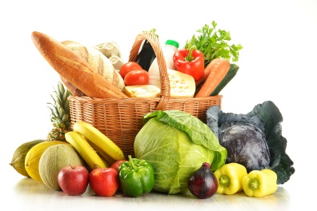SNAP PARTICIPANT SURVEY
Food and Shopping

How often do you usually shop for groceries?
More than once a week
Once a week
Once every two weeks
Once a month or less
Rarely make any major shopping trips, only small trips
Rarely shop for food

What is your household's usual MONTHLY expense for fruits and vegetables?
$
Don't know

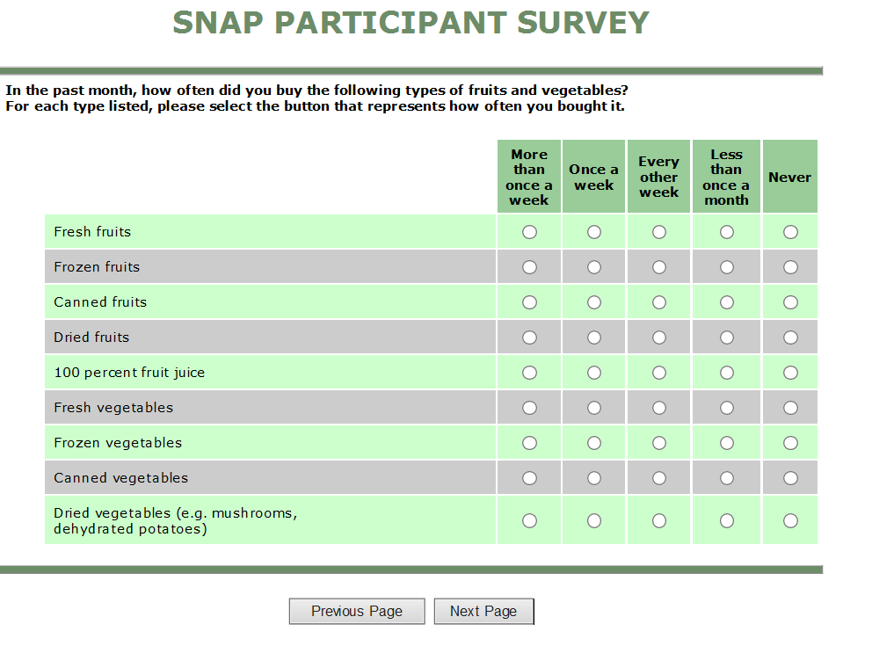

SNAP PARTICIPANT SURVEY
These questions are about the different kinds of fruits and vegetables you ate or drank during the LAST MONTH. Please think about all fruits, vegetables, and fruit juices that you had last month. Include those that were raw, cooked, eaten as snacks and at meals, eaten at home and away from home in restaurants, with friends, and as take-out, and eaten alone and mixed with other foods.
Over the past month, how many times per month, week, or day did you drink 100% juice such as orange, mango, apple, grape or pineapple juices? Do not count fruit-flavored drinks with added sugar, like cranberry cocktail, Hi-C, lemonade, Kool-Aid, Gatorade, Tampico, and Sunny Delight. Include juice you drank at all mealtimes and between meals.
Never
Once a week
1 to 3 times last month
1 to 2 times per week
3 to 4 times per week
5 to 6 times per week
2 times per day
3 times per day
4 times per day
5 or more times per day

These questions are about the food situation in your household in the last 30 days and whether you were able to afford the food you need. For each statement or question, please select one response that best describes your household's food situation.
In the last 30 days, "we worried whether our food would run out before we got money to buy more." Was that often, sometimes, or never true for your household?
Often true
Sometimes true
Never true
Don't know

