Appendix F9. Site Menu Follow-Up Report

Instructions
Your list of foods and beverages served and their recipes provided most of the information we need. In the tables below, we list items for which we need additional details organized by the type of meal component the item provides.

The meal components include: Grains/Bread, Fruits/Vegetables, Meats/Meat Alternates, and Milk. If the menu item was a combined food (like a sandwich) or a mixed dish (like pizza), the table lists the ingredient followed by the menu item containing the ingredient. For example, if the menu item was a peanut butter and jelly sandwich, we may have questions about the bread in the sandwich. The table will list “Bread (peanut butter & jelly sandwich)” in the section on Grains/Bread, and “Peanut butter (peanut butter & jelly sandwich)” in the section on Meats/Meat Alternates (see Figure 1.)

Figure 1. Followup report questions for components of PB&J sandwich
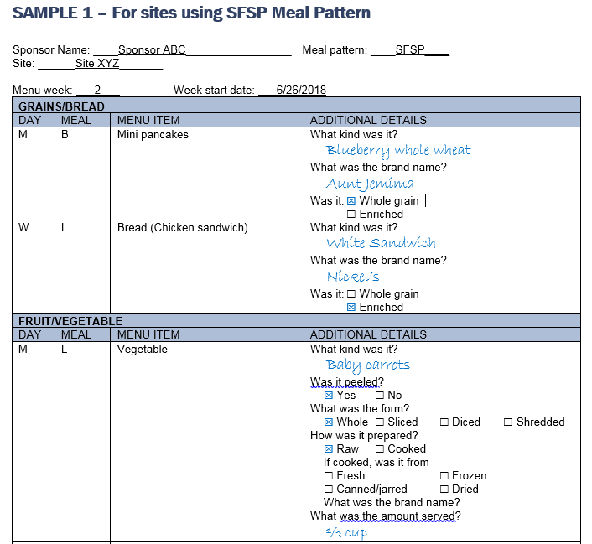

The details needed vary for the type of food, and include:
- Brand name and product name
- Grains/Bread: The details needed vary by the Meal Pattern you use:
  - If using the SFSP meal pattern: Was the item whole grain, enriched, or (for cereals only) fortified?
  - If using the CACFP or NSLP meal pattern: Was the item whole grain-rich, enriched, or (for cereals only) fortified?
- Fruits & Vegetables: Were they:
  - Peeled?
  - Whole, sliced, diced, shredded?
  - Raw, canned/jarred, cooked or dried?
    - For canned/jarred fruit, was it packed in heavy syrup, light syrup, extra light syrup, juice, or water?
    - For cooked fruit or vegetable, was it made from
      - Fresh
      - Frozen
      - Canned/jarred
      - Dried
    - For cooked fruit or vegetable, how was it prepared?
      - Baked/roasted
      - Microwaved
      - Broiled/grilled
      - Pan-fried/sautéed
      - Deep fried
      - Boiled
      - Steamed
      - Other (specify
  - Fruit or vegetable juice: Was it 100% juice?
- Meats/meat alternatives:
  - For meats: Was the item regular or lean?
  - For cheese: Was the item regular, reduced-fat or fat-free?
- Milk: Was it
  - Plain or flavored?
  - Regular (whole), reduced-fat (2%), low-fat (1%), fat-free (skim)

The table on the following pages shows an example of the form. The type of information that will be pre-filled is shown in black. The responses that a sponsor provided are shown in blue. The table with your menu items and the details needed begins on page ___.

If you have any questions about this form, please contact the study team at XXX-XXX-XXXX or xxxx@westat.com.

SAMPLE 1 – For sites using SFSP Meal Pattern
Sponsor Name: ____Sponsor ABC_________________ Meal pattern: ____SFSP____
Site: ______Site XYZ_______

Menu week: ___2___ Week start date: ___6/26/2018
GRAINS/BREAD
DAY | MEAL | MENU ITEM | ADDITIONAL DETAILS
M | B | Mini pancakes | What kind was it?  Blueberry whole wheat  What was the brand name?  Aunt Jemima  Was it: Whole grain  Enriched
W | L | Bread (Chicken sandwich) | What kind was it?  White Sandwich  What was the brand name?  Nickel’s  Was it: Whole grain  Enriched
FRUIT/VEGETABLE
DAY | MEAL | MENU ITEM | ADDITIONAL DETAILS
M | L | Vegetable | What kind was it?  Baby carrots  Was it peeled?  Yes No  What was the form?  Whole Sliced Diced Shredded  How was it prepared?  Raw Cooked  If cooked, was it from  Fresh Frozen  Canned/jarred Dried  What was the brand name?  What was the amount served?  ½ cup
F | L | Fruit | What kind was it?  Applesauce  What was the form?  Whole Sliced Diced Shredded  How was it prepared?  Fresh Frozen  Canned/jarred Dried  If canned/jarred, was it  Packed in water or unsweetened  Packed in juice  Packed in syrup or sweetened  Was the syrup:  Heavy Light Extra light  What was the brand name?  Motts
MEAT/MEAT ALTERNATE
DAY | MEAL | MENU ITEM | ADDITIONAL DETAILS
M | B | Cheese stix | What kind was it?  Mozzarella cheese stick  What was the brand name?  Poly-O  Was it:  Regular Reduced fat Fat free
 | D | Peanut butter (PBJ Uncrustable) | Was it:  Regular Reduced fat
MILK
DAY | MEAL | MENU ITEM | ADDITIONAL DETAILS
M | B | Menu was missing milk | Was milk served?  Yes No  Plain or flavored?  Plain Flavored  Was it:  Regular (Whole or vitamin D)  Reduced-fat (2%)  Low-fat (1%)  Fat-free (skim)
ADDITIONAL INGREDIENTS: Did the following foods include ingredients not mentioned in the name of the food?
DAY | MEAL | MENU ITEM | ADDITIONAL DETAILS
M | L | Pizza | What kind was it?  Cheese pizza  What was the brand name?  No brand name  Did it include meat?  Yes No  If yes, what kind of meat was it?  Was the meat:  Regular Lean
Did it include any vegetables?
Yes No
If yes, what kind of vegetable was it?

Was the vegetable peeled?
Yes No
What was the form of the vegetable?
Whole Sliced
Diced Shredded
How was the vegetable prepared?
Raw Cooked
If cooked, was it from
Fresh Frozen
Canned/jarred Dried
T | B | Ham/Egg Scrambler | Did it include any vegetables?  Yes No  If yes, what kind of vegetable was it?  Was the vegetable peeled?  Yes No  What was the form of the vegetable?  Whole Sliced  Diced Shredded  How was the vegetable prepared?  Raw Cooked  If cooked, was it from  Fresh Frozen  Canned/jarred Dried

SAMPLE 2 – For sites using CACFP or NSLP Meal Pattern
Sponsor Name: ____Sponsor ABC_________________ Meal pattern: ____CACFP____

Site: ______Site XYZ_______

Menu week: ___2___ Week start date: ___6/26/2018
GRAINS
DAY | MEAL | MENU ITEM | ADDITIONAL DETAILS
M | B | Mini pancakes | What kind was it?  Blueberry whole wheat  What was the brand name?  Aunt Jemima  Was it: Whole grain-rich  Enriched
W | L | Bread (Chicken sandwich) | What kind was it?  White Sandwich  What was the brand name?  Nickel’s  Was it: Whole grain-rich  Enriched
VEGETABLES
DAY | MEAL | MENU ITEM | ADDITIONAL DETAILS
M | L | Vegetable | What kind was it?  Baby carrots  Was it peeled?  Yes No  What was the form?  Whole Sliced Diced Shredded  How was it prepared?  Raw Cooked  If cooked, was it from  Fresh Frozen  Canned/jarred Dried  What was the brand name?  What was the amount served?  ½ cup
FRUITS
DAY | MEAL | MENU ITEM | ADDITIONAL DETAILS
F | L | Fruit | What kind was it?  Applesauce  What was the form?  Whole Sliced Diced Shredded  How was it prepared?  Fresh Frozen  Canned/jarred Dried  If canned/jarred, was it  Packed in water or unsweetened  Packed in juice  Packed in syrup or sweetened  Was the syrup:  Heavy Light Extra light  What was the brand name?  Motts
MEAT/MEAT ALTERNATE
DAY | MEAL | MENU ITEM | ADDITIONAL DETAILS
M | B | Cheese stix | What kind was it?  Mozzarella cheese stick  What was the brand name?  Poly-O  Was it:  Regular Reduced fat Fat free
 | D | Peanut butter (PBJ Uncrustable) | Was it:  Regular Reduced fat
FLUID MILK
DAY | MEAL | MENU ITEM | ADDITIONAL DETAILS
M | B | Menu was missing milk | Was milk served?  Yes No  Plain or flavored?  Plain Flavored  Was it:  Regular (Whole or vitamin D)  Reduced fat (2%)  Lowfat (1%)  Fat free (skim)
ADDITIONAL INGREDIENTS: Did the following foods include ingredients not mentioned in the name of the food?
DAY | MEAL | MENU ITEM | ADDITIONAL DETAILS
M | L | Pizza | What kind was it?  Cheese pizza  What was the brand name?  No brand name  Did it include meat?  Yes No  If yes, what kind of meat was it?  Was the meat:  Regular Lean
Did it include any vegetables?
Yes No
If yes, what kind of vegetable was it?

Was the vegetable peeled?
Yes No
What was the form of the vegetable?
Whole Sliced
Diced Shredded
How was the vegetable prepared?
Raw Cooked
If cooked, was it from
Fresh Frozen
Canned/jarred Dried
T | B | Ham/Egg Scrambler | Did it include any vegetables?  Yes No  If yes, what kind of vegetable was it?  Was the vegetable peeled?  Yes No  What was the form of the vegetable?  Whole Sliced  Diced Shredded  How was the vegetable prepared?  Raw Cooked  If cooked, was it from  Fresh Frozen  Canned/jarred Dried

