Appendix D25. Study Brochure
SUMMER MEALS STUDY 2018
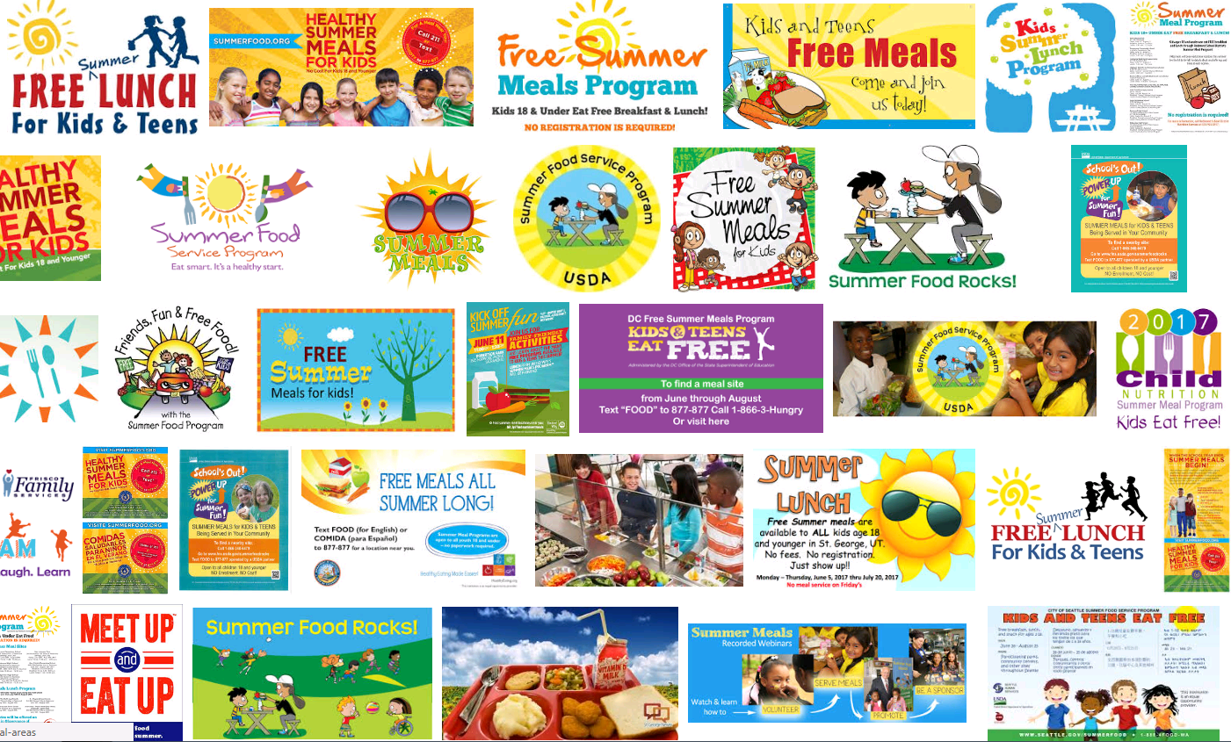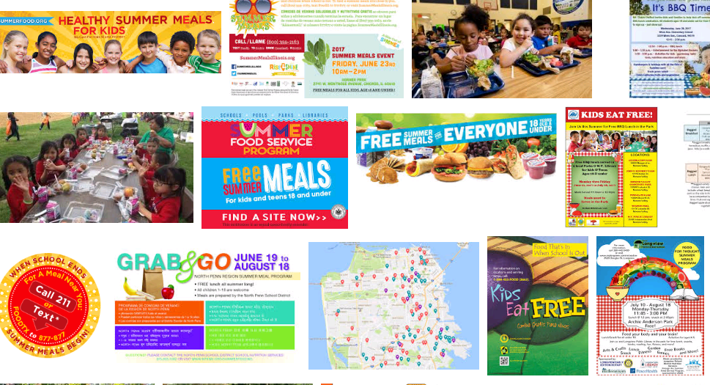

Background
The U.S. Department of Agriculture (USDA), Food and Nutrition Service (FNS) administers 15 nutrition assistance programs to improve access to food, improve food security, and provide healthy meals to low-income households. USDA’s Summer Meal Programs —the Summer Food Service Program (SFSP) and the Seamless Summer Option (SSO)—provide children in low-income areas with nutritious meals during the summer months, when school is not in session. In July 2016, 2.8 million children participated in the SFSP and a smaller number received free meals through the SSO.

USDA has contracted with researchers at Westat to run the Summer Meals Study to help us understand who participates in Summer Meal Programs and how these programs could better meet the nutritional needs of children in the summer. The study will ask about how satisfied participants are with the programs, and why some families and their children do not participate in summer meals. The study will also collect information on how the meals are served and where they’re served, and how healthy the summer meals are.

Planned data collection activities
The Summer Meals Study will collect data from selected summer meals sponsors, site supervisors, program participants and nonparticipants, and their caregivers. Data collection activities are scheduled from May to November 2018.

- CURRENT PROGRAM SPONSORS and SITE SUPERVISORS will be invited to fill out an online survey about their programs. Interested sponsors and site supervisors may be selected for follow-up telephone interviews. Staff who are responsible for menu planning activities will also provide site menus and fill out a menu planning survey.
- FORMER SPONSORS will be invited to participate in telephone interviews about their opinions and experience with the program and the reasons that they don’t serve summer meals anymore.
- PARENTS/CAREGIVERS AND THEIR CHILDREN will be invited to fill out an online or paper survey on what they think about the program. Interested parents/caregivers may be selected for follow-up telephone interviews.

We need your opinions!
If you were selected to help us with the Summer Meals Study, we want to hear your opinions! It is important that we hear from a wide variety of current and former program sponsors and site supervisors, caregivers, and their children to get all perspectives.

The study seeks to improve the Summer Meal Programs to make it easier for children, sponsors, and sites to participate. With your help, the study will help us understand how we can better feed children in the summer, how Summer Meal Programs operate and what people think about them, how healthy the meals are, and challenges that could prevent people from taking part.

For more information
For questions or concerns about the study, please contact the study team at SUMS@westat.com or at 1-XXX-XXX-XXXX.

For more information about the Summer Meal Programs, visit the USDA website at https://www.fns.usda.gov/sfsp/summer-food-service-program

Public reporting burden for this collection of information is estimated to average 3 minutes per response, including the time for reviewing instructions, searching existing data sources, gathering and maintaining the data needed, and completing and reviewing the collection of information. An agency may not conduct or sponsor, and a person is not required to respond to, a collection of information unless it displays a currently valid OMB control number. Send comments regarding this burden estimate or any other aspect of this collection of information, including suggestions for reducing this burden, to: U.S. Department of Agriculture, Food and Nutrition Services, Office of Policy Support, 3101 Park Center Drive, Room 1014, Alexandria, VA 22302 ATTN: PRA (0584-xxxx*). Do not return the completed form to this address.

